DISTRICT DEPARTMENT OF TRANSPORTATION
CS-12 Data Scientist | Technical Assessment

FHWA Functional Class Enrichment
for Public Space Occupancy Permits
Methodology, Data Validation, Spatial Decision Logic,
Results, Limitations, and Reproducibility

Data snapshot: 13 October 2026 | Report revised: 15 October 2026
Source project: 1_Python_test.zip | Scripts: 01 through 07

Executive summary
The task was to enrich calendar-year 2026 TOPS occupancy-permit locations for DC Water, PEPCO, and Washington Gas with the FHWA functional class of the associated road, and to calculate the highest roadway functional class within each permit application. The workflow retains one row per location, identifies roadway candidates through DDOT LRS, verifies official classes through Roadway SubBlock layer 162, and avoids silently choosing a road when address and spatial evidence disagree.
Metric | Value
Initial date/activity-matched locations | 7,194
Target-utility permit locations | 4,926
Unique permit applications (TrackingNumber) | 3,102
Location classes VERIFIED | 4,755 (96.5%)
Locations needing review | 171 (3.5%)
Applications with final highest class | 2,933
Applications needing review | 169
Table 1. Key results from the archived complete run.
Interpretation. The 96.5% value is algorithmic verification coverage, not a measured ground-truth accuracy rate. The 171 exceptional locations (118 PROVISIONAL and 53 UNRESOLVED) were retained, and the suggested remedies were NOT implemented for these final exceptions.
Boundary of the evidence. Results describe the October 13 source snapshot and checks recorded in the project, not a live year-end 2026 census or an independent field survey.

Contents
Section titles and page references can be updated in Word (Ctrl+A, then F9).
1. Problem statement, supplied inputs, and assumptions –
2. Data and workflow overview –
3. Data exploration and download validation (Steps 01–02) –
4. Company selection and record integrity (Steps 03–04) –
5. Coordinate interpretation and exploratory GIS sanity checks (Step 05) –
6. Complete LRS matching methodology (Step 06) –
7. Staged pilot-to-full checks and empirical findings –
8. Final outputs and substantive interpretation –
9. Exception analysis: 171 locations not finalized –
10. Validation, reproducibility, and independent quality assurance –
11. Reviewer questions answered by project evidence –
12. File guide and final-submission notes –
13. Conclusions and interpretation –
14. Sources and evidence record –

List of Tables
Table 1. Key results from the archived complete run. –
Table 2. Processing scripts and the validation activity integrated into each step. –
Table 3. Activity mix in the October 13 source snapshot. –
Table 4. Applicant aliases used for the final three-utility selection. –
Table 5. Coordinate QA observed before roadway matching. –
Table 6. Illustrative roadway-candidate comparison; not a real permit record. –
Table 7. Sequence of exploratory, pilot, and complete processing checks. –
Table 8. Final location-level functional-class decisions. –
Table 9. Final application-level confidence and highest-class outcomes. –
Table 10. Exhaustive audit of 171 final class exceptions and unimplemented remedies. –
Table 11. Validation matrix distinguishing completed checks from future independent tests. –
Table 12. Methodological questions and concise defensible responses. –
Table 13. Location of original source files, final deliverables and audit evidence. –

List of Figures
Figure 1. Decision tree for identical/different Original–OnSeg coordinates, LRS search, official class verification, and permit aggregation. –

List of Plots
Plot 1. Final Step 06 verification statuses across all 4,926 permit locations. –

1. Problem statement, supplied inputs, and assumptions
Problem statement. The Associate Director of Public Space Division requested a location-level CSV for occupancy permit applications or issued permits, with the roadway FHWA functional class at every location and the highest class for the associated permit application. Some applications affect multiple roads. Work-hour rules motivated the request, but work hours were not part of the requested calculations.
Supplied resources. TOPS Occupancy Permit MapServer layer 24, DDOT LRS getPointOnSubBlock, Roadway SubBlock layer 162, and an alternative MAR address lookup. The assessment states that no data dictionary was supplied and explicitly permits using AI. Source: _Python Test - CS12 Data Scientist.pdf.
Working assumptions, stated rather than hidden: (a) calendar-year 2026 is interpreted as January 1, 2026 inclusive to January 1, 2027 exclusive; (b) an application is grouped by TrackingNumber, whereas LocationID identifies a distinct TOPS location; (c) local X/Y is interpreted as EPSG:26985 based on coordinate comparison, pending authoritative field metadata; (d) ROADTYPE=1 is treated as street, excluding alleys; and (e) smaller numbered FHWA codes imply higher functional hierarchy in the recorded class scheme.
The source query is a snapshot extracted October 13, 2026. Thus, locations added to TOPS later in 2026 are not included. The extraction allows 2026 application OR issue dates and can include an application submitted earlier if issued during 2026.

2. Data and workflow overview
Step | Purpose | Embedded QA
01 | Explore TOPS fields and representative values | Schema, identifier and company sanity checks
02 | Query all date/activity-matched permits | OBJECTID completeness, batch reconciliation
03 | Explore organization names | Applicant/Permittee/Owner variants reviewed
04 | Filter three utilities | Dates, activity, unique IDs and ownership QA
05 | Check coordinates and nearby roads | CRS residual, Original vs OnSeg, proximity pilot
06 | Link location to official roadway class | LRS, address/block, nearest-road and class agreement
07 | Aggregate confirmed class per application | Independent grouping checks and exception propagation
Table 2. Processing scripts and the validation activity integrated into each step.
The seven scripts reside in src/. Input JSON is under data/raw/ and data/processed/. Step 06 primary/evidence outputs are stored in outputs/roadway_functional_class/{pilot,full}/; Step 07 separates primary results from quality-control and limitations under outputs/permit_highest_functional_class/.

3. Data exploration and download validation (Steps 01–02)

Exploration when no data dictionary was available
Step 01 examined ten unfiltered records to understand ArcGIS response structure and 500 records under a broad date filter to profile fields and values. The initial schema exploration identified 112 attribute fields and key candidate fields including TrackingNumber, LocationID, ApplicantCompany, ApplicationDate, IssueDate, EventTypeDescription, WorkLocationFullAddress, Original and OnSeg coordinates, and ArcGIS geometry. This small-first approach verified assumptions before filtering the entire population.

Extraction and completeness
Step 02 built a server-side condition for ApplicationDate OR IssueDate within the stated 2026 interval and EventTypeDescription in Construction Staging Area or Mobile Crane Work Zone. The script requested matching OBJECTIDs and downloaded by ID batches (500 at a time), checking returned IDs against requested IDs before writing the raw JSON. This provides a reproducible completeness check against the response at extraction time, not against future changes to the live service.
Requested permit activity | Records returned
Construction Staging Area | 6,938
Mobile Crane Work Zone | 256
Total date/activity-matched locations | 7,194
Table 3. Activity mix in the October 13 source snapshot.
Sanity-check interpretation. The 7,194 raw records were the output of the activity/date query, not the final three-utility population. Counts from the preserved raw JSON allow a reviewer to repeat the checks without relying exclusively on the code’s printed totals.

4. Company selection and record integrity (Steps 03–04)

How three utilities were recognized
Step 03 reviewed ApplicantCompany along with PermitteeName and OwnerName to understand naming variants. Step 04 deliberately used confirmed normalized ApplicantCompany aliases rather than broad substrings. This reduces false positives but may miss unobserved alternate names; the company-name inventory is retained for that reason.
Selected utility | Confirmed applicant-name aliases | Locations
DC Water | dcwater/cip; dcwater/ops; dcwater | 1,887
PEPCO | potomac electric power company; pepco | 1,373
Washington Gas | wash gas & light co. | 1,666
Three-utility total |  | 4,926
Table 4. Applicant aliases used for the final three-utility selection.

Checks attached to the filter
The recorded QA included zero duplicate OBJECTIDs, zero duplicate selected LocationIDs, zero missing TrackingNumbers, zero cross-utility application IDs, and zero TrackingNumbers jointly assigned to selected and excluded applicant locations. The filter removed 2,268 locations from other applicants and retained exactly 4,926 target-utility locations (3,102 distinct TrackingNumbers).
PermitNumber was missing from 2,495 of the selected 4,926 location records. This is why TrackingNumber was chosen as the application key. It is present across the selected population and allows several LocationIDs to be grouped without dropping applied-only records. PermitNumber is preserved as context and is not silently substituted for the application identifier.
Important scope finding. Although the initial query included both requested permit types, all 4,926 target-utility records are Construction Staging Area. The 256 Mobile Crane Work Zone records in the broader download had other ApplicantCompany values. This is an observed filter result, not a failure to request crane permits.

5. Coordinate interpretation and exploratory GIS sanity checks (Step 05)
TOPS includes Original XCoord/YCoord and OnSegX/OnSegY, as well as ArcGIS feature geometry in Web Mercator (reported as WKID 102100 / latest 3857). OnSeg is a second coordinate representation, not an independent address. The same TOPS WorkLocationFullAddress is the permit address against which candidate LRS roads are tested.
QA comparison | Observed | Interpretation
Original XY exactly equals OnSeg XY | 4,411 locations | Query one coordinate source in Step 06.
Original XY differs from OnSeg XY | 515 locations | Query both independently; no distance-based collapse.
Largest Original–OnSeg separation | 99.878 m | Differences sometimes materially affect candidate roads.
Largest OnSeg vs transformed ArcGIS residual | 0.889 m | Supports, but does not independently certify, EPSG:26985.
Table 5. Coordinate QA observed before roadway matching.
Step 05 also inspected nearby roadways at 30 m for nine illustrative locations, showing why a close roadway can be the wrong roadway near an intersection. These exploratory candidates were not assigned final FHWA classes. The archived project did not contain the expected outputs/spatial/*.csv artifacts, so those files should be regenerated if the exploratory QA must be reproduced from saved CSVs.
The EPSG:26985 interpretation is based on numerical consistency; it is not a documented statement of the TOPS field CRS. Official field metadata should be consulted if this analysis becomes operational.

6. Complete LRS matching methodology (Step 06)

Two coordinate scenarios
Scenario A: Original = OnSeg. The code sends OnSeg to LRS once. LRS may return many nearby route/subblock records, not one official answer. These candidates are compared with the TOPS permit address; the validated SubBlockKey(s) are then tied to official class values from Roadway SubBlock layer 162.
Scenario B: Original differs from OnSeg. The code queries BOTH coordinate sources. It independently checks roadway candidates nearest to each point against the SAME TOPS address. Only when the relevant address/block/official class and nearest-road evidence are consistent for every source does a standard numbered-address record become VERIFIED. If one source points closest to a conflicting street, the class remains reviewable.
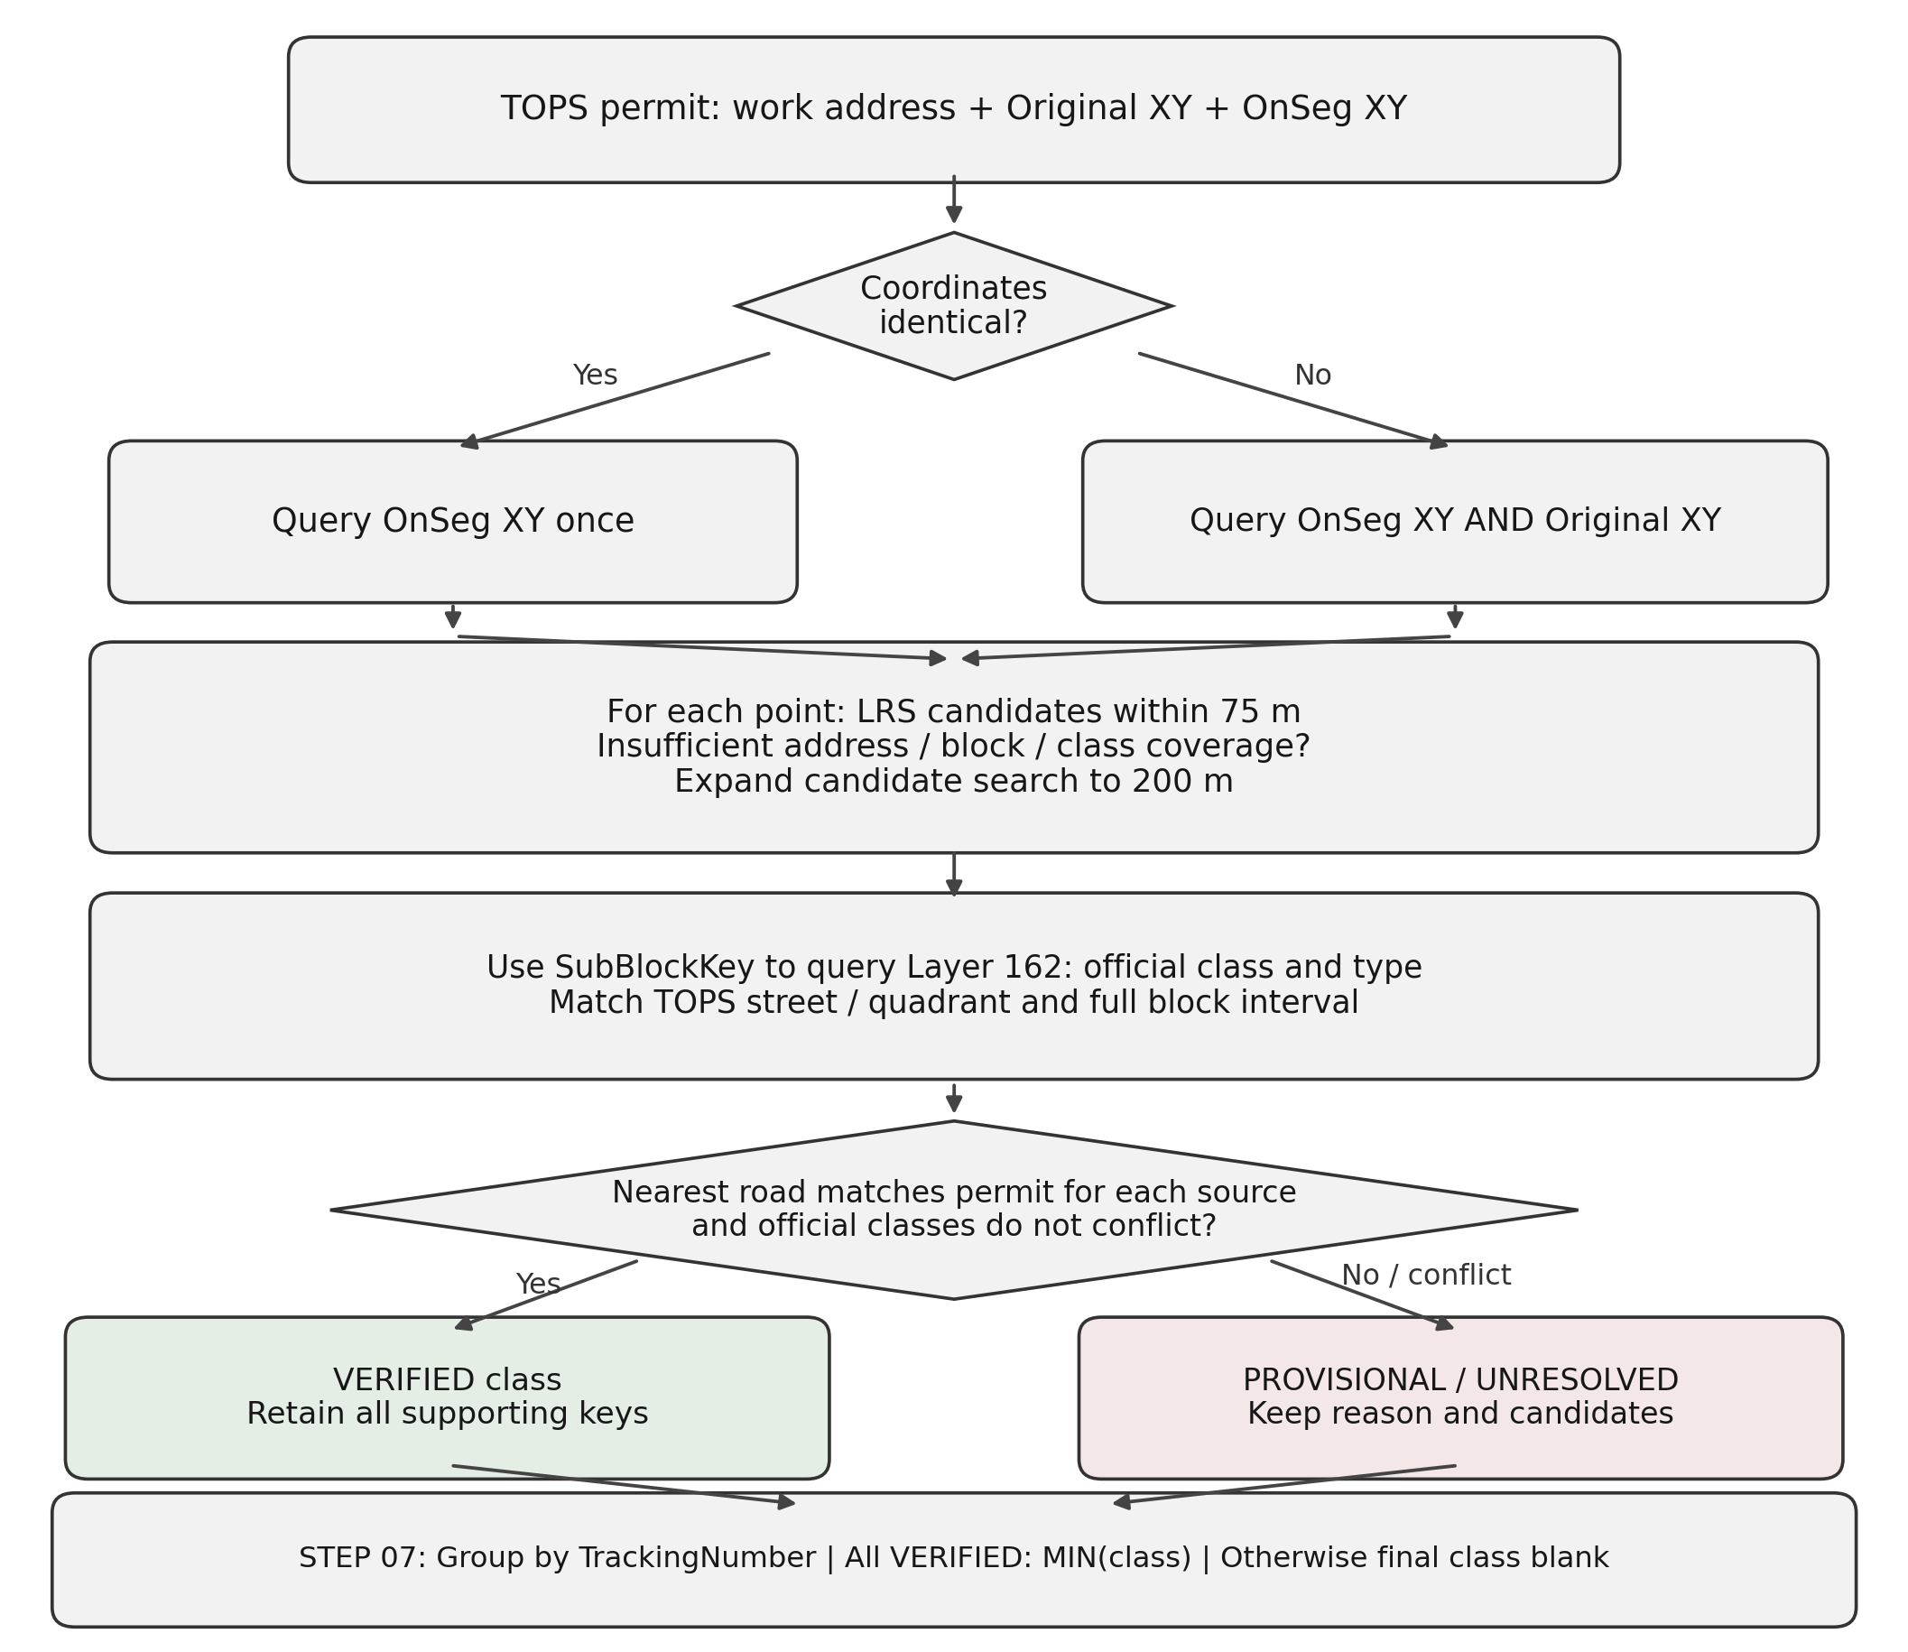
Figure 1. Decision tree for identical/different Original–OnSeg coordinates, LRS search, official class verification, and permit aggregation.

How the 75 m and 200 m searches are used
For each coordinate source, LRS first receives a 75 m candidate-discovery search. The script collects returned SubBlockKeys, route names, unit-block labels, route types and offsetInMeters. The 75 m value is a deliberate, bounded initial search window intended to retrieve plausible local roads without immediately accumulating more distant cross-street candidates. It is not a scientifically calibrated acceptance radius.
For an ordinary numbered address, the code can stop at 75 m ONLY if there are address-and-block-consistent LRS candidates covering the entire stated permit address range AND at least one official roadway/class match can be confirmed. Otherwise it expands candidate discovery to 200 m, the upper search setting selected for this project. For special-bridge and intersection parsing branches, the code does not use the early-completion rule and inspects both configured search windows.
Neither 75 m nor 200 m is a rule that a returned road is automatically correct. The assessment supplied the LRS service but did not prescribe those numerical distances. Consequently, this report documents them as implementation choices, not as a cited DDOT technical standard. The official service determines what queries it accepts; any claimed server-enforced maximum would require separate API metadata confirmation.

Official class retrieval and street validation
A returned SubBlockKey is used to query Roadway SubBlock layer 162 for ROUTENAME, ROADTYPE and FHWAFUNCTIONALCLASS. The code requires street ROADTYPE = 1 and a valid class code 1–7. It standardizes conventional street abbreviations while retaining meaningful directions/quadrants; a restricted BN alias is allowed for East/North/South Capitol Street only. It does not generally delete BN or roadway directions.
For a numbered permit address, the code compares the FULL numeric address range against LRS unitBlock ranges. A match is strong if the ranges are exact, an LRS range encloses the permit range, or valid LRS ranges collectively cover the permit range. Boundary-only/partial overlaps and implausibly broad blocks remain reviewable. Additionally, the official road name and LRS road name must agree with the permit street.

Nearest-road evidence and conservative final decision
Each LRS candidate includes offsetInMeters, a reported distance from the queried coordinate to that roadway. The code finds the minimum returned offset for each coordinate source. A normal numbered-address class is VERIFIED only if an address/block-eligible road is among the nearest candidates for every source, with no conflicting equal-nearest or boundary-class evidence. The candidate class must agree across accepted keys. This guards against selecting a farther road merely because its street name resembles TOPS.
Illustrative example (not an actual observation): suppose TOPS says “1500–1599 Georgia Ave NW” and LRS returns Georgia Ave NW at 5 m (Class 3), Morton St NW at 18 m (Class 7) and Park Rd NW at 45 m (Class 5). If Georgia Ave’s official roadway type and block also agree, it can be verified. If Park Rd were the closest reported route, the Georgia Ave class would be retained as provisional rather than silently accepted.
Permit (illustrative) | LRS road | LRS block | Offset | Class | Decision rationale
TOPS Georgia Ave NW | Georgia Ave NW | 1500–1599 | 5 m | 3 | Potential match if other gates pass
TOPS Georgia Ave NW | Morton St NW | 1500–1599 | 18 m | 7 | Not the named street
TOPS Georgia Ave NW | Park Rd NW | 1500–1599 | 45 m | 5 | Not the named street
Table 6. Illustrative roadway-candidate comparison; not a real permit record.
Multiple acceptable SubBlockKeys are not automatically a failure. When candidate keys remain nonunique but every accepted key has the same official class, the class can be VERIFIED and all keys are retained as evidence. If eligible candidate keys carry different classes, the case remains unresolved. At named two-road intersections, both streets must be jointly supported by nearest LRS evidence and have the same official class; otherwise the output remains PROVISIONAL or UNRESOLVED.

7. Staged pilot-to-full checks and empirical findings
The workflow deliberately progressed from narrow schema probing to a balanced 18-location pilot (three per utility times two coordinate groups), an extended 150-location development sample, and full runs. Earlier versions exposed intersection, bridge and Capitol Street name-label issues, which were corrected in the final matching algorithm. The archived final project retains separate pilot and full folders; historical development counts are reported only to explain how the method evolved.
Stage | Sample or result | Validation purpose
Schema exploration | 10 unfiltered records | Understand ArcGIS structure and fields.
Broader initial profiling | 500 filtered-date sample | Explore categories and applicant labels.
Exploratory spatial pilot | 9 nearby-road examples | Proximity alone not decisive.
Balanced Step 06 pilot | 18 records: 13 VERIFIED, 4 PROVISIONAL, 1 UNRESOLVED | Cover all three utilities and both coordinate groups.
Extended development test | 150: 131 VERIFIED, 19 review | Check behavior on a larger balanced sample.
Early full development run | 4,693 VERIFIED, 233 review | Identify parsable special-address opportunities.
Final complete Step 06 | 4,755 VERIFIED, 171 review | Updated Capitol Street and intersection handling.
Table 7. Sequence of exploratory, pilot, and complete processing checks.
The final archived 18-location Step 06 pilot has the same location-level classes as those records in Full. However, the Step 07 pilot samples LocationIDs, not necessarily all locations of their TrackingNumber. For example, application 11182457 has three of four full-data locations in pilot and 11204424 has one of four. Thus, application-level pilot “confirmed” only means confirmed WITHIN THE PILOT SAMPLE. Full remains the authoritative basis for permit-level conclusions.

8. Final outputs and substantive interpretation

Location-level verification coverage
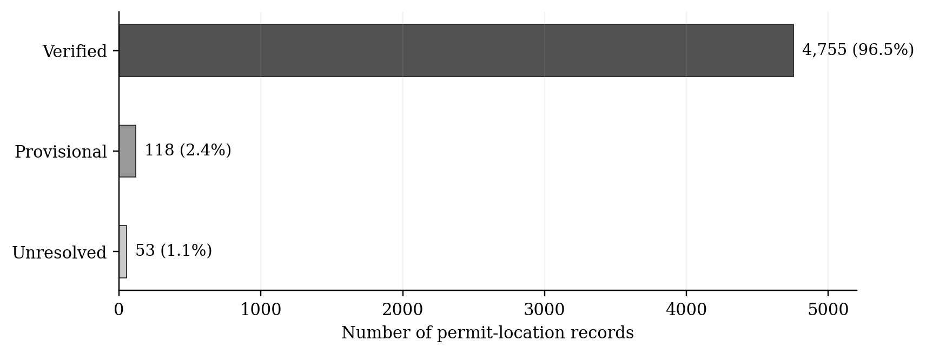
Plot 1. Final Step 06 verification statuses across all 4,926 permit locations.
Status | Locations | Share | Meaning
VERIFIED | 4,755 | 96.5% | All coded evidence gates pass.
PROVISIONAL | 118 | 2.4% | Candidate class exists but critical support remains insufficient.
UNRESOLVED | 53 | 1.1% | No class selected safely from available evidence.
Total | 4,926 | 100% | All selected locations retained.
Table 8. Final location-level functional-class decisions.
Among 4,755 verified location classes, 2,488 have multiple acceptable candidate SubBlockKeys, 2,258 have one verified key, and nine were verified named intersections where both roads have the same class. Class 3 appears in 479 verified locations; Class 4 in 1,066; Class 5 in 775; Class 6 in 107; and Class 7 in 2,328. This distribution is specific to the filtered 2026 TOPS snapshot, not to all DC roads.

Application-level highest class (Step 07)
Step 07 groups rows by TrackingNumber and calculates the HIGHEST functional hierarchy as the minimum numeric class among verified locations only when EVERY location in that application is VERIFIED. For example, classes [7, 4, 3] yield Class 3. When any location remains unverified, the confirmed highest-class field is blank; an optional separate field provides the best class among verified locations WITHOUT calling it final.
Application status | TrackingNumbers | Interpretation
CONFIRMED_ALL_LOCATIONS_VERIFIED | 2,933 | A confirmed highest class is available.
REVIEW_PARTIAL_VERIFIED_LOCATIONS | 18 | Some locations known; unknown locations may alter the maximum hierarchy.
REVIEW_NO_VERIFIED_LOCATIONS | 151 | No location has a verified class; do not provide a final class.
TOTAL | 3,102 | 169 applications still require review.
Table 9. Final application-level confidence and highest-class outcomes.
The final output maintains exactly 4,926 location rows, each carrying its own class/status and application-level result/status, plus an auditable application summary of 3,102 distinct TrackingNumbers. An application can have more than one LocationID, but each location remains represented. This is the requested analysis granularity.

9. Exception analysis: 171 locations not finalized
The remaining 171 location-level cases were NOT forced to a class. The breakdown below distinguishes the code’s precise problem from possible future remedies; these remedies were NOT executed for the final archived result. In particular, a provisional class is not the same as a validated roadway identity.
Exception | N | Reason final class is not defensible | Future action (NOT implemented)
Spatial disagreement | 98 | Nearest LRS roadway differs from permit-address roadway for one or both coordinate sources. | Inspect work-site footprint and both coordinates on official subblock geometry.
No valid address/block match | 19 | No road passes street AND complete block matching; spelling and block labels may differ. | Review TOPS address, DDOT unitBlock and official route labels.
Intersection class conflict | 18 | Both named intersecting roads are found but carry different valid official classes. | Determine which road/part of intersection work occupies.
Boundary class conflict | 15 | Overlapping/boundary road candidates have different official classes. | Examine street segment and full address interval boundaries.
Unparseable address | 9 | Ramp/exit or malformed address string is outside conservative parser rules. | Develop and test separate handling of special route descriptions.
Conflicting classes | 7 | Multiple eligible subblocks are class-inconsistent. | Use authoritative geometry or permit work details to pick correct road.
Special Roosevelt Bridge | 2 | I-66 alias suggests class, not exact bridge segment and lane/side. | Check bridge geometry, approach and permitted work position.
Intersection same-class, geometry uncertain | 2 | Both roads have same code, but nearest-distance evidence is insufficient. | Verify intersection geometry and point placement.
Nearest-road tie | 1 | Equally close different street candidates defeat unique nearest-road support. | Manually inspect intersection and tied road identities.
Table 10. Exhaustive audit of 171 final class exceptions and unimplemented remedies.
Interpretation. The majority of exceptions are source-coordinate/address ambiguities near multiple roads rather than missing Functional Class in the official roadway inventory. The 118 PROVISIONAL cases retain the tentative value strictly for review; the 53 UNRESOLVED cases have no selected value. These labels are not an independent estimate of geospatial accuracy.
Applications affected. The 171 uncertain locations occur across 169 TrackingNumbers: 151 have NO verified location, and 18 have both verified and unverified locations. Neither group receives a final application-wide highest class. These applications remain in deliverables and can be revisited without rerunning unrelated records.

10. Validation, reproducibility, and independent quality assurance

Completed checks versus proposed independent verification
Completed evidence: application/location ID uniqueness, input/output counts, activity and company filters, observed coordinate residuals, small-pilot versus full location agreement, candidate-class evidence reconciliation, API error inventory, independent groupby/minimum recomputation for confirmed application classes, and propagation of uncertainty to the application summary. These are internal consistency tests, not an independent on-the-ground street-identification benchmark.
Stage or test | Evidence or proposed procedure | Evidence status
Exploration | Field names/values sampled; missing data dictionary acknowledged. | Completed exploratory QA
Download | Matching OBJECTIDs enumerated; each downloaded batch reconciled. | Completed in saved code and archived data
Utility filter | 4,926 selected; company aliases and ID integrity checked. | Completed in outputs/validation/
Coordinate QA | 4,411 same; 515 different; Web Mercator transform residual ≤ 0.889 m. | Completed computational QA; CRS source not independently certified
Road matching | 75/200 m candidates, official roadway checks, review categories retained. | Completed rule-based verification; not ground truth
Highest class | 2,933 confirmed / 169 review; independent MIN recalculation agreed. | Completed independent numerical reconciliation
Independent map annotation | Compare random/stratified locations with official road geometry. | Recommended; NOT performed
Automated unit tests | Known-answer cases for address/road parser and permit grouping. | Recommended; NOT delivered in archived scripts
Table 11. Validation matrix distinguishing completed checks from future independent tests.

Recommended external validation protocol
A defensible follow-up would select a reproducible stratified sample across companies, classes, Original/OnSeg coordinate groups and ambiguous intersections. For each selected LocationID, a reviewer would display TOPS coordinates and Roadway SubBlock layer 162 together, determine the actual road or mark the location inconclusive, and compare the independently assigned class to the algorithmic class. Report agreement, disagreement and inconclusive counts separately, with confidence intervals only if sampling design justifies them. This validation was NOT performed in the present project.

Sensitivity and false-certainty considerations
The script uses exact numerical equality to distinguish Original and OnSeg and for equal reported nearest-road offsets. This is intentionally conservative: collapsing approximately equal coordinates may improve completion counts while incorrectly overlooking a different nearest street. An optional sensitivity study could rerun candidate evaluation with small offset tolerances, and with explicitly chosen Original/OnSeg distance tolerances (for example 1 m, 5 m and 10 m), without changing the archived main results. The analyst should report BOTH newly verified and newly ambiguous cases. No such sensitivity experiment is claimed here.
To reproduce after code edits, use a fresh output directory or invalidate processed-record checkpoints. Raw SQLite API response caching can be reused because it stores service responses, whereas saved classification decisions must not be silently reused after the decision rules change. All outputs correspond to the source snapshot and API state available when cached.

Reproducibility and documentation for reviewers
The scripts use pathlib for Windows 11 paths. README.md should give environment setup, package installation, data locations, sequential run order and Pilot/Full configuration; requirements.txt should list Python packages and, ideally, verified versions. These files were prepared after the original archived audit, so their presence in the FINAL submission ZIP must be checked rather than assumed. Unpack all required source JSON or document how it will be downloaded.

11. Reviewer questions answered by project evidence
Likely reviewer question | Evidence-based response
Why TrackingNumber and not PermitNumber? | TrackingNumber is present for the selected 4,926 location records; PermitNumber is absent in 2,495. Multiple locations can belong to one application.
Why not take the nearest road immediately? | Nearest distance is only one spatial check. Street, quadrant, full block, official road type and class must also agree.
Why query Original AND OnSeg? | The 515 differing coordinate pairs can generate different nearest candidates, especially near intersections. Both are assessed, not blindly merged.
Can LRS return multiple roads within 75 m? | Yes. The LRS response contains candidate subblocks and their offsetInMeters. The program does not assume a single response is correct.
What does insufficient 75 m evidence mean? | No valid official street/block candidate with full permit-range coverage; expand discovery to 200 m, then apply the same verification gates.
Why are multiple SubBlockKeys allowed? | Distinct road subblocks may independently support an identical class; the key remains ambiguous, but the class can be stable.
Does 96.5% mean prediction accuracy? | No. It is the share satisfying predefined code rules. Independent GIS annotation is needed for measured accuracy.
Why are 171 locations left unconfirmed? | There are explicit spatial, boundary, conflicting class and special-address exceptions; assigning a number would create unjustified certainty.
Why choose the minimum FHWA code? | The smaller numeric class represents higher functional hierarchy in the used scheme. MIN returns the highest hierarchy.
How was AI use validated? | AI assistance is permitted in the instructions; archived outputs were checked for completeness, candidate support and application aggregation. Separate ground-truth GIS testing remains future work.
Table 12. Methodological questions and concise defensible responses.

12. File guide and final-submission notes
Project-relative path | Function
data/raw/permits_2026_applied_or_issued_staging_crane_all_companies.json | 7,194 date/activity-matched source locations.
data/processed/permits_2026_applied_or_issued_staging_crane_three_utilities.json | 4,926 selected utility permit locations and attributes.
outputs/validation/*.csv | Applicant alias inventory, selection integrity and filter QA.
outputs/roadway_functional_class/full/permit_locations_fhwa_functional_class.csv | Step 06 authoritative per-location class and verification status.
outputs/roadway_functional_class/full/permit_locations_lrs_roadway_candidate_evidence.csv | All saved LRS candidates and official class evidence.
outputs/roadway_functional_class/full/permit_locations_functional_class_needing_review.csv | 171 exceptions, precise statuses and suggested actions.
outputs/permit_highest_functional_class/01_primary_results/full/permit_locations_with_highest_fhwa_functional_class.csv | MAIN final deliverable: one row per LocationID including application class.
outputs/permit_highest_functional_class/01_primary_results/full/permit_tracking_highest_fhwa_functional_class_summary.csv | One row per TrackingNumber: highest class and application confidence.
outputs/permit_highest_functional_class/02_quality_control_and_limitations/full/*.csv | Review permits/locations, reason and QA summaries.
Table 13. Location of original source files, final deliverables and audit evidence.
Submission checklist. Include a nonempty README.md and requirements.txt, make data files discoverable with relative paths, archive optional previous development artifacts separately, avoid shipping a large .git directory unintentionally, and verify that Step 05 spatial QA files are included or explicitly documented as exploratory material not packaged. The latest source snapshot and each full-output CSV must stay mutually consistent.

13. Conclusions and interpretation
The final workflow creates an auditable mapping from DDOT TOPS permit locations to official FHWA roadway classes. It is not merely a nearest-road join: it combines date/activity and utility filtering, identifiers, coordinate sanity checks, official DDOT roadway attributes, complete address ranges, spatial nearest-road agreement and conservative uncertainty labels. The staged pilot and full runs show how code assumptions were surfaced and corrected before final output.
Of 4,926 relevant locations, 4,755 (96.5%) satisfied the internal criteria for a verified roadway class. An additional 118 remain provisional and 53 remain unresolved; none was removed merely because matching was uncertain. Of the 3,102 applications, 2,933 have a confirmed highest roadway class under the complete-location rule. The remaining 169 applications are explicitly marked as requiring review rather than receiving fabricated final values.
The important interpretation is methodological: a high internal verification rate is useful for coverage and auditing, but it must not be advertised as externally measured classification accuracy. Future work could establish ground-truth GIS agreement and resolve the 171 documented exceptions through more detailed geometry, permit footprint inspection, MAR cross-checks, and specialized ramp/bridge logic. Those actions have been proposed but were NOT applied to this archived result.

14. Sources and evidence record
DDOT. “Python Test – CS12 Data Scientist.” Assessment instructions supplied with the task; describes the occupancy-permit request, permitted LRS/MAR alternatives, exclusion of alleys, Windows 11 and ZIP/README submission requirements.
DDOT TOPS Occupancy Permit, ArcGIS MapServer layer 24: https://maps2.dcgis.dc.gov/dcgis/rest/services/DCGIS_APPS/DDOT_TOPS/MapServer/24
DDOT RoadwayBlocks LRS, getPointOnSubBlock: https://rh.dcgis.dc.gov/dcgis/rest/services/DDOT/RoadwayBlocks/MapServer/exts/DdotLrsExtensions/getPointOnSubBlock
DDOT Roadway SubBlock, MapServer layer 162: https://maps2.dcgis.dc.gov/dcgis/rest/services/DCGIS_DATA/Transportation_WebMercator/MapServer/162
Source of reported counts and status judgments: archived 1_Python_test.zip (scripts 01–07, downloaded/filtered JSON, outputs/validation/, final Step 06 and Step 07 CSVs), reviewed 14–15 October 2026. Earlier 150-record development results were documented during implementation, but only the final Pilot and Full artifacts form the current deliverable.

