DISTRICT DEPARTMENT OF TRANSPORTATION
CS12 Data Scientist Assessment

Roadway Functional Class Enrichment
for Utility Permit Locations
  - Python Assessment Technical Report
Prepared by Amir Moayyedi
16 October 2026
Project repository: https://github.com/SAMIRHOSEIN/Python_DDOT.git
Overview
This project links qualifying TOPS utility permit locations to Federal Highway Administration (FHWA) roadway classes, then identifies the highest class for each permit application. The final CSV keeps every location, including cases that need review. This allows DDOT to examine the roadway class at each work location and the application as a whole.
The report follows the seven Python scripts in order. Each step explains the uncertainty it addressed, the decision made, and the evidence passed to the next step. The main challenge was establishing that a nearby roadway actually matched the permit address. Road names, address ranges, both coordinate representations, and official roadway attributes were checked together before a class was confirmed.
All file paths are relative to the project root 1_Python_test/. The report describes class enrichment; it does not calculate permitted work hours.
Contents
Step 01 Discover the permit fields 3
Step 02 Download the eligible 2026 locations 3
Step 03 Identify how the utilities are named 4
Step 04 Select and validate the utility locations 4
Step 05 Check the coordinates before matching roads 5
Step 06 Match roadways and confirm classes 7
Confirm the street and the complete address range 8
Handle intersections and special addresses 10
Step 07 Find the highest class for each application 11
Results and locations requiring review 13
Read the final CSV 14
List of tables
Table 1. Identifiers and their uses 3
Table 2. Utility aliases and current selected locations 5
Table 3. Coordinate checks in the current selected input 6
Table 4. Address matching rules and their reasons 9
Table 5. Class certainty and roadway key certainty 11
Table 6. Location classes for application 11182457 11
Table 7. Application outcomes in the saved full result 12
Table 8. Reasons the 174 full-run locations require review 14
Table 9. Key fields in the final location CSV 15
List of figures
Figure 1. Roadway matching and class decision sequence 8
Figure 2. A real address match that remains provisional 9
Figure 3. Intersection agreement and conflicting classes 10
Figure 4. Current full-run location status and verified class distribution 13
Contents, caption lists, and cross-references can be updated in Word with Ctrl+A, then F9.

Step 01 Discover the permit fields
Script src/01_explore_data.py
Without a data dictionary, filtering immediately would require guessing the correct fields and values. Step 01 therefore inspected 112 attributes in a 10-record unfiltered sample, then used a 500-record date-filtered sample to examine activities, dates, companies, and repeated applications.
The samples established the exact labels Construction Staging Area and Mobile Crane Work Zone and the identifiers in Table 1. These practical discovery samples were not accuracy samples. Step 01 reads the saved files and prints findings; it does not create or download them.
Saved in data/1_samples/
sample_10_unfiltered_schema_discovery.json
sample_500_date_filtered_2026_company_activity_exploration.json
Table 1. Identifiers and their uses
Field | Meaning and use
LocationID | One permit work location and one final CSV row.
TrackingNumber | One application; groups its work locations in Step 07.
PermitNumber | Issued-permit identifier; may be blank for an application.
SubBlockKey | A roadway identifier used to retrieve the official class.

Step 02 Download the eligible 2026 locations
Script src/02_download_permits.py
Using the discovered labels, Step 02 selected either activity when ApplicationDate or IssueDate fell in 2026. The calendar-year interpretation uses 1 January 2026 inclusive to 1 January 2027 exclusive; Step 04 checks the timestamps in UTC. An earlier application therefore remains eligible if issued in 2026. Company filtering was delayed until the actual utility aliases were known.
To avoid an incomplete response caused by service record limits, the script first requested all eligible OBJECTIDs, then retrieved them in batches of 500. The batch size is a practical request-size setting, not a DDOT requirement. Every returned batch had to contain the requested IDs, and the final count had to match the complete ID list.
The supplied raw JSON records a download at 18:51:14 UTC on 15 October 2026. It contains 7,314 locations: 7,049 staging-area and 265 crane-work records. This is a year-to-date extract, not a completed full-year total.
Saved in data/2_raw/
permits_2026_applied_or_issued_staging_crane_all_companies.json

Step 03 Identify how the utilities are named
Script src/03_identify_utility_companies.py
The same utility could appear under several company names, and ApplicantCompany, PermitteeName, and OwnerName could describe different parties. Step 03 searched all three fields in the complete download and printed the observed names and counts. This was exploration, not automatic inclusion: a utility mentioned as an owner did not establish that the applicant was that utility.
The resulting name inventory informed the exact aliases used in Step 04. Step 03 intentionally saves no CSV; Step 04 therefore repeats the essential checks for missed or conflicting utilities so that selection remains reproducible on its own.

Step 04 Select and validate the utility locations
Script src/04_validate_and_filter_permits.py
The adopted selection rule treats a normalized exact ApplicantCompany alias as evidence of utility identity. Normalization changes case and repeated spaces, while retaining the company name. This is a project assumption based on the observed fields. Matches in PermitteeName and OwnerName are checked for omissions or conflicts rather than included automatically. Table 2 gives the aliases and the current selected counts.
Table 2. Utility aliases and current selected locations
Utility | Normalized ApplicantCompany aliases | Locations
DC Water | dcwater/cip; dcwater/ops; dcwater | 1,937
PEPCO | potomac electric power company; pepco | 1,397
Washington Gas | wash gas & light co. | 1,714
Total | 3,171 distinct applications | 5,048

The selected input contains 5,048 unique locations, all for Construction Staging Area. The crane-work records were retrieved, but none matched these utility aliases. Checks found no duplicate or missing location IDs, missing selected TrackingNumbers, failed date or activity criteria, or cross-utility applications. Secondary company fields suggested no additional or conflicting utility locations.
PermitNumber was blank for 2,580 selected locations. These rows were retained because an application can be eligible before a permit number exists. TrackingNumber is available for every selected location and is therefore the grouping key used later. The original attributes and geometry were preserved, with UtilityCompany added.
Saved in data/3_processed/
permits_2026_applied_or_issued_staging_crane_three_utilities.json
Saved in outputs/1_validation/
applicant_company_name_inventory.csv
permit_filter_validation_summary.csv
Detailed review CSVs are written only when their checks find issues. No findings were recorded for the conditional company and identifier reviews in this selection.

Step 05 Check the coordinates before matching roads
Script src/05_spatial_assessment_and_pilot.py
A location can have a valid coordinate pair and still point toward the wrong roadway. Before enrichment, Step 05 checked coordinate availability and compared Original coordinates, XCoord/YCoord, with OnSeg coordinates, OnSegX/OnSegY. These are two points for the same TOPS work address, not two different addresses.
A coordinate reference system (CRS) defines how X/Y values map to physical positions. The ArcGIS geometry identifies its CRS as Web Mercator, EPSG 3857, while Original and OnSeg use different local coordinates. EPSG 26985 was tested as a geographically plausible local CRS by transforming the ArcGIS geometry and comparing it with OnSeg. This was a working hypothesis; the project did not compare every possible CRS or confirm the field definition from DDOT metadata.
Table 3. Coordinate checks in the current selected input
Check | Result and interpretation
Available coordinates | All 5,048 records have usable point geometry and both coordinate pairs.
Original equals OnSeg | 4,513 locations; one point can be queried in Step 06.
Original differs from OnSeg | 535 locations; both points must be evaluated.
Largest point separation | 99.878 m under the candidate local CRS; no record was excluded on distance alone.
Largest OnSeg to geometry residual | 0.889 m after transformation; supports consistency, not official CRS certification.

Table 3 summarizes the coordinate checks. Every numerical difference between Original and OnSeg was kept; no tolerance was used to collapse nearby points. This choice preserves discrepancies that could change the nearest roadway. RoadwaySegID was missing throughout, and StreetSegID was missing or zero throughout, so those source fields could not provide a direct roadway join.
A small pilot then queried Roadway SubBlock layer 162 within 30 m for three distinct addresses per utility. The nine locations returned 29 candidate rows, demonstrating why a nearby-road search can produce several alternatives. The 30 m radius and sample size were exploratory settings; this pilot assigned no final classes and did not measure accuracy. Its findings led to the more complete LRS and address checks in Step 06.
Saved in outputs/2_spatial/
spatial_data_quality_summary.csv
all_permit_records_original_onseg_arcgis_comparison.csv
records_with_different_original_onseg_coordinates.csv
pilot_nearby_roadway_candidates.csv

Step 06 Match roadways and confirm classes
Script src/06_match_roadways_and_assign_functional_class.py
Step 06 uses DDOT's linear referencing system (LRS). A point query returns candidate roadways and their SubBlockKeys; each key is then checked in official Roadway SubBlock layer 162. The Master Address Repository (MAR) alternative was not implemented. Figure 1 shows how the two TOPS coordinate representations lead to one documented location decision.
The initial 75 m radius limits unrelated road candidates. The 200 m fallback allows a broader search when the first search lacks full block coverage or valid official evidence. The observed point differences of about 100 m support allowing a wider fallback, but do not establish that these radii are optimal. Both settings are project choices, not DDOT standards or acceptance distances. Intersections and bridge aliases use both search windows.
For a regular numbered address, the search can stop at 75 m only when strong street-and-block candidates collectively cover the full address range and at least one has valid official street and class evidence. Missing coordinates remain unresolved. Raw replies are cached and progress is checkpointed to limit repeated requests and allow interrupted processing to resume. Pilot and full runs are kept separate.
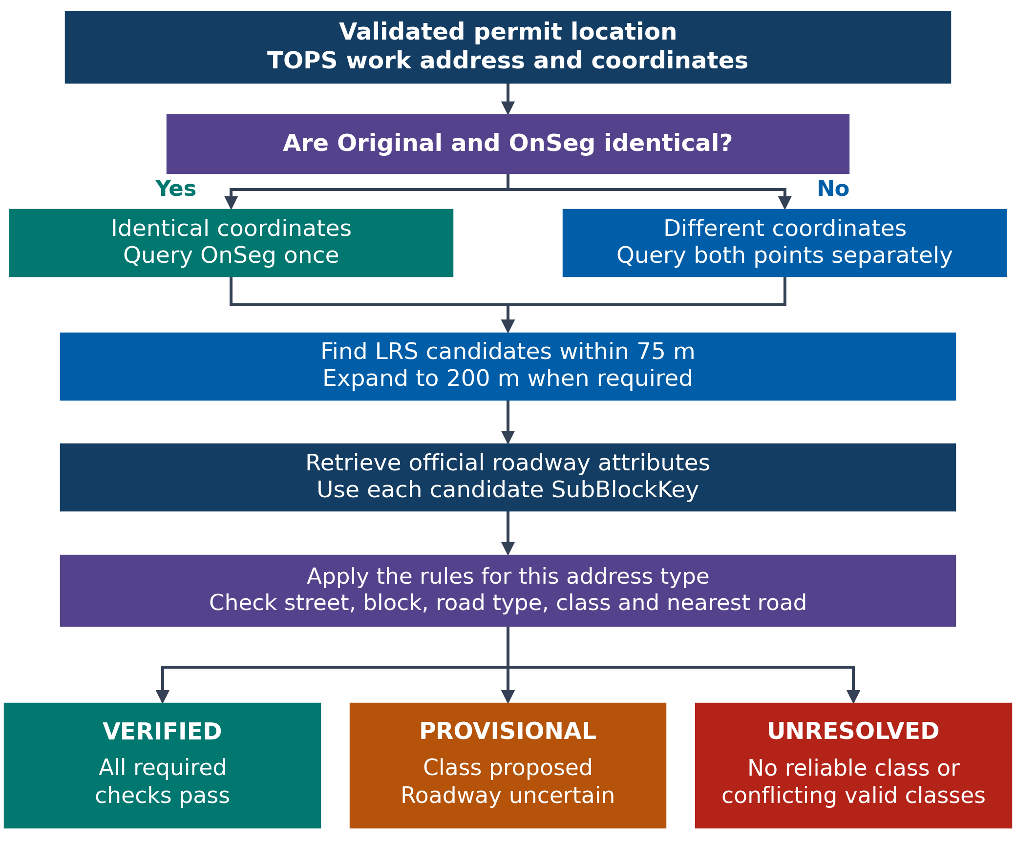
Figure 1. Roadway matching and class decision sequence
Saved in outputs/3_roadway_functional_class/full/
permit_locations_fhwa_functional_class.csv
Raw response cache: outputs/3_roadway_functional_class/ddot_lrs_raw_api_cache.sqlite3

Confirm the street and the complete address range
Finding the right street name is only the first check. The candidate must also support the address range, be a street rather than an alley, and have an official integer class from 1 to 7. Both the LRS and official route labels must agree with the TOPS street. Abbreviations such as STREET/ST and AVENUE/AVE are standardized; directions and quadrants are preserved. Table 4 explains the main checks.
Table 4. Address matching rules and their reasons
Evidence | Rule and reason
Street and quadrant | GEORGIA AVENUE NW can match GEORGIA AVE NW. NW and NE remain different streets.
Complete number range | Illustrative example: for a permit covering 2000-2099, support for only 2000-2049 is insufficient. Accepted subblocks must together cover 2000-2099.
Questionable block ranges | Partial or boundary-only overlap cannot establish full coverage. LRS spans over 1,000 address numbers are flagged as a project safeguard, not a calibrated standard.
Nearest road at each point | The minimum returned offset identifies the nearest candidate. It must support the same street, address block, and class at every queried point; an incompatible exact-distance tie requires review.

The rule assumes that agreement between the written work address and nearest-road evidence is needed before automated confirmation. Figure 2 shows why distance and address cannot be used separately. LocationID 1510889 is recorded at 3333 Georgia Avenue NW. Georgia Avenue has Class 3, but Morton Street is closer to both TOPS points. The result retains Class 3 as PROVISIONAL with SPATIAL_DISAGREEMENT_REVIEW; neither road is silently substituted for the other.
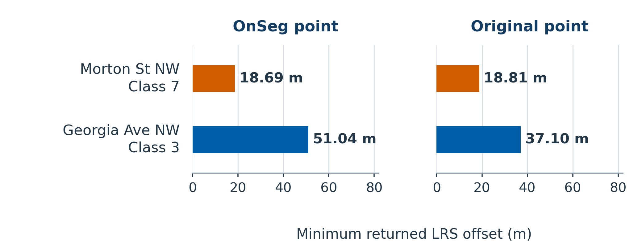
Figure 2. A real address match that remains provisional
The plotted values are minimum saved LRS offsets for each route, not surveyed work-area distances. Candidate names, block ranges, official classes, and every eligibility check are retained in permit_locations_lrs_roadway_candidate_evidence.csv under the Step 06 full-output folder.

Handle intersections and special addresses
An intersection names two roads, so selecting whichever road is closest could assign the wrong class. The implemented rule accepts two plain street names separated by AND. It confirms the class only when both named roads are among the nearest returned candidates at each queried point, their relevant official classes agree, and no unrelated road creates a nearest-distance tie. This is a deliberately conservative project rule.
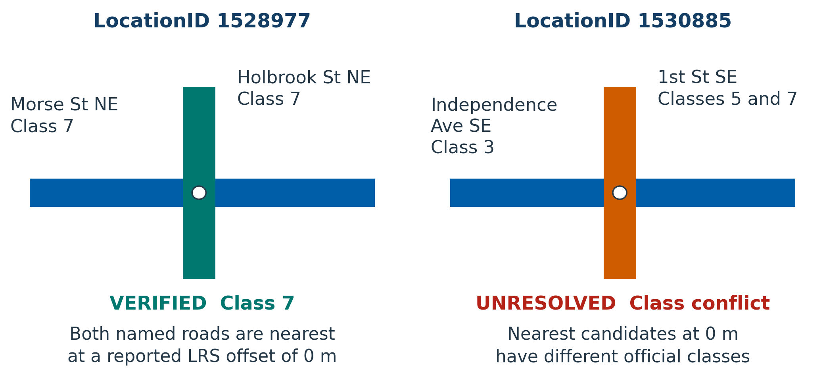
Figure 3. Intersection agreement and conflicting classes
Figure 3 is schematic, not a geographic map. Its 0 m values are reported LRS offsets. At LocationID 1535066, C Street SW and South Capitol Street both support Class 7, but an equally near C Street SE candidate creates quadrant ambiguity. The class therefore remains PROVISIONAL despite agreement between the two named roads. This illustrates why preserving NW, NE, SW, and SE matters.
For name matching, the code assumes SOUTH CAPITOL ST BN and SOUTH CAPITOL STREET refer to the same named route. The BN exception is limited to South, North, and East Capitol Street; direction labels elsewhere are kept. Roosevelt Bridge is treated as an I-66 alias, but that assumption does not establish the exact bridge segment or approach, so those cases remain provisional. Unsupported ramps and exits remain unresolved.
Table 5. Class certainty and roadway key certainty
Candidate evidence | Class decision | Roadway key decision
One accepted key; all checks pass | VERIFIED | Unique selected key.
Several accepted keys; one class; all checks pass | VERIFIED | All keys retained; no unique key invented.
Candidate class exists; a required check fails | PROVISIONAL | Candidate keys and reason retained.
No reliable class or conflicting valid classes | UNRESOLVED | No class selected.

Table 5 separates a confirmed class from a unique roadway key. The review CSV, permit_locations_functional_class_needing_review.csv, retains uncertain locations, their reasons, and suggested follow-up actions. Those actions are documented, not performed.

Step 07 Find the highest class for each application
Script src/07_calculate_highest_functional_class_per_permit.py
Step 07 receives the Step 06 location decisions and groups them by TrackingNumber. A lower numeric FHWA code represents a higher roadway hierarchy, so the required highest class is the minimum code across the application’s locations. Table 6 gives a real example from the saved results: application 11182457 has four verified locations with codes 7, 4, 4, and 4, so its highest class is 4.
Table 6. Location classes for application 11182457
LocationID | Location class | Location status
1485448 | 7 | VERIFIED
1485449 | 4 | VERIFIED
1485450 | 4 | VERIFIED
1485451 | 4 | VERIFIED

A confirmed application result requires every location in the group to be VERIFIED. For application 11213843, location 1530673 is verified Class 7 and location 1530674 is provisional Class 7. The confirmed application field remains blank because the second roadway is uncertain. The separate minimum among verified locations is still 7, but it does not resolve the entire application.
The application summary is joined back to every location using a many-to-one merge. Checks ensure that no LocationID is lost or duplicated, every location receives application context, and no application containing an unverified location receives a confirmed highest class. Step 07 makes no new API requests.
Table 7. Application outcomes in the saved full result
Application outcome | Applications
All locations verified; highest class confirmed | 3,000
Some locations verified; confirmed highest class withheld | 16
No locations verified; confirmed highest class withheld | 155
Total | 3,171

Table 7 summarizes the saved full-output groups. A pilot may include only some locations of an application, so a pilot confirmation applies only to the sample, not the complete application.
Saved in outputs/4_permit_highest_functional_class/01_primary_results/full/
permit_locations_with_highest_fhwa_functional_class.csv
permit_tracking_highest_fhwa_functional_class_summary.csv

Results and locations requiring review
The saved Step 06 and Step 07 outputs contain 5,048 unique locations in 3,171 applications. Of these locations, 4,874 pass all required automated matching checks, 120 have a proposed but unconfirmed class, and 54 have no selected class. Figure 4 summarizes these decisions. The 96.6% verified share is rule-based coverage; independent spatial accuracy was not measured.
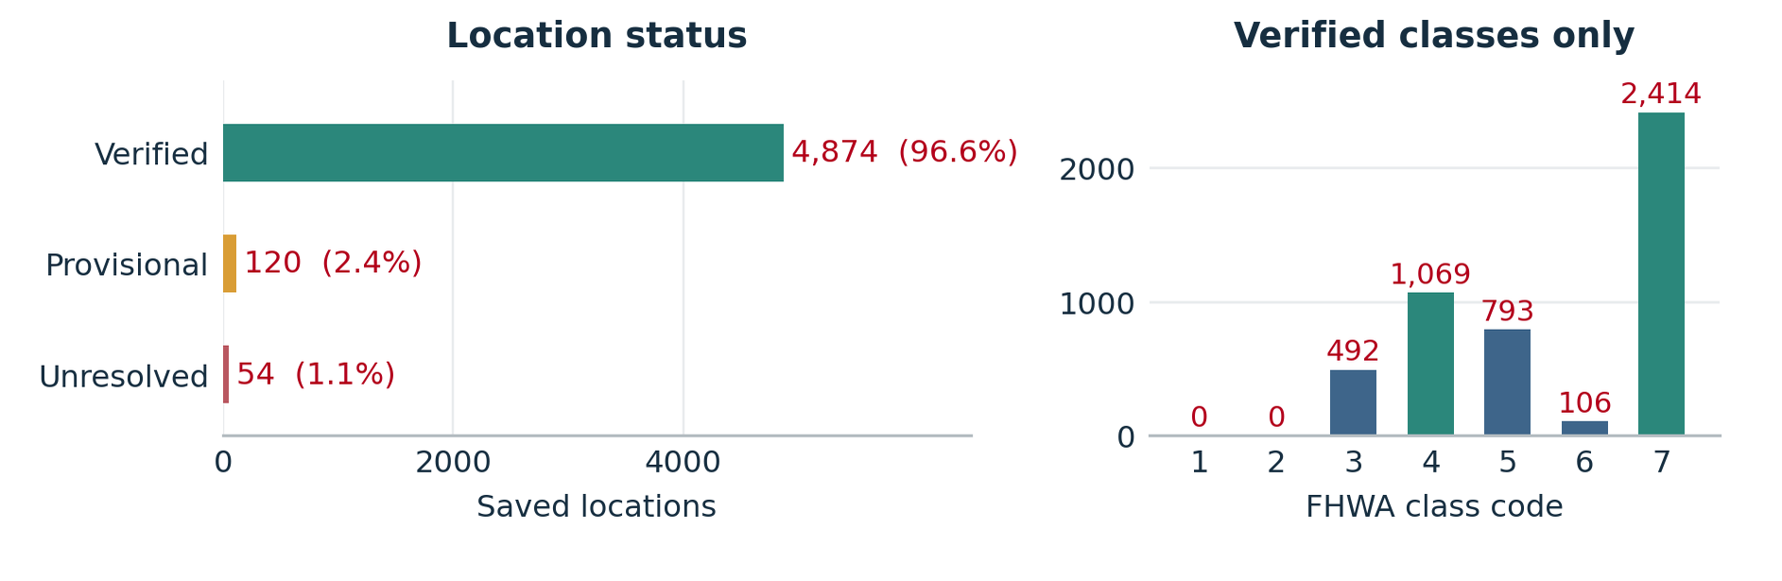
Figure 4. Current full-run location status and verified class distribution
Result scope. The downloaded and selected datasets and Steps 05–07 now refer to the same 15 October 2026 source snapshot: 5,048 selected locations in 3,171 applications. The full Step 06 and Step 07 outputs reconcile to this selection. This is a year-to-date extract, not a completed 2026 census.
Table 8 accounts for every location still requiring review.
Table 8. Reasons the 174 full-run locations require review
Observed issue | Count | What is still uncertain
Spatial disagreement | 101 | Nearest road differs from the written work address.
No valid street and block match | 19 | No official candidate passes the address checks.
Intersection class conflict | 18 | Named roads have different official classes.
Boundary class conflict | 15 | Nearby partial or boundary blocks have another class.
Unsupported address | 9 | Ramp, exit, or other format is not safely parsed.
Conflicting eligible classes | 6 | Accepted address candidates disagree on class.
Intersection geometry uncertain | 2 | Named roads agree on class but geometry is ambiguous.
Bridge segment unconfirmed | 1 | The route alias does not identify the exact segment.
API request failure | 2 | Two roadway-attribute queries failed (HTTP 503).
Nearest-road tie | 1 | An equally near incompatible candidate remains.

These 174 locations remain in the final CSV and affect 171 applications. Manual checks of permit details and roadway geometry remain pending. The saved evidence contains 38,906 candidate rows and two recorded API errors (HTTP 503). The 18-location Step 06 pilot contains 14 verified, three provisional, and one unresolved case; its statuses and classes agree with the corresponding saved full-run rows.

Read the final CSV
The main deliverable is permit_locations_with_highest_fhwa_functional_class.csv in outputs/4_permit_highest_functional_class/01_primary_results/full/. It preserves all 5,048 saved locations and repeats the application summary on each row. The companion permit_tracking_highest_fhwa_functional_class_summary.csv contains one row for each of the 3,171 saved applications.
A populated class is not sufficient on its own. Use LocationClassStatus to distinguish a verified location from a provisional candidate. For an application-wide comparison, use HighestClassDeterminationStatus to determine whether every location was verified. Table 9 identifies the fields needed to read these results correctly.
Table 9. Key fields in the final location CSV
Field or field group | How to interpret it
LocationID and TrackingNumber | Identify the location and its parent application.
UtilityCompany and WorkLocationFullAddress | Keep the utility and original work-address context.
LocationFHWAFunctionalClass and LocationClassStatus | Read the class together with VERIFIED, PROVISIONAL, or UNRESOLVED.
LocationMatchStatus and Explanation | Explain which road-matching checks passed or failed.
SelectedSubBlockKey and MatchedSubBlockKeys | Identify one confirmed key when justified, or retain the accepted or candidate keys.
HighestFHWAFunctionalClassPerPermit | Confirmed application result; blank if any saved location is unverified.
HighestFHWAClassAmongVerifiedLocations | Minimum among verified locations only; may be present when the confirmed application result is blank.
HighestClassDeterminationStatus and PermitNeedsClassReview | Show whether the application result is confirmed or needs review.

The four Step 07 review and quality files are saved in outputs/4_permit_highest_functional_class/02_quality_control_and_limitations/full/:
permit_tracking_numbers_needing_highest_class_review.csv
permit_locations_needing_fhwa_class_review_with_tracking_context.csv
permit_unverified_location_reason_summary.csv
permit_highest_class_quality_summary.csv
The review files identify the 171 affected applications and 174 uncertain locations, preserve the proposed actions, and reconcile their counts. The separate Step 06 roadway_matching_status_summary.csv and permit_locations_api_errors.csv summarize matching outcomes and API failures in the full-output folder.
The workflow’s main contribution is a traceable class decision for each location and a cautious application summary. Uncertainty remains visible in both outputs, allowing DDOT to use confirmed results and find the specific cases that still need review.

