DISTRICT DEPARTMENT OF TRANSPORTATION
CS12 Data Scientist Assessment

DDOT FY2026 Construction
Permit Approval Assessment
  - Tableau analysis and technical report

Prepared for the Associate Director
Public Space Division
District Department of Transportation

Prepared by Amir Moayyedi
October 16, 2026

Project repository: https://github.com/SAMIRHOSEIN/tableau_DDOT.git

Analysis period
Applications submitted on or after October 1, 2025
Permits issued October 1, 2025 through September 30, 2026

Contents
Overview 1
1 Data preparation and validation 1
2 Tableau findings 4
2.1 Approval duration by work category 4
2.2 Approval duration by ward 4
2.3 Monthly issue cohorts 5
2.4 Approval duration bands 6
List of Tables
Table 1. Overall approval measures for the primary cohort 1
Table 2. Validation of the saved assessment dataset 3
Table 3. Reasons for the approval-duration boundaries 6
List of Figures
Figure 1. From source location records to the permit-level analysis 2
Figure 2. Mean approval duration and permit count by work category 4
Figure 3. Mean approval duration for the eight individually identified wards 4
Figure 4. Monthly mean approval durations and counts for FY2026 issue cohorts 5
Figure 5. Distinct permits by approval duration category 6

Overview
The 2,025 new, non-renewal construction permits in the saved FY2026 assessment dataset averaged 29.33 business days from application to last approval. The median was 21 days, and 37.6% exceeded 30 business days. Table 1 gives the baseline. The report first explains how location records became a reliable permit-level dataset, then interprets the Tableau comparisons requested by DDOT.
Table 1. Overall approval measures for the primary cohort
Distinct permits | Mean duration | Median duration | 90th percentile
2,025 | 29.33 days | 21 days | 69 days
Durations are business days. Each permit has equal weight; results refer to the saved dataset.

1 Data preparation and validation

Step 1. Inspect the feed and identify its record unit
An initial 10-row REST sample from the TOPS Public Space Construction Permits layer (MapServer/23) exposed repeated TrackingNumbers. This prompted a record-level audit: one API row could represent a location associated with a permit. Repeated permit identifiers therefore required investigation before any rows were removed.

Step 2. Apply the assessment’s date and permit-type scope
The query required ApplicationDate ≥ October 1, 2025; October 1, 2025 ≤ IssueDate < October 1, 2026; and PermitTypeDescription = New. These conditions define an issue-year cohort with an application-date restriction. Current status was retained because an expired or revoked permit could still have been issued during FY2026. The final cohort contains 1,222 Issued, 800 Permit Expired, two Suspended and one Revoked permits.

Step 3. Download all matching rows and preserve the source
To avoid an API response limit truncating the extract, the downloader reconciled the matching record count with the full OBJECTID list. It requested 250 IDs per batch, allowing up to four attempts, and checked each returned ID set against its request. The 28,277-row extract required 114 batches. All 100 source attributes were saved unchanged in the raw CSV; audits and prepared data were written separately.

Step 4. Resolve repeated locations before selecting one permit row
Across the raw extract, 2,118 TrackingNumbers appeared more than once, accounting for 25,017 rows. The code first checked that dates, PermitNumber, status, renewal labels and codes, source DaysToApprove and activity flags agreed within each TrackingNumber. It also checked the one-to-one mapping with PermitNumber. Conflicts would stop processing. After these checks, the smallest OBJECTID supplied a representative row for each of 5,378 permits; location counts and ward coverage were aggregated from all associated rows.
For example, TrackingNumber 497055 has 75 source rows and 75 listed addresses, but contributes one permit to the analysis. This preserves its location coverage while preventing repeated locations from giving that permit extra weight in the mean.

Step 5. Distinguish new permits from renewals
PermitTypeDescription = New still included 3,353 permits labeled Renewal in RenewalDescription. The preparation validated the observed label-code pairs: New = 1 and Renewal = 2. The primary cohort therefore also requires RenewalDescription = New, leaving 2,025 permits linked to 11,351 original location rows. This explicit non-renewal interpretation resolves the overlapping “New” labels; an operational field dictionary was not supplied. Figure 1 brings the selection and processing sequence together.
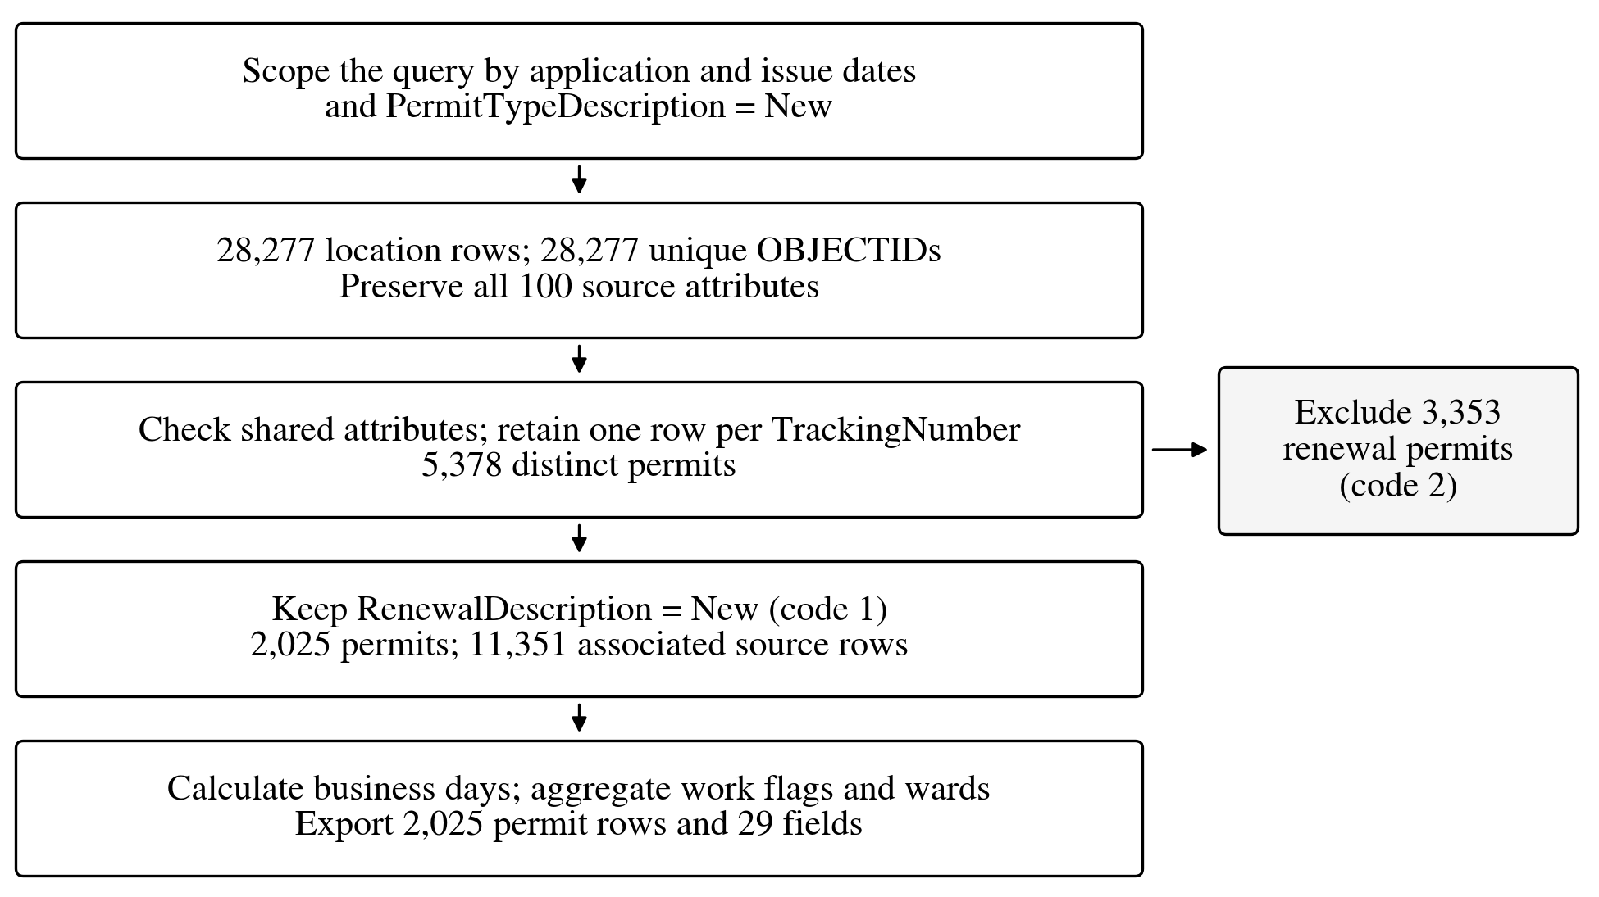
Figure 1. From source location records to the permit-level analysis

Step 6. Convert local dates and calculate approval duration
The API’s millisecond timestamps were converted through UTC to America/New_York before extracting dates. Required dates, fiscal-year eligibility and the order ApplicationDate ≤ LastApprovalDate ≤ IssueDate were checked. LastApprovalDate was adopted as the available approval milestone; IssueDate determines cohort membership. The measure is elapsed time between recorded events, including any intervening review or applicant pauses.
Business days count Monday–Friday after the application date and through the last-approval date, excluding 12 observed District legal holidays. The code advances both boundaries by one calendar day for NumPy’s end-exclusive count. The calendar includes DC Emancipation Day and July 3, 2026, the observed Independence Day holiday. The separate November 28, 2025 administrative closing is excluded only in an alternate field; it remains a counted weekday in the main measure.
As a manual check, Friday, October 10, 2025 to Tuesday, October 14 gives one business day: the weekend and Monday holiday are excluded. Same-day approval counts zero.

Step 7. Create useful comparison groups and the Tableau input
Because PermitTypeDescription is constant, work categories were derived from nine activity flags: one positive flag identifies its activity; multiple flags give Multiple Work Categories; none would give Unclassified (none occurred). Ward_Segment uses all recorded locations: one known ward gives that ward, several give Multiple Wards, and none gives Unknown. Location and ward counts were retained. The export has one row per permit, with local dates, months, durations, status and group fields: 2,025 rows and 29 columns.
Table 2 consolidates the checks documented for the saved snapshot. The main approval measure uses the explicit date calculation because the source DaysToApprove has no supplied definition; its differences do not establish a source error.
Table 2. Validation of the saved assessment dataset
Check | Recorded result
Complete extract | 28,277 rows; 28,277 unique OBJECTIDs
Permit identity | 5,378 TrackingNumbers and PermitNumbers; one-to-one mapping
Shared attributes and dates | No checked attribute conflicts, missing required dates, chronology or final-cohort scope violations
Export reproduction | Exact agreement for all 2,025 rows and 29 columns
Independent day counting | Day-by-day enumeration matched all 2,025 primary durations
Source duration comparison | 326 permits (16.1%) differed from the calculated calendar-day interval
Evidence: raw and processed CSVs; 03/04 audit summaries; 04_dc_holidays_used.csv. The source-duration comparison is with calendar days, not the business-day measure.

2 Tableau findings

2.1 Approval duration by work category
Figure 2 shows the longest mean for Multiple Work Categories: 61.13 days across 76 permits. Excavation accounts for 1,766 permits (87.2%) at 27.32 days, making it the largest share of permit volume despite its lower mean. Landscaping and Projections each have only nine permits; their means are sensitive to individual cases. Duration and count therefore highlight different features of the work groups.
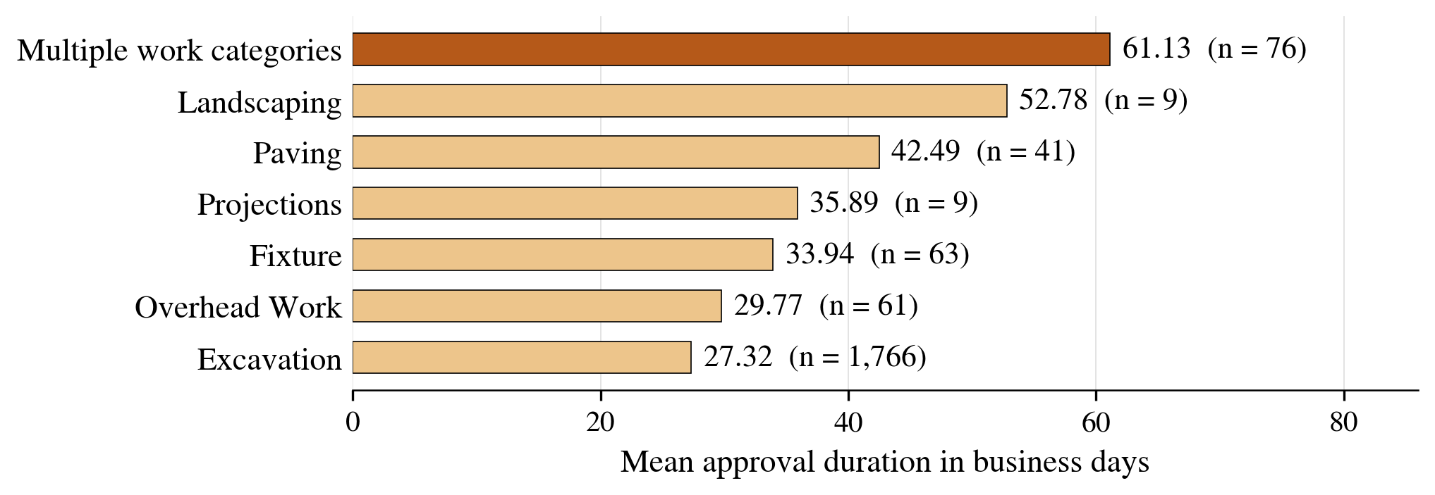
Figure 2. Mean approval duration and permit count by work category

2.2 Approval duration by ward
Among the eight named wards in Figure 3, Ward 3 has the highest mean (38.88 days; 221 permits), 13.54 days above Ward 7. Outside this chart, Multiple Wards has 14 permits averaging 43.43 days, and Unknown has 137 averaging 8.20 days. The latter reflects missing ward information, so its low mean needs that context. These location-based averages are not adjusted for work mix or project complexity.
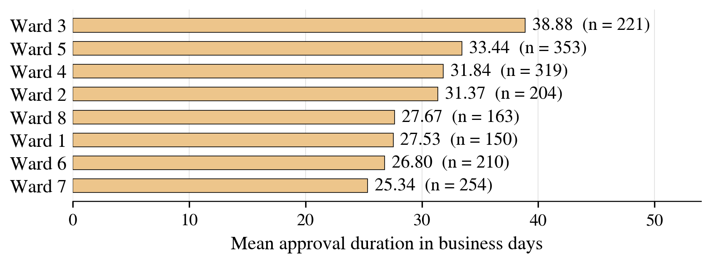
Figure 3. Mean approval duration for the eight individually identified wards
Both figures use the prepared Tableau input. Labels show mean business days and n, the distinct permit count. Each permit contributes to one work group and one ward segment.

2.3 Monthly issue cohorts
Figure 4 pairs each issue-month mean with the number of permits behind it. April and May have the highest means, 51.73 and 52.01 days, based on 51 and 79 permits. July and August fall to 25.96 and 25.01 days while accounting for 582 and 621 permits. Together, those two months represent 59.4% of the cohort. September increases to 29.00 days across 403 permits.
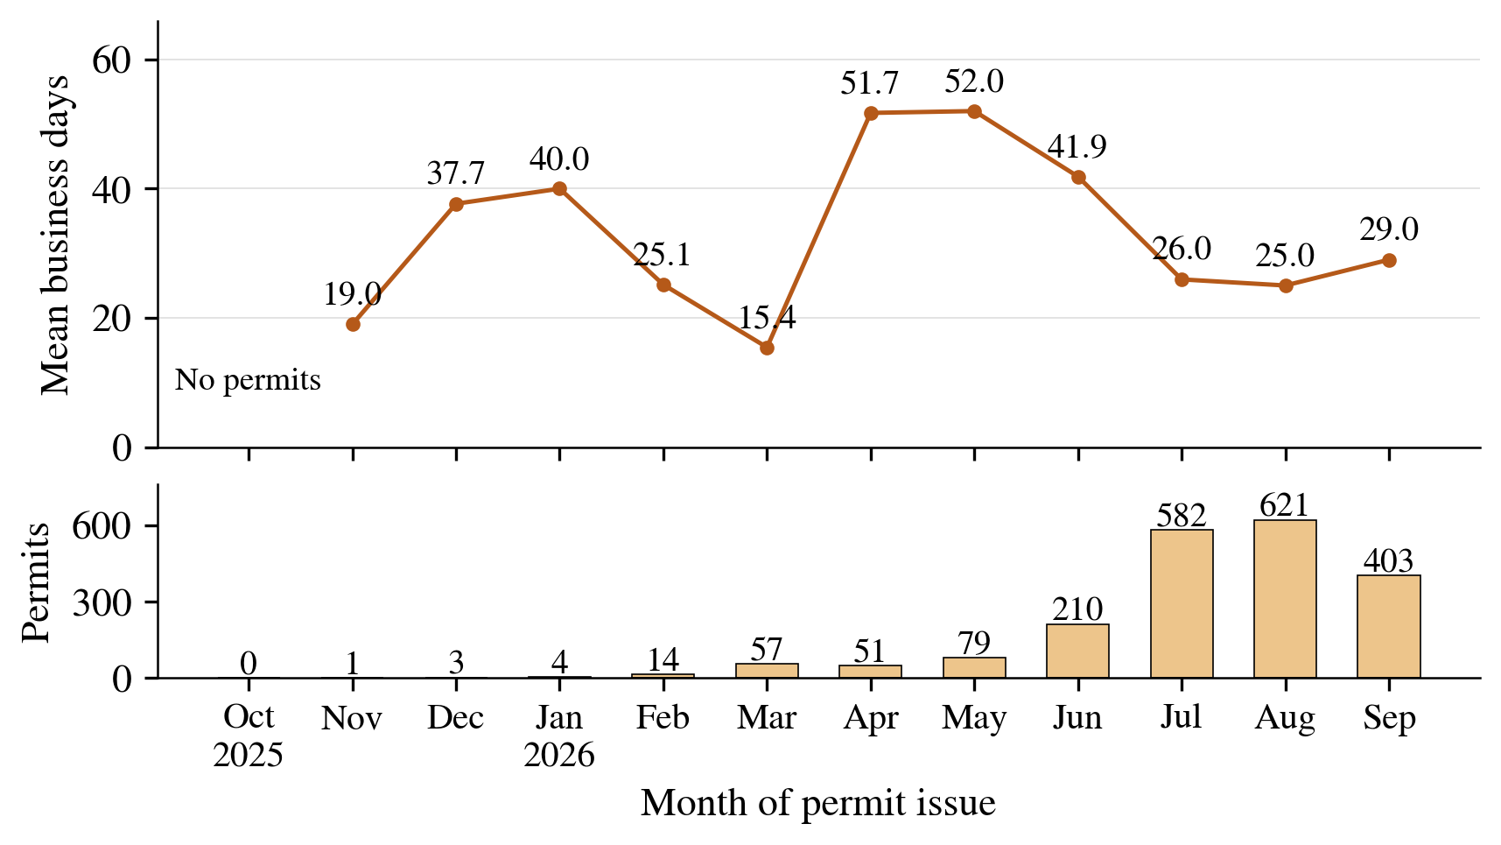
Figure 4. Monthly mean approval durations and counts for FY2026 issue cohorts
The lower panel adds the permit counts used to interpret the monthly Tableau comparison. October has no primary-cohort permits and therefore has no mean; chart labels are rounded to one decimal.
November, December and January contain only one, three and four permits, respectively. With so few permits, a single case can substantially change the mean. The later months contain more observations, but the line still reflects the mix of permits issued in each month.
Each approval interval may begin in an earlier month. July’s lower mean therefore describes July-issued permits; it does not establish that applications submitted in July were processed faster. The figure also excludes applications still awaiting issuance, so it does not measure the incoming workload or open backlog.

2.4 Approval duration bands
Figure 5 shows 489 permits in 31–60 days and 273 in 61 days or more: 762 permits (37.6%) above the 30-day reference. The mean exceeds the 21-day median because longer durations pull it upward; the maximum is 233 days. Table 3 explains the grouping choices.
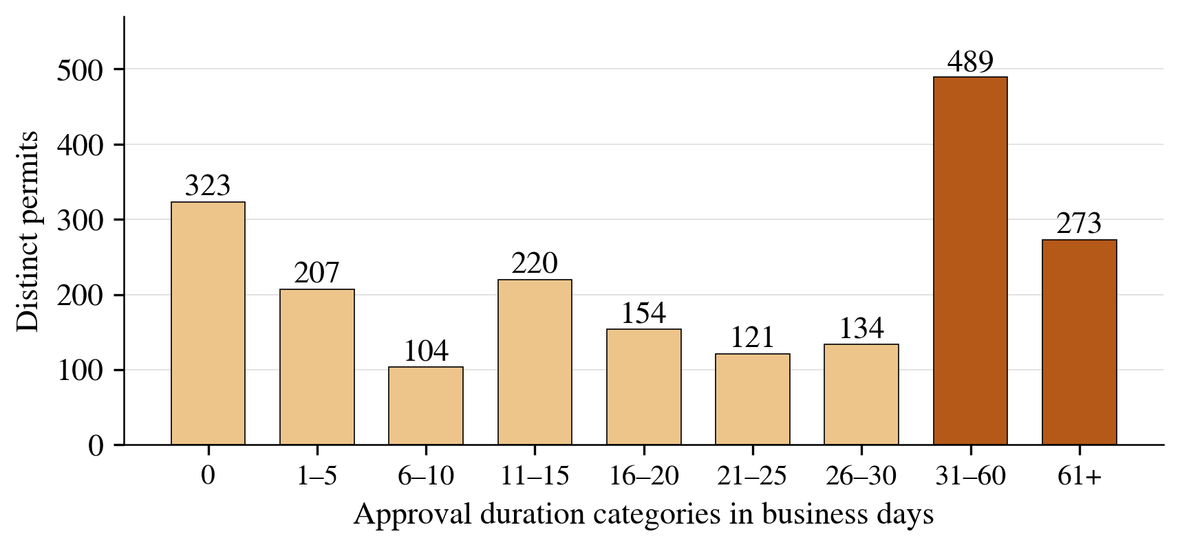
Figure 5. Distinct permits by approval duration category
Table 3. Reasons for the approval-duration boundaries
Duration category | Reason for the boundary
0 business days | Keep permits with no counted business day visible as a separate group.
1–5, 6–10, 11–15,  16–20, 21–25, 26–30 | Five-day intervals approximate working weeks and retain detail through 30 days. The 30-day reference is near the 29.33-day mean and about six standard workweeks before holidays.
31–60 business days | Combine the next 30 days to display the longer-duration group compactly.
61+ business days | Keep the remaining long tail visible without many sparse categories.
The 30-day boundary is an analytical reference, not a supplied DDOT service deadline. Also, these bands have unequal widths: the 489 permits in 31–60 days do not identify the most common equal-width duration or a density peak.
Of the 323 zero-business-day permits (16.0%), 301 were approved on the application date. The other 22 had a later approval date with no eligible weekday in the interval. Zero therefore means no counted business day, which is not always the same as same-day approval.

