TRANSPORTATION ANALYTICS / PUBLIC SPACE PERMITTING

FY2026 Construction Permit
Approval Performance
  - Data preparation, Tableau analysis, findings, and limitations
Prepared for: Associate Director, Public Space Division
District Department of Transportation (DDOT)
Prepared by: Amir Moayyedi | October 2026
Assessment: CS-12 Data Scientist | Tableau Test

Purpose
This report explains how a permit-level dataset was prepared from the DDOT public REST feed, how business-day approval times were calculated, what the five Tableau worksheets show, and where DDOT may focus a subsequent review. It is a descriptive analysis of issued permits, not an estimate of the causes of longer approval times.

At a glance
Main cohort | Mean approval time | Median | Longer than 30 days
2,025 distinct permits | 29.33 business days | 21 business days | 762 permits (37.6%)

Population definition: non-renewal permits issued in FY2026 with application dates on or after October 1, 2025. Current permit status was not used to exclude permits previously issued.

Executive summary
The DDOT REST query returned 28,277 location-level records representing 5,378 distinct permits when PermitTypeDescription was New. Applying the additional RenewalDescription = New condition yielded 2,025 new, non-renewal permits. Because several permits cover many listed work locations, the analysis counts each TrackingNumber once. This prevents permits with more listed locations from dominating the average.
Across the final cohort, approval took 29.33 business days on average; the median was 21 days. More than one-third of permits (37.6%) took over 30 business days. Average times varied across work categories and ward segments. The highest mean work-category value belonged to Multiple Work Categories (61.13 days; 76 permits). Ward 3 had the highest mean among the eight individually identified wards (38.88 days; 221 permits). These contrasts identify places for further review; they do not establish causes or service-level failures.
A key sensitivity is the meaning of “new permit.” Including renewals raises the population to 5,378 but lowers the average to 11.40 business days. The dashboard uses the narrower, non-renewal definition, and this choice should be confirmed with DDOT before the result is adopted for operational reporting.

1 | Request and analytical approach
The Tableau test asks for overall mean business days to approve Public Space Construction Permits issued during FY2026; the mean by permit-type category; and another useful segmentation. It requires at least three worksheets and one dashboard. The instructions also state that no explanatory model or formal statistical analysis is needed. This report therefore presents descriptive measures, cohort selection rules, and practical next steps rather than causal conclusions.
The Deliverables Summary occasionally says “days to close,” while the main scenario and most of the task refer to “days to approve.” The principal outcome here follows the stated business-days-to-approve question, measured to LastApprovalDate. A “days to issue” or “days to close” measure is not substituted.

2 | Data source, scope, and quality controls
The input was the DDOT TOPS Public Space Construction Permits layer (MapServer/23). Python scripts first explored the REST response and then downloaded the qualifying attributes. The source did not provide a data dictionary, so field meanings and permit-type flags were checked against record patterns and the assignment wording. The API returned more than one row for some TrackingNumbers because different listed work locations were represented.

2.1. Selection and unit of analysis
Step | Decision or validation | Count
REST query | ApplicationDate ≥ Oct 1, 2025; IssueDate in FY2026; PermitTypeDescription = New | 28,277 rows
Permit-level identity | Keep one observation per TrackingNumber after confirming permit-level fields agree | 5,378 permits
Non-renewal interpretation | Select RenewalDescription = New (exclude 3,353 Renewal permits) | 2,025 permits
Final Tableau table | One permit per row; preserve work type, ward segment, dates, and calculated durations | 2,025 rows

The original 28,277 rows include 11,351 rows belonging to the 2,025 final permits and 16,926 rows belonging to the 3,353 Renewal permits. The initial source check found 28,277 distinct OBJECTIDs. The TrackingNumber and PermitNumber fields each had 5,378 distinct values and a one-to-one mapping in the selected extract. Dates and other permit-level attributes were consistent across the location records of each TrackingNumber.

2.2. Why multiple locations matter
TrackingNumber 502829 appeared in 176 records with 176 distinct listed addresses but represented one permit. It was a Renewal and was not included in the final 2,025. In the main cohort, TrackingNumber 497055 appeared in 75 records with 75 distinct listed addresses; it still contributes one permit-level observation. Listed addresses should not automatically be interpreted as independent construction projects.
If each location row in the final non-renewal cohort were treated as a separate permit, the approval-time mean would increase from 29.33 to 44.69 business days. That difference is an artifact of repeated location-level records, not a change in permit performance.

2.3. Other validation checks
Check | Result / handling
Completeness | No missing application, last-approval, or issue dates in the selected records.
Chronology | No selected permits with approval before application, approval after issue, or issue before application.
Status | No current-status filter. Final cohort includes 1,222 Issued, 800 Permit Expired, 2 Suspended, and 1 Revoked.
Geography | 14 permits touch multiple wards; 137 have no identified ward. These are explicit segments.
Work type | 76 permits have multiple flagged work categories and are not assigned arbitrarily to one.

An Expired status can describe a permit that was issued within FY2026 and subsequently reached the end of its validity. It does not undo the historical issue event. Suspended and Revoked cases remain in this date-based cohort, but a future operational study could report them separately.

3 | Business-day calculation and processing steps

3.1. Definition of the approval measure
Business Days to Approve is the number of Monday-through-Friday dates strictly after ApplicationDate and up to and including LastApprovalDate, excluding the legal public holidays observed by the District of Columbia. The application date is not counted. The approval date counts only if it is a business day. Dates are converted from the source millisecond timestamps into the America/New_York local calendar before counting.
Example: an application submitted Friday, October 10, 2025 and approved Tuesday, October 14, 2025 has one counted business day. Saturday and Sunday are excluded, and Monday, October 13 is a District public holiday. Tuesday is the single counted day. Therefore, a result of zero business days need not mean the permit was approved on the same calendar date.

3.2. Holiday handling
The Python code uses NumPy busday_count with a curated list of 12 District legal public holidays within FY2026: October 13, November 11, November 27, and December 25 of 2025; January 1, January 19, February 16, April 16, May 25, June 19, July 3, and September 7 of 2026. Observed dates follow the official District holiday issuances. The extra administrative closing on Friday, November 28, 2025 is not part of the primary measure.
As a sensitivity check, also treating November 28 as a non-business day produces a mean of 29.31 instead of 29.33 days, a change of about 0.02 day per permit. This small difference does not resolve other uncertainties in the definition of approval time.

3.3. Reproducible data preparation
Stage | Python operation / evidence
Explore | Read a small API sample; examine field names, dates, status, permit-type labels, and possible repeated TrackingNumbers.
Retrieve | Query the server for OBJECTIDs and expected record count; download all attributes in 250-ID batches with checks and retries.
Audit | Verify row and OBJECTID totals, check key mappings and same-permit field consistency, retain an untouched raw CSV.
Prepare | Deduplicate to one row per permit, exclude Renewals under the strict definition, create ward and work-category segments.
Calculate | Convert source timestamps to DC-local dates; calculate main and alternate business-day durations and monthly labels.
Publish to Tableau | Export a 2,025-row CSV; construct five worksheets and an interactive management dashboard.

3.4. Files and traceability
The original extract is stored in data/raw; the final one-per-permit Tableau table is in data/processed. The data/audit folder contains duplicate-key reports, holiday dates, multi-location examples, and preparation summaries. Python scripts in src reproduce the extract and transformation. The original raw dataset was retained rather than overwritten.

4 | Tableau results and interpretation

4.1. Overall performance (Worksheet 1)
For the 2,025 new, non-renewal permits, the mean is 29.33 business days, the median is 21, and the 90th percentile is 69. The mean being higher than the median shows that longer approval durations pull the average upward. The dashboard KPI intentionally reports the mean requested by DDOT; the median and percentile provide supporting context rather than replacing it.

4.2. Work-category differences (Worksheet 2)
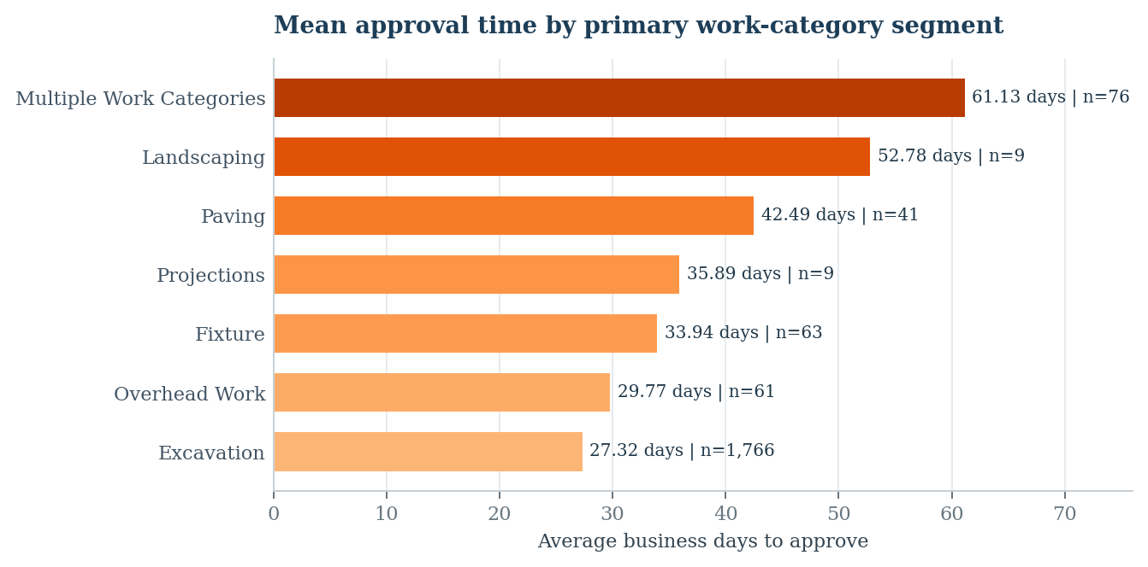
Figure 1. Average business days by work-category segment. Labels report the mean and the count of distinct permits; values were recalculated from the submitted Tableau input CSV.
Multiple Work Categories has the highest observed mean (61.13 days; n=76), followed by Landscaping (52.78 days; n=9) and Paving (42.49 days; n=41). These groups are candidates for a closer descriptive review of their permit types and handling steps. The Landscaping estimate depends on only nine permits and should not be treated as a stable benchmark.
Excavation accounts for 1,766 permits, about 87.2% of the final cohort, with a mean of 27.32 days. Even with a lower mean than several small categories, Excavation deserves attention because it represents most observed permit volume. “Multiple Work Categories” is a mixed segment, not a single operational work type.

4.3. Ward differences (Worksheet 3)
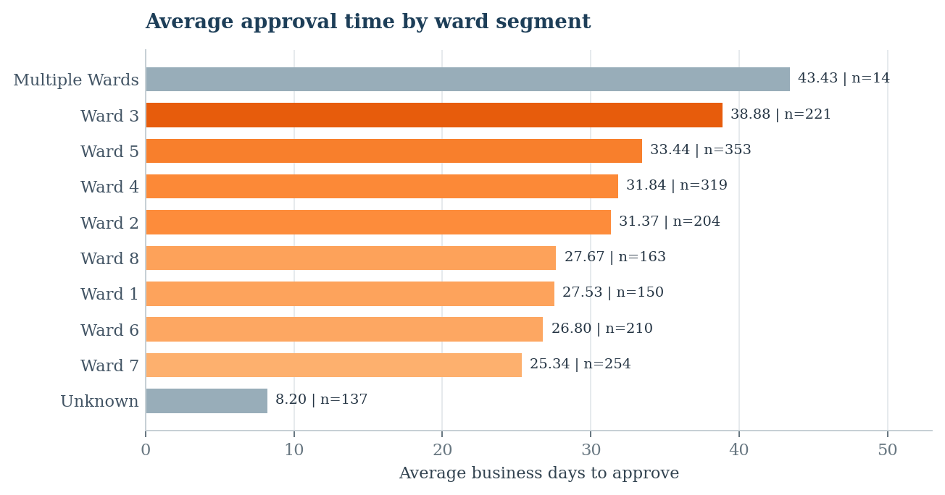
Figure 2. Approval time by ward segment. Grey bars denote multi-ward or unassigned geography, not separate numbered wards.
Among the eight named wards, Ward 3 has the highest observed mean (38.88 business days; 221 permits). Ward 5 follows at 33.44 days across 353 permits, while Ward 7 has a mean of 25.34 days across 254 permits. These are differences within this selected issue-date cohort. They do not establish differences in staff efficiency or equitable access; work mix and other unmeasured factors may vary by area.
The “Multiple Wards” segment contains 14 permits and has a mean of 43.43 days. The “Unknown” segment contains 137 permits and has a mean of 8.20 days. Neither is a geographic ward and neither should be ranked alongside the eight numbered wards as if it were one.

4.4. Monthly comparisons (Worksheet 4)
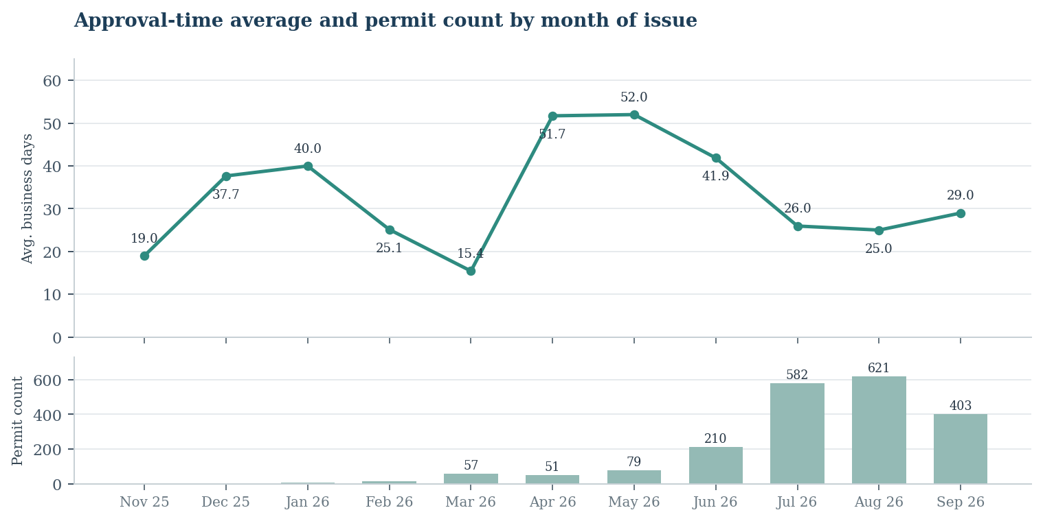
Figure 3. Mean approval duration for permits issued in each month of FY2026, with the number of permits in each month shown underneath. The lower volume series is supporting context added for this report.
The issue-month mean is highest in May 2026 (52.01 days; 79 permits), close to April (51.73 days; 51 permits). For August, the mean is 25.01 days across 621 permits; July is 25.96 days across 582 permits. Early issue months have very small samples: November contains one permit, December three, and January four.
This grouping is by month of issue, while duration ends at the approval date. The chart therefore does not measure the turnaround time of all applications submitted during each month and should not be read as a pure month-by-month measure of DDOT processing speed. The changing mix and count of issued permits can strongly affect the averages.

4.5. Distribution of approval times (Worksheet 5)
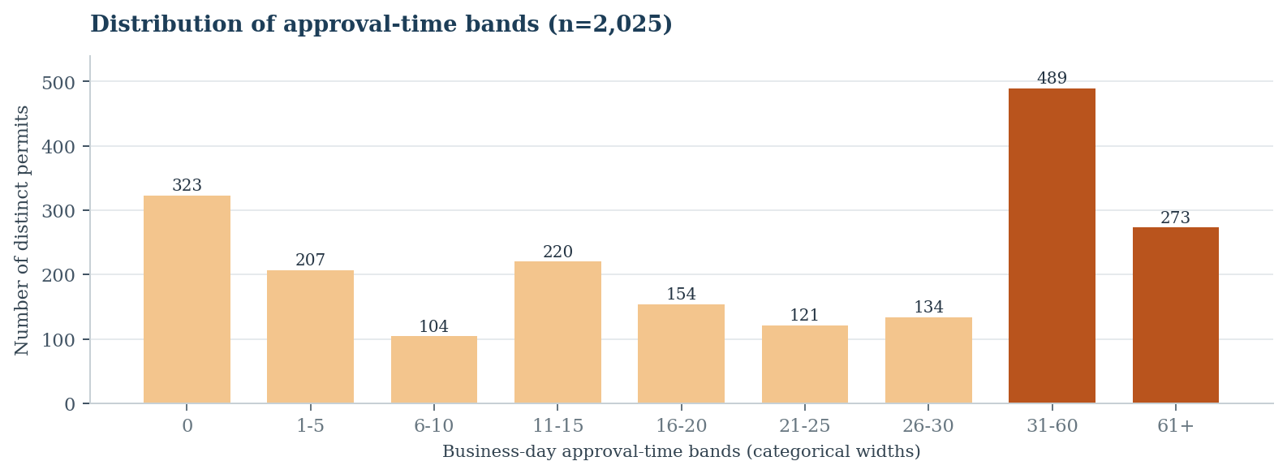
Figure 4. Counts of permits by approval-time band. These are categories with unequal time widths, not a fixed-width histogram. The over-30-day threshold is analytical, not an adopted DDOT service standard.
Of the 2,025 permits, 323 (16.0%) have a calculated duration of zero business days; 301 were approved on the same calendar date and the remaining 22 had no counted business date between application and approval. The 31–60-day band contains 489 permits (24.1%) and the 61+-day band contains 273 (13.5%). Together, 762 permits (37.6%) took more than 30 business days.
We selected 30 business days because it is close to the observed mean of 29.33 and is a simple reference equivalent to roughly six standard workweeks. Bins are five business days wide up to 30, with wider groups beyond 30 for a compact management view. A 31–60-day band spans much more time than a five-day band; its larger count should not be treated as evidence that a particular five-day duration is most common.

4.6. Interactive dashboard design
The executive dashboard combines five worksheets: overall KPI cards; work-category and ward comparisons; issue-month trend; and approval-time distribution. The submitted screenshots show dashboard filter actions configured for the work-category and ward charts. These let a reviewer select a group to update related views, including the permit count and mean. Tooltip content includes counts so very small groups can be recognized. The workbook itself must still be tested in its final packaged form.
The dashboard retains a short data-scope and interpretation note. Detailed processing decisions are described in this report to keep the management view readable. Its single-screen appearance depends on display scaling; the packaged workbook, rather than a fixed screenshot, is the intended interactive deliverable.

4.7. Tableau implementation choices and limitations
Business-day calculations and permit-level checks were performed in Python rather than as Tableau calculated fields. This made the holiday calendar, time-zone conversion, and deduplication explicit and testable. The dashboard uses an exported CSV snapshot rather than a live REST connection. Refreshing the dashboard therefore requires rerunning the scripts and refreshing the data source.
The five views use different chart types for different questions: mean and count KPI cards; sorted bars for work type and ward; a line plot for issue-month cohorts; and a categorical distribution chart. The last chart has unequal-width time bands, so its column heights compare counts per category, not density per business day. Fixed dashboard dimensions and display scaling may require scrolling or a wider display; a polished screenshot cannot replace a working packaged Tableau file.
Ward and work-category selections can change all dashboard averages and counts. When reviewing a selected subset, the user must confirm which selection is active before comparing its result with the 2,025-permit baseline. Tooltip counts and a clear-selection action are important safeguards against incorrect interpretation.

5 | Sensitivity analysis and key assumptions

5.1. How “new permit” is defined
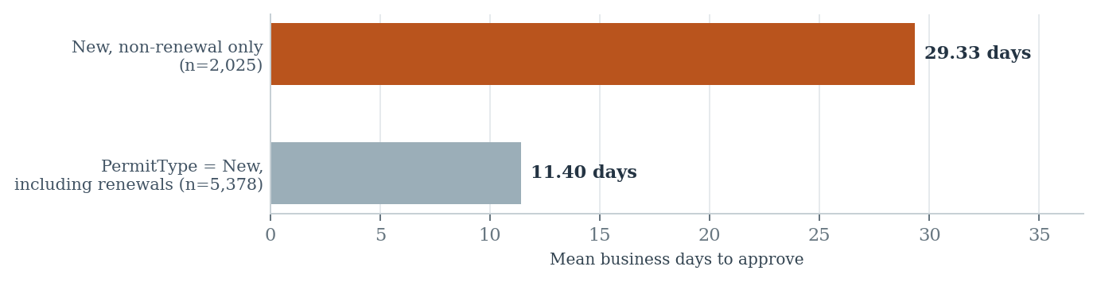
Figure 5. The observed mean changes with the definition of “new.” Both values use one record per distinct permit and the same business-day calendar.
Population definition | Distinct permits | Mean business days
PermitTypeDescription = New AND RenewalDescription = New (main dashboard) | 2,025 | 29.33
PermitTypeDescription = New, including RenewalDescription = Renewal (broader alternative) | 5,378 | 11.40

The assignment says “only new permits” but gives no data dictionary. The main analysis interprets this as a new, non-renewal application, using both fields. This excludes 3,353 Renewal permits. A broader reading of the permit-type field includes those renewals and reduces the overall mean to 11.40 days. This large shift makes the interpretation of “new” the most consequential eligibility assumption and warrants confirmation with the data owner.

5.2. Other operational and measurement assumptions
Assumption | Effect on interpretation
Approval event | LastApprovalDate is treated as the final approval point; it may differ from an initial approval or from IssueDate.
Counting convention | Application day is excluded; approval day counted if business day. Same-day events yield zero.
Holiday calendar | Monday-Friday with observed legal DC holidays; Nov 28 closing is only in a sensitivity measure.
Permit equality | Each distinct TrackingNumber has equal weight, regardless of its number of location rows.
Multi-tag cases | Multiple activity flags or wards receive an explicit mixed segment; no arbitrary selection.
Status at extraction | Current status may differ from status when issued; historical IssueDate defines the included cohort.

6 | Decision relevance, limitations, and next steps

6.1. What the Associate Director can do with these results
The dashboard supports triage for deeper investigation, rather than immediate conclusions about why a permit took longer to approve. Three follow-up questions have particular operational value:
- Review the 76 multi-category permits (61.13 mean days) to understand what work types and review paths occur within that mixed segment. Compare like-for-like permits before attributing differences to coordination or complexity.
- Examine Ward 3 (221 permits; 38.88 mean days) alongside work-category composition and location completeness. Treat it as a potential review segment, not a staff-performance ranking.
- Evaluate the large Excavation cohort (1,766 permits; 27.32 mean days) for opportunities where small changes in processing time could affect many applications. Measure any change using a consistent definition over time.

6.2. Limits of this assessment
- Selection bias: only permits issued in FY2026 with applications from October 1, 2025 onward are included. Pending, denied, withdrawn, and never-issued applications are outside the primary cohort. Results do not represent the entire applicant experience.
- Outcome interpretation: elapsed business days between dates is not the same as active DDOT staff review time. Applicant pauses, resubmissions, payments, and other stages cannot be separated from this source alone.
- Field semantics: no source data dictionary was supplied. The interpretations of “new” and LastApprovalDate are defensible but should be confirmed by a DDOT subject-matter expert.
- Group comparability: no formal significance test or causal adjustment was requested. Small groups, changing issue-month counts, and differences in work type can produce apparent gaps.
- Geography: ward identification is incomplete for 137 permits, and 14 span multiple wards. “Unknown” and “Multiple Wards” are data-handling groups, not administrative wards.
- Dynamic reporting: a live source can change after extraction. The report describes the downloaded snapshot and its reproducible scripts, not a continuously refreshed official statistic.

6.3. Recommended next steps
Before using these values as agency KPIs, confirm the business meaning of RenewalDescription, LastApprovalDate, and the counting convention with the Public Space Division. Then consider a second analysis using all submitted applications, application-cohort tracking, and a fuller timeline of review events. Additional outcomes such as time to issue, resubmission cycles, and number of review stages would help separate operational delays from applicant-dependent stages.
For immediate assessment use, retain the five-sheet interactive Tableau workbook, the cleaned permit-level CSV, the raw data audit and Python scripts, and this report. The assignment explicitly permits additional explanatory documents and a rough design when the insight is clear.

Appendix | Reproducibility and source notes

A.1. File map
Project path | Purpose
src/01_Explore_DDOT_Permits.py | Inspect source response and date fields.
src/02_Explore_FY2026_Permits.py | Query the initial scoped population and status distribution.
src/03_Download_and_Audit_FY2026_New_Permits.py | Download 28,277 rows in 250-row batches; validate and audit keys.
src/04_Prepare_Tableau_Permit_Level_Data.py | Produce permit-level CSV, holidays and quality summaries.
data/raw/fy2026_new_permits_all_api_records.csv | Source attributes retained unchanged by the preparation step.
data/processed/fy2026_new_nonrenewal_permits_tableau.csv | The 2,025-row source of five Tableau worksheets.
data/audit/04_dc_holidays_used.csv | List of included legal holidays and optional closure.
docs/04_Methodology_and_Data_Quality.md | Original methodology and audit evidence.

A.2. Independent audit checks reproduced for this report
Metric | Recalculated value
Raw rows / unique TrackingNumbers | 28,277 / 5,378
Strict New rows / non-renewal location rows | 2,025 / 11,351
Mean / median / 90th percentile | 29.33 / 21 / 69 business days
Permits with zero business days | 323 (301 same-calendar-date approvals)
Permits with > 30 business days | 762 (37.6%)
Mean if location rows wrongly treated as permits | 44.69 business days
Mean with Nov 28, 2025 administrative closure excluded | 29.31 business days

A.3. Source documents and URLs
- DDOT. Tableau Test - CS12 Data Scientist. Assessment instructions provided with the test packet.
- DDOT. Test Guidance CS12 Data Scientist. General assessment requirements provided with the test packet.
- DDOT TOPS public space permits REST layer: https://maps2.dcgis.dc.gov/dcgis/rest/services/DCGIS_APPS/DDOT_TOPS/MapServer/23
- DC Department of Human Resources. Legal Public Holidays 2025: https://edpm.dc.gov/issuances/legal-public-holidays-2025/
- DC Department of Human Resources. Legal Public Holidays 2026: https://edpm.dc.gov/issuances/legal-public-holidays/
- DC Department of Human Resources. District Government Closure, November 28, 2025: https://edpm.dc.gov/issuances/district-government-closure-friday-november-28-2025/
Figure data were recreated directly from the processed project CSV. Source screenshots supplied with the assessment were used to confirm the corresponding five Tableau views and the executive dashboard arrangement. The supplied ZIP contained Python, raw and processed data, and methodology files; it did not provide a packaged .twbx for independent interactive verification.

