SAMPLE VIEW OF CHATBOT(AUTOBOT) USING TKINTER

We have 2 options available: - Ask and Exit

On pressing Ask button we can ask the question to bot or press enter button.

You can even ask questions in the form of audio (i.e. your voice as input)

Other options include minimize, maximize and close tab option.

Widgets added

1)Buttons

2)List box

3)Scrollbar

4)Message box

5)Text Entry

6)Canvas

7)Labels

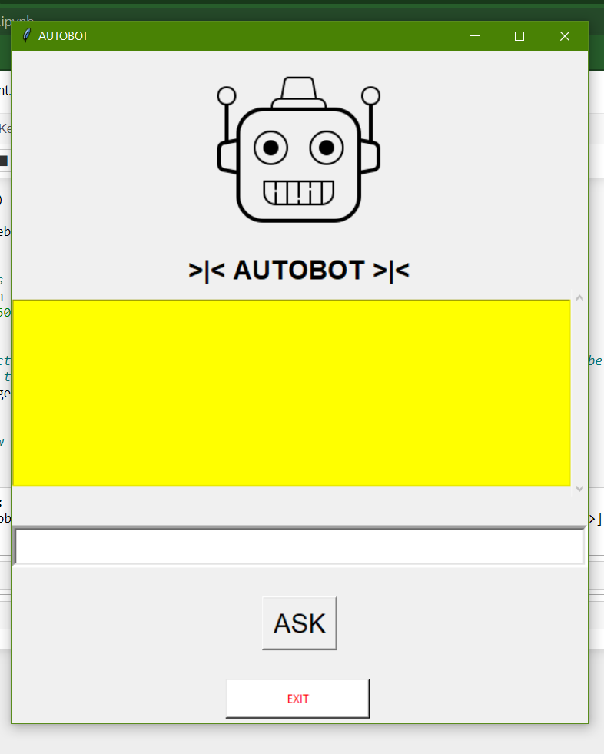

On pressing the Exit Button, you will get the following options

Yes or no. If you press yes the Main window application will close

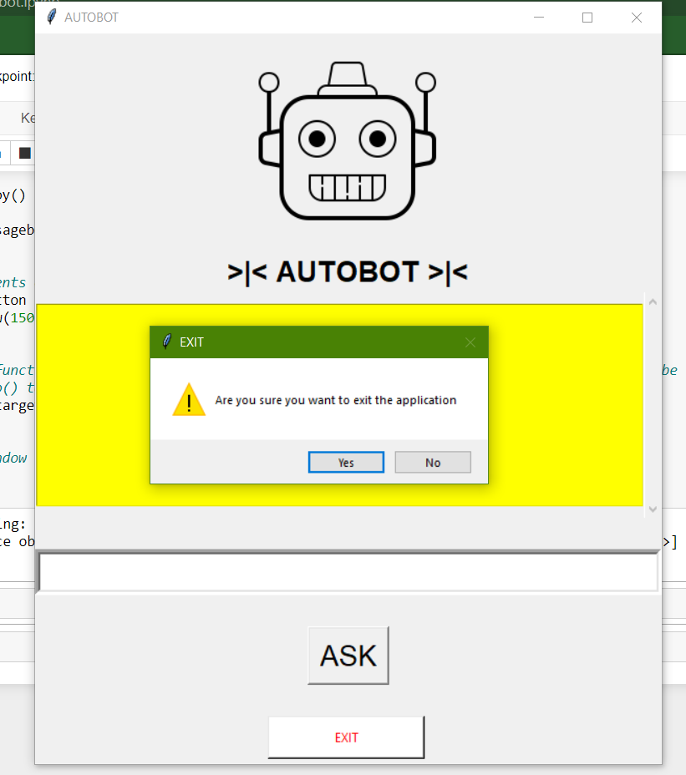

But if you press No you will get another message as shown below

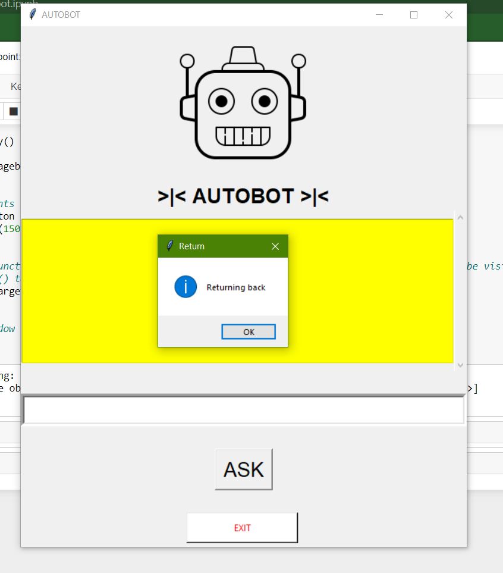

Finally, the text display when you ask questions to bot

