

(ISO 9001:2015 Certified), Accredited with ‘A’ Grade by NAAC

: 08258 - 281039 – 281263, Fax: 08258 – 281265

### Department of Computer Science and Engineering

B.E.CSE Program Accredited by NBA,New Delhi from 1-7-2018 to 30-6-2021

Report on Mini Project

ONLINE VEHICLE SERVICE MANAGEMENT SYSTEM

#### Course Code:18CSE41

#### Course Name: Web Programming

##### Semester: V SEM Section: C

**Submitted To:**

Mr. Shashank Shetty

Assistant Professor (GD II)

Department of Computer Science

and Engineering

**Submitted By:**

Samit D Manvar (4nm18cs152)

Sachinkrishna N K (4nm18cs143)

**Date of submission:**

10-12-2020

#### Signature of Course Instructor

# ABSTRACT

# Online Vehicle service management system is a web application which provides functionality to both customers and the company. In the current scenario most of the car service companies have switched over to online service booking where customers can book a service by filling necessary service details and choose a particular time slot. While the customer chooses a slot, he/she needs to get a confirmation from the admin whether their slot is booked at that time chosen by the customer via email or a call. A better approach is possible. We can develop a live slot availability checking system. Also, we can provide live service status availability to the customers so that they can keep a track of their service progress and provide them a good user interface to give their feedback.

# Data Visualization solves the problem of time taken to make decision for the company instead of depending on descriptive reports.

# Online Vehicle Service Management System is a web application which provides live slot availability feature, check service status, improved feedback user interface. Also provides the company to view them service details, view graphs and update customer service status.

# TABLE OF CONTENTS

Title Page i

Abstract ii

Table of Contents iii

Introduction 4

Problem Statement 5

Objectives 5

Literature Review 6

Methodology 7

Implementation Details 8

Results 8

Conclusion and Future Scope 9

References 9

Snapshots of the Project …...………………………………………………………………...10

# INTRODUCTION

# Vehicle repair service is all about time and quality. As internet came into existence it has changed the world. In today’s world most of the things is being carried out online, from online payment to online booking. Online Vehicle Service Management System is a web application that provides online vehicle service booking to the people, allows the customer to provide feedback and check their service status.

# The objective of this study is to provide a platform where customers can view and book their car service online with help of a web application platform. This platform provides the customer to select particular vehicle service they wish for by filling a service application form and choosing the available time slot. The live time slot availability system provides the customer to check which slots are free instead of waiting to get a confirmation slot from the company via email. This platform not only provides customer to book service but also provides the customer to view their service status after applying for a service.

# "Customer service shouldn't just be a department; it should be the entire company." This platform also provides the customer to give their feedback so that the company can decide where the company needs to improve.

# Apart from customer, this web application provides functionality to the company as well. The admin who handles the customer’s online booking service gets to view the number of people applied for service at a particular day, gives overall view of customer service details and also provides them to update the customer service status. Also, it provides a platform where the company can get to make better decisions with help of graphical data like bar graphs, pie charts etc.

# 

# PROBLEM STATEMENT

# To build an online vehicle service management web application which provides convenient online service booking with improvised time slot selection to customers, provide feedback system and also allow the customers to check their service status, data visualization features so that the company can make better decisions.

# OBJECTIVES

# To create a responsive online vehicle service management web application system.

# To provide convenient live time slot availability while booking a car/bike service.

# Provide the customers a convenient feedback section to express their views so that the company can decide how they can improve.

# Allow customer to check the status of their vehicle service.

# Company can view the graphs at a glance and can make-decision very quickly which it is hardly possible through the descriptive report. The decisions may be like what kind of services people prefer etc.

# Provide the admin to get a tabular view of customer and service details.

# Provide the admin to update customer’s service status.

# LITERATURE REVIEW

# Most of the private car service companies have started online service booking system to make it easy for the customers to book a particular service he wishes for This well as for the company.

# But the service booking system followed by some car service companies is different. When the customer books a service, he needs to choose the particular slot provided by the company. He chooses a slot but he needs to wait to get a confirmation from the company via email. Instead of waiting to get a confirmation message via email or a phone call there is a better approach.

# User can check live slot availability by clicking the check slot availability option for the particular slot time he selects. If it is available, he can book his slot. If not, available he needs to choose another slot. Customer feedback is important because it serves as a guiding resource for the growth of the company. Providing a better feedback user interface allows the customer to easily give their feedback.

# Graphical representation enables the quick analysis of large amounts of data at one time and can aid in making predictions and informed decision and implementing this feature in this web application allows the company to make a better decision.

# METHODOLOGY

# System requirements and code setup

# System Requirements

# XAMPP web server to host the server on your device and run the web application.

# Web Editors (E.g.: - notepad++, sublime text etc.) for editing the source code.

# A good Internet Connection.

# Code Setup

# Click on the following link as mentioned below.

# <https://github.com/SAMIT-D-MANVAR/webminiproject>

# Now click on code button and download the zip file to get the source code.

# Extract the zip files and copy the unzipped files to htdocs folders.

# Download the Readme files to follow the instructions on how to do Code Setup.

# 2) Project Details

# Front End

# Source Code is written in HTML5, CSS3, JavaScript, Bootstrap and jQuery

# jQuery is a JavaScript library.

# jQuery is a lightweight, "write less, do more", JavaScript library.

# Bootstrap is an open-source toolkit used to design and customize responsive mobile-first sites.

# Back End

# PHP (Hypertext preprocessor) a server-side scripting language for creating dynamic and interactive web applications.

# The PHP code is executed in server and so we use XAMPP to run our php files.

# MYSQL database is used to store, retrieve, manipulate, delete the data present in the database.

# Google Charts

# Google Charts provides a perfect way to visualize data on your website.

# It is a library which allows us to plot interactive graphs for better visualization

# It is simple to use. We need to use the CDN provided in order to plot the charts.

# The data required to display can be obtained from database, csv files etc.

# IMPLEMENTATION

# Implementation of any project requires selection of topic, requirements, project planning, changes in plans and final implementation and other references if needed. Planning involves project scope, duration. It also involves testing and debugging to find out errors and sort out the errors. Acceptance testing, Backend testing needs to be carried out to check if the application is running perfectly and also check whether it meets all the business requirements. To keep a track on the activities the following steps can be followed

# Actions should be based on plans decided.

# Divide the tasks and coordinate with the team.

# Regular reports need to be submitted to keep a track on how much work is completed

# Documentation of activities needs to be done; modifications needs to be carried out if required.

# Perform final verifications.

**RESULTS AND DISCUSSIONS**

Since bootstrap is used for mobile first devices this responsive web application is compatible with all devices. The live time slots system is achieved by displaying the user a tabular data showing the booked slots or a pop-up message. Improved feedback user interface is been created so that the customers can easily give their feedback and also the service status can be checked by the customer by entering his car registration number and the service date. The graphs are plotted based on the data available from database. Pie charts, Bar graphs is being implemented. A tabular view displaying customer’s service details is also been created and corresponding reports can also be generated from the tabular data in the form of pdf, excel sheets files and CSV files.

# CONCLUSION AND FUTURE SCOPE

To conclude, Online vehicle service management is a web application portal which allows user to book a vehicle service by providing live slot availability system, allows the user to check service status and give feedback. Also, it allows us to plot graphs to provide better decision to the company and also allow the admin to get tabular data of service details.

As this is a business website the company can decide to expand their business, apply new strategies and also promote their business through online advertising with help of Machine learning. New strategies can be like if the company gets maximum number of customers from a particular city say Mangalore then in order to increase the profits the company can set up another service center in Mangalore.

# REFERENCES

1. <https://www.w3schools.com>
2. <https://datatables.net>
3. <https://getbootstrap.com>
4. <https://www.php.net>
5. <https://jquery.com>
6. <https://developers.google.com/chart>

**Snapshots of the project**

**Home Screen:**

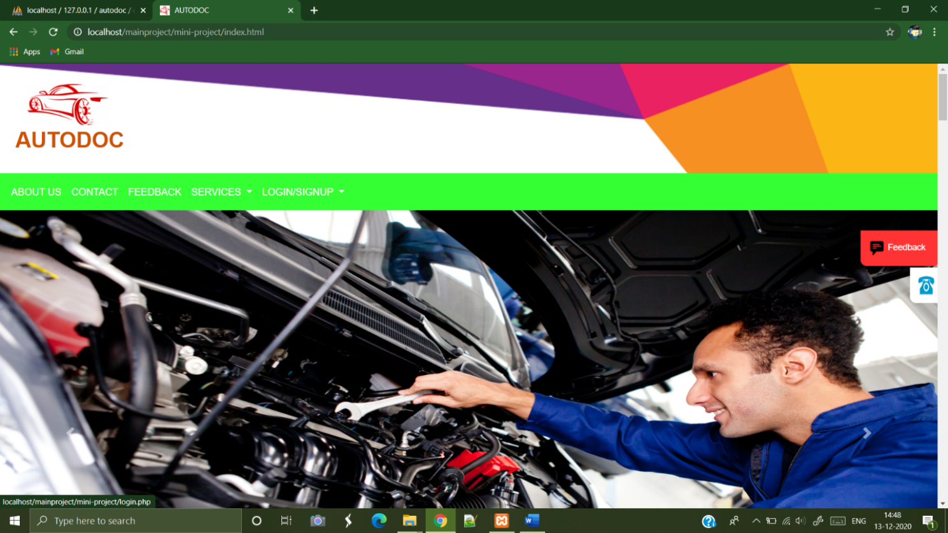

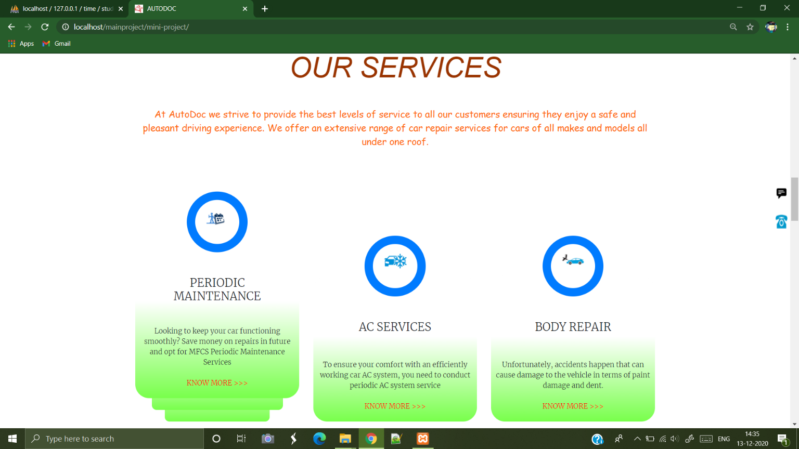

**User Portal:**

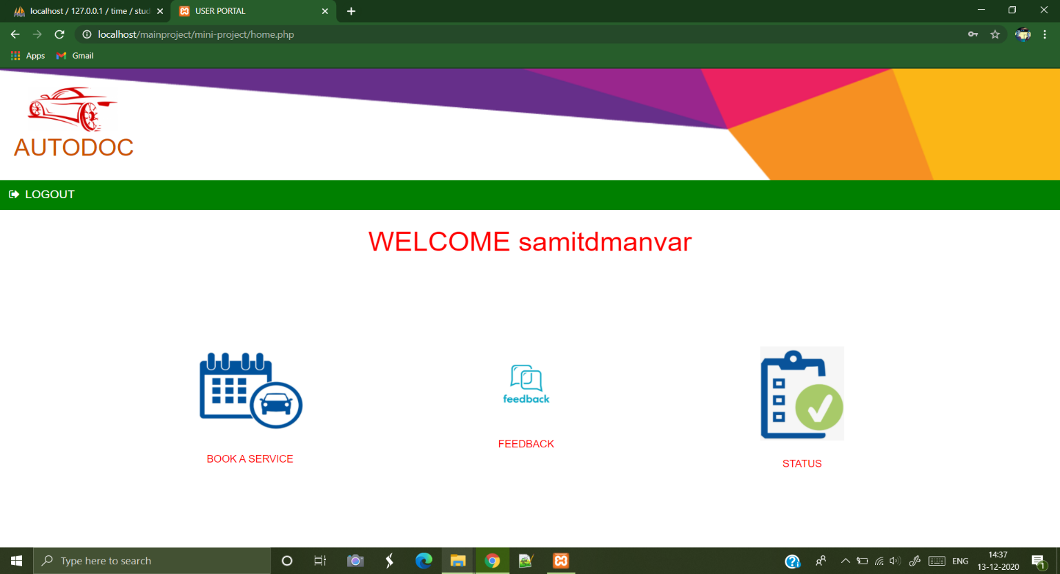

**Customer Service Form:**

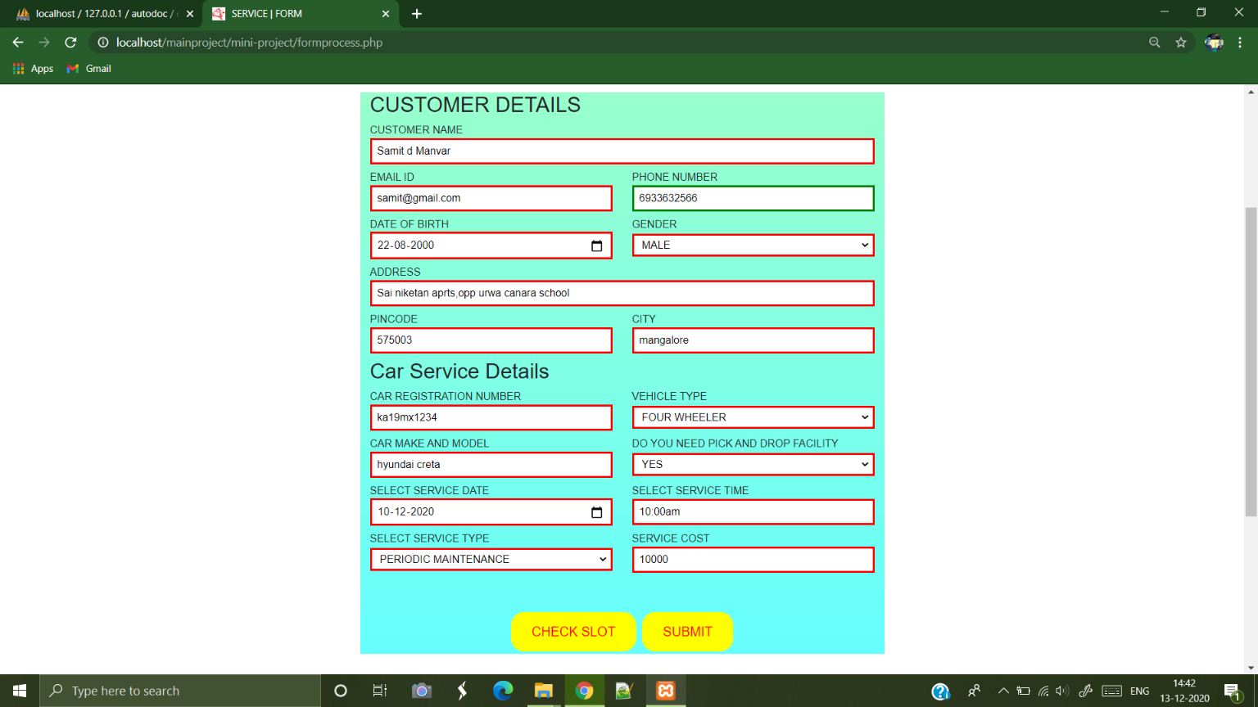

**Check Booked Slot by Date:**

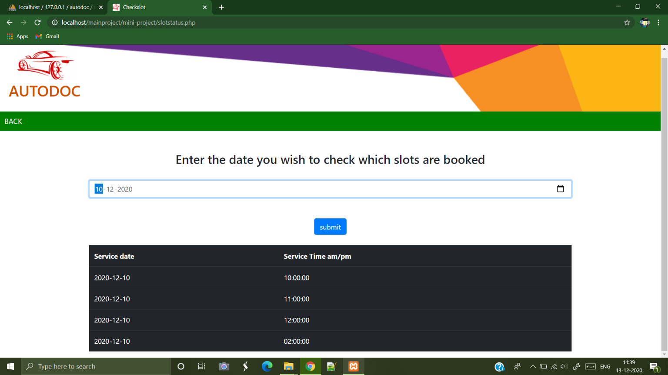

**Check Slot Availability by pop up message:**

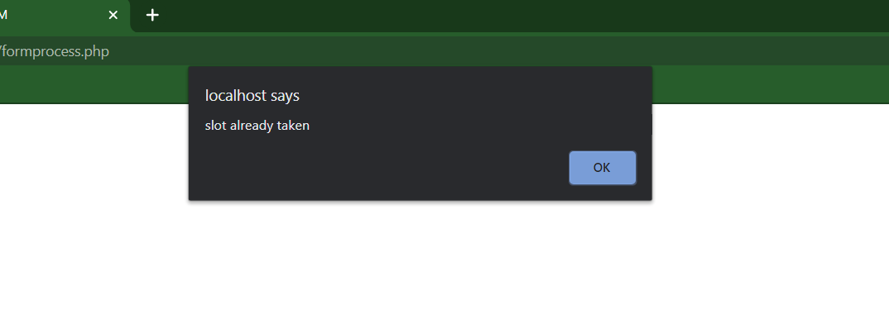

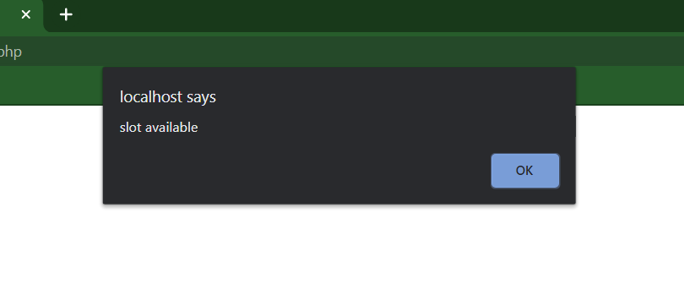

**Graphical Data Visualization:**

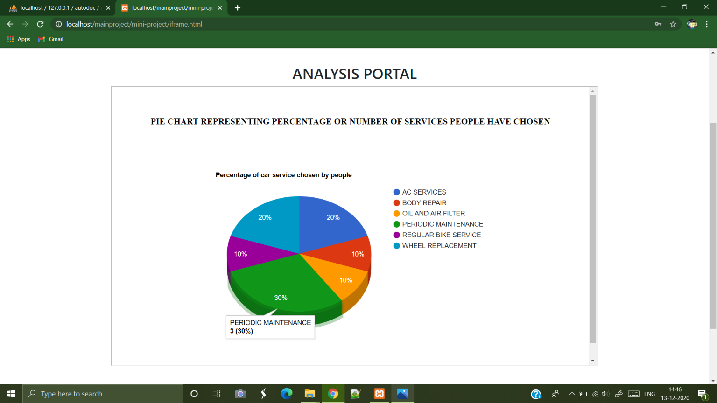

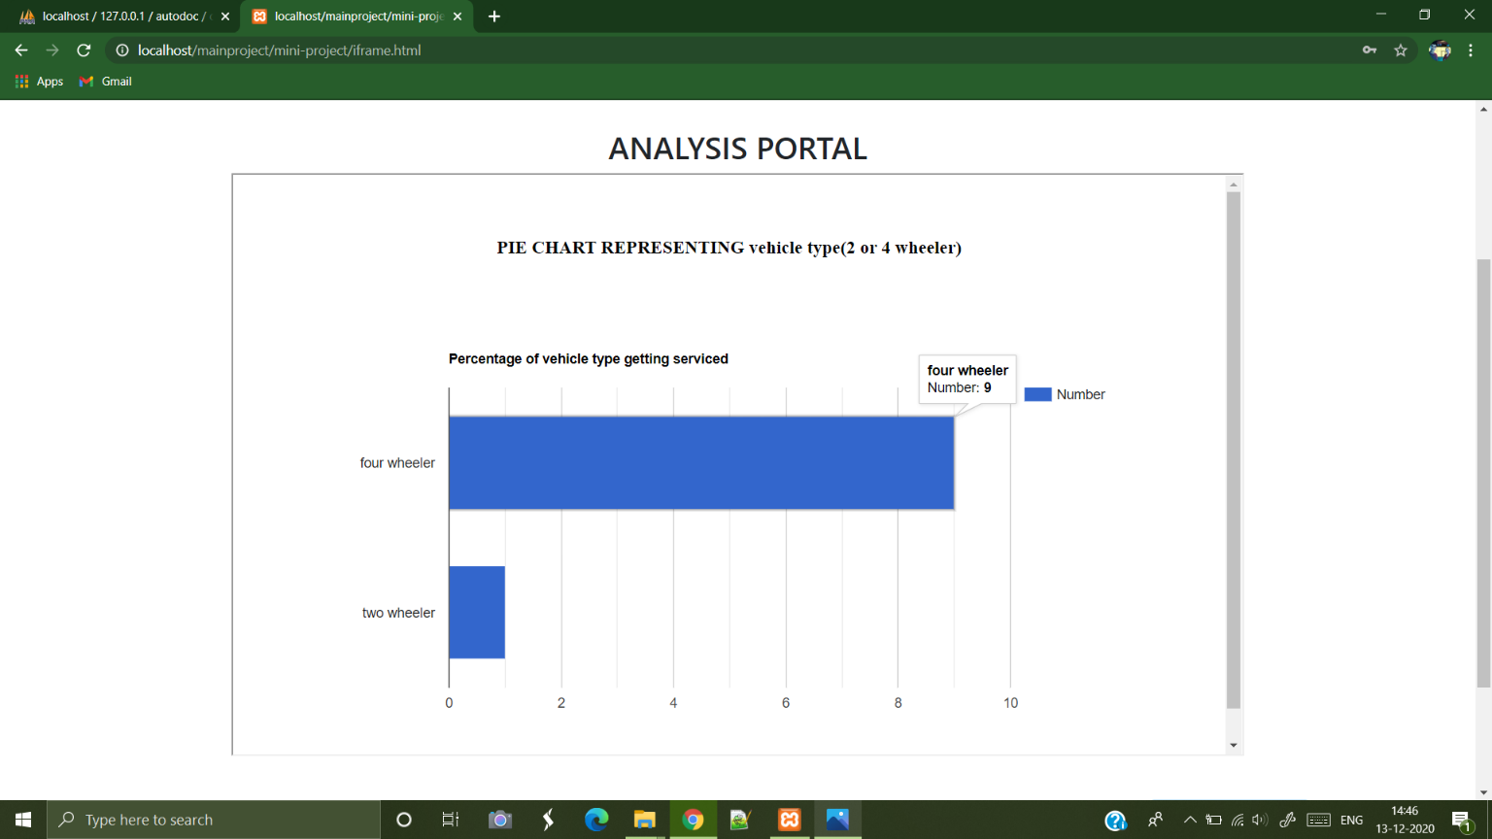

**Customer’s Service Details:**

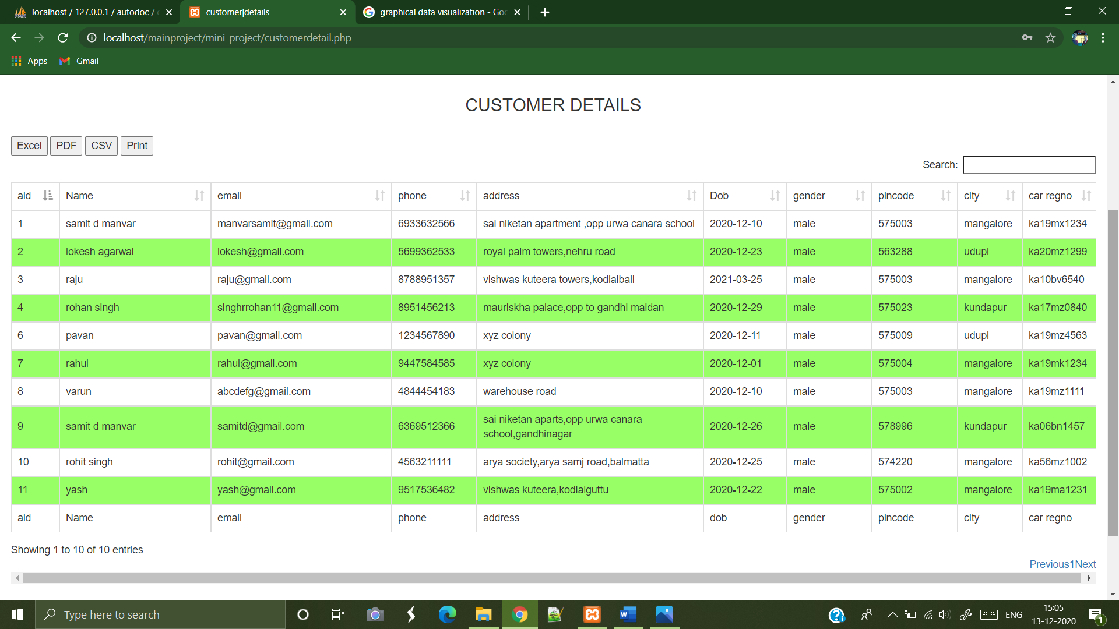

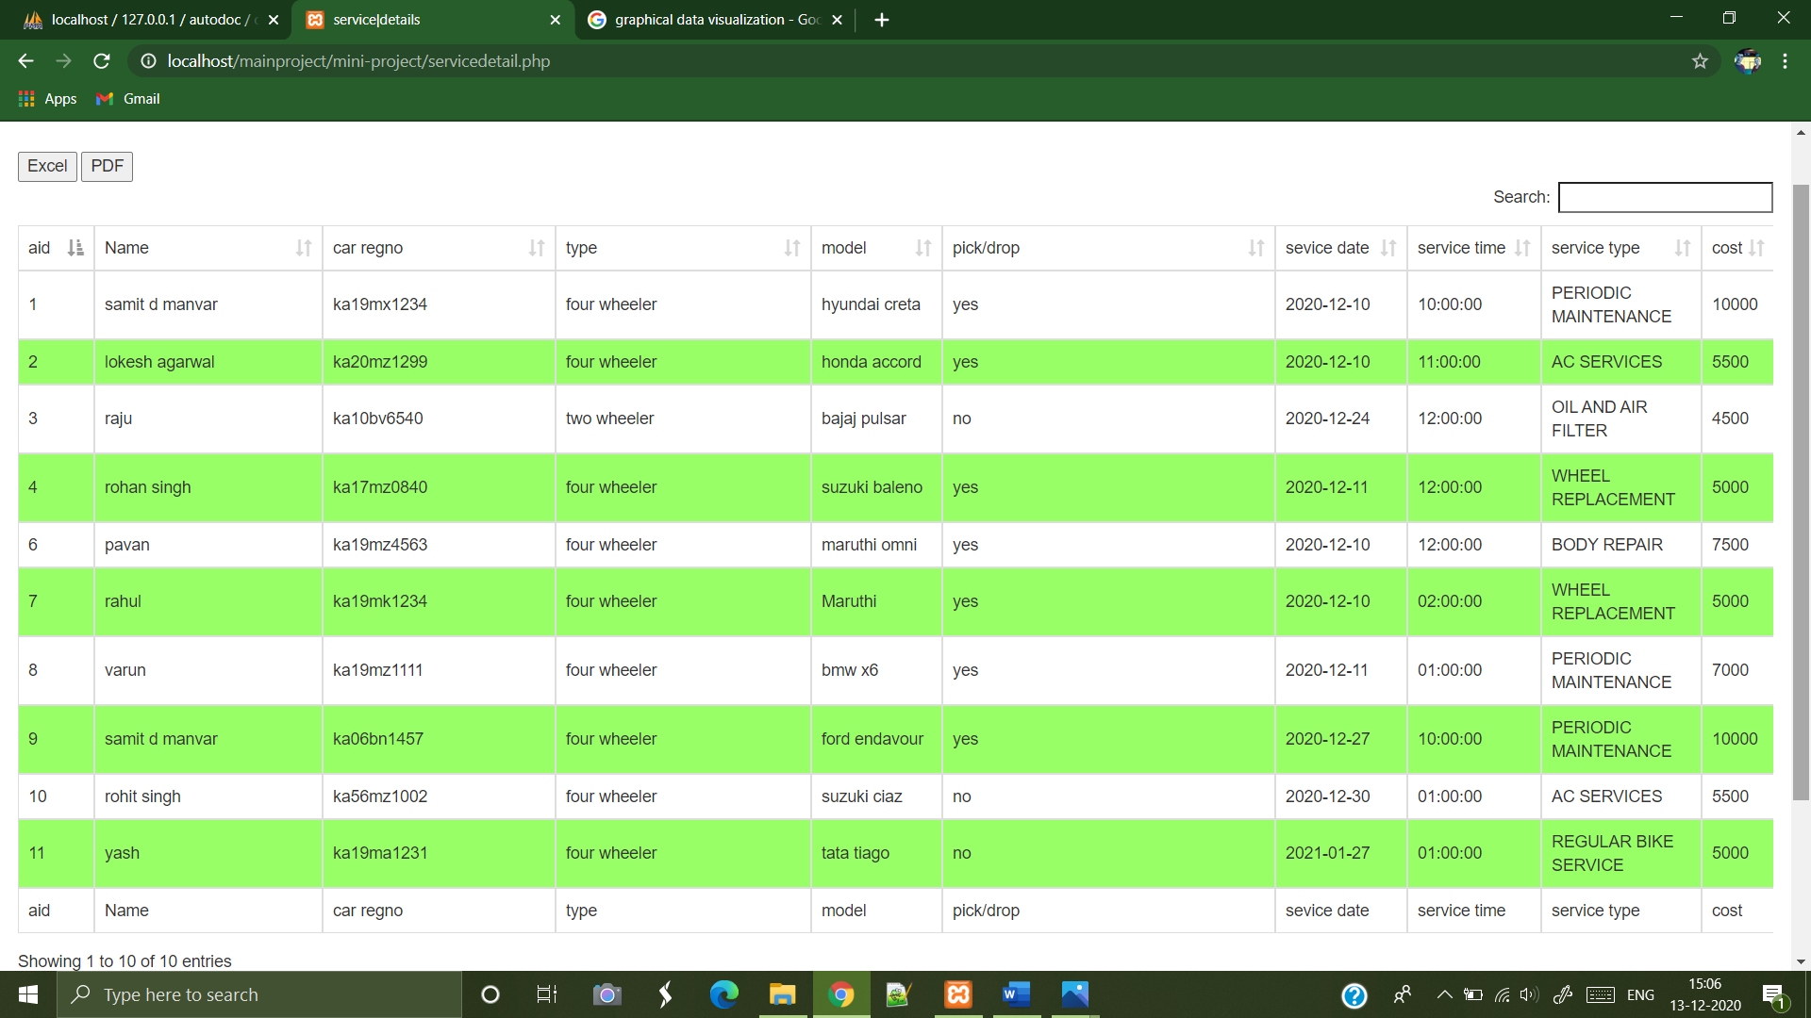

**Customer’s Feedback Form:**

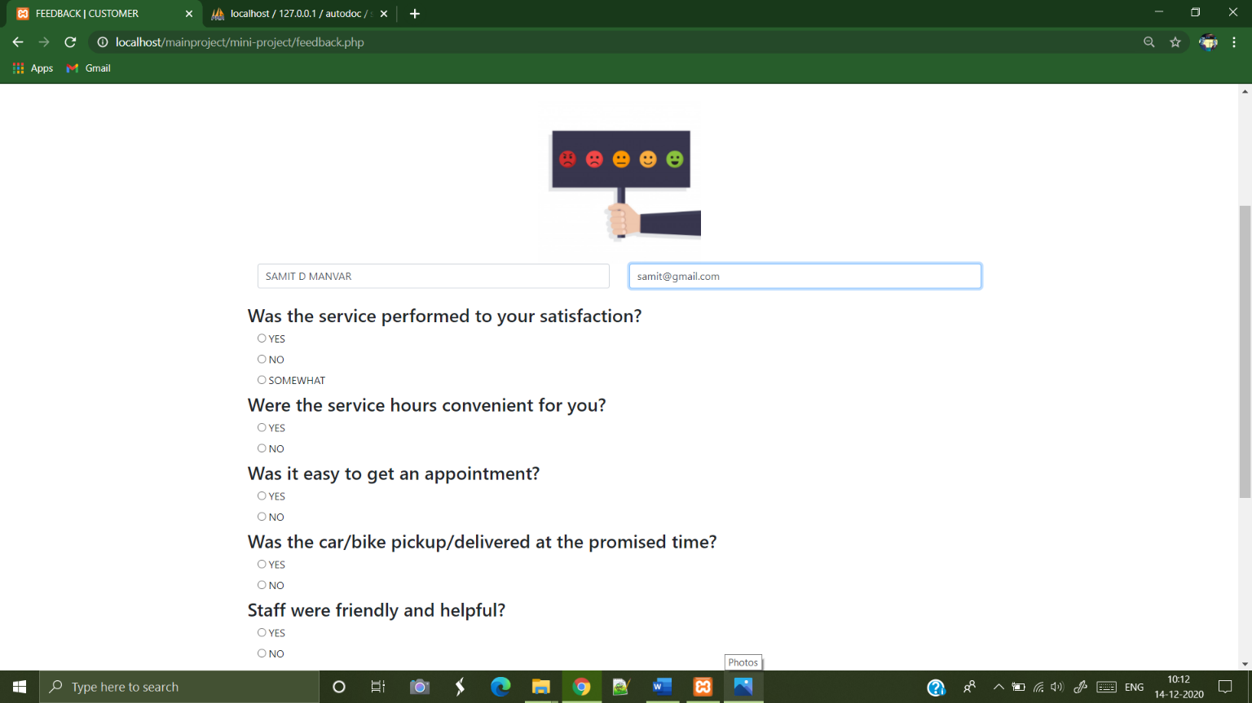

**Customer Service Status:**

