

(ISO 9001:2015 Certified), Accredited with ‘A’ Grade by NAAC

: 08258 - 281039 – 281263, Fax: 08258 – 281265

### Department of Computer Science and Engineering

B.E.CSE Program Accredited by NBA,New Delhi from 1-7-2018 to 30-6-2021

Report on Mini Project

COLLEGE BUS PASS MANAGEMENT SYSTEM

#### Course Code:18CS502

#### Course Name: Database Management

#### System

##### Semester: V SEM Section: C

**Submitted To:**

Ms. Ankitha A Nayak

Assistant Professor (GD I)

Department of Computer Science

and Engineering

**Submitted By:**

Ryan Menezes (4nm18cs139)

S Dhruva (4nm18cs140)

Samit D Manvar (4nm18cs152)

**Date of submission:**

26-12-2020

#### Signature of Course Instructor

# ABSTRACT

# College bus pass management system is a web application which provides functionality to both students and the college authorities. Usually most of the colleges follow the system for providing bus pass to students where students need to fill a hard copy of bus application form, wait in queue, pay the bus fees then show the bus fee receipt to get their bus pass. This is a long process. Instead of waiting in long queues to get a bus pass student can apply for college bus pass from their home itself. This would save a lot of time and also students need not carry a separate hard copy of the bus pass which is issued by the college. Instead, we can provide them a pdf copy which will be stored in their mobile phones. Students can also check their application status such as which seat number is allotted, which bus no etc.

# This web application is also helpful to the admin or say the college officials who is handling the college transportation department as they can get a tabular data of students who have applied for college bus pass. Data Visualization solves the problem of time taken to make decision for the management instead of depending on descriptive reports. The decisions could be like finding out maximum number of students coming from a particular location etc.

# TABLE OF CONTENTS

Title Page i

Abstract ii

Table of Contents iii

Introduction 4

Literature Review 5

Methodology 6

Results 7

Conclusion 7

References 8

Code Snippets…………………………………………………………………………………….9

Snapshots of the Project …...………………………………………………………………...10

# INTRODUCTION

# As internet came into existence it has changed the world. In today’s world most of the things is being carried out online, from online payment to online booking. College Bus Pass Management System is a web application that provides students to apply for their college bus pass online instead of waiting in long queues. This would also save the time of students as well as the college authorities. Also, the students need not carry a hard copy of their bus pass. Instead we can provide them a digital pass. This web application has two modules, the student portal and the admin portal.

# Student can book a bus pass only after he login/signup. In student portal there are two sections – Book a pass and view status. A student can get his bus pass only after he successfully submits the online bus application form.

# The admin or the department who handles the college transportation facility can get a tabular view of all the student booking details who has applied for a bus pass. graphical Data visualization platform where the admin or the department can make better decisions with help of graphical data like bar graphs, pie charts etc.

# LITERATURE REVIEW

# If a student wants to apply for college bus pass normally most of the colleges follow a standard procedure where the students needs to fill a hard copy of bus application form, pay the bus fees, show the bus fee receipt to the authority handling the college bus transportation to get the bus pass. This process is quite long and not that efficient way. Students need to wait in long queues. Also, students need to always carry a hard copy of bus pass. There is a better approach to solve this problem.

# Students can apply for their bus pass online by entering the necessary details and after on successful submission they can obtain their digital bus pass (or can say a pdf copy) which will be stored in their phone. This also saves a lot of time and more efficient method.

# Usually, the admin or the authorities have to maintain hard/physical copies of the college bus application form applied by the students for record purpose. Instead, we can provide them a digital platform where the admin gets a tabular view of student booking details where they can easily filter records. Also provide the department to make better decisions by providing them a visualized data (bar charts, pie charts) etc.

# METHODOLOGY

# System requirements and code setup

# System Requirements

# XAMPP web server to host the server on your device and run the web application.

# Web Editors (E.g.: - notepad++, sublime text etc.) for editing the source code.

# A good Internet Connection.

# Code Setup

# Click on the following link as mentioned below.

# <https://github.com/SAMIT-D-MANVAR/buspass>

# Now click on code button and download the zip file to get the source code.

# Extract the zip files and copy the unzipped files to htdocs folders.

# Download the Readme files to follow the instructions on how to do Code Setup.

# 2) Project Details

# Front End

# Source Code is written in HTML5, CSS3, JavaScript, Bootstrap and jQuery

# jQuery is a JavaScript library.

# jQuery is a lightweight, "write less, do more", JavaScript library.

# Bootstrap is an open-source toolkit used to design and customize responsive mobile-first sites.

# Back End

# PHP (Hypertext preprocessor) a server-side scripting language for creating dynamic and interactive web applications.

# The PHP code is executed in server and so we use XAMPP to run our php files.

# MYSQL database is used to store, retrieve, manipulate, delete the data present in the database.

# Google Charts

# Google Charts provides a perfect way to visualize data on your website.

# It is a library which allows us to plot interactive graphs for better visualization

# It is simple to use. We need to use the CDN provided in order to plot the charts.

# The data required to display can be obtained from database, csv files etc.

# Results

# With this web application students are able to apply for bus pass online by entering the necessary details. Students can get their digital copy of their bus pass and also get to know which seat is allotted to them. If the same student who has already applied for a bus pass and got his bus pass, tries to apply again he cannot apply it again. The application system allows only one student to book one bus pass. The tabular view of students booking details is obtained where the admin/department can get a clear view and can also filter the records based, search a particular data easily. The graphs are plotted based on the data available from database. Pie charts, Bar graphs is being implemented.

# Conclusion

# To conclude, College Bus Pass Management System is a web application which provides a convenient method for students to apply for college bus pass online and also obtain a digital bus pass instead of carrying a hard copy. This application also provides the department/admin to get a tabular view of students booking details, provide them a Graphical visualized data. In future the department handling the transportation facility can come up with new strategies such as introducing more college buses at that particular locations where maximum numbers of student’s board.

# REFERENCES

1. <https://www.w3schools.com>
2. <https://datatables.net>
3. <https://getbootstrap.com>
4. <https://www.php.net>
5. <https://jquery.com>
6. <https://developers.google.com/chart>

# Code Snippets

# Iframe to display graphs

# 

# Display student booking details by fetching from database and display it in tabular form

# 

**Snapshots of the project**

**Home Screen:**

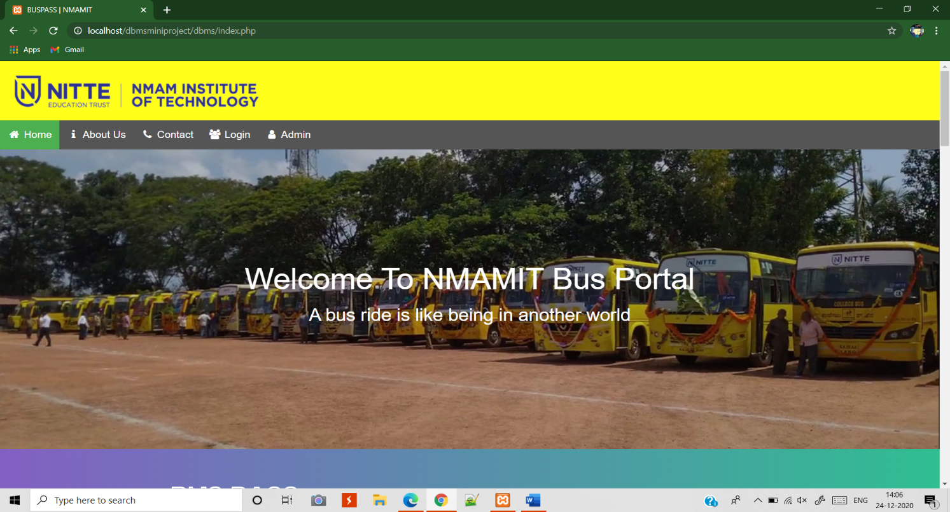

**Bus Routes with Price Table**

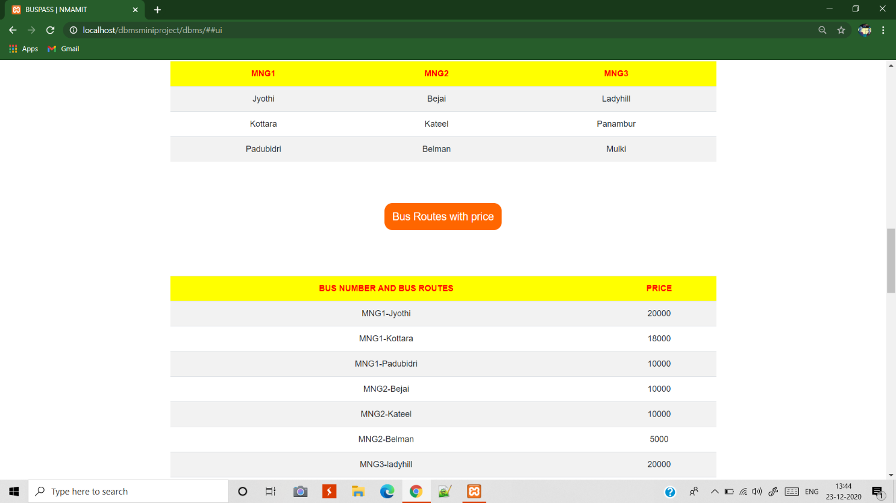

**Login/Sign-up page**

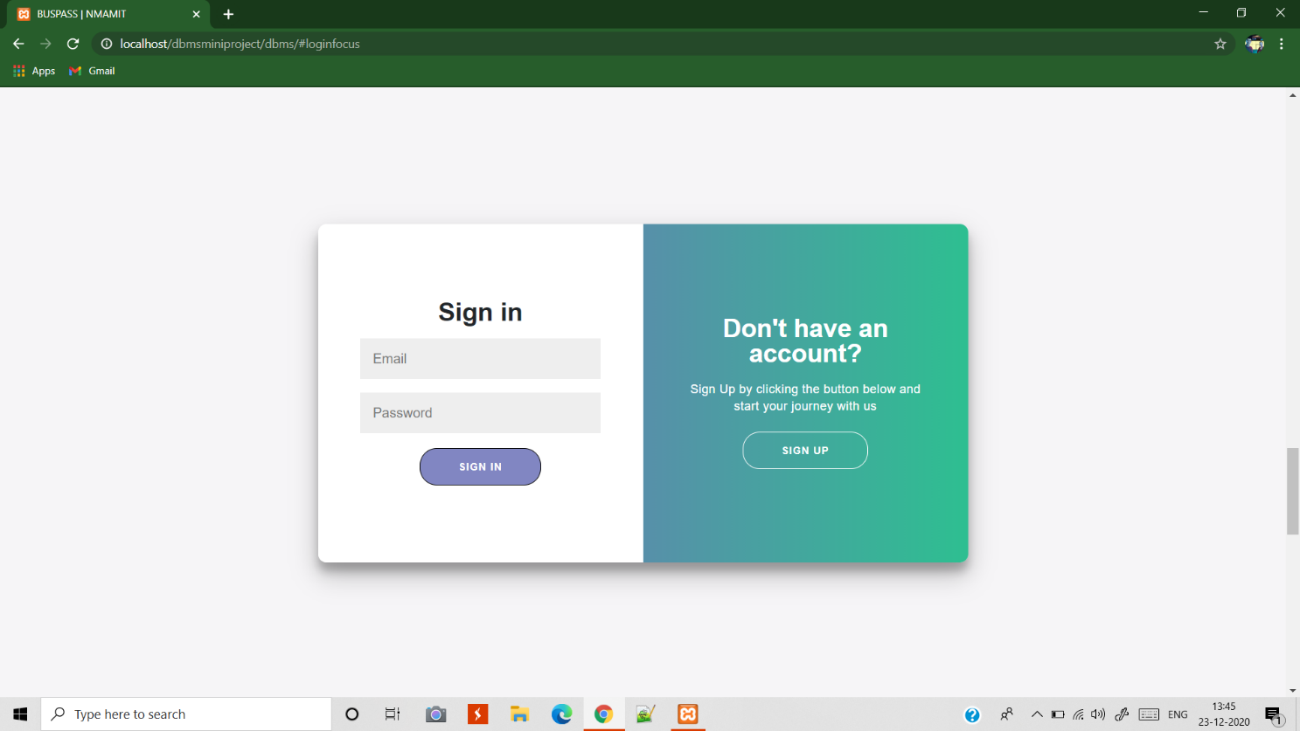

**Admin Login**

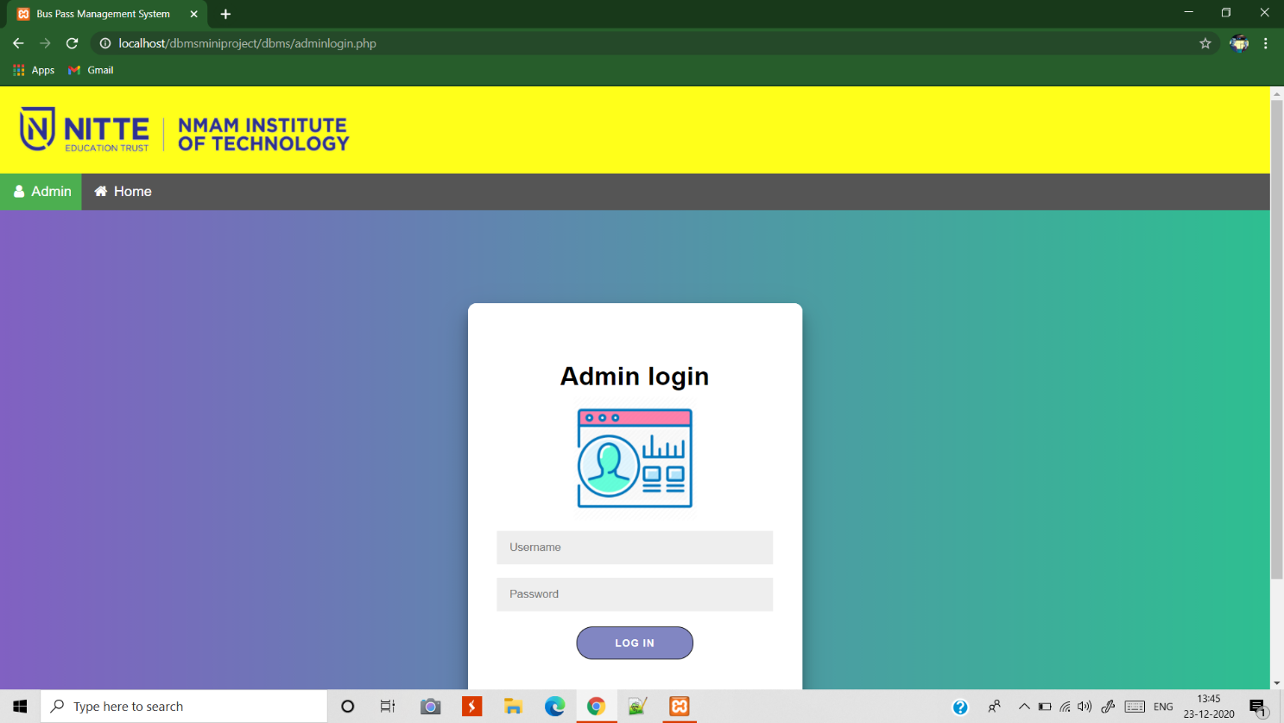

**Student Portal**

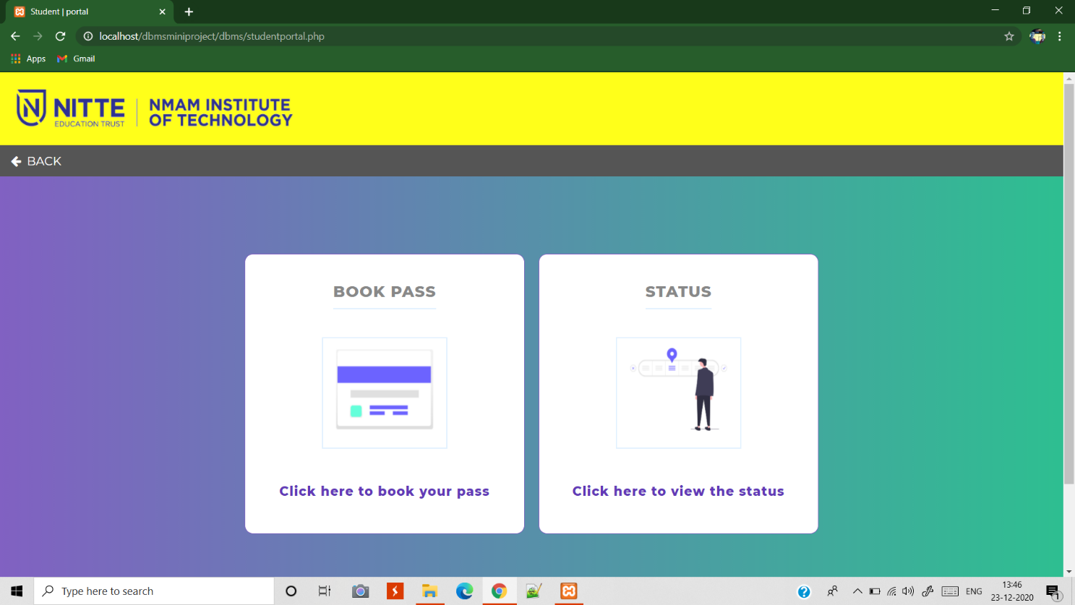

**Student Bus booking Status**

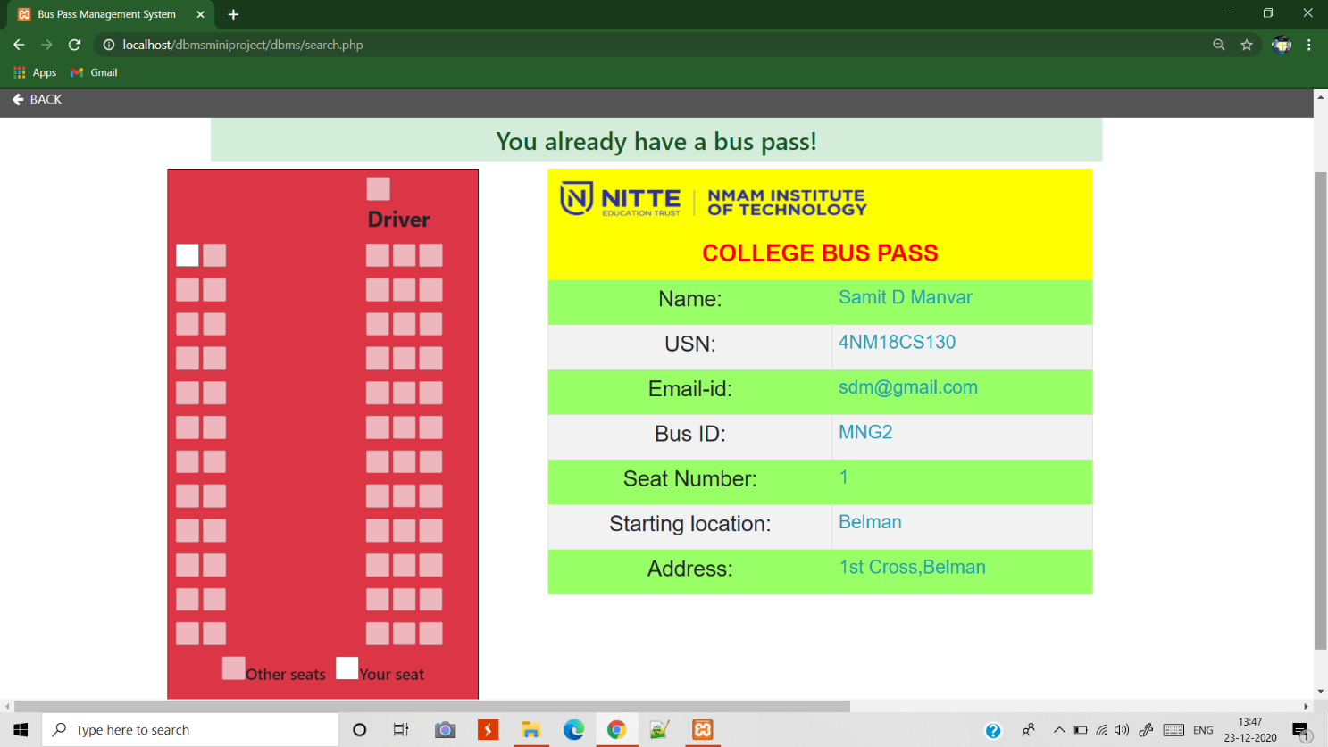

**Student Bus Pass Application Form**

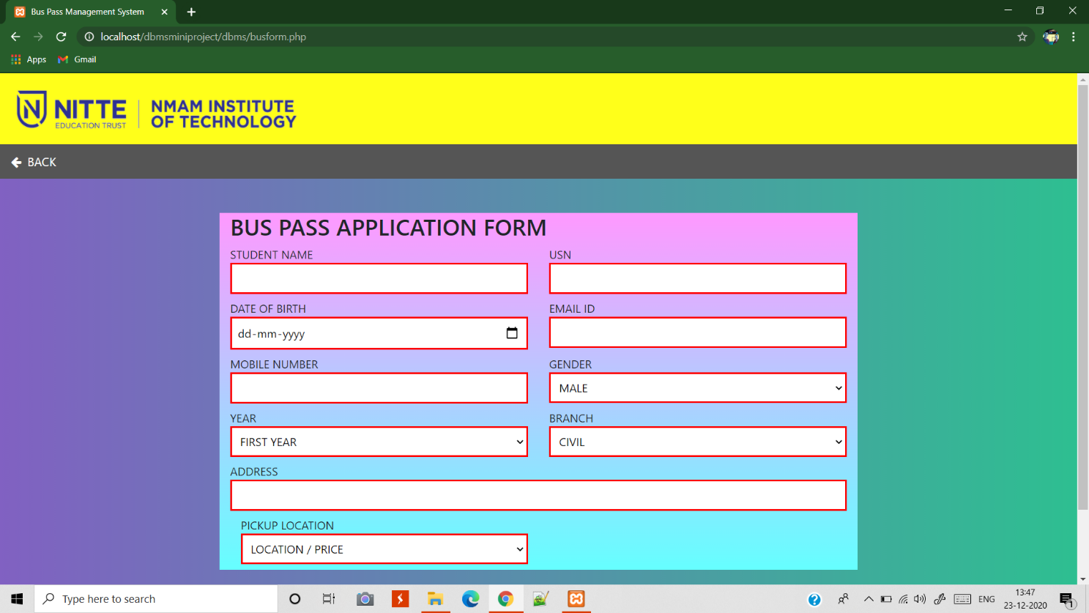

**Analysis (Graphical Visualization)**

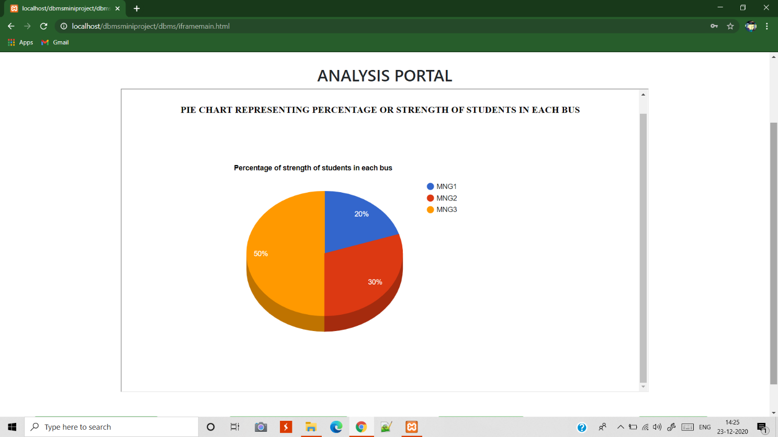

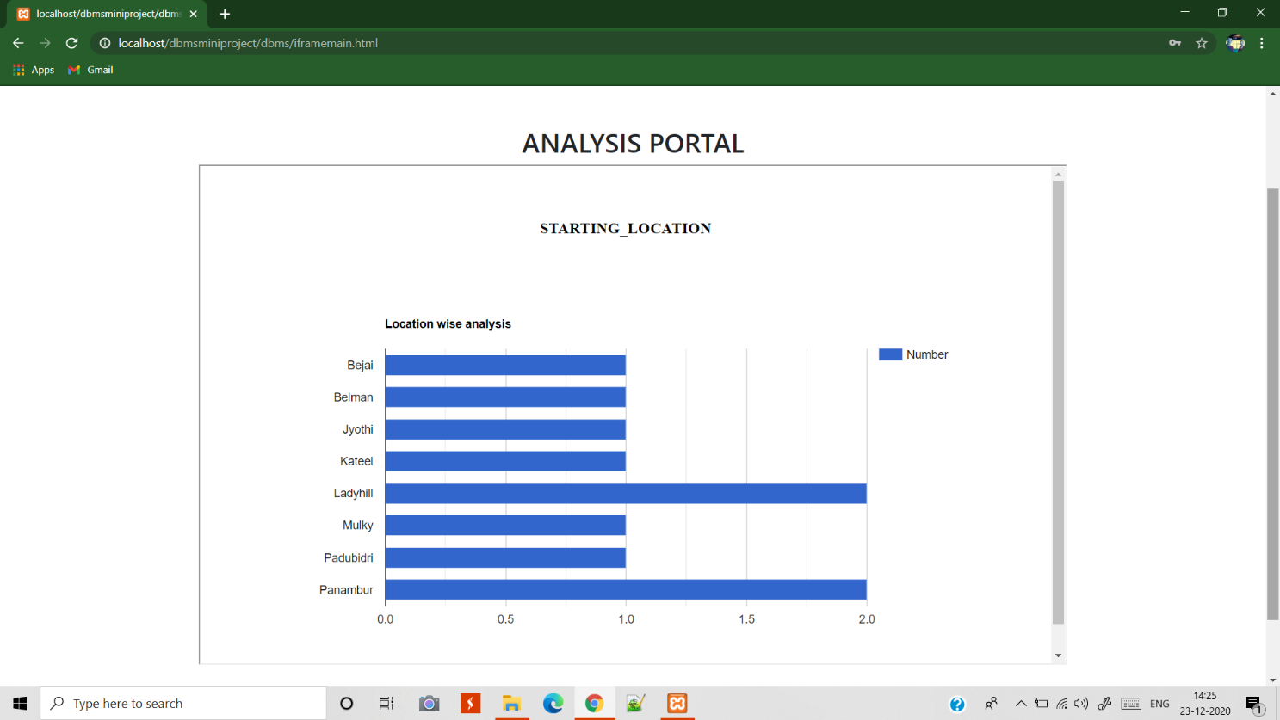

**Student Details (Admin view)**



