MAKING A CHATBOT USER INTERFACE USING RIVESCRIPT

PICTURE OF USER INTERFACE OF BOT WITH THE HELP OF HTML ,CSS AND JAVASCRIPT.

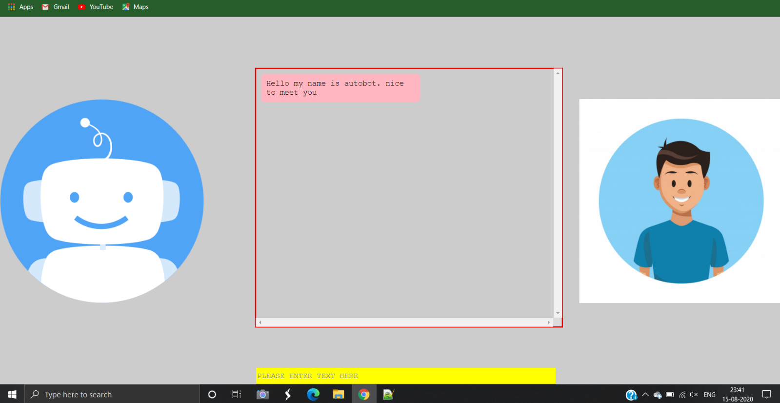

THE ONE IN RIGHT SIDE IS USER AND THE ONE IN LEFT SIDE IS A BOT

ENTER THE QUESTION BELOW IN THE YELLOW BOX AND PRESS ENTER

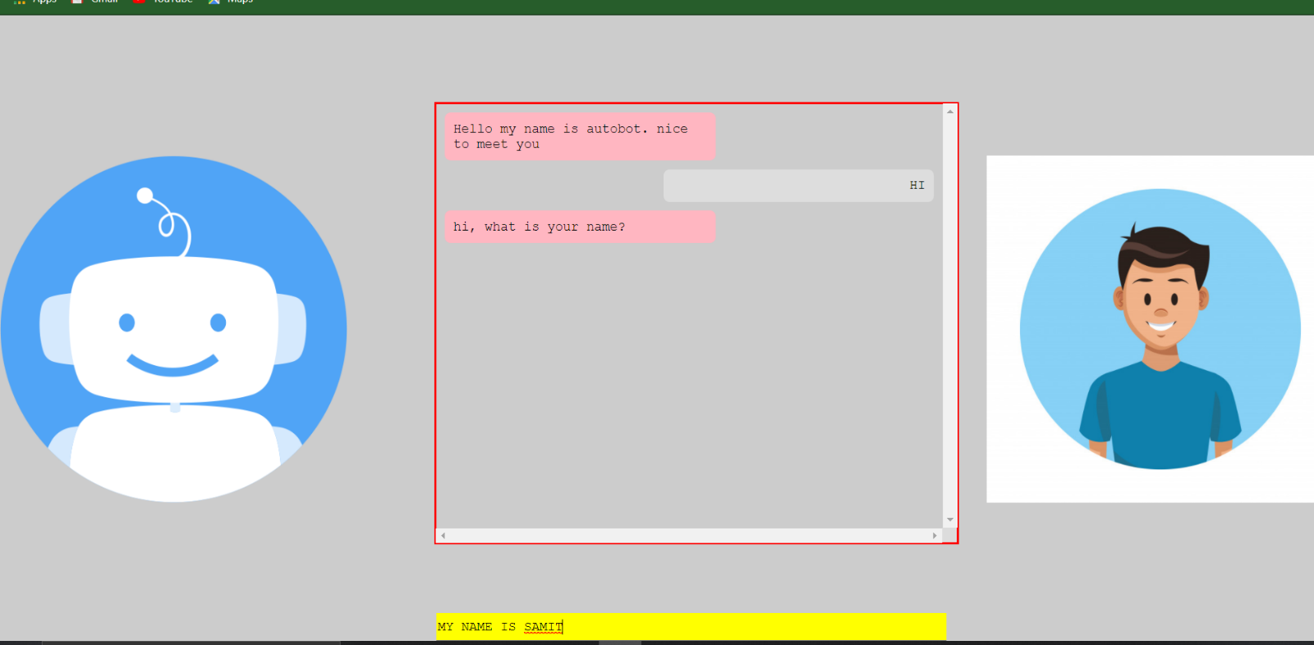

SIMPLE INTERACTION WITH BOT AND USER

