TripMate AI
From Idea to End Product
A techno-functional walkthrough of a multi-agent travel planner — told by the Product Manager, the Solution Architect, and the AI Engineer who each shaped it
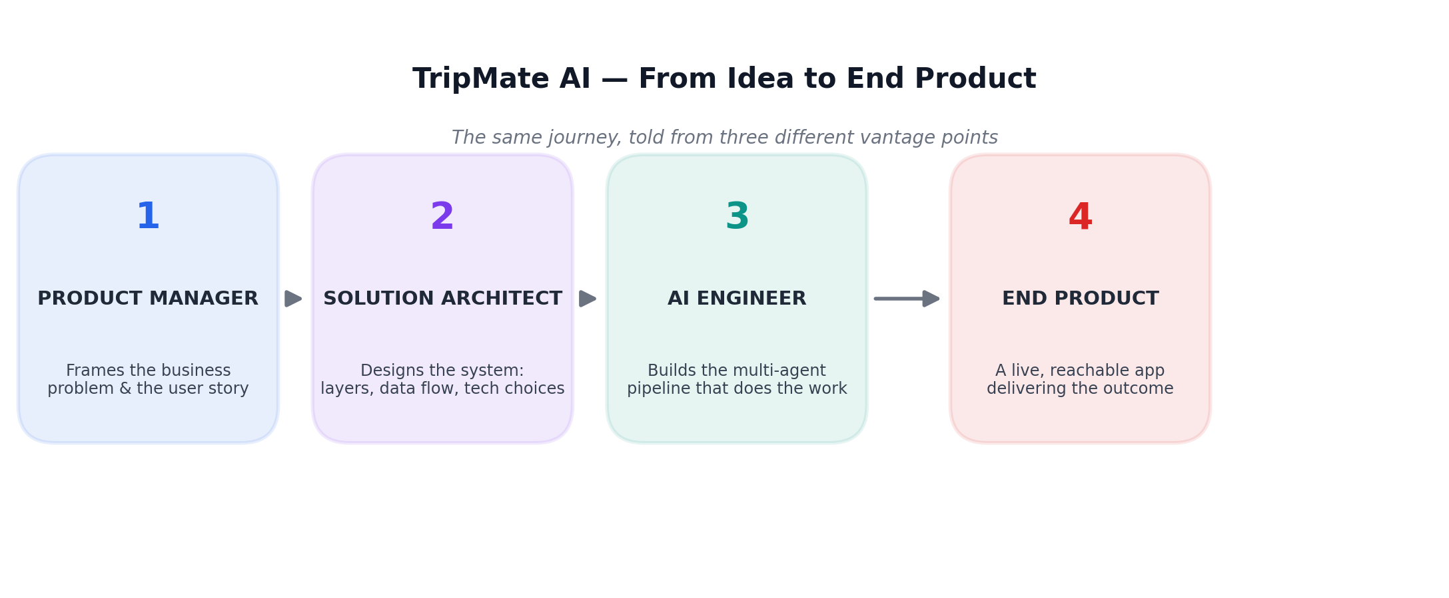

How to read this document: each part is written from the vantage point of the person who owned that stage — the language gets progressively more technical as we move from the business problem to the working system, but every technical term is explained the moment it's introduced.

Executive Summary
TripMate AI turns a single free-text request — “Plan a 7-day Japan trip from Bangladesh under 2 lakhs” — into a structured, budget-aware travel plan, built from live flight data, live web search, and a large language model that stitches it all into a readable itinerary.
The point of this document is not to explain what each file in the codebase does. It's to walk through the full journey the idea took to become a working product — and specifically, to make one concept land clearly for a non-engineering audience: what “multi-agent orchestration” actually means, in plain business terms, before we get technical about it.

The three vantage points
- The Product Manager frames why this needs to exist and what “good” looks like for the user.
- The Solution Architect decides how the system is laid out — which piece talks to which, and why.
- The AI Engineer builds the actual orchestration — the sequence of specialised “agents” that do the real work.

By the end, you'll be able to trace one user's trip request all the way from a text box on a webpage to a fully-formed itinerary — and understand exactly which piece of the system did what, and why it was built that way.

Part One — The Business Problem
Narrated by the Product Manager

THE PM'S OPENING PROBLEM STATEMENT
“Planning a trip today means fifteen browser tabs — one for flights, one for hotel reviews, one for a packing checklist, one for a currency converter. Nobody wants to do that. They want to type one sentence and get back something they can actually use.”

Who is this for?
The target user is anyone who wants a starting point for a trip, fast — not a travel agent, and not someone who wants to click through twenty flight comparison sites. They know roughly where they want to go, roughly what they can spend, and they want a plan they can then refine, not a blank page.

Why a chatbot alone isn't good enough
A plain LLM chatbot can already write something that sounds like a travel itinerary. The problem is it's guessing — flight names, hotel suggestions, even prices can be entirely made up (a well-known failure mode called hallucination). For a product where people might actually act on the advice, “sounds right” isn't good enough. It has to be grounded in something real.

The business requirement, in one sentence
REQUIREMENT
The final plan must combine real, current data (actual flight schedules, actual web search results for hotels and sights) with the language model's writing ability — never let the model invent facts it hasn't been given.

What success looks like
Business goal | How we'll know
User gets a usable plan, not generic filler | Plan references real flight numbers/status and real, current hotel/sight names
User trusts the output | Product is explicit about what it doesn't know (e.g. no ticket prices) rather than guessing
User can pick up where they left off | Returning to the same browser continues the same planning conversation
The product is affordable to run | Cost per request is understood and bounded (see Part Three, §9)

The brief handed to the Solution Architect
PM → SOLUTION ARCHITECT
“I need a system where the ‘thinking’ part of the AI never works from thin air — it should always be handed real flight data and real search results before it's allowed to write anything. And I need it reachable from a normal web page, not a script someone has to run manually.”

Part Two — The Solution Architecture
Narrated by the Solution Architect

THE ARCHITECT'S FRAMING
“Think of this as three layers stacked on top of each other. One layer the user sees. One layer that does all the thinking and fetching. One layer that remembers everything. None of them should need to know the internal details of the others — they only talk through clean, well-defined doorways.”

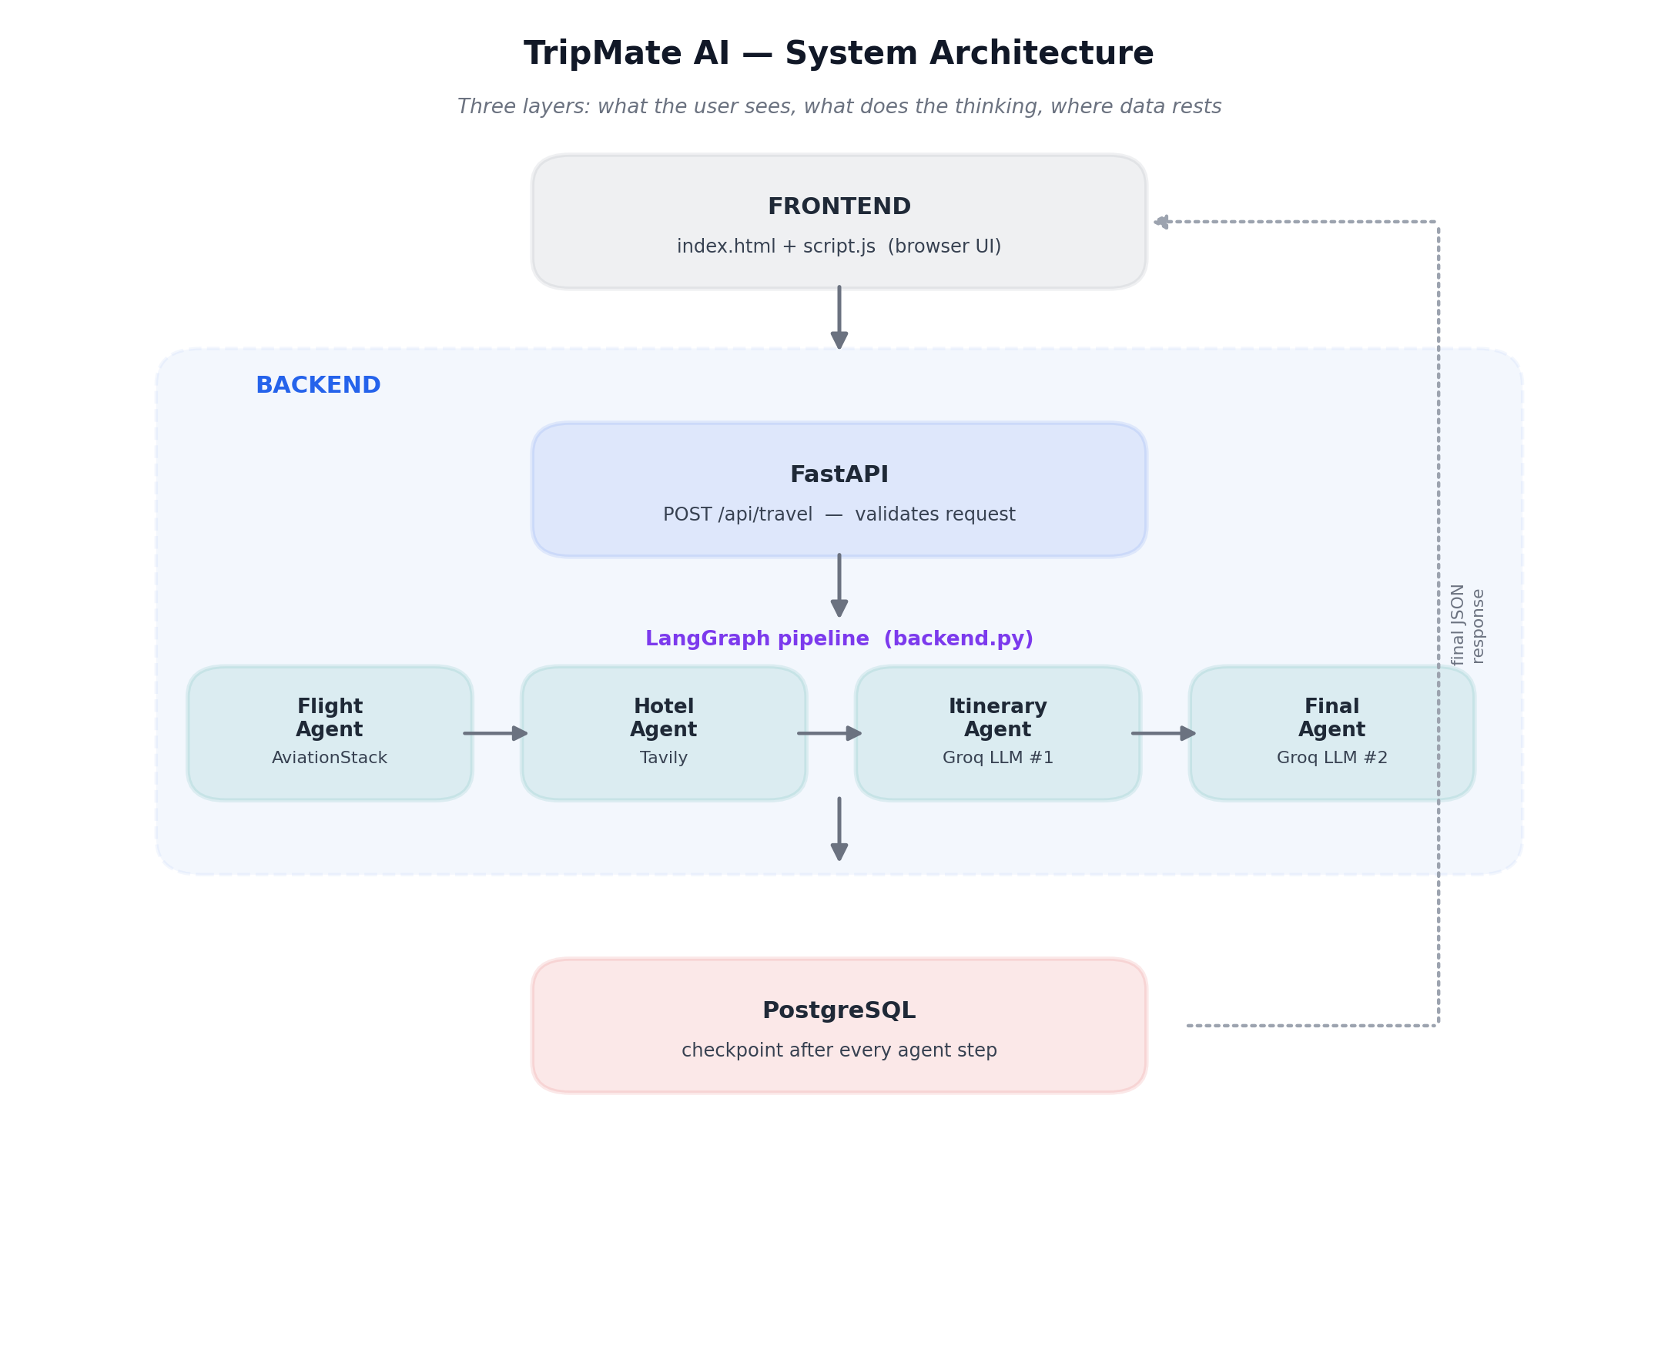
Figure 1 — The three-layer system: Frontend, Backend (FastAPI + LangGraph agents), and PostgreSQL

Layer 1 — Frontend: the doorway the user actually sees
A single web page (index.html, styled with style.css, wired up with script.js). The user types a request into a textarea, or picks a quick example prompt. This layer has no intelligence of its own — it just collects the request and displays whatever comes back. It also remembers a thread_id in the browser's local storage, so a returning visitor continues their earlier conversation instead of starting cold.

Layer 2 — Backend: where the real work happens
This is the layer with two distinct jobs, handled by two distinct technologies working together:
Component | Role | Why this exact choice
FastAPI | The receptionist. Receives the HTTP request, checks it's well-formed, and hands it off. | Fast, and automatically rejects malformed requests before any expensive work starts — no LLM call is wasted on bad input.
LangGraph | The orchestrator. Decides the order in which specialised ‘agents’ run, and passes data between them. | Purpose-built for chaining multiple AI reasoning/tool-calling steps together with shared, inspectable state.

A critical architectural decision here: the frontend never talks to the database, and never talks to the AI reasoning layer directly. Every request goes through FastAPI first. This matters for three reasons: the database credentials never have to be exposed to anyone's browser; every request gets validated before anything expensive runs; and the actual “intelligence” — the agents — can only be triggered through one controlled doorway.

Layer 3 — PostgreSQL: the system's memory
A single database doing two jobs: storing ordinary application data, and storing a checkpoint of the AI pipeline's progress after every single step. That second job is what makes the conversation resumable — explained fully in Part Three.

Why this shape, and not something simpler
- A single giant prompt to one LLM was rejected — it can't reliably call two different external data sources in a structured, checkable way and keep its reasoning separate from its data-gathering.
- Letting the frontend query the database directly (a pattern some tools like Supabase encourage) was rejected — it would expose credentials publicly and bypass validation, and it still couldn't run the agents, since a database can't call external APIs or an LLM on its own.
- Everything is deployed as two independently hosted pieces — the backend application and the Postgres database — so the product stays live for end users even when nobody's own laptop is switched on.

The brief handed to the AI Engineer
SOLUTION ARCHITECT → AI ENGINEER
“I've drawn the boxes and the doorways. Now I need you to build what happens inside that middle box — the actual sequence of specialised workers that turns a raw request into a grounded, factual itinerary. Make sure every step's progress is saved, so nothing is ever silently lost.”

Part Three — Building the Multi-Agent Orchestration
Narrated by the AI Engineer

THE AI ENGINEER'S FRAMING
“An ‘agent’ here isn't a robot — it's just a specialised worker with one job, given exactly the tools it needs to do that job and nothing else. ‘Orchestration’ is simply the fixed order I make them run in, and the shared notebook they all write into as they go.”

Meet the four agents
Agent | Job | Tool it calls | What it deliberately does NOT do
Flight Agent | Turn the request into real flight schedule/status data | AviationStack API | Does not touch the LLM, does not know about hotels; and it cannot fetch ticket prices — only schedule/status
Hotel Agent | Find current, real web content on hotels and sights | Tavily Search API | Returns search results, not a bookable inventory — these are suggestions, not reservations
Itinerary Agent | Draft a first-pass day-by-day plan using the real data gathered so far | Groq LLM (call #1) | Does not go fetch new data — only reasons over what the first two agents already found
Final Agent | Polish and format that draft into the finished, readable answer | Groq LLM (call #2) | Does not re-verify facts — trusts the itinerary agent's draft and focuses purely on presentation

Why this exact order, not parallel, not a free-for-all
The four agents run one after another, always in the same sequence: Flight → Hotel → Itinerary → Final. This is a deliberate, simple design choice, and it directly enforces the PM's requirement from Part One — the LLM is never allowed to write a single word of the itinerary until it has been handed real flight and hotel data first. There's no branching, no agent deciding to skip another — the business rule “ground it in real data before generating prose” is baked directly into the pipeline's shape.

The shared notebook — TravelState
Every agent reads from and writes to one shared object, called TravelState. Rather than each agent handing its output only to the next one in line, everything is added to this same growing record — which means any agent, or a developer debugging later, can see the full history of how the answer was built.
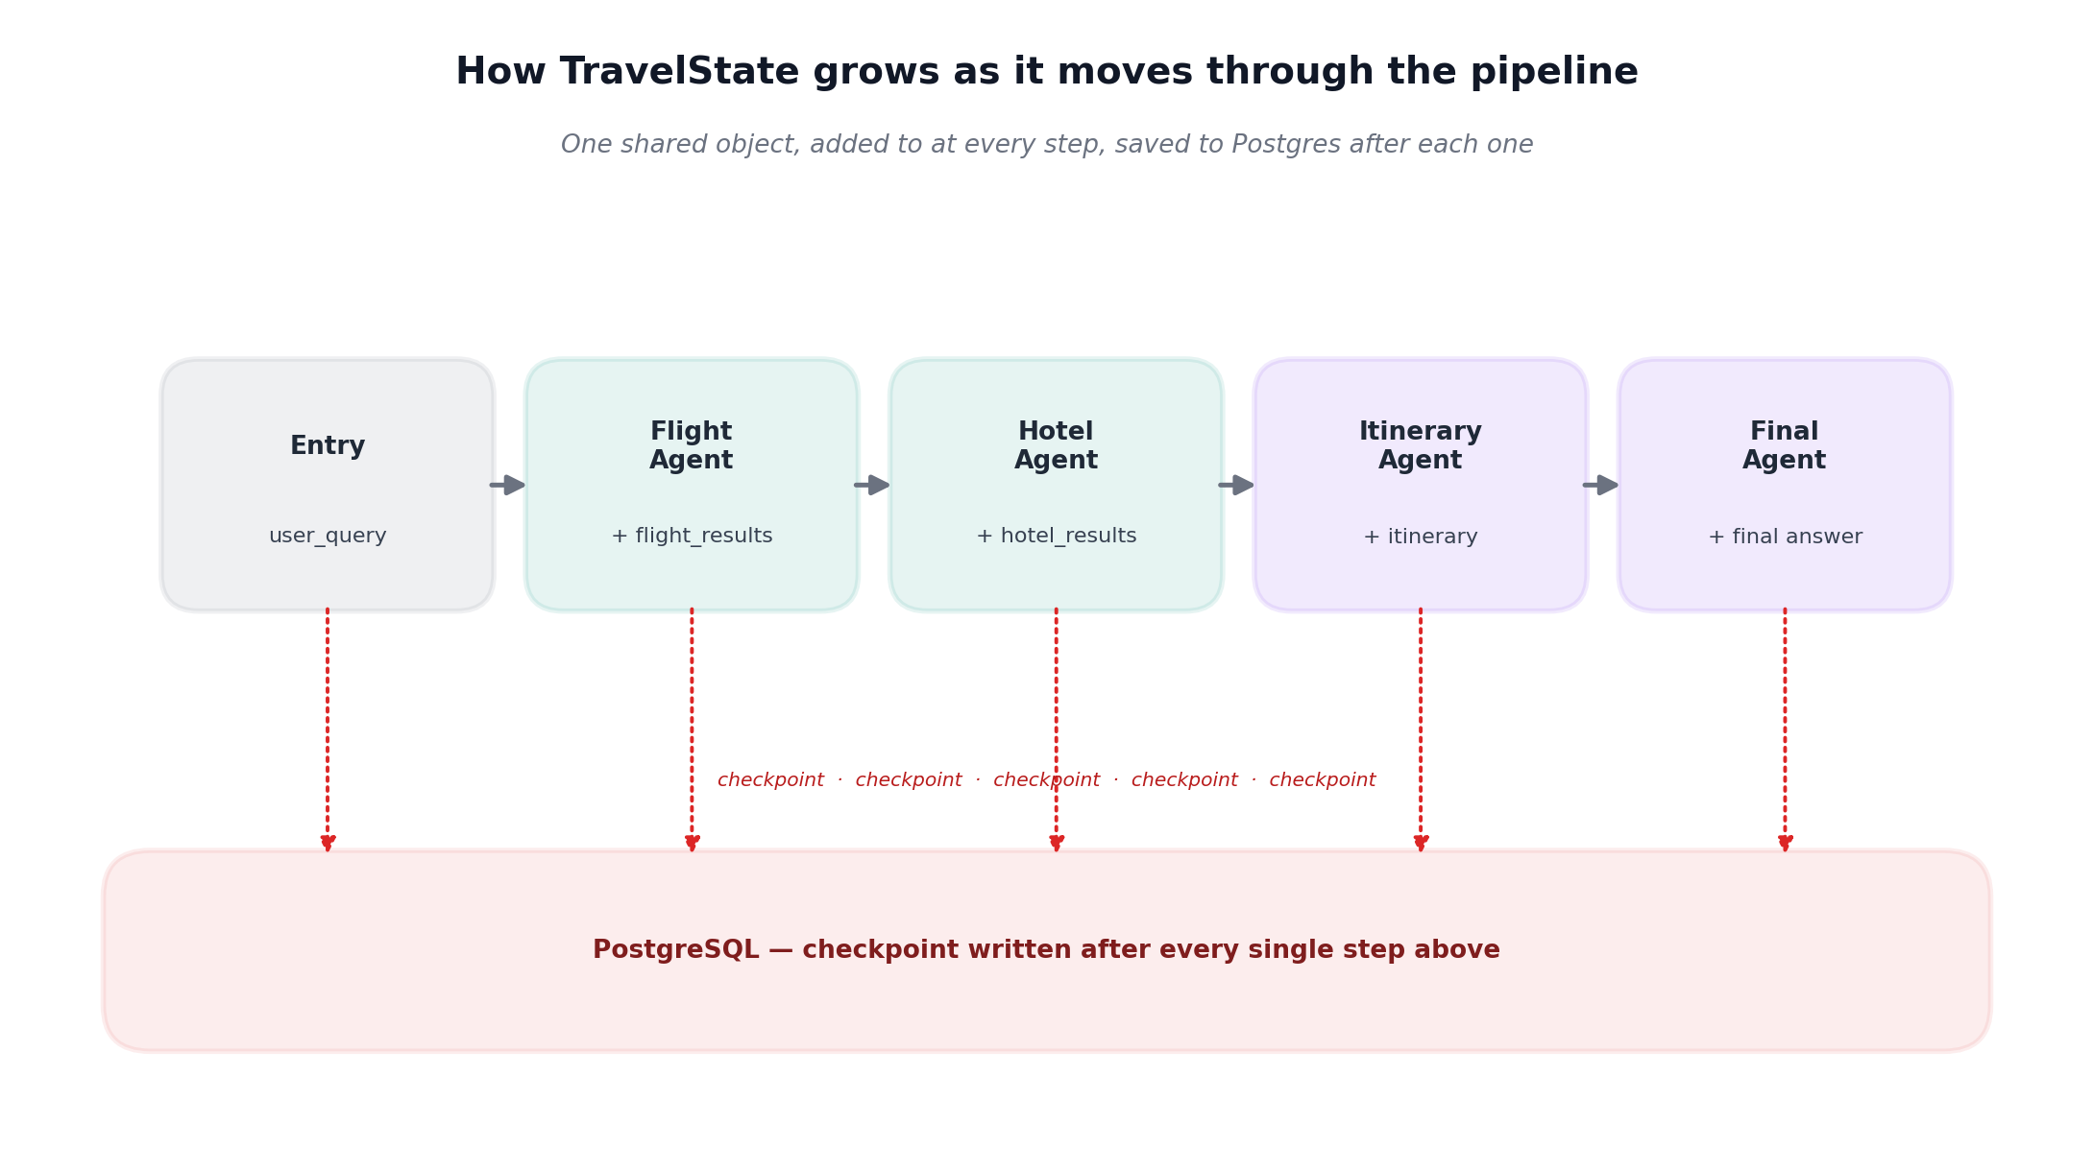
Figure 2 — TravelState accumulates fields as it passes through each agent, and is checkpointed to Postgres after every one
Field | Set by | Purpose
user_query | Entry point | The raw request, available to every downstream agent
flight_results | Flight Agent | Real flight data, fed into both LLM stages later
hotel_results | Hotel Agent | Real search results, fed into both LLM stages later
itinerary | Itinerary Agent | The first-draft plan produced by LLM call #1
messages | Every agent | The running conversation log — this is what actually gets saved to Postgres
llm_calls | Every agent | A simple running counter, useful for tracking cost per request

Persistence — why this pipeline can't lose its place
After every single agent finishes, not just at the very end, LangGraph's checkpointer writes the current TravelState to PostgreSQL. Each conversation is tied to a thread_id. If the same thread_id shows up again later, the pipeline can resume that exact conversation rather than starting from zero — this is what “session memory” means in this product, in plain terms.
The business payoff: if a user closes their browser mid-plan, or the server has to restart, no work is silently thrown away. The system's progress is durable, not just held in temporary memory.

Cost and latency — what one request actually costs
Because this is a sequential pipeline, one user request triggers, in order: one AviationStack call, one Tavily call, two separate Groq LLM calls, and several Postgres writes (one checkpoint per agent). None of this happens in parallel — each step waits for the one before it. That's the honest reason the product shows a loading spinner: the total wait time is the sum of four real, external round-trips, not an instant response.

What this pipeline deliberately doesn't do yet
- No authentication — anyone who knows a thread_id can currently access that conversation.
- No pricing anywhere — flight data is status-only; the budget figure in any itinerary is the LLM's estimate, not a quoted fare.
- No automated test suite — only a manual scratch script exists today for exercising the tools by hand.
- No production deployment configuration yet — today it only runs via a local development server.

Part Four — One Request, Start to Finish
Bringing all three vantage points together, here is exactly what happens when a real user types: “Plan a 7-day Japan trip from Bangladesh under 2 lakhs.”

Step | What happens | Which layer
1 | User types the request into the web page and hits submit | Frontend
2 | Browser sends it as a POST request, along with a thread_id, to /api/travel | Frontend → Backend
3 | FastAPI checks the request is well-formed before doing anything else | Backend — FastAPI
4 | LangGraph starts the pipeline, loading any prior state for this thread_id | Backend — LangGraph
5 | Flight Agent calls AviationStack for real schedule/status data | Backend — Agent
6 | Progress is checkpointed to Postgres | Database
7 | Hotel Agent calls Tavily for current hotel/sightseeing search results | Backend — Agent
8 | Progress is checkpointed to Postgres | Database
9 | Itinerary Agent's LLM call drafts a day-by-day plan using only the real data gathered so far | Backend — Agent
10 | Final Agent's LLM call polishes that draft into the finished, readable answer | Backend — Agent
11 | FastAPI packages the final answer as JSON and returns it | Backend → Frontend
12 | The web page renders the plan; the user can copy it or download it as a PDF | Frontend

Every one of those twelve steps maps directly back to a decision made in Parts One through Three: the PM's insistence on grounded facts before prose (steps 5, 7, 9), the architect's three clean layers (steps 1-3, 11-12), and the engineer's durable, checkpointed pipeline (steps 4, 6, 8).

Appendix — Glossary, in plain business language
Term | In plain terms
API | A defined doorway that lets one piece of software ask another for data or action, without needing to know how the other one works internally
LLM (Large Language Model) | The AI model that reads text and generates text back — in this product, that's Groq
Agent | A specialised worker with one job and a fixed set of tools — not a general-purpose AI, a narrow one
Orchestration | The fixed order agents run in, and how they pass information to one another
Multi-agent pipeline | Several agents chained together, each handling one part of a larger task
Shared state / TravelState | One growing record that every agent reads from and adds to, instead of passing isolated messages to each other
Checkpoint | A saved snapshot of progress, written after each step, so nothing is lost if something goes wrong
Hallucination | When an LLM confidently states something false because it was never given real facts to work from — the core risk this whole architecture is built to avoid
Backend | The layer that does the actual work, invisible to the end user
Frontend | The layer the end user actually sees and interacts with

End of document.

