HR ANALYTICS

HR Analytics Workforce Report
  - Dashboard findings and recommended next steps
October 2026
This report summarizes the workforce profile shown in the HR Analytics & Workforce Insights dashboard. It covers workforce size and mix, department and state concentration, and the annual hiring record trend. The dashboard points to a workforce of about 19,000, with Engineering and Ohio as the largest displayed groups. The next step is to validate the population definitions and time coverage before treating the chart values as exact or comparing them across measures.

Executive summary
The dashboard displays 19K active employees and an average age of 42.03 years. Its classification cards show 75.02% HQ and 24.98% Remote. Engineering is the largest department, while Ohio is much larger than the other states shown.
The hiring line is broadly steady at roughly 1.05K to 1.14K employee records per year from 2001 through 2019. The 2000 and 2020 points are lower. The dashboard does not indicate whether those are complete years, so validate the period coverage before describing the change as a hiring trend.

Headline measures
Measure | Dashboard display | How to read it
Active employees | 19K | Rounded display; the exact count and as-of date are not shown.
Average age | 42.03 | Displayed average age; confirm the unit and population in the model.
HQ share | 75.02% | Use the dashboard label; confirm what HQ means in the source field.
Remote share | 24.98% | Complements the displayed HQ share to 100.00%.
Table 1 Key measures shown on the dashboard

Dashboard snapshot
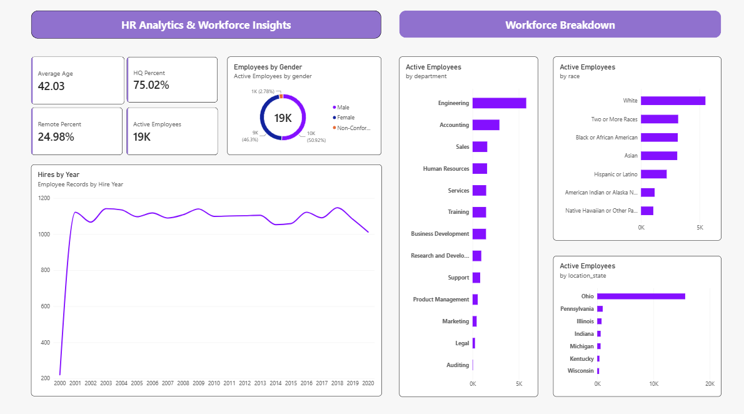
Figure 1 HR Analytics and Workforce Insights dashboard

What the dashboard shows
- The gender chart assigns 50.92% to Female, 46.3% to Male, and 2.78% to a third category whose legend is truncated as “Non-Confor…” in the screenshot.
- Engineering leads the department chart, with Accounting next. The remaining displayed departments have substantially shorter bars; exact counts are not printed.
- White is the largest displayed race category. Two or More Races, Black or African American, and Asian appear similar in size from their bar lengths. These are visual comparisons, not exact counts.
- Ohio dominates the state chart. The other displayed states are much smaller, but the dashboard does not explain whether location_state represents home location, assigned office, or another classification.

Detailed findings

Workforce composition
The gender chart is close to an even split between Female and Male, with a third category at 2.78%. The third category's full label is not visible, so it should be confirmed in the data model before the report is circulated. The race chart shows White as the largest group; the next three bars appear close to one another. The screenshot does not show exact counts for these bars.

Department structure
Engineering has the longest department bar, followed by Accounting. The visible distribution then tapers across Sales, Human Resources, Services, Training, and smaller functions. This shows where the displayed workforce is concentrated, but it does not establish whether staffing levels match business demand.

State concentration
Ohio's bar is several times longer than the other displayed state bars. Pennsylvania, Illinois, Indiana, Michigan, Kentucky, and Wisconsin appear below roughly 1,000 each on the chart scale, while Ohio is around 15,000. Verify the state field and the report filters before using this gap for workforce planning.

Hiring records by year
The line chart is labeled Employee Records by Hire Year. It shows about 220 records in 2000, then roughly 1,050 to 1,140 annually from 2001 through 2019, followed by about 1,010 in 2020. These are approximate readings from the plotted line. The difference between hiring records and active headcount should be kept clear, and the 2000 and 2020 periods should be checked for partial-year coverage.

What these results do and do not establish
The report is descriptive. It shows the distribution of the displayed employee records, but it cannot explain why a function, state, or demographic category is larger. It also does not show retention, turnover, tenure, pay, performance, or changes in headcount over time. Those measures are needed to answer questions about workforce movement or outcomes.

Recommended next steps
Complete these checks before using the dashboard to support staffing or workforce policy decisions.
Priority | Action | Check to complete
1 | Confirm the employee base | Record the exact active employee count, the as-of date, and the rule used to define active status. Confirm that all charts use the intended filters.
2 | Validate location and HQ fields | Confirm what location_state and HQ mean, review blanks or unmapped values, and check whether the Ohio concentration reflects employee location or office assignment.
3 | Check the hiring timeline | Verify whether 2000 and 2020 contain full-year records. Compare hires by month and distinguish hires from year-end active headcount.
4 | Add workforce movement measures | Add exits, turnover, tenure, and headcount change by year or quarter so the report can explain movement as well as current distribution.
5 | Confirm demographic labels and denominators | Use full category names and show the population denominator. Keep analysis aggregated and apply appropriate privacy rules before sharing small groups.
Table 2 Checks to strengthen the analysis

Data notes and limitations
This report uses the values and labels visible in the supplied dashboard image. The active employee KPI is rounded to 19K, and most bar counts are estimates read from the chart scales. The dashboard does not show an as-of date, exact counts, filter state, field definitions, or whether the first and last hiring years are complete. The race legend also truncates “American Indian or Alaska N…” and the gender legend truncates “Non-Confor…”. Confirm the exact labels and definitions in the underlying data before publication.
The hiring chart measures employee records by hire year, while the other distribution visuals are labeled Active Employees. Treat these as different populations unless the model confirms they use the same base.

