

Faculty of Computing Engineering Media

MSc Data Analytics
2023-2024

Comparative Analysis of Advanced Machine Learning
Models for Predicting Fetal Health Outcomes Using
Cardiotocographic Data

By
Sam Moses Ignatius Sathish Kumar(P2824256)

Abstract

This study looks at the use of advanced machine learning models to classify fetal health using cardiotocographic (CTG) data. The study was carried out in three steps. First, models including Logistic Regression, K-Nearest Neighbors (KNN), Decision
Trees, Random Forest, Extreme Gradient Boosting (XGBoost), and Support Vector Machines (SVM) were trained on raw, unprocessed data to generate baseline performance measures. The second step involves resolving class imbalance with the Synthetic Minority Over-Sampling Technique (SMOTE) and standardizing data with the Min-Max Scaler, which improved the models' recall and F1 scores, particularly for minority classes. The third step improved model accuracy and efficiency by using feature selection approaches such as Pearson Correlation, Forward Selection, Backward Elimination, and Recursive Feature Elimination (RFE).Random Forest consistently outperformed the other models, with an accuracy of 96.22% after hyperparameter adjustment, followed by XGBoost. The study shows that a comprehensive approach to data preprocessing, feature selection, and model optimization improves the effectiveness of machine learning models in fetal health monitoring, resulting in better clinical decision-making and outcomes for maternal and fetal health.

Acknowledgments

I would like to express my deepest gratitude to everyone who supported me throughout the completion of the dissertation.
First and foremost, I want to express my heartfelt gratitude to my supervisor, Amudhavel Jayavel, for their invaluable guidance, insightful feedback, and unwavering support. Their expertise and encouragement helped shape this research.
Thank you to De Montfort University for offering valuable tools and a supportive atmosphere for research and growth. Your assistance has been critical in accomplishing my aims.
Finaly, I am forever indebted to my family, particularly my dad Ignatius Sathish Kumar, mom Agnes Mary and my sister Sherly, for their unwavering love, encouragement, and patience. Their belief in me has been a constant source of strength throughout this journey.

Table of Contents

Abstract 2
Acknowledgments 3
Chapter 1: Introduction 5
1.1 Background 6
1.2 Problem Statement 7
1.3 Aim and Objectives 7
1.4 Research Questions 8
1.5 Dissertation Structure 9
Chapter 2: Literature Review 9
2.1 Overview of Fetal Health Monitoring 9
2.2 Cardiotocography (CTG) and Its Evolution 10
2.3 Traditional vs. Machine Learning Approaches in CTG Analysis 10
2.4 Machine Learning in Medical Data Analysis 11
2.5 Addressing Challenges in CTG Analysis 11
Chapter 3 Methodology 12
3.1 Research Design 12
3.2 Data Collection 13
3.3 Exploratory Data Analysis (EDA) 15
3.4 Data Preprocessing 20
3.5 Feature Selection 22
3.6 Model Development 24
3.6 Model Evaluation 26
3.7 Hyperparameter Tuning: 28
Chapter 4: Results 28
Raw Data Results 29
Logistic Regression 29
K-Nearest Neighbors (KNN) 30
Decision Tree 31
Random Forest 32
XGBoost 33
Support Vector Machines (SVM) 33
4.2 SMOTE Model results 34
4.3 SMOTE + Feature Selection Models Results 40
4.4 Comparison of Model Performance: Raw Data, SMOTE, and SMOTE + Forward Selection 52
4.5 Model Optimization Results 53
Chapter 5: Discussion 56
5.1 Comparison with Existing Studies 57
5.2 Recommendations for Future Research 58
Chapter 6: Conclusion 58
References 60

Chapter 1: Introduction

1.1 Background
Monitoring the fetus's development throughout pregnancy is still one of the most difficult and complicated process in medicine. The shocking statistics regarding newborn mortality highlight the importance of this study. In 2012, around 213 million pregnancies were recorded globally; 89% of these pregnancies occurred in underdevelopment countries, whereas just 11% occurred in developed countries. The next year, 293,336 women died as a result of pregnancy-related complications such as infections, hypertension, obstructed birth, maternal hemorrhage, and abortion problems. By 2015, the World Health Organization (WHO) reported 303,000 maternal deaths associated with pregnancy and delivery. As a result, around 830 women die every day due to these concerns. Frequent fetal development monitoring is essential to mitigate these risks and improving outcomes of both mothers and babies. [1] [2]
To address these challenges, Cardiotocography (CTG) was developed as the cornerstone of prenatal care. CTG is a popular non-invasive, affordable method for monitoring fetal health throughout pregnancy and childbirth. It continuously monitors the fetal heart rate and uterine contractions to identify potential issues that affect both mother and child. CTG devices utilize ultrasound technology to provide valuable information on fetal growth, uterine contractions, and fetal heart rate (FHR) patterns. This enables healthcare professionals to promptly identify problems and take immediate action to prevent the risk of maternal and infant death and morbidity.[3] [7].
However, effectiveness of manual CTG interpretation has been limited by its high variability. Studies have shown that interpretations can differ significantly between clinicians, and even within the same clinician over different times. This variability undermines the reliability of manual CTG evaluations highlighting the need for objective and consistent analytical methods. Advances in machine learning (ML) have significantly enhanced CTG analysis, allowing for more precise predictions of fetal health outcomes. Traditional machine learning methods paved the way for advanced techniques such as ensemble learning and neural networks, which have further improved fetal health outcomes. [6][8]
Since the early 2000s, the use of machine learning (ML) has revolutionized fetal cardiology. Since 2004, the field has evolved to include quantitative assessments of heart health and the diagnosis of cardiac abnormalities. This integration has improved prenatal care and outcomes, enhanced the effectiveness of fetal health monitoring, which is increasingly crucial in the early diagnosis of illnesses such as hereditary heart disease and intrauterine growth restriction [4]. Despite significant development in this field, including the development of various machine learning models, challenges such as class imbalance in datasets and the need for enhanced feature selection approaches remain [7].
In this context, the aim of this research is to enhance the accuracy of CTG analyses by applying advanced techniques in balancing, feature selection and machine learning to solve the ongoing challenges with fetal health monitoring. This study plays an important role because it aims to develop and improve ML models that not only increase fetal health prediction ability, but also address significant challenges that limit successful clinical implementation of these technologies. By focusing on these qualities, our study adds to continuing efforts to minimize maternal and fetal mortality, particularly in resource-limited settings where accurate and timely health assessment are essential.

1.2 Problem Statement
The deployment of machine learning in cardiotocography (CTG) monitoring is critical for improving the accuracy and reliability of fetal health assessments. Current research aims to improve these qualities. However, feature extraction and classification continue to provide major issues. Ongoing problems with model accuracy and consistency, such as class imbalance in datasets and difficulties with feature extraction, provide a barrier to further use of machine learning (ML) in clinical settings. Furthermore, depending only on medical professionals for CTG interpretation can be inconsistent and could result in misdiagnoses, especially in settings with limited resources. While ensemble learning models have potential, problems with feature selection, hyperparameter tuning, and inconsistent assessment criteria limit their efficacy. [8] [10] In order to improve prenatal care and reduce mother and fetal mortality, our research attempts to address these issues by making machine learning models more predictable and interpretable.

1.3 Aim and Objectives

This study uses Cardiotocography (CTG) data to evaluate fetal health more accurately and reliably. The first objective of the project is to develop many machine learning models, including Logistic Regression, K-Nearest Neighbors (KNN), Decision Trees, Random Forests (RF), Extreme Gradient Boosting (XGBoost) and Support Vector Machines (SVM) to train them on raw, unprocessed data to find which machine learning algorithms provide the highest accuracy and reliability for classifying fetal health statuses, particularly in the presence of imbalanced datasets.
The second objective focuses on data preprocessing. The Synthetic Minority Over-Sampling Technique (SMOTE) is used to create synthetic samples for underrepresented groups in order to address class imbalance. Min-Max Scaler technique is used to normalize the dataset, ensuring that all variables have equal feature scaling. Post which we will retrain the models again using SMOTE-balanced and scaled data, to find how data preprocessing performs.
The third objective is to improve model performance by implementing advanced feature selection techniques. To find the most important features, this study uses a combination of filter methods, such as Pearson correlation, and wrapper methods, such as Forward Selection, Backward Elimination, and Recursive Feature Elimination. The objective is to identify the most effective technique. The models are then retrained using the balanced, scaled data along with the best features selected based on the most effective technique to improve accuracy and reliability.

To fulfill the fourth objective, the study picks the top three best models from all available options and fine-tunes them using Randomized Search CV and other hyperparameter tuning techniques. This approach helps to enhance the accuracy, robustness, and reliability of these models, promising that they're ready for clinical usage. To test and validate the finalized models using confusion matrices and key performance matrices such as accuracy, precision, recall, and F1 score to evaluate model performance and identify misclassification spots. The models are then validated using different test datasets to ensure their durability and applicability in various clinical scenarios. By improving fetal health monitoring, these comprehensive initiatives aim to improve clinical decision-making and outcomes for both mothers and fetuses.

1.4 Research Questions
The study aims to address the following key research questions:
1. A comparative analysis of machine learning models for predicting fetal health outcomes:
Research Question: Which machine learning algorithms provide the highest accuracy and reliability for classifying fetal health statuses using CTG data, particularly in the presence of imbalanced data?

2. Addressing Class Imbalance in Predictive Modelling of Fetal Health Outcomes
Research Question: How effective is the Synthetic Minority Over-sampling Technique (SMOTE) in addressing class imbalance in Cardiotocographic (CTG) data and how does this technique affect the accuracy and reliability of machine learning models for predicting fetal health outcomes?
3. Feature Selection's Impact on Model Performance in Fetal Health Prediction:
Research Question: How can advanced feature selection methods be used to find the most important CTG features, improving the predictive accuracy and reliability of machine learning models for fetal health classification?

1.5 Dissertation Structure
The dissertation has been divided into six chapters that cover the research objectives systematically. Chapter 1, Introduction, gives background information, describes the issue statement, and includes the research objectives and questions that will lead the investigation. Chapter 2, Literature Review, critically evaluates current literature on fetal health monitoring, CTG analysis, and the application of machine learning algorithms in medical data analysis, noting research gaps that this study attempts to address. Chapter 3 describes the study's methodology, which includes data collection, preprocessing, feature selection, development of models, and evaluation procedures. Chapter 4 shows the results of data preprocessing, feature selection, machine learning model building, optimization, and evaluation. Chapter 5, Discussion, evaluates these findings in context with previous research and discusses their significance for clinical practice and future study. Finally, Chapter 6 concludes by summarizing the important findings.

Chapter 2: Literature Review

2.1 Overview of Fetal Health Monitoring
Fetal health refers to an unborn child's entire development and well-being throughout pregnancy. The fetus's health, or its growth and well-being throughout pregnancy, is critical to a good pregnancy result and serves as the basis for the child's future physical and mental development. A variety of factors, including fetal growth, organ development, and anomalies in development or infections, are used to assess the health of the growing fetus [7]. Both pregnant parents and healthcare practitioners have to understand the complexities of fetal development. For parents, this knowledge helps them to understand the major changes that occur within the womb, this makes them take careful decision about lifestyle, diet, and pregnancy care. Understanding fetal development is critical for healthcare providers because it allows them to effectively monitor progress, spot abnormalities early, and take appropriate action [14].
The environment in which a fetus develops has significant influence on long-term health outcomes, raising the risk of chronic illness later in life. Mother’s stress, poor nutrition, and exposure to environmental toxins during pregnancy can all have long-term consequences for the fetuses. These early exposures have an impact on a variety of important organs and systems, including the brain, heart, and immune system, and can lead to long-term health issues in adults. Studies have linked maternal obesity and gestational diabetes to an increased risk of obesity, type 2 diabetes, and cardiovascular disease in infants. Similarly, children exposed to air pollution during pregnancy are more likely to develop respiratory disorders such as asthma [15].
In order to address these concerns, effective fetal monitoring methods are absolutely necessary. These techniques can be used by healthcare professionals to monitor the fetus's health throughout pregnancy, identify problems early, and provide appropriate care to reduce neonatal mortality from preterm delivery, intrapartum complications, and infections [13].

2.2 Cardiotocography (CTG) and Its Evolution
Cardiotocography has been used since the 1960s to assess uterine contraction pressure (UCP) and fetal heart rate (FHR) [5]. Traditional CTG treatments involve placing an ultrasound device on the mother's belly to collect FHR data, which is subsequently analyzed to identify any serious fetal abnormalities. Clinicians frequently use CTG to monitor the fetus's health during the prenatal and postpartum stages of pregnancy. [2]
Traditional CTG analysis is often manual and subjective, resulting in inconsistent interpretation and delays in critical decision-making [4]. Because of its subjective nature and the problems associated with interpreting CTG data, fetal monitoring has become more objective and consistent. Developments in computer-aided detection (CAD) have introduced automated analytical approaches with the goal of reducing reliance on human interpretation and enhancing diagnostic accuracy [2].

2.3 Traditional vs. Machine Learning Approaches in CTG Analysis
The subjectivity and complexity of clinical outcomes have long been concerns when it comes to manual interpretation of CTG data. These characteristics make it difficult to evaluate CTG data using traditional methods, which leads to inaccurate assessments of fetal health [4]. Machine learning (ML) approaches, on the other hand offer a practical answer by reducing the possibility of human mistake and automating the categorization of fetal health statuses. Large data sets may be analyzed by ML systems, which can also identify subtle patterns of prenatal issues that people would overlook [7].
Several studies show that ML models increase the quality and consistency of CTG data processing. To improve the accuracy of fetal health prediction, a variety of strategies have been used, including Random Forest (RF), Extreme Gradient Boosting (XGBoost), and support vector machines. Advanced strategies, such as the Synthetic Minority Oversampling Technique (SMOTE), are used to successfully manage imbalanced datasets, which provide a significant difficulty in CTG data processing. Identifying significant characteristics for model training enhances classification using feature selection strategies
[6][9].

2.4 Machine Learning in Medical Data Analysis
Machine learning approaches are more effective than traditional statistical methods in dealing with complicated, high-dimensional data, and they have dramatically changed medical data analysis. By automating the classification of fetal health states based on CTG data, machine learning algorithms have been used to improve the accuracy and efficiency of diagnosis. These algorithms can examine vast amounts of data and discover tiny trends which indicate fetal distress, delivering accurate predictions that allow clinicians to take action quickly [9].
The Random Forest classifier is one of the most promising machine learning algorithms in this field, having effectively classified fetal status as normal, suspect, or abnormal [5]. Random Forest classifiers can achieve high classification accuracy with fewer features by focusing on a selected set of important features. It allows them to optimize processing resources while maintaining diagnostic accuracy [12]. However, further research is needed to develop stronger prediction models that perform better in a variety of clinical contexts and reliably identify minority groups (such as suspicious and sick states) [10].

2.5 Addressing Challenges in CTG Analysis
CTG analysis involves several challenging issues, including feature selection, data imbalance, and model optimization. Imbalanced data could result in predictive modeling more difficult by underrepresenting some groups, including pathological scenarios. This imbalance may result in models that perform well on the majority class but badly on the minority class, resulting in suboptimal clinical results [9]. To address this, the minority class was artificially balanced by oversampling it with methods such as SMOTE [6].
To increase model performance and minimize computational complexity, feature selection techniques are employed to determine the most important variables for training [7]. Even though machine learning has made significant advances in CTG data processing, previous study has been limited by the deployment of filter-based feature selection approaches. Because these approaches do not account for feature interactions, they may miss out on feature combinations that might considerably increase model performance. This study attempts to overcome this gap by using wrapper-based feature selection techniques, which provide an alternative framework for evaluating feature subsets in respect to model performance. This method is expected to produce more reliable and precise prediction models, leading in better clinical results for prenatal health monitoring. [6] [9] which are more precise since they assess feature subsets based on model performance. This will assist to overcome the constraint. According to [6], this method has the potential to improve the accuracy and generalizability of fetal health categorization models. Model optimization techniques like cross-validation and hyperparameter tuning enhance the resilience and reliability of ML models employed in CTG analysis [6].

Chapter 3 Methodology

3.1 Research Design
Python was used for all analyses, including feature selection, model training, data preparation, and evaluation. Because of its ease of use and availability of strong processing resources, such GPUs—which are especially useful for training models like XGBoost and SVM—the Google Collab platform was selected. Building machine learning models and displaying results required the integration of several Python libraries, such as Scikit-learn, Pandas, Matplotlib, and others, which Google Collab supported. It also offered an interactive coding environment that made collaboration easy.
The dataset was initially assessed by exploratory data analysis, followed by preprocessing to address class imbalance with the Synthetic Minority Over-Sampling Technique (SMOTE) and feature scaling with the Min-Max Scaler. This preprocessing was essential for models such as Support Vector Machines (SVM) and K-Nearest Neighbors (KNN). To maximize model performance, feature selection was done using both statistical filter approaches (such as Pearson correlation) and wrapper methods (forward selection, backward elimination, and recursive feature elimination).
The study's model creation and comparison were carried out in three stages. To build baseline measurements, different machine learning models, such as Logistic Regression, Random Forest, KNN, Decision Trees, SVM, and XGBoost, were first trained on raw data. In the second step, models were retrained with SMOTE-balanced and normalized data, which resulted in better performance. The most efficient feature selection technique was used to refine the models in the third step, which produced even more improvements.
Finally, the best-performing models were chosen and fine-tuned via hyperparameter optimization (e.g., Randomized Search CV), assuring robustness and dependability. Accuracy, precision, recall, and F1 score were used to assess model performance, with confusion matrices demonstrating categorization results. To make sure the models were appropriate for clinical use and could be used generally, they were tested on a test dataset.

3.2 Data Collection
The Cardiotocography (CTG) dataset, available on Kaggle, is a commonly used source of data for research purposes. Given that it includes important values taken from a cardiotocogram recorded during pregnancy, this dataset is suitable for the study's objectives. The dataset was initially created by the Biomedical Engineering Institute and the Faculty of Medicine at the University of Porto in Portugal. Many studies on machine learning applications and fetal health monitoring have employed it, proving its use and durability. There are 2,126 records in this collection, and each one represents a distinct observation on prenatal health monitoring. [2] [11]
The dataset consists of by 21 variables, each of them includes important elements of fetal health as evaluated by cardiotocography (CTG). These features include:
- Fetal Heart Rate Baseline (FHR): The average heart rate of the fetus, measured in beats per minute (bpm), which is an important sign of fetal health.
- Uterine Contractions: The frequency and strength of uterine contractions, which are critical for determining the health of the fetus during childbirth.
- Accelerations and decelerations: Periods of increased or reduced fetal heart rate, which might indicate fetal discomfort or well-being.
- Histogram Features: A variety of statistical measures obtained from FHR data, such as mean, mode, and variance, that provide a complete picture of the fetal state.
- Short-term and long-term variability (S-TV and L-TV): Measures of fetal heart rate variability, reflecting autonomic nervous system function and general fetal health.

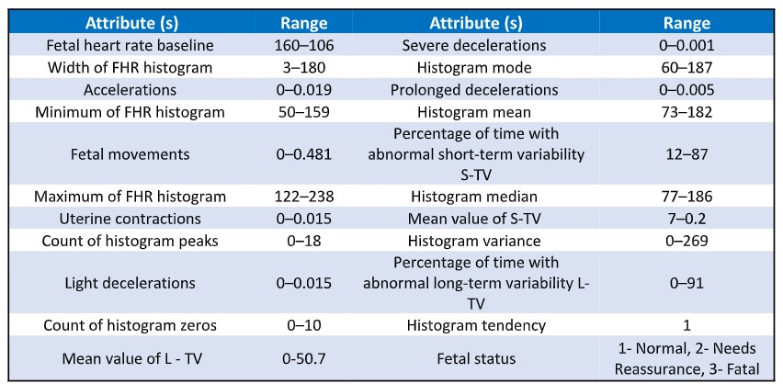
Figure 1. Features of Carditocography Data [1]

The fetal health target variable, which divides the data into three different classes, is predicted using these characteristics.

- 1: Normal.

- 2. Suspect.

- 3. Pathological

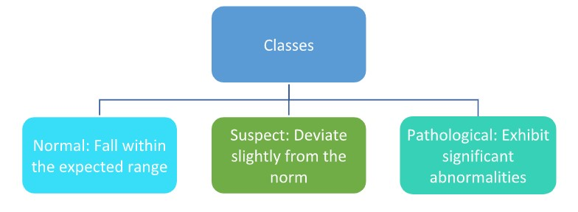1 Figure 2. Target Variable classes [2]

This classification is critical for assessing the fetus's well-being and detecting potential difficulties. The CTG recordings were processed using the SisPorto 2.0 program, which is an automated method that strictly follows to FIGO criteria, assuring data gathering reliability and correctness. The presented CTG data is a Supervised learning problem, especially a Multiclass Classification Task.

3.3 Exploratory Data Analysis (EDA)
EDA is an important initial step to understanding the dataset. It involves a thorough review of the data to identify patterns, anomalies, test hypotheses, and validate assumptions. The objective is to identify underlying structures in the data, which will guide the next stages of data preparation and model development.

Data Distribution
Histograms were created for each numeric characteristic to help understand the distribution of the dataset's numeric features. Histograms are graphic representations of the frequency distribution of data points across different ranges for every feature.

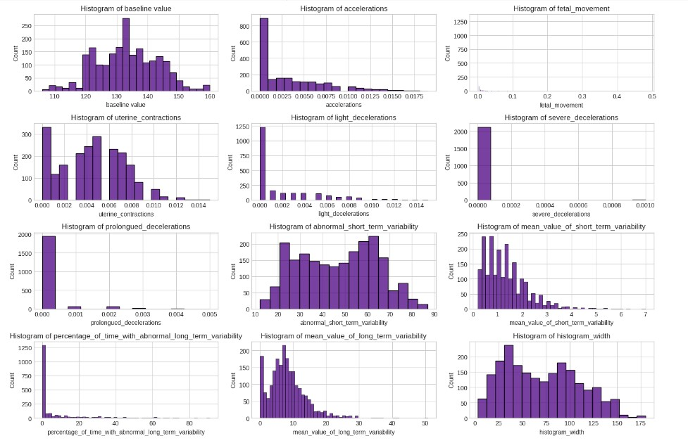
Figure 3. Data Distribution Plots

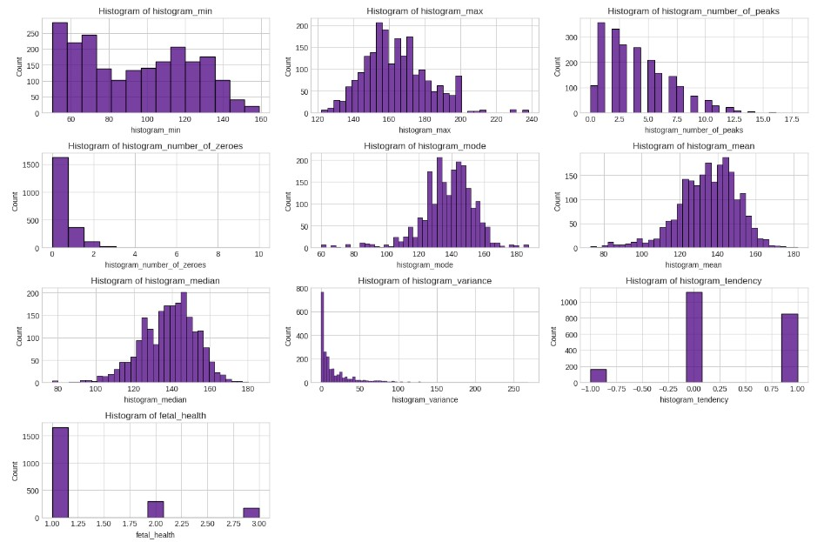
Figure 3. Data Distribution Plots continue
Before developing a model, it is necessary to address many patterns of significance that the exploratory data analysis of the dataset shows. A number of features, such as accelerations, decelerations, and other histogram-derived features, exhibit skewed distributions, which might have an impact on how broadly the model can be applied. Furthermore, possible connections or dependencies that may be used in feature engineering or feature selection are suggested by the distribution patterns across different histogram features and variability measures. The target variable's class imbalance, where the majority of records fall into the "normal" group, is one of the most important findings. The Synthetic Minority Over-Sampling Technique (SMOTE) will be used to reduce the possibility that the model may be skewed toward producing predictions for the majority class.
Moreover, sparsity in some features (e.g., the histogram number of zeroes) and the presence of outliers, as shown by the long tails in a number of histograms (e.g., light decelerations, severe decelerations), highlight the necessity for careful preprocessing in order to ensure that these features do not negatively impact model performance.
Class Distribution Analysis:
In this dataset, the target variable "fetal health" is used to categorize fetal health into three groups: Normal, Suspect, and Pathological. This variable is important because it provides an accurate representation of the fetal condition, which is used to guide healthcare decisions and predict potential issues.
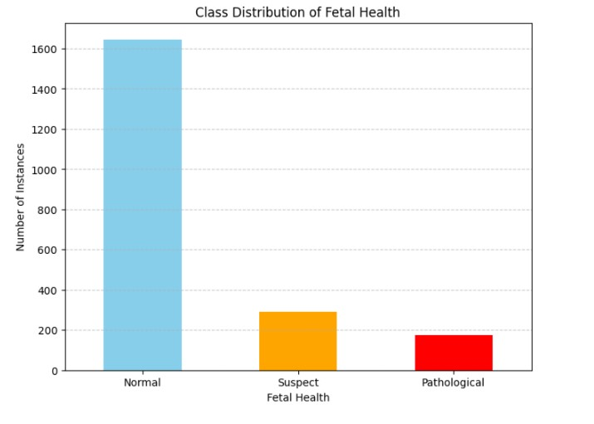
Figure 4. Class Distribution Plots
The bar plot shows how extremely unbalanced the target variable's class distribution is. The majority of cases about 1,600 are classified as Normal, but somewhat fewer cases around 300 are classified as Suspect and roughly 200 as Pathological.This significant class imbalance might result in biased machine learning algorithms. Models trained on this dataset may get skewed toward predicting the Normal class simply because it dominates the data. This might lead to poor performance for identifying Suspect and Pathological instances; to successfully address the class imbalance, SMOTE (Synthetic Minority Oversampling Technique) will be used during preprocessing.

Correlation Analysis
Correlation assesses the link between two variables and ranges from -1 (perfect negative correlation) to +1 (perfect positive correlation), with 0 signifying no linear relationship. Correlation is important in data analysis since it helps to understand variable connections and aids in feature selection. In machine learning, knowing correlations is essential to prevent multicollinearity, which can provide biased results by over emphasize some variables. This is especially true for models like logistic regression. Correlation analysis identifies duplicate features that may complicate the model without enhancing the accuracy of the predictions.
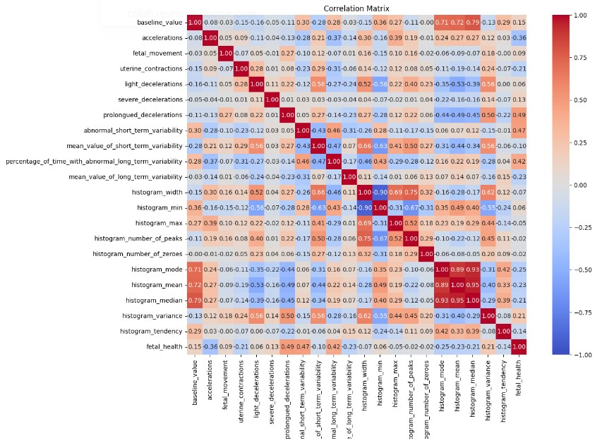
Figure 5. Correlation Plot

The correlation matrix generated for our dataset reveals several strong correlations:
Positive Correlations: There is a strong correlation between features such as histogram_mean, histogram_median, and histogram_mode. Including all of these features might result in overfitting, a situation where the model performs badly on new data because it is too closely tuned to the training set. This is because these variables effectively convey the same information.

Negative Correlations: Histogram_min has a significant negative correlation with histogram_mean and mode. This indicates an inverse relationship, which may also need attention in order to avoid these opposing signals misleading the model.
These relationships allow us to make informed decisions concerning the addition, deletion, or retention of characteristics. This simplifies the model and improves its interpretability and computational efficiency. It also makes the model more generalizable to new and untested data. Reducing multicollinearity in the context of fetal health prediction guarantees that the model relies on the most useful elements, ultimately producing predictions that are more accurate and dependable.

3.4 Data Preprocessing
Preprocessing data is a crucial part of the machine learning process. To make the raw data suitable for modeling, it must be prepared. Many preparation procedures are used to make sure the dataset is suitable for machine learning. A first check is carried out for outliers, inconsistencies, and missing values in the dataset. Fortunately, the dataset is clean, with no missing values or notable abnormalities, allowing for easy application of preprocessing techniques. The first crucial step is to solve the dataset's class imbalance, which has the majority of records classed as "normal" and few as "suspicious" or "pathological." To address this imbalance, the Synthetic Minority Over-Sampling Technique (SMOTE) is used. SMOTE provides synthetic instances for minority classes, which results in a more balanced class distribution and improves machine learning models' capacity to generalize across all classes.
Data Splitting:
Before addressing class imbalance, the data was divided into 80% training and 20% testing. This eliminates data leaking by guaranteeing that synthetic samples from resampling only impact the training set, allowing the model to be evaluated on previously unseen data. This represents real-world data distribution, giving realistic measurements for model evaluation and assuring that performance increases are the result of successful imbalance control rather than data loss. This strategy improves the validity and consistency of the study's findings.[16]
Handling Imbalanced Data:
The fetal health dataset is highly imbalanced, with the majority of cases classed as Normal (1,600) and just a few classified as Suspect (300) or Pathological (200). To fix this, the Synthetic Minority Over-sampling Technique (SMOTE) is employed to create synthetic samples from underrepresented classes. By interpolating between instances of minority classes and their closest neighbors, SMOTE balances the distribution of classes and produces artificial copies rather than replicating real cases. [7]

SMOTE has various advantages, including expanding the training data, improving the model's capacity to reliably categorize minority classes, and reducing overfitting by introducing variety. In medical diagnostics, this is critical for detecting and treating high-risk situations. SMOTE additionally enables the flexible change of oversampling parameters to fit individual dataset requirements.

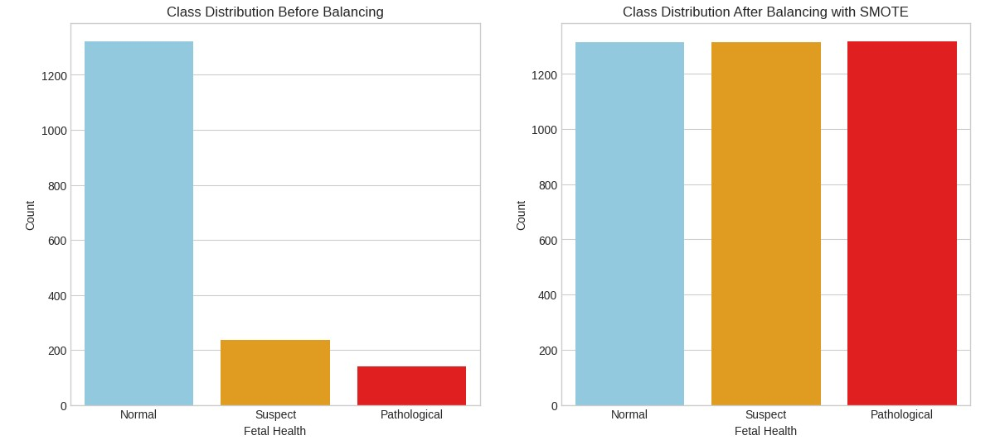
Figure 6. Before and After balancing

Normalization/Scaling:

Scaling is essential for ensuring that all characteristics in a dataset contribute equally to model predictions, especially when they have varied ranges. By converting features to a [0, 1] range using approaches such as Min-Max Scaling, characteristics with greater ranges are prevented from significantly impacting the model. This is especially crucial for distancebased models like K-nearest neighbors (KNN), which require precise distance estimates, as well as gradient-based models like logistic regression, which benefit from more stable and efficient training. In our fetal health dataset, scaling improves model performance by ensuring that each feature is suitably weighted, as well as enhancing accuracy and prediction across models.

3.5 Feature Selection

Feature selection is a critical stage in machine learning, since it identifies the most important features from a dataset to enhance model prediction. By reducing the dataset, feature selection improves model interpretability and lowers the risk of overfitting. In fetal health monitoring with cardiotocographic (CTG) data, which contains a variety of physiological signals, feature selection finds essential characteristics that increase model accuracy. This approach promotes higher interpretability and generalizability, which are critical in clinical settings.
Feature selection methods are broadly categorized into three types:
- Filter methods,
- Wrapper methods, • Embedded methods.
Each category provides a different method of identifying the most important features, suitable for the specific data features and modeling requirements. In this study, we will use Cardiotocographic (CTG) data to enhance the predictive modeling of fetal health outcomes by using and comparing various feature selection strategies from filter and wrapper approaches. The goal is to identify how much that these methods are effective in selecting the most effective features to enhance model performance. The approaches we're going to explore into are
Filter Method:

Filter techniques are used to quickly analyze and choose features based on their statistical significance to the target variable. These approaches perform well on high-dimensional datasets, making them excellent for initial feature selection in our CTG data processing.

Pearson Correlation Coefficient: This approach was used to determine the linear relationship between each feature and the target variable (fetal health outcome). For example, particular heart rate patterns and deceleration rates, particularly had a strong connection with pathological outcomes, were recognized to be important. By choosing features with high absolute correlation values, we guaranteed that the model incorporated the most significant physiological signals.[6]

Wrapper Methods:

Wrapper methods were used to improve the feature selection process by analyzing subsets of features during iterative model training. These approaches need more computing power, but they give a better understanding of relationship between features and their overall impact on model performance.
Common wrapping techniques are:
Forward Selection: Forward selection is a feature selection strategy in machine learning that involves iteratively adding features to a model to enhance its performance. The approach begins with an empty model and gradually adds features one by one, choosing the feature that provides a significant improvement in models performance at each stage. This process is repeated until adding new features does not significantly improve the model's performance, or until all features have been examined. Forward selection is very beneficial for selecting the most important features in a dataset, hence reducing model complexity, preventing overfitting, and improving interpretability.
Backward Elimination: The backward elimination feature selection approach begins with a complete model that contains all available features and then progressively removes the least relevant features one at a time. At each phase, the feature with the least harming effect on model performance is removed. This method is repeated until deleting further features will harm the model's performance or until only a certain number of features remain. Backward elimination helps to simplify models by deleting unnecessary or redundant features, lowering the risk of overfitting and enhancing model interpretability.
Recursive Feature Elimination (RFE): Recursive Feature Elimination (RFE) is an advanced feature selection technique for machine learning that systematically removes features in order to discover the most significant ones for model training. The process begins with all of the features in the dataset, and a model is trained on the whole set of features. RFE then ranks the features according to their relevance, usually using the model's coefficients or feature importance. The least significant feature is eliminated, and the model is re-trained with the remaining features. This elimination procedure continues recursively until the required number of features is achieved. RFE is very useful in improving model accuracy and interpretability because it retains just the most important characteristics while discarding those that add little to the prediction job.
Previous research, such as [6], have used filter-based approaches that choose features based upon their statistical qualities. While successful, these strategies fail to account for feature interactions and their combined impact on model performance. To overcome this constraint, this work employs filter and wrapper-based feature selection strategies, which evaluate feature subsets by directly analyzing model performance. This technique, is suggested for future study in [6], is likely to improve model accuracy and resilience by using only the most important features for fetal health classification.

Comparative Analysis
These feature selection strategies will be evaluated based on their ability to increase the accuracy, interpretability, and computing efficiency of predictive models. By implementing different techniques, we need to find which method is most effective at identifying the most important variables that generate highest accuracy level in fetal health predictions. This comparative research will shed light on the strengths and limits of each approach in the context of CTG data, ultimately directing the creation of more robust and trustworthy models for clinical use.

3.6 Model Development
For this investigation, a variety of machine learning models were used to deal with the multiclass classification problem of predicting prenatal health outcomes. The models used include Logistic Regression (LR), K-Nearest Neighbors (KNN), Decision Trees (DT), Random Forest (RF), XGBoost, and Support Vector Machine (SVM). These models were chosen for their unique methods to classification, which provide a thorough comparison between various methods.

Logistic Regression
Logistic regression is a popular statistical approach for binary classification, which predicts one of two outcomes. The sigmoid function is used to represent the connection between input data and result probabilities, converting linear combination of characteristics into probabilities ranging from 0 to 1. The model classifies inputs using a threshold, usually 0.5. Logistic Regression is preferred because of its simplicity and interpretability, since its coefficients show the influence of each factor on the result. Training involves minimizing log loss (binary cross-entropy) using approaches such as gradient descent. Although essentially a binary classifier, Logistic Regression can handle multiclass issues using approaches such as One-vs-Rest or Softmax Regression. Its adaptability makes it appropriate for applications such as medical diagnostics, spam detection, and customer churn prediction.

K-Nearest Neighbors (KNN)
K-Nearest Neighbors (KNN) is a simple classification technique that classifies a new data point using the majority class of its 'k' nearest neighbors in the feature space. It is nonparametric, which means it does not rely on any underlying data distribution, making it suitable for a variety of classification problems. KNN is simple to develop and understand since it is based on the similarity of data points, which is usually measured using Euclidean distance. However, it can be computationally costly for huge datasets because distances to all other points must be calculated. KNN's performance can be affected by the 'k' parameter and the size of the input, necessitating proper data preparation such as normalization to ensure accurate results. Despite these problems, KNN remains a common alternative for classification.

Decision Trees (DT)
Decision Trees (DT) are a common machine learning model that uses a tree-like structure to produce decisions based on input data. Internal nodes represent decisions on particular characteristics, whereas leaf nodes represent output labels. To maximize homogeneity, the dataset is recursively partitioned into subgroups before constructing the tree. Decision trees are popular because they are simple and easy to read, making them suitable for classification and regression applications. However, decision trees can overfit, particularly with large datasets, becoming too customized to the training data and losing generalizability. This problem can be solved by pruning away less important branches or by reducing the tree's depth. Despite their propensity to overfit, decision trees are useful when model interpretability and flexibility in managing feature-target interactions are critical.

Random Forest (RF)
Random Forest (RF) is an ensemble learning technique that generates many decision trees during training and then mixes their predictions to improve accuracy and reduce overfitting.
Each tree is trained on a random set of attributes and data via bootstrapping, resulting in fewer connected trees and a more robust model. The final predictions are made by averaging the predictions of all trees (for regression) or by a majority vote (for classification). Random forests are well-known for their ability to handle massive, complex datasets while also giving trustworthy feature importance measures. One significant advantage is their resistance to overfitting, as averaging many trees decreases variation while increasing generalization. However, due to their complexity, they are less interpretable than individual decision trees, although they still provide information on feature significance. Random forests are widely used in many kinds of domains, particularly those requiring high precision and stability, and they perform well with minimum hyperparameter adjustment.

XGBoost
XGBoost (Extreme Gradient Boosting) is a sophisticated and scalable machine learning algorithm in the ensemble learning field, namely boosting. Boosting is the process of adding models in a sequential order, with each new model correcting faults from the prior ones. XGBoost improves on this strategy by including regularization to minimize overfitting, parallel processing for speed, and efficient handling of missing information. It creates trees in a sequential manner, concentrating on residuals from previous trees to increase performance iteratively. XGBoost is well-known for its flexibility, since it excels at classification and regression problems, particularly with structured/tabular data. It also includes sophisticated features like early halting and built-in cross-validation. However, its complex nature necessitates careful tweaking and a thorough grasp of its characteristics in order to attain peak performance.

Support Vector Machine (SVM)
Support Vector Machine (SVM) is a sophisticated and adaptable machine learning algorithm that is usually used for classification but may also be applied to regression. SVM determines the best hyperplane that divides classes in the feature space while maximizing the margin between the nearest data points, also known as support vectors. This margin maximization helps SVMs avoid overfitting, especially in high-dimensional domains. SVM can handle both linear and non-linear classification by mapping data into higher dimensions that allow for linear separation. It performs well in high-dimensional settings with difficult decision boundaries, but it is computationally costly with big datasets and necessitates careful parameter tweaking, such as kernel selection and regularization. Despite these obstacles, SVM is commonly utilized for reliable classification in applications such as text categorization, picture recognition,

3.6 Model Evaluation
To evaluate the performance of the machine learning models, several key metrics were used, each of which provided insights into different aspects of model performance in identifying fetal health outcomes. The metric used include accuracy, precision, recall, F1 score, and the confusion matrix. These metrics are especially important in the context of imbalanced data sets.
Confusion Matrix:
A confusion matrix summarizes the prediction outcomes for a classification problem. It gives an extensive description of the actual vs. predicted categories and includes the following components:

where:

TP = True Positives (correctly predicted positive instances).
TN = True Negatives (correctly predicted negative instances).
FP = False Positives (incorrectly predicted positive instances)
FN = False Negatives (incorrectly predicted negative instances).
The confusion matrix helps you to visualize the classification model's performance by showing how effectively it distinguishes between classes. It also forms the foundation for computing other performance indicators like as accuracy, recall, and F1 score.
Accuracy:
Accuracy is defined as the proportion of accurately predicted cases out of all instances. The calculation is as follows:
Accuracy = (TP + TN)/ (TP + TN + FP + FN)
While accuracy is a general measure of model performance, it can be misleading in the case of class imbalance since it may dominate the dominant class.
Precision:
Precision is the proportion of true positive predictions to all positive predictions produced by the model. It's computed as:
Precision= TP/ (TP + FP)
Precision is particularly important when the cost of false positives is high since it shows the model's ability to avoid incorrect positive classifications.
Recall (Sensitivity):
Recall is a count of true positive predictions among all positive cases. It's computed as:
Recall = TP/ (TP + FN)
Recall is crucial for discovering minority classes, such as suspicious and abnormal fetal health conditions, since it shows the model's capacity to properly identify all relevant instances.
F1 Score:
The F1 score is calculated as the harmonious mean of accuracy and recall, providing a balanced metric that takes into consideration both false positives and false negatives. It's computed as:
F1 score =2*(Precision*Recall/ Precision+Recall)
The F1 score is especially valuable when dealing with imbalanced datasets since it gives a more nuanced overview of model performance across classes.

3.7 Hyperparameter Tuning:
Random Search is a hyperparameter tuning strategy that optimizes machine learning models by randomly picking combinations of hyperparameters from a given range, as opposed to exhaustively testing every conceivable combination like Grid Search does. This strategy is more efficient, particularly when working with a large number of hyperparameters, because it allows for a more thorough investigation of the hyperparameter space at a lower computing cost. Random Search improves the chances of discovering a near-optimal collection of hyperparameters by concentrating on a wide range of possible configurations, making it a viable and frequently quicker alternative to more thorough approaches such as Grid Search.

Chapter 4: Results

This chapter provides a comprehensive review of the study's findings, focusing on the effectiveness of several machine learning models in predicting fetal health outcomes using Cardiotocography (CTG) data. The findings are divided into three major areas, that are relate to the various stages of the study process.
First, models are trained on raw, unprocessed data to create baseline measurements and identify potential areas of improvement. The dataset is then balanced using SMOTE to address the class imbalance, followed by Min-Max scaling to ensure consistent feature ranges. Models are retrained using the processed data, and performance is measured using measures such as accuracy, precision, recall, F1 score, and confusion matrices.

Finally, the chapter investigates how different feature selection procedures used on SMOTEbalanced data improve model accuracy and efficiency. The chapter determines the most effective method for predicting fetal health by comparing raw data, balanced data, and balanced data with feature selection.

Raw Data Results
This section evaluates the performance of multiple machine learning models trained on raw, unprocessed CTG data. This analysis includes the following models: Logistic Regression, kNearest Neighbors (KNN), Decision Trees, Support Vector Machines (SVM), Extreme Gradient Boosting (XGBoost), and Random Forest.

Model | Accuracy | Precision | Recall | F1 Score
Logistic Regression | 89.20% | 89.08% | 89.20% | 88.82%
K-Nearest Neighbors (KNN) | 88.26% | 87.57% | 88.26% | 87.48%
Decision Tree | 90.14% | 89.83% | 90.14% | 89.94%
Random Forest | 92.49% | 92.18% | 92.49% | 92.20%
XGBoost | 92.96% | 92.67% | 92.96% | 92.63%
Support Vector Machines (SVM) | 88.73% | 88.03% | 88.73% | 88.12%
Figure 7. Raw Data Results

Logistic Regression
Logistic Regression performed well, with an accuracy of 89.20%, precision of 89.08%, recall of 89.20%, and an F1 score of 88.82%, suggesting its adaptability in classification tasks, despite difficulties in balancing precision and recall.
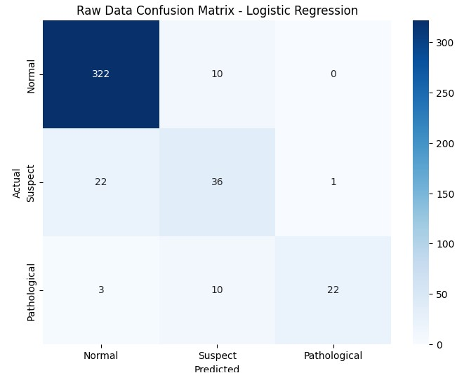
Figure 8. Raw Data Confusion Matrix – Logistic Regression

The confusion matrix for Logistic Regression shows that the model accurately identified 322 Normal occurrences, 36 Suspect instances, and 22 Pathological instances.

K-Nearest Neighbors (KNN)
The K-Nearest Neighbors (KNN) model provided an accuracy of 88.26%, a precision of 87.57%, a recall of 88.26%, and an F1 score of 87.48%, resulting in slightly lower metrics than Logistic Regression, particularly in handling minority classes.
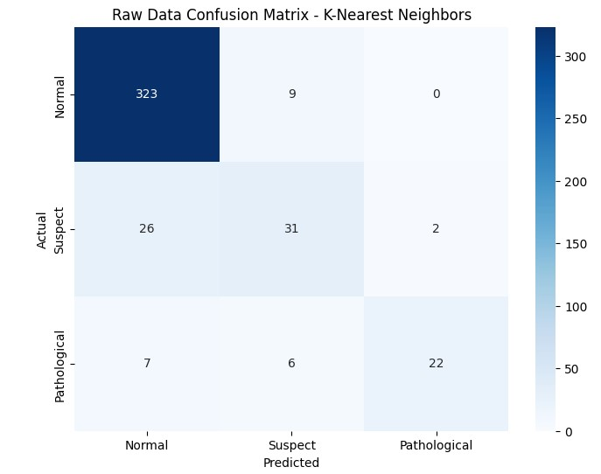
Figure 9. Raw Data Confusion Matrix – K-Nearest Neighbors

The KNN model's confusion matrix shows that it accurately recognized 323 instances of the Normal class, 31 instances of the Suspect class, and 22 cases of the Pathological class. The model encountered some difficulties with the Suspect class.

Decision Tree
Decision Tree performed better, with an accuracy of 90.14%, precision of 89.83%, recall of 90.14%, and F1 score of 89.94%, indicating its ability to better manage the dataset's complexity.
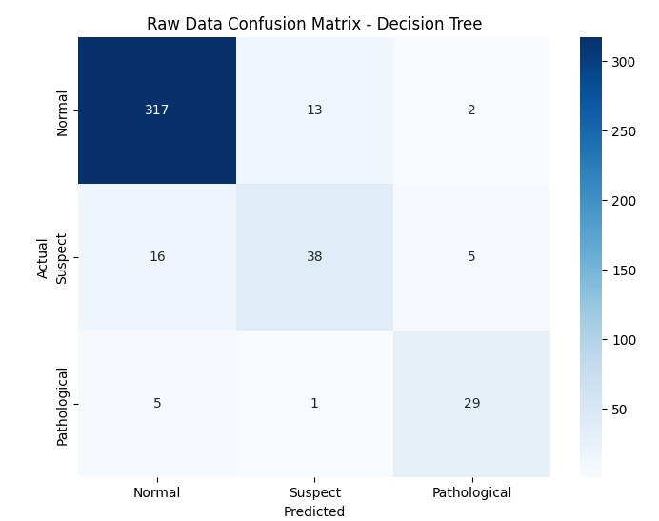
Figure 10 Raw Data Confusion Matrix – Decision Tree
The confusion matrix for the Decision Tree model demonstrates that 317 Normal, 38 Suspect, and 29 Pathological occurrences were properly identified.

Random Forest
Random Forest's performance was further enhanced, with an accuracy of 92.49%, precision of 92.18%, recall of 92.49%, and an F1 score of 92.20%, demonstrating its efficacy in eliminating false positives and properly recognizing meaningful occurrences.
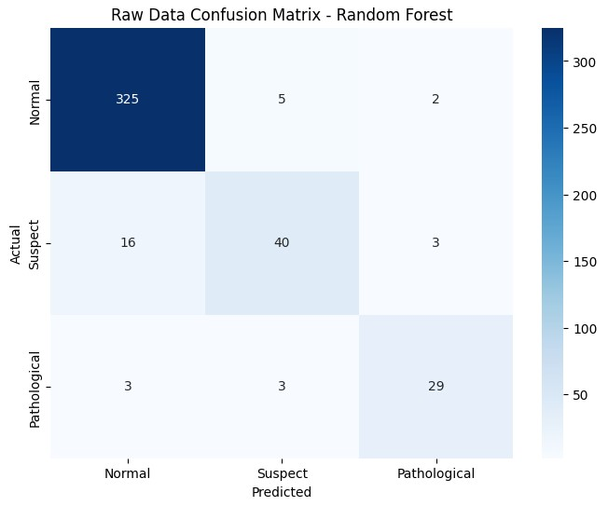
Figure 11. Raw Data Confusion Matrix – Random Forest
The Random Forest confusion matrix performs well, properly classifying 325 Normal examples, 40 Suspect instances, and 29 Pathological occurrences.

XGBoost
XGBoost, the best performer, had the greatest metrics across the board, with an accuracy of 92.96%, precision of 92.67%, recall of 92.96%, and an F1 score of 92.63%, demonstrating its supremacy in dealing with the complexities of the CTG data.
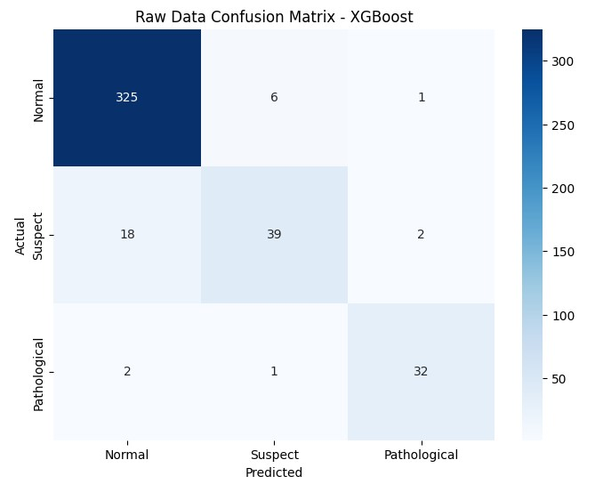
Figure 12. Raw Data Confusion Matrix - XGBoost
The confusion matrix for XGBoost shows that it accurately identified 325 normal cases, 39 suspect instances, and 32 pathological examples.

Support Vector Machines (SVM)
Finally, Support Vector Machines (SVM) performed well, with an accuracy of 88.73%, precision of 88.03%, recall of 88.73%, and an F1 score of 88.12%, comparable to Logistic Regression but with a tiny advantage in precision and recall.
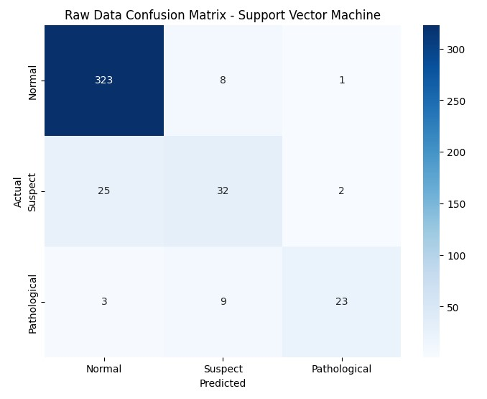
Figure 13. Raw Data Confusion Matrix – Support Vector Machine
The SVM's confusion matrix shows that it accurately detected 323 Normal occurrences, 32 Suspect instances, and 23 Pathological cases.
XGBoost and Random Forest models outperformed other models when dealing with imbalanced data. XGBoost had the highest metrics: 92.96% accuracy, 92.67% precision,
92.96% recall, and an F1 score of 92.63%. The Random Forest model was close behind, with 92.49% accuracy, 92.18% precision, 92.49% recall, and 92.20% F1 score. These studies illustrate their use in dealing with raw unprocessed data with class imbalances.

4.2 SMOTE Model results

After using the Synthetic Minority Over-Sampling Technique (SMOTE) to solve class imbalance, machine learning models shown significant increases in their ability to accurately categorize minority groups. These improvements are reflected in the performance measures, including as accuracy, precision, recall, and F1 score, which are crucial for measuring the effectiveness of models in detecting all relevant instances, especially in imbalanced data sets.

Model | Accuracy |  | Precision |  | Recall | F1 Score
Logistic Regression | 86.15% |  | 90.07% |  | 86.15% | 87.29%
K-Nearest Neighbors (KNN) | 86.85% |  | 88.83% |  | 86.85% | 87.58%
Decision Tree | 88.97% |  | 88.69% |  | 88.97% | 88.73%
Random Forest |  | 92.26% |  | 92.98% | 92.96% | 92.96%
XGBoost |  | 92.49% |  | 92.91% | 92.49% | 92.65%
Support Vector Machines (SVM) |  | 88.73% |  | 91.65% | 88.73% | 89.58%
Figure 14. Confusion Matrix SMOTE –Model results

Logistic Regression
The Logistic Regression model obtained 86.15% accuracy, 90.07% precision, 86.15% recall, and an F1 score of 87.29%. Compared to the raw data findings, there is a significant gain in recall and F1 score, demonstrating that SMOTE assisted the model in better capturing minority classes without losing accuracy.
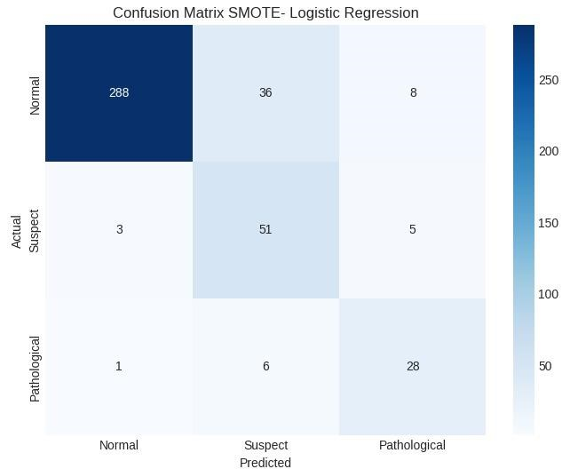
Figure 15. Confusion Matrix SMOTE – Logistic Regression
Logistic Regression (LR) performed well, accurately identifying 288 instances of the Normal class. The model also correctly identified 51 instances of the Suspect class. The Pathological class saw 28 accurate instances.

K-Nearest Neighbors (KNN)
Similarly, the k-Nearest Neighbors (KNN) model has an accuracy of 86.85%, precision of 88.83%, recall of 86.85%, and F1 score of 87.58%. The use of SMOTE improved the model's ability to balance accuracy and recall, resulting in stronger classification performance across all classes.
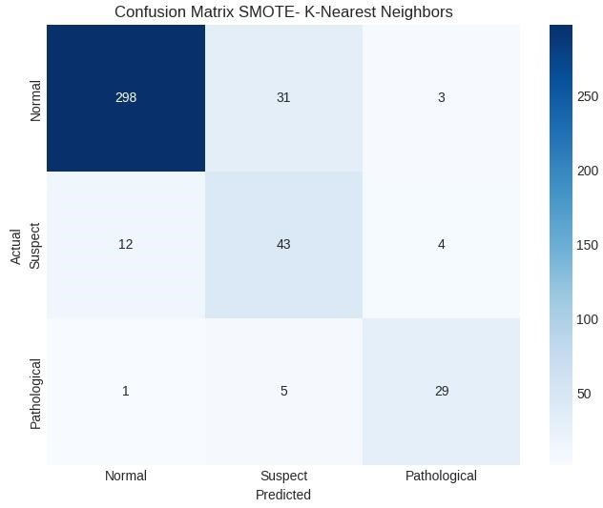
Figure 16. Confusion Matrix SMOTE – K-Nearest Neighbors
K-Nearest Neighbors (KNN) also performed well, properly identifying 298 Normal classes. It accurately recognized 43 Suspect classes. In the Pathological class, 29 occurrences were accurately classified.

Decision Trees (DT)

SMOTE also helped the Decision Trees (DT) model, which achieved 88.97% accuracy, 88.69% precision, 88.97% recall, and an F1 score of 88.73%. The increase in recall indicates that the Decision Tree model developed more effective at identifying instances in minority classes, lowering the risk of bias towards the majority class.
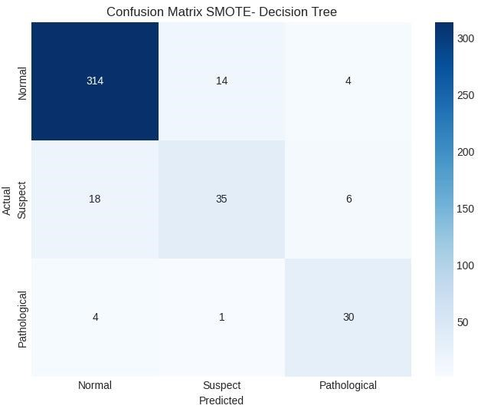
Figure 17. Confusion Matrix SMOTE – Decision Tree

The Decision Tree (DT) model performed effectively, correctly classifying 314 instances in the Normal class. In the Suspect class, 35 instances were accurately classified. The pathological class has 30 effective classifications.

Random Forest (RF)
The Random Forest (RF) model improved significantly, with an accuracy of 92.96%, precision of 92.98%, recall of 92.96%, and F1 score of 92.96%. The Random Forest model's robustness is highlighted by its constant performance across all criteria, which is further enhanced by SMOTE's balanced training dataset.
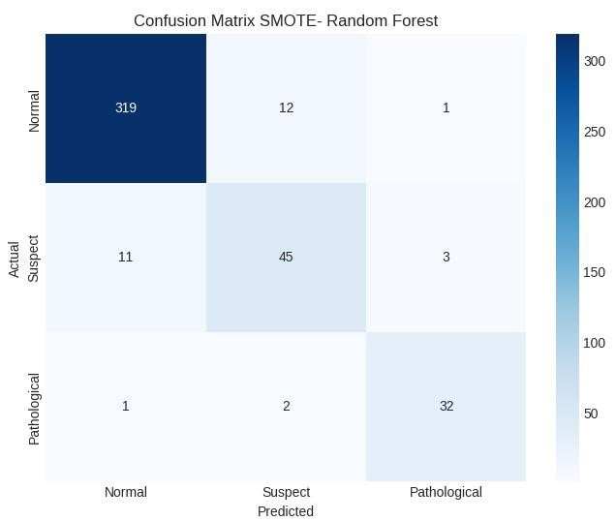
Figure 18. Confusion Matrix SMOTE – Random Forest

Random Forest (RF) achieved the best score, accurately classifying 319 instances of Normal class. It successfully categorized 45 instances of Suspect class. The pathological class has 32 valid instances.

Extreme Gradient Boosting (XGBoost)
Extreme Gradient Boosting (XGBoost) also performed better, with an accuracy of 92.49%, precision of 92.91%, recall of 92.49%, and F1 score of 92.65%. The slight boost in accuracy and F1 score indicates XGBoost's capacity to efficiently use balanced data to make extremely accurate predictions.
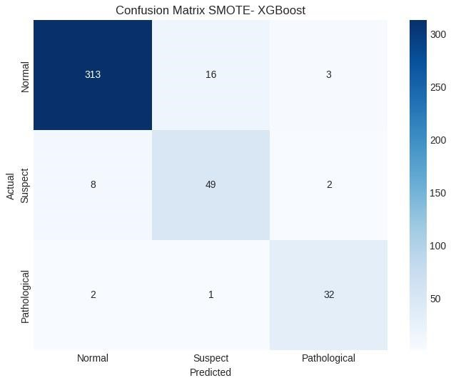
Figure 19. Confusion Matrix SMOTE– XGBoost
XGBoost performed similarly well, accurately classifying 313 instances of Normal class. It properly identified 49 instances of Suspect class. The Pathological class has 32 valid instances.

Support Vector Machines (SVM)
Finally, the Support Vector Machines (SVM) model had an accuracy of 88.97%, precision of 91.21%, recall of 88.97%, and F1 score of 89.67%. The use of SMOTE resulted in significant recall gains, demonstrating SVM's improved capacity to recognize minority class instances.
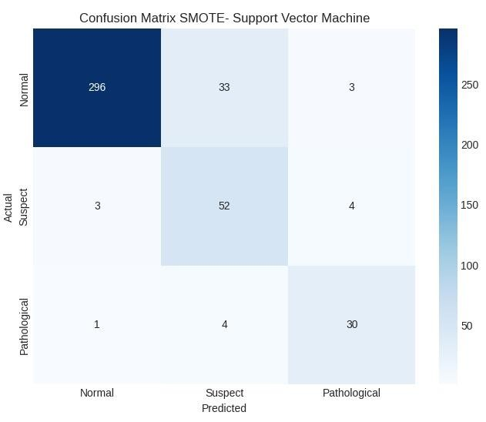
Figure 20. Confusion Matrix SMOTE – SVM

The Support Vector Machine (SVM) performed well, properly categorizing 300 Normal cases. It properly detected 50 instances of Suspect class. For the Pathological class, 29 were correctly categorized.
After applying SMOTE and scaling the data, the Random Forest and XGBoost models remained the top performers. Random Forest produced the best results, with accuracy, precision, recall, and F1 scores all at 92.72%. XGBoost was close behind, with 92.49% accuracy, 92.91% precision, 92.49% recall, and 92.65% F1 score. When comparing the top models from both scenarios, XGBoost performed slightly better on raw data, with an accuracy of 92.96%, precision of 92.67%, recall of 92.96%, and F1 score of 92.63%. However, after applying SMOTE and scaling, Random Forest achieved the highest accuracy, precision, recall, and F1 score (92.72%). This suggests that, while XGBoost originally performed well, Random Forest gained more from data preparation, making it more capable of managing imbalanced data.

4.3 SMOTE + Feature Selection Models Results
In this part, the results of applying several feature selection techniques to the SMOTEbalanced dataset are shown. Techniques include wrapper methods like Forward Selection, Backward elimination, and Recursive Feature Elimination (RFE). Additionally, Pearson
Correlation was used to narrow the feature set further. The results show that feature selection reduced model complexity while simultaneously improving accuracy and efficiency, especially when used after SMOTE balancing.

Pearson Correlation
The features selected for Pearson Correlation technique are as follows.
Filter Techniques | Selected Features
Pearson Correlation Coefficient (18 features) | baseline_value, accelarations, fetal_movements, uterine_contractions, light_decelarations, severe_decelerations, prolongued_decelerations, abnormal_short_term_variability, mean_value_of_short_term_variability, percentage_of_time_with_abnormal_long_term_variability, mean_value_of_long_term_variability, histogram_width, histogram_max, histogram_number_of_peaks, histogram_number_of_zeroes, histogram_median, histogram_variants, histogram_tendency

Figure 21. Pearson Correlation Selected Features
The results obtained by applying Pearson Correlation technique showed more than 80% similarity in the values obtained for the parameters histogram_mean, histogram_median and histogram_min. As mentioned above in Correlation analysis, these variables effectively convey the same information. Hence, this has been removed from the dataset to reduce overfitting. Therefore, the effective result obtained is mentioned in the table below.

Model | Accuracy | Precision | Recall | F1 Score
Logistic Regression | 84.87% | 88.88% | 84.87% | 86.12%
K-Nearest Neighbors (KNN) | 88.89% | 90.98% | 88.89% | 89.59%
Decision Tree | 88.89% | 89.02% | 88.89% | 88.95%
Random Forest | 94.56% | 94.37% | 94.56% | 94.35%
XGBoost | 93.38% | 93.21% | 93.38% | 93.26%
Support Vector Machines (SVM) | 90.07% | 92.22% | 90.07% | 90.70%
Figure 22. Pearson Correlation Coefficient Results

After applying Pearson correlation to select features, the Random Forest model performed most effectively, with an accuracy of 94.56%, precision of 94.37%, recall of 94.56%, and F1 score of 94.35%. This was closely followed by XGBoost, which had an accuracy of 93.38%, precision of 93.21%, recall of 93.38%, and F1 of 93.26%. These findings show that Pearson correlation increased the performance of these models by identifying the most significant traits, resulting in higher prediction accuracy and consistency. Random Forest, in particular, outperformed other models, making it the most dependable following feature selection.
The confusion matrix analysis displays classification performance in the Normal, Suspect, and Pathological categories. Random Forest and XGBoost performed very well, with Random Forest successfully identifying 325 Normal instances, 42 Suspect cases, and 33 Pathological cases, while XGBoost correctly identified 320 Normal cases, 43 Suspect cases, and 32 Pathological cases. SVM also performed well, accurately identifying 298 normal instances, 51 suspect cases, and 32 pathological cases.
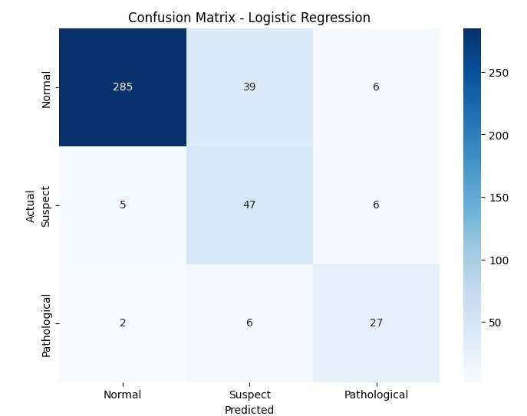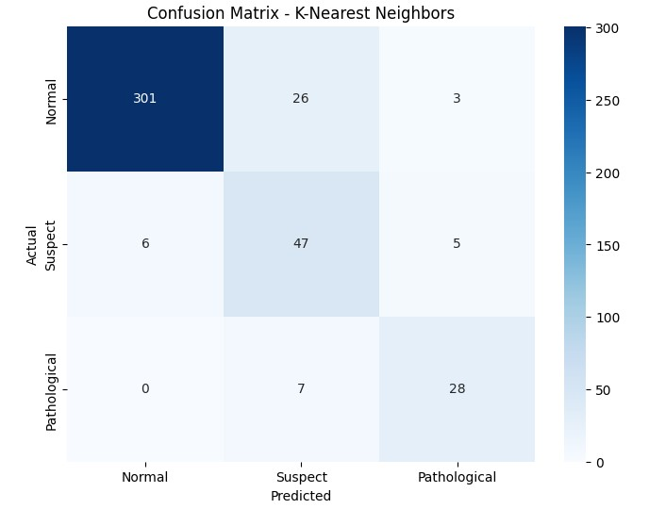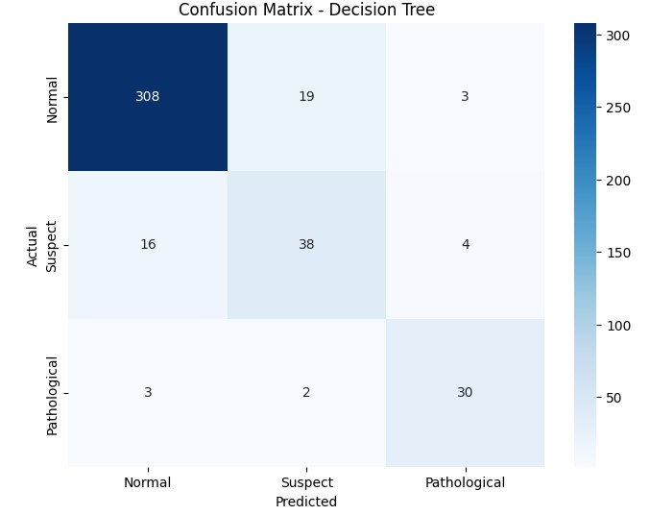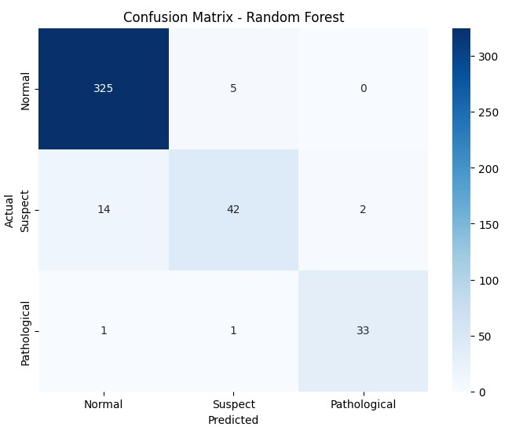

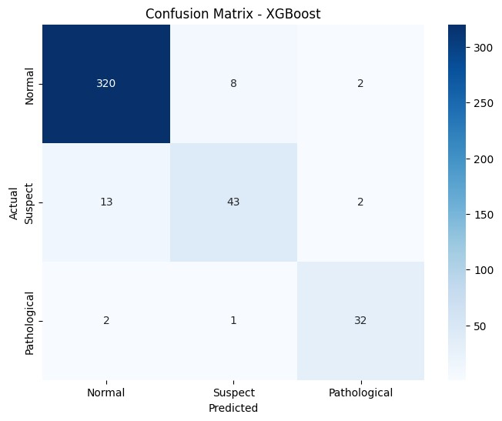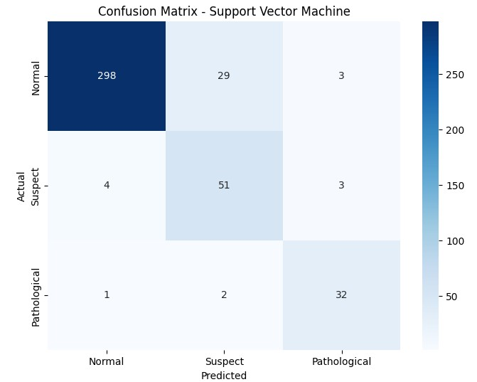

The Decision Tree model properly identified 308 Normal, 38 Suspect, and 30 Pathological instances. KNN identified 301 normal instances, 47 suspect cases, and 28 pathological cases. Despite being significantly less accurate, Logistic Regression accurately identified 285 normal cases, 47 suspect cases, and 27 pathological cases.

Forward Selection

The features selected for Forward Selection technique are as follows.

Wrapper Techniques | Selected Features
Forward Selection (10 features) | accelarations, light_decelarations, severe_decelarations, prolongued_decelerations, abnormal_short_term_variability, percentage_of_time_with_abnormal_long_term_variability, histogram_max, histogram_number_of_peaks, histogram_mean, histogram_variance.
Figure 23. Forward Selection Features
After using SMOTE, the Forward Selection feature selection strategy performs well across several models. Random Forest performed the best, with an accuracy of 95.04% and an F1 Score of 94.95%, suggesting its ability to handle the dataset. XGBoost also performed well, with 91.96% accuracy and an F1 score of
92.06%. The Decision Tree model followed closely behind, with an accuracy of 91.73% and an F1 Score of 91.74%. K-Nearest Neighbors (KNN) performed with 90.54% accuracy and a 91.15% F1 Score, indicating its utility in this context. While SVM and Logistic Regression performed significantly lower than the top models, they still produced decent results. SVM achieved an accuracy of 88.42% and an F1 Score of 89.43%, whilst Logistic Regression maintained an accuracy of 86.29% and an F1 Score of 87.26%. These findings show that, while all models benefit from the Forward Selection strategy, Random Forest and XGBoost perform exceptionally well in this scenario, with the best accuracy and F1 scores.

Model | Accuracy | Precision | Recall | F1 Score
Logistic Regression | 86.29% | 89.30% | 86.29% | 87.26%
K-Nearest Neighbors (KNN) | 90.54% | 92.56% | 90.54% | 91.15%
Decision Tree | 91.73% | 91.75% | 91.73% | 91.74%
Random Forest | 95.04% | 94.97% | 95.04% | 94.95%
XGBoost | 91.96% | 92.19% | 91.96% | 92.06%
Support Vector Machines (SVM) | 88.42% | 92.04% | 88.42% | 89.43%
Figure 24. Forward Selection Features’ Results

After performing forward feature selection, the Random Forest model beat the other models again, achieving the top metrics with an accuracy of 95.04%, precision of 94.97%, recall of 95.04%, and F1 score of 94.95%. XGBoost also performed well, with accuracy of 91.96%, precision of 92.19%, recall of 91.96%, and F1 score of 92.06%. Decision Tree and K-Nearest Neighbors (KNN) performed well, however they behind Random Forest and XGBoost. This result suggests that forward selection enhanced these models' performance by focusing on the most important features, with Random Forest emerging as the most effective model for classification tasks in this situation.

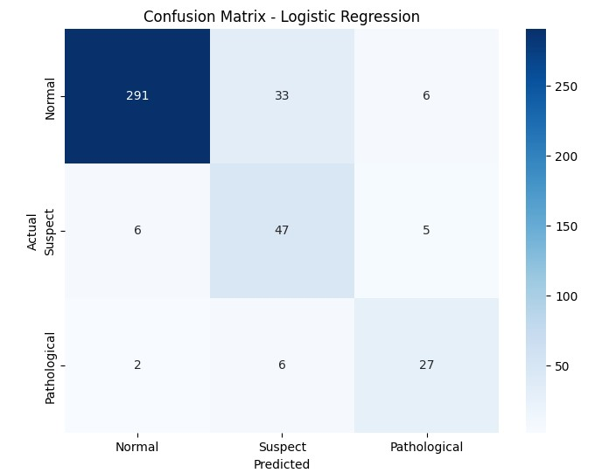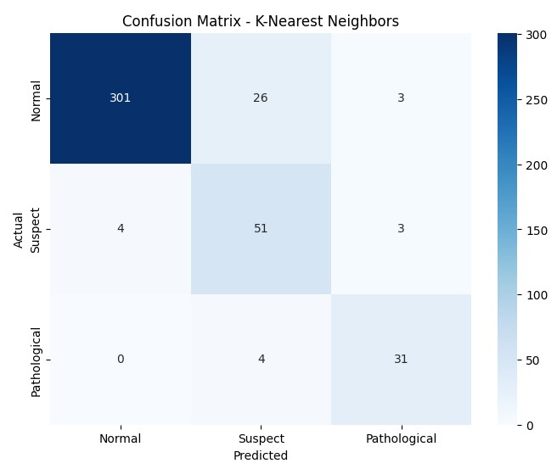

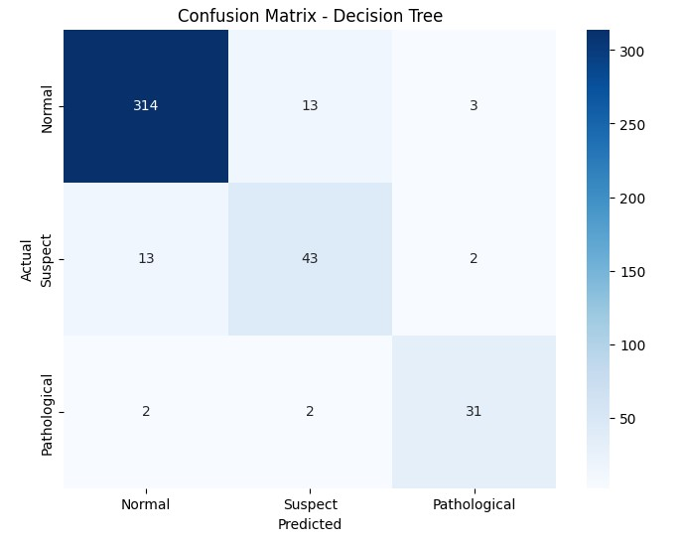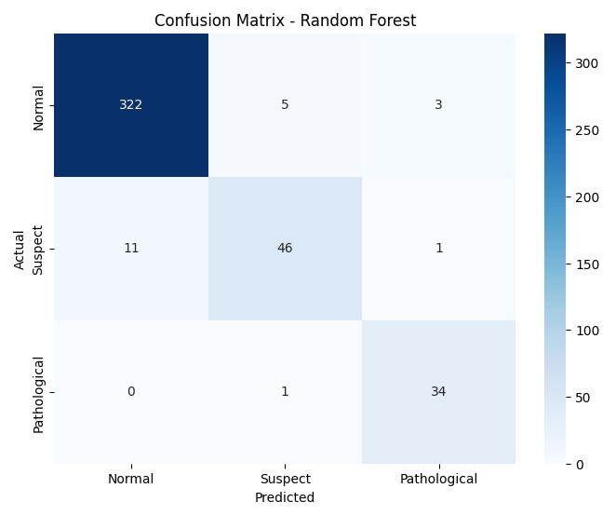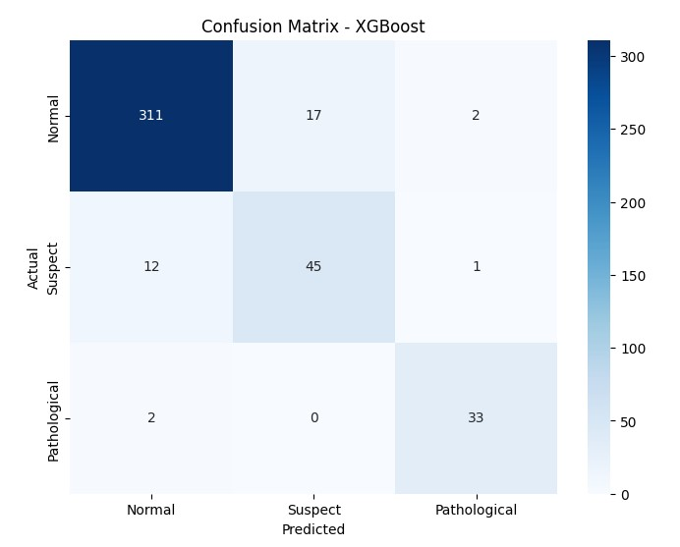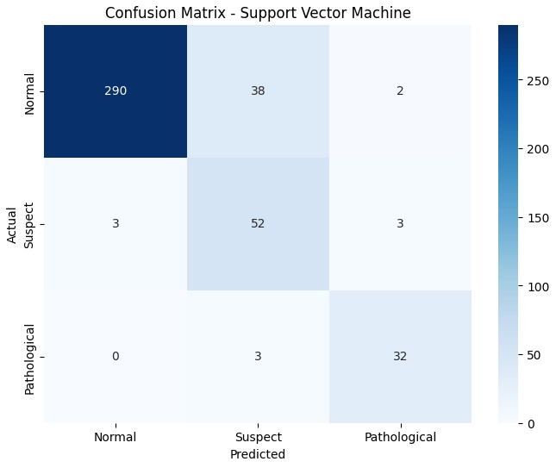

The Logistic Regression model correctly classified 291 Normal, 47 Suspect, and 27 Pathological cases. The K-Nearest Neighbors (KNN) model did slightly better, correctly classifying 301 Normal, 51 Suspect, and 31 Pathological cases. The Decision Tree model performed well, correctly classifying 314 Normal, 43 Suspect, and 31 Pathological cases. The Random Forest model outperformed the others, correctly classifying 322 Normal, 46 Suspect, and 34 Pathological cases. XGBoost also performed well, properly classifying 311 Normal, 45 Suspect, and 33 Pathological instances, Finally, the Support Vector Machine (SVM) model correctly classified 290 Normal, 52 Suspect, and 32 Pathological cases. Overall, the Random Forest model outperformed the other models in this comparison by having the best accuracy and the fewest misclassifications.

Backward elimination
The features selected for Backward Elimination technique are as follows.

Wrapper Techniques | Selected Features
Backward Elimination (10 features) | accelarations, light_decelarations, prolongued_decelerations, abnormal_short_term_variability,mean_value_of_short_term_variab ility, percentage_of_time_with_abnormal_long_term_variability, histogram_max, histogram_number_of_peaks, histogram_mode, histogram_variance.
Figure 25. Backward Elimination Features

The Backward elimination feature selection strategy, combined with SMOTE (Synthetic Minority Over-sampling Technique), resulted in significant performance gains across a variety of machine learning models. Random Forest outperformed the other models, with an F1 Score of 94.75% and an accuracy of 94.80%. XGBoost followed closely behind with an accuracy of 93.14% and an F1 Score of 93.24%, indicating its resilience in classification problems. Decision trees also performed well, with an accuracy of 92.20% and an F1 Score of 92.30%. K-Nearest Neighbors (KNN) performed admirably with 90.31% accuracy and an F1 Score of 90.90%, demonstrating its effectiveness with the selected features. The Support Vector Machine (SVM) maintained a competitive advantage with an accuracy of 89.60% and an F1 Score of 90.41%, notably in terms of precision. Despite having the lowest performance among the models, Logistic Regression achieved balanced findings with 85.11% accuracy and an F1 Score of 86.27%.

Model | Accuracy | Precision | Recall | F1 Score
Logistic Regression | 85.11% | 88.74% | 85.11% | 86.27%
K-Nearest Neighbors (KNN) | 90.31% | 92.31% | 90.31% | 90.90%
Decision Tree | 92.20% | 92.43% | 92.20% | 92.30%
Random Forest | 94.80% | 94.72% | 94.80% | 94.75%
XGBoost | 93.14% | 93.38% | 93.14% | 93.24%
Support Vector Machines (SVM) | 89.60% | 92.65% | 89.60% | 90.41%
Figure 26. Backward Elimination Features’ Results

Logistic Regression accurately identified 286 normal, 46 suspect, and 28 pathological cases, with some misclassifications in each group. The K-Nearest Neighbors (KNN) model did slightly better, correctly recognizing 300 Normal, 51 Suspect, and 31 Pathological instances, even it still suffered from significant misclassifications, especially in the Suspect category.
The Decision Tree model demonstrated enhanced accuracy, properly categorizing 313
Normal, 46 Suspect, and 31 Pathological instances with little misclassification. Random Forest emerged as the best-performing model, correctly identifying 322 Normal, 47 Suspect, and 32 Pathological instances with minimal mistakes. Similarly, XGBoost worked excellently, properly recognizing 314 Normal, 47 Suspect, and 33 Pathological instances with few mistakes. Finally, the Support Vector Machine (SVM) model correctly identified 293 Normal, 53 Suspect, and 33 Pathological instances, with minor misclassifications, notably in the Normal category.
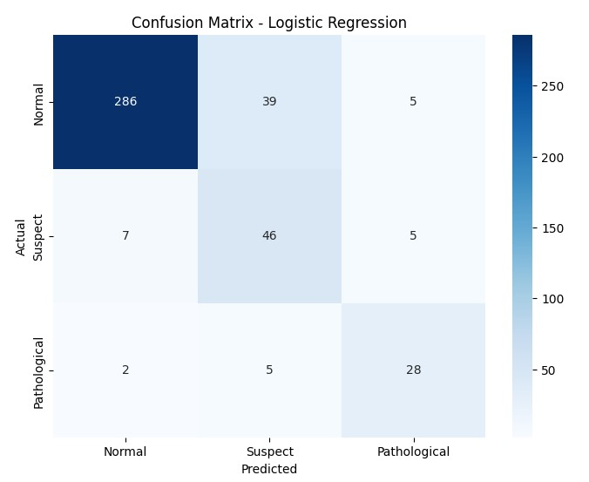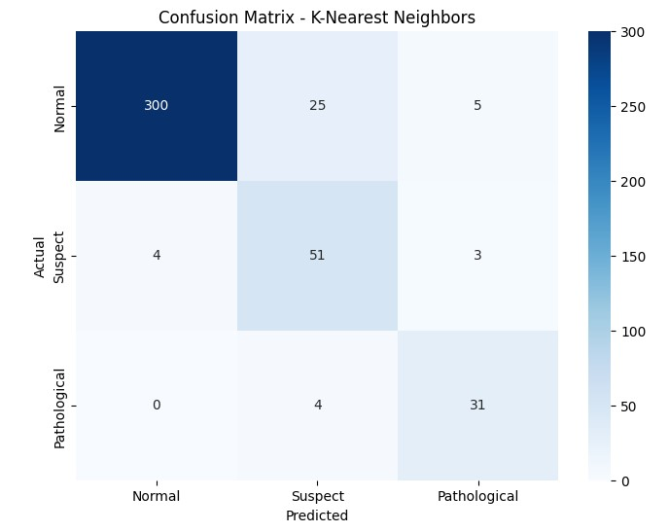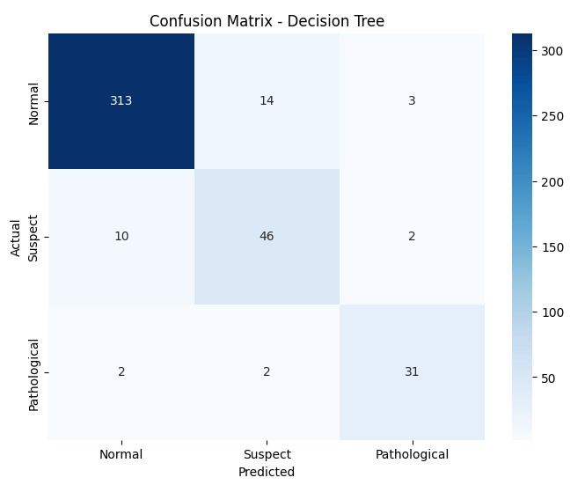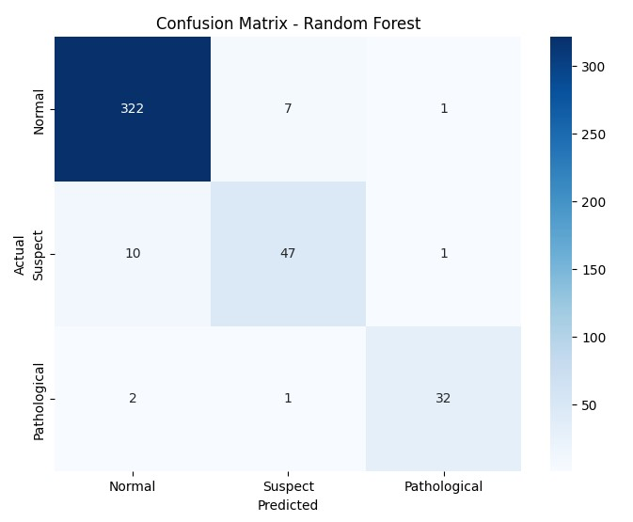
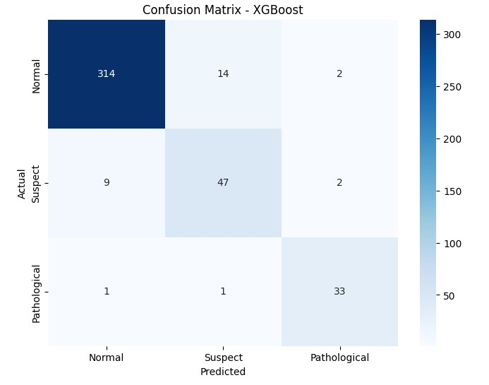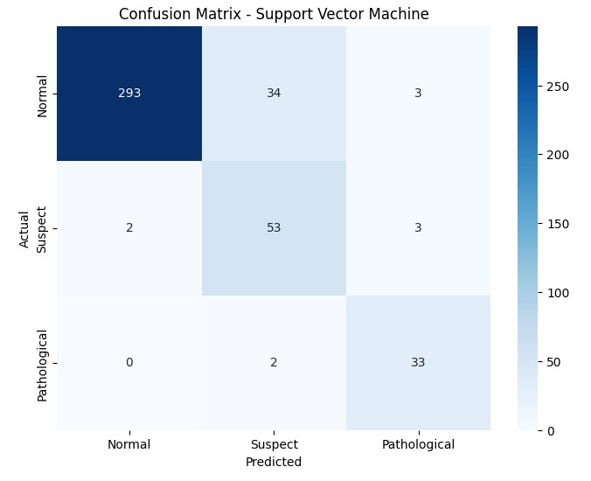

After performing backward feature selection, the Random Forest model again dominated the performance metrics with 94.80% accuracy, 94.84% precision, 94.80% recall, and a 94.75% F1 score. XGBoost was a close second, with an accuracy of 93.14%, precision of
93.38%, recall of 93.14%, and F1 score of 93.24%. Although Decision Tree and K-Nearest Neighbors (KNN) performed well, they did not outperform Random Forest and XGBoost. These findings show that backward elimination significantly enhanced the models, with Random Forest remaining the most resilient and accurate model in this case.

Recursive Feature Elimination (RFE)
The features selected for Recursive Feature Elimination technique are as follows.

Filter Techniques | Selected Features
RFE (10 features) | baseline_value,accelarations, uterine_contractions, prolongued_decelerations, abnormal_short_term_variability, percentage_of_time_with_abnormal_long_term_variability, histogram_mode, histogram_mean, histogram_median, histogram_variance
Figure 27. Recursive Feature Elimination Features

The Recursive Feature Elimination (RFE) feature selection study identifies Random Forest as the best-performing model, with an accuracy of 94.80%, precision of 94.64%, recall of
94.80%, and F1 Score of 94.62%. XGBoost was close behind, with an accuracy of 94.56%, precision of 94.72%, recall of 94.56%, and F1 score of 94.62%. Decision Tree also performed well, with an accuracy of 94.09%, precision of 93.92%, recall of 94.09%, and F1 score of 93.98%. K-Nearest Neighbors (KNN) performed effectively, with an accuracy of 89.13%, precision of 91.17%, recall of 89.13%, and F1 score of 89.79%. The Support Vector Machine (SVM) achieved 88.89% accuracy, 91.23% precision, 88.89% recall, and an F1 score of 89.61%. even with the least accurate of all models, Logistic Regression maintained a balanced performance with an accuracy of 85.34%, precision of 89.10%, recall of 85.34%, and F1 Score of 86.51%.

Model | Accuracy | Precision | Recall | F1 Score
Logistic Regression | 85.34% | 89.10% | 85.34% | 86.51%
K-Nearest Neighbors (KNN) | 89.13% | 91.17% | 89.13% | 89.79%
Decision Tree | 94.09% | 93.92% | 94.09% | 93.98%
Random Forest | 94.80% | 94.64% | 94.80% | 94.62%
XGBoost | 94.56% | 94.72% | 94.56% | 94.62%
Support Vector Machines (SVM) | 88.89% | 91.23% | 88.89% | 89.61%
Figure 28. Recursive Feature Elimination Features’ Results
The Logistic Regression model effectively classified 286 normal, 47 suspect, and 28 pathological patients, with some misclassifications in each category. The K-Nearest Neighbors (KNN) model did slightly better, accurately identifying 299 Normal, 48 Suspect, and 30 Pathological instances, although there were still significant misclassifications, particularly in the Suspect category. The Decision Tree model shown additional progress, properly identifying 322 Normal, 43 Suspect, and 33 Pathological instances with few mistakes.
The Random Forest model outperformed the other models, correctly identifying 325 Normal, 43 Suspect, and 33 Pathological instances with few misclassifications. XGBoost also worked admirably, accurately recognizing 316 Normal, 49 Suspect, and 35 Pathological instances with little mistakes. The Support Vector Machine (SVM) model performed well as well, properly identifying 296 Normal, 49 Suspect, and 31 Pathological instances, despite some misclassifications in the Normal category.

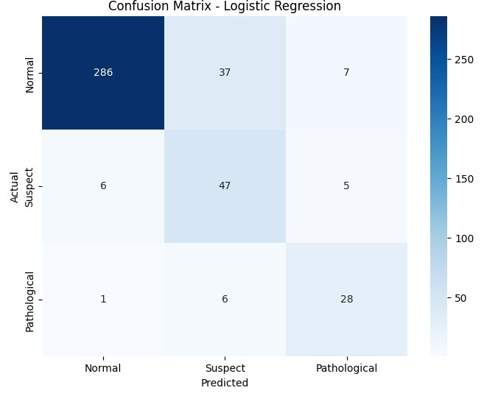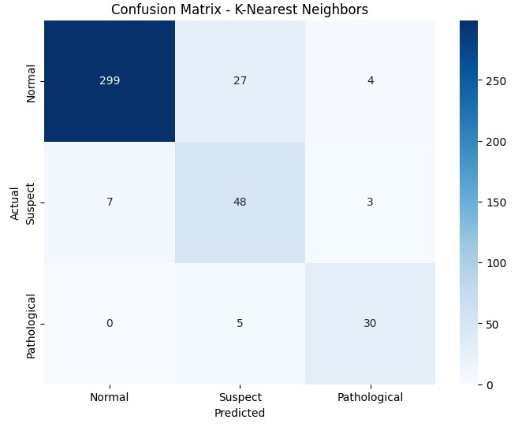

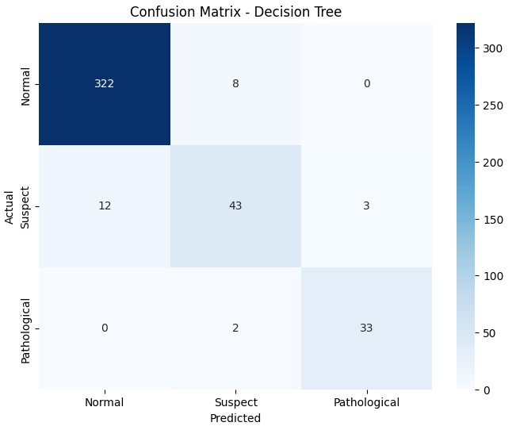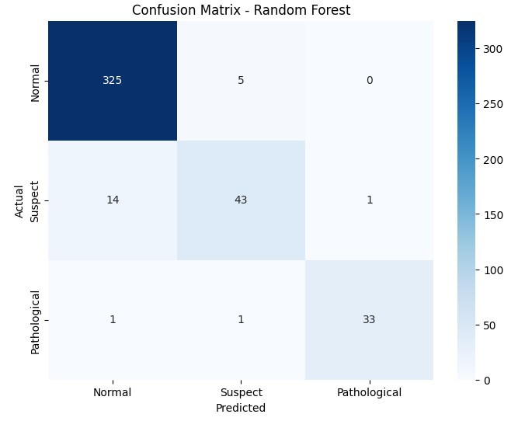

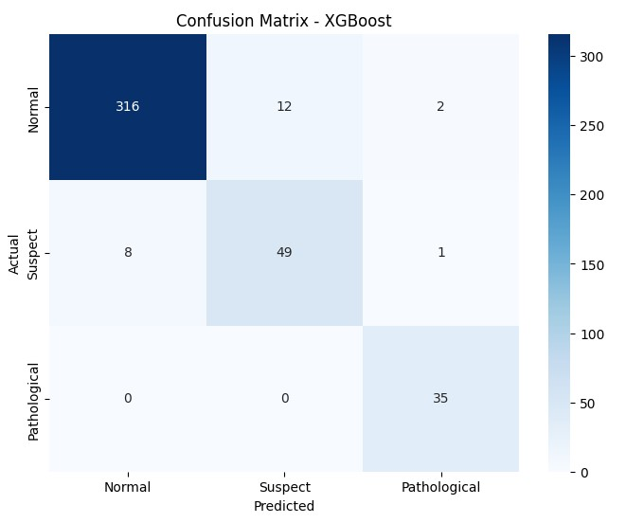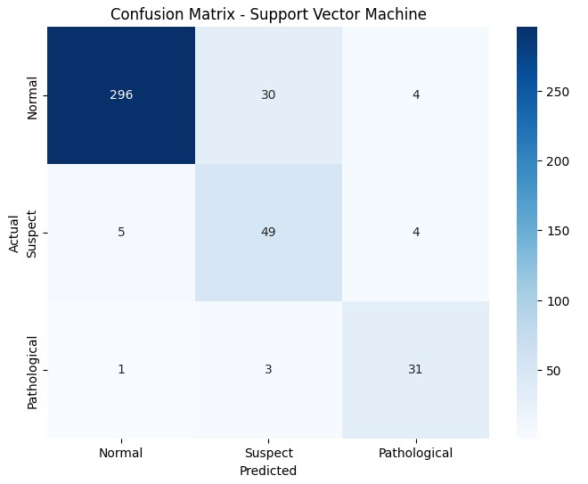

After applying Recursive Feature Elimination (RFE), the Random Forest model showed its ability to perform once more, with an accuracy of 94.80%, precision of 94.64%, recall of 94.80%, and F1 score of 94.62%. These measurements show that Random Forest regularly produced good accuracy and balanced performance across all assessment measures, including feature reduction with RFE. The model's ability to sustain high accuracy and recall indicates that it efficiently used the most significant RFE-identified characteristics, resulting in solid predictions with minimum information loss. This supports Random Forest's status as a top-performing model for complicated datasets, especially when paired with excellent feature selection approaches such as RFE.
Comparative Analysis of SMOTE + Feature Selection Techniques and Model

Performance
Various feature selection techniques, including Pearson Correlation, Forward Selection, Backward elimination, and Recursive Feature Elimination (RFE), were tested across multiple machine learning models, including Random Forest, XGBoost, Support Vector Machine (SVM), K-Nearest Neighbors (KNN), Decision Trees (DT), and Logistic Regression. The models' ability to classify fetal health statuses (Normal, Suspect, Pathological) was evaluated using accuracy, recall, F1 Score, and confusion matrices.
Pearson Correlation:
- Top Performers: Random Forest achieved the best accuracy at 94.56% with an F1 Score of 94.35%, followed by XGBoost with 93.38% accuracy and 93.26% F1 Score.
- Other models: SVM performed well, with 90.07% accuracy and a 90.70% F1 Score. KNN and Decision Trees both achieved 88.89% accuracy, with F1 Scores averaging 89%. Logistic Regression trailed behind with 84.87% accuracy and an F1 Score of 86.12%.
Forward Selection:
- Top Performer: Random Forest defeated the other models with an accuracy of 95.04% and an F1 Score of 94.95%, suggesting its resilience and superior handling of the dataset following feature selection. XGBoost also performed well, with 91.96% accuracy and an F1 Score of 92.06%. The Decision Tree model was close behind, with 91.73% accuracy and 91.74% F1 Score.
- Other Models: KNN performed well, with 90.54% accuracy and a 91.15% F1 Score. SVM and Logistic Regression are slightly lower in performance, achieving good accuracies of 88.42% and 86.29%, respectively.
Backward elimination:
- Top Performers: Random Forest maintained its strong performance with an accuracy of 94.80% and an F1 Score of 94.75%, closely followed by XGBoost with 93.14% accuracy and a 93.24% F1 Score. Decision Trees performed admirably, with 92.20% accuracy and an F1 Score of 92.30%.
- Other Models: KNN produced excellent results, with 90.31% accuracy and a 90.90% F1 Score. SVM was competitive, with an F1 score of 90.41% and an accuracy of 89.60%. Logistic Regression has the lowest accuracy of the models, 85.11%, with an F1 Score of 86.27%.
Recursive Feature Elimination (RFE):
- Top Performers: Random Forest was the best performer, with an accuracy of 94.80% and F1 Score of 94.62%. XGBoost followed with an accuracy of 94.56% and an F1 Score of 94.62%. Decision Tree scored 94.09% accuracy and 93.98% F1 Score. KNN fared well, with 89.13% accuracy and an F1 score of 89.79%.
- Other Models: SVM had 88.89% accuracy with an F1 Score of 89.61%, when Logistic Regression, however slightly lower, managed 85.34% accuracy with an F1 Score of 86.51%.

Conclusion: Best Feature Selection Technique and Model
Best Feature Selection method: Forward Selection, which combines SMOTE and Feature Selection methodology, is the most effective approach of all the approaches examined, allowing the Random Forest model to reach the highest overall accuracy and F1 Score (95.04% and 94.95%, respectively). This method proved helpful in optimizing model performance by picking the most relevant features, making it the best option for predictive modeling in the context of prenatal health monitoring.

4.4 Comparison of Model Performance: Raw Data, SMOTE, and SMOTE + Forward Selection
An in-depth examination of raw data, SMOTE-balanced data, and SMOTE + Forward Selection data.
Raw Data: When dealing with imbalanced raw data, XGBoost and Random Forest models performed well. XGBoost had the greatest metrics: 92.96% accuracy, 92.67% precision,
92.96% recall, and an F1 score of 92.63%. The Random Forest model followed closely, with 92.49% accuracy, 92.18% precision, 92.49% recall, and a 92.20% F1 score. These findings demonstrate the benefits in managing imbalanced datasets without data preprocessing.
SMOTE Data: After applying SMOTE and scaling, both Random Forest and XGBoost performed well, but Random Forest emerged as the best model. It scored 92.96% in accuracy, 92.98% precision, 92.96% recall, and 92.96% F1 score. XGBoost maintained a close relationship with 92.49% accuracy, 92.91% precision, 92.49% recall, and 92.65% F1 score. This comparison indicates that, whereas XGBoost excelled with raw data, Random Forest profited more from SMOTE and scaling, making it more successful at managing imbalanced data.
SMOTE + Forward Selection: After applying forward feature selection to the SMOTEbalanced data, Random Forest outperformed all other models with a significant increase in performance, achieving 95.04% accuracy, 94.97% precision, 95.04% recall and a 94.95% F1 score, demonstrating its robustness and superior ability to handle the dataset postfeature selection. XGBoost also worked admirably, with 91.96% accuracy, 92.19% precision, 91.96% recall and a 92.06% F1 score. Decision Tree followed closely behind, scoring
91.73% accuracy, 91.75% precision, 91.73% recall and 91.74% F1 score.
In conclusion, Random Forest effectively improved its performance when data preparation approaches were employed, eventually emerging as the most robust model, especially after feature selection. XGBoost remained a strong contender, particularly in the raw data category. This comparison emphasizes the significance of data preparation and feature selection in improving model performance, particularly when dealing with imbalanced datasets.

4.5 Model Optimization Results
Randomized Search CV was used to tune hyperparameters, which is an effective approach for exploring a wide range of hyperparameters by sampling from convinced distributions. Each model performed 100 iterations with 5-fold cross-validation to determine the ideal hyperparameters that maximized accuracy. This thorough tweaking guaranteed that the models were not only well-suited to the training data, but also able to generalize successfully to new data.

Model | Accuracy | Precision | Recall | F1 Score
Tuned Decision Tree | 94.33% | 94.22% | 94.33% | 94.23%
Tuned Random Forest | 96.22% | 96.20% | 96.22% | 96.18%
Tuned XGBoost | 94.80% | 94.74% | 94.80% | 94.75%

Fig 29 Tuned Models Result
Decision Tree: Hyperparameters adjusted included max_depth, min_samples_split, min_samples_leaf, and the splitting criterion (gini or entropy). The adjusted Decision Tree obtained balanced metrics, including a 94.33% accuracy, 94.22% precision, 94.33% recall and 94.23% F1 score. The confusion matrix for this model revealed that it accurately identified 321 normal instances, 45 suspect cases, and 33 pathological cases. However, it incorrectly identified 6 Normal cases as Suspect, 3 Normal cases as Pathological, 12 Suspect cases as Normal, 1 Suspect case as Pathological, and 1 Pathological case as Normal.

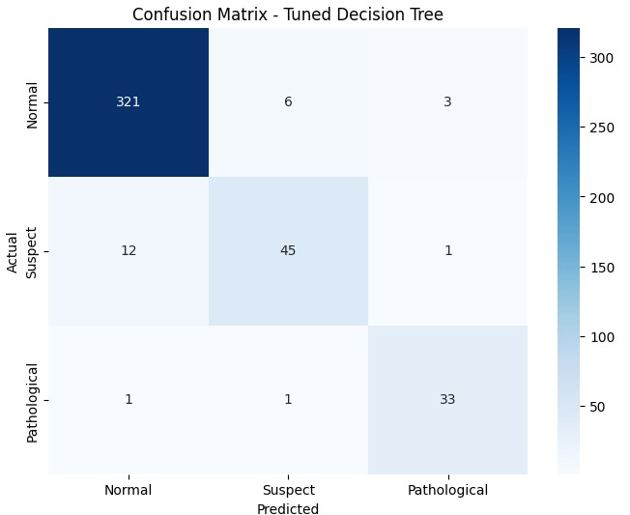
Fig 30 Tuned Decision Tree Confusion Matrix
Random Forest: The tuning procedure focused on hyperparameters such n_estimators, max_depth, min_samples_split, min_samples_leaf, and max_features. The Random Forest model outperformed the other models, with 96.22% accuracy, 96.20% precision, 96.22% recall and 96.18% F1 score. The confusion matrix demonstrated its efficiency, as 323 normal cases, 49 suspect cases, and 35 pathological cases were accurately categorized. This model had extremely few misclassifications: 6 Normal cases as Suspect, 1 Normal case as Pathological, 7 Suspect cases as Normal, and 2 Suspect cases as Pathological. It correctly classified pathological cases.

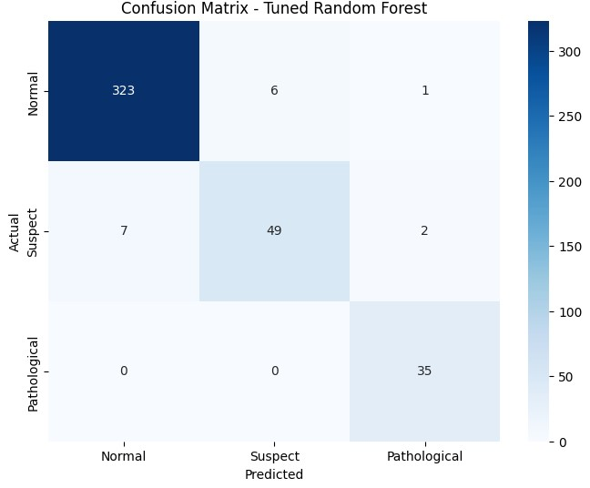
Fig 31 Tuned Random Forest Confusion Matrix

XGBoost: XGBoost's key hyperparameters were n_estimators, learning_rate, max_depth, subsample, colsample_bytree, and gamma. The XGBoost model worked excellently, with all metrics reaching 95%. The confusion matrix successfully identified 320 Normal cases, 47 Suspect cases, and 34 Pathological cases. Eight normal instances were misclassified as suspect, two normal cases as pathological, ten suspect cases as normal, one suspect case as pathological, and one pathological case as normal.

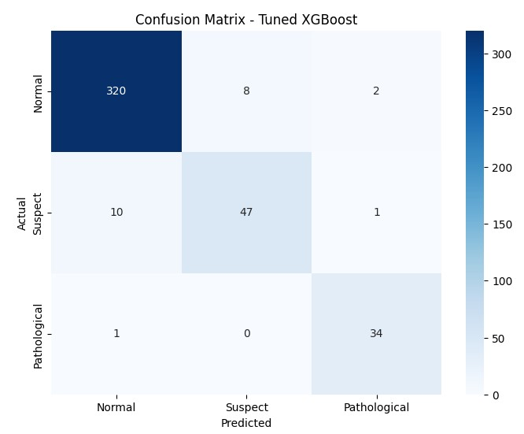
Fig 32 Tuned XGBoost Confusion Matrix

The comparison clarifies Random Forest as the strongest model for clinical applications, especially where precision and recall are crucial. Random Forest's confusion matrix findings show that it can properly categorize all categories with little mistakes. It had just 9 misclassified instances in total, the lowest of the three models. XGBoost, while significantly less performant with 22 misclassifications, remains a viable option, demonstrating high overall accuracy but a few more mistakes. The Decision Tree approach, while successful and balanced, has 23 misclassifications and is better suited to simpler circumstances. Given its excellent performance across all criteria and minimal misclassification rates, the Random Forest model is recommended for medical use.

Chapter 5: Discussion

The study's findings demonstrate the critical importance of a structured approach to data preprocessing, feature selection, and model optimization to enhance the accuracy and reliability of machine learning models for fetal health monitoring based on cardiotocography (CTG) data. Models were first trained on raw, unprocessed data to create baseline performance metrics. At this point, models such as Decision tree, Random Forest and XGBoost showed superior performance. However, these models were still limited by the dataset's underlying class imbalance, which affected their recall and F1 scores, particularly for minority classes. The Synthetic Minority Over-Sampling Technique (SMOTE) addressed this imbalance by creating synthetic samples for underrepresented classes, resulting in much higher recall and F1 scores across all models. The Min-Max Scaler also helped by standardizing the dataset, which was critical for models like Support Vector Machines (SVM) and K-Nearest Neighbors (KNN), which are sensitive to data scaling.
Following this, feature selection with both filter and wrapper methods enhanced the models by focusing on the most relevant features, resulting in further increases in accuracy and other key matrices. The Random Forest model gained the most from the combination of SMOTE and forward feature selection, resulting as the top performer with the best accuracy, precision, recall, and F1 score following hyperparameter tuning. This model's performance, with an accuracy of 96.21% and few misclassifications, especially in the important classification of pathological cases, showed its ability to adapt as well the suitability for clinical use. While XGBoost and Decision Tree improved significantly after tuning, Random Forest consistently beat both, making it the most trustworthy model for clinical deployment. These findings agree with the study's objectives, demonstrating that a comprehensive approach to preprocessing, feature selection, and model optimization can significantly improve the effectiveness of machine learning models in fetal health monitoring, resulting in better clinical decision-making and improved maternal and fetal outcomes.

5.1 Comparison with Existing Studies

This study's findings align with previous studies, which highlighted the importance of feature selection in improving machine learning models for prenatal health classification and achieved up to 92% accuracy using approaches such as Pearson Correlation and ANOVA, our work expands on these foundations by including filter and wrapper feature selection procedures into SMOTE. By merging these techniques with advanced algorithms such as Random Forest and XGBoost, we were able to significantly boost performance metrics. In the case of the executing hyperparameter tuning, our Random Forest model scored 96.21% accuracy and 96.18% F1 score. This is around a 3% improvement in accuracy over the best results from [6], suggesting that combining SMOTE with sophisticated feature selection leads to more robust and accurate predictions.

In comparison to Mahmoud Abouelyazid and Chen Xiang's (2021) [7], who achieved 93.2% accuracy with a Decision Tree after applying SMOTE and Robust Scaler [7], our Random Forest model demonstrated a significant improvement in accuracy of 2.8%, highlighting the effectiveness of combining SMOTE, forward feature selection, and hyperparameter tuning. Moreover, Li and Liu reported 95.9% accuracy and 91.6% recall [3]. While their Blender model performed well, our Random Forest model had a higher recall, indicating a more accurate classification of minority classes. This demonstrates the efficacy of integrating SMOTE with sophisticated feature selection and hyperparameter tuning, resulting in better classification performance. Our technique improves the reliability and accuracy of fetal health forecasts while providing a more comprehensive answer for clinical decision-making.

5.2 Recommendations for Future Research

Based on the study's findings and limitations, many significant objectives for future research are offered to improve the accuracy and reliability of fetal health prediction models. Future research should explore different strategies for feature selection, such as embedding methods with different models of machine learning, in order to improve model performance and interpretability. The model's generalizability might be improved by expanding the dataset to include diverse populations as well as new data sources, such as maternal health records and genetic information. Furthermore, combining other machine learning models or ensemble approaches in addition to Random Forest and XGBoost may result in significant performance gains, and investigating the models' applicability in real-time clinical situations may aid in their optimization for practical usage. To solve class imbalance more effectively, future research should look into further approaches beyond SMOTE, such as adaptive synthetic sampling or cost-sensitive learning. Finally, multidisciplinary collaboration between data scientists and clinicians is required to adjust these models to the unique demands of fetal health monitoring, ensuring that they are both technically sound and practical for clinical decision-making. Future study might expand on existing findings to produce even more effective and trustworthy models for predicting fetal health, eventually improving clinical results.

Chapter 6: Conclusion

The major goal of this study was to improve the accuracy and reliability of predicting fetal health outcomes using cardiotocographic (CTG) data using advanced machine learning algorithms. The study conducted a comprehensive evaluation of various models, including Logistic Regression, K-Nearest Neighbors (KNN), Decision Tree, Random Forest, Support Vector Machines (SVM), and Extreme Gradient Boosting (XGBoost). A major discovery was that the Random Forest model regularly outperformed others, especially when paired with the Synthetic Minority Over-sampling Technique (SMOTE) and forward feature selection, obtaining an outstanding accuracy of 96.21% following these optimizations. This result demonstrates the model's capacity to manage issues associated with imbalanced data sets, which is critical for accurate categorization of fetal health statuses, particularly in minority problematic situations.
The study provides immensely to the field of fetal health monitoring, particularly by proving the successful use of SMOTE to rectify class imbalances in CTG data. This strategy enhanced models' capacity to correctly recognize underrepresented cases, which is crucial for early diagnosis and intervention in prenatal care. Furthermore, the study emphasized the importance of feature selection in enhancing model performance, demonstrating that combining SMOTE and forward feature selection might improve the accuracy and efficiency of machine learning models. These findings provide an effective model that may be used in other fields of medical data analysis where data imbalance and feature relevance are major problems.

In conclusion, this work demonstrates the potential for change of machine learning in fetal health monitoring by solving critical concerns such as class imbalance and feature selection. The enhanced Random Forest model proved to be a trustworthy tool for clinical decision-making, emphasizing machine learning's more significant potential for improving patient outcomes. The approaches presented here not only improve fetal health monitoring, but also serve as a platform for future applications in other medical disciplines. This study emphasizes the significance of continuing exploration and refining these strategies to improve their application and robustness in a variety of healthcare settings, eventually leading to better maternal and newborn health outcomes.

References

- Mehbodniya, A., Lazar, A.J.P., Webber, J., Sharma, D.K., Jayagopalan, S., K, K., Singh, P., Rajan, R., Pandya, S. and Sengan, S., 2022. Fetal health classification from cardiotocographic data using machine learning. Expert Systems, 39(6), p.e12899.
- Alam, M.T., Khan, M.A.I., Dola, N.N., Tazin, T., Khan, M.M., Albraikan, A.A. and Almalki, F.A., 2022. [Retracted] Comparative Analysis of Different Efficient Machine Learning Methods for Fetal Health Classification. Applied Bionics and Biomechanics, 2022(1), p.6321884.
- Li, J. and Liu, X., 2021, March. Fetal health classification based on machine learning. In 2021 IEEE
2nd International Conference on Big Data, Artificial Intelligence and Internet of Things Engineering (ICBAIE) (pp. 899-902). IEEE.
- Garcia-Canadilla, P., Sanchez-Martinez, S., Crispi, F. and Bijnens, B., 2020. Machine learning in fetal cardiology: what to expect. Fetal diagnosis and therapy, 47(5), pp.363-372.
- Das, S., Mukherjee, H., Santosh, K.C., Saha, C.K. and Roy, K., 2020, July. Periodic change detection in fetal heart rate using cardiotocograph. In 2020 IEEE 33rd International Symposium on ComputerBased Medical Systems (CBMS) (pp. 104-109). IEEE.
- Jebadurai, I.J., Paulraj, G.J.L., Jebadurai, J. and Silas, S., 2022. Experimental analysis of filteringbased feature selection techniques for fetal health classification. Serbian Journal of Electrical Engineering, 19(2), pp.207-224.
- Abouelyazid, M. and Xiang, C., 2021. Machine Learning-Assisted Approach for Fetal Health Status Prediction using Cardiotocogram Data. International Journal of Applied Health Care Analytics, 6(4), pp.1-22.
- Bhowmik, P., Bhowmik, P.C., Ali, U.M.E. and Sohrawordi, M., 2021. Cardiotocography data analysis to predict fetal health risks with tree-based ensemble learning. Inf. Technol. Comput. Sci, 5, pp.30-40.
9. Salini, Y., Mohanty, S.N., Ramesh, J.V.N., Yang, M. and Chalapathi, M.M.V., 2024. Cardiotocography
Data Analysis for Fetal Health Classification Using Machine Learning Models. IEEE Access.
10. Feng, J., Liang, J., Qiang, Z., Li, X., Chen, Q., Liu, G., Hong, J., Hao, Z. and Wei, H., 2021, December.
Effective techniques for intelligent cardiotocography interpretation using XGB-RF feature selection and stacking fusion. In 2021 IEEE International Conference on Bioinformatics and Biomedicine (BIBM) (pp. 2667-2673). IEEE.
- Ayres-de-Campos, D., Bernardes, J., Garrido, A., Marques-de-Sa, J. and Pereira-Leite, L., 2000. SisPorto 2.0: a program for automated analysis of cardiotocograms. Journal of Maternal-Fetal Medicine, 9(5), pp.311-318.
- Arif, M., 2015. Classification of cardiotocograms using random forest classifier and selection of important features from cardiotocogram signal. Biomaterials and Biomechanics in Bioengineering, 2(3), pp.173-183.
- Hoodbhoy, Z., Noman, M., Shafique, A., Nasim, A., Chowdhury, D. and Hasan, B., 2019. Use of machine learning algorithms for prediction of fetal risk using cardiotocographic data. International Journal of Applied and Basic Medical Research, 9(4), pp.226-230.
- Almond, D. and Currie, J., 2011. Killing me softly: The fetal origins hypothesis. Journal of economic perspectives, 25(3), pp.153-172.
- Leddy, M.A., Power, M.L. and Schulkin, J., 2008. The impact of maternal obesity on maternal and fetal health. Reviews in obstetrics and gynecology, 1(4), p.170.
- Raza, A., Siddiqui, H.U.R., Munir, K., Almutairi, M., Rustam, F. and Ashraf, I., 2022. Ensemble learning-based feature engineering to analyze maternal health during pregnancy and health risk prediction. Plos one, 17(11), p.e0276525.

