Project Title
Exploring the Relationship Between Weather and Seoul Bike Sharing Demand

Dataset
Dataset Name: Seoul Bike Sharing Demand
Source: Kaggle - Seoul Bike Sharing Demand Dataset
Data Size: Approximately 8,760 rows × 14 columns (CSV file, ~500 KB)
Dataset Description
This dataset contains daily counts of rented bikes in Seoul along with weather and environmental data, including temperature, humidity, wind speed, visibility, and rainfall. It provides information to analyze how different weather conditions affect the usage of Seoul’s public bike-sharing system.

Brief Write-up
I aim to analyze how weather and seasonal patterns influence bike-sharing demand in Seoul. Using the Seoul Bike Sharing Demand dataset, I will visualize and explore relationships between temperature, humidity, and other environmental variables with the total number of rented bikes.
Research Question:
How do weather conditions and seasonal trends affect bike-sharing demand in Seoul, and which environmental factors most strongly correlate with usage patterns?
Data Transformations and Visualizations:
I performed data transformations such as aggregating hourly data to daily and weekly summaries, normalizing numerical variables, and categorizing months into seasons. These transformations helped identify interesting patterns, including peaks in bike usage during mild temperatures, lower usage on rainy days, and seasonal trends across spring, summer, fall, and winter.

Planned Visualizations
- Daily Total Bike Rentals (Line Plot)
This plot shows the daily variation in bike rentals.
It helps identify trends over time and observe patterns on special days such as holidays or events.
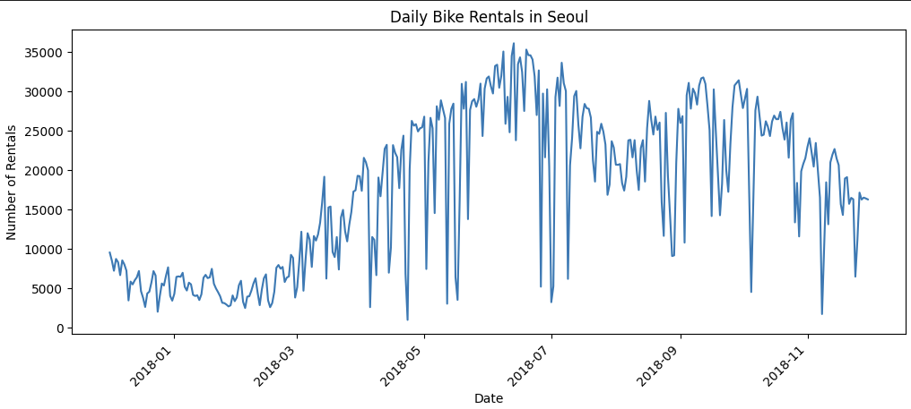
- Average Bike Rentals by Weekday (Bar Plot)
This bar plot compares average bike rentals across weekdays. It highlights differences between weekday and weekend usage, useful for operational planning.
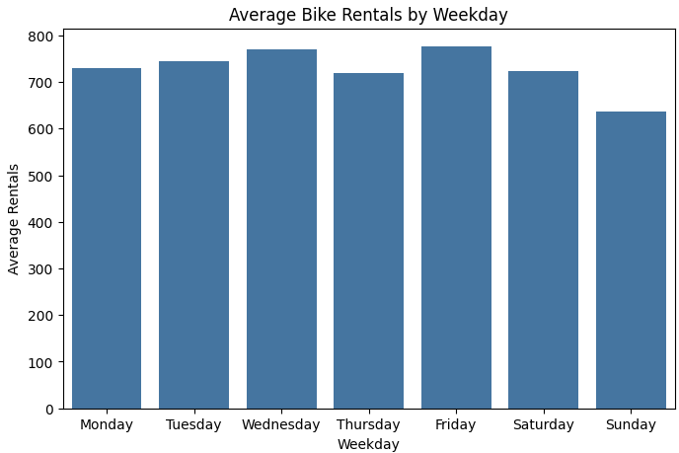
- Bike Rentals by Season/Month (Box Plot)
This box plot shows the distribution of bike rentals across different seasons. It allows us to visually compare demand and variability during spring, summer, fall, and winter.
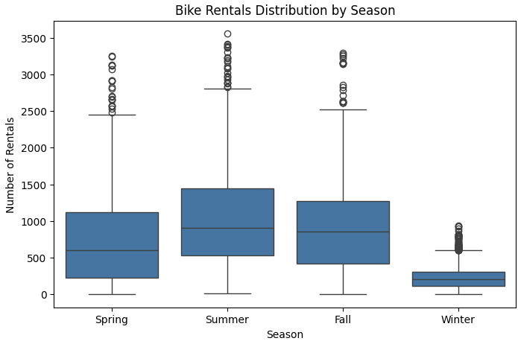
- Bike Rentals by Temperature (Histogram)
This histogram illustrates the total bike rentals across different temperature ranges. It reveals patterns such as higher demand in moderate temperature ranges.
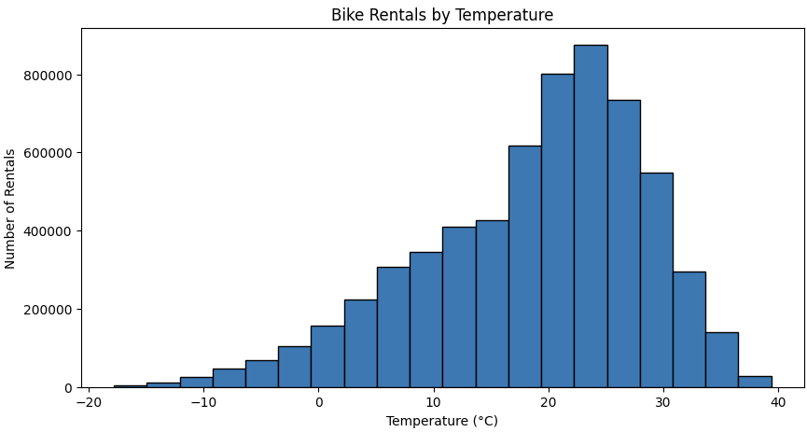
- Correlation between Environmental Factors and Rentals (Heatmap)
This heatmap shows correlations between bike rentals and factors like temperature, humidity, wind speed, and rainfall. It helps identify which environmental variables have the strongest impact on rental demand.
