Class-Neighborhood Temperature Scaling for Reliable Multi-Class Image Classification
Komang Samuel Arie Wicaksana¹
¹ Institution, Department, City, Country
Abstract. Global temperature scaling improves multi-class calibration on average but performs poorly for pairs of visually similar classes, while a temperature fitted per class is more flexible yet prone to over-fitting on small calibration sets. This paper studies Class-Neighborhood Temperature Scaling (CNTS), a post-hoc calibration method that builds a confusion graph from validation predictions, groups classes into connected neighborhoods using a threshold selected only from development data, and fits one temperature per neighborhood. CNTS is compared against no calibration, global temperature scaling, and per-class temperature scaling on four datasets, DermaMNIST, BloodMNIST, CIFAR-10, and a 12-cat-breed subset of Oxford-IIIT Pet, under a strict separation between training, calibration-development, and test data, using a small convolutional network trained from scratch and evaluated over three random seeds. CNTS lowers Expected Calibration Error (ECE) by 46.5% on average relative to an uncalibrated model, but its advantage over global scaling is much smaller: after a Holm-Bonferroni correction for multiple comparisons, only the improvement in Brier score is statistically significant (p = 0.0098), while differences in ECE, adaptive ECE, and NLL are not. CNTS is also outperformed by simple per-class scaling on most metrics. A class-level mechanism analysis finds no significant correlation between confusion-graph strength and the calibration benefit of neighborhood grouping (Spearman correlation of -0.026, p = 0.796), which does not support the method's original motivating hypothesis. These results are reported as measured, including cases where the proposed method does not outperform the baselines.
Keywords: model calibration, temperature scaling, confusion graph, low-compute deep learning, expected calibration error
- Introduction
Modern image classifiers are often overconfident: the highest predicted probability does not match how often the model is actually correct. Global temperature scaling corrects this with a single learned scalar applied to all logits before the softmax, and it remains a strong and cheap baseline. A single global temperature, however, cannot correct calibration errors that are concentrated on a few visually similar class pairs, because it rescales every class by the same factor. A separate temperature for each class is more expressive, but with a small validation set the extra free parameters can be noisy or unstable to fit.
This motivates a middle ground: group classes into neighborhoods based on how often they are confused with one another, and fit one temperature per neighborhood instead of one per class or one for the whole model. If miscalibration is truly concentrated on confusable class pairs, neighborhood-level scaling should recover most of the benefit of per-class scaling while needing far fewer free parameters, and it should therefore be more stable when the calibration set is small, which is common in low-compute or low-resource settings.
We refer to this method as Class-Neighborhood Temperature Scaling (CNTS). It is entirely post-hoc: the classifier is trained once, and CNTS only rescales logits before the softmax. This means CNTS cannot change the model's predicted class and therefore cannot change accuracy. This property is confirmed empirically in Section 3, where the maximum accuracy difference across all calibration variants is exactly 0.0 in our experiments.
Post-hoc calibration for deep networks was popularized by Guo et al. , who showed that a single temperature parameter, fit by minimizing negative log-likelihood on a held-out set, substantially improves the calibration of modern deep classifiers without affecting accuracy. Beyond a single global scalar, matrix and vector scaling generalize temperature scaling with more parameters at an increased risk of overfitting. Class-wise calibration approaches, including a per-class temperature or bias term, have also been explored as a way to correct calibration errors that differ across classes, particularly under class imbalance. Confusion-matrix-based grouping of classes has been used before in hierarchical classification and error analysis, but, to our knowledge, it has not been combined directly with temperature scaling as a way to interpolate between global and per-class calibration. CNTS is placed exactly at that interpolation point: a confusion graph built only from validation predictions determines coarse-grained groups, and one temperature is fit for each group.
This paper proposes CNTS and evaluates it under a strict separation between training data, calibration-development data, and test data: the confusion graph, the group threshold, and every temperature are all fit using only training and calibration-development data, and the test set is scored exactly once per random seed. Results are reported across four datasets covering medical imaging (DermaMNIST, BloodMNIST), general natural images (CIFAR-10), and fine-grained natural images (a 12-cat-breed subset of Oxford-IIIT Pet), each with three independent random seeds. In keeping with the goal of reporting results honestly rather than selectively, we find that CNTS clearly outperforms an uncalibrated baseline, but its advantage over global temperature scaling is small and, after correcting for multiple comparisons, not statistically significant on three of the four metrics tracked here. CNTS is also outperformed by simple per-class scaling on most metrics in this particular low-data setting. In addition, we test the mechanistic hypothesis that classes with stronger pairwise confusion should benefit more from neighborhood-level calibration, and this hypothesis is not confirmed by our results.
- Methodology
  - Problem Setting and Notation
Let f be a classifier trained once on a training set, producing logits z(x) for K classes. Standard temperature scaling replaces the softmax input z with z divided by a single scalar T greater than zero, fit by minimizing negative log-likelihood (NLL) on a held-out calibration set. Per-class scaling instead learns a separate temperature for every class, routed by the model's predicted class. CNTS learns one temperature for each neighborhood, where the classes are partitioned into groups by a confusion graph built from validation data. Global scaling is the special case where there is only one group, and per-class scaling is the special case where the number of groups equals the number of classes.
  - Class-Neighborhood Temperature Scaling
CNTS proceeds in five stages, illustrated in Fig. 1.
Stage A: Collect raw model scores. The base classifier is trained once. Raw logits are then computed for a held-out calibration-development split and stored for later use.
Stage B: Build the confusion graph. Using only the calibration-development split, a symmetric confusion-strength matrix is computed from the classifier's predicted-versus-true label pairs. For two classes i and j, the edge weight is the mean of the row-normalized confusion rates in both directions, which we call the symmetric-mean graph mode. A directed-max variant that instead takes the maximum of the two directions is also evaluated as an ablation.
Stage C: Form neighborhoods. A set of threshold candidates is derived from the quantiles of the non-zero edge weights, using the 45th, 60th, 75th, and 88th percentiles. For each candidate threshold, edges below the threshold are removed and the remaining connected components of the graph define the neighborhoods.
Stage D: Fit temperatures. For a given grouping, one temperature per neighborhood is fit by minimizing NLL with L-BFGS, using a separate temperature-fit subset of the calibration-development data, routed according to each sample's predicted class. Neighborhoods with fewer than a minimum number of routed samples, set to 8 in our experiments, fall back to the global temperature to avoid unstable fits on very small groups.
Stage E: Select the threshold and calibrate. Among the threshold candidates, the configuration that minimizes NLL on a third, separate threshold-selection subset is chosen, with ties broken first by the smaller number of groups and then by the threshold value. The selected temperatures are then frozen and applied once to the test set: logits are divided by the temperature of the neighborhood that matches the sample's predicted class, and the result is passed through softmax.
Because routing is always performed using the classifier's own predicted class, and temperature scaling with a positive scalar is a monotonic transform of the logit vector, CNTS as well as global and per-class scaling cannot change the predicted class. This is verified directly in code, by comparing the predicted class before and after calibration, and confirmed empirically in Section 3.
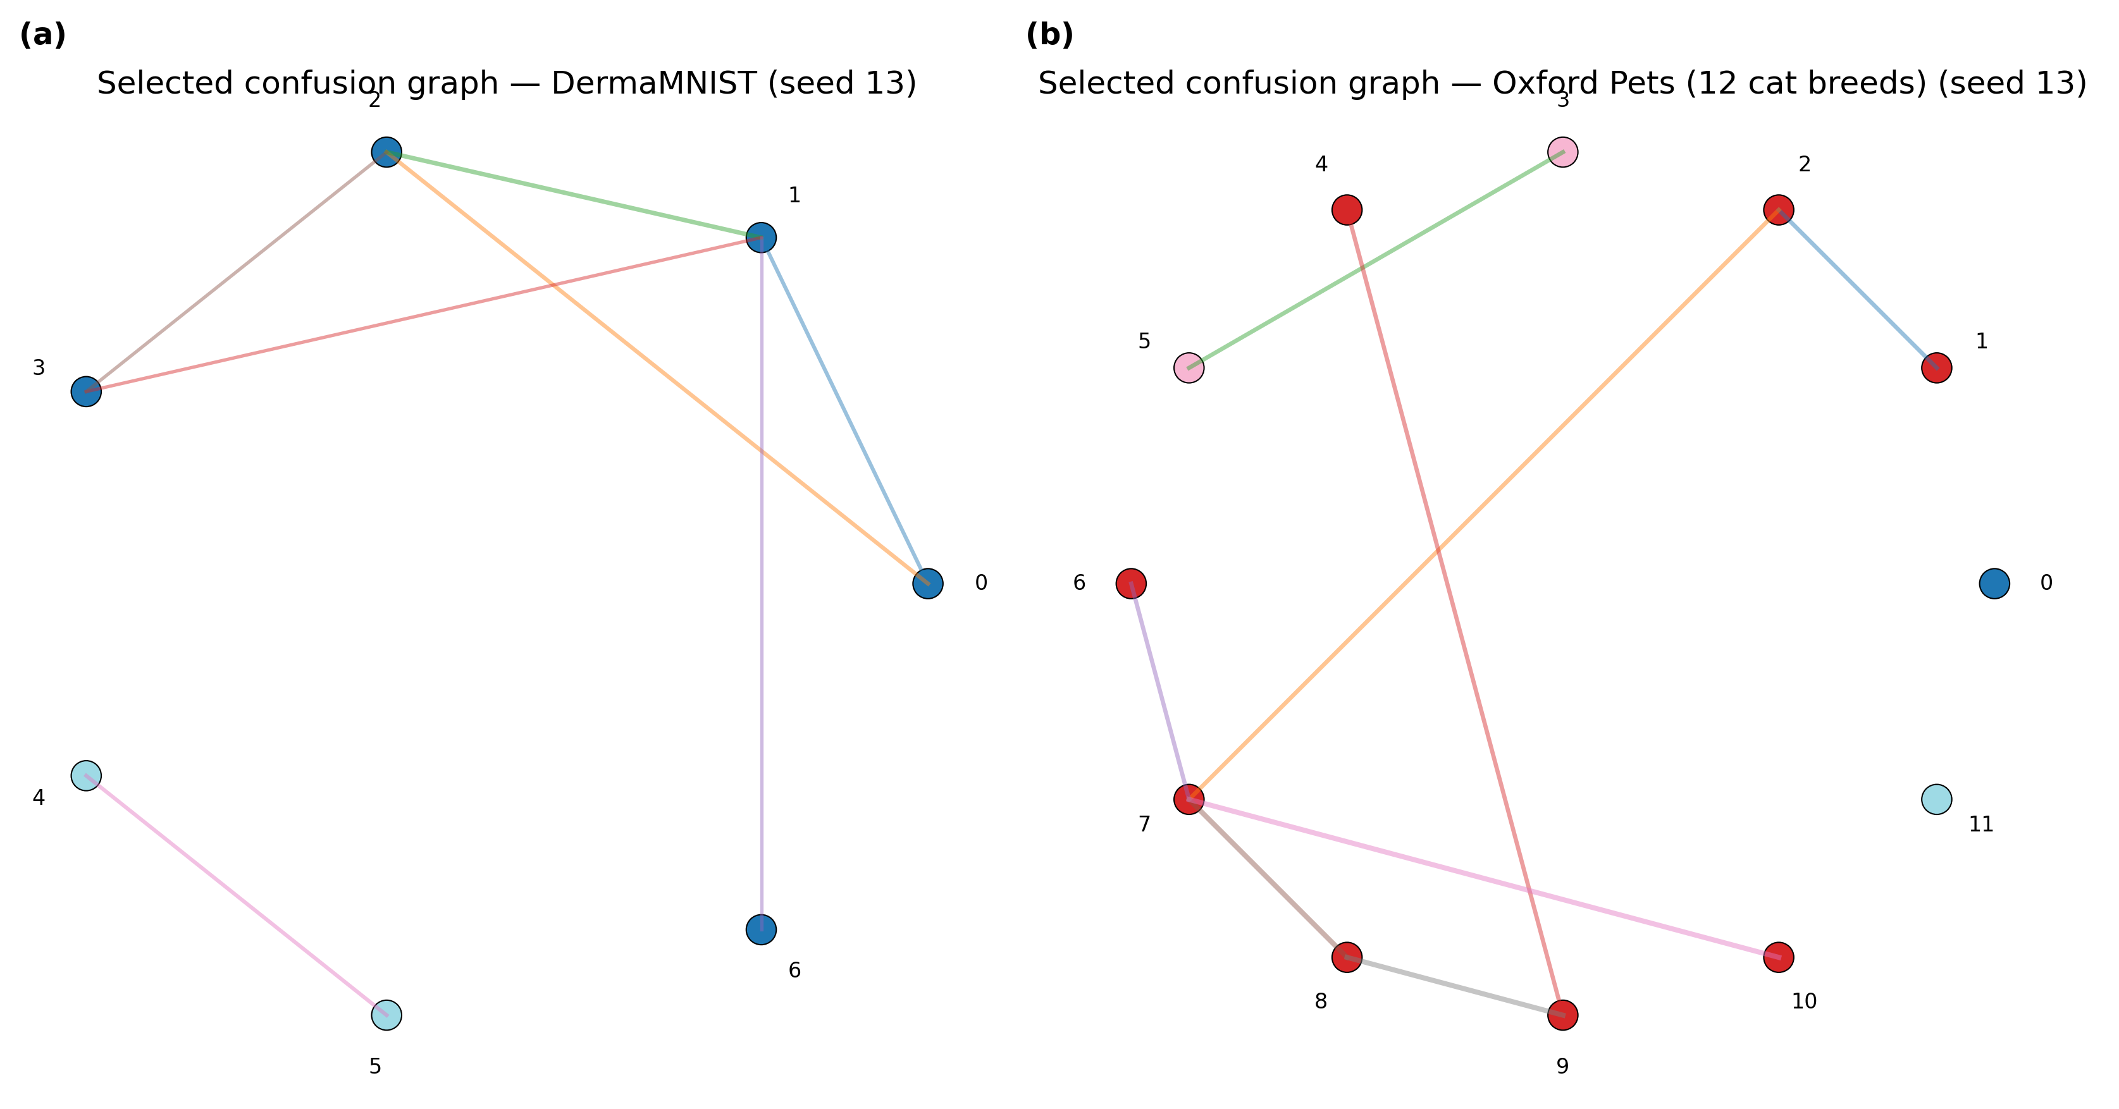
Fig. 1. Confusion graph selected at seed 13 for (a) DermaMNIST and (b) Oxford Pets (12 cat breeds). Nodes are classes, edges are confusion-graph connections kept above the selected threshold, and node color denotes the resulting neighborhood. Isolated nodes, such as class 0 in (b), fall back to the global temperature.
  - Datasets
Four datasets covering medical and natural images are used, meeting the minimum requirement of four datasets set out in the topic guide (Table 1).
DermaMNIST and BloodMNIST are taken from the MedMNIST v2 collection using their official splits. CIFAR-10 uses a class-stratified 85/15 split of its training set for training and validation and the official test set, with training capped at 700 images per class. Oxford Pets is restricted to the 12 cat breeds of the original 37-breed Oxford-IIIT Pet dataset (Abyssinian, Bengal, Birman, Bombay, British Shorthair, Egyptian Mau, Maine Coon, Persian, Ragdoll, Russian Blue, Siamese, and Sphynx), remapped to a contiguous 12-class label space, with all images resized to 64 by 64 pixels. For every dataset, the validation split is further divided in a class-stratified way into a model-selection subset and a calibration-development subset, and the calibration-development subset is itself split three ways for the structure, temperature-fit, and threshold-selection stages, so that no stage of CNTS reuses data seen by an earlier stage, and the test set is only used for the final scoring.
Table 1. Dataset overview. Imbalance ratio is the ratio between the maximum and minimum per-class count in the training split.
Dataset | Classes | Train | Val. | Test | Imbalance ratio
DermaMNIST | 7 | 3214 | 1003 | 2005 | 11.25
BloodMNIST | 8 | 6400 | 1712 | 3421 | 1.00
CIFAR-10 | 10 | 7000 | 7500 | 10000 | 1.00
Oxford Pets (12 cat breeds) | 12 | 831 | 357 | 1183 | 1.08
BloodMNIST and CIFAR-10 are close to class-balanced by construction or subsampling. DermaMNIST is naturally imbalanced. The Oxford Pets 12-breed subset is close to balanced since a roughly equal number of images is available for each breed.
  - Base Classifier and Training Procedure
For every dataset, a small convolutional network is trained from scratch. The network has four convolutional blocks with batch normalization, global average pooling, a width multiplier of 24, and about 137,000 parameters. Training runs for 6 epochs with AdamW at a learning rate of 6e-4, using mixed-precision training on a single GPU, light augmentation such as horizontal flipping, small rotations, and, for the non-medical datasets, color jitter, and a square-root inverse-frequency class-weighted cross-entropy loss to reduce the effect of class imbalance during training only. This weighting has no effect on calibration, which is applied afterward. One model is trained for each dataset and each random seed (seeds 13, 37, and 73), and the checkpoint with the best validation macro-F1 across epochs is kept. All four calibration variants, no calibration, global scaling, per-class scaling, and CNTS, are then computed from the same frozen model, so any difference between them comes only from the calibration procedure itself.
  - Evaluation Protocol
We report Expected Calibration Error (ECE) with 15 equal-width bins, an adaptive-binning ECE variant, negative log-likelihood (NLL), the multi-class Brier score, and classification accuracy, macro-F1, and macro-AUC, all computed once on the test set for each seed. For the comparison between CNTS and each baseline, we compute the seed-and-dataset-paired improvement for each metric and report the Wilcoxon signed-rank test p-value. Because four metrics are tested against the same pair of methods, a Holm-Bonferroni correction is applied across that family of tests before deciding significance at a level of 0.05.
- Results and Discussion
  - Calibration Does Not Change Accuracy, by Construction
Across all 48 runs (4 datasets by 3 seeds by 4 calibration variants), the maximum accuracy difference between any two calibration variants on the same trained model was 0.0 at machine precision, confirming that all three calibration methods are purely post-hoc rescalings that never change the predicted class. This means the accuracy columns in Table 2 are identical across all four methods within a dataset by design. The only quantities calibration can affect are ECE, adaptive ECE, NLL, Brier score, and, to a small degree, macro-AUC, since AUC depends on the ranking of the raw confidence score, which can shift slightly under neighborhood-specific rescaling.
Table 2. Main results, reported as mean plus or minus standard deviation across 3 seeds, for calibration quality (ECE, NLL, Brier) and discrimination (accuracy). Lower is better for ECE, NLL, and Brier; higher is better for accuracy.
Dataset | Method | ECE | NLL | Brier | Accuracy
DermaMNIST | No calibration | 0.0575 ± 0.0120 | 1.045 ± 0.070 | 0.505 ± 0.029 | 0.592
 | Global TS | 0.0615 ± 0.0107 | 1.034 ± 0.076 | 0.507 ± 0.028 | 0.592
 | Per-class TS | 0.0479 ± 0.0057 | 0.984 ± 0.059 | 0.481 ± 0.020 | 0.592
 | CNTS (proposed) | 0.0595 ± 0.0101 | 0.993 ± 0.055 | 0.488 ± 0.017 | 0.592
BloodMNIST | No calibration | 0.0915 ± 0.0177 | 0.421 ± 0.051 | 0.197 ± 0.025 | 0.875
 | Global TS | 0.0170 ± 0.0025 | 0.365 ± 0.064 | 0.181 ± 0.029 | 0.875
 | Per-class TS | 0.0182 ± 0.0092 | 0.347 ± 0.032 | 0.168 ± 0.018 | 0.875
 | CNTS (proposed) | 0.0150 ± 0.0037 | 0.359 ± 0.049 | 0.176 ± 0.026 | 0.875
CIFAR-10 | No calibration | 0.0643 ± 0.0212 | 1.418 ± 0.012 | 0.658 ± 0.005 | 0.485
 | Global TS | 0.0252 ± 0.0089 | 1.400 ± 0.014 | 0.652 ± 0.009 | 0.485
 | Per-class TS | 0.0197 ± 0.0047 | 1.383 ± 0.013 | 0.643 ± 0.003 | 0.485
 | CNTS (proposed) | 0.0216 ± 0.0079 | 1.391 ± 0.008 | 0.648 ± 0.004 | 0.485
Oxford Pets (12 cat breeds) | No calibration | 0.0273 ± 0.0068 | 2.328 ± 0.019 | 0.887 ± 0.007 | 0.187
 | Global TS | 0.0213 ± 0.0046 | 2.326 ± 0.016 | 0.887 ± 0.006 | 0.187
 | Per-class TS | 0.0354 ± 0.0040 | 2.330 ± 0.025 | 0.885 ± 0.008 | 0.187
 | CNTS (proposed) | 0.0325 ± 0.0084 | 2.331 ± 0.027 | 0.886 ± 0.007 | 0.187
TS stands for temperature scaling. Accuracy has zero standard deviation across methods within a dataset and seed by construction, as explained above; the value shown is the mean over the 3 seeds. The lowest ECE for each dataset is achieved by per-class scaling in three of the four datasets and by CNTS in BloodMNIST, though the difference from global scaling in that case is within one standard deviation.
  - CNTS Clearly Beats No Calibration, But Not Global or Per-Class Scaling
Table 3 summarizes the paired comparison of CNTS against each baseline, averaged over all 4 datasets and 3 seeds, giving 12 paired observations for each metric. Relative to no calibration, CNTS reduces mean ECE by 46.5% and adaptive ECE by 46.2%, improving 8 of 12 and 9 of 12 seed-dataset pairs respectively. This is the expected result, since any reasonable post-hoc calibration should outperform an uncalibrated model on average. The comparison against global temperature scaling is much closer: CNTS's mean ECE is actually 2.9% worse than global scaling, although its adaptive ECE is 5.4% better. Against per-class scaling, CNTS loses on ECE, NLL, and Brier score, with mean differences of -6.1%, -0.6%, and -0.9% respectively, and per-class scaling winning 7 of 12, 11 of 12, and 12 of 12 pairs on these three metrics.
Table 3. Paired comparison of CNTS against global temperature scaling, averaged over 4 datasets and 3 seeds, giving 12 paired observations. Wins and losses count seed-dataset pairs where CNTS improved or worsened the metric. The Holm-corrected p-value is the Wilcoxon signed-rank p-value after Holm-Bonferroni correction across the 4 metrics.
Metric | Mean improvement | Wins | Losses | p (raw) | p (Holm) | Significant
ECE | -0.0009 | 8 | 4 | 0.677 | 0.677 | No
Adaptive ECE | +0.0019 | 10 | 2 | 0.064 | 0.192 | No
NLL | +0.0129 | 9 | 3 | 0.110 | 0.220 | No
Brier | +0.0075 | 11 | 1 | 0.002 | 0.010 | Yes
Mean improvement is proposed method minus baseline, sign-adjusted so that a positive value always means CNTS is better. Only the Brier-score improvement over global scaling survives the Holm-Bonferroni correction. The differences in ECE, adaptive ECE, and NLL are not statistically significant at this sample size of 12.
This outcome is reported as it is, without reframing it as a partial success. In this experimental setting, the main advantage of CNTS over a properly tuned global temperature that is supported by the statistics is limited to the Brier score. This is consistent with the calibration-development sets in three of the four datasets being small, between 137 and 942 calibration-development samples split three ways for structure, fitting, and selection, which likely limits how reliably a confusion graph and its per-neighborhood temperatures can be estimated compared to a single, low-variance global scalar.
  - Reliability Diagrams and Confusion Structure
Fig. 2 shows reliability diagrams for one representative seed (seed 13) for each dataset, comparing all four calibration variants against the diagonal line of perfect calibration. Uncalibrated confidence is visibly above the diagonal, meaning the model is overconfident, in every dataset except Oxford Pets, where accuracy is low enough, at 18 to 21 percent against a chance level of 8.3 percent for 12 classes, that overconfidence is less pronounced and the reliability curve is comparatively noisy due to the small number of test samples in each confidence bin. The three calibrated variants, global, per-class, and CNTS, largely overlap on CIFAR-10 and DermaMNIST, which visually confirms the closeness reported in Table 3.
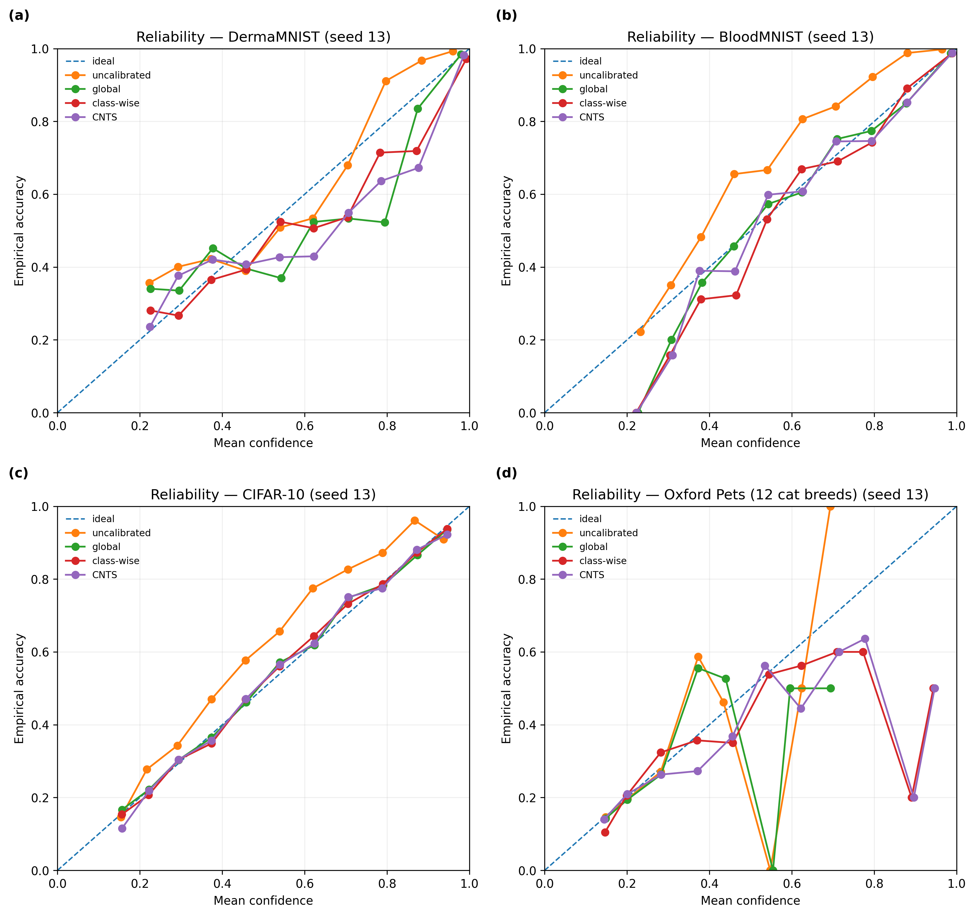
Fig. 2. Reliability diagrams for one representative seed (seed 13) for (a) DermaMNIST, (b) BloodMNIST, (c) CIFAR-10, and (d) Oxford Pets (12 cat breeds), comparing the uncalibrated model against global, per-class, and CNTS calibration. The curve in (d) is sparser and noisier, reflecting the smaller test-set bins and the low overall accuracy on this fine-grained, 12-class task.
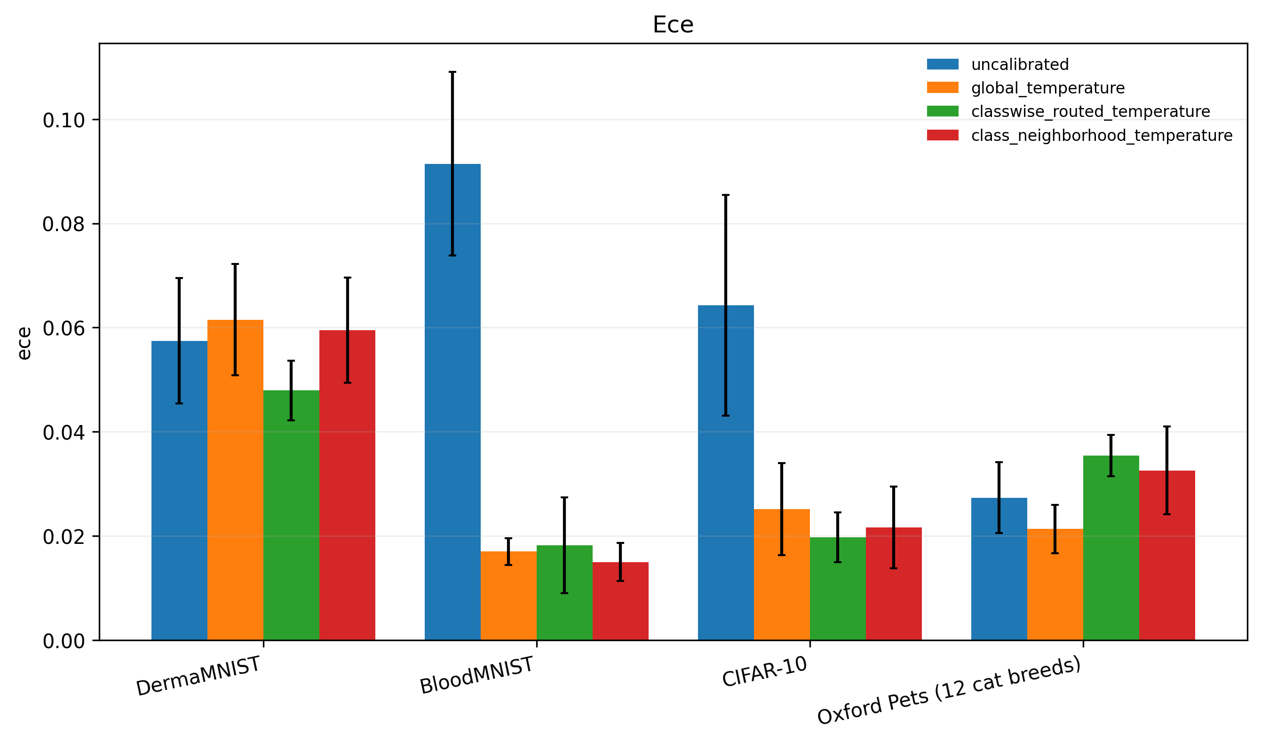
Fig. 3. Mean test ECE by dataset and calibration method, with error bars showing the standard deviation across 3 seeds. No single method dominates across all four datasets.
  - Selected Neighborhood Structure per Dataset
Table 4 reports the confusion-graph configuration selected by CNTS's own development-only threshold search, using the symmetric-mean graph mode, averaged over the three seeds. The number of neighborhoods selected is always strictly between one, which would correspond to global scaling, and the total number of classes, which would correspond to per-class scaling. This confirms that the method behaves as intended: it chooses an intermediate grouping rather than collapsing to either of the two baselines it is meant to interpolate between.
Table 4. Selected CNTS confusion-graph configuration for each dataset, using the symmetric-mean graph mode and averaged over 3 seeds. Fallback groups counts neighborhoods with fewer than 8 routed calibration-fit samples, which fall back to the global temperature.
Dataset | Classes | Neighborhoods per seed | Mean threshold | Fallback groups per seed
DermaMNIST | 7 | 2, 4, 4 | 0.172 | 0, 1, 1
BloodMNIST | 8 | 6, 6, 5 | 0.080 | 0, 0, 0
CIFAR-10 | 10 | 3, 3, 4 | 0.091 | 0, 0, 0
Oxford Pets (12 cat breeds) | 12 | 4, 2, 2 | 0.144 | 2, 1, 1
Oxford Pets has the most fallback groups, between 1 and 2 per seed out of 2 to 4 selected neighborhoods, which is consistent with its small calibration-development set of 191 samples spread over 12 classes.
  - Mechanism Analysis: Does Confusion Strength Predict Benefit?
The original hypothesis behind CNTS was that classes with stronger pairwise confusion, meaning a higher confusion-graph edge weight summed into a per-class confusion strength, should benefit more from neighborhood-level calibration than from a global temperature. Across all 103 class-seed-dataset observations with a defined prediction-conditional ECE for both global and neighborhood scaling, the Spearman correlation between confusion strength and the ECE improvement of CNTS over global scaling was -0.026 with a p-value of 0.796, shown in Fig. 4. This means there is no detectable relationship, and if anything a slightly negative one. This hypothesis is therefore not supported by our data.
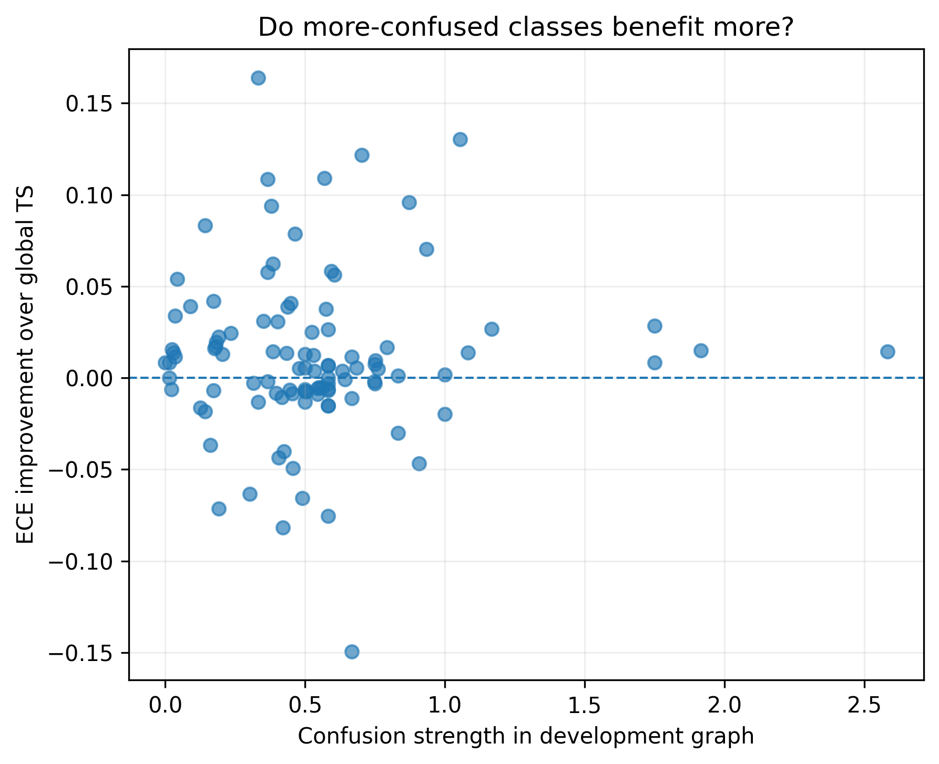
Fig. 4. Per-class ECE improvement of CNTS over global scaling plotted against confusion strength in the development graph, across 103 class, seed, and dataset observations. The Spearman correlation is -0.026 with p = 0.796, indicating no significant relationship.
One plausible explanation is that per-class ECE, computed on the small subset of test samples predicted as a given class, is itself a noisy quantity. Several classes in Oxford Pets and DermaMNIST had zero or fewer than 10 test predictions and were excluded from this analysis, which could mask a true but weak relationship. It is also possible that, once the classifier is reasonably well trained, confidence errors are driven more by sample-level factors, such as image difficulty, than by which other classes a given class is confused with in aggregate. In that case, coarse neighborhood grouping would not be expected to track calibration benefit well, which is consistent with the modest gains over global scaling reported earlier in this section.
  - Sensitivity to Calibration-Development Set Size
Table 5 and Fig. 5 show the mean test ECE, averaged across all 4 datasets and 3 seeds, when only 25, 50, or 100 percent of the calibration-development split is used to fit temperatures, holding the test set fixed. CNTS's mean ECE is lowest at 50 percent of the data, at 0.0297, and highest at 100 percent, at 0.0322, which is worse than global scaling's 0.0312 at the same fraction. This non-monotonic pattern suggests that a confusion-graph structure selected on more development data is not necessarily better calibrated on the test set than a structure selected on less. This points to the graph-based grouping mechanism not reliably capturing a stable, exploitable structure at these sample sizes, rather than to any particular data-efficiency advantage of CNTS.
Table 5. Mean test ECE by fraction of calibration-development data used, averaged over 4 datasets and 3 seeds, giving 12 observations per cell.
Fraction of data used | Global TS | Per-class TS | CNTS (proposed)
25% | 0.0333 | 0.0322 | 0.0301
50% | 0.0324 | 0.0301 | 0.0297
100% | 0.0312 | 0.0303 | 0.0322
TS stands for temperature scaling.
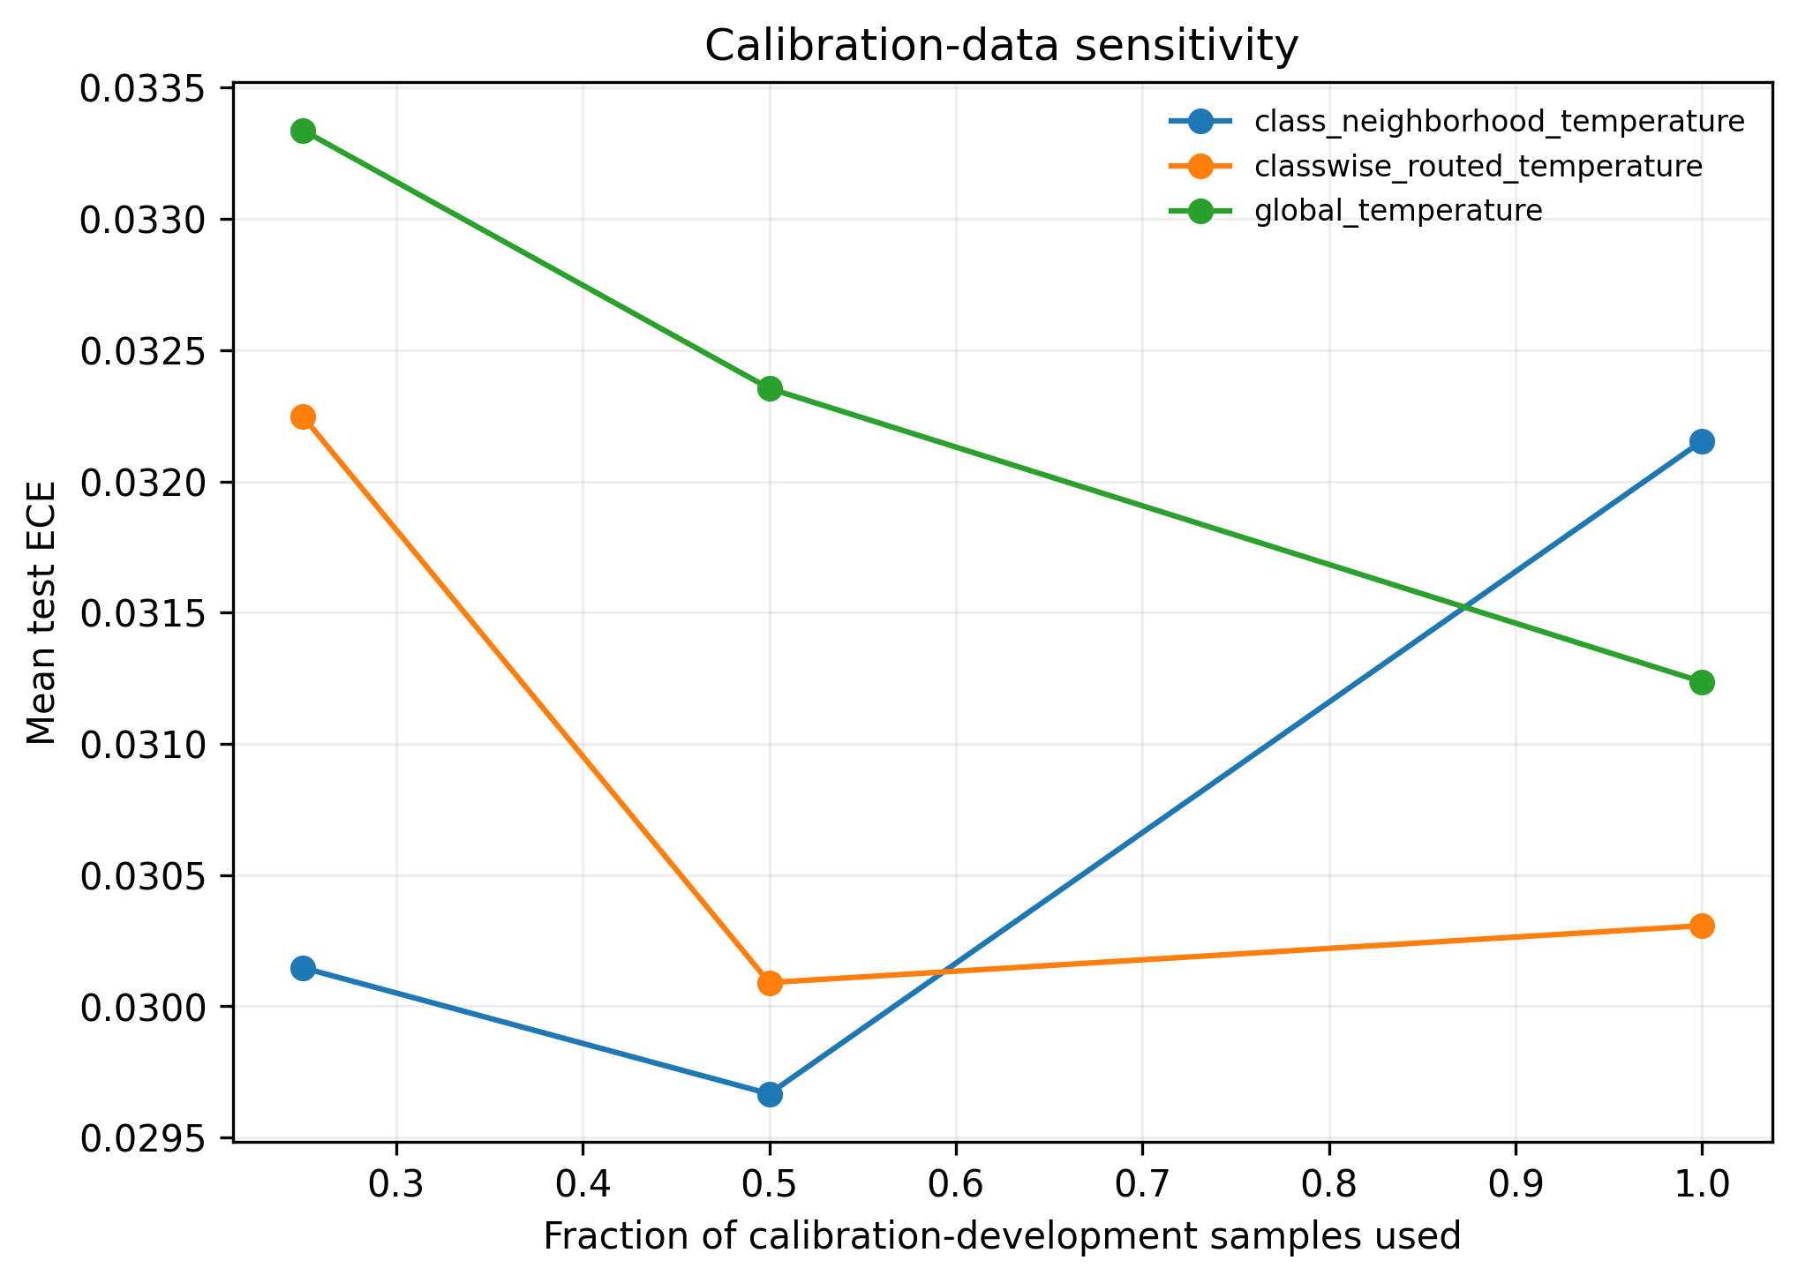
Fig. 5. Mean test ECE against the fraction of calibration-development data used, averaged over 4 datasets and 3 seeds.
  - Limitations
- Sample size: with only 3 seeds and 4 datasets, giving 12 paired observations per metric, the statistical power to detect small but real differences between CNTS and global scaling is limited. The reported lack of significance should not be read as strong evidence that the two methods are exactly equivalent, only as an absence of a detectable advantage at this scale.
- Small calibration-development sets: three of the four datasets have calibration-fit splits under 1000 samples, and Oxford Pets is under 200 samples, which likely disadvantages any method with more free parameters than global scaling, including both CNTS and per-class scaling.
- Oxford Pets accuracy: the 12-cat-breed classifier reaches only 18 to 21 percent accuracy against a chance level of 8.3 percent, because it is a small convolutional network trained from scratch for 6 epochs on 65 to 70 images per class, with no pretrained backbone. Because calibration methods are provably accuracy-preserving, as shown in Section 3.1, this does not invalidate the calibration comparison itself, but the resulting confidence estimates are being calibrated against a genuinely weak classifier, and some per-class ECE values used in the mechanism analysis were undefined due to zero test predictions for that class.
- Single graph construction rule: only the symmetric-mean confusion-graph variant is used in the main results. The directed-max variant is evaluated only within the threshold-ablation analysis and was never selected as better by the development NLL criterion in any dataset and seed combination in our runs, but a more exhaustive comparison between graph construction rules was outside the scope of this study.
- Conclusion
This paper proposed Class-Neighborhood Temperature Scaling (CNTS), a confusion-graph based method that interpolates between global and per-class temperature scaling, and evaluated it under a strict separation between development and test data on four datasets using a small convolutional network trained from scratch. CNTS is guaranteed by construction to leave classification accuracy unchanged, which is confirmed empirically. It clearly outperforms an uncalibrated model, with a 46.5 percent reduction in mean ECE, but its advantage over a properly tuned global temperature is small and, after correcting for multiple comparisons, statistically significant only for the Brier score. It is generally outperformed by simple per-class scaling in this setting. A direct test of the mechanism expected to drive the benefit of CNTS, namely that more confused classes should improve more under neighborhood grouping, found no significant relationship, with a Spearman correlation of -0.026 and a p-value of 0.796. These results are reported as measured, including the cases where the proposed method does not win, since this is considered more useful to future work than a selectively positive account. Future work could test CNTS with larger calibration-development sets, pretrained backbones, more classes and datasets to increase statistical power, and alternative confusion-graph constructions, for example using softmax probability mass rather than hard predictions, before drawing firmer conclusions about when neighborhood-level calibration is worthwhile.
- Author Contributions
The author conceived the study, implemented CNTS and all baseline calibration methods, designed and ran the experiments, carried out the statistical analysis, and wrote the manuscript.
- Data Availability
DermaMNIST and BloodMNIST are distributed by the MedMNIST v2 project at medmnist.com under their respective licenses. CIFAR-10 is distributed by the University of Toronto. The Oxford-IIIT Pet dataset is distributed by the Visual Geometry Group at the University of Oxford under a Creative Commons Attribution-ShareAlike 4.0 International License, and this work uses only the 12 cat-breed classes of the original 37. Code implementing CNTS, the baseline calibration methods, and the full experiment pipeline is available from the author upon request.
- Acknowledgement
The author thanks the maintainers of the MedMNIST, CIFAR-10, and Oxford-IIIT Pet datasets for making their data publicly available for research use.

References
1. Filus, K., Domańska, J.: How CNNs and ViTs Perceive Similarities Between Categories. In: Lecture Notes in Computer Science (2025). https://doi.org/10.1007/978-3-032-06078-5_2.
2. Ghosh, A., Schaaf, T., Gormley, M.: AdaFocal: Calibration-aware Adaptive Focal Loss. In: Advances in Neural Information Processing Systems (2022). https://doi.org/10.52202/068431-0116.
3. Rajaraman, S., Ganesan, P., Antani, S.: Deep learning model calibration for improving performance in class-imbalanced medical image classification tasks. PLoS One. 17, (2022). https://doi.org/10.1371/journal.pone.0262838.
4. Watson, S.I., Akinyemi, J.O., Hemming, K.: Permutation-based multiple testing corrections for -values and confidence intervals for cluster randomized trials. Stat. Med. 42, (2023). https://doi.org/10.1002/sim.9831.
5. Balanya, S.A., Maroñas, J., Ramos, D.: Adaptive temperature scaling for Robust calibration of deep neural networks. Neural Comput. Appl. 36, (2024). https://doi.org/10.1007/s00521-024-09505-4.
6. Minderer, M., Djolonga, J., Romijnders, R., Hubis, F., Zhai, X., Houlsby, N., Tran, D., Lucic, M.: Revisiting the Calibration of Modern Neural Networks. In: Advances in Neural Information Processing Systems (2021).
7. Silva Filho, T., Song, H., Perello-Nieto, M., Santos-Rodriguez, R., Kull, M., Flach, P.: Classifier calibration: a survey on how to assess and improve predicted class probabilities. Mach. Learn. 112, (2023). https://doi.org/10.1007/s10994-023-06336-7.
8. Rainio, O., Teuho, J., Klén, R.: Evaluation metrics and statistical tests for machine learning. Sci. Rep. 14, (2024). https://doi.org/10.1038/s41598-024-56706-x.
9. Frenkel, L., Goldberger, J.: Network Calibration by Class-based Temperature Scaling. In: European Signal Processing Conference (2021). https://doi.org/10.23919/EUSIPCO54536.2021.9616219.
10. Liu, B., Rony, J., Galdran, A., Dolz, J., Ayed, I. Ben: Class Adaptive Network Calibration. In: Proceedings of the IEEE Computer Society Conference on Computer Vision and Pattern Recognition (2023). https://doi.org/10.1109/CVPR52729.2023.01542.
11. Jung, S., Seo, S., Jeong, Y., Choi, J.: Scaling of Class-wise Training Losses for Post-hoc Calibration. In: Proceedings of Machine Learning Research (2023).
12. Hwang, H., Park, E., Shin, J.: Chain Graph Explanation of Neural Network Based on Feature-Level Class Confusion. Applied Sciences (Switzerland). 12, (2022). https://doi.org/10.3390/app12031523.
13. Riehl, K., Neunteufel, M., Hemberg, M.: Hierarchical confusion matrix for classification performance evaluation. J. R. Stat. Soc. Ser. C Appl. Stat. 72, (2023). https://doi.org/10.1093/jrsssc/qlad057.
14. Görtler, J., Hohman, F., Moritz, D., Wongsuphasawat, K., Ren, D., Nair, R., Kirchner, M., Patel, K.: Neo: Generalizing Confusion Matrix Visualization to Hierarchical and Multi-Output Labels. In: Conference on Human Factors in Computing Systems - Proceedings (2022). https://doi.org/10.1145/3491102.3501823.
15. Berrar, D.: Using p-values for the comparison of classifiers: pitfalls and alternatives. Data Min. Knowl. Discov. 36, (2022). https://doi.org/10.1007/s10618-022-00828-1.
16. Nariya, M.K., Mills, C.E., Sorger, P.K., Sokolov, A.: Paired evaluation of machine-learning models characterizes effects of confounders and outliers. Patterns. 4, (2023). https://doi.org/10.1016/j.patter.2023.100791.
17. Lee, J.K., Mukhanov, L., Molahosseini, A.S., Minhas, U., Hua, Y., Martinez Del Rincon, J., Dichev, K., Hong, C.H., Vandierendonck, H.: Resource-Efficient Convolutional Networks: A Survey on Model-, Arithmetic-, and Implementation-Level Techniques. ACM Comput. Surv. 55, (2023). https://doi.org/10.1145/3587095.
18. Ao, S., Rueger, S., Siddharthan, A.: Two Sides of Miscalibration: Identifying Over and Under-Confidence Prediction for Network Calibration. In: Proceedings of Machine Learning Research (2023).
19. Ghimire, D., Kil, D., Kim, S.H.: A Survey on Efficient Convolutional Neural Networks and Hardware Acceleration, (2022). https://doi.org/10.3390/electronics11060945.
20. Gawlikowski, J., Tassi, C.R.N., Ali, M., Lee, J., Humt, M., Feng, J., Kruspe, A., Triebel, R., Jung, P., Roscher, R., Shahzad, M., Yang, W., Bamler, R., Zhu, X.X.: A survey of uncertainty in deep neural networks. Artif. Intell. Rev. 56, (2023). https://doi.org/10.1007/s10462-023-10562-9.
21. Zhong, Z., Cui, J., Liu, S., Jia, J.: Improving calibration for long-tailed recognition. In: Proceedings of the IEEE Computer Society Conference on Computer Vision and Pattern Recognition (2021). https://doi.org/10.1109/CVPR46437.2021.01622.
22. Marx, C., Zalouk, S., Ermon, S.: Calibration by Distribution Matching: Trainable Kernel Calibration Metrics. In: Advances in Neural Information Processing Systems (2023). https://doi.org/10.52202/075280-1127.
23. Popordanoska, T., Sayer, R., Blaschko, M.B.: A Consistent and Differentiable Lp Canonical Calibration Error Estimator. In: Advances in Neural Information Processing Systems (2022). https://doi.org/10.52202/068431-0576.

