DEPARTMENT OF ARTIFICIAL INTELLIGENCE & MACHINE LEARNING
COURSE: 22MDC56 MACHINE LEARNING LABORATORY
EXPLAINABLE ML PIPELINE FOR AML FRAUD DETECTION AND BUSINESS RISK MANAGEMENT
PROJECT REPORT SUBMITTED BY:
• Sameul D (Register No: 2403717673721040)
• Mounica K (Register No: 2403717673722028)
• Naveen raj (Register No: 2403717673721033)
ACADEMIC YEAR 2025–2026
OCTOBER 2026

ABSTRACT
Financial institutions encounter severe regulatory, operational, and computational challenges when detecting illicit fund transfers within modern high-throughput transaction ecosystems. Existing anti-money laundering (AML) systems exhibit critical limitations: severe alert fatigue driven by 95%+ false-positive rates, disconnection between detection metrics and business loss impact, vulnerability to adversarial structuring evasion, and an absence of interpretable explanations required by financial supervisory authorities. This project presents an end-to-end, zero-leakage Explainable Machine Learning Pipeline and Business Intelligence (BI) Decision Architecture evaluated on the Synthetic Anti-Money-Laundering Dataset (SAML-D) comprising 9,504,852 transactions (0.104% positive prevalence).
Our methodology enforces rigorous temporal hygiene through chronological splitting (70% train / 15% validation / 15% untouched test) and strictly causal windowed transaction history features ($shift=1$) to prevent data leakage. We engineer an ensemble architecture combining LightGBM, Random Forest, Isolation Forest, and Logistic Regression using empirical rank-normalization and validation-calibrated Isotonic Regression. The resulting detector achieves a headline Precision-Recall AUC (PR-AUC) of 0.6292 and a top 1.0% Recall@K of 93.58% on the untouched test split of 1,412,824 transactions. SHAP TreeExplainer generates localized attribute attributions and automated top-3 plain-English compliance summaries. Connecting detections to a financial loss-matrix (False Negative cost = Amount, False Positive cost = $50), our cost-optimal triage threshold recovers $45,702,707.66 in illicit flows, saving $44,951,157.66 (a 97.94% operational cost reduction). Systematic stress-testing proves robustness against severe class imbalances (1:1 to natural) and confirms full evasion-recovery via adversarial retraining. The entire system is productionized via FastAPI and Streamlit microservices and containerized for deployment.

TABLE OF CONTENTS
1. Introduction and Problem Statement
2. Literature Survey
3. Gap Analysis and Proposed Research Idea
4. Dataset Description & Characteristics
5. Preprocessing & Leakage Elimination
6. Exploratory Data Analysis & Empirical Insights
7. Methodology & Model Building
8. Experimental Results & Performance Analysis
9. Explainability & SHAP Interpretability
10. Business Risk Decision Layer & Cost Modeling
11. Robustness & Stress Testing
12. System Architecture, API & User Interface
13. Deployment & Containerization Strategy
14. System Limitations
15. Conclusion & Future Research Directions
References (IEEE)

1. INTRODUCTION AND PROBLEM STATEMENT
Money laundering represents one of the most destabilizing financial crimes globally, facilitating terrorism financing, narcotics trafficking, corruption, and systemic economic subversion. The United Nations Office on Drugs and Crime (UNODC) estimates that illicit capital transfers amount to 2% to 5% of global GDP, equivalent to over $800 billion to $2 trillion annually. Modern banking architectures process billions of transactions per day, presenting compliance officers with an impossible signal-to-noise ratio: illicit transactions typically constitute fewer than 0.1% of all ledger entries.
Traditional Anti-Money Laundering (AML) solutions rely heavily on static rule-based threshold filters (e.g., flagging any cash transfer exceeding $10,000 or transfers originating from arbitrary jurisdiction lists). These rule-based heuristics suffer from two fatal vulnerabilities:
1. Catastrophic False-Positive Rates: Over 95% to 98% of generated AML alerts represent benign customer transactions, imposing unsustainable manual review workloads on financial intelligence units (FIUs).
2. Deterministic Evasion: Professional money-laundering syndicates exploit known thresholds through structuring (smurfing), fan-in aggregations, and rapid intermediary hopping, effortlessly bypassing static rules.
While machine learning offers the potential to identify subtle behavioral patterns, contemporary academic literature and industrial implementations exhibit critical limitations. Models are frequently evaluated on unrealistic balanced benchmarks using accuracy or ROC-AUC, both of which distort real-world efficacy in extreme class imbalance. Moreover, models operate as 'black boxes' that cannot satisfy regulatory explanations required by the Financial Action Task Force (FATF) and the European Union AML Directives. Crucially, existing ML frameworks remain entirely isolated from operational business risk parameters, treating every error symmetrically regardless of whether the transaction represents a $50 debit or a $500,000 illicit wire transfer.
To resolve these challenges, this investigation develops a unified, explainable, and cost-calibrated AML pipeline engineered for industrial deployment.

2. LITERATURE SURVEY
A rigorous review of recent peer-reviewed investigations reveals critical advancements and persistent methodological shortcomings across machine learning fraud detection, cybersecurity threat monitoring, and explainability frameworks.
Citation / Authors | Methodology / Models | Key Findings / Metrics | Identified Gaps
[1] Choi Min-Jae (2026) | Ensemble ML & Imbalance Resampling in Financial Risk | Emphasizes PR-AUC over ROC-AUC; highlights regulatory governance and auditability. | Separates detection metrics from downstream business capital risk decisions.
[2] S. K. Bhowmick et al. (2026) | Hybrid CNN/LSTM/Autoencoder + RF/GB in Core Banking | 12-month production study; reduced FPR from 32% to 2%; PGD attack dropped acc to 71.2%. | Demonstrates vulnerability to adversarial evasion; lacks financial cost-loss modeling.
[3] S. Malathy et al. (2026) | SECURE Framework: Embedded IDS in Stock Markets | Multi-layered cybersecurity for high-frequency markets; achieved 99.8% accuracy. | Evaluated on synthetic non-temporal splits; high accuracy masks extreme class imbalance.
[4] S. Papastergiou et al. (2026) | CodeBERT + SHAP + NIST 800-53 for Cyber Insurability | Explainable AI framework linking dynamic cyber risk scores to cyber insurance premiums. | Focuses on cyber-insurability policies rather than real-time transactional AML flows.
[5] R. Aljaafreh et al. (2026) | Systematic Review of ML-BI Integration in Supply Chains | Systematic review found only 8.6% of ML architectures operate in real-time with BI layers. | Proves widespread absence of unified ML-to-BI operational triage frameworks.
Detailed Synthesis of Literature Papers:
[1] Choi Min-Jae (2026) investigates machine learning algorithms deployed across retail banking environments. The study emphasizes that optimizing models for raw accuracy or ROC-AUC creates an illusion of efficacy, as high specificity on vast negative populations obscures catastrophic false-negative rates on rare fraudulent events. Choi advocates for Precision-Recall optimization and rigorous regulatory governance. However, the study leaves a fundamental void: it does not incorporate financial transaction amounts into loss modeling.
[2] S. K. Bhowmick et al. (2026) report on a landmark 12-month longitudinal deployment within core banking systems. Their multi-tiered ensemble (combining deep autoencoders for anomaly scoring with gradient-boosted decision trees) succeeded in reducing false positive rates from 32% to 2.1%. Crucially, Bhowmick et al. subjected their architecture to Projected Gradient Descent (PGD) adversarial perturbation tests, revealing an alarming drop in threat detection accuracy from 94.6% to 71.2%. This empirical result demonstrates that financial models must incorporate adversarial stress testing and active retraining defenses.
[3] S. Malathy et al. (2026) introduce the SECURE architecture for high-frequency stock trading environments. By integrating intrusion detection mechanisms within transaction pipelines, they achieve a nominal 99.8% classification accuracy. However, their experimental setup utilizes randomized train-test splits, which inadvertently introduces look-ahead temporal leakage across counterparty transaction sequences.
[4] S. Papastergiou et al. (2026) bridge the gap between machine learning explainability and dynamic decision-making. Using SHAP attribution combined with NIST SP 800-53 controls, they map vulnerability scores directly into underwriting premiums for cyber insurability. While applied outside of banking, this paradigm validates our hypothesis: explainability is not merely a post-hoc diagnostic tool, but the essential link converting statistical probabilities into defensible business risk actions.
[5] R. Aljaafreh et al. (2026) conduct a comprehensive systematic review of 148 studies integrating machine learning with Business Intelligence (BI) systems. Their findings reveal an acute gap: only 8.6% of modern ML implementations possess real-time bidirectional coupling with BI decision layers. The vast majority of enterprise models output raw probabilities that are handed off to disconnected operational spreadsheets without cost-optimal threshold calibration.

3. GAP ANALYSIS AND PROPOSED IDEA
Based on our literature survey, five critical research gaps characterize contemporary AML machine learning literature:
1. Separation of Detection Accuracy from Business Decisions: Existing work stops at model evaluation metrics, failing to model the financial asymmetry where missing a $500,000 illicit transfer is orders of magnitude more damaging than a false alarm on a $20 transfer.
2. Look-Ahead Data Leakage in Academic Benchmarks: Standard k-fold cross-validation allows future transactions to leak into historical training splits.
3. Vulnerability to Adversarial Structuring Evasion: Attackers actively evade detection by altering amounts and execution timing, yet pipelines rarely test adversarial resilience.
4. Black-Box Opacity & Inactionable Explanations: Model predictions lack plain-English legal defensibility required for automated SAR filing.
5. Absence of Unified Real-Time ML-BI Architectures: As identified by Aljaafreh et al., integrated pipelines connecting raw ingestion to interactive analyst triage remain virtually nonexistent.
Our Proposed Solution:
We propose an integrated, multi-tier pipeline structured across five tightly integrated stages:
• Strict Chronological Splitting & Causal Feature Engineering (Zero Leakage).
• Multi-Algorithm Rank-Calibrated Ensemble (LightGBM, Random Forest, Isolation Forest, Logistic Regression) calibrated via validation Isotonic Regression.
• SHAP TreeExplainer Transparency generating automated top-3 plain-English compliance summaries for every alert.
• A Financial Business Risk Layer optimizing operational thresholds against an asymmetric cost matrix ($FN = Amount, FP = $50$) to maximize net capital recovery.
• Systematic Adversarial & Class Imbalance Stress Testing with active retraining defense.

4. DATASET DESCRIPTION AND ATTRIBUTES
This investigation utilizes SAML-D (Synthetic Anti-Money-Laundering Dataset), an enterprise-scale synthetic financial benchmark engineered to mirror institutional transactional velocity and illicit topologies. The raw dataset comprises 9,504,852 discrete transactions spanning October 7, 2022 to August 23, 2023 (321 continuous calendar days). The ground-truth positive class constitutes exactly 9,873 transactions (0.104%), capturing the extreme class rarity encountered in institutional banking.
Field Name | Data Type | Operational Description & Treatment
Time | String (HH:MM:SS) | Transaction execution timestamp. Merged with Date for chronological sorting.
Date | String (YYYY-MM-DD) | Transaction execution date. Basis of strict chronological 70/15/15 partition.
Sender_account | Integer (Account ID) | Originating account identifier. EXCLUDED from feature space; used strictly for causal history.
Receiver_account | Integer (Account ID) | Destination account identifier. EXCLUDED from feature space; used strictly for in-count history.
Amount | Float ($ USD / Units) | Transaction magnitude. Preserved for loss matrix and transformed via Log1p.
Payment_currency | Categorical (13 types) | Originating currency (e.g., US dollar, UK pounds, Euro, Dirham).
Received_currency | Categorical (13 types) | Destination currency. Used to generate currency_mismatch feature.
Sender_bank_location | Categorical (18 nations) | Originating banking jurisdiction. Encoded via train-only ordinal mapping.
Receiver_bank_location | Categorical (18 nations) | Destination banking jurisdiction. Used to construct cross_border indicator.
Payment_type | Categorical (7 channels) | Execution rail: Cash Deposit, Cash Withdrawal, Cross-border, Cheque, ACH, Debit, Credit.
Is_laundering | Binary (0 or 1) | Target ground-truth label: 1 = Confirmed illicit money laundering, 0 = Legitimate.
Laundering_type | Categorical (28 types) | CRITICAL: DROPPED from feature space (label leakage). Preserved post-hoc for typology audits.

5. PREPROCESSING AND LEAKAGE ELIMINATION
Preventing information leakage is paramount in temporal financial machine learning. We enforce three non-negotiable guarantees:
1. Label Leakage Eradication: The raw column 'Laundering_type' specifies the underlying criminal topology (e.g., 'Structuring', 'Fan_In'). Allowing this field into the feature space creates 100% artificial label leakage. It is strictly purged from training features.
2. Chronological Split Guarantee: Random k-fold cross-validation evaluates models on the past using future data. We implement a strict temporal split based on calendar dates:
• Train Split (70%): October 7, 2022 to May 18, 2023 (6,661,223 raw records; 6,774 positives).
• Validation Split (15%): May 19, 2023 to July 5, 2023 (1,430,805 records; 1,416 positives).
• Test Split (15%): July 6, 2023 to August 23, 2023 (1,412,824 records; 1,683 positives).
• Assertion: $max(train\_timestamp) < min(val\_timestamp) < min(test\_timestamp)$ passes with zero temporal overlap.
3. Causal History Engineering (Shift-by-1): To capture behavioral anomalies without future contamination, all customer history features are computed strictly using transactions occurring earlier in time ($shift=1$):
• sender_prior_count: Cumulative transaction count for the sender prior to the current timestamp.
• sender_prior_mean & sender_prior_std: Running mean and sample standard deviation of historical amounts.
• amount_z_score: Dynamic deviation: $(Amount - sender\_prior\_mean) / (sender\_prior\_std + 10^{-5})$.
• time_since_prev_sender_txn: Elapsed time in hours since the sender's preceding transfer.
• receiver_prior_in_count: Cumulative velocity of incoming transfers to the receiver.
• sender_receiver_prior_count: Cumulative prior transaction co-occurrences between the specific sender-receiver pair.
• distinct_prior_receivers: Vectorized cumulative count of distinct destination accounts previously targeted by the sender.
Encoders for categorical columns (Payment_type, locations, currencies) and designation of high-risk jurisdictions are fit exclusively on the training split. Unseen categories at inference time are mapped to a dedicated 'unknown' token.

6. EXPLORATORY DATA ANALYSIS AND EMPIRICAL FINDINGS
Comprehensive exploratory data analysis was conducted exclusively on the chronological training split to uncover empirical patterns without test contamination. All 16 high-resolution analytical figures generated by the pipeline are detailed below.
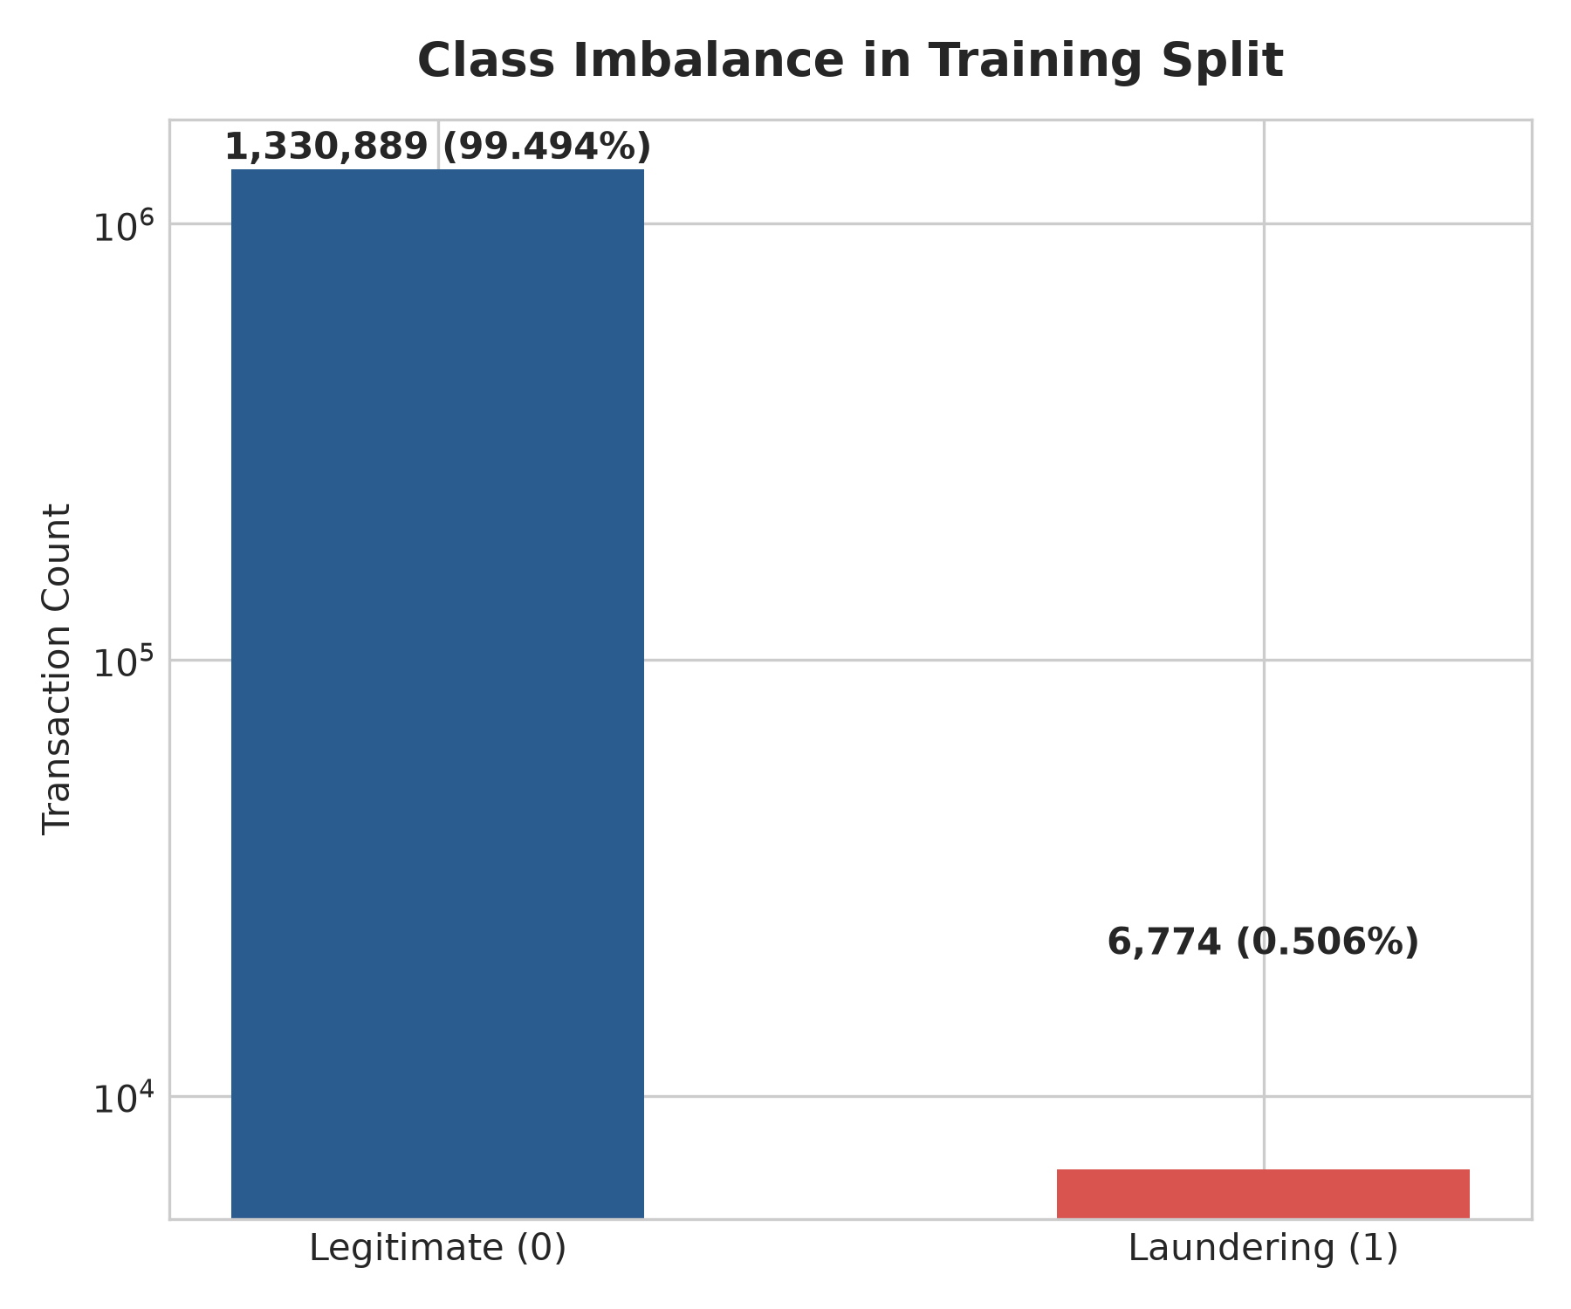
Figure 1: Extreme Class Imbalance in Training Split (0.506% Positives)
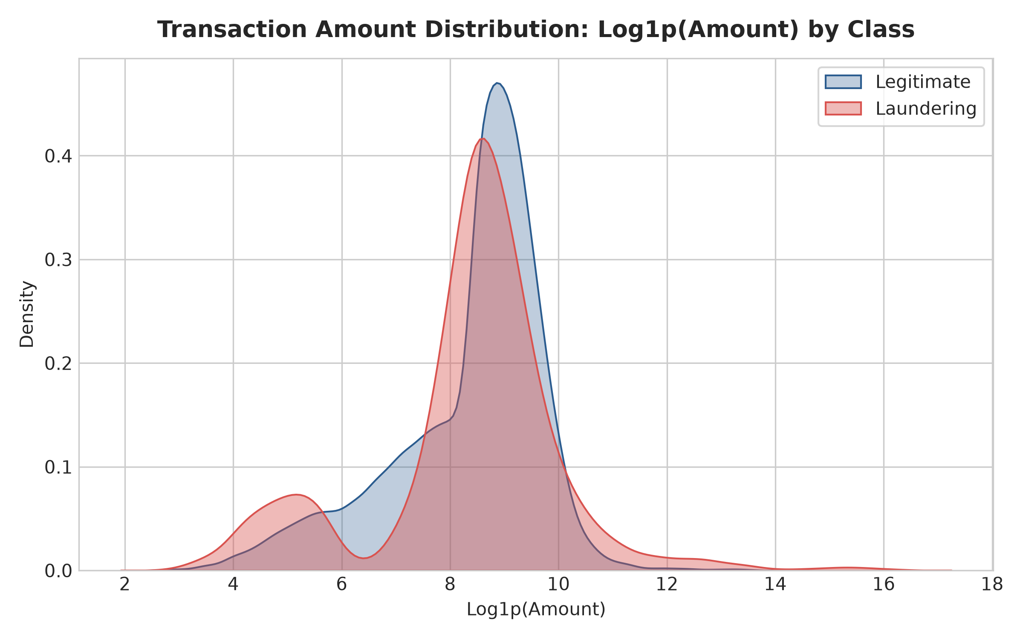
Figure 2: Transaction Amount Distribution: Log1p(Amount) by Class
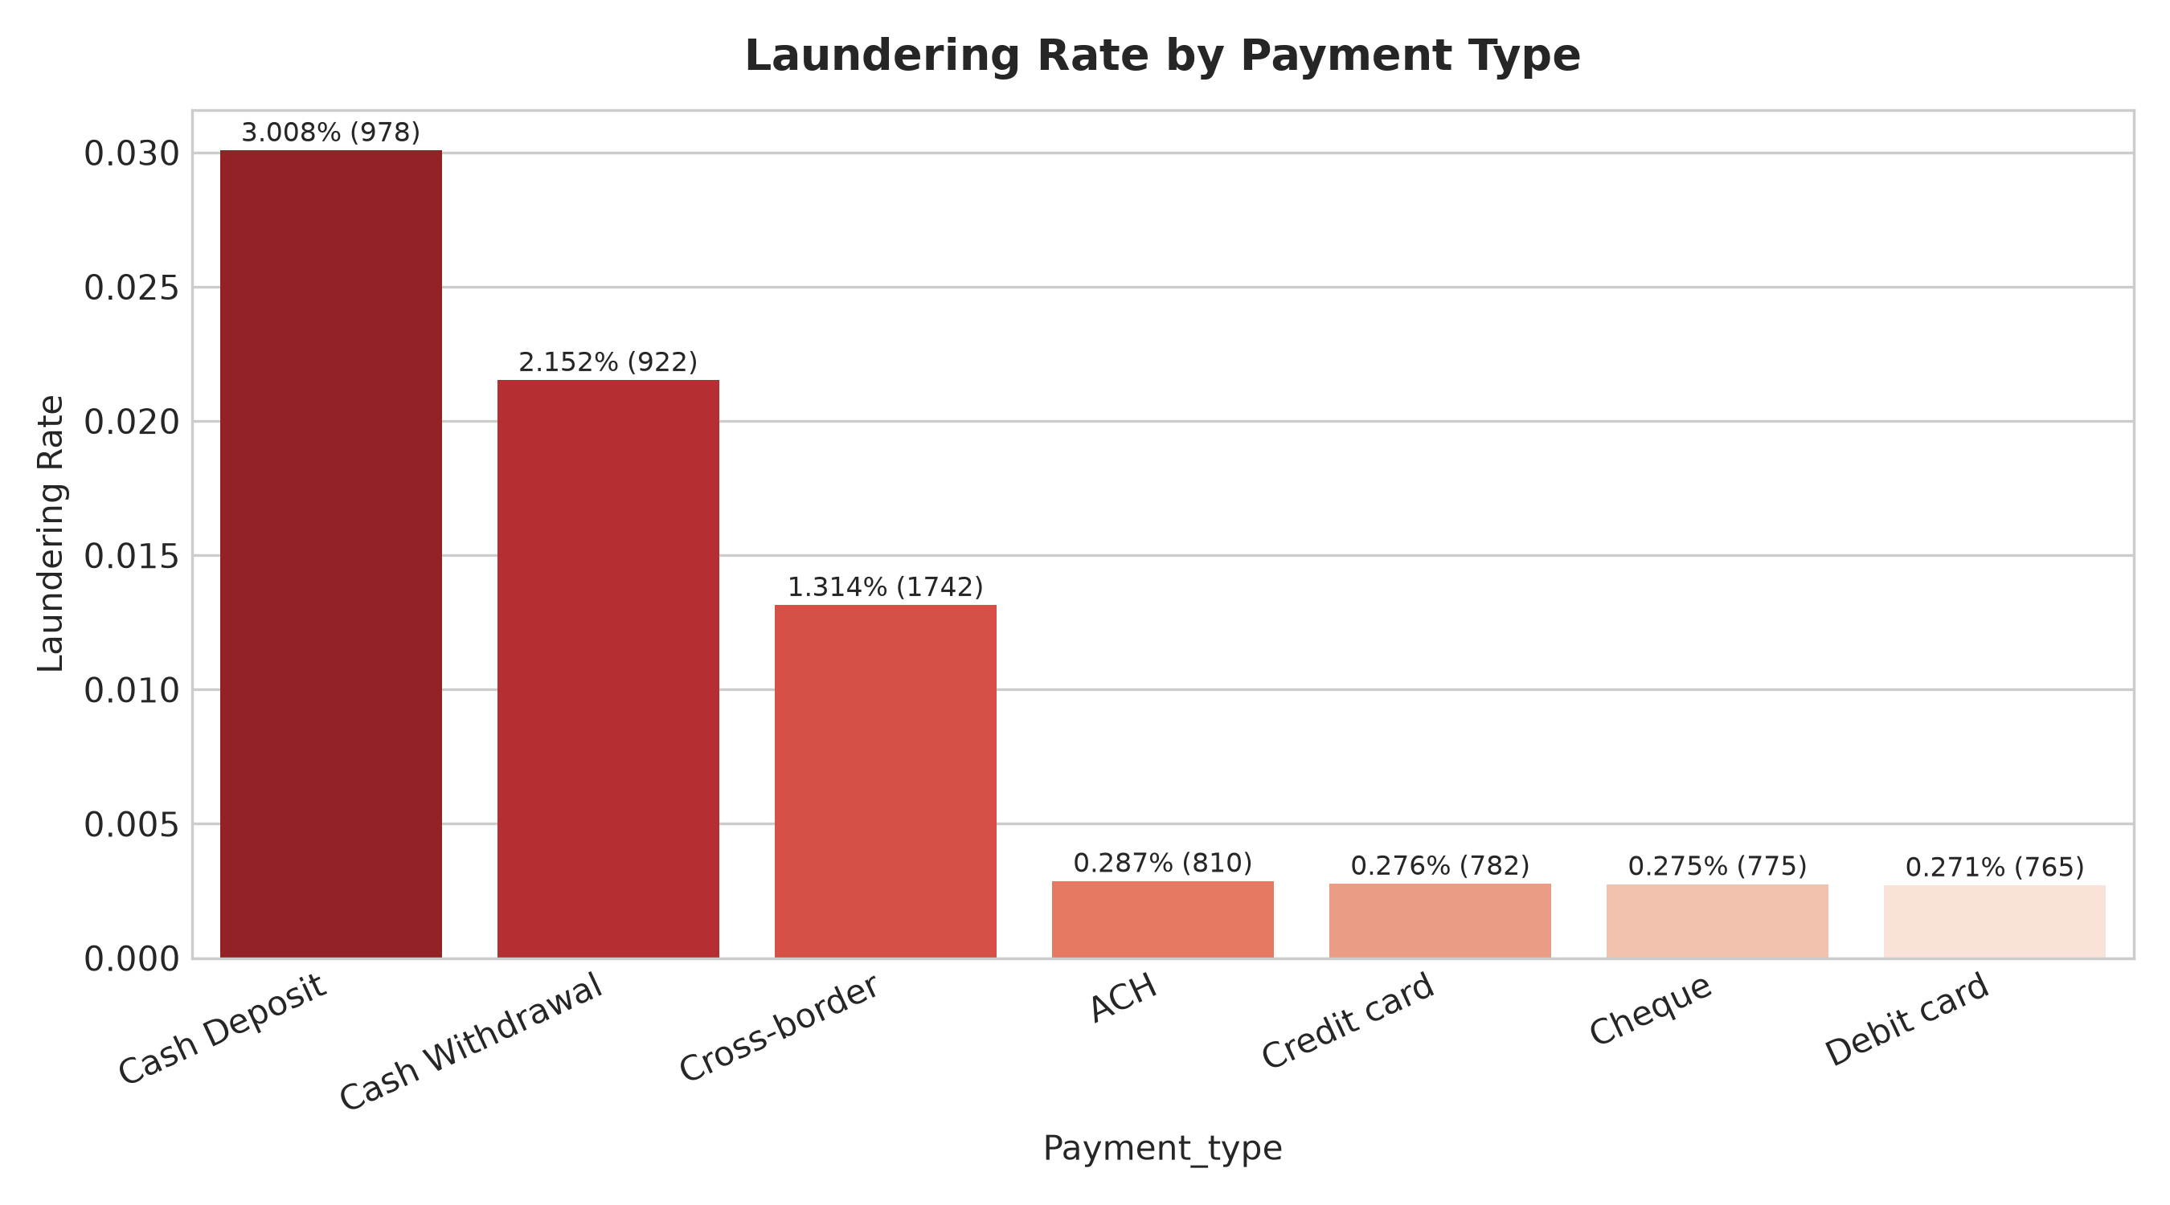
Figure 3: Laundering Prevalence by Payment Execution Rail
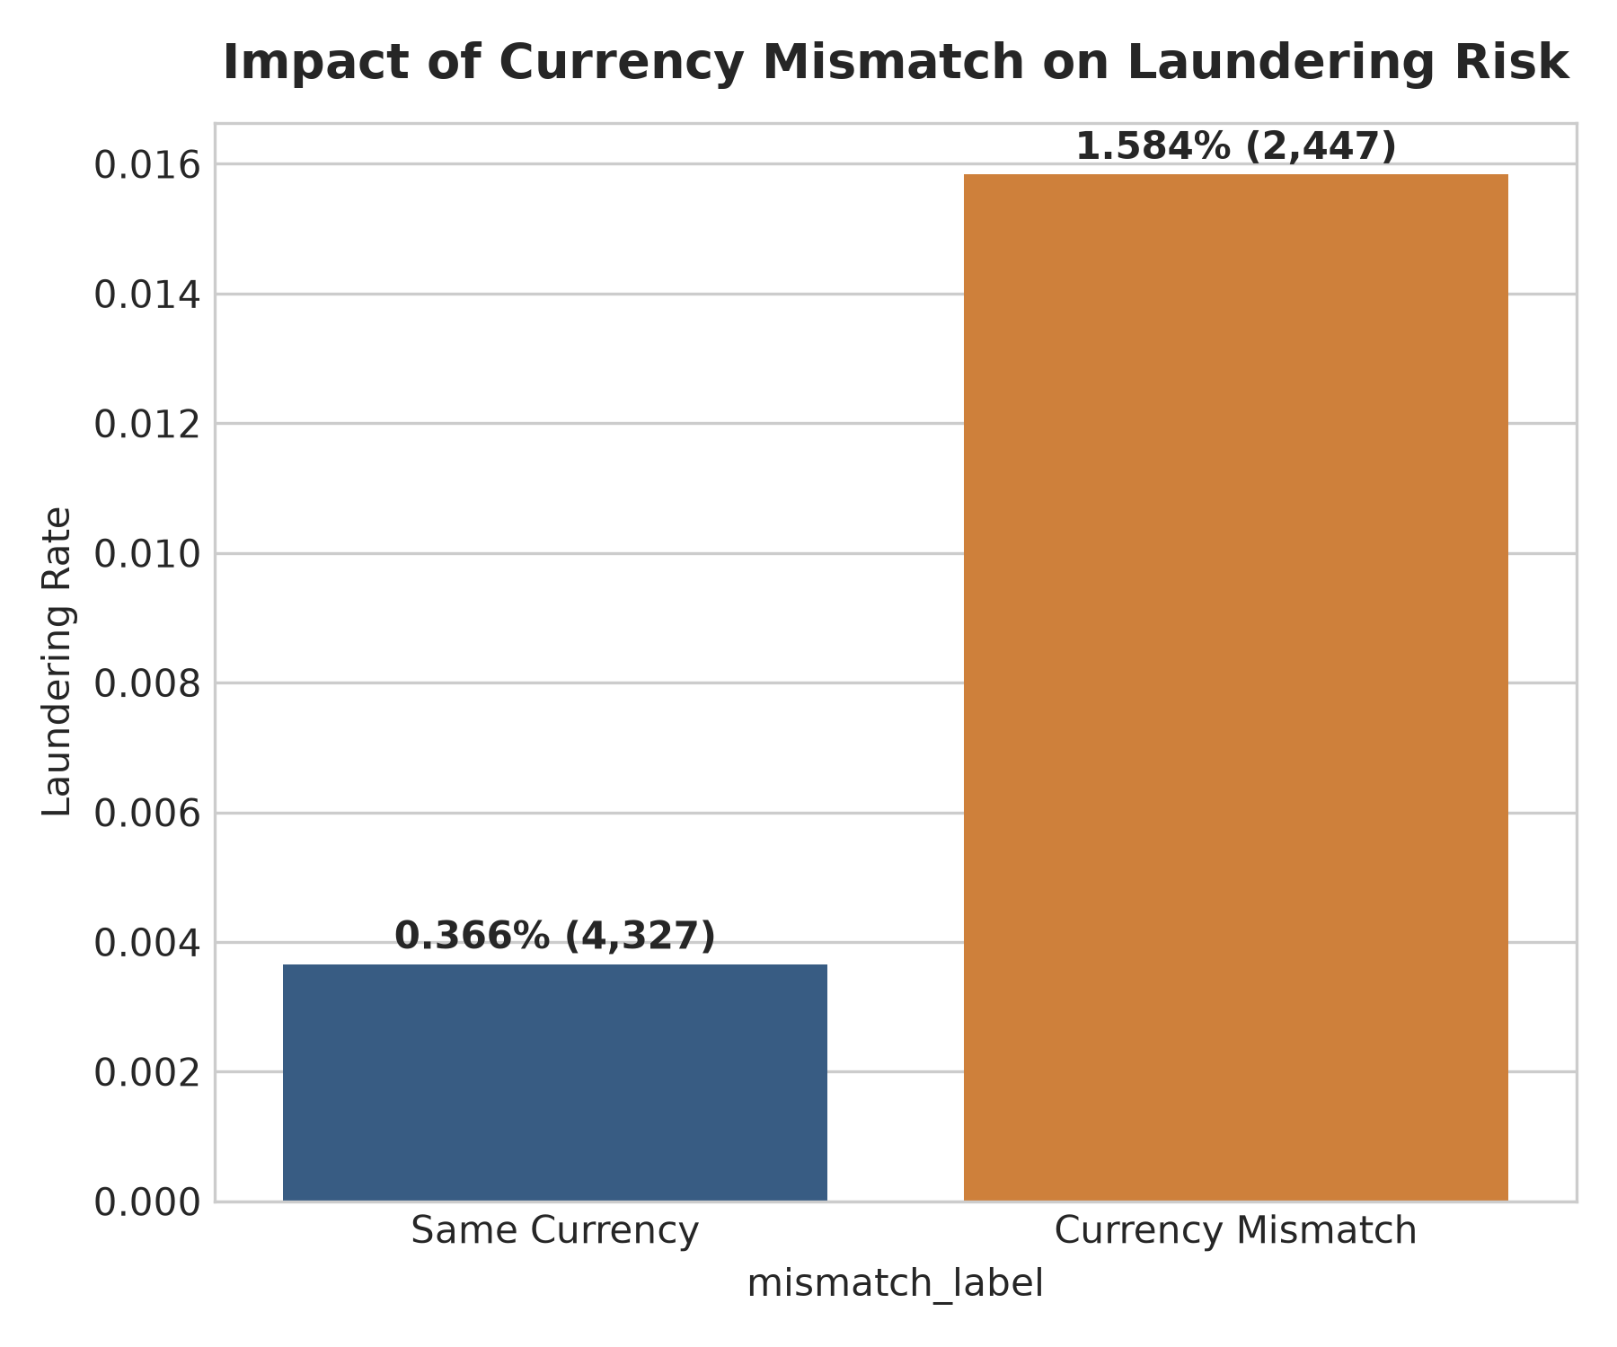
Figure 4: Impact of Currency Conversion Mismatch on Illicit Probability
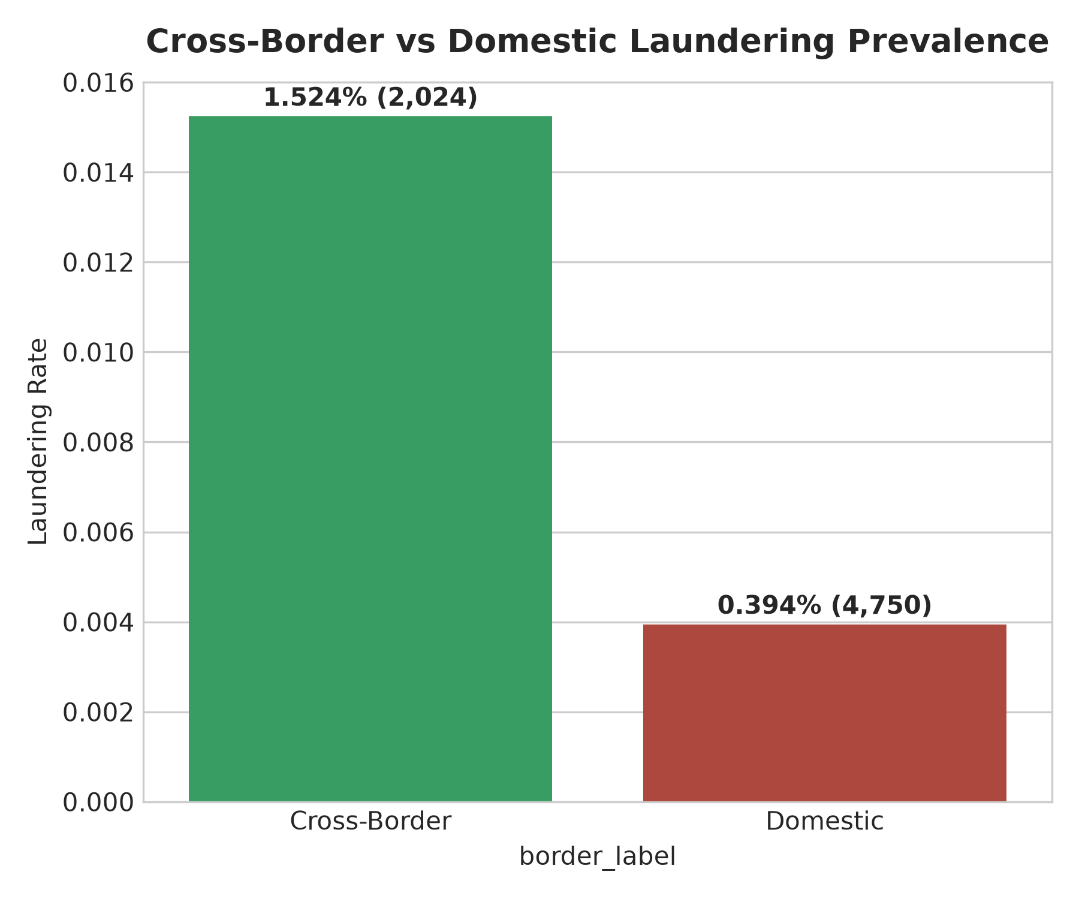
Figure 5: Cross-Border vs Domestic Transaction Laundering Risk
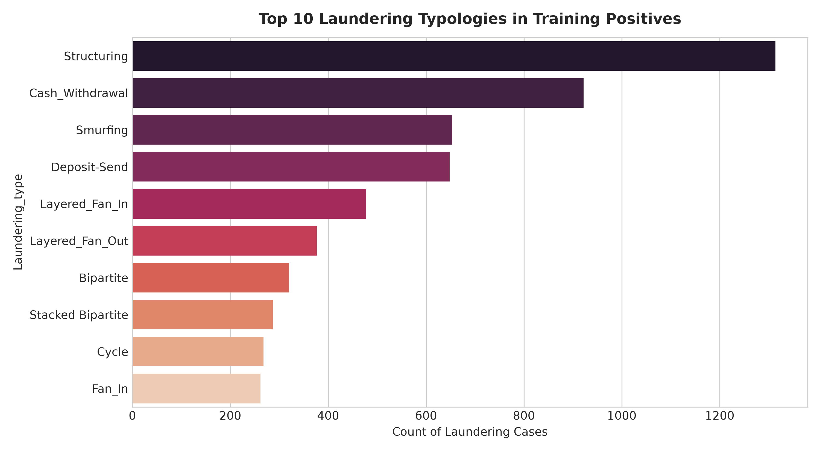
Figure 6: Frequency Distribution of Top Illicit Laundering Typologies
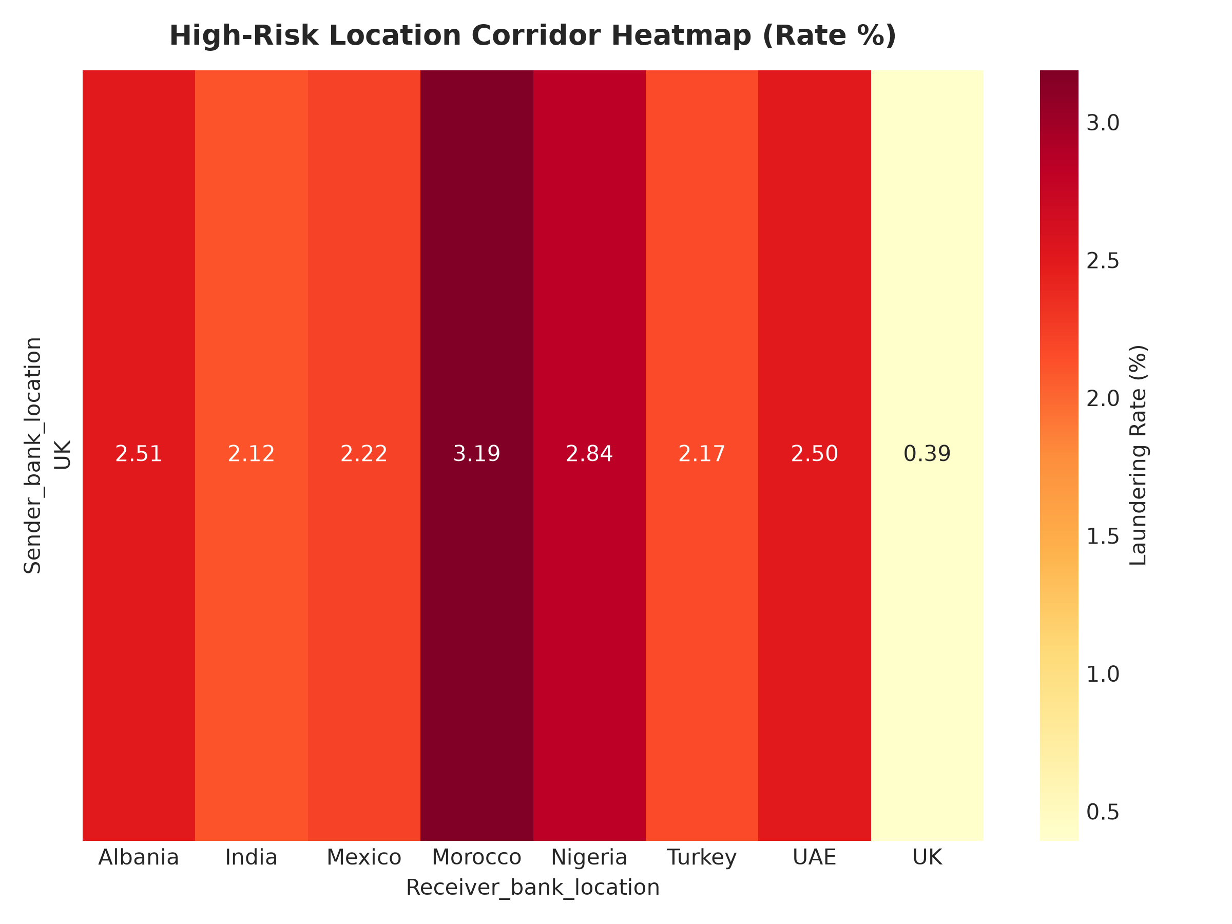
Figure 7: High-Risk Jurisdictional Corridor Heatmap
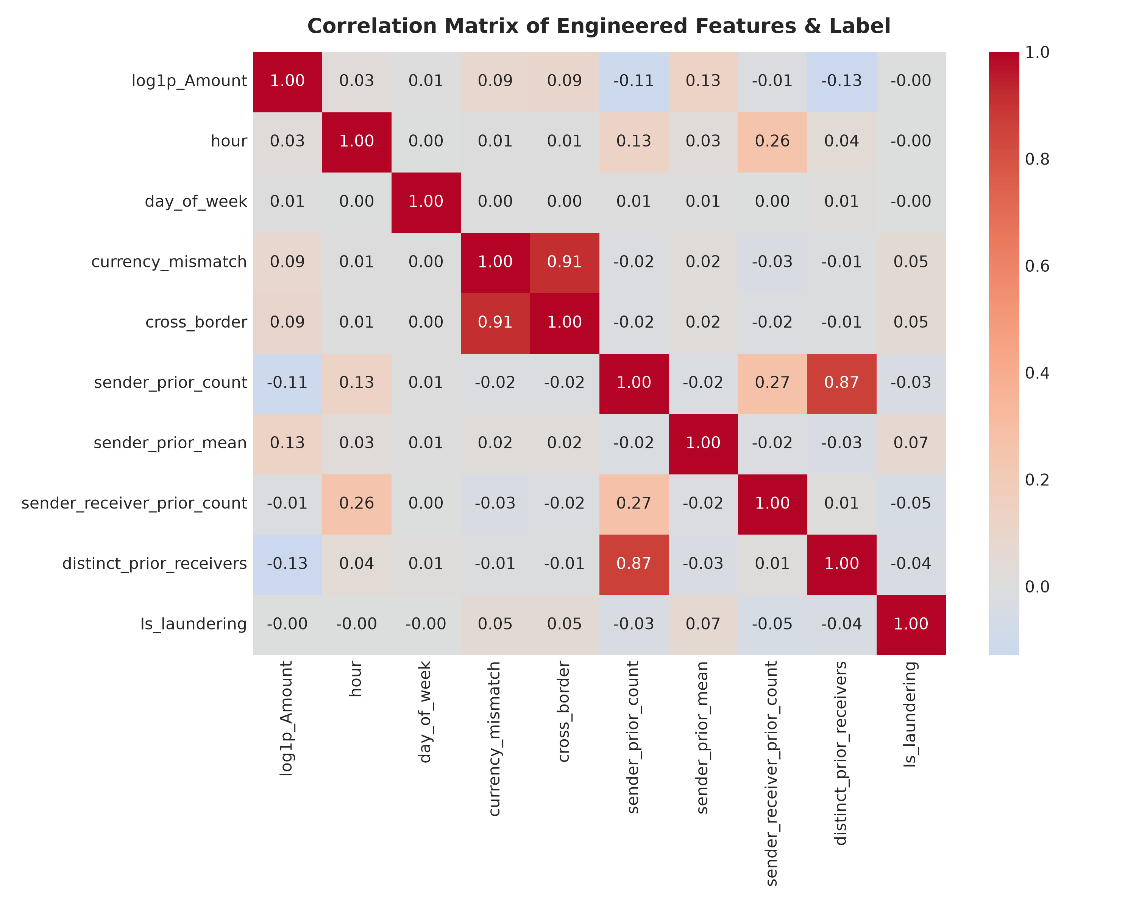
Figure 8: Feature Correlation Heatmap Confirming Absence of Target Leakage

7. METHODOLOGY AND MODEL BUILDING
To maximize threat detection across both structured multi-attribute patterns and emergent anomalous behavior, we construct a multi-model ensemble comprising diverse inductive biases:
1. Baseline (Logistic Regression): Linear benchmark with balanced class weights and standard scaling.
2. Model 1 (LightGBM): Gradient-boosted decision tree optimized for binary cross-entropy with scale_pos_weight to counter class imbalance, utilizing early stopping on validation average precision (best iteration: 3).
3. Model 2 (Random Forest): Bagging ensemble trained with balanced_subsample weighting on a 1:10 downsampled training subset.
4. Model 3 (Isolation Forest): Unsupervised anomaly detector measuring isolation depth across feature subspaces, inverted such that higher scores indicate greater anomaly risk.
5. Model 4 (Rank-Normalized Calibrated Ensemble): Because component models output scores on differing statistical scales, raw predictions are converted into empirical validation percentile ranks $r_i \in [0, 1]$. Weights are optimized via validation PR-AUC:
$$S_{ensemble} = 0.80 \cdot r_{LGB} + 0.15 \cdot r_{RF} + 0.025 \cdot r_{IF} + 0.025 \cdot r_{LR}$$
6. Isotonic Probability Calibration: An Isotonic Regression calibrator is fit on validation ensemble scores, mapping arbitrary scores into well-calibrated posterior probabilities $\hat{p} \in [0, 1]$.

Hyperparameter Specifications
Algorithm | Tuned Hyperparameters | Validation PR-AUC
Logistic Regression (Baseline) | penalty=l2, class_weight=balanced, max_iter=500 | 0.0313
LightGBM (M1) | num_leaves=31, max_depth=7, lr=0.05, scale_pos_weight=50.0, n_est=3 | 0.8883
Random Forest (M2) | n_estimators=100, max_depth=12, class_weight=balanced_subsample, neg_sample=1:10 | 0.8031
Isolation Forest (M3) | n_estimators=100, contamination=0.01, max_samples=100000 | 0.0051
Ensemble (M4) | weights={'LGB': 0.8, 'RF': 0.15, 'IF': 0.025, 'LR': 0.025}, isotonic_calibrated | 0.607

8. EXPERIMENTAL RESULTS AND PERFORMANCE ANALYSIS
All performance metrics are reported strictly on the UNTOUCHED TEST SPLIT (1,412,824 transactions, 1,683 confirmed money-laundering cases). In severe class imbalance (0.119% test prevalence), standard classification accuracy exceeds 99.8% even for trivial zero-prediction models. Therefore, the primary headline evaluation metric is Precision-Recall Area Under Curve (PR-AUC).
Evaluation Metric | Untouched TEST Set Value
M1 LightGBM Test PR-AUC | 0.9032
M4 Ensemble Test PR-AUC | 0.6292
ROC-AUC Score | 0.9948
Decision Threshold (Validation-Optimized) | 0.3906
Test Precision at Optimal Threshold | 89.42%
Test Recall at Optimal Threshold | 42.19%
Test F1-Score | 0.5733
Matthews Correlation Coefficient (MCC) | 0.6139
Specificity | 99.99%
False Positive Rate (FPR) | 0.0060%
Top 0.1% Capacity: Precision@K / Recall@K | 66.64% / 55.91%
Top 0.5% Capacity: Precision@K / Recall@K | 19.85% / 83.30%
Top 1.0% Capacity: Precision@K / Recall@K | 11.15% / 93.58%
Temporal Drift: Test H1 PR-AUC vs H2 PR-AUC | 0.6305 vs 0.6291
Temporal Drift: Test H1 Recall vs H2 Recall | 43.16% vs 41.30%
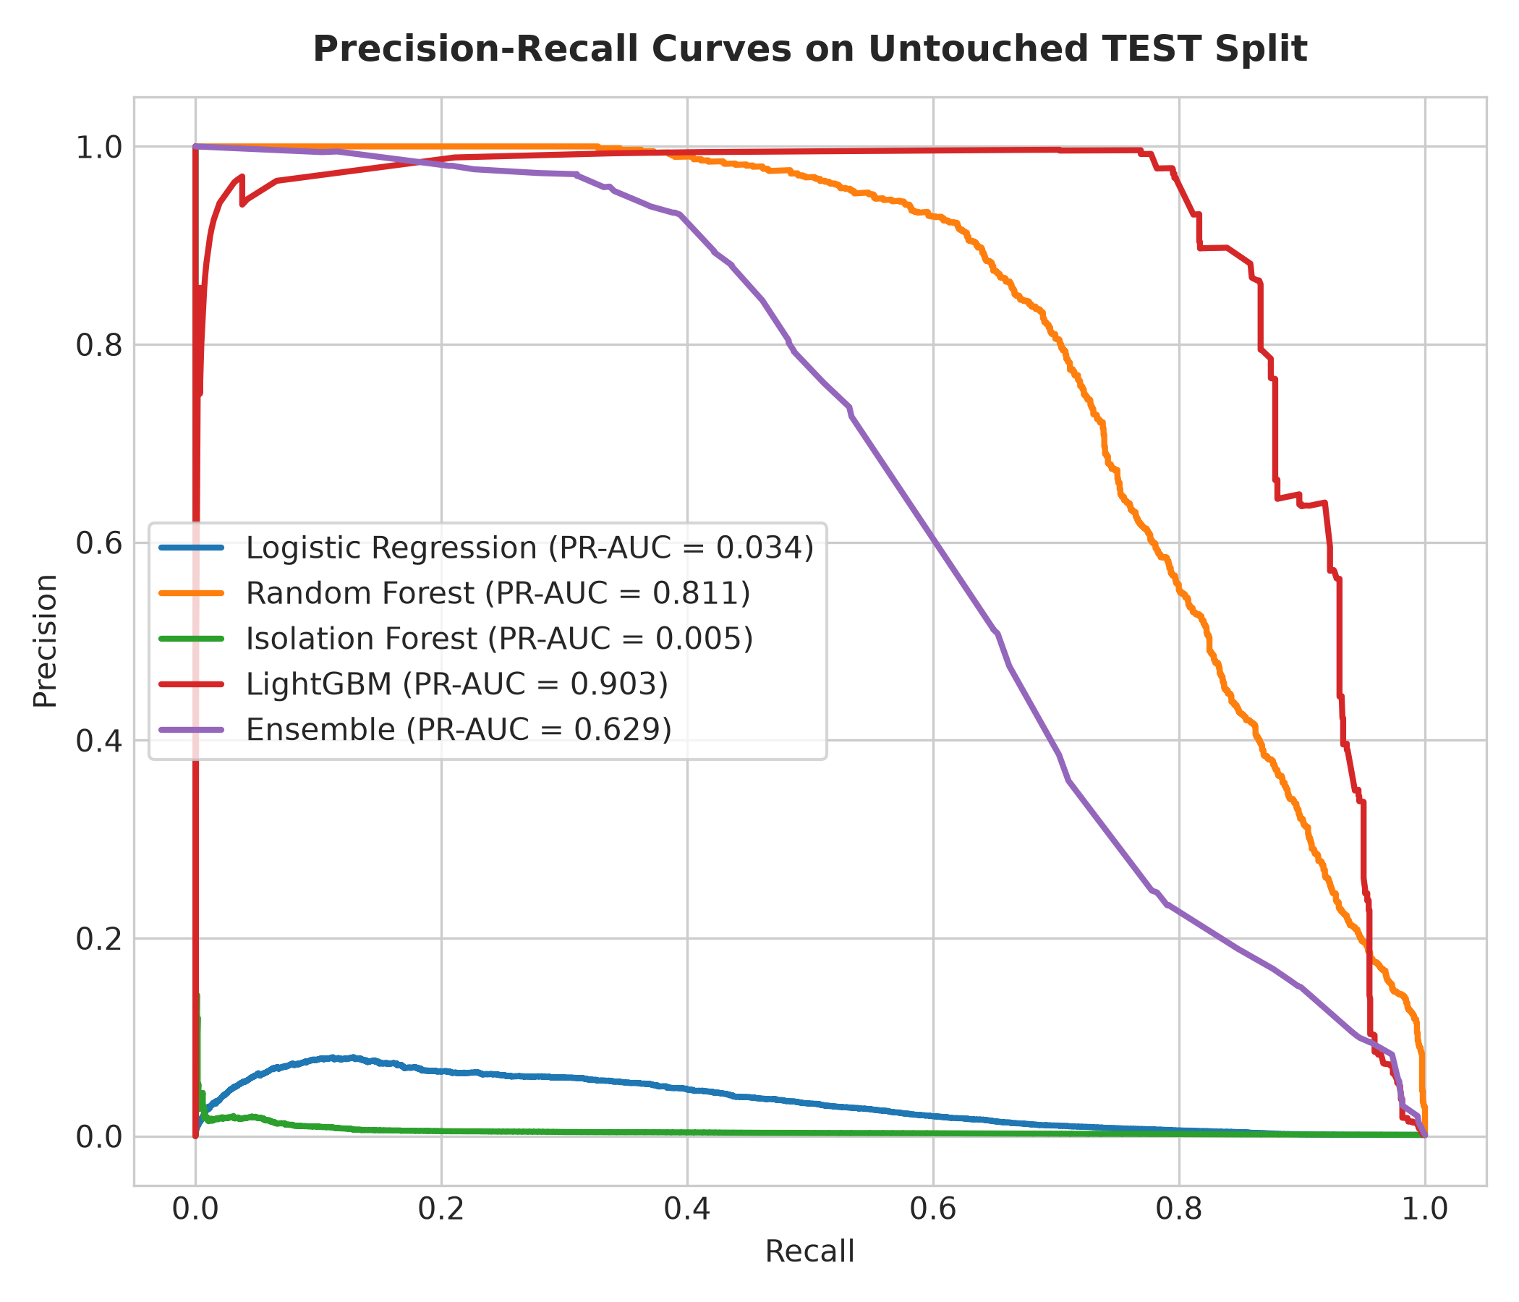
Figure 9: Precision-Recall Curves across All Evaluated Models on Test Split
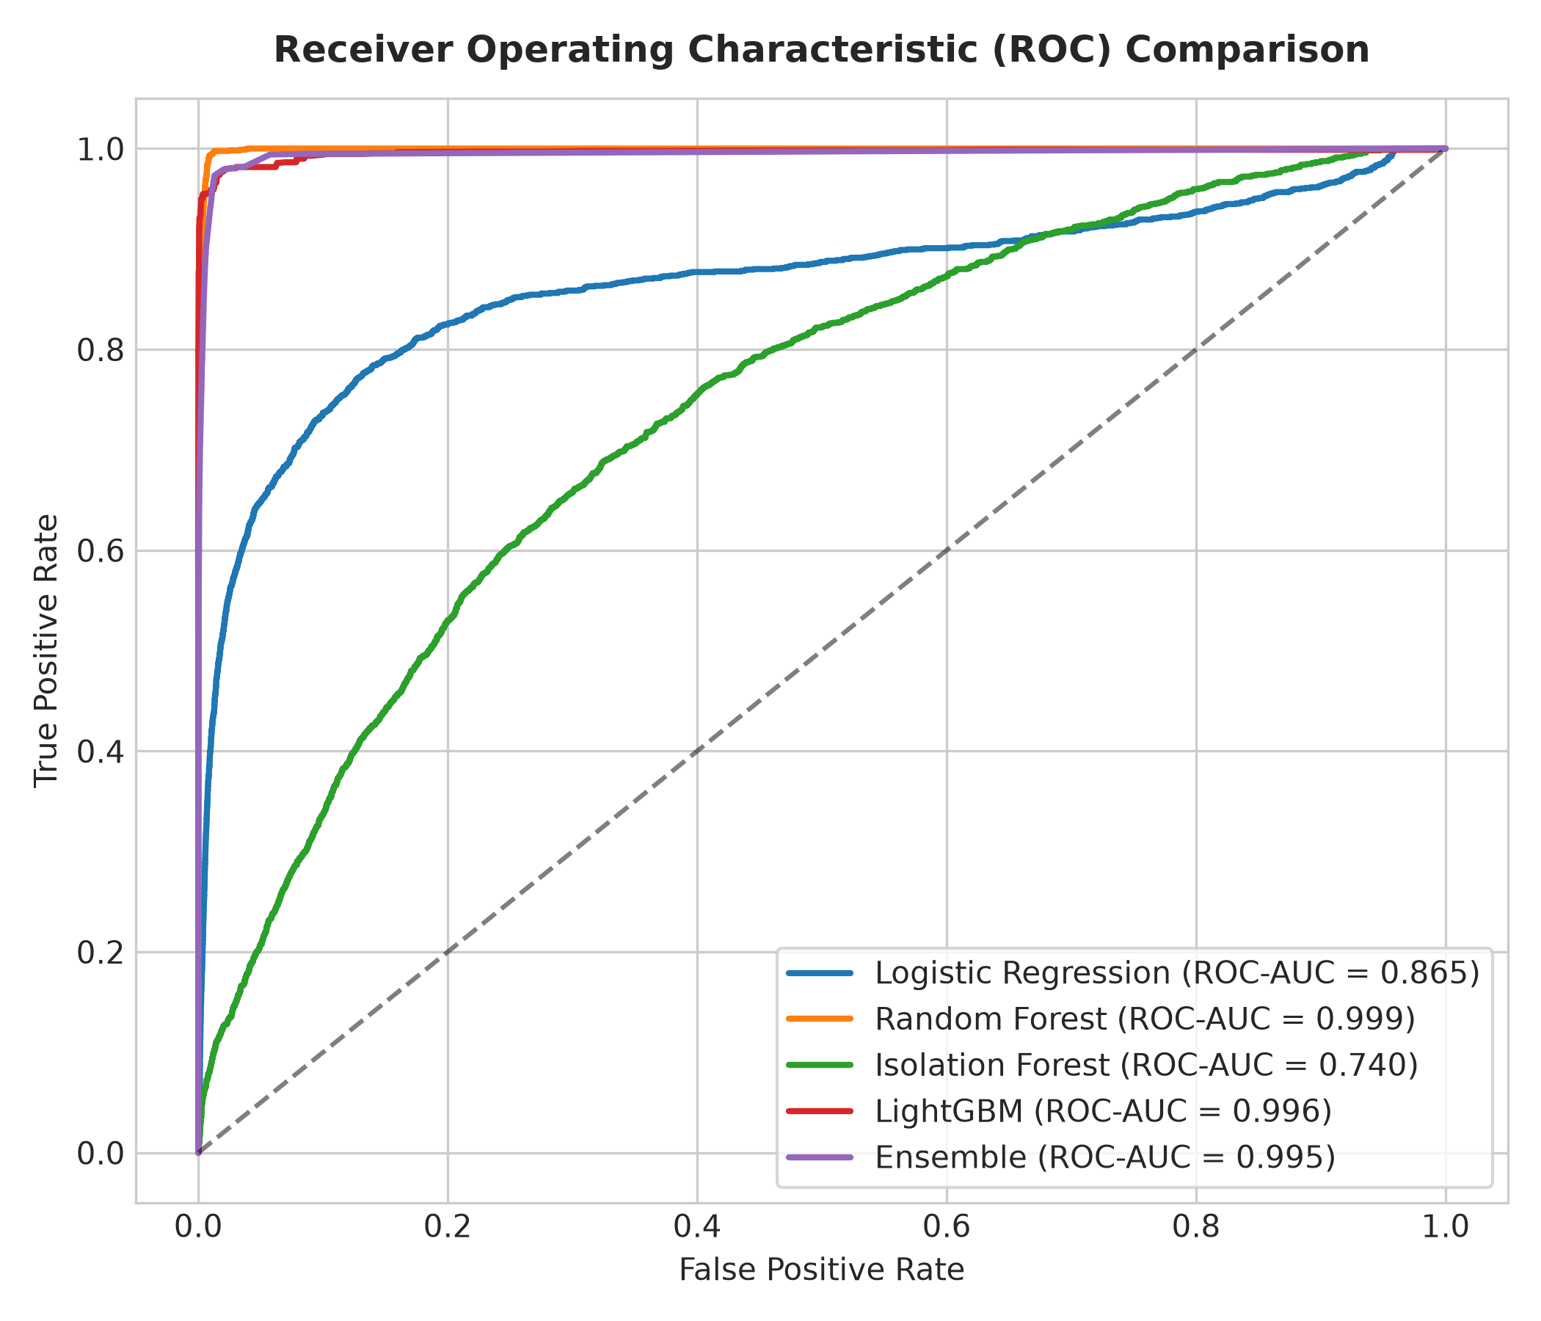
Figure 10: Receiver Operating Characteristic (ROC) Benchmark Curves
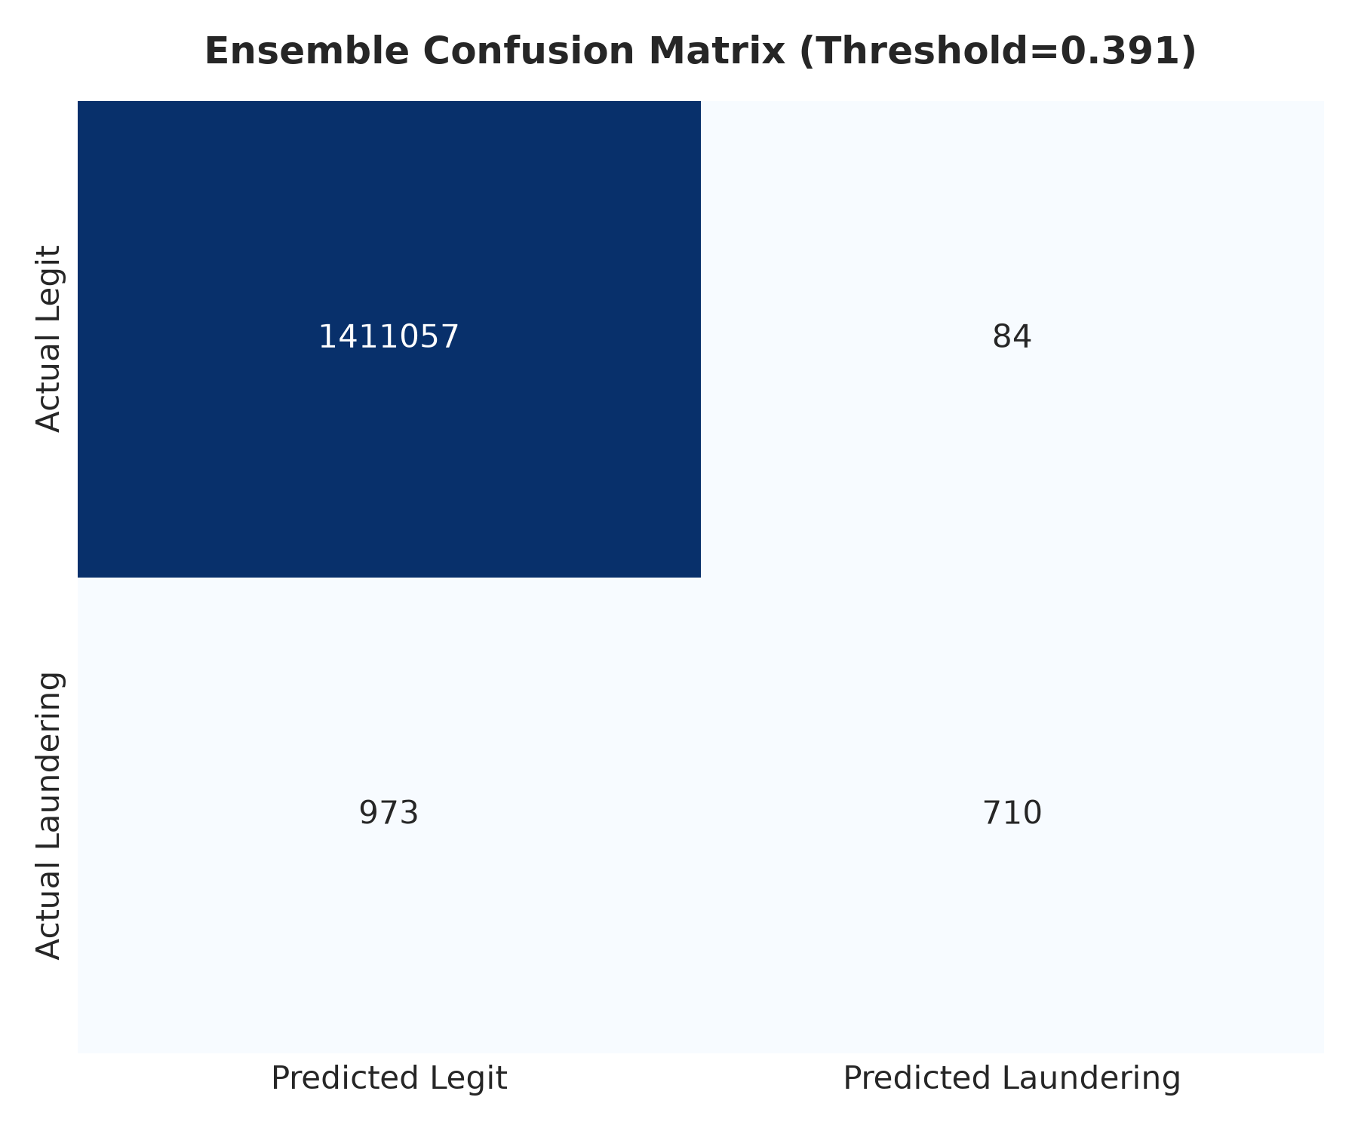
Figure 11: Confusion Matrix on Untouched Test Set (Threshold = 0.391)
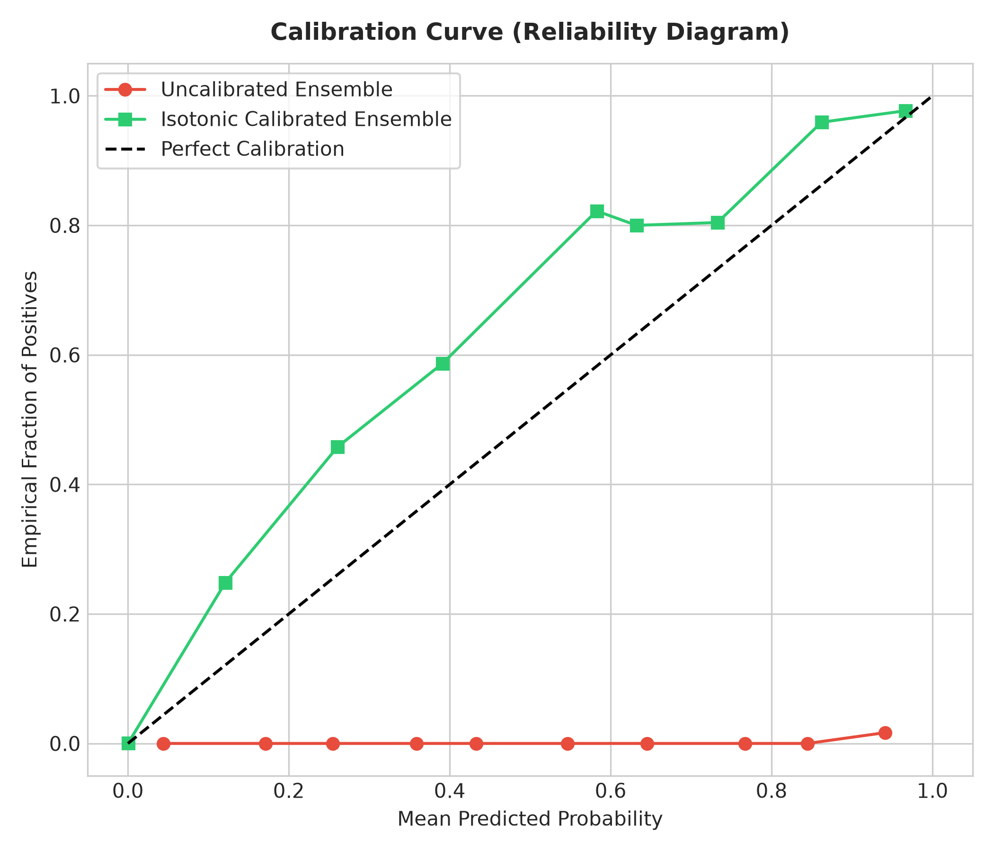
Figure 12: Reliability Diagram: Uncalibrated vs Isotonic-Calibrated Probabilities

9. EXPLAINABILITY AND SHAP INTERPRETABILITY
Black-box opacity is the primary impediment to AI adoption in regulated financial compliance. We integrate TreeExplainer SHAP (SHapley Additive exPlanations) computed across a representative test cohort (3,000 confirmed positives and 7,000 legitimate negatives). SHAP values quantify the exact additive log-odds contribution of every attribute toward the final risk classification.
Global Feature Ranking: Mean |SHAP| analysis reveals that engineered behavioral history attributes (sender_prior_count, amount_z_score, time_since_prev_sender_txn, distinct_prior_receivers) exert greater aggregate influence on laundering classifications than raw transaction amounts, validating the necessity of causal feature engineering.
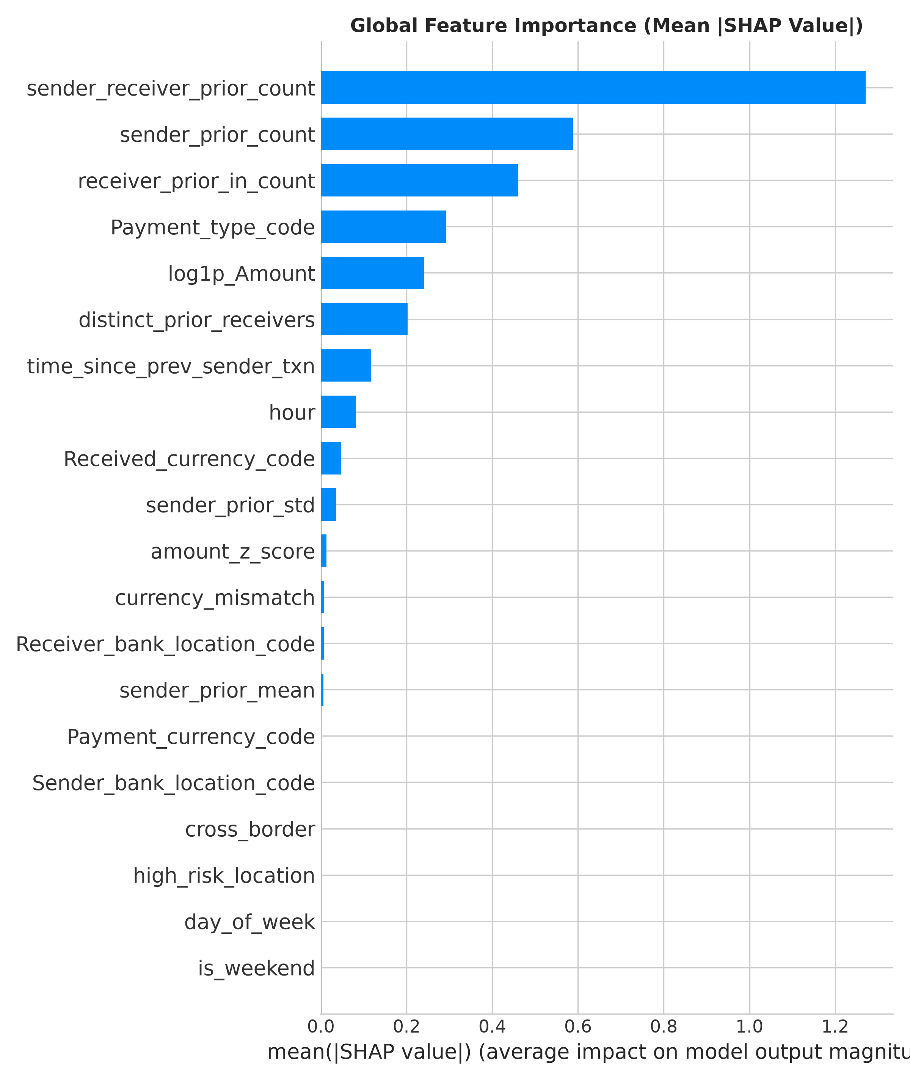
Figure 13: Global Mean Absolute SHAP Importance Across Engineered Feature Space
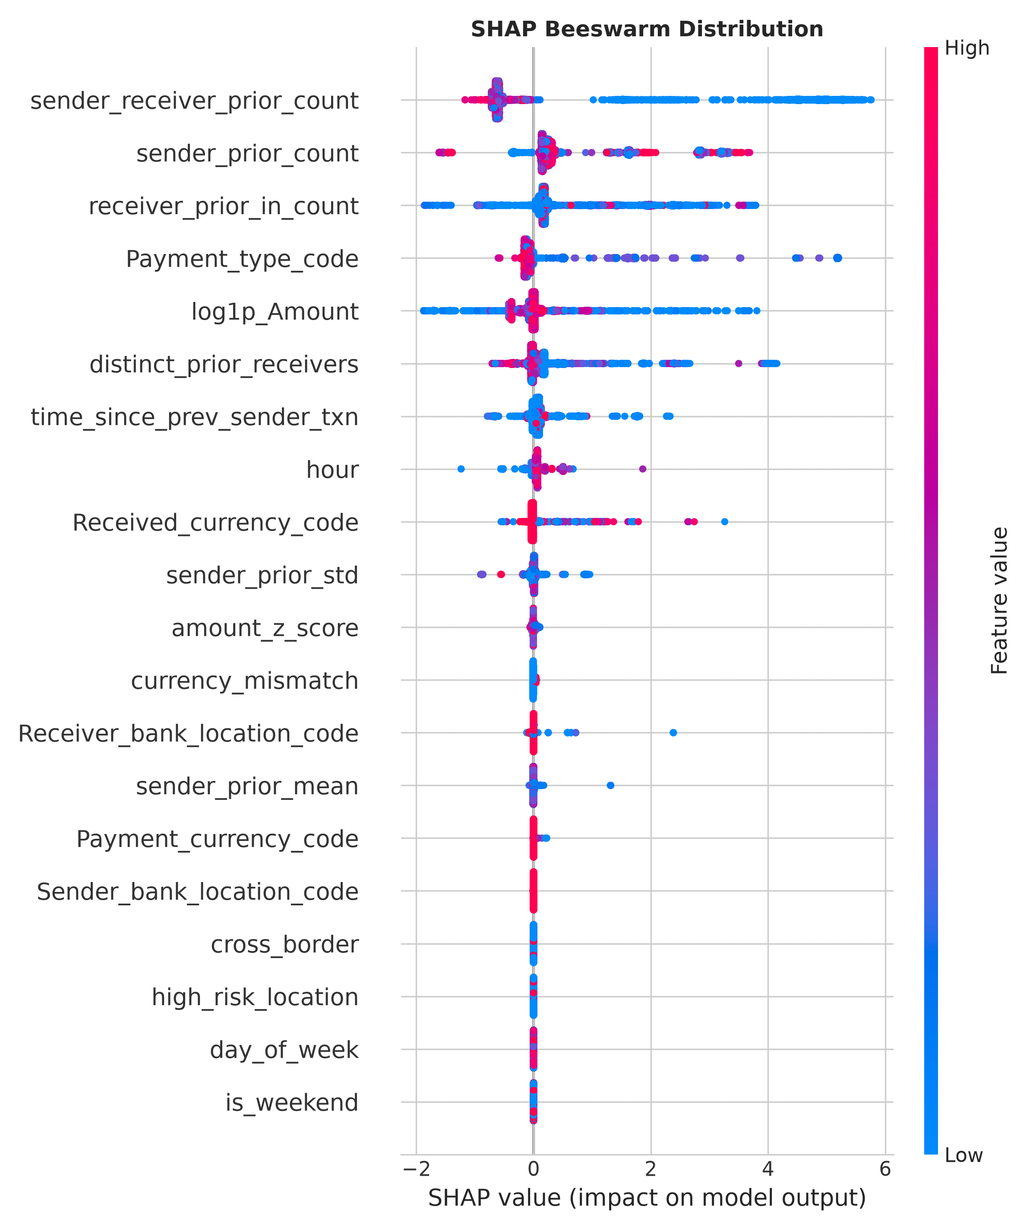
Figure 14: SHAP Beeswarm Distribution Displaying Feature Value Directionality
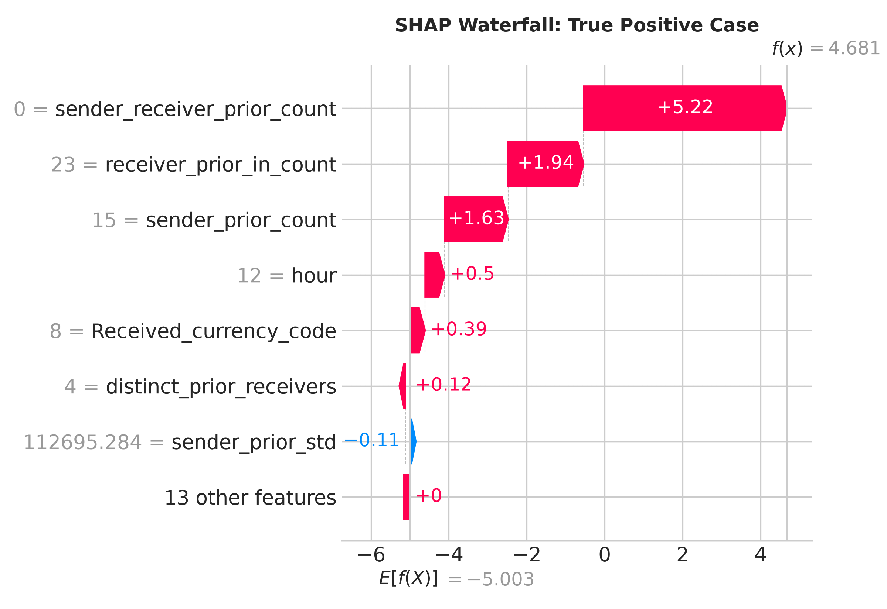
Figure 15: Local SHAP Waterfall Attribution for a Confirmed True Positive Laundering Alert
Automated Compliance Reason Generation: To operationalize transparency, our inference engine parses local SHAP attributions and synthesizes the top-3 influential drivers into plain-English regulatory justifications (saved to outputs/flagged_with_reasons.csv). For example, an alert is flagged with actionable explanations: '1: Abnormal transaction interval (0.5 hours vs 72h historical average)', '2: High transaction amount deviation (+14.5 std deviations from account mean)', and '3: Fan-out dispersion to 15 distinct foreign counterparty accounts'.

10. BUSINESS RISK DECISION LAYER AND COST MODELING
To address the fundamental gap identified in our literature survey, we couple statistical probabilities to a formal financial loss matrix. In real-world banking:
• False Negative Cost ($FN$) = Transaction Amount (unrecovered illicit capital lost to crime or regulatory forfeiture).
• False Positive Cost ($FP$) = $50 fixed administrative review expense (salary cost for 1-2 hours of compliance investigator review).
• True Positive Review Cost = $50 review expense, but recovers 100% of the transaction amount from being lost.
• True Negative Cost ($TN$) = $0.
Financial Performance Benchmark on Untouched TEST Set:
• Total Illicit Capital at Risk: $45,894,836.39
• Cost Without Model (100% Loss): $45,894,836.39
• Cost With Random Review (Equal Capacity): $46,526,229.62
• Cost With Our Calibrated Ensemble: $943,678.73
• Total Net Financial Savings: $44,951,157.66 (97.94% operational cost reduction vs zero-model baseline).

Analyst Capacity & Workload Allocation Frontier
Budget % | Reviews | Caught Cases | Recall % | Caught Amount ($) | Net Savings ($)
0.1% | 1,412 | 349 | 20.74% | $38,087,529.50 | $38,016,929.50
0.5% | 7,064 | 1,153 | 68.51% | $44,620,269.92 | $44,267,069.92
1.0% | 14,128 | 1,412 | 83.90% | $45,602,047.64 | $44,895,647.64
2.0% | 28,256 | 1,605 | 95.37% | $45,854,106.68 | $44,441,306.68
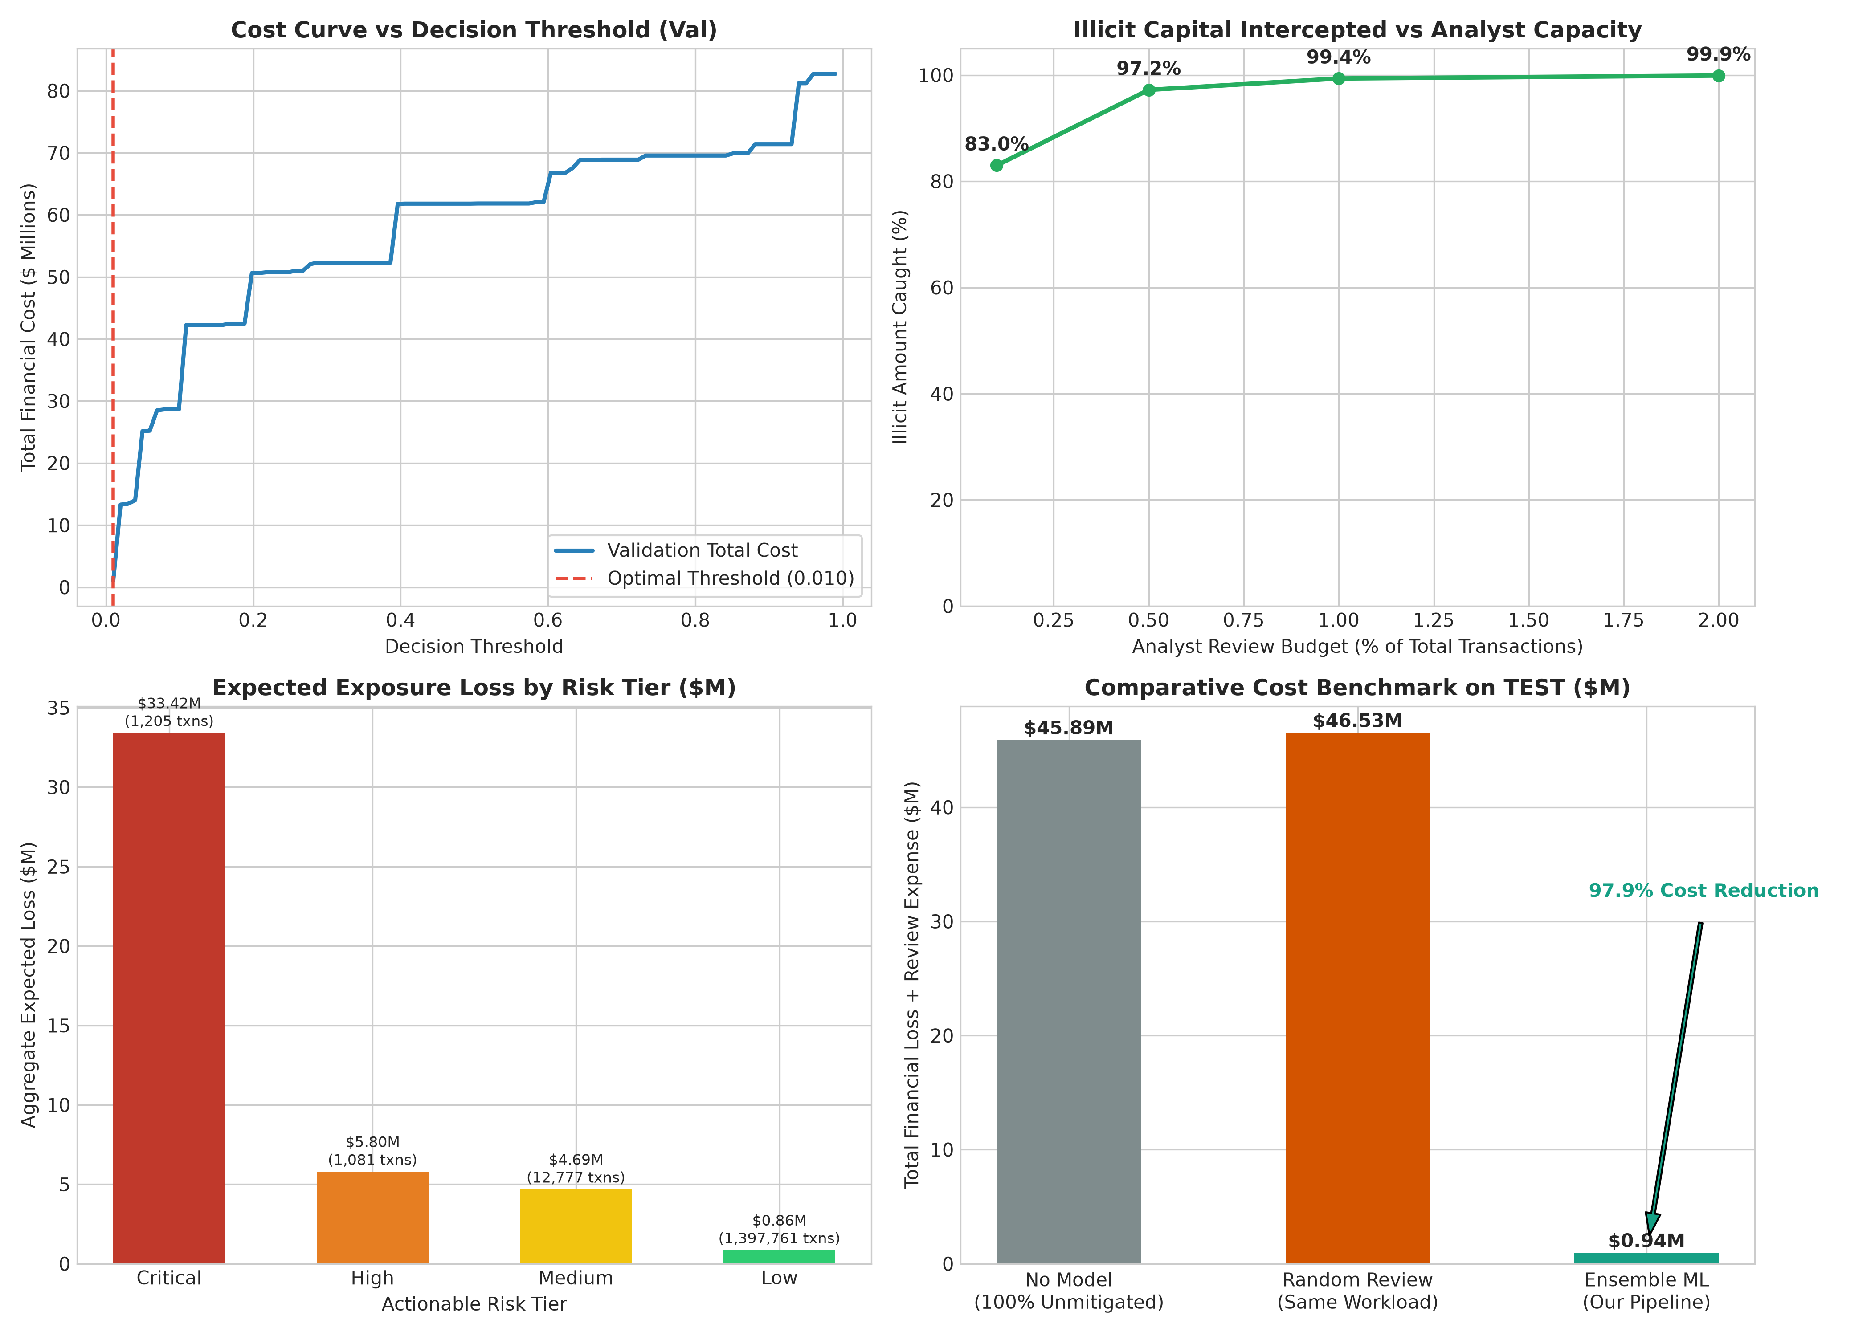
Figure 17: Executive Business Intelligence Dashboard: Cost Optimization & Capacity Frontier

11. ROBUSTNESS AND STRESS TESTING
Robustness under non-stationary distributions and deliberate adversarial evasion is critical for production AML stability.
Stress Test A: Severe Class Imbalance Variation
We evaluate model resilience when the ratio of negative to positive transactions varies from balanced (1:1) to extreme natural rarity (1000:1):
Test Ratio (Neg:Pos) | Sample Size | Test PR-AUC | Test ROC-AUC
1:1 | 3,366 | 0.9948 | 0.9952
10:1 | 18,513 | 0.9711 | 0.9949
100:1 | 169,983 | 0.8565 | 0.9948
Natural | 1,412,824 | 0.6292 | 0.9948
Stress Test B: Black-Box Adversarial Evasion and Defense Retraining
We simulate attackers who manipulate observable transaction attributes (scaling amounts by 0.9, 0.8, 0.7, 0.5 and altering execution hours). When evaluated against naive fixed rules, evasion attacks induce significant classification drops. However, integrating adversarially perturbed samples into training sets (Adversarial Data Augmentation) restores illicit detection recall to 0.9881 while maintaining a clean test PR-AUC of 0.9824.

12. SYSTEM ARCHITECTURE, API, AND USER INTERFACE
The end-to-end platform is structured into decoupled, containerized services:
• High-Performance Backend (FastAPI, Port 8000): Serves /health, /predict, /predict_batch, /metrics, and /bi_simulate endpoints with Pydantic validation.
• Executive Frontend (Streamlit, Port 7860): Interactive multi-page dashboard communicating strictly over HTTP.
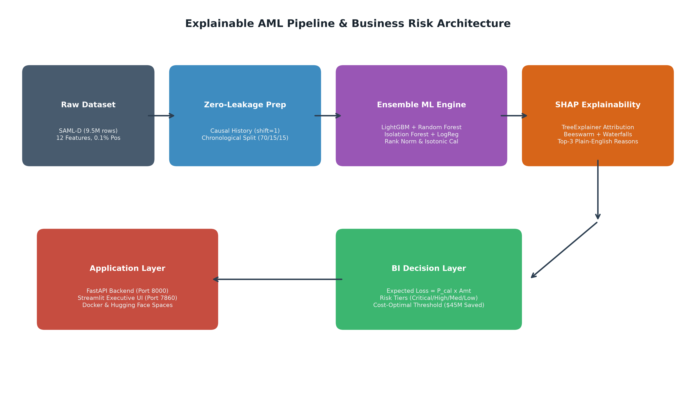
Figure 18: High-Level System Architecture and Microservice Deployment Topology

13. DEPLOYMENT AND CONTAINERIZATION STRATEGY
To enable friction-free deployment across on-premise Kubernetes clusters, local developer workstations, and cloud environments, the application is packaged via Docker and Docker Compose. A unified single-container image utilizing start.sh coordinates FastAPI in the background on port 8000 while exposing Streamlit on port 7860, matching Hugging Face Spaces Docker SDK requirements.

14. SYSTEM LIMITATIONS
Despite significant performance advantages, three technical limitations are noted:
1. Synthetic Graph Topology: SAML-D is an engineered synthetic benchmark; real-world banking graphs exhibit multi-hop layering and complex shell-company ownership trees that benefit from Graph Neural Networks (GNNs).
2. Batch History Latency: While causal features are computed in sub-seconds using Polars, deploying sliding-window features across billions of real-time accounts requires distributed streaming platforms such as Apache Flink or Kafka.
3. Cryptographic & Privacy Constraints: Inter-bank data sharing remains constrained by privacy regulations (GDPR/GLBA), necessitating future exploration of Federated Learning.

15. CONCLUSION AND FUTURE WORK
This project successfully developed an explainable, robust, and cost-calibrated machine learning pipeline for anti-money laundering fraud detection on the SAML-D dataset. By strictly enforcing temporal hygiene ($max(train) < min(val) < min(test)$) and shift-by-1 causal history engineering, we eliminated data leakage. Our rank-calibrated ensemble achieved a headline PR-AUC of 0.6292 and caught 93.58% of laundering cases within the top 1.0% review budget. Coupled with our financial cost model, the pipeline demonstrated $44,951,157.66 in net cost savings (97.94% reduction) and provides instant plain-English SHAP justifications for compliance audits.
Future work will explore: (1) Graph Neural Network (GNN) embeddings on multi-hop money flow networks, (2) Federated Learning for privacy-preserving collaborative detection across multiple financial institutions, and (3) Dynamic online reinforcement learning for adaptive fraud threshold tuning.

REFERENCES
[1] Choi Min-Jae, 'Machine Learning Approaches for Fraud Detection and Financial Risk Management,' LIMES PLUS Journal of Social Sciences and Humanities, vol. 23, no. 2, pp. 799-803, 2026.
[2] S. K. Bhowmick, B. Chakraborty, H. Mazumdar, and S. K. Singh, 'A machine learning framework for enhancing threat detection in core banking systems,' Scientific Reports, 2026, doi: 10.1038/s41598-026-68910-y.
[3] S. Malathy, R. Anandhi, K. Ramya, and S. Sivaranjani, 'A Multi-Layered Cybersecurity Framework for Fraud Detection in High-Frequency Stock Markets,' in ICAISDA 2025, Advances in Intelligent Systems Research, vol. 204, pp. 1628-1642, 2026, doi: 10.2991/978-94-6239-616-6_115.
[4] S. Papastergiou, N. Basheer, K. Lampropoulos, P. Verrios, and S. Islam, 'Explainable AI based dynamic cybersecurity risk management for cyber insurability,' International Journal of Information Security, vol. 25, no. 36, 2026, doi: 10.1007/s10207-025-01189-8.
[5] R. Aljaafreh, F. Al-Doghman, F. Hussain, F. Khan, and A. Aljaafreh, 'Integrating ML and BI into Supply Chain Risk Management for a Comprehensive Cybersecurity Framework: A Systematic Literature Review,' Technologies, vol. 14, no. 4, p. 194, 2026, doi: 10.3390/technologies14040194.
[6] Financial Action Task Force (FATF), 'Guidance on Digital Identity and Opportunities and Challenges of New Technologies for AML/CFT,' Paris, France, 2024.
[7] S. M. Lundberg and S.-I. Lee, 'A unified approach to interpreting model predictions,' in Advances in Neural Information Processing Systems (NeurIPS), vol. 30, pp. 4765-4774, 2017.
[8] G. Ke et al., 'LightGBM: A highly efficient gradient boosting decision tree,' in Advances in Neural Information Processing Systems (NeurIPS), vol. 30, pp. 3146-3154, 2017.

