**WEEK – 5**

**MICROSERVICES WITH SPRING BOOT 3 AND SPRING CLOUD**

**CREATING MICROSERVICES FOR ACCOUNT AND LOAN**

**APPROACH**

* Create two separate Spring Boot projects: account and loan with Spring Web dependency.
* Set ports in application.properties.
* Create REST controllers for each with dummy data (/accounts/{number}, /loans/{number}).
* Build and run both services using Eclipse or mvn spring-boot:run.
* Test both endpoints via browser using their respective localhost URLs.

**CODE - Account**

**ApplicationController.java**

package com.cognizant.account.controller;

import org.springframework.web.bind.annotation.GetMapping;

import org.springframework.web.bind.annotation.PathVariable;

import org.springframework.web.bind.annotation.RestController;

import java.util.Map;

@RestController

public class AccountController {

@GetMapping("/accounts/{number}")

public Map<String, Object> getAccountDetails(@PathVariable String number) {

return Map.of(

"number", number,

"type", "savings",

"balance", 234343);}}

**AccountApplication.java**

package com.cognizant.account;

import org.springframework.boot.SpringApplication;

import org.springframework.boot.autoconfigure.SpringBootApplication;

@SpringBootApplication

public class AccountApplication {

public static void main(String[] args) {

SpringApplication.run(AccountApplication.class, args);

}

}

**OUTPUT**

(for Account)

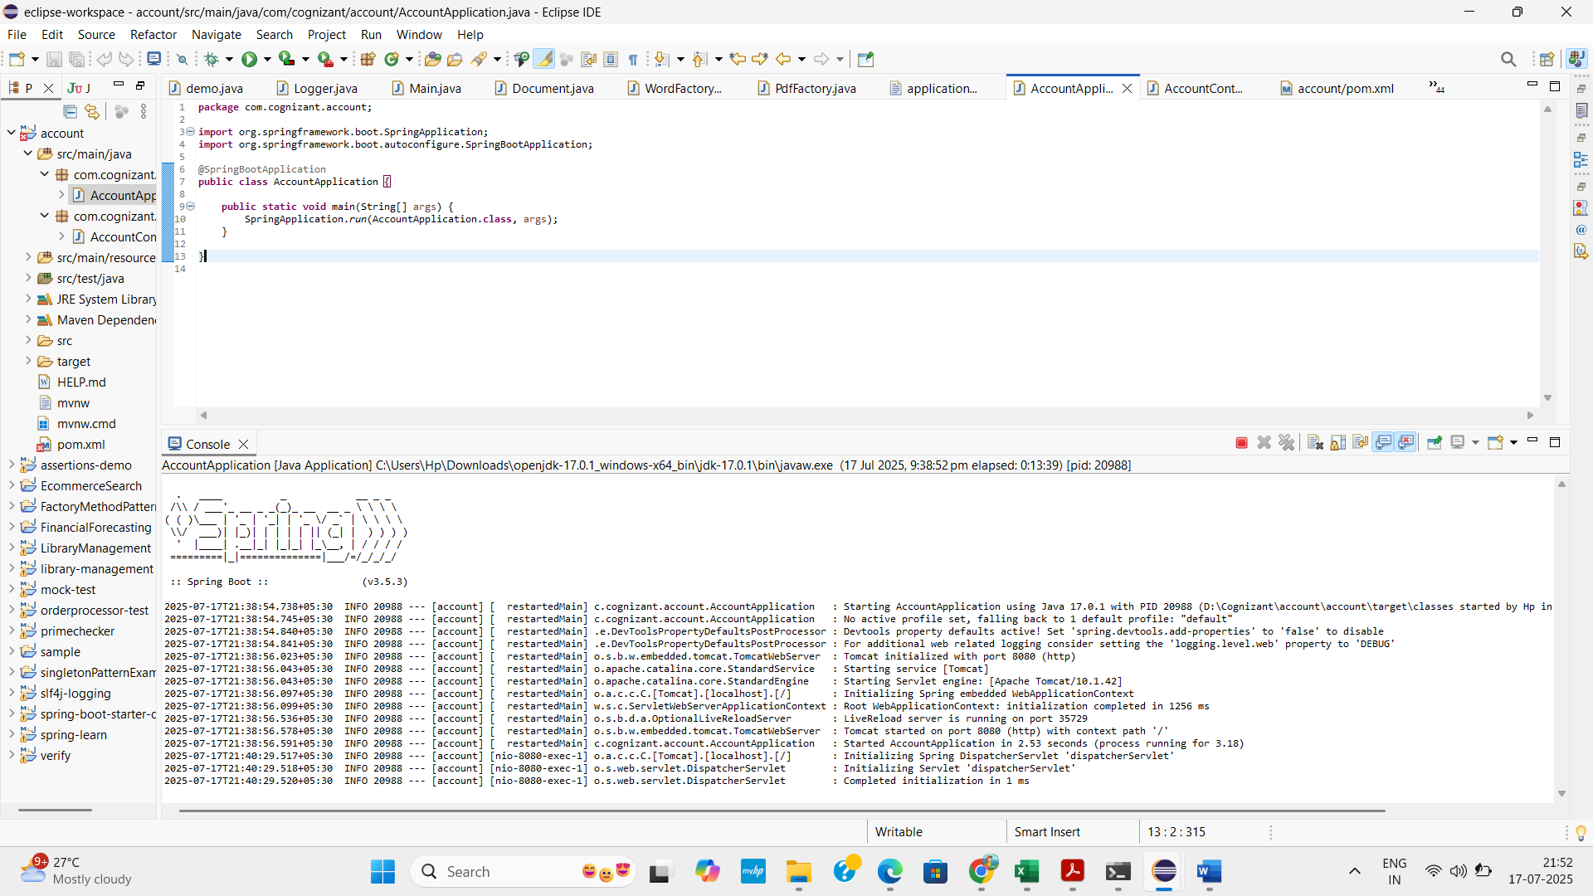

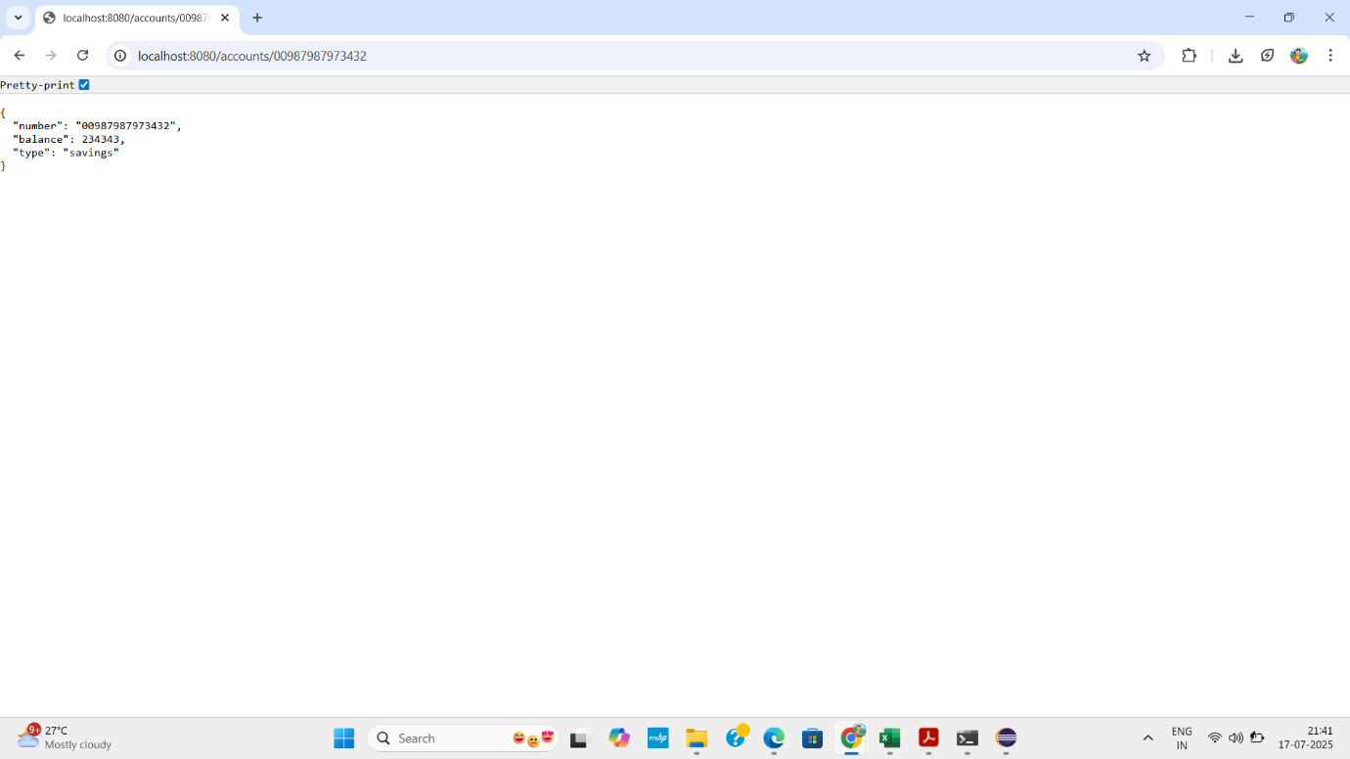

**CODE – Loan**

**LoanController.java**

package com.cognizant.loan.controller;

import org.springframework.web.bind.annotation.GetMapping;

import org.springframework.web.bind.annotation.PathVariable;

import org.springframework.web.bind.annotation.RestController;

import java.util.Map;

@RestController

public class LoanController {

@GetMapping("/loans/{number}")

public Map<String, Object> getLoanDetails(@PathVariable String number) {

return Map.of(

"number", number,

"type", "car",

"loan", 400000,

"emi", 3258,

"tenure", 18

);

}

}

**LoanApplication.java**

package com.cognizant.loan;

import org.springframework.boot.SpringApplication;

import org.springframework.boot.autoconfigure.SpringBootApplication;

@SpringBootApplication

public class LoanApplication {

public static void main(String[] args) {

SpringApplication.run(LoanApplication.class, args);

}

}

**OUTPUT**

(for loan)

