 | Heaven’s Light is our Guide  DIRECTOR OF RESEARCH & EXTENSION  RAJSHAHI UNIVERSITY OF ENGINEERING & TECHNOLOGY  Rajshahi-6204, Bangladesh

Application form (Guidelines) for approval of Ph.D/M.Phil/M.Sc.Engg./MURP/M.Engg. Thesis/project proposal by the CASR. All items applicable to the following list must be mentioned and filled in correctly. Please submit four (04) hard copies [One original and the other three (03) photocopies in the entire script plain paper] and also submit a scanned copy of the proposal.
Date: 11.10.2026
1. Name of the student: NASRULLAH MASUD Status: Part-Time
(Block Letters)
Roll No.: 2204101013 Session: 2022-23
2. Present Address: Chishtiya Chattrabash, Room no: 115, Upor Vodra, Kazla, Rajshahi-6204
3. Present Designation & Organization: Lecturer, Dept. of Electrical and Electronic Engineering, Varendra University, Rajshahi.
4. Name of the Department: Electrical & Electronic Engineering Programme: M.Sc. in Engineering
5. Name of the Supervisor: Dr. Md. Sohel Rana Designation: Professor
6. Name of the Co-Supervisor (if any): ............................... Designation: ........................
7. Date of First Enrolment in the Programme: 06/05/2023
8. Tentative Title (Block Letters, Times New Roman, Font size 11 points, Not more than 25 words):
Development and Evaluation of a Zone-Wise Post-Quantum and QKD-Assisted Cryptographic Security Framework for Small Modular Reactor Control Systems
9. Background and present state of the problem
(Not more than 250 words. Please mention only those activities carried out in different places as reported in publications. Please support your information by citing the relevant references.)
Nuclear power plants use industrial control systems (ICS) to run sensors, pumps and safety functions. The Stuxnet attack in 2010 showed that malicious software can damage physical industrial equipment [4]. Small modular reactors (SMRs) use a layered network of five zones, from safety instrumentation up to the enterprise office network, following NRC Regulatory Guide 5.71 defence-in-depth and IEC 62443 zones and conduits [10].
Where used, cryptography is classical (RSA/ECC key exchange and signatures, AES). A large quantum computer could break RSA and ECC using Shor’s algorithm and weaken AES using Grover’s algorithm [2], [9]; over 40–60-year SMR lifetimes, signing keys and retained data are most exposed. Quantum key distribution (QKD) such as the BB84 protocol [1] uses the physics of light to generate shared secret keys. Its limits are distance, finite key lengths, photon-number-splitting (PNS) attacks (bounded by decoy states) [3], [5], and the need for an authenticated classical channel [7]. Post-quantum cryptography (PQC), such as ML-KEM, ML-DSA and SLH-DSA standardized by NIST in FIPS 203, 204 and 205, runs on ordinary hardware but depends on mathematical assumptions rather than physical laws [2]; European agencies prioritise PQC and see QKD as niche [7].
Recent studies combine QKD and PQC and test them on FPGA hardware and city fibre networks [6]. However, zone-by-zone guidance that links IEC 62443 security-level targets to PQC, hybrid or QKD-assisted profiles for nuclear ICS, within control-loop timing limits, is still limited [4], [9].
10. Justification of the study
(Not more than 150 words. Please justify research/study based on the present state of the problem and works that have been carried out in different places as reported in publications. Please support your information by citing the relevant references.)
Existing nuclear and industrial cyber security work relies mainly on classical encryption, network segmentation and anomaly detection, and rarely addresses the quantum threat to long-lived keys and data [8]. Research on QKD and PQC progressed separately. QKD is often assessed without an authentication model or zone-based risk analysis [3], [5], [7].
In addition, SMR cyber security reviews report a lack of measurable security metrics linked to IEC 62443 Security Levels and NRC guidance [4]. Without such evidence, designers cannot decide zone by zone where PQC suffices and where QKD adds value.
This study therefore proposes a zone-wise framework that (i) compares classical, PQC, classical+PQC and QKD-assisted profiles on a reference five-zone SMR network, (ii) derives latency budgets from control-loop delay margins, and (iii) scores zones with a validated, weakest-link-aware metric. We found no earlier study that addresses all three for SMRs.

11. Objectives with specific aims
(Please list the objectives(s) using short sentences. If you are writing one or two paragraphs describing the objectives, please limit yourself to 150 words.)
The objectives of this thesis are:
- To model a reference five-zone small modular reactor (SMR) industrial control system (ICS) (IEC 62443 zones, conduits, target security levels) and rank zone and conduit weaknesses using Monte Carlo simulation of network-level attacks.
- To build a finite-key, decoy-state BB84 quantum key distribution (QKD) model with an explicit authentication scheme, and combine it with NIST-standardized post-quantum cryptography (PQC) algorithms through a standards-based hybrid key combiner.
- To compare five setups (plaintext legacy, classical ECDHE/AES-256, PQC-only, classical+PQC, PQC with QKD-seeded keys) on attack success rate, handshake and rekey delay, and control-loop delay margin.
- To design a weakest-link-aware zone protection index (ZPI) and validate it against IEC 62443-3-3 security-level requirements using expert review, rank correlation and sensitivity analysis.
- To derive a zone-wise recommendation on where PQC suffices and where QKD adds measurable value, with a phased PQC migration path for SMR I&C.

12. Outline of Methodology / Experimental Design
(Outline the approach and the sequence of activities in not more than 500 words to describe how the work will be carried out. Figure/Table will be considered as 100 words.)
Zone-wise PQC and QKD-assisted profiles are tested on a reference five-zone SMR network (19 nodes, 20 inter-zone links; Zone 1 = safety instrumentation, Zone 5 = enterprise) using Monte Carlo attack simulation and an emulated OpenPLC/Mininet testbed with a reactor model. Fig. 1 shows the zone-wise key-management architecture.
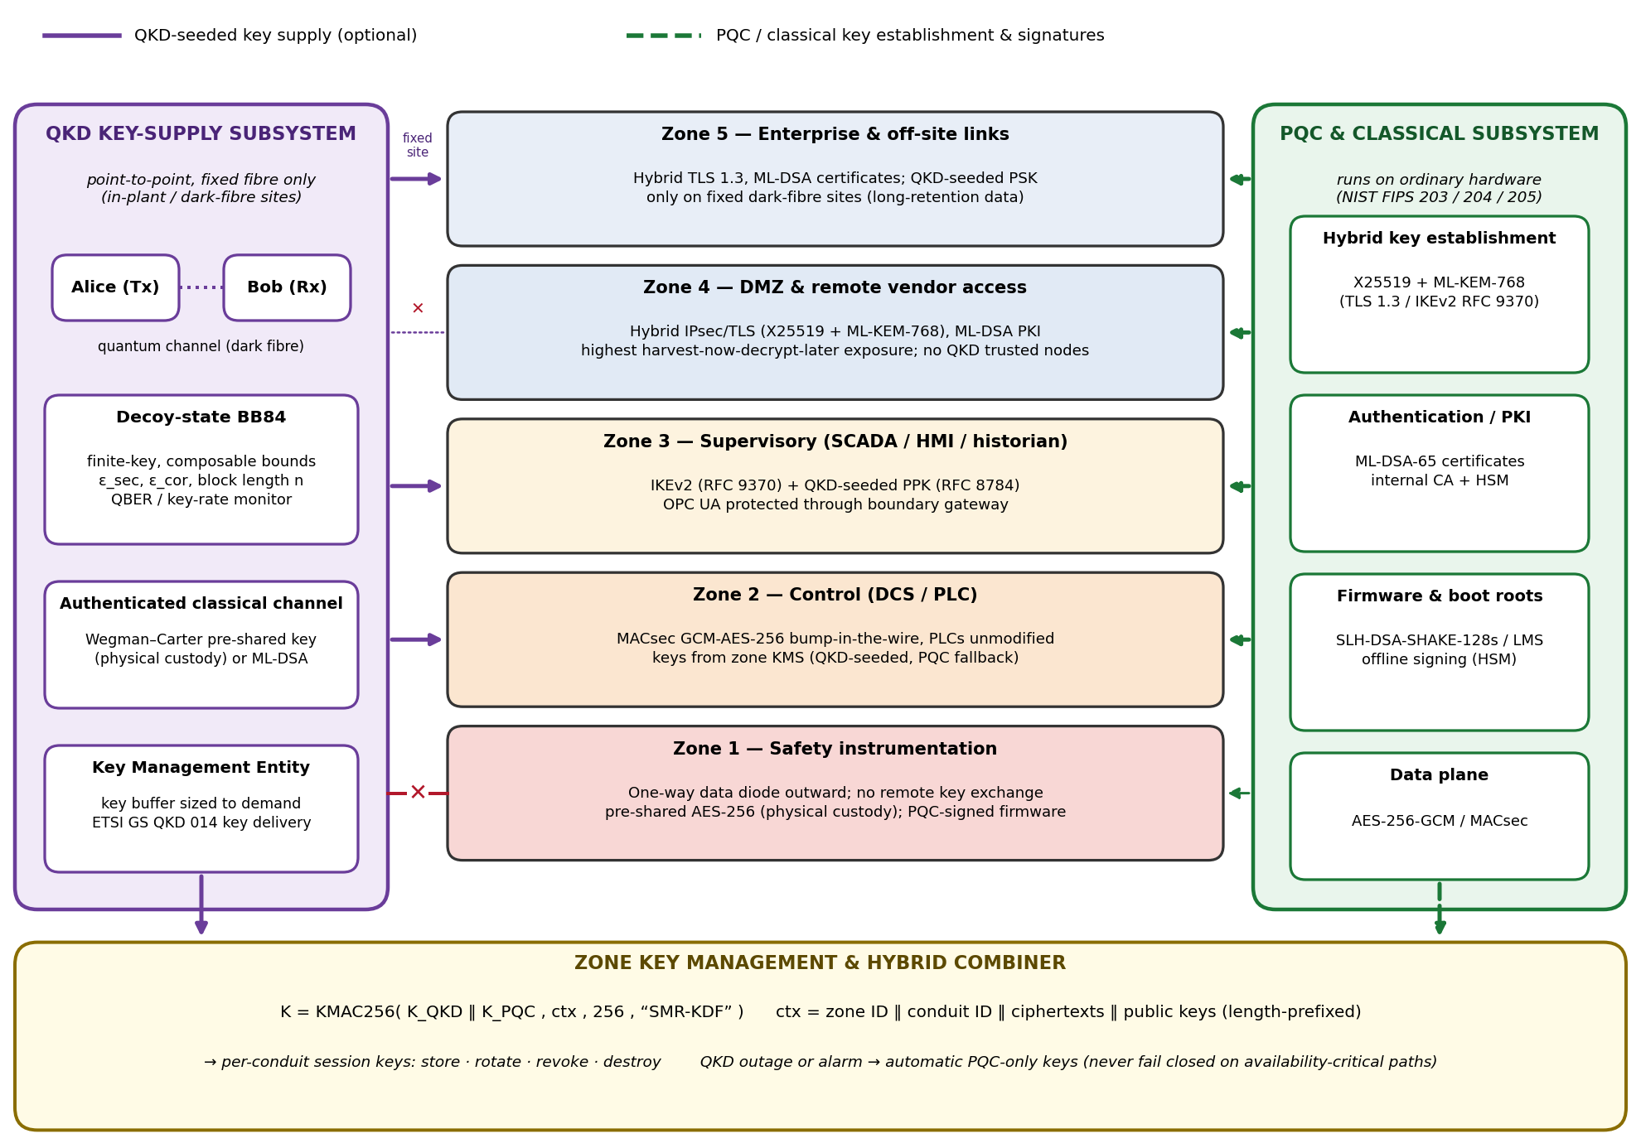
Fig. 1: Zone-wise PQC/QKD key-management architecture for a five-zone SMR ICS

Fig.2. shows the four-step methodology.
Step 1: QKD model: Fibre loss, quantum bit error rate (QBER) and composable finite-key bounds [5] give Eqs. (1)–(3); authentication uses a pre-shared Wegman–Carter key or ML-DSA:
$η_{ch} = {10}^{-α_{f}L/10}$ (1)
$e = e_{\text{opt}} + \frac{Y_{0}}{2Q_{μ}} + 0.25 p_{\text{Eve}}$ (2)
$ℓ = s_{0} + s_{1}[1 − h(φ)] − λ_{\text{EC}} − 6 {\text{log}}_{\text{2}}\left(\frac{21}{ε_{\text{sec}}}\right) − {\text{log}}_{\text{2}}\left(\frac{2}{ε_{\text{cor}}}\right)$ (3)
Here α_{f} is fibre loss, L distance, η total efficiency, e_{opt} optical error, Y₀ dark-count yield, p_{Eve} eavesdropped share, h(·) binary entropy, f error-correction efficiency, n_{sift} sifted key length, s₀, s₁ vacuum and single-photon bounds, φ phase-error bound, λ_{EC} error-correction leakage, and ε_{sec}, ε_{cor} failure probabilities.
Decoy states [3] bound the PNS attack, giving Eq. (4):
$s_{1} = n_{\text{sift}}\frac{Q_{1,L}}{Q_{μ}}, φ = e_{1,U}, λ_{\text{EC}} = f n_{\text{sift}} h(E_{μ})$ (4)
where Q_{1,L} is the single-photon gain lower bound, Q_{μ} the total gain, e_{1,U} the single-photon error upper bound, and E_{μ} the overall error [5].
Step 2: PQC and hybrid key: ML-KEM-768, ML-DSA-65 and SLH-DSA-SHAKE-128s are benchmarked on Raspberry Pi and Cortex-M4 hardware, with X25519+ML-KEM-768 as a classical+PQC arm; a KMAC combiner with transcript binding joins the keys [2], [6], Eq. (5):
$K = \text{KMAC256}\left(K_{\text{QKD}} ‖ K_{\text{PQC}}, ctx, 256, “SMR-KDF”\right)$ (5)
Step 3: Scoring: Each zone z is scored from availability A, integrity I and confidentiality C (AHP weights w; Eq. 6). QKD and PQC scores merge by a break-both rule into H (Eq. 7). ZPI combines the weakest zone with a weighted zone average (Eq. 8).
$S_{z} = w_{A}A_{z} + w_{I}I_{z} + w_{C}C_{z}$ (6)
$H_{z} = 1 − \left(1 − S_{z}^{\text{QKD}}\right)\left(1 − S_{z}^{\text{PQC}}\right)$ (7)
$\text{ZPI} = λ {\text{min}}_{z}H_{z} + (1 − λ) \sum_{z∈Z}{ω_{z}H_{z}}$ (8)

Step 4: Validation: Five setups are compared by Monte-Carlo attack simulation, handshake/rekey delay and control-loop delay margin; HAI/SWaT anomaly detection is reported separately. Effect sizes (Cohen’s d, Cliff’s δ) with 95% CI report differences. An eight-scenario check verifies ZPI ranking, and Morris/Sobol analysis of the threat-mitigation matrix tests sensitivity. ZPI is compared with IEC 62443-3-3 security-level requirements (Kendall’s τ); the top-ZPI configuration per zone forms the validated profile.
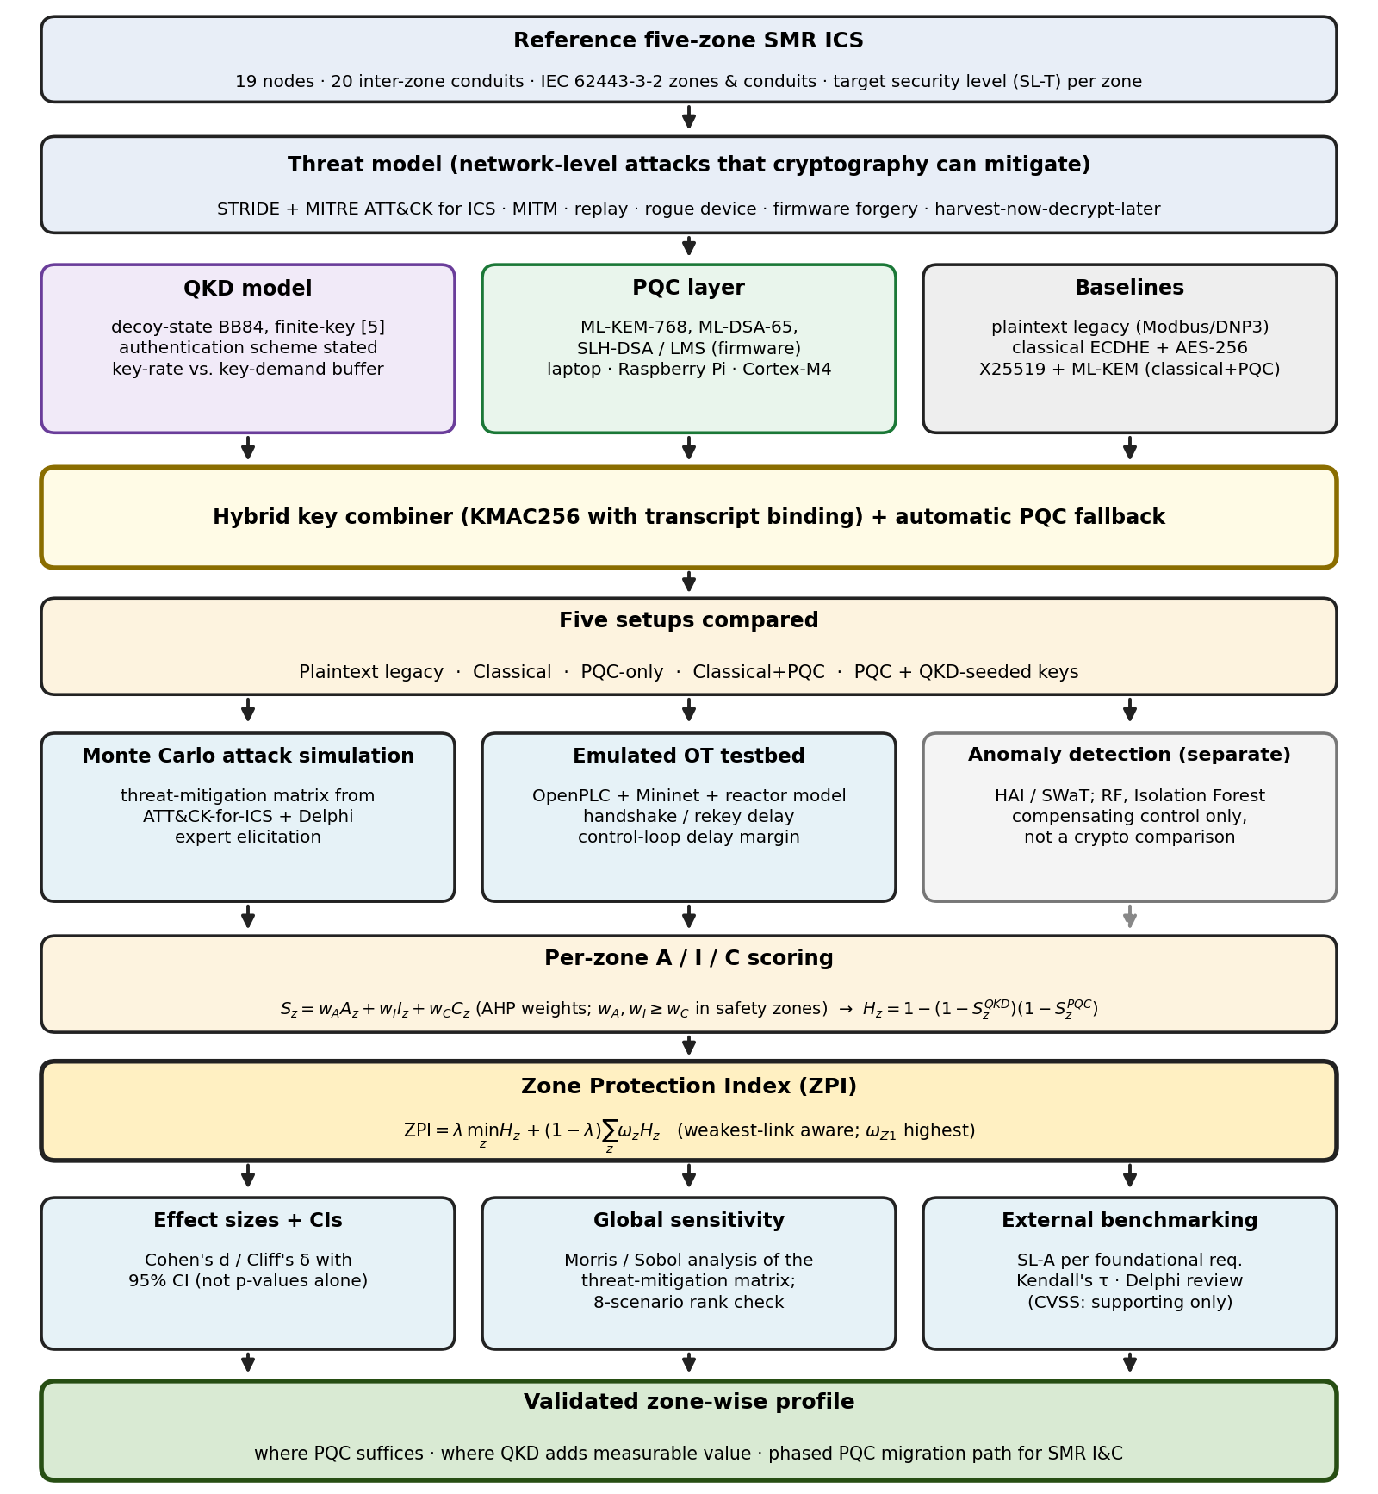
Fig. 2: Overview of the revised zone-wise PQC/QKD evaluation methodology
13. Expected outcomes
(Please list the possible outcomes using short sentences. If you are writing one or two paragraphs describing the expected outcomes, please limit yourself to 150 words.)
- A reference five-zone SMR network model will be developed that shows how vulnerable each zone and each conduit is under simulated network-level attacks.
- A finite-key, decoy-state QKD model will be combined with NIST-standardized PQC through a standards-based hybrid key combiner, with QBER, secret-key rate and key-buffer size kept within safe limits and automatic PQC fallback.
- A comparison of the five setups will show whether PQC-based setups lower the attack success rate and keep handshake and rekey delay within each zone’s control-loop delay margin.
- A zone protection index (ZPI) will be shown to remain rank-stable under global sensitivity analysis of the threat-mitigation matrix. It will be compared with IEC 62443-3-3 security-level requirements, giving a reusable way to compare SMR cyber security designs.
- A zone-wise recommendation will state where PQC suffices and where QKD adds measurable value.
14. References
(All the references should be cited inside the texts, and a maximum of 10 references should be used. While giving the references, you must mention the author, title of the paper, and name of the journal/proceeding, Vol. no., Year of publication, etc., in the standard style given below)
[1] C. H. Bennett and G. Brassard, “Quantum cryptography: Public key distribution and coin tossing,” in Proc. IEEE Int. Conf. Comput., Syst. Signal Process., Bangalore, India, Dec. 1984, pp. 175–179.
[2] National Institute of Standards and Technology, “Module-lattice-based key-encapsulation mechanism standard,” U.S. Dept. Commerce, Gaithersburg, MD, USA, FIPS 203, Aug. 2024; “Module-lattice-based digital signature standard,” FIPS 204, Aug. 2024; “Stateless hash-based digital signature standard,” FIPS 205, Aug. 2024.
[3] H.-K. Lo, X. Ma, and K. Chen, “Decoy state quantum key distribution,” Phys. Rev. Lett., vol. 94, no. 23, Art. no. 230504, Jun. 2005.
[4] C. Siserman-Gray and G. Landine, “Cybersecurity for small modular reactors (SMRs): Regulatory challenges and opportunities,” in Proc. INMM/ESARDA Joint Annu. Meeting, Vienna, Austria, May 2023, p. 785.
[5] C. C. W. Lim, M. Curty, N. Walenta, F. Xu, and H. Zbinden, “Concise security bounds for practical decoy-state quantum key distribution,” Phys. Rev. A, vol. 89, no. 2, Art. no. 022307, Feb. 2014.
[6] L. Garms et al., “Experimental integration of quantum key distribution and post-quantum cryptography in a hybrid quantum-safe cryptosystem,” Adv. Quantum Technol., vol. 7, no. 4, Art. no. 2300304, Apr. 2024,
[7] ANSSI, BSI, NLNCSA and Swedish NCSA, “Position paper on quantum key distribution,” Jan. 2024. [Online]. Available: https://cyber.gouv.fr/en/publications/jointly-led-international-publications/position-paper-on-quantum-key-distribution/
[8] J. Son, T. Tak, and I. Hahm, “Modeling cryptographic algorithms validation and developing block ciphers with electronic code book for a control system at nuclear power plants,” Nucl. Eng. Technol., vol. 55, no. 1, pp. 25–36, Jan. 2023.
[9] Cybersecurity and Infrastructure Security Agency, “Post-quantum considerations for operational technology,” U.S. Dept. Homeland Security, Washington, DC, USA, Oct. 2024. [Online]. Available: https://www.cisa.gov/resources-tools/resources/post-quantum-considerations-operational-technology
[10] U.S. Nuclear Regulatory Commission, “Cyber security programs for nuclear facilities,” U.S. NRC, Rockville, MD, USA, Regulatory Guide 5.71, Jan. 2010. [Online]. Available: https://www.nrc.gov/docs/ML0903/ML090340159.pdf; International Electrotechnical Commission, “Security for industrial automation and control systems—Part 3-2: Security risk assessment for system design,” IEC 62443-3-2, 2020; “Part 3-3: System security requirements and security levels,” IEC 62443-3-3, 2013.
15. List of courses taken (Completed/registered) so far
(To be verified and signed by the Course Advisor, and a Photocopy of Grade Sheets should be provided)
Sl. No. | Course No. | Course Name | Grade | Credit | Grade point | G.P.A
1 | EEE 6001 | Engineering Analysis | A+ | 3.00 | 12.00
2 | EEE 6201 | Modern Control Theory | A+ | 3.00 | 12.00
3 | EEE 6103 | Renewable Energy | A+ | 3.00 | 12.00
4 | EEE 6206 | Multivariable Control Systems | A+ | 3.00 | 12.00
5 | EEE 6609 | Digital Circuit Design | A+ | 3.00 | 12.00
6 | EEE 6608 | Digital Signal Processing | A+ | 3.00 | 12.00
Total |  |  |  | 18.00 | 72.00 | 4.00
Signature of the Course Advisor: .......................................
16. Cost Estimate
(Invoice / Quotation must be provided for each item which costs Tk. 5,000/- and more)
(a) Cost of Material Tk. 0,000
(b) Fieldworks (if applicable) Tk. 0,000
(c) Conveyance / Data Collection (With Breakup) Tk. 10,000
(d) Drafting, Binding & Paper, etc. (Max. 3000/-) Tk. 3,000
(e) Miscellaneous (compute cluster / cloud usage) Tk. 7,000
Total Tk. 20,000

17. Justification of having Co-Supervisor
Co-supervisor is not encouraged in a master’s level thesis unless there is an absolute necessity. At the Ph.D. level, Co-supervisor(s) are acceptable if required. In both cases, it is necessary to justify to the supervisor that the work requires considerable knowledge of a discipline other than his field.
Co-supervisor (proposed): [Name, Designation — to be confirmed]. The thesis combines post-quantum cryptography, quantum key distribution and nuclear I&C cyber security, which require considerable knowledge of cryptography and quantum communication beyond the main supervisor’s field. Guidance is needed on protocol design, finite-key security analysis and testbed validation.
For Office Use Only
18. Doctoral Committee/PGAC reference: Meeting no.: .................... Resolution No.: ........................ Date: .................................
19. Appointment of Supervisor & Co-Supervisor Approved by the CASR Meeting No. (For Ph.D): Resolution No.: ......................... Date: .................................
20. Appointment of Doctoral Committee Approved by the CASR Meeting No. (For Ph.D): Resolution No.: ............................... Date: .............................
21. Result of the comprehensive examination for Ph.D (Photocopy of the result should be enclosed) Date: .............................. Satisfactory/Unsatisfactory.
22. Number of Post-Graduate Student(s) working with the Supervisor at Present:

Signature of the Student | Signature of the Supervisor | Signature of the Co-Supervisor | Signature of the Head of the Department

