 | Heaven’s Light is our Guide  DIRECTOR OF RESEARCH & EXTENSION  RAJSHAHI UNIVERSITY OF ENGINEERING & TECHNOLOGY  Rajshahi-6204, Bangladesh

Application form (Guidelines) for approval of Ph.D/M.Phil/M.Sc.Engg./MURP/M.Engg. Thesis/project proposal by the CASR. All items applicable to the following list must be mentioned and filled in correctly. Please submit four (04) hard copies [One original and the other three (03) photocopies in the entire script plain paper] and also submit a scanned copy of the proposal.
Date: 11.10.2026
1. Name of the student: NASRULLAH MASUD Status: Part-Time
(Block Letters)
Roll No.: 2204101013 Session: 2022-23
2. Present Address: Chishtiya Chattrabash, Room no: 115, Upor Vodra, Kazla, Rajshahi-6204
3. Present Designation & Organization: Lecturer, Dept. of Electrical and Electronic Engineering, Varendra University, Rajshahi.
4. Name of the Department: Electrical & Electronic Engineering Programme: M.Sc. in Engineering
5. Name of the Supervisor: Dr. Md. Sohel Rana Designation: Professor
6. Name of the Co-Supervisor (if any): ............................... Designation: ........................
7. Date of First Enrolment in the Programme: 06/05/2023
8. Tentative Title (Block Letters, Times New Roman, Font size 11 points, Not more than 25 words):
Development and Evaluation of a Hybrid Quantum–Classical Framework for Enhancing Security in Small Modular Reactors
9. Background and present state of the problem
(Not more than 250 words. Please mention only those activities carried out in different places as reported in publications. Please support your information by citing the relevant references.)
Nuclear power plants use industrial control systems (ICS) to run sensors, pumps and safety functions. These systems are attractive targets for cyber-attacks. The Stuxnet attack in 2010 showed that malicious software can damage physical industrial equipment [4]. Small modular reactors (SMRs) use a layered network of five zones, from safety instrumentation up to the enterprise office network, as recommended by IEC 62443-3-3 and NRC Regulatory Guide 5.71 [10].
These networks protect data with classical encryption such as RSA and AES. A large quantum computer could break RSA and ECC key exchange using Shor’s algorithm and weaken AES using Grover’s algorithm [2], [9]. Two technologies address this risk. Quantum key distribution (QKD) such as the BB84 protocol [1] uses the physics of light to share secret keys safely. Its limits are short distance, finite key lengths, and photon-number-splitting (PNS) attacks which decoy states can reduce [3], [5]. Post-quantum cryptography (PQC), such as ML-KEM, ML-DSA and SLH-DSA standardized by NIST in FIPS 203, 204 and 205. These algorithms run on ordinary hardware but depend on mathematical assumptions rather than physical laws [2].
Recent studies combine QKD and PQC and test them on FPGA hardware and city fibre networks [6], [7]. However, guidance for applying this hybrid approach to five-zone nuclear ICS using real attack data and formal security-level checks is still limited [4], [6].
10. Justification of the study
(Not more than 150 words. Please justify research/study based on the present state of the problem and works that have been carried out in different places as reported in publications. Please support your information by citing the relevant references.)
Existing nuclear and industrial cyber security work relies mainly on classical encryption, network segmentation and anomaly detection, and largely ignores the future quantum threat [8], [9]. Research on QKD and PQC has also progressed separately. QKD studies rarely use real ICS data or zone-based risk models, while PQC studies seldom include quantum key exchange [1]–[3], [5].
In addition, SMR cyber security reviews report a lack of measurable security metrics linked to IEC 62443 Security Levels and NRC guidance [4], [6]. Without such evidence, designers cannot compare quantum-safe options zone by zone.
This study therefore proposes a framework that (i) combines finite-key decoy-state QKD with NIST-standardized PQC in a realistic five-zone SMR network, (ii) is tested on real ICS attack datasets while checking delay against PLC deadlines, and (iii) is evaluated with a statistically validated security metric. To our knowledge, no earlier study integrates all three for SMRs.

11. Objectives with specific aims
(Please list the objectives(s) using short sentences. If you are writing one or two paragraphs describing the objectives, please limit yourself to 150 words.)
The objectives of this thesis are:
- To model a five-zone small modular reactor (SMR) industrial control system (ICS) based on IEC 62443 zoning and measure the weak points of each zone using Monte Carlo threat simulation.
- To build a finite-key, decoy-state BB84 quantum key distribution (QKD) model and combine it with NIST-standardized post quantum cryptography (PQC) algorithms through a hybrid key combiner.
- To compare four setups (classical (RSA/AES), QKD-only, PQC-only and hybrid) on attack success rate, anomaly detection (on real ICS attack datasets) and delay against PLC deadlines.
- To design a zone protection index (ZPI) and validate it against IEC 62443-3-3 Security Levels and CVSS scores using statistical tests.

12. Outline of Methodology / Experimental Design
(Outline the approach and the sequence of activities in not more than 500 words to describe how the work will be carried out. Figure/Table will be considered as 100 words.)
A hybrid QKD+PQC framework is tested on a simulated five-zone SMR network (19 nodes, 20 inter-zone links; Zone 1 = safety instrumentation, Zone 5 = enterprise) using Monte Carlo threat simulation and anomaly detection based on open ICS datasets (HAI, SWaT, WADI). Fig.1 represents the hybrid security workflow for layered (five-zone) industrial control system.
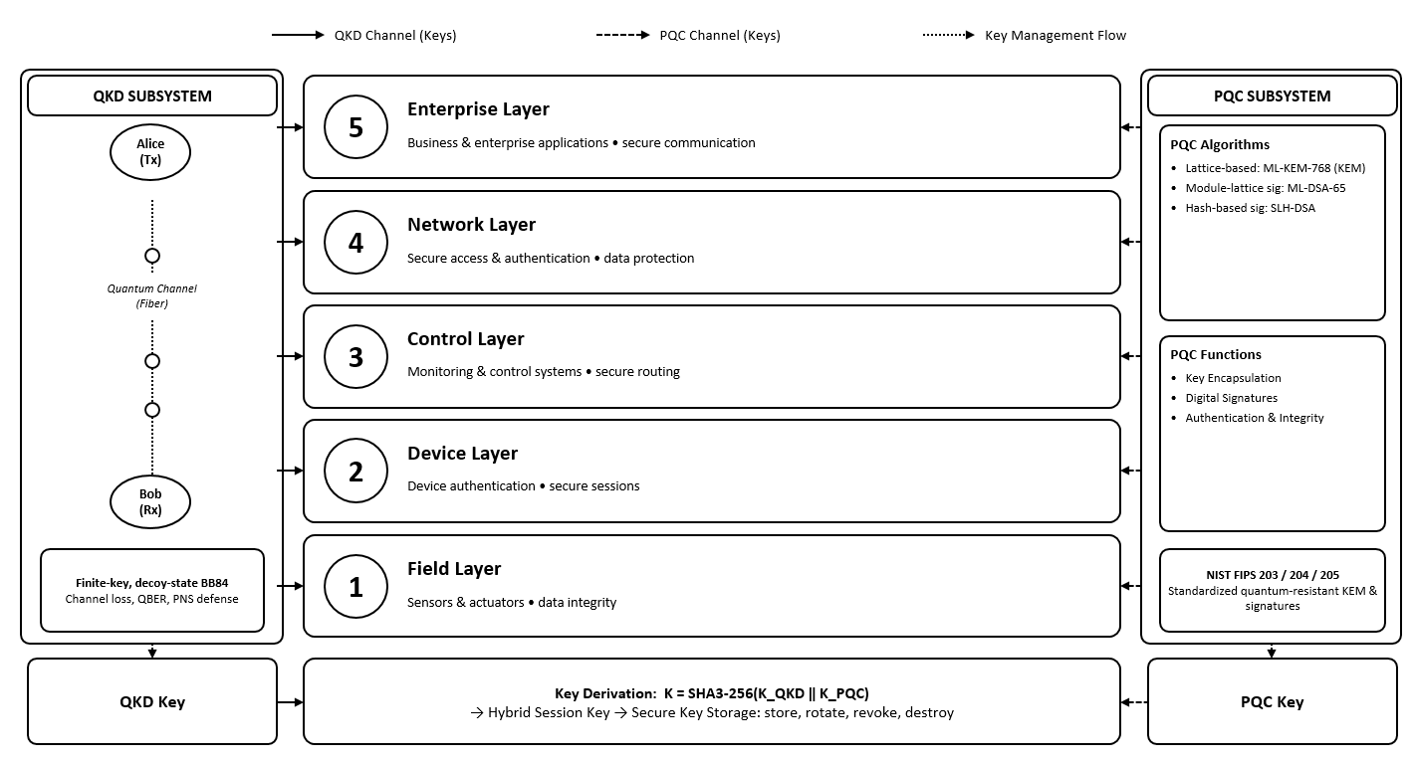
Fig. 1: End-to-end hybrid QKD+PQC security workflow for five-zone SMR ICS

Fig.2. represents the detailed methodology of the research work. It has been divided into four steps.
Step 1: QKD model: Fibre loss, quantum bit error rate (QBER) and finite-key bounds [5] give Eqs. (1)–(3):
$η_{ch} = {10}^{-α_{f}L/10}$ (1)
$e = e_{opt} + e_{dark} + 0.25 p_{Eve}$ (2)
$l = n_{sift}\left[1 - h\left(e_{ph}\right)\right] - f n_{sift}h\left(e\right) - Δ_{finite}n_{sift}$ (3)
Here α_{f} is fibre loss, L distance, e_{opt} and e_{dark} optical and dark-count errors, p_{Eve} the eavesdropped share, e_{ph} the phase-error bound (with finite-size fluctuation), h(·) binary entropy, f error-correction efficiency, n_{sift} the sifted key length, Δ_{finite} = $\frac{2 \log_{2}(\frac{1}{ε})}{n_{sift}}$ the finite-size penalty, and ε the failure probability.
Decoy states [3] block the PNS attack, giving Eq. (4):
$l = n_{sift}\left(\frac{Q_{1,L}}{Q_{μ}}\right)\left[1 - h\left(e_{1,U}\right)\right] - f n_{sift}h\left(E_{μ}\right) - Δ_{finite}n_{sift}$ (4)
where Q_{1,L} is the single-photon gain lower bound, Q_{μ} the total gain, e_{1,U} the single-photon error upper bound, E_{μ} the overall error, and Δ_{finite} the finite-size penalty.
Step 2: PQC and hybrid key: ML-KEM-768, ML-DSA-65 and SLH-DSA-SHAKE-128s are benchmarked; a SHA3-256 combiner joins the keys [2], [7], Eq. (5):
$K = \text{SHA3-256}\left(K_{QKD} ‖ K_{PQC}\right)$ (5)
Step 3: Scoring: Each zone z is scored from availability A, integrity I and confidentiality C (weights w, Eq. 6). QKD and PQC scores merge into H (weights α, β; Eq. 7). ZPI averages H over |Z| zones, each divided by its classical baseline R (Eq. 8).
$S_{z} = w_{A}A_{z} + w_{I}I_{z} + w_{C}C_{z}$ (6)
$H_{z} = α S_{z}^{QKD} + (1 - α) S_{z}^{PQC} + β S_{z}^{QKD}S_{z}^{PQC}$ (7)
$ZPI = \frac{1}{|Z|}\sum_{z}{\frac{H_{Z}}{{ R}_{Z}^{baseline}}}$ (8)

Step 4: Validation: Setups are compared by Monte-Carlo attack simulation, anomaly detection (RF, SVM-RBF, Isolation Forest) and a latency model vs. PLC deadlines (10–2000 ms). Mann–Whitney U, Kruskal–Wallis H, Welch’s t-test, Cohen’s d and 95% CI test differences. An eight-scenario check verifies ZPI ranking, and ±30% perturbation of the threat-mitigation matrix (attack-to-defense weights) tests sensitivity. ZPI is benchmarked against IEC 62443-3-3 Security Levels and CVSS v3.1; the top-ZPI configuration per zone forms the validated profile.
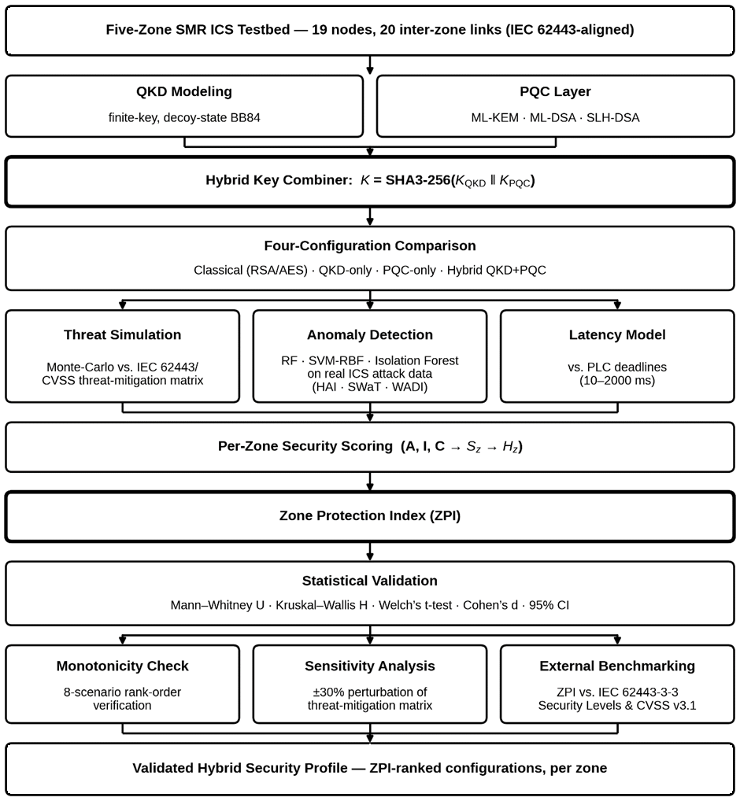
Fig. 2: Overview of the proposed hybrid QKD+PQC evaluation methodology
13. Expected outcomes
(Please list the possible outcomes using short sentences. If you are writing one or two paragraphs describing the expected outcomes, please limit yourself to 150 words.)
- A five-zone SMR network model will be developed that shows how vulnerable each zone and each inter-zone link is under simulated attacks.
- A finite-key, decoy-state QKD model will be combined with NIST-standardized PQC through a hybrid key combiner, with QBER and secret key length kept within safe limits.
- A comparison of the four setups will show whether the hybrid setup lowers the attack success rate, improves or maintains anomaly detection performance, and keeps key-exchange delay within the PLC deadline of each zone.
- A zone protection index (ZPI) will be shown to remain statistically robust under ±30% changes in the threat-mitigation matrix. It will be correlated with CVSS scores and IEC 62443-3-3 Security Levels, giving a reusable way to compare SMR cyber security designs.
14. References
(All the references should be cited inside the texts, and a maximum of 10 references should be used. While giving the references, you must mention the author, title of the paper, and name of the journal/proceeding, Vol. no., Year of publication, etc., in the standard style given below)
[1] C. H. Bennett and G. Brassard, “Quantum cryptography: Public key distribution and coin tossing,” Theor. Comput. Sci., vol. 560, pt. 1, pp. 7–11, Dec. 2014.
[2] National Institute of Standards and Technology, “Module-lattice-based key-encapsulation mechanism standard,” U.S. Dept. Commerce, Gaithersburg, MD, USA, FIPS 203, Aug. 2024; “Module-lattice-based digital signature standard,” FIPS 204, Aug. 2024; “Stateless hash-based digital signature standard,” FIPS 205, Aug. 2024.
[3] H.-K. Lo, X. Ma, and K. Chen, “Decoy state quantum key distribution,” Phys. Rev. Lett., vol. 94, no. 23, Art. no. 230504, Jun. 2005.
[4] C. Siserman-Gray and G. Landine, “Cybersecurity for small modular reactors (SMRs): Regulatory challenges and opportunities,” in Proc. INMM/ESARDA Joint Annu. Meeting, Vienna, Austria, May 2023, p. 785.
[5] C. C. W. Lim, M. Curty, N. Walenta, F. Xu, and H. Zbinden, “Concise security bounds for practical decoy-state quantum key distribution,” Phys. Rev. A, vol. 89, no. 2, Art. no. 022307, Feb. 2014.
[6] L. Garms et al., “Experimental integration of quantum key distribution and post-quantum cryptography in a hybrid quantum-safe cryptosystem,” Adv. Quantum Technol., vol. 7, no. 4, Art. no. 2300304, Apr. 2024,
[7] P. Zeng et al., “Practical hybrid PQC-QKD protocols with enhanced security and performance,” 2024, arXiv:2411.01086.
[8] J. Son, T. Tak, and I. Hahm, “Modeling cryptographic algorithms validation and developing block ciphers with electronic code book for a control system at nuclear power plants,” Nucl. Eng. Technol., vol. 55, no. 1, pp. 25–36, Jan. 2023.
[9] Cybersecurity and Infrastructure Security Agency, “Post-quantum considerations for operational technology,” U.S. Dept. Homeland Security, Washington, DC, USA, Oct. 2024. [Online]. Available: https://www.cisa.gov/resources-tools/resources/post-quantum-considerations-operational-technology
[10] U.S. Nuclear Regulatory Commission, “Cyber security programs for nuclear facilities,” U.S. NRC, Rockville, MD, USA, Regulatory Guide 5.71, Jan. 2010. [Online]. Available: https://www.nrc.gov/docs/ML0903/ML090340159.pdf
15. List of courses taken (Completed/registered) so far
(To be verified and signed by the Course Advisor, and a Photocopy of Grade Sheets should be provided)
Sl. No. | Course No. | Course Name | Grade | Credit | Grade point | G.P.A
1 | EEE 6001 | Engineering Analysis | A+ | 3.00 | 12.00
2 | EEE 6201 | Modern Control Theory | A+ | 3.00 | 12.00
3 | EEE 6103 | Renewable Energy | A+ | 3.00 | 12.00
4 | EEE 6206 | Multivariable Control Systems | A+ | 3.00 | 12.00
5 | EEE 6609 | Digital Circuit Design | A+ | 3.00 | 12.00
6 | EEE 6608 | Digital Signal Processing | A+ | 3.00 | 12.00
Total |  |  |  | 18.00 | 72.00 | 4.00
Signature of the Course Advisor: .......................................
16. Cost Estimate
(Invoice / Quotation must be provided for each item which costs Tk. 5,000/- and more)
(a) Cost of Material Tk. 0,000
(b) Fieldworks (if applicable) Tk. 0,000
(c) Conveyance / Data Collection (With Breakup) Tk. 10,000
(d) Drafting, Binding & Paper, etc. (Max. 3000/-) Tk. 3,000
(e) Miscellaneous (compute cluster / cloud usage) Tk. 7,000
Total Tk. 20,000

17. Justification of having Co-Supervisor
Co-supervisor is not encouraged in a master’s level thesis unless there is an absolute necessity. At the Ph.D. level, Co-supervisor(s) are acceptable if required. In both cases, it is necessary to justify to the supervisor that the work requires considerable knowledge of a discipline other than his field.
For Office Use Only
18. Doctoral Committee/PGAC reference: Meeting no.: .................... Resolution No.: ........................ Date: .................................
19. Appointment of Supervisor & Co-Supervisor Approved by the CASR Meeting No. (For Ph.D): Resolution No.: ......................... Date: .................................
20. Appointment of Doctoral Committee Approved by the CASR Meeting No. (For Ph.D): Resolution No.: ............................... Date: .............................
21. Result of the comprehensive examination for Ph.D (Photocopy of the result should be enclosed) Date: .............................. Satisfactory/Unsatisfactory.
22. Number of Post-Graduate Student(s) working with the Supervisor at Present:

Signature of the Student | Signature of the Supervisor | Signature of the Co-Supervisor | Signature of the Head of the Department

