1‏-‏1‏-‏ Loading Image and adding noise 1
1‏-‏2‏-‏ Cross-Validation for Selecting Hyperparameters 1
1‏-‏3‏-‏ Cross-Validation for Aniso 1
1‏-‏4‏-‏ Cross-Validation for Iso 7
1‏-‏5‏-‏ Denoising 10
close all
clear
clc

Loading Image and adding noise
img = imread('image2.png');
img = im2double(img);
imgNoisy = imnoise(img, 'gaussian');

Cross-Validation for Selecting Hyperparameters

Cross-Validation for Aniso
bestSsim = -Inf;
bestNiqe = Inf;
bestLambda = 0;
bestKappa = 0;
nIter = 5;
for option = 1:2
for lambdaVal = 0.05:0.05:0.2
t = 20:5:100;
ssims = [];
niqes = [];
for kappaVal = 20:5:100
anisoImgDenoised = anisodiff(imgNoisy, nIter, kappaVal, lambdaVal, option);
ssimScore = ssim(anisoImgDenoised, img);
niqeScore = niqe(anisoImgDenoised);
ssims = [ssims, ssimScore];
niqes = [niqes, niqeScore];
% fprintf("lambda=%.2f, kappa=%.2f, ", lambdaVal, kappaVal);
% fprintf("ssim=%.2f, niqe=%.2f\n", ssimScore, niqeScore);
% Update best SSIM and NIQE scores
if ssimScore > bestSsim
bestSsim = ssimScore;
bestLambda = lambdaVal;
bestKappa = kappaVal;
bestOption=option;
end
if niqeScore < bestNiqe
bestNiqe = niqeScore;
bestLambda = lambdaVal;
bestKappa = kappaVal;
bestOption=option;
end
end
% Plot SSIM and NIQE for the current lambda and option
figure;
subplot(1, 2, 1); plot(t, ssims); title(['SSIM (lambda=', num2str(lambdaVal), ', option=', num2str(option), ')']);
subplot(1, 2, 2); plot(t, niqes); title(['NIQE (lambda=', num2str(lambdaVal), ', option=', num2str(option), ')']);
end
end
fprintf("Best SSIM: %.2f, with lambda=%.2f, kappa=%.2f and option:%.2f \n ", bestSsim, bestLambda, bestKappa,bestOption);
fprintf("Best NIQE: %.2f, with lambda=%.2f, kappa=%.2f and option:%.2f \n", bestNiqe, bestLambda, bestKappa, bestOption);
Best SSIM: 0.70, with lambda=0.15, kappa=20.00 and option:1.00
Best NIQE: 4.62, with lambda=0.15, kappa=20.00 and option:1.00
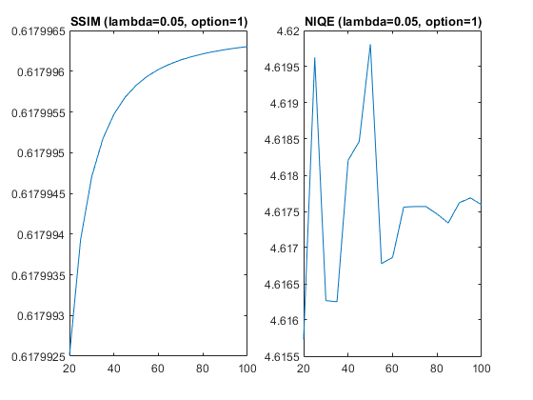
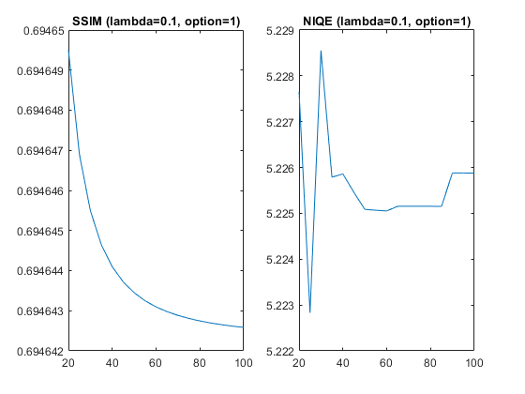
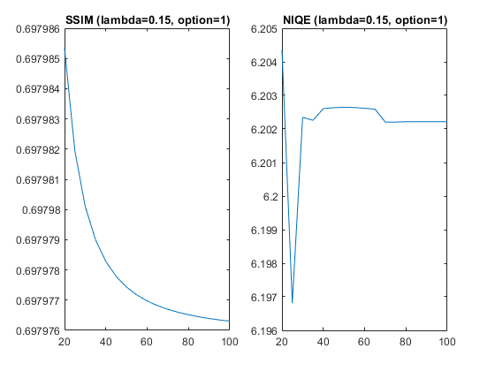
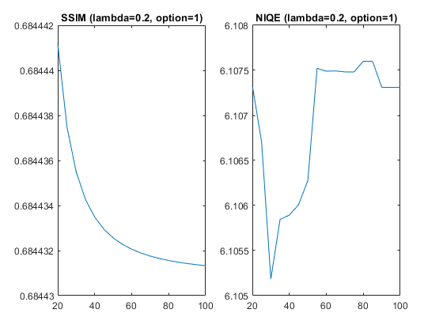
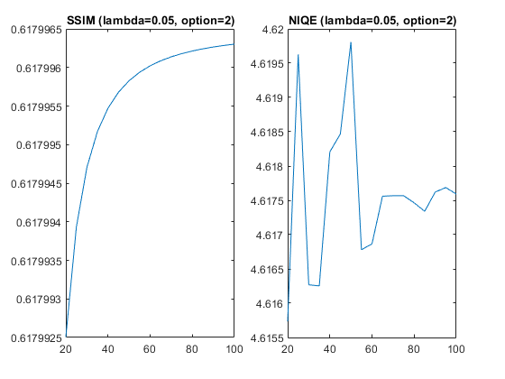
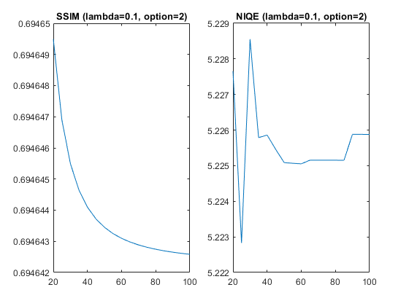
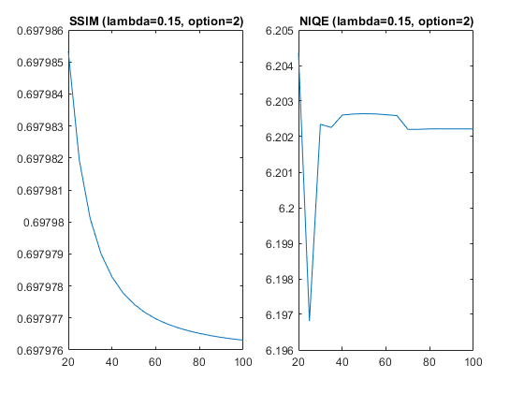
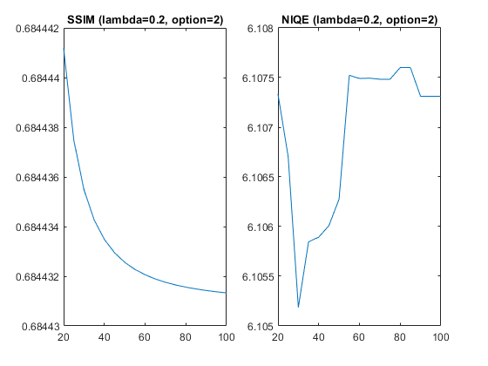

Cross-Validation for Iso
best_ssim = -Inf;
best_niqe = Inf;
best_lambda = 0;
best_constant = 0;
for lambdaVal = 0.05:0.05:0.2
t = 1.1:0.05:2;
ssims = [];
niqes = [];
for constantVal = 1.1:0.05:2
isoImgDenoised = isodiff(imgNoisy, lambdaVal, constantVal);
ssimScore = ssim(isoImgDenoised, img);
niqeScore = niqe(isoImgDenoised);
ssims = [ssims, ssimScore];
niqes = [niqes, niqeScore];
% fprintf("lambda=%.2f, c=%.2f, ", lambdaVal, constantVal);
% fprintf("ssim=%.2f, niqe=%.2f\n", ssimScore, niqeScore);
% finding the best SSIM and NIQE scores
if ssimScore > best_ssim
best_ssim = ssimScore;
best_lambda = lambdaVal;
best_constant = constantVal;
end
if niqeScore < best_niqe
best_niqe = niqeScore;
best_lambda = lambdaVal;
best_constant = constantVal;
end
end
figure;
subplot(1, 2, 1); plot(t, ssims); title(['SSIM (lambda=', num2str(lambdaVal),')']);
subplot(1, 2, 2); plot(t, niqes); title(['NIQE (lambda=', num2str(lambdaVal),')']);
end
fprintf("Best SSIM: %.2f, with lambda=%.2f and constant=%.2f\n", best_ssim, best_lambda, best_constant);
fprintf("Best NIQE: %.2f, with lambda=%.2f and constant=%.2f\n", best_niqe, best_lambda, best_constant);
Best SSIM: 0.61, with lambda=0.10 and constant=1.85
Best NIQE: 3.89, with lambda=0.10 and constant=1.85
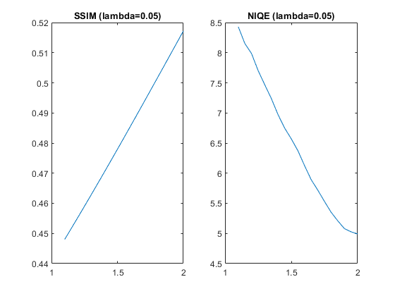
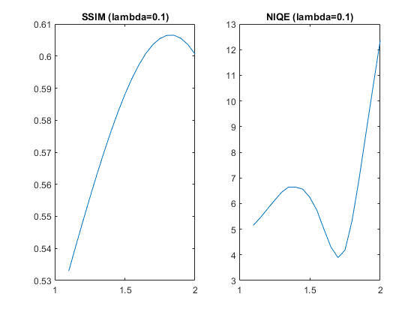
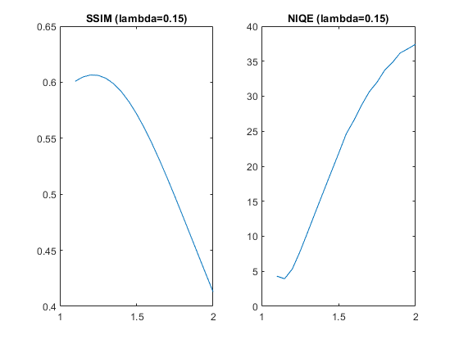
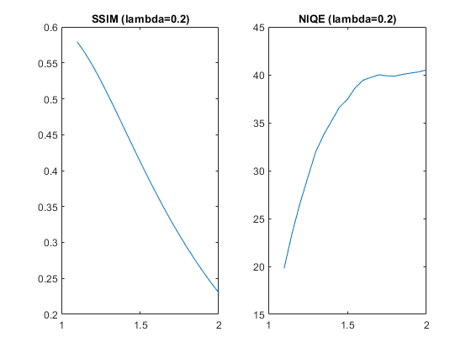

Denoising
Denoise the image using anisotropic diffusion
niter = 5; % Number of iterations
kappa = 20; % Conduction coefficient
lambda = 0.15; % Maximum value for stability
option = 1; % Diffusion equation No 2
anisoImgDenoised = anisodiff(imgNoisy, niter, kappa, lambda, option);
% Denoise the image using isotropic diffusion
lambda = 0.1;
constant = 1.8;
isoImgDenoised = isodiff(imgNoisy, lambda, constant);
subplot(2,2,1); imshow(img);
title(['Original image: SSIM=', num2str(ssim(img, img)), ', NIQE=', num2str(niqe(img))]);
subplot(2,2,2); imshow(imgNoisy);
title(['Noisy image: SSIM=', num2str(ssim(imgNoisy, img)), ', NIQE=', num2str(niqe(imgNoisy))]);
subplot(2,2,3); imshow(anisoImgDenoised);
title(['Aniso Denoised image: SSIM=', num2str(ssim(anisoImgDenoised, img)), ', NIQE=', num2str(niqe(anisoImgDenoised))]);
subplot(2,2,4); imshow(isoImgDenoised);
title(['Iso Denoised image: SSIM=', num2str(ssim(isoImgDenoised, img)), ', NIQE=', num2str(niqe(isoImgDenoised))]);
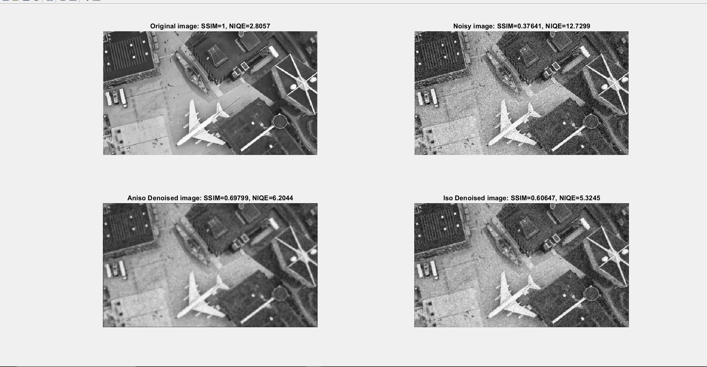
Published with MATLAB® R2021b

