1‏-‏1‏-‏ Loading Functions 1
1‏-‏2‏-‏ Part 1.1 1
1‏-‏3‏-‏ Part 1.2 and 1.3 1
1‏-‏4‏-‏ Part 1.4 2
1‏-‏5‏-‏ Showing the Results 7
close all
clear all
clc

Loading Functions
addpath('C:\Users\asus\Desktop\MIAP_HW4\Q1\Functions'); % if you want to run the code, please change the path

Part 1.1
data=load("data.mat");
imageMask=data.imageMask;
imageData=data.imageData;
scaledData = mat2gray(imageData);
imwrite(scaledData, 'imageData.jpg');
scaledData = mat2gray(imageMask);
imwrite(scaledData, 'imageMask.jpg');

Part 1.2 and 1.3
%{
Description: Returns the initial segmentation using K-means algorithm
Inputs:
img : The input image
mask : The background mask
k : The number of classes to segment into
eps : We stop the iterations when |loss_new - loss_prev|/loss_prev <= eps
Outputs:
seg : The segmented image, each pixel \in {1,...,k}
mu : k-vector with the class means
sigma : k-vector with the class std devs
%}
k=3;
q=5;
bConst=1;
[R, C] = size(imageMask);
bInit=(bConst * ones(R, C)) .* imageMask;
kerSize=9;
gaussianKernel=fspecial('gaussian',kerSize,2.5);
eps=1e-7;
[seg, mu, sigma] = KMeans(imageData, imageMask, k, eps);
figure;
path = 'K-Means Result';
title_str = 'K-Means Result';
showSegmented(seg, k, title_str, path);
K-Means ran for 17 iterations
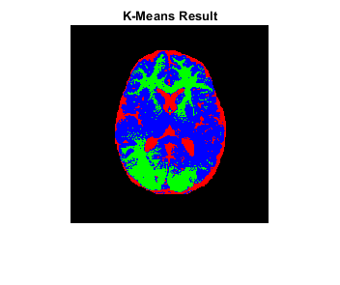

Part 1.4
%{
Description: Runs the specified algorithm / Driver class for the algorithm
Inputs:
img : The corrupted image
mask: The background mask
u : The class memberships
b : The bias field
c : The class means
q : The q-parameter as specified in the slides
w : The neighbourhood mask
J_init : The initial value of the loss function
eps : Specifes when the algorithm stops the iterations
N_max : Maximum number of iterations to run for in any case
Outputs:
u : The updated class memberships
b : The updated bias field
c : The updated class means
J : Array that stores the loss function values for each iteration
%}
u = zeros(R, C, k);
for i=1:k
u(:, :, i) = (seg == i);
end
b = bInit;
c = mu;
q = 5;
w = gaussianKernel;
J_init = objectiveFunction(imageData, b, c, q, u, w); % Initial value of the loss function
eps = 1e-5;
N_max = 200;
[u, b, c, J] = iterate(imageData, imageMask, u, b, c, q, w, J_init, eps, N_max);
biasRemovedImage = imageMask .* imageData ./ b;
figure;
plot(1:N_max, J);
title(['Objective Function (N=', num2str(N_max), ')']);
grid minor;
figure;
path = 'Segmentation Result';
title_str = 'Segmented Image';
showSegmented(u, 1, title_str, path);
Before: 114.625816 | After: 56.815121
Iteration 1 completed
Before: 56.815121 | After: 52.912628
Iteration 2 completed
Before: 52.912628 | After: 50.236568
Iteration 3 completed
Before: 50.236568 | After: 48.024349
Iteration 4 completed
Before: 48.024349 | After: 46.126049
Iteration 5 completed
Before: 46.126049 | After: 44.501450
Iteration 6 completed
Before: 44.501450 | After: 43.209400
Iteration 7 completed
Before: 43.209400 | After: 42.302898
Iteration 8 completed
Before: 42.302898 | After: 41.668499
Iteration 9 completed
Before: 41.668499 | After: 41.161942
Iteration 10 completed
Before: 41.161942 | After: 40.729271
Iteration 11 completed
Before: 40.729271 | After: 40.387119
Iteration 12 completed
Before: 40.387119 | After: 40.115849
Iteration 13 completed
Before: 40.115849 | After: 39.885368
Iteration 14 completed
Before: 39.885368 | After: 39.711689
Iteration 15 completed
Before: 39.711689 | After: 39.566090
Iteration 16 completed
Before: 39.566090 | After: 39.447380
Iteration 17 completed
Before: 39.447380 | After: 39.354061
Iteration 18 completed
Before: 39.354061 | After: 39.269779
Iteration 19 completed
Before: 39.269779 | After: 39.189190
Iteration 20 completed
Before: 39.189190 | After: 39.121799
Iteration 21 completed
Before: 39.121799 | After: 39.059349
Iteration 22 completed
Before: 39.059349 | After: 39.021999
Iteration 23 completed
Before: 39.021999 | After: 38.997459
Iteration 24 completed
Before: 38.997459 | After: 38.985149
Iteration 25 completed
Before: 38.985149 | After: 38.974689
Iteration 26 completed
Before: 38.974689 | After: 38.951370
Iteration 27 completed
Before: 38.951370 | After: 38.948132
Iteration 28 completed
Before: 38.948132 | After: 38.942230
Iteration 29 completed
Before: 38.942230 | After: 38.928581
Iteration 30 completed
Before: 38.928581 | After: 38.922821
Iteration 31 completed
Before: 38.922821 | After: 38.918190
Iteration 32 completed
Before: 38.918190 | After: 38.905720
Iteration 33 completed
Before: 38.905720 | After: 38.902920
Iteration 34 completed
Before: 38.902920 | After: 38.895290
Iteration 35 completed
Before: 38.895290 | After: 38.890060
Iteration 36 completed
Before: 38.890060 | After: 38.890629
Iteration 37 completed
Before: 38.890629 | After: 38.892590
Iteration 38 completed
Before: 38.892590 | After: 38.889351
Iteration 39 completed
Before: 38.889351 | After: 38.884838
Iteration 40 completed
Before: 38.884838 | After: 38.878151
Iteration 41 completed
Before: 38.878151 | After: 38.871819
Iteration 42 completed
Before: 38.871819 | After: 38.869240
Iteration 43 completed
Before: 38.869240 | After: 38.869129
Stopping
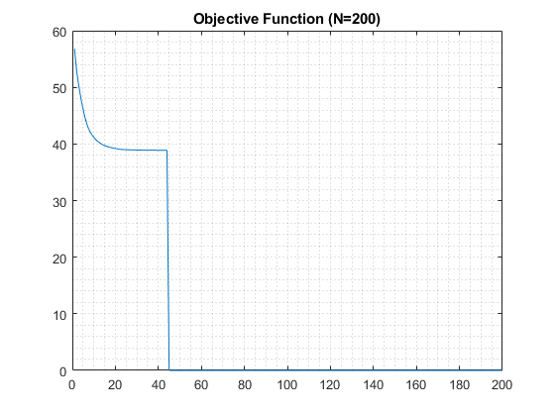
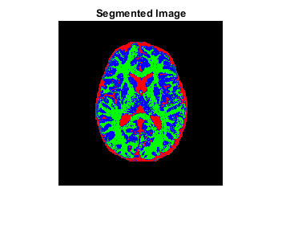

Showing the Results
figure;
imshow(imageData);
title('Corrupted Image');
figure;
fig = imshow(b);
title('Bias Field');
saveas(fig, 'BiasRemovedField', "jpg");
figure;
fig = imshow(biasRemovedImage);
title('Bias Removed Image');
saveas(fig, 'BiasRemovedImage', "jpg");
figure;
showSegmented(seg, k, 'Initial Image: using K-Means', 'K-Means Result');
figure;
showSegmented(u, 1, 'Segmented Image', 'SegmentedImage');
figure;
fig = imshow(imageData - imageMask .* imageData);
title('Residual Image');
saveas(fig, 'ResidualImage', "jpg");
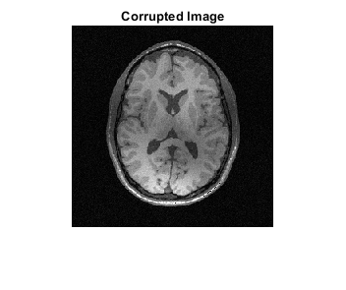
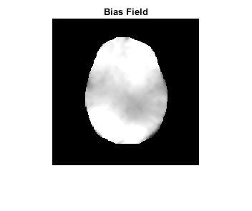
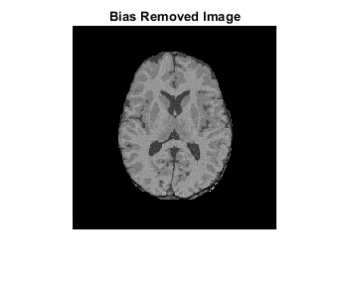
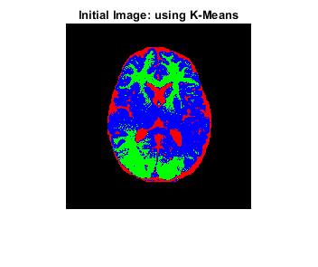
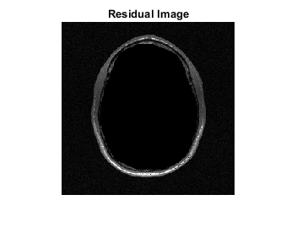
Published with MATLAB® R2021b

