Finite-redshift identifiability of cosmological distance ratios
Sean Brady
Independent researcher
25 September 2026 - expanded author-review manuscript

Abstract
Finite-redshift standard-siren data cannot, without restrictions on the allowed redshift dependence, identify either the infinite-redshift plateau or the zero-redshift relative calibration of a cosmological distance-ratio law. We prove two finite-window non-identifiability results. An arbitrarily slow component can shift the asymptotic ratio by a fixed amount while remaining uniformly small on any bounded redshift interval; an arbitrarily fast component can shift the extrapolated calibration while remaining uniformly small above any strictly positive minimum redshift. If positive decay components are bounded below by a known exponent, we derive one-sided plateau bounds for both decreasing ($Ξ_{0}<1$) and increasing ($Ξ_{0}>1$) branches. We then specialize to the Belgacem et al. family $Ξ\left(z\right)=Ξ_{0}+\left(1−Ξ_{0}\right){\left(1+z\right)}^{−n}$ and develop exact finite-redshift reconstruction, an irregular-grid four-point consistency condition, covariance-aware tests, and calibration separation. The multiplicative calibration is identified with the relative absolute distance scale: for supernova reconstructions it inherits the familiar $M_{B}−5\log_{10}H_{0}$ degeneracy, and for BAO reconstructions the $r_{d}h$ scale. Synthetic tests use 2–5% marginal ratio errors and a redshift-dependent non-Gaussian lensing-like tail. They show that realistic precision sharply limits discrimination among smooth alternatives even when the fitted plateau is biased. The result is a theorem-driven statement of what a finite standard-siren distance-ratio data set can and cannot establish about modified propagation and dark-energy phenomenology.

Introduction
Cosmological distance measurements carry both shape and scale. The supernova evidence for acceleration established the importance of the distance–redshift relation [1, 2]; baryon acoustic oscillations and gravitational-wave standard sirens now provide independent distance channels with different calibrations and systematics; the standard-siren idea originates with Schutz and has an observational realization in GW170817 [6, 7]. Their comparison is central to tests of cosmic acceleration, distance duality, and modified propagation [3, 4, 5].
A useful example is the gravitational-wave/electromagnetic luminosity-distance ratio. Belgacem, Dirian, Foffa, and Maggiore showed that modified gravitational-wave amplitude propagation can produce a luminosity distance different from its electromagnetic counterpart even when the wave speed remains $c$ [8, 9]. Their widely used parametrization is
$$Ξ\left(z\right)≡\frac{d_{L}^{GW}\left(z\right)}{d_{L}^{EM}\left(z\right)}=Ξ_{0}+\frac{1−Ξ_{0}}{{\left(1+z\right)}^{n}},$$
(1)
with $n>0$ and $Ξ_{0}>0$. Belgacem, Foffa, Maggiore, and Yang subsequently reconstructed the associated distance functions with Gaussian processes [10]; Matos and collaborators developed a complementary tripartite comparison of gravitational-wave, luminosity, and angular-diameter distances [4]; recent work has extended nonparametric ratio inference and its connection to evolving dark-energy models [11, 12].
The lead result of this paper is not another estimator for Eq. (1). It is a finite-window identifiability theorem. If the allowed response class contains arbitrarily slow positive components, a fixed change in the infinite-redshift plateau can be hidden below any prescribed error tolerance on a bounded observed interval. Dually, if arbitrarily fast components are allowed below the lowest observed redshift, a fixed change in the zero-redshift calibration can be hidden from the data. Thus neither endpoint is model-independently determined by finite-redshift measurements without restrictions on the allowed redshift scales. These two obstructions are stated and proved in Sec. II, together with conditional plateau bounds that apply once a minimum decay exponent is specified.
Within the single-power family, much more can be established. Following the broader cosmological tradition of null and consistency diagnostics [13, 14], we derive exact constant extraction, unique exponent recovery from three irregularly spaced samples, a four-point consistency condition on arbitrary grids, full-covariance tests for noisy data, and calibration-aware confidence and prediction constructions. The classical Aitken, Prony/Hankel, and variable-projection ideas used in parts of the analysis are credited to their original literature [15, 16, 17]; the contribution here is their combination with the finite-window theorem and their application to an established cosmological distance-ratio observable.
The calibration parameter is physically important rather than merely algebraic. A supernova Hubble diagram carries the absolute-scale combination $M_{B}−5\log_{10}H_{0}$ (equivalently $H_{0}{10}^{−M_{B}/5}$ up to fixed units) [23]; uncalibrated BAO constrains $r_{d}h$ [24]. A distance-ratio analysis that imports either electromagnetic reconstruction therefore inherits a corresponding relative scale uncertainty. Treating that uncertainty as part of the inference connects the present problem directly to the $H_{0}$ literature.
The paper proceeds from the finite-window theorem to the propagation observable and then to exact and noisy-data reconstruction. The synthetic validation uses 2–5% compressed-ratio errors with a stylized weak-lensing tail, motivated by the known impact of magnification on standard-siren distances [30]. The numerical experiment is deliberately conservative: it tests the method under realistic percent-level precision rather than assuming sub-percent ratio measurements.

Finite-window identifiability theorem

High-redshift obstruction: the plateau is not model-independently identifiable
Let $s=ln\left(1+z\right)$ and consider a normalized decreasing response on the finite interval $0≤s≤s_{max}$. Take
$$\begin{matrix}Q_{1}\left(s\right) & =1−a+ae^{−ns}, \\ Q_{2}\left(s\right) & =1−a−b+ae^{−ns}+be^{−ϵs},\end{matrix}$$
with $a,b>0$, $a+b<1$, $n>0$, and $ϵ>0$. The two asymptotes differ by the fixed amount $b$, but
$$∥Q_{2}−Q_{1}∥_{∞,\left[0,s_{max}\right]}=b\max_{s}\left(1−e^{−ϵs}\right)≤bϵs_{max}.$$
(4)
For any finite observation interval and any tolerance $τ>0$, choosing $ϵ<τ/\left(bs_{max}\right)$ makes the two curves observationally closer than $τ$ while leaving their plateaus separated by $b$.
Theorem 1 (finite-redshift plateau non-identifiability). Over any model class that permits arbitrarily slow positive decaying components, no uniformly stable estimator can recover the infinite-redshift plateau from data restricted to a finite redshift interval. A precise plateau therefore requires either a parametric continuation, a lower bound on the allowed decay exponents, or additional information beyond the interval.
This obstruction is independent of the particular single-power form in Eq. (1). It states what finite data can establish about any plateau inferred by extrapolation.

Low-redshift twin: the calibration is not model-independently identifiable
The opposite endpoint has a dual obstruction. Suppose observations begin at $s_{min}>0$ and let $Y_{1}\left(s\right)$ be any positive reference curve. Define
$$Y_{2}\left(s\right)=Y_{1}\left(s\right)+de^{−Ns},$$
(5)
where $d$ is a fixed calibration shift and $N>0$. The zero-redshift values differ by $d$,
$$Y_{2}\left(0\right)−Y_{1}\left(0\right)=d,$$
while on the observed interval
$$∥Y_{2}−Y_{1}∥_{∞,\left[s_{min},s_{max}\right]}≤\left|d\right|e^{−Ns_{min}}.$$
(7)
Thus an arbitrarily fast component can alter the extrapolated $Y\left(0\right)$ by a fixed amount and become arbitrarily small before the first observed redshift.
Theorem 2 (finite-redshift calibration non-identifiability). If arbitrarily fast components are allowed below the lowest observed redshift, the zero-redshift calibration $C=Y\left(0\right)$ is not uniformly identifiable from measurements with $z≥z_{min}>0$. A low-redshift anchor or an upper bound on unresolved decay rates is required to turn the extrapolated normalization into a physical calibration measurement.
Theorems 1 and 2 are mirror statements: very slow modes hide information beyond the high-redshift end of the data, while very fast modes hide information below its low-redshift end.
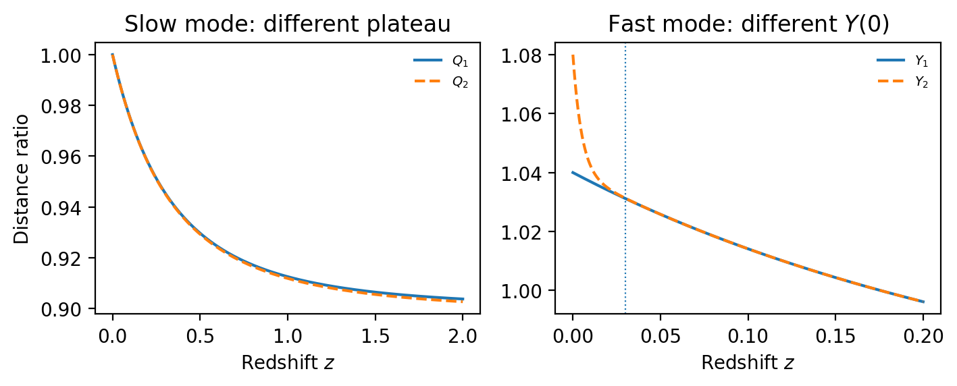
Figure
Figure 1. Two finite-window non-identifiability constructions. Left: a slow positive component changes the $z→∞$ plateau by 0.05 while keeping the curves close on $0≤z≤2$. Right: a fast component changes $Y\left(0\right)$ by 0.04 but is already negligible above the illustrative first observed redshift $z_{min}=0.03$ (vertical line).

Conditional plateau bounds for both branches
The high-redshift obstruction can be weakened if the allowed positive modes have a known minimum exponent $n_{min}>0$. For a decreasing branch with $Q_{∞}<1$, write
$$\begin{matrix}Q\left(s\right) & =Q_{∞}+\int_{n_{min}}^{∞}{e^{−ns}} dB\left(n\right), \\ dB & ≥0, ∫dB=1−Q_{∞}.\end{matrix}$$
With $E\left(s\right)=e^{−n_{min}s}$,
$$\boxed{\frac{Q\left(s\right)−E\left(s\right)}{1−E\left(s\right)}≤Q_{∞}≤Q\left(s\right)} \left(Q_{∞}<1\right).$$
(10)
For an increasing branch with $Q_{∞}>1$, write instead
$$Q\left(s\right)=Q_{∞}−\int_{n_{min}}^{∞}{e^{−ns}} dB\left(n\right), ∫dB=Q_{∞}−1,$$
which gives the mirror inequality
$$\boxed{Q\left(s\right)≤Q_{∞}≤\frac{Q\left(s\right)−E\left(s\right)}{1−E\left(s\right)}} \left(Q_{∞}>1\right).$$
(12)
For multiple exact samples, the decreasing branch uses the largest lower bound and smallest measured $Q$; the increasing branch uses the largest measured $Q$ and smallest upper bound. Simultaneous confidence bands provide the corresponding noisy-data construction. These inequalities turn an assumed lower limit on the decay rate into a directly reportable finite-redshift statement about the plateau.
The low-redshift theorem has an analogous conditional bound. Suppose the plateau $Y_{∞}$ is fixed independently and all positive transient modes obey $0≤n≤n_{max}$. For a decreasing response,
$$Y\left(s\right)=Y_{∞}+\int_{0}^{n_{max}}{e^{−ns}} dB\left(n\right), dB≥0,$$
with $C=Y\left(0\right)$. Since $e^{−n_{max}s}≤e^{−ns}≤1$,
$$\boxed{Y\left(s\right)≤C≤Y_{∞}+e^{n_{max}s}\left[Y\left(s\right)−Y_{∞}\right].}$$
(14)
For an increasing response the mirror inequality is
$$\boxed{Y_{∞}−e^{n_{max}s}\left[Y_{∞}−Y\left(s\right)\right]≤C≤Y\left(s\right).}$$
(15)
A restriction on unresolved fast modes therefore converts low-redshift extrapolation into an interval statement, just as $n_{min}$ converts the high-redshift obstruction into Eqs. (10)–(12). Stable inference of both endpoints needs control of both tails of the allowed decay-rate spectrum.

Consequences for survey leverage
The two endpoint obstructions explain why redshift coverage matters in different ways. Data near the transition constrain the exponent; high-redshift data constrain the measured plateau; low-redshift anchors constrain the absolute normalization. For the single-power family, $\left|∂Y/∂n\right|=\left|β\right|se^{−ns}$ at fixed linear coefficients, so exponent sensitivity peaks at $s=1/n$. The later Fisher calculation quantifies this geometry for the declared synthetic designs.

Cosmic acceleration, wave propagation, and the role of the ratio

Two physical questions carried by one distance measurement
A standard-siren amplitude can be affected by the expansion history through the background luminosity distance and by the propagation law through an additional amplitude factor. These effects should be kept conceptually separate even when the final likelihood estimates them together. A comparison of two distance channels is useful precisely because a common background factor can cancel while a channel-dependent response remains. Lombriser and Taylor illustrated how tensor propagation can distinguish models that are degenerate in background and scalar observables [18]. That example motivates testing an independent propagation sector.
In an illustrative flat matter-plus-dark-energy background, neglecting radiation over the stated low-redshift range,
$$\begin{matrix}H^{2}\left(z\right) & =H_{0}^{2}\left[Ω_{m}u^{3}+\left(1−Ω_{m}\right)f_{DE}\left(z\right)\right], \\ f_{DE}\left(z\right) & =exp​\left[3\int_{0}^{z}{\frac{1+w\left(v\right)}{1+v}} dv\right], \\ d_{L}^{GW}\left(z\right) & =Ξ\left(z\right) \left(1+z\right)c\int_{0}^{z}{\frac{dv}{H\left(v\right)}}.\end{matrix}$$
(18)
These equations display the different roles of the equation of state $w$ and the propagation ratio $Ξ$. They are not used to generate the likelihood inputs in our numerical tests. A change in $w$ changes the background distance in both channels, whereas a nontrivial $Ξ$ changes their relative relation. Additional cosmological observables can constrain the common background while the ratio tests propagation. The current DESI distance measurements [5] make this separation relevant, without requiring that every observed tension be attributed to modified gravity.
The parametrization in Eq. (1) is therefore valuable as an economical description of one sector rather than a complete theory of cosmic acceleration. Its parameters are not interchangeable with $\left(w_{0},w_{a}\right)$, $H_{0}$, or a density fraction. A theory may connect those quantities, but the connection is additional physical information. The recent model-specific study of Lagos and Wolf [12] illustrates the need to check that a phenomenological fit respects the dynamics and stability restrictions of the proposed dark-energy model.

Amplitude damping is distinct from propagation speed
A useful starting equation for a freely propagating tensor polarization is, in units $c=1$,
$$h_{A}″+2H\left[1−δ\left(η\right)\right]h_{A}′+k^{2}h_{A}=0,$$
(19)
where $η$ is conformal time and $H=a′/a$. This is the amplitude-friction sector of a more general propagation framework [19]. Here primes refer only to $η$; redshift derivatives below are written explicitly. With $\tilde{a}′/\tilde{a}=H\left(1−δ\right)$, the field $\tilde{a}h_{A}$ obeys an approximately oscillatory equation at wavelengths much shorter than the background variation scale. The amplitude dilution changes while the high-frequency phase speed remains unity. This provides the origin of Eq. (21) under the stated propagation and source assumptions [8].
The multimessenger observation of GW170817 and GRB 170817A tightly restricted a relative propagation-speed difference for that event [20]. It did not turn the amplitude-friction coefficient into a measured speed. The distinction and its implications for dark-energy models are discussed systematically by Ezquiaga and Zumalac'arregui [21]. The present paper consequently treats $Ξ$ as a luminosity-distance ratio: a change in its constant component is an amplitude-distance statement, not a changing-$c$ statement.
A familiar model-dependent specialization uses an effective Planck mass $M_{eff}$ and
$$α_{M}=\frac{dlnM_{eff}^{2}}{dlna}, δ=−\frac{α_{M}}{2}, Ξ\left(z\right)=\frac{M_{eff}\left(0\right)}{M_{eff}\left(z\right)}.$$
(20)
These relations apply when this running controls the friction term and source and detector normalization are treated consistently. Lagos and collaborators developed standard-siren inference for this case [22]. A reconstructed ratio can then be translated into the model’s running; otherwise it remains an empirical propagation descriptor.

From reconstruction to a checkable finite-redshift statement
The two-parameter description is already well developed [9]. Nonparametric reconstruction offers a different way to estimate a distance curve without fixing Eq. (1); Gaussian processes were developed for expansion and dark-energy reconstruction by Seikel, Clarkson, and Smith [25] and applied directly to modified gravitational-wave propagation [10]. The present tests operate on such a reconstructed ratio and ask whether one constant plus one power is sufficient.
The added layer here is to identify finite-redshift combinations that a constant-plus-one-power response must satisfy and determine how their uncertainties behave. Evaluating a reconstruction on a finer grid does not create independent information; its covariance must accompany the samples. Fitting the family, detecting redshift dependence, and extrapolating an infinite-redshift plateau are distinct inference problems.

The measured ratio and its constant component

A propagation observable, not a speed measurement
In the setting of Refs. [8, 9], the amplitude-propagation modification is written
$$Ξ\left(z\right)=exp​\left[−\int_{0}^{z}{\frac{δ\left(v\right)}{1+v}} dv\right].$$
(21)
The function $δ$ changes the damping of the gravitational-wave amplitude. It need not change its propagation speed. In this convention,
$$δ\left(z\right)=−\left(1+z\right)\frac{dlnΞ}{dz}=\frac{n\left(1−Ξ_{0}\right)}{1−Ξ_{0}+Ξ_{0}{\left(1+z\right)}^{n}}.$$
Thus the ratio and the friction function are two descriptions of the same specified amplitude response.
The ratio is an amplitude-distance observable. Its dark-energy relevance comes from the propagation sector, while the common cosmological distance and the relative calibration are handled by the joint inference of the two channels.

Separate the relative calibration
Let $u=1+z$, $s=lnu$, and let $Y$ denote the measured distance ratio with an unknown constant multiplicative calibration $C>0$:
$$Y\left(z\right)=CΞ\left(z\right)=α+βu^{−n}, α=CΞ_{0}, β=C\left(1−Ξ_{0}\right).$$
(23)
Once $α$ and $β$ are determined,
$$C=α+β, \boxed{Ξ_{0}=\frac{α}{α+β}.}$$
(24)
With the normalization $Ξ\left(0\right)=1$, $C=Y\left(0\right)$ is the relative absolute distance scale between the reconstructed channels. For supernova distances the corresponding Hubble-diagram scale is the familiar intercept combination $M_{B}−5\log_{10}H_{0}$, equivalently $H_{0}{10}^{−M_{B}/5}$ up to fixed unit factors [23]. For BAO with a free drag ruler the analogous absolute scale is $r_{d}h$ [24]. Thus $C$ is the place where standard-siren ratios meet the same $H_{0}$-calibration problem that appears in supernova and BAO distance ladders.
The branch $0<Ξ_{0}<1$ decreases toward a nonzero floor, whereas $Ξ_{0}>1$ increases toward a plateau. Figure 2 illustrates both cases. An additive offset is separately degenerate with $α$ and requires an external constraint.
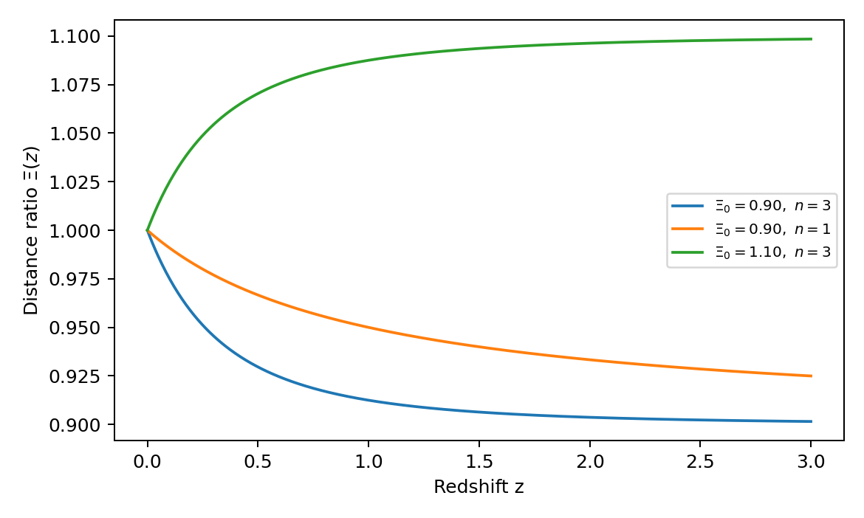
Figure
Figure 2. Representative single-power distance ratios for decreasing and increasing branches of Eq. (1).

An interval-averaged friction readout
For positive ratios, Eq. (21) supplies a derivative-free interval average. With $s_{i}=ln\left(1+z_{i}\right)$,
$${\overline{δ}}_{ij}=−\frac{ln\left[Y\left(z_{j}\right)/Y\left(z_{i}\right)\right]}{s_{j}−s_{i}}=\frac{1}{s_{j}−s_{i}}\int_{s_{i}}^{s_{j}}{δ}\left(s\right) ds.$$
(25)
A constant relative calibration cancels. This quantity does not recover an asymptote, but it tests redshift evolution without either differentiating a noisy curve or assuming a power law. In the running-mass specialization of Eq. (20), the corresponding interval average of $α_{M}$ is $−2{\overline{δ}}_{ij}$.
For small relative errors, its variance is approximately
$$Var\left({\hat{\overline{δ}}}_{ij}\right)≃\frac{Σ_{ii}/Y_{i}^{2}+Σ_{jj}/Y_{j}^{2}−2Σ_{ij}/\left(Y_{i}Y_{j}\right)}{{\left(s_{j}−s_{i}\right)}^{2}}.$$
At low signal-to-noise ratio the logarithm requires the joint positive-ratio likelihood instead. Under the single-power family, writing $δ=−dlnY/ds$ gives
$$\frac{dδ}{ds}=δ\left(δ−n\right).$$
Interval averages can locate a transition; the reconstruction below then asks whether one exponent and one constant describe it coherently.

Exact recovery from finite redshifts

The differential projection
A constant plus one homogeneous power can be separated without a large-redshift limit. For Eq. (23),
$$\boxed{P_{n}Y≡Y+\frac{u}{n}\frac{dY}{du}=α.}$$
(28)
Equivalently, $d^{2}Y/ds^{2}+n dY/ds=0$. Constancy of Eq. (28) is therefore a diagnostic of the adopted two-dimensional function space, not independent evidence for the law used to generate a theoretical curve. The derivative formula is useful for analytic models or posterior reconstructions, but numerical differentiation can amplify measurement noise. Finite-redshift alternatives follow directly.
For known $n$, put $x_{i}=u_{i}^{n}$. Then $xY=αx+β$ is affine. Two distinct exact samples give
$$\begin{matrix}α & =\frac{x_{j}Y_{j}−x_{i}Y_{i}}{x_{j}−x_{i}}, \\ β & =\frac{x_{i}x_{j}\left(Y_{i}−Y_{j}\right)}{x_{j}−x_{i}}.\end{matrix}$$
(30)
Together with Eq. (24), these recover the asymptote and constant calibration. Additional samples test the same line instead of merely adding freely adjustable coefficients.

Three equally spaced logarithmic redshifts
If $u_{j}=u_{ref}k^{j}$ for a reference factor $u_{ref}>0$ and $k>1$, then
$$Y_{j}=α+Bλ^{j}, B=βu_{ref}^{−n}, λ=k^{−n}.$$
For $B≠0$ and $0<λ<1$,
$$\begin{matrix}λ & =\frac{Y_{2}−Y_{1}}{Y_{1}−Y_{0}}, & n & =−\frac{lnλ}{lnk}, \\ α & =\frac{Y_{0}Y_{2}−Y_{1}^{2}}{Y_{0}−2Y_{1}+Y_{2}}, & β & =\left(Y_{0}−α\right)u_{ref}^{n}.\end{matrix}$$
(33)
The expression for $α$ is exactly Aitken’s $Δ^{2}$ transformation applied to a geometric transient [15]. Its use here is to reconstruct a distance-ratio asymptote and to expose its conditioning. Close to a constant ratio, or after the transient has nearly vanished, the denominator is small. We therefore use Eq. (33) for exact reconstruction, intuition, and model checks, not as an unqualified estimator for noisy triplets.

Unique exponent recovery at arbitrary spacing
Equal logarithmic spacing is not essential. Let $s_{0}<s_{1}<s_{2}$, $h_{1}=s_{1}−s_{0}$, $h_{2}=s_{2}−s_{1}$, and
$$r=\frac{Y_{2}−Y_{1}}{Y_{1}−Y_{0}}.$$
For a nonconstant member of Eq. (23),
$$\boxed{r=F\left(n\right)≡\frac{1−e^{−nh_{2}}}{e^{nh_{1}}−1}.}$$
(35)
This equation is independent of $α$, $β$, and a constant multiplicative calibration. Moreover, $F\left(n\right)$ decreases strictly from $h_{2}/h_{1}$ to zero as $n$ increases from zero to infinity. Indeed,
$$\frac{dlnF}{dn}=\frac{h_{2}}{e^{nh_{2}}−1}−\frac{h_{1}}{1−e^{−nh_{1}}}<0,$$
because the first term is smaller than $1/n$ and the second is larger. Consequently,
$$\boxed{0<r<h_{2}/h_{1}}$$
(37)
is necessary and sufficient for a unique positive exponent fitting the three exact samples. Once $n$ is obtained by a scalar root solve, Eq. (30) gives the constant and amplitude.
This is a precise distinction between recovery and testing. Three admissible exact points determine a member of the family; they do not establish that the family describes other redshifts. A fourth point or a larger data vector supplies an overdetermined test. Noise can also move a true-model triplet outside Eq. (37); such an event should enter a likelihood, not be discarded as an inadmissible observation.

Four-point consistency on arbitrary redshift grids
Four exact samples overdetermine the single-power family. Let $d_{i}=Y_{i+1}−Y_{i}$ and $h_{i}=s_{i+1}−s_{i}$ for $i=0,1,2$. The first and second overlapping triplets require the same exponent:
$$\begin{matrix}\frac{d_{1}}{d_{0}} & =F_{01}\left(n\right)≡\frac{1−e^{−nh_{1}}}{e^{nh_{0}}−1}, \\ \frac{d_{2}}{d_{1}} & =F_{12}\left(n\right)≡\frac{1−e^{−nh_{2}}}{e^{nh_{1}}−1}.\end{matrix}$$
(39)
Whenever both triplets satisfy their admission bounds, each equation has a unique positive inverse by the monotonicity proved above. Thus an exact four-point consistency condition is
$$\boxed{F_{01}^{−1}\left(d_{1}/d_{0}\right)=F_{12}^{−1}\left(d_{2}/d_{1}\right).}$$
(40)
This is the irregular-grid generalization of the equal-spacing Hankel condition. It uses two $F\left(n\right)$ equations that must share one $n$, rather than forcing the data onto a logarithmically uniform grid.
For noisy data it is numerically preferable to avoid explicit ratios when increments are small. Define
$$g\left(n\right)=\left(\begin{matrix}d_{1}−F_{01}\left(n\right)d_{0} \\ d_{2}−F_{12}\left(n\right)d_{1}\end{matrix}\right).$$
(41)
A covariance-aware four-point statistic minimizes $g{\left(n\right)}^{T}V_{g}{\left(n\right)}^{−1}g\left(n\right)$ over the declared exponent range, with the same fit performed in simulations or posterior draws to obtain its reference distribution. One exponent is fitted to two overlapping triplet conditions, leaving one shape constraint.
At equal spacing $h_{0}=h_{1}=h_{2}$, the two functions coincide and Eq. (40) reduces algebraically to
$$\boxed{H=d_{0}d_{2}−d_{1}^{2}=0.}$$
(42)
For two distinct powers on that grid,
$$Y_{j}=α+B_{1}λ_{1}^{j}+B_{2}λ_{2}^{j},$$
the departure is
$$H=B_{1}B_{2}\left(λ_{1}−1\right)\left(λ_{2}−1\right){\left(λ_{1}−λ_{2}\right)}^{2}.$$
(44)
The equal-grid determinant is therefore a compact special case; Eq. (40) is the form relevant to irregular cosmological bins.

Correlated noisy data and calibration-aware tests

Linear contrasts for a specified exponent
Suppose $y$ contains $m$ ratio estimates with known positive-definite sampling covariance $Σ$. At trial exponent $n$, let $t_{i}=u_{i}^{−n}$. A contrast involving consecutive samples is
$$\begin{matrix}r_{i}\left(n\right) & =y_{i+2}−\left(1+λ_{i}\right)y_{i+1}+λ_{i}y_{i}, \\ λ_{i}\left(n\right) & =\frac{t_{i+2}−t_{i+1}}{t_{i+1}−t_{i}}.\end{matrix}$$
(46)
These expressions apply to irregular grids. They annihilate both the constant vector and $t$, and therefore remove both coefficients in Eq. (23). Let $A_{n}$ collect the $m−2$ consecutive contrasts. Its rows have full rank for distinct $t_{i}$, and
$$r=A_{n}y, V_{r}=A_{n}ΣA_{n}^{T}.$$
Overlapping triples share measurements, so even independent $y_{i}$ do not give independent $r_{i}$. The global statistic is
$$\boxed{T_{n}=r^{T}V_{r}^{−1}r.}$$
(48)
For exactly Gaussian errors, known $Σ$, and $n$ specified independently of the tested data, $T_{n}∼χ_{m−2}^{2}$ under the single-power family. The unknown relative calibration is removed rather than set to one.
This test is equivalent to a generalized least-squares residual. With $X_{n}=\left[1,t\right]$,
$$\begin{matrix}{\hat{θ}}_{n} & ={\left(X_{n}^{T}Σ^{−1}X_{n}\right)}^{−1}X_{n}^{T}Σ^{−1}y, \\ T_{n} & ={\left(y−X_{n}{\hat{θ}}_{n}\right)}^{T}Σ^{−1}\left(y−X_{n}{\hat{θ}}_{n}\right),\end{matrix}$$
(50)
where $θ={\left(α,β\right)}^{T}$. Appendix A proves the equivalence. No information is gained by counting the contrasts as additional data; they expose the same fit as directly interpretable consistency conditions.
The coefficient covariance is ${\left(X_{n}^{T}Σ^{−1}X_{n}\right)}^{−1}$. Away from $α+β=0$, the leading uncertainty of ${\hat{Ξ}}_{0}$ follows with gradient
$$g=\frac{1}{{\left(α+β\right)}^{2}}{\left(β,−α\right)}^{T}, Var\left({\hat{Ξ}}_{0}\right)≃g^{T}Cov\left(\hat{θ}\right)g.$$
Physical constraints $C>0$ and $Ξ_{0}>0$ should be imposed when interpreting estimates. The exact chi-square statement above uses the unconstrained linear fit; active parameter boundaries require their own calibration.

Unknown exponent and singular limits
When $n$ is not fixed, minimize $T_{n}$ over a stated interval of positive exponents. The linear coefficients are solved at each trial; only one variable requires nonlinear optimization. This is a variable-projection problem [17].
At $Ξ_{0}=1$, the coefficient $β$ vanishes and $n$ is unidentifiable. Near this limit, assigning a universal $χ_{m−3}^{2}$ distribution to the optimized statistic is not justified. The exponent range, constraints, ratio-estimation procedure, and selection effects should be reproduced in a parametric bootstrap or posterior-predictive calculation. The synthetic profile test below is explicitly calibrated at one nondegenerate fiducial point; it is not advertised as a parameter-uniform significance rule.
Very small $n$ also makes the constant and exponential columns nearly collinear. Very high-redshift data can constrain $α$ while carrying little information about $β$ or $n$. Combining a low-redshift anchor with measurements over the transition is therefore more useful for separation than obtaining only a dense set of nearly saturated points.

Confidence sets for the normalized constant
The transformation from $\left(α,β\right)$ to $Ξ_{0}$ is nonlinear, so the local variance formula need not describe a poorly determined normalization. At a specified exponent, $\left(\hat{α},\hat{C}\right)$ is jointly Gaussian with known covariance. Write
$$v_{αα}=V_{00}, v_{CC}=V_{00}+2V_{01}+V_{11}, v_{αC}=V_{00}+V_{01},$$
where $V=Cov\left(\hat{θ}\right)$. A Fieller confidence set [26] for a trial normalized constant $x$ is
$${\left(\hat{α}−x\hat{C}\right)}^{2}≤k_{γ}^{2}\left(v_{αα}−2xv_{αC}+x^{2}v_{CC}\right),$$
(53)
with $k_{γ}$ the two-sided standard-normal critical value. At the true $x=α/C$, the normalized left-hand linear combination is exactly standard normal. Inverting that pivot gives coverage $1−γ$ under the fixed-exponent Gaussian assumptions, without a small-error expansion.
The result may be a bounded interval, two unbounded pieces, or the whole line. A bounded interval requires, in particular, ${\hat{C}}^{2}>k_{γ}^{2}v_{CC}$. An unbounded set records inadequate normalization information; it should not be replaced by a narrow symmetric error bar. Intersecting the set with $x>0$ states the physical domain, but imposing additional restrictions or profiling $n$ calls for calibration of the modified procedure. This construction extends an established ratio-inference method to the distance-ratio coefficients; it does not claim a new general confidence-interval algorithm.

Testing redshift dependence when the exponent is absent under the null
A goodness-of-fit test of one power and a test against general-relativistic propagation answer different questions. Under a constant measured ratio, $y=C1+ϵ$, the exponent is absent. This is the nuisance-parameter situation discussed by Davies [27]. A direct calibration is available here because the null is a linear Gaussian model.
Let $z=L^{−1}y$, let $e_{0}$ be the unit vector along $L^{−1}1$, and define
$$q_{n}=\frac{\left(I−e_{0}e_{0}^{T}\right)L^{−1}t_{n}}{∥\left(I−e_{0}e_{0}^{T}\right)L^{−1}t_{n}∥}.$$
The improvement from adding the transient at a specified exponent is
$$Δ_{n}={\left(q_{n}^{T}z\right)}^{2}.$$
For a finite, predeclared grid $G$, use
$$Δ_{G}=\max_{n∈G}Δ_{n}.$$
(56)
Under the null, $q_{n}^{T}z$ is a zero-mean unit-variance Gaussian process on that grid with covariance $q_{n}^{T}q_{n′}$. Its distribution is independent of $C$. Drawing standard-normal vectors and applying the same $q_{n}$ therefore calibrates the complete finite-grid search, including its correlations, without estimating an unidentified exponent.
For an observed statistic and $B$ independent null simulations, the upper-tail Monte Carlo rank
$$p_{MC}=\frac{1+\#\{b:Δ_{G}^{\left(b\right)}≥Δ_{G}^{obs}\}}{B+1}$$
is a valid finite-simulation test by exchangeability. The result is for the declared grid, covariance, and unconstrained two-sided transient. A continuous search, a data-selected grid, or a one-sided physical alternative must be replicated in the null simulation. Rejecting the constant-ratio null identifies redshift dependence after constant calibration; it does not establish that a single power is an adequate physical model. The separate shape tests remain necessary.

Noise correction for the four-point determinant
For the three observed increments in Eq. (42), write $d=Dy$ and $V=DΣD^{T}$. Their covariance changes the expectation of the determinant:
$$E\left[\hat{H}\right]=H+V_{02}−V_{11}.$$
An unbiased estimator is consequently
$$\boxed{{\hat{H}}_{c}=d_{0}d_{2}−d_{1}^{2}−V_{02}+V_{11}.}$$
(59)
For independent equal-variance ratio errors $σ^{2}$, the correction is $+2σ^{2}$. Omitting it produces a negative apparent departure even when the exact curve has rank one.
Let $B$ be the symmetric matrix with $B_{02}=B_{20}=1/2$, $B_{11}=−1$, and other entries zero. For Gaussian increments of true mean $μ$, the exact variance is
$$Var\left({\hat{H}}_{c}\right)=2tr\left(BVBV\right)+4μ^{T}BVBμ.$$
(60)
The quadratic statistic need not be Gaussian, particularly near a constant ratio. Equation (60) is a variance identity, not permission to use Gaussian tail probabilities. The supplied code checks the identity by simulation. More generally, write a collection of overlapping determinants as ${\hat{H}}_{j}=y^{T}Q_{j}y$, where each symmetric $Q_{j}$ embeds the appropriate four-point difference operator. Their bias-corrected covariance is
$$\begin{matrix}Cov\left({\hat{H}}_{i,c},{\hat{H}}_{j,c}\right) & =2tr\left(Q_{i}ΣQ_{j}Σ\right) \\ & +4m^{T}Q_{i}ΣQ_{j}m,\end{matrix}$$
(61)
where $m=Ey$. The overlapping diagnostics cannot be counted as independent confirmations. At a specified mean and covariance, the quadratic forms can be evaluated by Gaussian simulation or by quadratic-form distribution methods of the kind developed by Imhof [28]. Unknown means or selected windows require the same fitting or selection steps in the calibration.

Binning and ratio construction
If a reported bin estimates $∫W_{i}\left(s\right)Y\left(s\right)ds$, with normalized known window $W_{i}$, replace $t_{i}$ by
$${\overline{t}}_{i}\left(n\right)=∫W_{i}\left(s\right)e^{−ns}ds.$$
(62)
The linear fit remains valid. A Gaussian window with mean $s_{i}$ and variance $v_{i}$ gives ${\overline{t}}_{i}=e^{−ns_{i}+n^{2}v_{i}/2}$. Using only bin centers can create apparent shape changes when widths differ. This formula applies to a bin mean of the ratio, not automatically to a ratio of separately binned distances.
Similarly, a covariance quoted for a Gaussian-process posterior is not automatically the repeated-sampling covariance assumed in the chi-square statement. A diagnostic applied to a reconstructed function should be calibrated through the reconstruction procedure or evaluated with its joint posterior draws. These tests are a complement to the reconstruction in Ref. [10], not a replacement for its data model.

Correlated held-out prediction
A useful additional test estimates the two coefficients on one redshift subset and predicts another. This makes the difference between fitting and testing operational. For specified $n$, partition the data into training $T$ and held-out $H$ blocks, retaining their cross-covariance. Set
$$\begin{matrix}K & =Σ_{HT}Σ_{TT}^{−1}, \\ V_{T} & ={\left(X_{T}^{T}Σ_{TT}^{−1}X_{T}\right)}^{−1}, \\ B_{H} & =X_{H}−KX_{T}.\end{matrix}$$
With the training-only generalized least-squares estimate ${\hat{θ}}_{T}$, the predictor is
$${\hat{y}}_{H}=Ky_{T}+B_{H}{\hat{θ}}_{T}.$$
(66)
The repeated-sampling covariance of its error is
$$V_{H}=Σ_{HH}−KΣ_{TH}+B_{H}V_{T}B_{H}^{T}.$$
(67)
The first two terms are the conditional noise covariance; the last propagates coefficient-estimation uncertainty. The Gaussian innovation in the held-out block is independent of the training noise, which proves Eq. (67). Hence the squared $V_{H}$-weighted prediction error has a $χ_{\left|H\right|}^{2}$ distribution under the stated null. Omitting either cross-covariance or parameter uncertainty changes that test.
When $n$ is learned from the training set, its uncertainty must also enter, for example by repeating the training fit in simulated complete catalogs. A redshift split can test finite-range extrapolation, but successful prediction at the largest observed redshift still does not certify an infinite-redshift plateau. It verifies an additional interval, not an unrestricted continuation.

Calibration drift and finite-window interpretation
A constant $C$ can be separated within Eq. (23); an arbitrary redshift-dependent calibration cannot. If $Y\left(s\right)=C\left(s\right)Ξ\left(s\right)$, the transformation $Ξ\left(s\right)→f\left(s\right)Ξ\left(s\right)$ and $C\left(s\right)→C\left(s\right)/f\left(s\right)$ leaves the observations unchanged. For the illustrative drift $C\left(s\right)=C_{0}e^{ϵs}$,
$$Y\left(s\right)=C_{0}Ξ_{0}e^{ϵs}+C_{0}\left(1−Ξ_{0}\right)e^{−\left(n−ϵ\right)s},$$
so a slowly varying scale error can mimic changed propagation over a finite interval. Theorem 2 is the sharper endpoint statement: even with no drift in the observed region, unresolved structure below $z_{min}$ can change the extrapolated calibration.
These results separate three claims that are often conflated: fitting a curve on the observed interval, identifying its zero-redshift calibration, and identifying its infinite-redshift plateau. The first can be tested directly; the latter two require explicit assumptions about modes outside the measured window.

Synthetic validation and sensitivity examples

Declared experiment
We use $m=24$ hypothetical compressed ratio estimates, equally spaced in $s=ln\left(1+z\right)$ between $z=0.03$ and $z=2$. The fiducial curve has $\left(Ξ_{0},n,C\right)=\left(0.90,3,1.04\right)$. Rather than assume sub-percent ratio precision, the marginal fractional uncertainty is
$$f_{i}={\left[{0.02}^{2}+{\left(0.0225z_{i}\right)}^{2}\right]}^{1/2},$$
(69)
which rises from 2.00% to 4.92% across the grid. To stress the Gaussian likelihood with an asymmetric distance error, we add an independent centered lognormal component with shape parameter $τ=0.75$ and rms fraction
$$ℓ_{i}=0.004+0.004z_{i},$$
which rises from 0.41% to 1.20%. This is a stylized lensing-like tail, not a ray-tracing forecast. The remaining Gaussian core has $f_{core,i}={\left(f_{i}^{2}−ℓ_{i}^{2}\right)}^{1/2}$ and covariance
$$\begin{matrix}Σ_{ij}^{core}=​ & μ_{i}μ_{j}f_{core,i}f_{core,j}\left[0.80δ_{ij}+0.20e^{−\left|s_{i}−s_{j}\right|/0.12}\right], \\ Σ_{ij}=​ & Σ_{ij}^{core}+δ_{ij}{\left(μ_{i}ℓ_{i}\right)}^{2},\end{matrix}$$
(72)
where $μ_{i}$ is the fiducial mean. The quasi-GLS tests use $Σ$, while simulated catalogs are generated from the correlated Gaussian core plus the centered non-Gaussian tail. Weak-lensing magnification is one reason standard-siren distance likelihoods can acquire redshift-dependent asymmetric structure [30].
Because the generated errors are not exactly Gaussian, both fixed-$n$ and profiled 5% thresholds are calibrated empirically. We use 30,000 null catalogs to obtain critical values 34.1599 and 32.8542, respectively, and 20,000 independent catalogs per reported case. The exponent profile uses $n∈\left[0.25,8\right]$ with spacing 0.025. The fixed pseudorandom seed is 20260927.
In addition to the fiducial and a different constant gain, we test three explicit departures:
$$\begin{matrix}Y_{two}/1.04 & =0.90+0.07e^{−3s}+0.03e^{−s/2}, \\ Y_{drift}/1.04 & =e^{0.01s}\left(0.90+0.10e^{−3s}\right), \\ Y_{local}/1.04 & =0.90+0.10e^{−3s} \\ & +0.015e^{−{\left(s−0.60\right)}^{2}/\left(2×{0.09}^{2}\right)}.\end{matrix}$$
The drift reaches about 1.10% at $z=2$. The alternatives are chosen to contrast smooth and localized departures at the same observational precision.
Table I. Synthetic rejection rates using 2–5% marginal ratio errors plus the lensing-like tail in Eq. (69). Each row uses 20,000 independent test catalogs; the 5% thresholds are calibrated from 30,000 independent null catalogs under the same non-Gaussian error model. The last two columns fit the noiseless mean with a single power and free calibration.
Input | Fixed $n=3$ rejection | Profile rejection | Fitted $n$ | Fitted $Ξ_{0}$
Single power, $C=1.04$ | 5.09% | 5.06% | 3.00000 | 0.90000
Same shape, $C=0.96$ | 4.97% | 5.15% | 3.00000 | 0.90000
Second power | 5.20% | 5.20% | 2.57760 | 0.91611
Relative-calibration drift | 4.97% | 5.03% | 3.34482 | 0.90972
Localized shape departure | 6.20% | 5.87% | 2.95009 | 0.90775

What the tests establish
Table I shows that the empirically calibrated null behaves as intended at realistic percent-level precision. For the fiducial, the fixed-$n$ estimate has mean ${\hat{Ξ}}_{0}=0.90073$ and standard deviation 0.02150; changing the constant gain to 0.96 leaves the normalized plateau unchanged within Monte Carlo error.
If the relative gain is instead forced to $C=1$ on the noiseless $C=1.04$ fiducial mean, the fit moves to ${\hat{Ξ}}_{0}=0.95034$ and has noncentrality 6.38. Allowing the two linear coefficients therefore separates a constant scale mismatch that would otherwise be absorbed into the inferred plateau.
The more important change from a sub-percent toy experiment is the loss of power against smooth alternatives. At 2–5% precision, the second power and 1% calibration drift are rejected at essentially the null rate after profiling $n$. Even the localized feature is detected only at the 6% level in this particular compressed product. The noiseless two-power mean has true plateau 0.90 but is closely approximated over the measured interval by a single power with $\left(Ξ_{0},n\right)=\left(0.91611,2.57760\right)$. Figure 3 shows why: the fitted residuals remain small compared with the declared marginal errors. This is the numerical counterpart of Theorem 1 rather than a failure of the test construction.
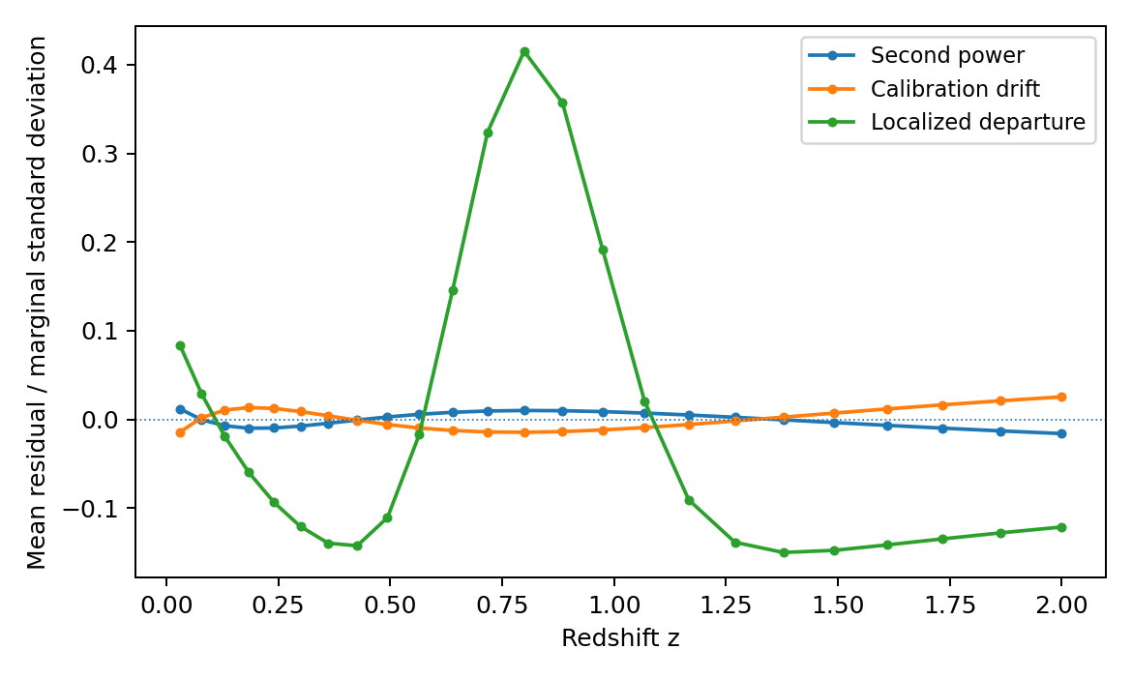
Figure
Figure 3. Residuals of the noiseless alternatives after fitting a single power with free exponent and constant calibration, divided by the marginal uncertainty. The likelihood uses the full covariance. Smooth departures are readily absorbed into shifted single-power parameters at the adopted 2–5% precision.

Confidence coverage and a calibrated search against a constant ratio
The expanded tests use the same 24-point covariance and an independent pseudorandom seed, 20260926. A 100,000-catalog experiment checks the fixed-$n$ Fieller set in Eq. (53). It contains the injected $Ξ_{0}=0.90$ in 95.017% of catalogs. Applied to the noiseless fiducial mean with the realistic covariance, the interval is $\left[0.85863,0.94365\right]$; the corresponding standard deviation of the inferred calibration $C$ is 0.01595. The broader interval makes explicit how much information was hidden by the earlier sub-percent toy precision.
For the constant-ratio null, 20,000 simulations calibrate Eq. (56) on the same $0.25≤n≤8$ grid with step 0.025. A separate 20,000-catalog sample measures rejection. The scan’s 95th-percentile threshold is 4.81599, compared with 3.84146 for one specified $χ_{1}^{2}$ improvement. The calibrated search rejects 5.08% of null samples; incorrectly using the single-exponent threshold rejects 8.93%. Figure 4 shows why the difference matters.
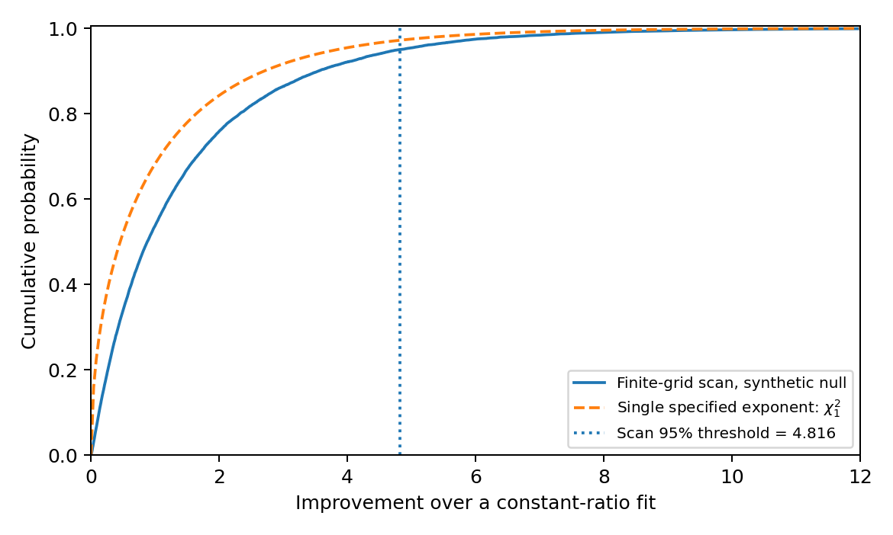
Figure
Figure 4. Empirical null distribution for the declared exponent-grid search in Eq. (56). The search threshold is calibrated from the full grid rather than borrowed from a one-exponent $χ_{1}^{2}$ test.
The held-out test fits the first sixteen points and predicts the final eight using Eqs. (66)–(67). Over 100,000 catalogs its mean statistic is 8.00894, compared with eight degrees of freedom, and it rejects 5.005% at a nominal 5% threshold. This checks finite-redshift prediction with both shared noise and coefficient uncertainty carried through.
We also test two overlapping equal-grid Hankel contrasts on five points with independent 3% errors. Their analytical correlation is $−0.20587$ and 200,000 simulations give $−0.20501$. Shared increments therefore matter even when the input measurements are independent. A separate common-gain covariance check leaves a maximum contrast-covariance residual of $1.4×{10}^{−18}$, as expected because a constant multiplicative gain lies in the fitted two-dimensional model space.

Redshift leverage at a matched information budget
A design calculation illustrates the distinction between plateau measurements and normalization leverage. We compare four sets of 24 hypothetical independent ratios with the same absolute error 0.03 and the same fiducial $\left(Ξ_{0},n,C\right)=\left(0.9,3,1.04\right)$. The low-only, broad, and high-only designs are uniform in $s$ over their tabulated intervals. The three-band design places eight points in each of $z∈\left[0.03,0.12\right]$, $\left[0.3,0.6\right]$, and $\left[1,2\right]$, again uniform in $s$ within each band.
Table II. Local Fisher uncertainties with all three parameters free, at identical point count and 3% absolute error.
Design | $z$ range | $σ_{n}$ | $σ_{Ξ_{0}}$
Low only | 0.03–0.35 | 10.8103 | 0.20500
Broad | 0.03–2.00 | 2.0498 | 0.02174
High only | 1.00–3.00 | 21.8409 | 1.20322
Three bands | 0.03–2.00 | 1.9063 | 0.01883
Table II and Fig. 5 show that high-redshift sampling alone can constrain the measured plateau $α$ while leaving its normalized value $α/\left(α+β\right)$ weakly determined. Low-redshift sampling alone does not resolve the curvature well enough to determine $n$. Broad coverage combines normalization, transition, and plateau information. The three-band example performs somewhat better than a uniform broad grid under these fixed assumptions; the weak endpoint-only designs also produce Fisher errors large enough that a local Gaussian approximation should be treated cautiously.
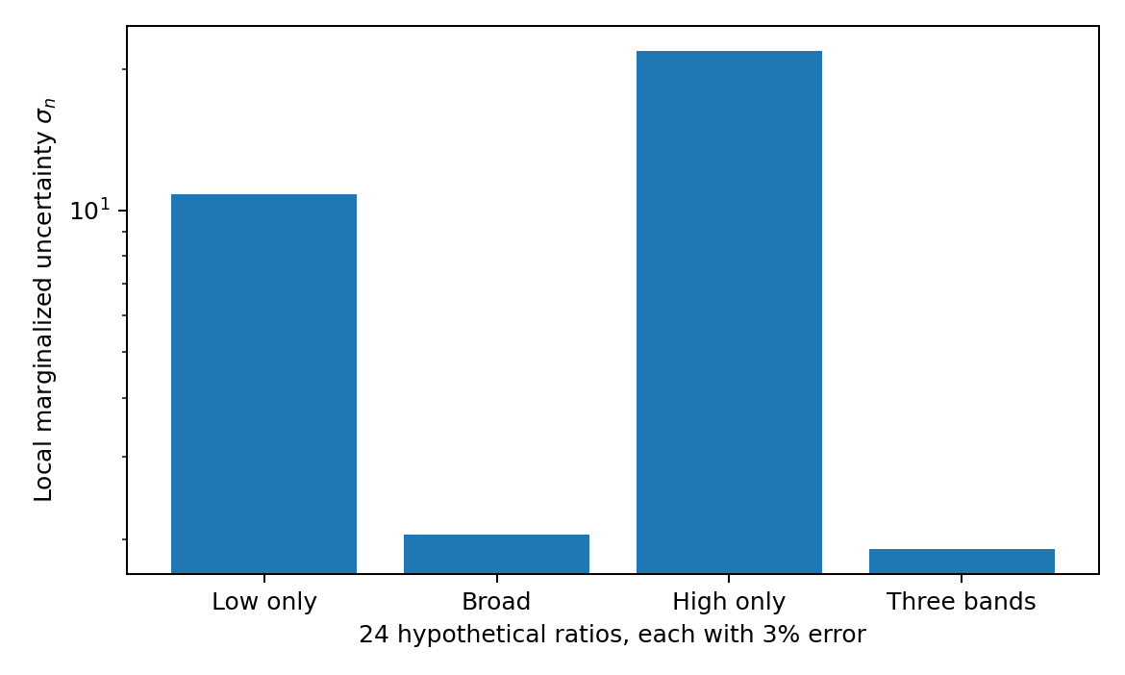
Figure
Figure 5. Marginalized local exponent uncertainty for the four matched-budget designs in Table II. Broad or three-band coverage carries far more curvature information than either endpoint alone.

A finite-bin implementation check
For a top-hat window in $s$ with center $s_{i}$ and halfwidth $h_{i}$, the exact design element is
$$t_{i}\left(n\right)=e^{−ns_{i}}\frac{sinh\left(nh_{i}\right)}{nh_{i}}.$$
(76)
Using the original grid, choose $h_{i}=min\left[0.015+0.22{\left(s_{i}/s_{max}\right)}^{2},0.8s_{i}\right]$, so all windows stay at positive redshift. The exact binned fiducial mean fitted with point-center values gives $\left(n,Ξ_{0},C\right)=\left(3.01539,0.900323,1.040059\right)$ with noncentrality $1.94×{10}^{−6}$. The window-aware fixed-$n$ fit recovers $\left(0.90,1.04\right)$ to floating-point precision. The example illustrates that a good shape fit can coexist with a small deterministic bin-centering bias.

Implementation and reproducibility
The accompanying Python program uses symbolic simplification for the constant-mode, Aitken, and two-mode determinant identities; a bracketed scalar solve for irregular-grid reconstruction; triangular solves and QR factorization for the Gaussian likelihood; and direct simulations for the null distributions. The irregular-grid inverse is checked on 72 combinations of exponent, asymptote, and calibration at $z=\left(0.07,0.47,1.83\right)$, with maximum absolute parameter error $9.7×{10}^{−14}$. The contrast and least-squares statistics agree to $1.1×{10}^{−12}$ in the retained test.
A separate 200,000-quadruple experiment checks the equal-grid Hankel noise correction at 3% independent errors. The analytical raw bias is $−1.8×{10}^{−3}$ and the simulated value is $−1.7894×{10}^{−3}$; the analytical and simulated standard deviations are 0.0043105 and 0.0043074. The corrected mean is $1.06×{10}^{−5}$. The irregular-grid four-point reconstruction is independently checked on 72 parameter combinations, with a maximum shared-exponent discrepancy $2.8×{10}^{−13}$.
The author directed the research question and the use of constant-component recovery. OpenAI ChatGPT (GPT-6 Astra Pro) assisted in literature identification, derivations, code construction, interpretation, manuscript drafting, and figure-generating code. Validation consisted of the explicit symbolic identities and numerical comparisons described above; AI output was not used as an independent correctness certificate. The numerical runs used Python 3.13.5, NumPy 2.3.5, SciPy 1.17.0, and SymPy 1.14.0. The realistic Table-I experiment and the extended validation have separate fixed seeds and result files. The scripts, covariances, result tables, reference-verification notes, and reproducibility instructions are supplied as Supplemental Material.

Application to dark-energy studies

A diagnostic layer for reconstructed distance ratios
The observational application begins with an estimate of $Ξ\left(z\right)$ and its joint uncertainty. In a bright-siren analysis, host-redshift information and waveform-distance likelihoods can be combined with a reconstructed electromagnetic distance relation. In dark-siren analyses, redshift, population, and selection modeling must remain part of the inference [29, 11]. Their uncertainties and correlations cannot be replaced by independent Gaussian errors without validation.
One may then test a specified exponent with Eq. (48), profile a free exponent with forward calibration, or examine the four-point residual on a suitably constructed logarithmic grid. Agreement supports the single-power description over the measured interval. The fitted $Ξ_{0}$ should be reported with the exponent range, calibration treatment, tested redshift range, and sensitivity to a slower additional component. This turns the asymptote from an isolated fitted number into a parameter with an explicit consistency and extrapolation record.

From individual distance likelihoods to a ratio product
The Gaussian vectors used above are an explicit compressed data model. A real analysis must first establish how that compression relates to individual measurements. At sufficiently small relative errors, let $G$ and $E$ denote jointly estimated GW and EM distances, and $Y_{i}=G_{i}/E_{i}$. The Jacobian is
$$J_{Y}=\left[diag\left(E_{i}^{−1}\right), −diag\left(G_{i}/E_{i}^{2}\right)\right].$$
For their full block covariance $V_{GE}$,
$$Σ_{Y}≃J_{Y}V_{GE}J_{Y}^{T}.$$
(78)
This retains cross-channel and cross-redshift errors. It is not generally reproduced by dividing marginal error bars. The leading bias of one ratio is
$$E\left[{\hat{Y}}_{i}\right]−G_{i}/E_{i}≃\frac{G_{i}Var\left({\hat{E}}_{i}\right)}{E_{i}^{3}}−\frac{Cov\left({\hat{G}}_{i},{\hat{E}}_{i}\right)}{E_{i}^{2}}.$$
For broad or non-Gaussian distance likelihoods, the joint positive-distance distribution is the appropriate starting point instead of this expansion. Coherent posterior draws can be transformed into ratios without discarding their dependence, but posterior dispersion still does not automatically supply the repeated-sampling calibration of Eq. (48).
Redshift uncertainty creates another dependence. To first order, a perturbation in $s$ shifts the mean by $∂Y/∂s=−nβe^{−ns}$. If redshift errors are small and independent of distance errors, their covariance can be propagated through that derivative and added to $Σ_{Y}$. Otherwise a joint latent-redshift calculation is needed. Source peculiar velocities, uncertain hosts, and selection then affect both the assigned redshift and the inferred distance relation. The bin windows in Eq. (62) should describe the actual reported statistic, not merely a convenient grid chosen afterward.

Selection-aware event inference and diagnostic validation
For events without a secure host, the redshift is part of the inference. A schematic likelihood, conditional on the detected event count, is
$$L\left(ϑ\right)∝A{\left(ϑ\right)}^{−N_{ev}}\prod_{j=1}^{N_{ev}}{∫}p\left(d_{j}∣θ,ϑ\right)π\left(θ∣ϑ\right) dθ,$$
(80)
where $θ$ includes source properties and redshift, $ϑ$ includes population, distance, calibration, and propagation parameters, and
$$A\left(ϑ\right)=∫p\left(detected∣θ,ϑ\right)π\left(θ∣ϑ\right) dθ.$$
This is the selection normalization of the population framework in Ref. [29]. The event likelihood may include counterpart information when supplied, while any shared electromagnetic-distance likelihood must be incorporated once, not independently reused for every event. A changed distance-amplitude law can change the detection fraction; that dependence cannot be corrected merely by widening pointwise ratio errors.
A practical application would specify the channels and their calibrations, construct their joint likelihood, and release either validated compressed ratios or joint function draws. The fixed-exponent, free-exponent, and constant-ratio questions would then be declared separately. Simulated catalogs would pass through the same detection, reconstruction, binning, and fitting procedure before a rejection probability is assigned. This preserves the reconstruction role of Refs. [25, 10, 11] and uses the present formulas as an interpretable diagnostic of its output.
The approach does not require a derivative estimate for every analysis. A fixed-$n$ contrast uses only the recovered ratios and covariance; a free-$n$ fit requires a one-dimensional search. An interval-friction contrast uses positive endpoint ratios, whereas the equal-logarithmic four-point diagnostic requires a suitably defined grid. Each can be chosen for the actual data product rather than forcing that product into an unnecessary reconstruction.

Separating electromagnetic opacity
A GW/EM discrepancy is not uniquely a modification of gravitational-wave propagation if electromagnetic flux is also altered. The tripartite construction of Ref. [4] provides a way to separate these possibilities. Define
$$η_{EM}=\frac{d_{L}^{EM}}{{\left(1+z\right)}^{2}d_{A}}, η_{GW}=\frac{d_{L}^{GW}}{{\left(1+z\right)}^{2}d_{A}}.$$
Then $Ξ=η_{GW}/η_{EM}$. Applying the diagnostics to independently inferred channels can help localize a discrepancy, provided the angular-distance/ruler calibration and shared covariance are retained. In particular, a ratio of two single-power functions is not generally another single-power function. A nonzero residual in $Ξ$ may indicate two channel responses rather than the breakdown of one specified gravity theory.
A common re-expression of all distance and ruler quantities cancels from a dimensionless ratio. A universal remapping therefore requires an independently defined observable before this GW/EM ratio can constrain it.

What a departure would and would not establish
The diagnostics support a staged interpretation. A constant ratio with uncertain constant calibration is compatible with the general-relativistic shape, even when its numerical level is not one. A detected redshift trend excludes that shape under the calibrated data model. A trend well described by one power allows reconstruction of $\left(Ξ_{0},n\right)$ within that family. A significant shape residual asks for an enlarged propagation description or an investigation of the source, calibration, and electromagnetic channels. These conclusions are related but not interchangeable.
For example, the observed logarithmic derivative obeys
$$−\frac{dlnY}{ds}=δ\left(s\right)−\frac{dlnC\left(s\right)}{ds}.$$
A relative-calibration drift is therefore exactly degenerate with a contribution to the inferred friction unless the drift is independently constrained. Similarly, electromagnetic opacity changes the denominator channel in the tripartite relation. Additional distance channels provide a way to diagnose that ambiguity [4]; a single excellent fit to Eq. (1) does not identify which physical sector generated the fitted curve.
The asymptotic interpretation is an additional step. In the running-Planck-mass specialization, a finite $Ξ_{0}$ represents the corresponding large-redshift mass ratio only if that limit exists and the same source/detector treatment remains applicable. In a general propagation model, $Ξ_{0}$ is the constant in its distance response. The slow-component theorem quantifies why a well-measured finite-redshift curve can still leave its asymptotic interpretation uncertain.

The resulting extension
References [9, 10] established a useful parametrization and reconstruction program for modified propagation. The present work adds an explicit finite-redshift consistency framework around that program: exact recovery with irregular sampling, separation of a constant gain, covariance-aware shape tests, and a quantified obstruction to interpreting a finite-redshift fit as a model-independent asymptotic measurement.
The results also clarify what should be targeted next. Data near the transition constrain the exponent, a well-controlled low-redshift normalization separates gain from plateau, and a longer redshift baseline tests slower components. Additional channels can distinguish electromagnetic attenuation from gravitational-wave damping. These are observational requirements derived from the structure of the adopted relation, rather than from a change in the underlying speed of light.

Conclusions
The constant-plus-power distance ratio permits a simple differential projection and exact finite-redshift reconstruction. Its structure remains identifiable in the presence of an unknown constant relative calibration when the zero-redshift normalization is specified. At arbitrary redshift spacing, three nonconstant exact samples have a unique positive exponent precisely when their increment ratio satisfies Eq. (37). Additional samples provide consistency tests rather than more arbitrary model freedom.
For Gaussian ratio estimates, the full-covariance contrast statistic is exactly the generalized least-squares residual after eliminating calibration and asymptotic amplitude. A bias-corrected four-point determinant provides an exponent-independent shape test. Controlled simulations confirm the fixed-exponent null calibration and demonstrate both the removal of a constant-gain bias and the finite-redshift difficulty of detecting smooth additional components. The expanded construction provides exact fixed-exponent confidence sets for the normalized plateau, a finite-grid calibration when the exponent is absent under the constant-ratio null, and a correlated held-out prediction test. The additional experiments verify each of those distinct inferential roles.
Most importantly, reconstruction and extrapolation are separate claims. A constant is exactly recoverable within a declared single-power law, but a sufficiently slow additional component can preserve the finite-redshift curve while changing the infinite-redshift limit. Reporting that dependence makes the diagnostic more useful for dark-energy studies: the observable relation, its calibration, its functional form, and its extrapolation can be tested separately.
No observational data were analyzed. The complete synthetic specification, code, numerical outputs, and figure scripts are included in the accompanying Supplemental Material. The cited observational and theoretical studies are used for scientific context, not imported as fitted data.
The constant-component question was first encountered in the author’s separate unpublished distance-model work; no physical identification from that work enters the analysis here. The author acknowledges the substantive research and manuscript assistance of OpenAI ChatGPT described in Sec. VIII,F. The inherited constant-floor research also used OpenAI Codex; no new Codex or GEN4 execution is represented by the simulations in this paper.

Statistics of the contrast and quadratic tests
Let $Σ=LL^{T}$ and whiten the observations as $z=L^{−1}y$. The whitened model matrix is $Z=L^{−1}X_{n}$. Since $A_{n}X_{n}=0$, the rows of $A_{n}L$ span the orthogonal complement of the columns of $Z$. Therefore
$${\left(A_{n}L\right)}^{T}{\left[\left(A_{n}L\right){\left(A_{n}L\right)}^{T}\right]}^{−1}\left(A_{n}L\right)=I−Z{\left(Z^{T}Z\right)}^{−1}Z^{T}.$$
Sandwiching this identity between $z^{T}$ and $z$ proves Eqs. (48)–(50). The right-hand side is a rank-$m−2$ orthogonal projector. Under the fixed-exponent Gaussian null, its quadratic form has exactly the stated chi-square distribution. This proof also shows why rescaling individual contrasts does not change the test if their covariance is transformed consistently.
For the determinant, write $d=μ+e$, where $Ee=0$ and $Cov\left(e\right)=V$. Then
$$E\left[d^{T}Bd\right]=μ^{T}Bμ+tr\left(BV\right).$$
For Gaussian $e$, the centered linear and quadratic terms are uncorrelated, and their variances are $4μ^{T}BVBμ$ and $2tr\left(BVBV\right)$, respectively. This proves Eq. (60). Bias correction alone does not make the distribution Gaussian.
For fixed $n$ and independent weights $w_{i}$, the determinant of the coefficient information matrix is
detXnTWXn=i​wi2Varwti.
It directly measures the redshift leverage of the decaying mode. When all $t_{i}$ are nearly equal, two linear coefficients become difficult to separate even with a formally valid inverse.

Shared calibration modes and prediction covariance
The contrast construction also identifies which correlated systematic modes it removes. If a covariance contribution has the form
$$Σ_{sys}=X_{n}ΩX_{n}^{T},$$
then $A_{n}Σ_{sys}A_{n}^{T}=0$. A small stochastic common gain around a given single-power mean is an example, with $Σ_{sys}=τ_{C}^{2}mm^{T}$. Its presence changes coefficient uncertainties but supplies no additional shape residual. A redshift-dependent calibration template generally has a component outside the two-column model space and is not removed by this identity. This statement is about a known covariance contribution at a specified exponent; it is not permission to estimate or discard arbitrary systematic covariance after inspecting residuals.
For the held-out result, write
$$y_{H}=Ky_{T}+B_{H}θ+ϵ_{c},$$
where $ϵ_{c}$ is independent of $y_{T}$ and has covariance $Σ_{HH}−KΣ_{TH}$. Subtracting Eq. (66) leaves
$$e_{H}=ϵ_{c}−B_{H}\left({\hat{θ}}_{T}−θ\right).$$
The covariance follows by independence. This is a repeated-sampling prediction theorem with unknown but fixed coefficients; it is not obtained by treating fitted parameters as known. If the exponent is selected on the training set, the predictor becomes nonlinear and the fixed-$n$ proof no longer supplies its entire reference distribution.

References
- A. G. Riess et al., Observational evidence from supernovae for an accelerating universe and a cosmological constant, Astron. J. 116 (https://doi.org/10.1086/300499), 1009–1038 (1998).
- S. Perlmutter et al., Measurements of $Omega$ and $Lambda$ from 42 high-redshift supernovae, Astrophys. J. 517 (https://doi.org/10.1086/307221), 565–586 (1999).
- B. A. Bassett and M. Kunz, Cosmic distance-duality as a probe of exotic physics and acceleration, Phys. Rev. D 69 (https://doi.org/10.1103/PhysRevD.69.101305), 101305(R) (2004).
- I. Matos, M. Quartin, L. Amendola, M. Kunz, and R. Sturani, A model-independent tripartite test of cosmic distance relations, JCAP 08 (https://doi.org/10.1088/1475-7516/2024/08/007) (2024) 007.
- M. Abdul-Karim et al. (DESI Collaboration), DESI DR2 results. II. Measurements of baryon acoustic oscillations and cosmological constraints, Phys. Rev. D 112 (https://doi.org/10.1103/tr6y-kpc6), 083515 (2025).
- B. F. Schutz, Determining the Hubble constant from gravitational wave observations, Nature 323 (https://doi.org/10.1038/323310a0), 310–311 (1986).
- B. P. Abbott et al., A gravitational-wave standard siren measurement of the Hubble constant, Nature 551 (https://doi.org/10.1038/nature24471), 85–88 (2017).
- E. Belgacem, Y. Dirian, S. Foffa, and M. Maggiore, Gravitational-wave luminosity distance in modified gravity theories, Phys. Rev. D 97 (https://doi.org/10.1103/PhysRevD.97.104066), 104066 (2018).
- E. Belgacem, Y. Dirian, S. Foffa, and M. Maggiore, Modified gravitational-wave propagation and standard sirens, Phys. Rev. D 98 (https://doi.org/10.1103/PhysRevD.98.023510), 023510 (2018).
- E. Belgacem, S. Foffa, M. Maggiore, and T. Yang, Gaussian processes reconstruction of modified gravitational wave propagation, Phys. Rev. D 101 (https://doi.org/10.1103/PhysRevD.101.063505), 063505 (2020).
- S. A. Vallejo-Pe na, A. E. Romano, and J. Gair, Non parametric constraints of gravitational-electromagnetic luminosity distance ratio, arXiv:2603.25305 (2026) (https://arxiv.org/abs/2603.25305), preprint.
- M. Lagos and W. J. Wolf, Consistency between cosmological and standard siren observations in evolving dark energy, arXiv:2609.04112 (2026) (https://arxiv.org/abs/2609.04112), preprint.
- V. Sahni, A. Shafieloo, and A. A. Starobinsky, Two new diagnostics of dark energy, Phys. Rev. D 78 (https://doi.org/10.1103/PhysRevD.78.103502), 103502 (2008).
- C. Clarkson, B. Bassett, and T. H.-C. Lu, A general test of the Copernican principle, Phys. Rev. Lett. 101 (https://doi.org/10.1103/PhysRevLett.101.011301), 011301 (2008).
- A. C. Aitken, On Bernoulli’s numerical solution of algebraic equations, Proc. R. Soc. Edinburgh 46 (https://doi.org/10.1017/S0370164600022070), 289–305 (1927).
- D. Potts and M. Tasche, Parameter estimation for exponential sums by approximate Prony method, Signal Processing 90 (https://doi.org/10.1016/j.sigpro.2009.11.012), 1631–1642 (2010).
- G. H. Golub and V. Pereyra, The differentiation of pseudo-inverses and nonlinear least squares problems whose variables separate, SIAM J. Numer. Anal. 10 (https://doi.org/10.1137/0710036), 413–432 (1973).
- L. Lombriser and A. Taylor, Breaking a dark degeneracy with gravitational waves, JCAP 03 (https://doi.org/10.1088/1475-7516/2016/03/031) (2016) 031.
- A. Nishizawa, Generalized framework for testing gravity with gravitational-wave propagation. I. Formulation, Phys. Rev. D 97 (https://doi.org/10.1103/PhysRevD.97.104037), 104037 (2018).
- B. P. Abbott et al., Gravitational waves and gamma-rays from a binary neutron star merger: GW170817 and GRB 170817A, Astrophys. J. Lett. 848 (https://doi.org/10.3847/2041-8213/aa920c), L13 (2017).
- J. M. Ezquiaga and M. Zumalac’arregui, Dark energy in light of multi-messenger gravitational-wave astronomy, Front. Astron. Space Sci. 5 (https://doi.org/10.3389/fspas.2018.00044), 44 (2018).
- M. Lagos, M. Fishbach, P. Landry, and D. E. Holz, Standard sirens with a running Planck mass, Phys. Rev. D 99 (https://doi.org/10.1103/PhysRevD.99.083504), 083504 (2019).
- D. Camarena and V. Marra, Local determination of the Hubble constant and the deceleration parameter, Phys. Rev. Research 2 (https://doi.org/10.1103/PhysRevResearch.2.013028), 013028 (2020).
- L. Pogosian, G.-B. Zhao, and K. Jedamzik, Recombination-independent determination of the sound horizon and the Hubble constant from BAO, Astrophys. J. Lett. 904 (https://doi.org/10.3847/2041-8213/abc6a8), L17 (2020).
- M. Seikel, C. Clarkson, and M. Smith, Reconstruction of dark energy and expansion dynamics using Gaussian processes, JCAP 06 (https://doi.org/10.1088/1475-7516/2012/06/036) (2012) 036.
- E. C. Fieller, Some problems in interval estimation, J. R. Stat. Soc. B 16 (https://doi.org/10.1111/j.2517-6161.1954.tb00159.x), 175–185 (1954).
- R. B. Davies, Hypothesis testing when a nuisance parameter is present only under the alternative, Biometrika 64 (https://doi.org/10.1093/biomet/64.2.247), 247–254 (1977).
- J. P. Imhof, Computing the distribution of quadratic forms in normal variables, Biometrika 48 (https://doi.org/10.1093/biomet/48.3-4.419), 419–426 (1961).
- I. Mandel, W. M. Farr, and J. R. Gair, Extracting distribution parameters from multiple uncertain observations with selection biases, Mon. Not. R. Astron. Soc. 486 (https://doi.org/10.1093/mnras/stz896), 1086–1093 (2019).
- C. T. Mpetha, G. Congedo, A. Taylor, and M. A. Hendry, Impact of weak lensing on bright standard siren analyses, Phys. Rev. D 110 (https://doi.org/10.1103/PhysRevD.110.023502), 023502 (2024).

