**Objective:**

Extract VMT data from an ABM scenario for any jurisdiction to import into Excel for the published VMT disaggregation methodology in support of Climate Action Plans (CAP).

**Steps:**

1. Open Emme Project of the ABM. Open Emme Notebook and make sure the notebook home directory is

“%<$ProjectPath>%/Scripts”

This is the folder where all the scripts are located. You can change the directory by selecting “Application Options” form Tools tab in Emme desktop and then clicking on “Modeller” tab.

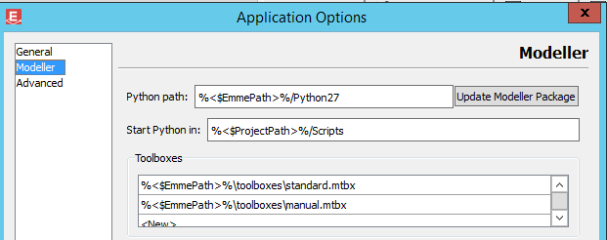

1. Run both **delete_extra_attribute_link_multiple.ipynb** and **delete_matrix.ipynb** from the notebook. This will delete all the extra attributes and matrix tables (if any) to free up some space for new select link assignments.
2. Open “**set_selected_zone.ipynb”.** This script aims to change database dimension based on the number of select link assignment. Currently, the default value for adding extra attribute is 22,000,000 . This is based on performing 4 select regions. If you are trying to add more regions you may need more extra attributes. For instance, is you are running 8 regions try 44,000,000 and replace it in the script.

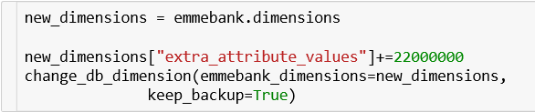

1. Go to “xref_taz13_jur_unique.csv” file in the database folder for a list of regions and their group_id number
2. Close the Notebook and open the Modeller in Emme. Go to the master run toolbox on SANDAG toolbox.

Depending on the number of selected link assignments, one needs to enter the expression and result suffix accordingly. The @selected_zone value corresponds to the district ID value, and result suffix correspond to the district.

@selected_zone = 1 or @selected_zonej = 1

Using the master run tool,

1. Check the *skip build highway and transit network* to *Skip copy bike logsum* as shown in the hightlighted screen capture below.
2. Then select iteration 4 as shown in the highlight
3. Check skip transit assignment, skip data export and skip data load request as shown highlighted below

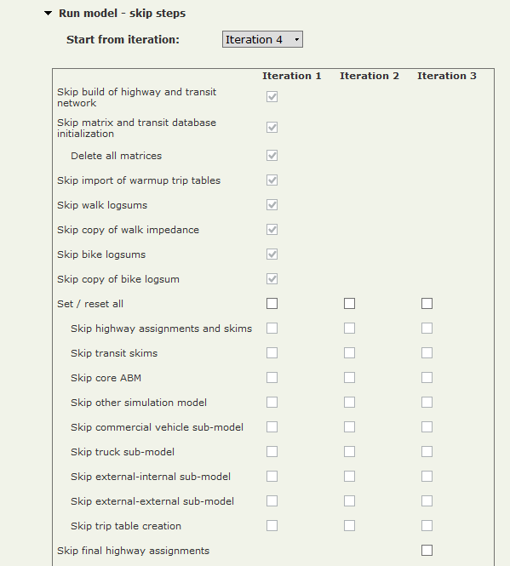

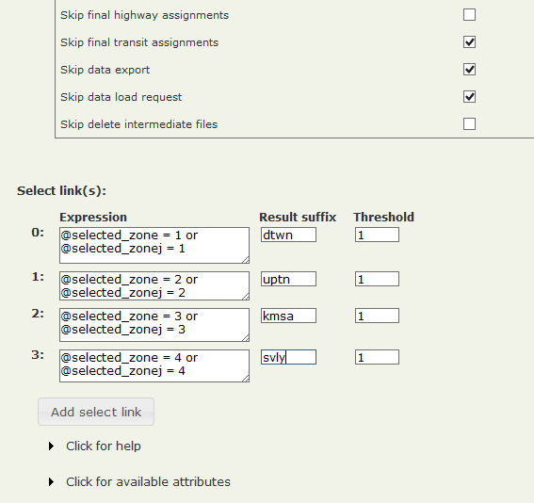

For a list of regions and their corresponding group_id numbers and suffixes go to xref_taz13_jur_unique.csv file in the database folder and fill out the Expression box base on group_id numbers

1. After the run is finished (depending of number of regions run time may be couple of hours), open the “**summarize_select_link.ipynb”** in Emme notebookand run the script
2. Run “**export_select_ link_volumes.ipynb”** to export thedirectional daily total select link volumes to a CSV file in the output folder. Check the output folder after the run to see if you have **“loadselk.csv”** file
3. Run “**Aggregate_SL_Demand.ipnyb”** to generate the aggregated trip table for selected regions. Check the output folder after the run to see if you have “**SL_Agg_SLDaily_*suffix* csv**” files in the output folder
4. Run **“Intrazonal_VMT.ipnyb”** to calculate the intrazonal VMT for all the selected areas. Check the output folder after the run to see if you have “**Intazonal_VMT csv**” files in the output folder
5. Run **“Assignment.Summary.ipnyb**” to output the required attributes from the loaded network. Check the output folder after the run to see if you have “**hwyload_*period*.csv**” files in the output folder. Note that this step is only required once. Meaning that if you already have these files in your output folder you can skip this part. The only time when you need to run this step is when the assignment results has been change because of a change in model setup.