DEMOGRAPHIC CHARACTERISTICS ESTIMATES SYSTEM
HOUSEHOLD INCOME DISTRIBUTIONS
Volume IV

PROGRAMMER’S REFERENCE

June 1996


401 B Street * Suite 800
San Diego, CA 92101

(619) 595-5300

Prepared by
The San Diego Association of Governments

This report was financed with federal funds from the U.S. Department of Transportation, Urban Mass Transportation Administration (UMTA) and Federal Highway Administration; state funds from the California Department of Transportation; and local funds from SANDAG Member Jurisdictions. The contents of this report reflect the views of the San Diego Association of Governments which is responsible for the facts and the accuracy of the data presented herein. The contents do not necessarily reflect the official views or policy of the U.S. Department of Transportation. This report does not constitute a standard, specification or regulation.

MEMBER AGENCIES: Cities of Carlsbad, Chula Vista, Coronado, Del Mar, El Cajon, Encinitas, Escondido, Imperial Beach, La Mesa,
Lemon Grove, National City, Oceanside, Poway, San Diego, San Marcos, Santee, Solana Beach, Vista, and County of San Diego
ADVISORY/LIAISON MEMBERS: California Department of Transportation, U.S. Department of Defense, S.D. Unified Port District, San Diego County Water Authority, and Tijuana/Baja California Norte

ABSTRACT

TITLE | Demographic Characteristics Estimates -  Household Income Distributions,  Volume IV - Programmer’s Reference
AUTHOR | San Diego Association of Governments
SUBJECT | Detailed Demographic Characteristics Estimates
DATE | June 1996
SOURCE OF COPIES | San Diego Association of Governments  401 B Street, Suite 800  San Diego, CA 92101
PAGES | 20
ABSTRACT | This is the programmers’s reference for the Household Income Distributions Estimation Program. It provides information to help maintain the source code for the various models and utilities, to update model algorithms and to produce executable programs.

ACKNOWLEDGEMENTS

The following staff of SANDAG participated in the preparation of the Demographic Characteristics Estimates System documentation:

- Kenneth E. Sulzer, Executive Director
- Stuart R. Shaffer, Deputy Executive Director
- Bob Parrott, Director of Research
- Jeff Tayman, Senior Regional Planner, Project Manager
- Terry Beckhelm, Senior Regional Planner
- Charles Rynerson, Senior Demographic Research Technician

TABLE OF CONTENTS

INTRODUCTION 1
USES OF THE INFORMATION 2
DATA DETAIL 2
GEOGRAPHIC DETAIL 3
METHODOLOGY 3
DOCUMENTATION 4
OVERVIEW 5
INTRODUCTION 6
ENVIRONMENT 7
PROGRAMMING 7
NOMENCLATURE 8
COMPONENTS 8
INC_EST 9
INPUT 10
OUTPUT 12
PROGRAMMING 12
EXECUTION 14
INC_CALIB 15
INPUT 16
OUTPUT 17
PROGRAMMING 19
EXECUTION 20

LIST OF TABLES

Table 2-1 ESTINC Software and Data Organization 6

Table 2-2 ESTINC Components 8

Table 3-1 INC_EST Input 10

Table 3-2 INC_EST Output 12

Table 3-3 INC_EST File Organization 12

Table 3-4 INC_EST Procedures 13

Table 4-1 INC_CALIB Input 16

Table 4-2 INC_CALIB Output 17

Table 4-3 INC_CALIB File Organization 19

Table 4-4 INC_CALIB Procedures 19

LIST OF FIGURES

Figure 3-1 INC_EST 11

Figure 4-1 INC_CALIB 18

INTRODUCTION

INTRODUCTION

Results of the census provide detailed demographic characteristics of the population every ten years, but the data soon become obsolete for many applications. Also, current trends may not mirror previous trends, so changes observed between 1980 and 1990 are not sufficient to predict current demographic and economic profiles. One objective of the Demographic Characteristics Estimates Program is to fill this need for data by preparing annual estimates of characteristics such as age, sex, ethnicity and income.

This document focuses on ESTINC, the system for estimating the region’s household income distributions (i.e., households within various income ranges). Because ESTINC has been designed for comparability with historical census data, these estimates may be used to evaluate changes occurring over a period of several years and to update historical information with the current estimates.

USES OF THE INFORMATION

While it is important to address planning issues on the basis of the overall change in population size, changes in the characteristics of the population can be of equal or greater significance. For example, changes in the age structure, ethnic or sex composition of a population affect school, health care, and marketing issues. Increases in the number of children under the age of five are likely to accelerate the recent growth in elementary school enrollment. Growing numbers of older adults suggest increased demand for particular types of housing and transportation facilities, social and recreational opportunities, and health care and retirement programs. Changes in the income levels of the population influence things such as housing affordability, tax revenues, and travel and purchasing behavior. Income information also is required in many federal and state grant applications.

DATA DETAIL

Estimates of households are produced for eight income ranges: less than $10,000, $10,000 to $14,999, $15,000 to $24,999, $25,000 to $34,999, $35,000 to $49,999, $50,000 to $74,999, $75,000 to $99,999, and $100,000 and over. These income distribution estimates are expressed in current dollars lagged one year from the estimate date. This follows the convention used in the 1990 census, which reports income for 1989. Median household income is calculated in both current dollars and constant (real) 1989 dollars. Because median income is calculated from the eight income ranges, values will not match those published by the Census Bureau, which are based on more detailed categories.

GEOGRAPHIC DETAIL

Estimates are available for the San Diego Region, major statistical areas (MSAs), subregional areas (SRAs), and census tracts. MSAs are groupings of SRAs that distinguish general sections of the San Diego Region. SRAs, aggregations of census tracts, identify large communities within the region. Census tracts are defined by the Census Bureau with the input of local committees, and usually contain between 2,500 and 8,000 persons.

To fill the need for income estimates for cities, ESTINC includes a module that allocates census tract estimates based on the city’s share of each census tract’s households. Income data for zip codes and other geographic areas not conforming to census tract boundaries are developed by aggregating estimates for split census block areas known as MGRAs.

METHODOLOGY

ESTINC uses a mathematical model that represents the shape of the household income distribution curve. This model has undergone extensive evaluation and accurately replicates known income distributions for the region and its geographic areas. Three factors are needed to specify this model. The first, median household income, represents the central point of the household income distribution. The second factor represents the distribution’s variability. The third factor is a non-linear adjustment that provides a more accurate estimate of the income distribution. The estimates are produced using a top-down approach. Estimates are done first for the region, then for each SRA, and finally for census tracts.

DOCUMENTATION

The ESTINC documentation includes four volumes oriented to different audiences:

Volume I. Overview. Volume I contains a general description of this system.

Volume II. Technical Description. Volume II contains a detailed flow of the methods used to estimate income characteristics at different levels of geographical detail.

Volume III. Database Description. Volume III describes the database sources and details the structure of data files.

Volume IV. Programmer Reference. Volume IV outlines procedures to maintain source code files, to update model equations and parameters, and to produce executable programs.

OVERVIEW

OVERVIEW

INTRODUCTION

This document provides general programming information for the ESTINC household income distribution estimates programs including a description of source files, data, and utilities. The discussion covers the current program organization and operation, and provides general detail to assist in making changes to source code to prepare executable programs. Additional technical information describing the various relationships and equations is available in Volume II of this documentation series. Detailed program documentation is provided in each source file as described below. Furthermore, much of what is discussed here may be described in more detail in Volume III, Database Description, which contains the detailed database formats and organization for the input and output data discussed in each section.

ESTINC consists of one principal model that encompasses several computer programs, and a variety of data sources. In the following discussions, the system is described in terms of a primary program and ancillary programs, utilities, and procedures.

ENVIRONMENT

ESTINC is maintained on SANDAG’s UNIX network. The main directory is /box1/udm/mod/db/income. In addition, there are utilities and applications that reside on SANDAG’s Novell network in the common directory m:\res\estinc. Most of the ESTINC data are maintained in the Ingres relational database management system. The primary database for ESTINC is research. Table 2-1 summarizes the organization of the ESTINC development and operational software and data.

Table 2-1
ESTINC Software and Data Organization

Label | System (location) | Description
/box1/udm/mod/db/income | UNIX Network | Primary ESTINC working directory
/box1/udm/mod/db/income/  estimates | UNIX Network | ESTINC estimates program development directory
/box1/udm/mod/db/income/  calib_income | UNIX Network | ESTINC income model calibration directory
/box1/udm/mod/db/income/  scripts | UNIX Network | ESTINC SQL table maintenance scripts
/box1/udm/mod/db/income/  v1.00 | UNIX Network | ESTINC Version 1.00 source files and executable programs
m:/res/estinc | Novell Network | Common directory for PC-based INCOME applications
research | UNIX Network - Ingres RDBMS | ESTINC Ingres database

PROGRAMMING

The main estimation routines are written in UNIX C. Data originating in or being sent to Ingres tables are managed in a variety of ways. Programatically, access to Ingres tables is provided through Structured Query Language (SQL) calls that are embedded in the host language. Some utilities for constructing or analyzing data tables are written as SQL scripts that are processed by the Ingres Terminal Monitor. Output programs or report routines may be C programs, SQL scripts or Microsoft Excel spreadsheet applications.

Executable programs are constructed from a UNIX make file that usually performs three distinct steps. First, source code that contains embedded SQL calls to Ingres are examined by calls to the Ingres C preprocessor. The preprocessor produces C source files as output. C source files, either edited or output from the preprocessor, are compiled by the UNIX C compiler. The output from the compiler is an object file. Object files are linked, with appropriate libraries, into an executable program. Consult the UNIX Make documentation for details.

NOMENCLATURE

In general, a file or table name is descriptive and its extension, if applicable, identifies its purpose. The UNIX environment, including Ingres, is case sensitive. Most program or file (also table) names are in lower case, may be up to 32 characters, and may use the underscore character (“_”) or the dot character (“.”) in the name or extension.. PC-based files are usually named in lower case, but the PC environment is not case sensitive. PC file names are limited to 8 characters; an extension is limited to 3 characters. Generally, the “.” character is used to separate a file name and extension. Ingres tables have no extension, but may make use of the underscore character. Ingres table names cannot contain the dot character. The following nomenclature is used to help identify the assorted programs, tables, files and scripts used in ESTINC (the <> symbols represent a name or parameter and are not typed:
- <file_name>.sc : identifies C source files that may contain embedded SQL calls. These are processed by the Ingres C preprocessor into C source files.
- <file_name>.c : identifies C source files, either as edited or as output from the Ingres C preprocessor.
- <file_name>.o : object files created by the C compiler.
- < file_name> : executable programs, output files and other data.
- < file_name>.build, <file_name>.load : SQL scripts
- <table_name>_xx, <file_name>_xx : xx identifies a base year in the form (90,91, and so on).
- <argument_name> or <flag_name> : identifies a runtime argument, parameter or flag.

In the paragraphs that follow, the appropriate directory path is identified. Unless stated otherwise, files are assumed to reside in the listed directory. Where more than one directory is discussed, the symbol "~" signifies the parent directory path for the UNIX components of the system: /box1/udm/mod/db/income. Path and file names are listed in italics. Any PC-based utilities or applications are identified with the complete path. Any files, utilities or programs that don’t conform to the general naming conventions will be identified as necessary. Each of the ESTINC components is discussed in the sections that follow.

COMPONENTS

Table 2-2 lists the components of ESTINC.
Table 2-2
ESTINC Components

Component | Description
INC_EST | Program for household income estimates. Region, Census Tract and SRA estimations.
INC_CALIB | Program for calibrating income distributions and producing initial distribution parameters.

INC_EST

INCOME ESTIMATES
(INC_EST)

INC_EST is the main estimation program. Its flow of information is illustrated in Figure 3-1. INC_EST is run from, and all ASCII output is directed to /box1/udm/mod/db/income/estimates. Because much of INC_EST Version 1.00 was exploratory, the program contains code that is not used in the final estimates, but was retained for future consideration. In particular, there may be entire blocks of source code that are never called, and data tables that are required for successful program execution, but have no bearing on the estimates. Any extraneous coding items will be removed in the next version of INC_EST.

INPUT

All input for INC_EST come from Ingres tables as identified in Table 3-1. Each table is described in Volume III, Database Description.

Table 3-1
INC_EST Input

Table | Description
popest_xx | Base year popest data.
income_model_parms_xx | Income model parameters.
income_model_adj | Annual adjustment factors computed from 1990 estimates.
inc_hh_xx | Household income distribution estimates output.

Figure 3-1
INC_EST

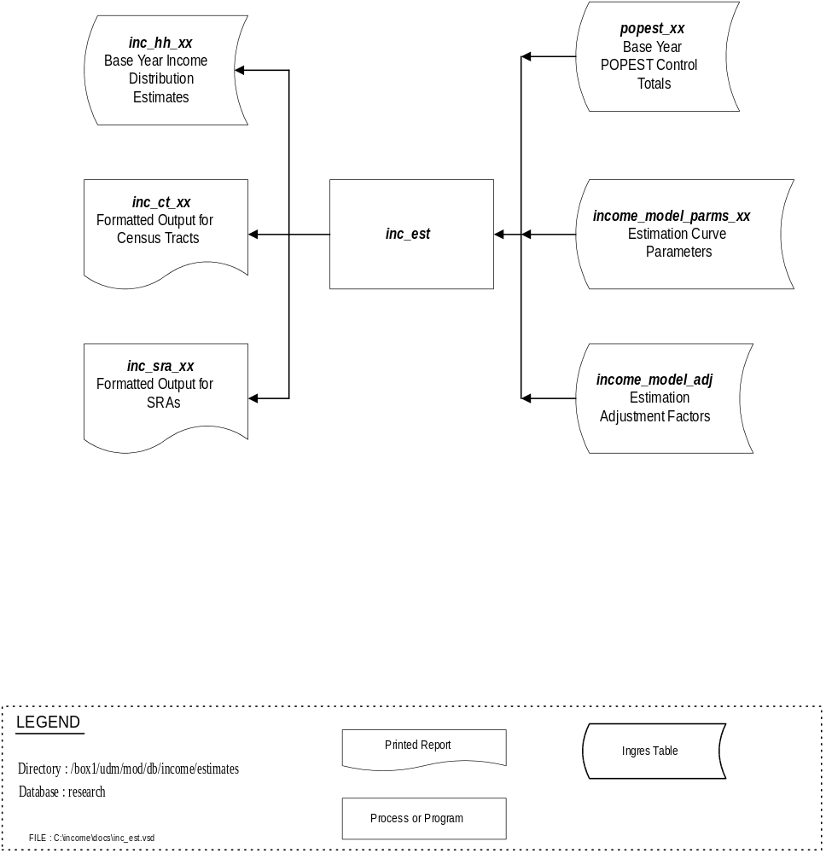
OUTPUT

INC_EST has three principal output forms. Table 3-2 identifies the INC_EST output. Output in Ingres tables is described in detail in Volume III.

Table 3-2
INC_EST Output

File/Table | Description
inc_hh_xx | Ingres table - Base year xx income distribution estimates.
inc_ct_xx | Formatted ASCII report - Base year income distributions for cennsus tracts.
inc_sra_xx | Formatted ASCII report - Base year income distributions for SRAs.

PROGRAMMING

Source code and executable programs for INC_EST Version 1.00 are maintained in the directory ~/v1.00. All development files are located in ~/estimates. INC_EST is a C program with four source files. The executable is created by the INC_EST make instructions (makefile). Table 3-3 summarizes the INC_EST file organization.

Table 3-3
INC_EST File Organization

File | Description
inc_est.h | Include file - contains system include files, define statements, procedure declarations, and structure type declarations.
inc_est.sc | Source file - contains main program, SQL preprocessor instructions and most of the embedded SQL procedures.
inc_est1.c | Source file - contains most program operations not dealing directly with SQL calls.
city_agg.sc | Source file - contains procedures to aggregate income estimates to city boundaries.
update.c | Source file - principal INC_CALIBalization routine.
makefile | UNIX make file - precompiler, compiler and linking commands.
inc_est | Executable program

Procedures

Table 3-4 describes the individual procedures that comprise INC_EST.

Table 3-4
INC_EST Procedures

Source File | Procedure | Description
inc_est.sc | main | Main program.
 | get_adj | Extract income model distribution adjustments
 | get_ct_base | Extract base year income distribution
 | get_ct_controls | Extract CT household control totals
 | get_ct_parms | Extract CT income calibration parameters
 | get_msa_totals | Extract MSA control totals
 | get_regional_adj | Extract regional income model adjustments
 | get_regional_base | Extract regional total base year income distribution
 | get_sra_adj | Extract SRA income model adjustments
 | get_sra_base | Extract SRA base year income distribution
 | get_sra_controls | Extract SRA control totals
 | get_sra_parms | Extract SRA income calibration parameters
 | quitit | Database error and disconnect processing
 | write_adj | Write 1990 computed adjustment factors to Ingres table
 | write_regional_adj | Write 1990 computed regiona asjustment factors to Ingres table
 | write_table1 | Output income distribution estimates to Ingres table
 | write_table_2 | Output region income distribution estimates to Ingres table
inc_est1.c | do_ct_income | Derive CT income distribution
 | do_regional_income | Derive region income distribution
 | do_stats | Perform log-normal computations
 | do_sra_income | Derive SRA income distribution
 | erf | One of the log-normal error functions
 | get_array_stats | Compute array totals for update function processing
 | get_array_sum | Compute array summation for update function processing
 | get_index | Return position in array
 | list_correct | Display correct command line arguments
 | median_income | Compute median income

Table 3-4 (continued)
INC_EST Procedures

Source File | Procedure | Description
inc_est1.c | pachinko | Distribution scheme using random number and cumulative distribution
city_agg.sc | city_agg | Aggregate income estimates to city boundaries
 | agg_pachinko | Pachinko routine for distributing CT estimates to split tracks for aggregating to city boundaries
 | print_slaves | Output routine for city boundary aggregations
update.c | print_dist | Output computed distributions
 | update | Normalization routine
 | chk_base_tot | Estimate values for rows with control totals - update function processing
 | chk_grand_tot | New row and col totals - update function processing
 | count_matches | Determine row and col total matches
 | get_sum | Compute row and col sums and total
 | print_colsum | Output column totals

EXECUTION

INC_EST is run from the UNIX prompt, directory ~/estimates, and requires one runtime parameter. (The INC_EST executable is a logical link to ~/v1.00/inc_est). The command line usage is:
inc_est <base_year> (Remember, UNIX is case-sensitive)
where
<base_year> is in the form 90,91 ... and so on.

INC_calib

INC_CALIB

INC_CALIB consists of two C programs that are used to calibrate the historical income distributions and produce a series of income model parameters. INC_CALIB calibrates an income distribution to known observations such as the census. Using the median income and income distribution as inputs, this program estimates the other two parameters needed to fully specify the modified log normal income distribution. An iterative method is used to find the parameters that minimize the error between the observed and the estimated income distributions. This error is measured by the index of dissimilarity The flow of information is illustrated in Figure 4-1. The components of INC_CALIB are run from ~/calib_income. Output goes to Ingres tables and ASCII files.

INPUT

The input for INC_CALIB come from Ingres tables as identified in Table 4-1. Each table is described in detail in Volume III - Database Documentation.

Table 4-1
INC_CALIB Input

Table | Description
inc_hh_80 | 1980 census tract household income by 8 income groups
inc_hh_90 | 1990 census tract household income by 8 income groups
ftb_income_89 | 1989 franchise tax board income data
ftb_income_92 | 1992 franchise tax board income data

OUTPUT

INC_CALIB output is to Ingres tables for each estimate year as listed in Table 4-2. The output tables are described in detail in Volume III, Database Description.

Table 4-2
INC_CALIB Output

Table | Description
income_parms_80 | 1980 calibration parameters
income_parms_90 | 1990 calibration parameters
income_parms_ftb_89 | 1989 ftb calibration parameters
income_parms_ftb_92 | 1992 ftb calibration parameters

Figure 4-1
INC_CALIB

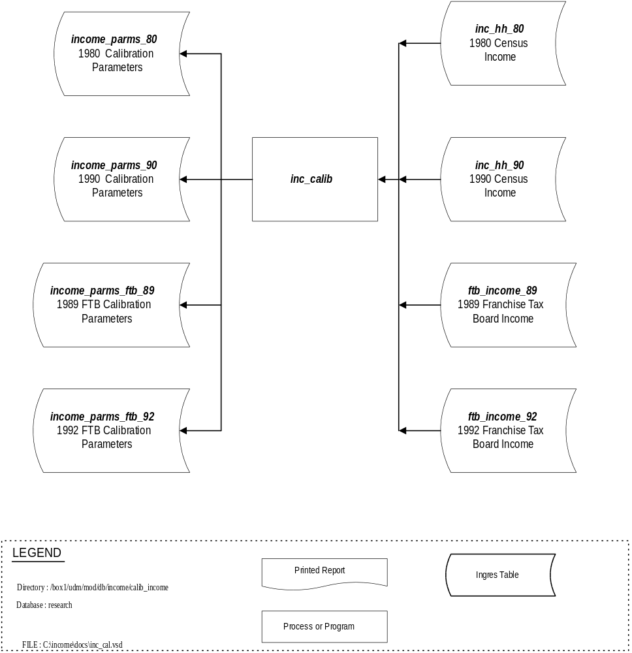

PROGRAMMING

Source code and the executable programs for INC_CALIB are maintained in the directory ~/calib_income. INC_CALIB consists of two C programs, INC_CALIB and CONV_80TO90, each with one source file. INC_CALIB is the actual calibration program. CONV_80TO90 is a utility used to convert Franchise Tax Board income data, defined in terms of 1980 Census Tracts, into a comparable 1990 Census Tract definition. The executable programs are created by the INC_CALIB and CONV_80TO90 make instructions (makefile). Table 4-3 summarizes the INC_CALIB organization.

Table 4-3
INC_CALIB File Organization

File | Description
inc_calib.sc | INC_CALIB source file, contains the main and all called procedures.
con_80to90.sc | CONV_80TO90 source file, contains the main and all called procedures

Procedures

Table 4-4 describes the individual procedures that comprise INC_CALIB and CONV_80TO90.

Table 4-4
INC_CALIB Procedures

Source File | Procedure | Description
inc_calib.sc | main | INC_CALIB main program
 | erf | Log-normal error function
 | list_correct | Display correct runtime command line
 | median_income | Compute median income from distribution
 | quitit | SQL error processing and database disconnect
 | unerf | Log-normal error function
conv_80to90.sc | main | CONV_80TO90 main program
 | get_index | Return index position in array
 | list_correct | Display correct runtime command line
 | quitit | SQL error processing and database disconnect

EXECUTION

INC_CALIB is run from the UNIX prompt, directory ~/calib_income, and requires two runtime parameters. The command line usage is :
inc_calib <geo_id> <file_id>
where
<geo_id> is:
1 : Census tracts
2 : SRA’s
3 : MSA’s
4 : Region
<file_id> is:
80 : 1980 Census Income
90 : 1990 Census Income
89 : 1989 Franchise Tax Board Income Data
92 : 1992 Franchise Tax Board Income Data

CONV_80TO90 is run from the UNIX prompt, directory ~/calib_income, and requires no runtime parameters. The command line usage is :
conv_80to90.

