1. **Freeway Checks**

Checks for three scenarios. Freeways in A, B and C networks have some differences due to different projects but all of them are consistent with projects definition

* Tolled and HOV lanes check:

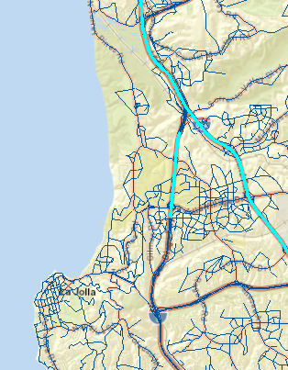

The ramp for connecting HOV lane has toll=0 whereas the upstream and downstream links have tolls

**Profile of speed:**

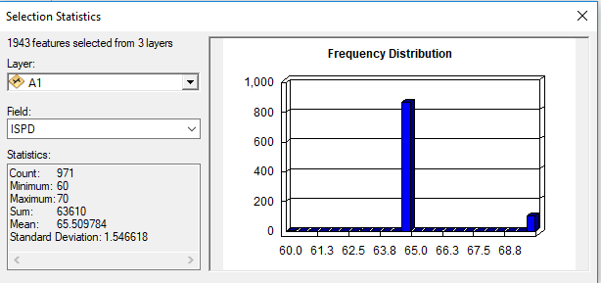

Number of lanes plot. Checked some links with Google map and they are coded correctly

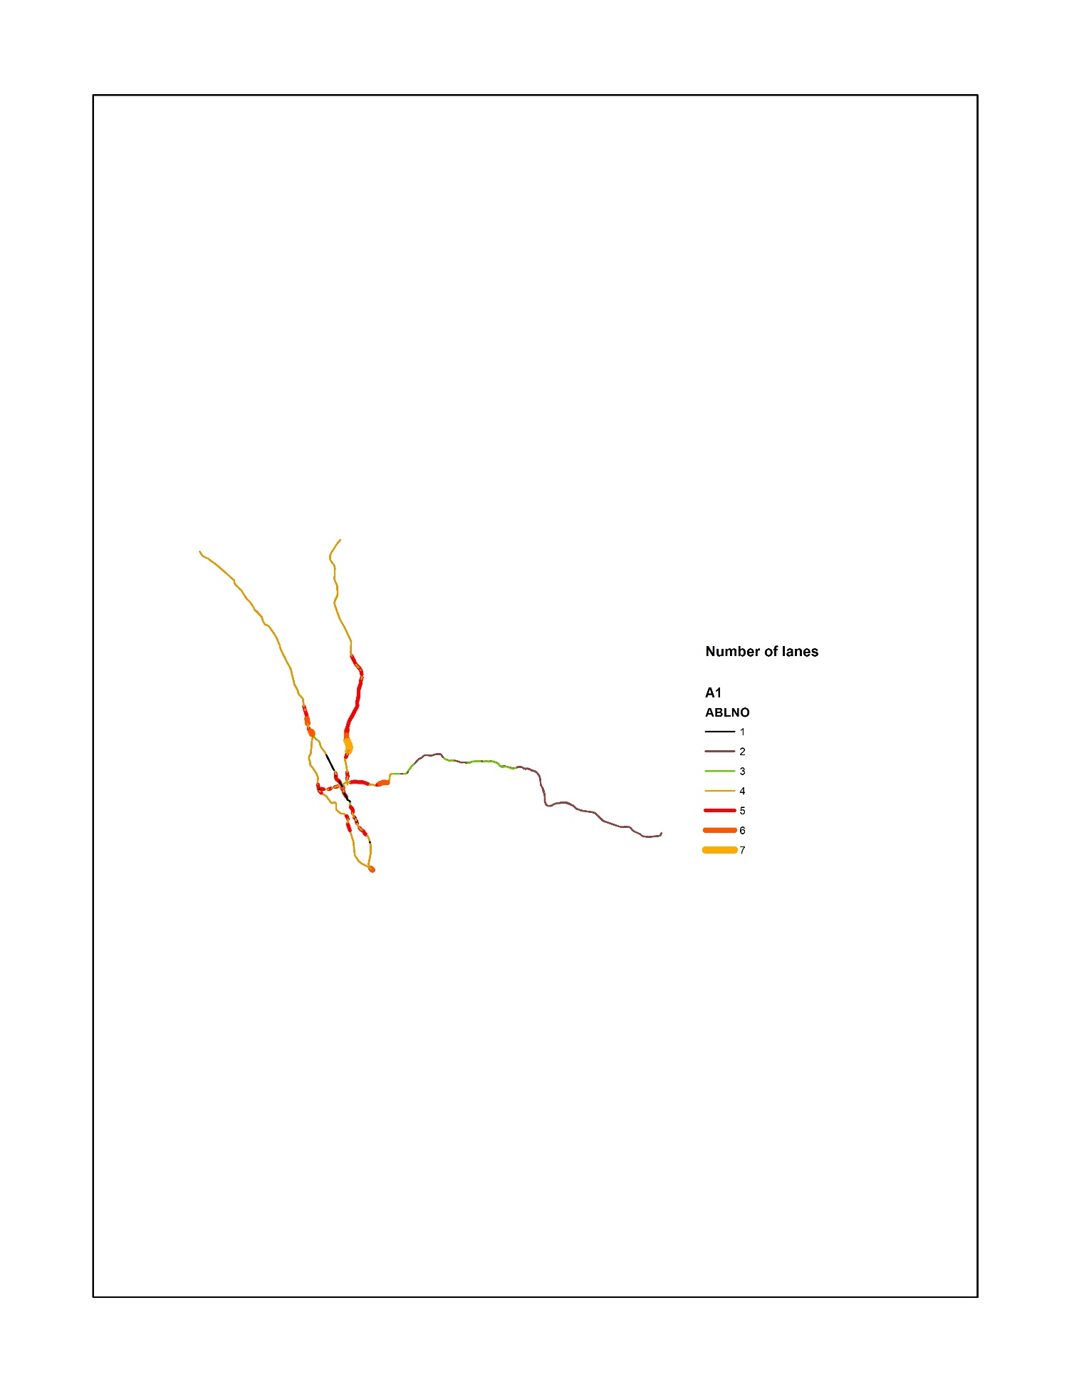

**Capacity Check:**

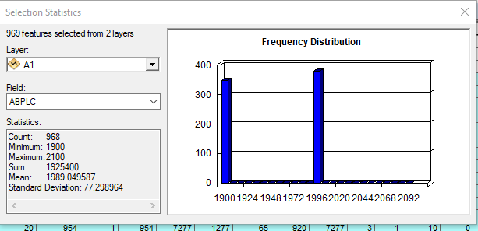

1. **Primary links Check:**

All networks A, B and C are same for IFC=2

**Link Speeds:**

Distributions looks correct. Checked some links by Google Map and the speeds were coded correctly

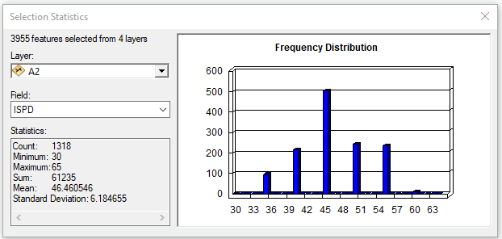

**Number of lanes:**

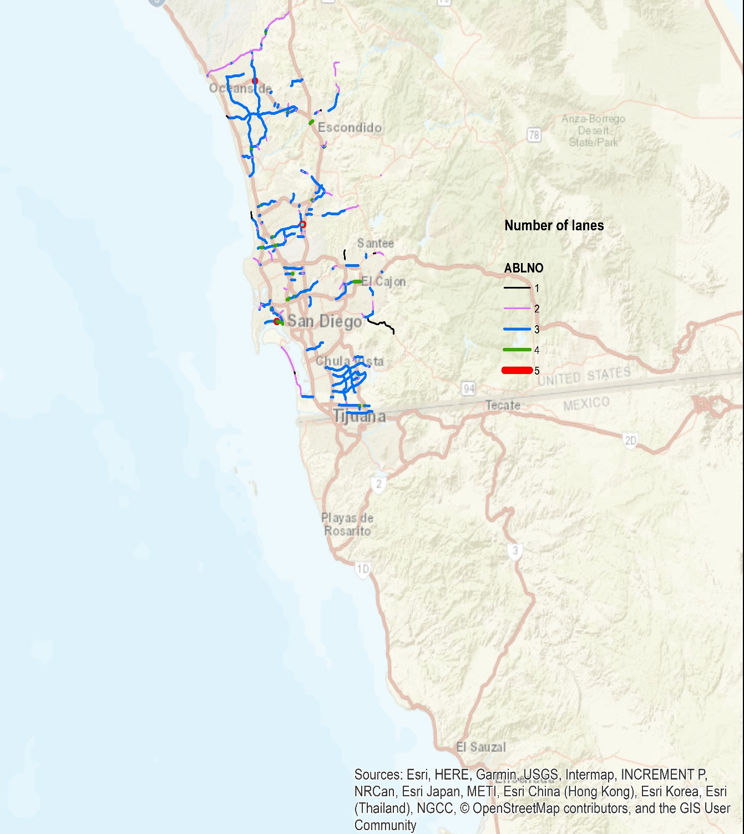

Checked some of the roads in google map and they are consistent in number of lanes.

**Right and Left turn lanes:**

Two issues:

There are links with 7,8,9 number of right or left turn lanes.

Checked some of the links with google map and they are not completely consistent. For example, the lane has two left lanes but it is coded as 1)

**Capacity check:**

Only 70 out of 1318 links have non-zero capacities. (all 70 have 950 veh/hr)

IWAY, IHOV and TOLL also checked and all are correct.