PLEASE READ THE INSTRUCTIONS BELOW PRIOR TO THE EXAM
If you have any questions, please ask an examiner before proceeding.

Please find this line at the bottom of the first page of the exam booklet:



Verify that your exam booklet shows the exam element that you intend to take.

Verify your exam booklet is complete and that all the pages have the same exam ID.

Please complete the following items on your answer sheet before beginning the test:

- Write your name on the answer sheet.
- Bubble the correct exam element: T - Technician, G - General, or E - Extra.
- Write your PIN in the “Applicant ID” field and bubble the corresponding digits under it. If you do not have your PIN, ask an examiner.
- Copy your Exam ID from YOUR exam booklet (not the samples above or below) onto the “Exam ID” field and bubble the corresponding digits under it.
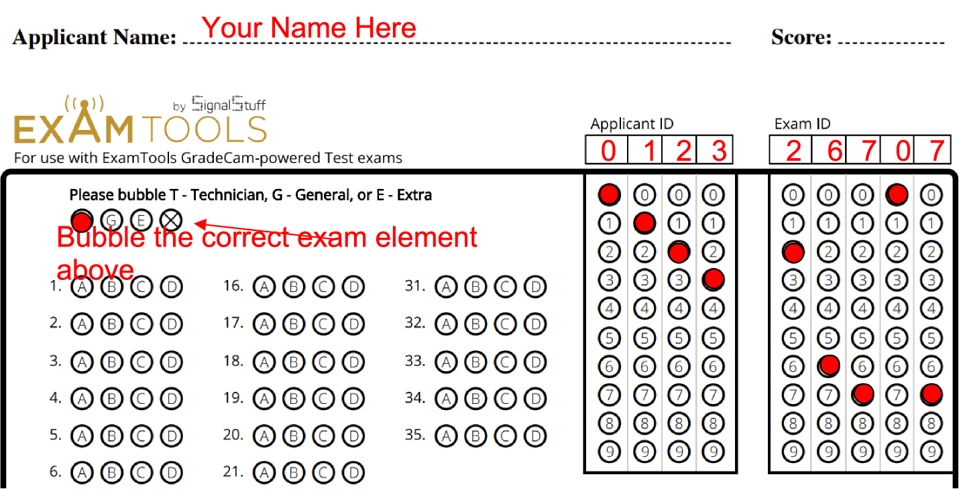

GOOD LUCK! Make sure you answer all of the questions. Let us know when you finish.

