Assignment 5

## Fundamentals of Data Analytics

Sandeep Mandalapu

S ID:-11527195

**Given** **Sample:**

**20, 12, 8, 10, 3, 15, 7, 35, 7, 33, 5, 17, 9, 18, 4**

**1.Find and report the Range of the Sample**

The range of the sample is nothing but the minimum and maximum of sample.

Here the Minimum is 3

Maximum is 35

**2.Find and report the Mean (X-Bar) of the Sample**

**20, 12, 8, 10, 3, 15, 7, 35, 7, 33, 5, 17, 9, 18, 4**

The mean is the usual average, so I'll add and then divide:

(20+12+8+10+3+15+7+35+7+33+5+17+9+18+4) ÷ 15

203 ÷15= 13.5333

**3.Find and report the Median of the Sample**

Median is nothing but the middle most element in our sample set

**4.Find and report the Mode of the Sample**

Mode is nothing but repeated element in the set

Here 7 is mostly repeated element

**5.Find and report the Variance of the Sample**

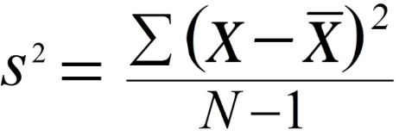

* σ2 = population variance
* Σ = sum of…
* Χ = each value
* Ν = number of values in the population

**6.Find and report the Degrees of Freedom (DF) of the Sample**

Degree of Freedom is defined as df

df=N-1

here N is the number of elements in the sample

**7.Find and report the Standard Deviation of the Sample**

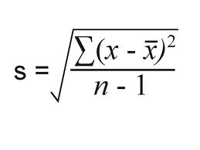

X=mean

N=number elements

S=sample standard deviation

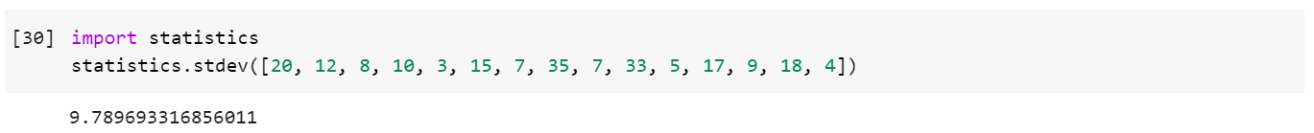

**THANK YOU**