**Terraform-Managed-VPC-with-EC2-WebHosting**

* File structure- Used VS code Editor and AWS provider

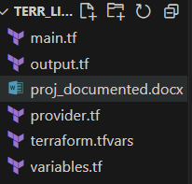

**main.tf** file is the main file which is used by the terraform to build resources.

**output.tf** file contains variables of specific resources which users might want to see when an apply is finished.

**provider.tf** is the file which contains the provider whose resources are being used.

**variables.tf** file contains all the declarations of the variables that have been used in the **main.tf** file.

**terraform.tfvars**  file contains the values of the variables declared inside **variables.tf**  and used in **main.tf**

**Description of main.tf file**

* **Created a VPC known as “proj-VPC”**

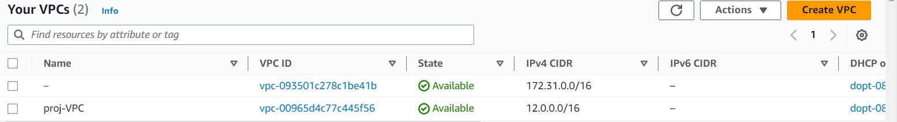

* **Created a subnet called “Public subnet” and “Private subnet”**

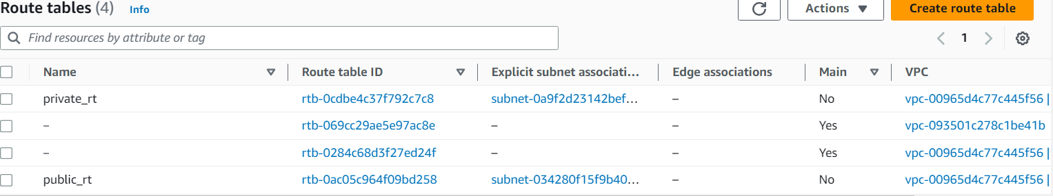

* **Created Internet Gateway as "proj_vpc_igw"**

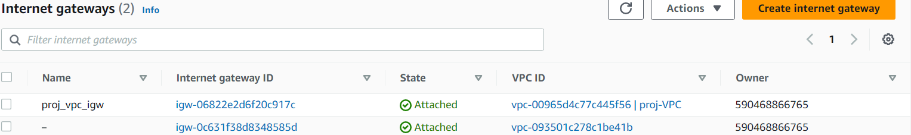

* **Created public and private route table**
* **Associated the route tables with their respective subnets**
* **Created a NAT gateway in public subnet and assigned Elastic IP to it**

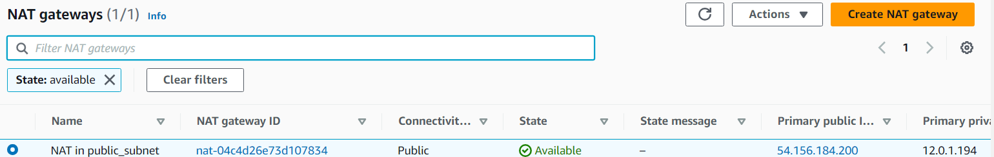

* **Created a security group with name public_ec2 group and “All Traffic from Anywhere” feature**

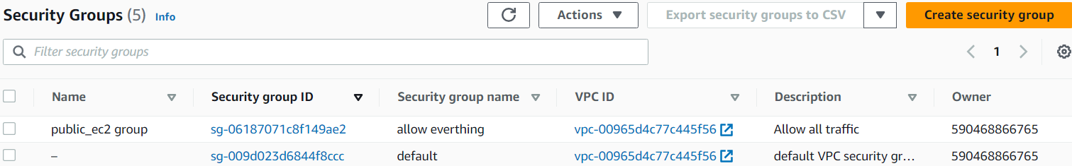

* **Created an EC2 instance in public subnet**

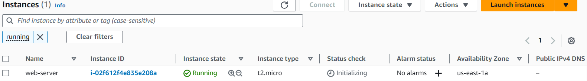

* **Created a null_resource block of name remote_exec which has a direct relationship with the building of EC2.**
* **A connection block is there which does ssh into the EC2 with the username as ec2-user.**
* **Next, there is a provisioner block and all the commands written in it gets executed one-by-one once the ssh is successful.**

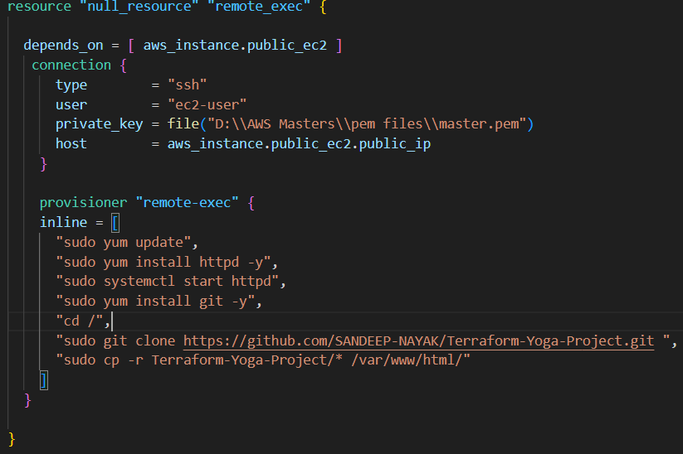

**Commands in provisioner block:**

* **Updated the yum package manager**
* **Installed httpd**
* **Started httpd service**
* **Installed git**
* **Changed to root directory**
* **Cloned git repository storing the website**
* **Recursively copying all the files in the “Terraform-Yoga-Project” into /var/www/html/ folder to host the website**



**Commands Used in this terraform project**

terraform init

terraform validate

terraform plan

terraform apply

terraform state list

terraform state show

terraform apply with target flag

terraform destroy

