

**Jason Miller**

SALES DIRECTOR

jason.miller@email.com | +1 (312) 555-7890  
New York, NY  
linkedin.com/in/jasonmiller

**DIPLOMAS Y HOBBIES**

**Formaciones :** Diplomados, Congresos, xxxxxxxxxx xxxxxx xxxxxxxxx xxxxxxxxxxxxxxxxx

**Hobbies:** xxxxxxxxxxxxxxxxxxxxxxxxxxxxxx

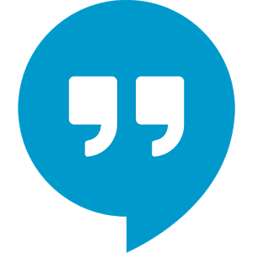

©AZURIUS – Modelos-de-curriculum.com

Sales Director with 15 years of experience in strategic business development and sales team management. Proven expertise in revenue growth, high-level negotiations, and market expansion. Strong leadership skills with a track record of successfully driving sales performance.

**WORK EXPERIENCE**

* Managed a client portfolio generating $150M in annual sales.
* Negotiated complex commercial deals with major retail chains.
* Increased customer satisfaction by 15% through tailored solutions.

**EDUCATION**

**Sales Director**

*Druni Stores*, New York, NY | 20XX – Present

* Led a team of 50 sales professionals across multiple regions.
* Implemented a sales strategy that increased revenue by 25%.
* Worked closely with the marketing team to launch new products.

**Key Account Manager**

*L’Oréal USA*, Chicago, IL | 20XX – 20XX

**Commercial Manager**

*Nestlé USA*, Los Angeles, CA | 20XX – 20XX

* Developed and executed high-impact sales strategies.
* Led cross-functional teams to optimize sales processes.
* Strengthened relationships with key clients to drive business growth.

**MBA in Business Administration**

*University of California, Berkeley* | 20XX – 20XX

**Bachelor’s Degree in Economics**

*New York University, NY*| 20XX – 20XX

**SKILLS**

Sales strategy & business development, Team leadership & management, Negotiation & contract management, Data-driven decision-making, Strategic partnerships

**LANGUAGES**

* Assurer la mise à jour des coordonnées administrative relatives au compte client
* Traiter les demandes d’échantillon depuis la saisie jusqu’à l’expédition.
* Assurer l'interface entreprise-client export pour tout service sollicité.

Assistant Commercial Stagiaire

***DANONE*, Paris** | 2015

* English: Native
* Spanish: Fluent
* German: Upper Intermediate (B2)

©AZURIUS – Modelos-de-curriculum.com

**Dear Job Seeker,**

If you're having difficulty composing your resume, here are some free resources available that can assist you in creating a strong resume that highlights your suitability for the position to potential employers:

* [How to Make a Good Resume](https://www.my-resume-templates.com/how-to-make-a-resume/?utm_source=Word_Doc&utm_medium=Model_CV_Link&utm_campaign=MDC_Downloads)
* [Skills to Put on a Resume](https://www.my-resume-templates.com/skills-to-put-on-a-resume/?utm_source=Word_Doc&utm_medium=Model_CV_Link&utm_campaign=MDC_Downloads)
* [Resume Objective Examples](https://www.my-resume-templates.com/resume-objective-examples/?utm_source=Word_Doc&utm_medium=Model_CV_Link&utm_campaign=MDC_Downloads)

Also, discover other free downloadable and ready-to-fill CV templates in Word format:

* [Basic Resume Templates](https://www.my-resume-templates.com/basic-resume-templates/?utm_source=Word_Doc&utm_medium=Model_CV_Link&utm_campaign=MDC_Downloads)
* [Modern Resume Templates](https://www.my-resume-templates.com/modern-resume-samples/?utm_source=Word_Doc&utm_medium=Model_CV_Link&utm_campaign=MDC_Downloads)
* [Creative Resume Templates](https://www.my-resume-templates.com/creative-cv-templates/?utm_source=Word_Doc&utm_medium=Model_CV_Link&utm_campaign=MDC_Downloads)
* [Professional Resume Templates](https://www.my-resume-templates.com/career-resume-templates/?utm_source=Word_Doc&utm_medium=Model_CV_Link&utm_campaign=MDC_Downloads)
* [Europass CV](https://www.my-resume-templates.com/europass-cv/?utm_source=Word_Doc&utm_medium=Model_CV_Link&utm_campaign=MDC_Downloads)

Best regards,

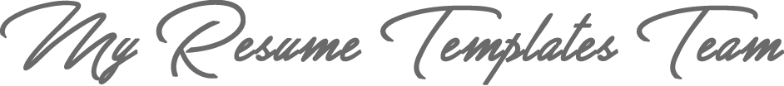

[www.my-resume-templates.com](https://www.modelos-de-curriculum.com/?utm_source=Word_Doc&utm_medium=Model_CV_Link&utm_campaign=MDC_Downloads)

**COPYRIGHT - PLEASE READ THIS MESSAGE**

©These examples of free resume templates are the property of Azurius S.L. You may   
download and modify them without any problem if they are for personal use.

Do not forget to remove this copyright notice before modifying and printing your CV.

You cannot resell these examples or their derivatives. You cannot make them available on other websites without our consent. For any related questions, please write to us at contact@my-resume-templates.com

Discover more resume templates at [www.my-resume-templates.com](https://www.my-resume-templates.com/)