Software Testing Report

Sandesh Chaudhary
International American University

CSE 220 Principles of Software Engineering

Professor: Poshan karki

August 12, 2026

Introduction
From the Use Case, Sequence, Class, and Activity diagrams that were developed previously in this course, a design for a system, called the Campus Course Registration System (CCRS), was set forth that would allow students to search for and register in courses, allow professors to submit grades, and allow the registrar to manage the course catalog. After a design has been written in UML, it is necessary to see if the system designed in that way behaves as the design depicts.
The definition of Testing is generally considered to be the act of running a system with the aim of identifying faults and ensuring that it satisfies the requirements it was developed to address (Sommerville, 2016). This report is the record of the testing period for CCRS. It explains the strategy followed to test the system, links that strategy to the seven use cases and sequence, class and activity diagrams previously designed, and presents the outcomes of the testing, including some defects that were discovered during the testing. The complete list of thirty-two test cases is documented within a companion spreadsheet called CCRS_Test_Cases.xlsx which contains one row for each test case and a Summary tab constructed using formulas. This report outlines the strategy, traceability and a sample of that suite.
Testing Objectives and Scope
The goal of this testing stage was to confirm that CCRS is able to execute all the use cases defined at the design stage (UC-1 through UC-7) as intended and to test that it fails safely when it receives bad input or encounters an unusual condition, and to test the fork/join concurrency as implemented in a Activity Diagram does not corrupt the data under load.

The scope included the following: authentication, course search, registration, including the prerequisite and seat-conflict check relationships with others, grade submission, registrar's catalog management, the relationship with the external Billing System displayed in the Use Case Diagram, and performance and security goals that supported these features. The outer workings of the external Billing System (exposed outside the CCRS boundary) were not tested, but were only tested at the interface where CCRS passes an invoice request to the external Billing System.
Testing Strategy
There were four types of testing, each at a specific stage of the system, corresponding to the stage at which the defect is easiest to fix (Sommerville, 2016; ISTQB, 2023). The four levels are mapped to the four phases of design work according to the V-Model in Figure 1.

Figure 1
V-Model showing how each test level validates a corresponding stage of the CCRS design.

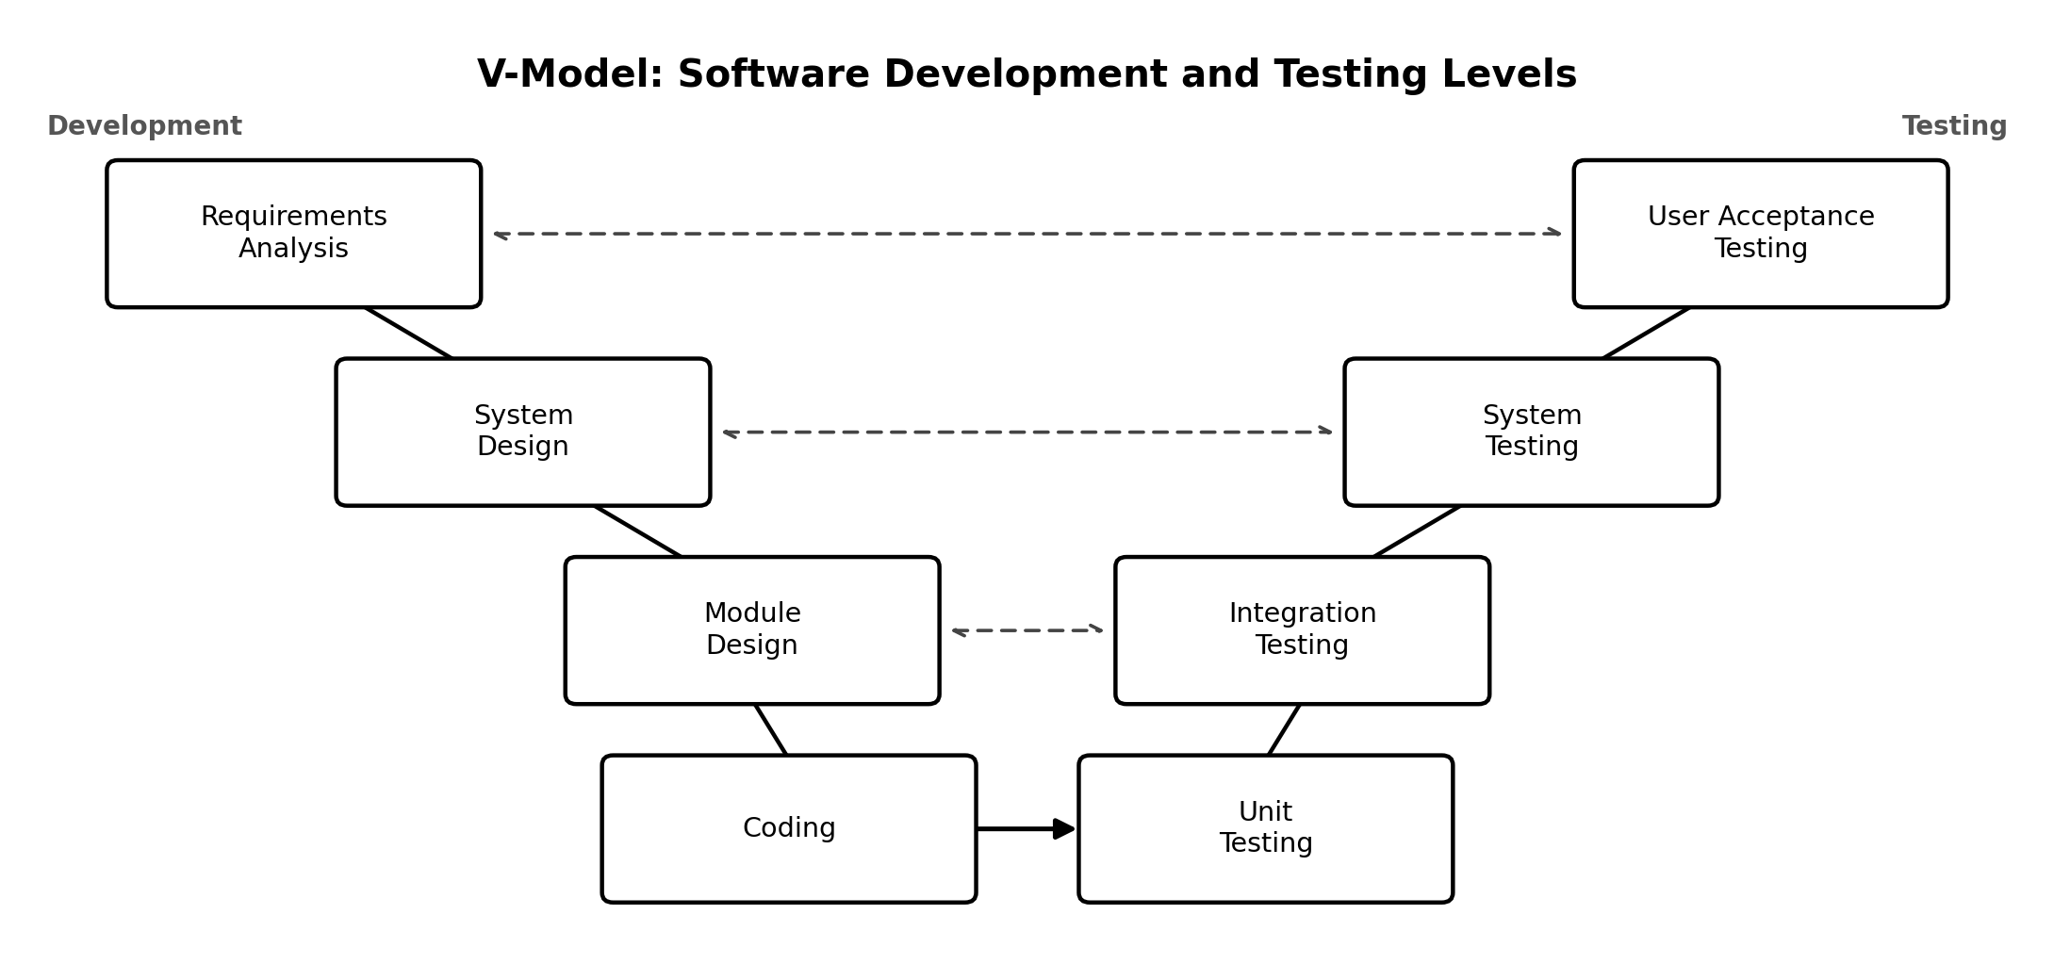
Each function was tested with unit testing, with various individual functions from different Sequence Diagrams or Classes Diagram tested against the smallest testable unit of code such as checkPrerequisite() and verifySeatAvailability() from the Sequence Diagram or checkAvailability() from the Class Diagram. Integration testing verified that two or more collaborating parts operated together correctly, such as Register for Course (UC-3) sending the correct message to the included Verify Prerequisites (UC-4) part, or whether the RegistrationUI, CourseController, and CourseDB objects in the Sequence Diagram actually sent and received the correct messages as per the diagram. Completed end-to-end full system tests were conducted using the fully integrated system, as well as the fork/join concurrency modelled in the Activity Diagram and the non-functional performance and security goals. User Acceptance Testing (UAT) introduced a panel of students, faculty and registrar staff to prove that the system was not only technically correct but actually usable.
Each test case also included a scenario type, Positive or Negative, to indicate whether the input was valid or invalid, or a boundary condition, or an un-authorized action, for which the system should either accept or reject or fail safely. The same fields were recorded for each case in the spreadsheet: Test Case ID, Test Level, Related Use Case, Scenario Type, Test Objective, Preconditions, Test Input, Test Steps, Expected Output, Actual Output and Status. The grade was Passed in a case where the Actual Output was equal to the Expected Output.

Requirements Traceability
The mapping of each use case and key diagram element to the test levels that exercised it is presented in Table 1. The two relationships – registration and prerequisite check – were tested at all levels, as this one contains the most business risk in the system.

Table 1
Use case and diagram-element traceability across the four test levels.
Use Case / Diagram Element | Unit | Integration | System | UAT
Authenticate User (UC-1) | ✓ |  | ✓ | ✓
Search Course Catalog (UC-2) | ✓ | ✓ |  | ✓
Register for Course (UC-3) |  | ✓ | ✓ | ✓
Verify Prerequisites (UC-4) | ✓ | ✓ | ✓ | ✓
Check Schedule Conflict (UC-5) | ✓ |  |  | ✓
Submit Grades (UC-6) |  | ✓ |  | ✓
Manage Course Catalog (UC-7) |  | ✓ |  | ✓
Billing System (external) |  | ✓ | ✓
Fork/Join concurrency (Activity Diagram) |  |  | ✓
NFRs (performance, security) |  |  | ✓
Test Case Design and Sample Results
Ten unit tests, eight integration tests, seven system tests and seven UAT tests were designed and executed, made up of twenty-one positive cases and eleven negative cases. The Summary sheet from CCRS_Test_Cases.xlsx is used to create Table 2 which provides a summary of the number of cases in the template that passed and failed at each level.

Table 2
Test results by level.
Test Level | Total | Pass | Fail | Pass Rate
Unit | 10 | 8 | 2 | 80.0%
Integration | 8 | 7 | 1 | 87.5%
System | 7 | 6 | 1 | 85.7%
UAT | 7 | 6 | 1 | 85.7%
Total | 32 | 27 | 5 | 84.4%

Table 3 pulls out five representative cases across all four levels, with the exact objective, input, expected output, and actual output recorded for each one.
Table 3
Sample test cases with objective, input, expected output, and actual output.

ID / Level | Objective | Input | Expected Output | Actual Output | Status
TC-U-06 Unit (Neg.) | checkPrerequisite() returns valid=false when the prerequisite is missing. | studentId without CS201 completed; courseId CS301. | Function returns valid=false and blocks registration. | Function returned valid=true; registration was not blocked. | Fail
TC-I-05 Integration (Pos.) | Successful registration triggers invoice generation in the Billing System. | studentId S-2041; courseId CS301-01 (3 credits). | Invoice for the correct tuition amount is generated and linked. | Invoice generated correctly and linked to the student record. | Pass
TC-S-03 System (Pos.) | Only one of two simultaneous registrations for the last seat succeeds. | Two students submit registration for the same 1-seat section seconds apart. | Only one registration succeeds; the other receives a 'Class Full' error. | Student A's registration succeeded; Student B received the error. | Pass
TC-S-07 System (Neg.) | Registration behavior when the external Billing System is unreachable. | Billing System deliberately taken offline during registration. | Registration still completes; invoice is queued for retry. | Entire registration was rolled back instead of completing. | Fail (Minor)
TC-A-07 UAT (Neg.) | Student registering for overlapping sections receives a clear conflict warning. | Student already booked Mon/Wed 10:00-11:15; attempts an overlapping Mon 10:30-11:45 section. | Message names both conflicting courses and their meeting times. | Message shown, but did not name the conflicting existing course. | Fail (Minor)

Findings and Analysis
The overall pass rate was 84.4% (27 of 32 test cases). There were twenty-one positive tests, which all passed, and eleven negative tests, which passed 54.5%. The pattern is consistent with the results of testing research, which generally shows that negative and boundary testing discovers significantly more defects than testing the path the system was designed to follow (Wiegers & Beatty, 2013): Developers tend to pay more attention to the test for the expected path than they do to negative and boundary testing because they naturally focus more on the expected path than on the different paths that can be followed.
Five defects were observed. The test case TC-U-06 demonstrated that checkPrerequisite() returned the value of true when the prerequisite was not satisfied by the student, so the actual problem was not with the prerequisite check itself but somewhere higher up the chain. TC-U-10 was used to demonstrate that registering for a non-existent course ID resulted in an unhandled exception, instead of the expected ‘Course not found’ message.TC-U-10 was used to illustrate that when a non-existent course ID is registered, a raw error screen is displayed rather than the expected ‘Course not found’ message. In the case of a missing CourseDB during a prerequisite lookup, the student was presented with a raw database error code, as opposed to a readable message, as depicted by TC-I-04. Notably, the whole registration was rolled back when the external Billing System was down, rather than completed with the invoice queued for re-try as per the intent of treating the Billing System as a separate external system on the Use Case Diagram. A smaller usability concern was TC-A-07, which displayed the schedule-conflict message, but failed to identify which existing course the new course was in conflict with, so the student had to guess.
The two most dangerous defects are TC-U-06 and TC-I-04, as they both affect the part of the prerequisite-checking logic that the Use Case Diagram views as an include relationship for all registrations. One of the fundamental rules of the academic system, that a student must satisfy a prerequisite check before being allowed to take a given course, is being violated when the check is not met but goes unnoticed. The Billing rollback issue (TC-S-07) is sitting on the lower risk day to day but would be a real bugger for students during any downtime of the external system; the UAT wording issue (TC-A-07) is cosmetic, and easy to rectify.

Conclusion
This was done at unit, integration, system and UAT levels and both in valid and invalid scenarios, thus providing a fairly complete picture of how the system performs against its own design. The overall pass rate is 84.4% (all positive scenarios passed) which indicates that when all things go well, the core registration workflow provided by the four UML diagrams (from authentication to search, prerequisite validation, seat validation and confirmation) works as expected. The 5 failures were all focused on edge cases and negative behaviors, thus making an easy to-do list for the development team in terms of what they need to fix before the next batch of testing, particularly with regards to exception handling, database and external Billing System behaviors, and a single unclear message.

References
International Software Testing Qualifications Board. (2023). Certified tester foundation level syllabus (Version 4.0). ISTQB.
Sommerville, I. (2016). Software engineering (10th ed.). Pearson.
Wiegers, K., & Beatty, J. (2013). Software requirements (3rd ed.). Microsoft Press.

