UML Design Report: Campus Course Registration System (CCRS)

Sandesh Chaudhary
International American University

CSE 220 Principles of Software Engineering

Professor: Poshan karki

August 12, 2026

Introduction

This report provides the design specifications for the Campus Course Registration System (CCRS) based on the requirements identified during the Lesson 3 case study. The report will present four diagrams that contain the complementary views of the proposed system. The initial diagram is the Use Case diagram, the second is the Sequence diagram, the third is the Class diagram, and the fourth is the Activity diagram. It should be noted that these diagrams have been developed using different notations, where the UML notations have been used to depict a comprehensive view of the Campus Course Registration System (CCRS). According to Booch, Rumbaugh, and Jacobson (2005), “No single model can capture all aspects of a system, and no single diagram can even capture all aspects of a particular model.” Therefore, these four diagrams together can be used to understand the proposed project and proceed with its development

The Use Case Diagram has been developed to illustrate the functions provided by the system, as well as the relationships between its actors. The Sequence diagram was developed for a specific interaction between the Actors and the system, illustrating the sequence of activities taking place when a student registers for the course. It should also be noted that the other two diagrams were developed as well, including the Class diagram that illustrates the structure, as well as the key relationships of the proposed system. The Activity diagram was developed to depict the flow of the registration process. All these diagrams together provide a comprehensive view of the proposed system, which would allow a development team to proceed with the development of the Campus Course Registration System according to the outlined requirements.

These diagrams have been developed using Draw.io. The notations depicted in the diagrams have been adopted from OMG (2017).

Use Case Diagram
Figure 1
Use Case Diagram for the Campus Course Registration System

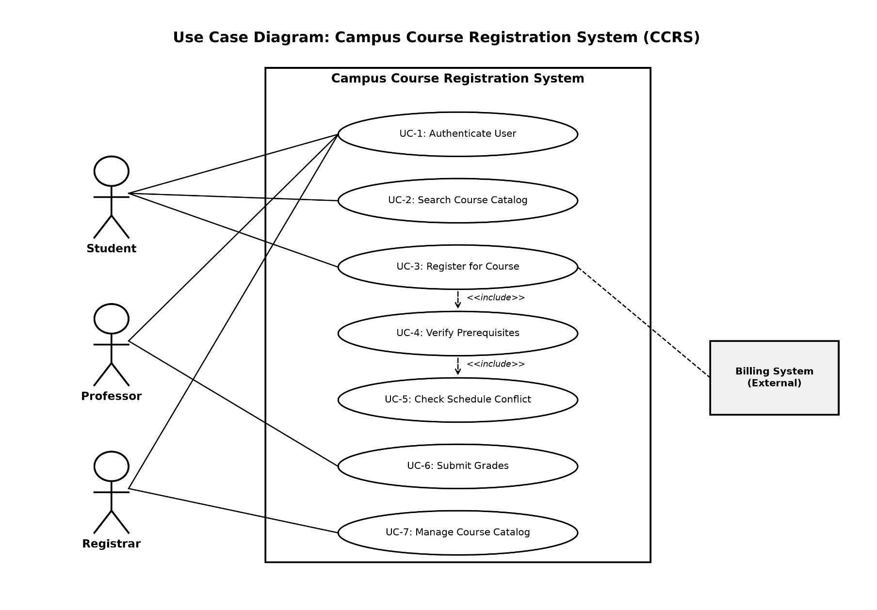
The Use Case Diagram (Figure 1) represents the functional requirements of the CCRS and the actors involved. As a result of the requirements analysis, three main actors were identified: Student, Professor, and Registrar. In addition, one external system was identified – Billing System, which is connected to the CCRS as the student’s registration course information is transferred to it.
Student uses the CCRS to perform three primary use cases: Authenticating a User (UC-1), Searching the Catalog (UC-2), and Registering for a Course (UC-3). Professors access the system in order to Submit Grades (UC-6) and Authenticating a User (UC-1). Similarly, the Registrar accesses the system in order to Manage the Catalog (UC-7) and Authenticating a User (UC-1). As a result, the UC-1 use case is included in all actors’ activities, as it should be authenticated in order to perform other use cases.
Two include relationships were established in order to identify the sub-activities for UC-3 Registering for a Course. UC-3 includes UC-4 Verifying Prerequisites which, in turn, includes UC-5 Checking Schedule Conflicts. Such a relationship was established in order to ensure that UC-3 is not overly complex and in line with the UC-2 Search Catalog. Additionally, a dashed line relationship was added between UC-3 Registering for a Course and the Billing System as each time a course is registered, it is necessary to bill the student for it. Thus, the connection between the system and the Billing System should be identified.

Sequence Diagram
Figure 2
Sequence Diagram for the Course Registration scenario

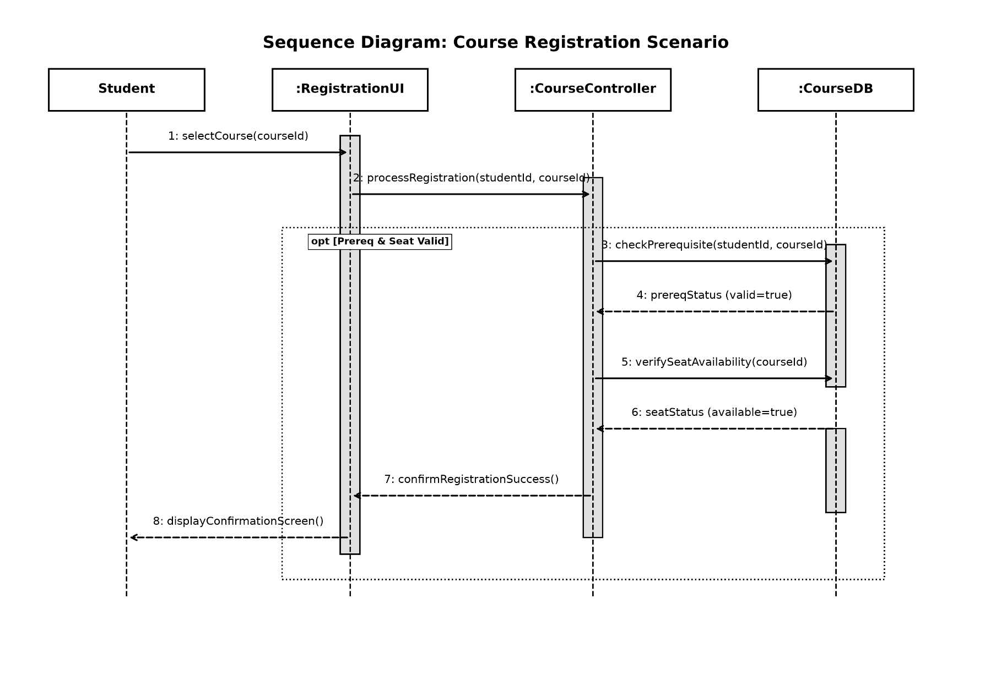
The Sequence Diagram (Figure 2) describes the Register for Course use case by illustrating the temporal ordering of messages sent between objects that are involved in the use case. The diagram has four main objects: Student, RegistrationUI (boundary), CourseController (control), and CourseDB (entity).
The student selects a course, which is received by the RegistrationUI . The UI passes the request to the CourseController , which then checks prerequisites and seat availability. Inside an opt fragment, which means that the following messages occur only if the guard expression Prereq & Seat Valid is satisfied, the controller asks the database about the prerequisites (checkPrerequisite(studentId,courseId)) and receives a response (prereqStatus) and then checks the seat availability (verifySeatAvailability(courseId)) and receives a status (seatStatus). These steps are included in the use case based on the include relationship in the Use Case Diagram. Both are required to register for a course, which explains the opt fragment in the sequence diagram.
If both are true, the controller sends a message to the UI confirming registration (return confirmRegistrationSuccess()) and the UI then notifies the student by displaying a confirmation screen ( displayConfirmationScreen()). The opt fragment indicates that these messages will happen only if the guard expression is satisfied, which is left to the activity diagram to specify.

Class Diagram
Figure 3
Class Diagram for the Campus Course Registration System

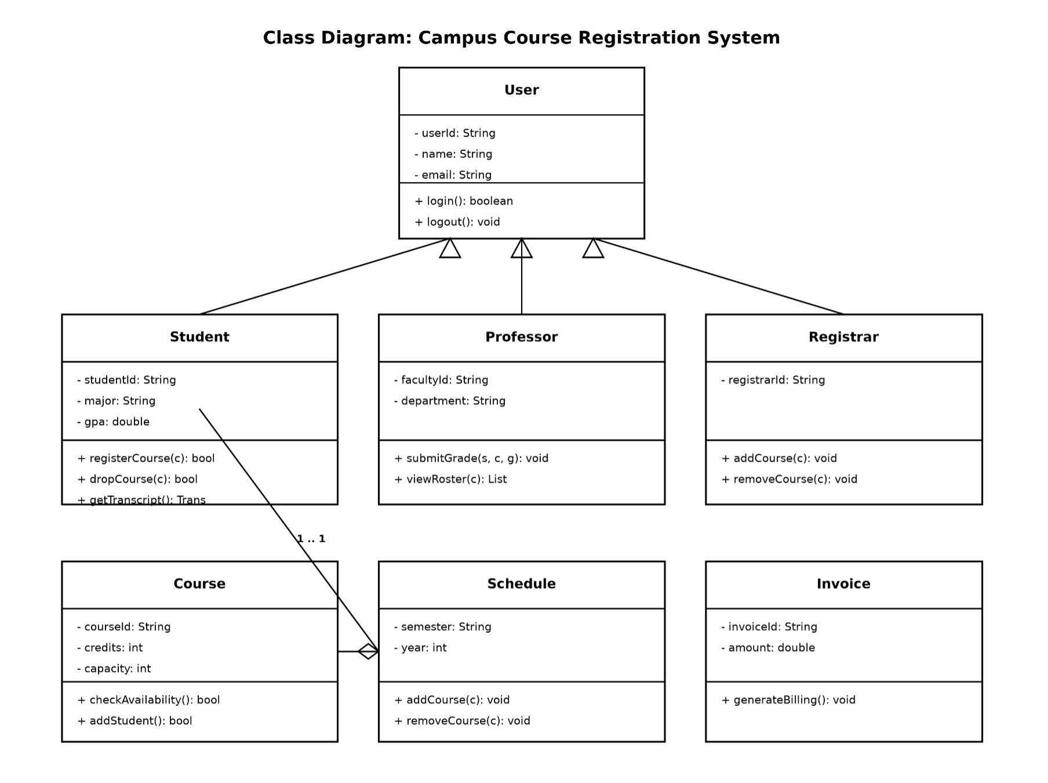
The CCRS Class diagram (Figure 3) represents the static structure of the system, including its classes, attributes, operations, and relationships. The User class is abstract, while Student, Professor, and Registrar inherit its features, each of which adds its own unique aspects. The user class handles basic permissions, providing login and logout methods and storing user IDs, names, and emails. It is essential to make these three types of users separate classes, as they have different features (according to Use Case Diagram). However, since they all require authentication, it is more efficient to use one general class, from which the others inherit authentication methods instead of rewriting the same code for each user type. For instance, students can register and drop courses and thus have methods registerCourse (), dropCourse (), getTranscript (), professors can enter grades and view their rosters (submitGrade (), viewRoster ()) and the registrar can add or remove courses from the catalog (addCourse (), removeCourse ()).
Three other classes are required for the CCRS: Course , Schedule , and Invoice . The course has attributes: course ID, credits, capacity, methods: checkAvailability (), addStudent () and associations: a student (one-to-one). This class is used to store information about the course and manage its characteristics, such as availability. Schedules have an aggregate association (depicted by a hollow diamond) with courses, meaning that a student can add several courses to their schedule, but a course is not necessarily assigned to any student. The invoice is associated with a student on the one side and represents the billing data for the student after they have successfully registered for courses. It also corresponds to the Billing System use case in the Use Case Diagram.
Thus, the static structure of the CCRS is presented by six classes: three abstract (User ) and concrete (Student , Professor, Registrar) and three other classes, each of which serves specific purposes. Separately managing the identity of users from their academic records allows for flexibility and easier maintenance of the system.

Activity Diagram
Figure 4
Activity Diagram for the Course Registration Process Workflow

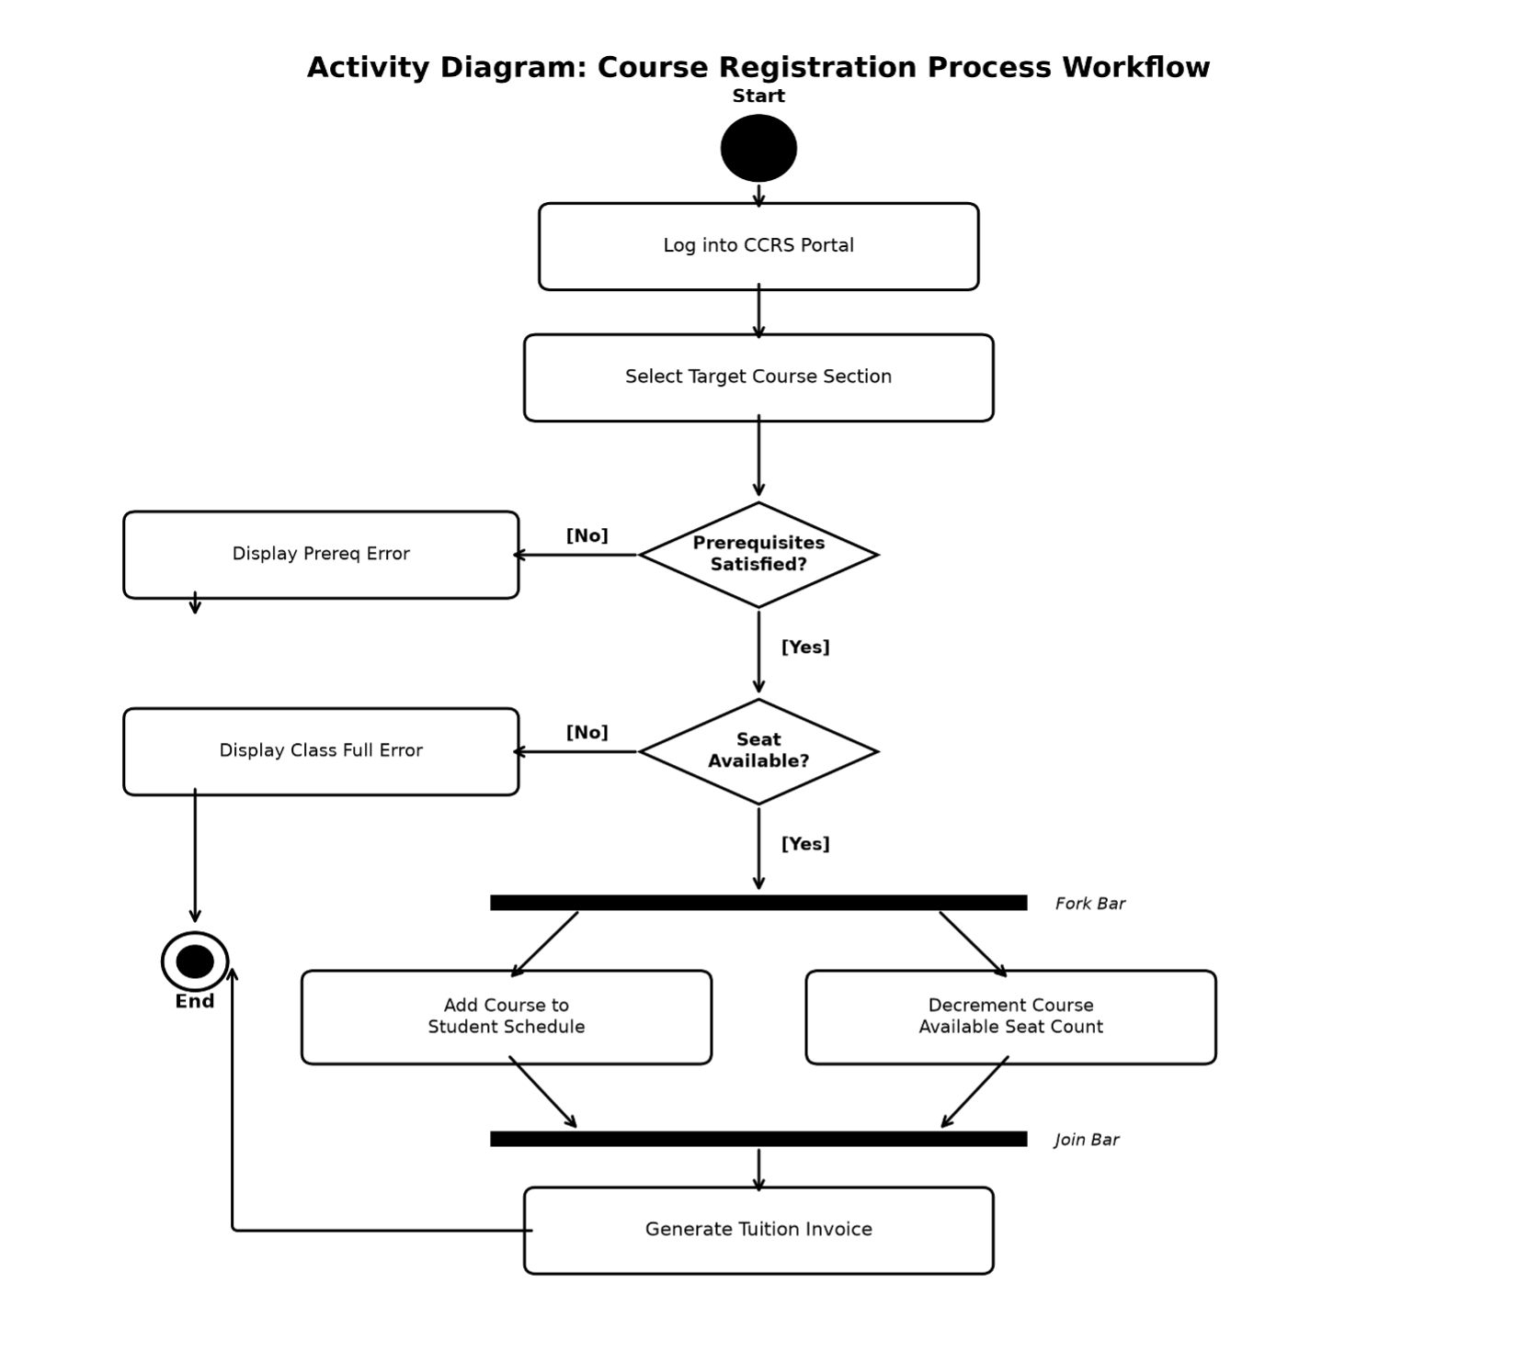
The activity diagram (figure 4) shows the flow of activity for the described process. The activities include the decision points and the two parallel activities that the sequence diagram simplifies into a single ‘optional’ fragment.
The process begins when the student accesses the CCRS and selects the desired course section. Two decision points follow. The first decision point ‘prerequisites satisfied?’ is equivalent to the checkPrerequisite activity in the sequence diagram and Verify Prerequisites include relationship in the use case diagram. If this decision point yields a negative response, the process concludes by displaying a prerequisite error message. The second decision point is ‘seat available,’ which is equivalent to the verifySeatAvailability activity and Check Schedule Conflicts use case. A negative response to this decision point ends the process by displaying the class-full message.
If both decision points yield positive responses, a fork bar branches the process into two activities – Add Course to Student Schedule and Decrement Course Available Seat Count . These two activities run concurrently before joining at the join bar. Similarly, after joining, the process encounters another decision point ‘pay tuition?’ which is equivalent to the handoff to the external billing system in the use case diagram. If the student selects ‘no,’ the process ends with a ‘not enrolled’ message. However, if the student selects ‘yes,’ the process continues to the Generate Tuition Invoice activity before concluding.

Cross-Diagram Consistency

Because the four diagrams represent the same system from different perspectives, they are interrelated and should complement each other. The Register for Course Use case depicted in the Use Case Diagram is elaborated upon in the Sequence Diagram. The two included Use Cases are related to the two guard conditions in the Activity Diagram (“Prerequisites Satisfied?” and “Seat Available?”) and the two validation calls in the opt fragments of the Sequence Diagram (checkPrerequisite and verifySeatAvailability). The CourseController object in the Sequence Diagram realizes the behavior described by the Course and Student classes in the Class Diagram. The Billing System actor shown in the Use Case Diagram via a dashed line is related to the Generate Tuition Invoice activity and the Invoice class. This cross-referencing was performed deliberately as it is recommended to validate the use-case model, interaction model, structural model, and behavioral models against each other before proceeding to implementation (Booch, Rumbaugh, & Jacobson, 2005).

Conclusion

The four UML diagrams included in this report represent a set of requirements for the Campus Course Registration System described in the lesson 3 in a consistent way. First of all, the Use Case Diagram displays what should the system under consideration be able to do for whom. Second, the Sequence Diagram illustrates the interaction of the system’s objects with one another in order to achieve the functional requirements of the system, namely, the course registration process. Third, the Class Diagram describes the system’s architecture by displaying the necessary classes and their relationships. Finally, the Activity Diagram documents all the possible processes, including those related to validation and errors handling. Together these diagrams help a development team to understand the requirements clearly enough in terms of system’s behavior in order to implement it successfully.

References
Booch, G., Rumbaugh, J., & Jacobson, I. (2005). The Unified Modeling Language user guide (2nd ed.). Addison-Wesley.
Object Management Group. (2017). OMG Unified Modeling Language (OMG UML), Version 2.5.1. https://www.omg.org/spec/UML/2.5.1/

