IOT-BASED SMART IRRIGATION AND PLANT DISEASE DETECTION FOR SUSTAINABLE FARMING

ABSTRACT

This project introduces a smart farming system aimed at improving crop health and resource efficiency. It integrates hardware and software to meet modern agricultural challenges. The hardware component automates irrigation and fertilizer application using real-time data from sensors that monitor soil moisture, temperature, and water levels. This enables precise resource control, minimizing waste and promoting optimal plant growth. On the software side, machine learning algorithms analyze sensor data to detect early signs of disease in rice leaves. Early detection allows for timely interventions and targeted treatments. The system also provides customized fertilizer recommendations based on the identified disease, further enhancing crop health and yield. By combining intelligent automation with real-time analytics, the system reduces the need for manual labor. It supports sustainable farming by optimizing inputs and minimizing environmental impact. This innovative approach shows how technology can make agriculture more resilient, productive, and eco-friendly.
Keywords: IOT Module, Arduino microcontroller, Temperature Sensor, Moisture sensor, Ultrasonic sensor.

LIST OF ABBREVIATIONS
ACRONYM |  | ABBREVIATION
IOT | - | Internet of Things
CNN | -
  Convolutional Neural Network
ADC | - | Analog to Digital Converter
ESP32 | - | Espressif Systems 32-bit Microcontroller
USB | - | Universal Serial Bus
ATmega | - | Advanced Technology Mega
LCD | - | Liquid Crystal Display
SMS | - | Short Message Service
PCB | - | Printed Circuit Board
FTDI | - | Future Technology Devices International
IDE | -
  Integrated Development Environment
EEPROM | - | Electrically Erasable Programmable Read-Only Memory
SRAM | - | Static Random Access Memory
UART | - | Universal Asynchronous Receiver/Transmitter
TX | - | Transmit
RX | - | Receive
SPI | -
  Serial Peripheral Interface
GND | - | Ground
IOREF | - | Input/Output Reference
RTOS | - | Real-Time Operating System
SNR | - | Signal to Noise Ratio
THD | - | Total Harmonic Distortion
VCC | - | Voltage Common Collector
mA | - | Milliampere
KB | - | Kilobyte
MHz | - | Megahertz

CHAPTER 1
INTRODUCTION
- OVERVIEW
Agriculture remains the backbone of the global economy, feeding billions and supporting millions of livelihoods. However, with growing food demand, climate change, and resource scarcity, traditional farming practices are becoming unsustainable. Modern, tech-driven solutions are crucial to improving productivity, reducing waste, and promoting sustainability. Among these, smart farming—leveraging technologies like the Internet of Things (IoT), machine learning, and automation has emerged as a transformative approach to optimizing agricultural practices.
A significant focus of smart farming is improving crop health management and resource utilization. Automated irrigation and fertilizer systems, guided by real-time environmental and soil data, drastically improve efficiency. Unlike traditional irrigation, which often wastes water and overuses fertilizers, smart systems monitor soil moisture, temperature, and water levels to deliver precise amounts of water and nutrients. This not only reduces costs but also minimizes environmental impacts such as soil degradation and water pollution.
Equally important is the early detection and management of crop diseases. Conventionally, farmers rely on visual inspections, which may lead to delayed interventions and crop loss. However, machine learning and image processing now enable real-time disease detection through crop leaf analysis. These systems can identify early signs of disease invisible to the human eye and recommend tailored treatments, boosting yield and limiting damage.
This project proposes a comprehensive smart farming system that integrates hardware and software for efficient, sustainable agriculture. The hardware includes sensors to monitor soil moisture, temperature, and water levels, driving an automated system that controls irrigation and fertilizer application. On the software side, machine learning algorithms analyze images of rice leaves to detect diseases and suggest appropriate treatments, ensuring timely and precise interventions.
The fusion of real-time analytics and intelligent automation revolutionizes agriculture by reducing manual labor, enhancing productivity, and promoting eco-friendly practices. Automation reduces water usage and fertilizer runoff, while early disease detection improves crop yield and food security. The system not only enhances operational efficiency but also ensures environmental sustainability by reducing waste and protecting soil and water resources.
Designed for adaptability and scalability, the system suits both small-scale farms and large agricultural enterprises. Its modular design allows easy integration with existing practices. Furthermore, the machine learning model improves over time, offering increasingly accurate diagnostics and smarter resource management.
In conclusion, this project offers a powerful solution to modern agricultural challenges by combining automation, machine learning, and real-time data. It enables farmers to increase yield, reduce waste, and promote sustainability—paving the way for a smarter, more resilient future in farming.
  - OBJECTIVE
- Automate Irrigation and Fertilizer Application: Develop a system that monitors environmental and soil conditions (water levels, temperature, soil moisture) in real-time to control irrigation and fertilizer delivery efficiently.
- Monitor Crop Health: Use machine learning techniques to analyze crop health, particularly for detecting diseases in rice leaves.
- Provide Disease-Specific Fertilizer Recommendations: Generate tailored fertilizer recommendations based on the detected crop diseases to improve treatment effectiveness and enhance crop yield.
- Optimize Resource Utilization: Minimize resource wastage by delivering the exact amount of water and fertilizers needed, ensuring efficient use of resources.
- Reduce Human Intervention: Implement an intelligent automation system that reduces the need for manual intervention in crop care and management.
- Support Sustainable Agriculture: Promote sustainable farming practices through efficient resource management and improved crop health, contributing to long-term agricultural sustainability.
- Leverage Smart Farming Technologies: Combine automation, machine learning, and real-time data analytics to address modern agricultural challenges and improve productivity.
- Enhance Crop Yield: Focus on increasing crop yield by providing precise care and treatment to crops, ensuring optimal growth conditions.

  - INTERNET OF THINGS
The Internet of Things (IoT) is a network of goods that include electronics, software, actuators, and connectivity, allowing these devices to connect, interact, and exchange data as shown in Fig 1.1. The Internet of Things means extending Internet connectivity beyond standard devices such as PCs, laptops, smartphones, and tablets to a wide range of previously dumb or non-internet-enabled physical gadgets and everyday objects. These technologically implanted items can connect and interact over the Internet, and they can be remotely monitored and controlled.
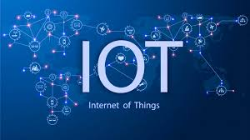
Fig 1.1 Internet of Things
The definition of the Internet of Things has changed as a result of the convergence of several technologies, including real-time analytics, machine learning, inexpensive sensors, and embedded systems. The Internet of things is made possible by embedded systems, wireless sensor networks, control systems, automation (including home and building automation), and other conventional disciplines.
WORKING PROCESS
An Internet of Things (IoT) ecosystem is made up of web-enabled smart devices that employ embedded computers, sensors, and communication gear to gather, communicate, and act on environmental data. By connecting to an IoT gateway or other edge device, which either sends data to the cloud for analysis or analyzes it locally, IoT devices exchange the sensor data they gather as shown in Fig 1.2. These gadgets converse with other similar devices on occasion, acting on the data they exchange. Although individuals may engage with the devices to set them up, give them instructions, or retrieve the data, the gadgets accomplish the majority of the job without their help. These web-enabled devices' connection, networking, and communication protocols are primarily determined by the particular IoT.
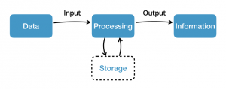
Fig 1.2 Example of an IOT System

ADVANTAGES

Organizations can use the internet of things to:
- Monitor their overall business processes.
- Improve the customer experience.
- Save time and money.
- Increase employee productivity.
- Integrate and adapt business models
- Make better business decisions.
- Generate more revenue.

IoT pushes organizations to reconsider how they approach their enterprises, sectors, and markets, and it provides them with the means to better their business plans.

APPLICATIONS
The applications of the Internet of Things (IoT) are vast and diverse, as the technology can be applied to various industries and use cases. Some common applications of IoT include:
Smart homes: IoT devices can be used to automate and control various home appliances and systems, such as lighting, heating, and security systems.
Industrial automation: IoT can be used to optimize and automate industrial processes, such as manufacturing, logistics, and supply chain management.
Healthcare: IoT devices can be used to monitor patient health and vital signs, automate medication management, and improve patient outcomes.
Agriculture: IoT can be used to monitor soil moisture, temperature, and other environmental factors to optimize crop yields and reduce water usage.
Smart cities: IoT can be used to optimize urban infrastructure, such as traffic management, waste management, and energy usage.
Transportation: IoT can be used to optimize transportation systems, such as monitoring traffic patterns and optimizing vehicle routes.
  - EMBEDDED SYSTEM
An embedded system is one kind of a computer system mainly designed to perform several tasks like to access, process, store and also control the data in various electronics-based systems. Embedded systems are a combination of hardware and software where software is usually known as firmware that is embedded into the hardware. One of its most important characteristics of these systems is, it gives the o/p within the time limits. Embedded systems support to make the work more perfect and convenient. So, we frequently use embedded systems in simple and complex devices too. The applications of embedded systems mainly involve in our real life for several devices like microwave, calculators, TV remote control, home security and neighborhood traffic control systems, etc.
An embedded system is integration of hardware and software, the software used in the embedded system is set of instructions which are termed as a program. The microprocessors or microcontrollers used in the hardware circuits of embedded systems are programmed to perform specific tasks by following the set of instructions. These programs are primarily written using any programming software like Proteus or Lab-view using any programming languages such as C or C++ or embedded C. Then, the program is dumped into the microprocessors or microcontrollers that are used in the embedded system circuits as shown in Fig 1.3.
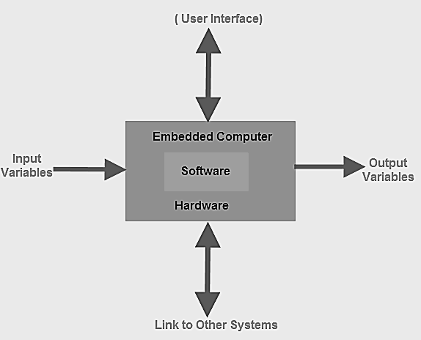
Fig 1.3 Embedded System
Embedded System Classification
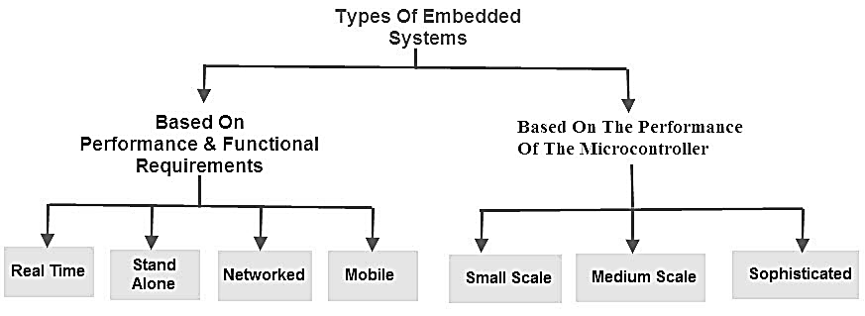
Fig 1.4 Types of Embedded Systems

Embedded systems are primarily classified into different types based on complexity of hardware & software and microcontroller (8 or 16 or 32-bit) as shown in Fig 1.4. Thus, based on the performance of the microcontroller, embedded systems are classified into three types such as:
- Small scale embedded systems
- Medium scale embedded systems
- Sophisticated embedded systems

Further, based on performance and functional requirements of the system embedded system classified into four types such as:
- Real time embedded systems
- Standalone embedded systems
- Networked embedded systems
- Mobile embedded systems

CHAPTER 2
LITERATURE REVIEW
- TITLE: Spatial-Spectral Image Classification with Edge Preserving Method
AUTHOR: S Merugu, A Tiwari, and SK Sharma
YEAR: 2020
DESCRIPTION: Spatial-spectral image classification is vital in remote sensing, especially for analyzing multispectral and hyperspectral images that combine spatial and spectral information. A major challenge is preserving object boundaries, as traditional methods often blur edges, leading to misclassification. Edge-preserving techniques address this by smoothing regions while retaining sharp edges, which is crucial for accurate classification in applications like land cover mapping and urban monitoring. By integrating spatial and spectral data, these methods enhance classification accuracy and provide clearer insights into environmental, agricultural, and urban features[1].
- TITLE: Design and Comparative Analysis of On-Chip Sigma Delta ADC for Signal Processing Applications
AUTHOR: P.A.H. Vardhini and M.L. Makkena
YEAR: 2021
DESCRIPTION: This project involves the design and comparative analysis of an on-chip Sigma-Delta Analog-to-Digital Converter (ADC) for signal processing applications. Known for high resolution and noise shaping, Sigma-Delta ADCs are ideal for low-frequency signals. The goal is to develop a compact, power-efficient ADC and evaluate its performance in terms of SNR, THD, dynamic range, and power consumption. Key components like the modulator, integrators, quantizer, and digital filter are implemented using CMOS technology. Various modulator architectures are simulated to compare trade-offs in resolution, speed, area, and power. Simulations using industry-standard tools confirm suitability for applications like audio encoding, biomedical signals, and sensors. The study also explores circuit optimization for improved efficiency, highlighting the benefits of on-chip integration in reducing noise and supporting miniaturization[2].
- TITLE: Wind Energy in Smart Agriculture
AUTHOR: Xiang Li, Yuying Cao, Xin Yu
YEAR: 2022
DESCRIPTION: Li et al. (2022) present a novel method for wind energy harvesting in smart agriculture using triboelectric nanogenerators (TENGs). These devices convert mechanical wind energy into electricity through the triboelectric effect, making them ideal for powering IoT-based farming tools like sensors and irrigation systems, especially in off-grid or wind-rich areas. The study highlights how TENGs can reduce reliance on traditional energy sources, lower costs, and enhance the sustainability of agricultural practices by harnessing clean, renewable energy[3].
- TITLE: Sustainable Smart Farm Strategies
AUTHOR: Mincheol Jung, Jimin Kim, Handon Kim
YEAR: 2023
DESCRIPTION: Jung et al. (2023) explore market strategies that drive the success of sustainable smart farming ventures, focusing on factors like market demand, technological investment, and operational efficiency. Using a correlation and causal relationship approach, the study emphasizes how early adoption of technologies such as IoT, AI, and robotics gives farmers a competitive edge. It also highlights the growing consumer demand for sustainably produced food, which is reshaping farming practices. Smart farming-enabled by real-time monitoring, AI-driven decisions, and automation-boosts productivity, reduces waste, and supports environmental sustainability. The study concludes that adopting these technologies is essential, not optional, for farmers aiming to stay competitive in today’s evolving agricultural landscape[4].
- TITLE: Blockchain for IoT-enabled Agricultural Supply Chains
AUTHOR: Ali Hamidoglu, Omer Melih Gul, Seifedine Nimer Kadry
YEAR: 2024
DESCRIPTION: Hamidoglu et al. (2024) examine the adoption of blockchain in IoT-enabled agricultural supply chains, highlighting its potential to enhance transparency, security, and efficiency. Using a game-theoretical approach, the study explores how government-backed initiatives can encourage stakeholder adoption, leading to more sustainable and reliable supply chains. By integrating IoT sensors with blockchain’s decentralized and immutable ledger, real-time data on crop growth, transportation, and storage can be securely tracked. This improves food traceability, reduces waste, and ensures product authenticity. The study emphasizes blockchain’s role in preventing fraud and increasing trust among farmers, suppliers, retailers, and consumers through transparent record-keeping across the supply chain[5].

CHAPTER 3
EXISTING SYSTEM
Existing systems in agriculture for crop health management and resource utilization rely heavily on traditional methods and partially automated tools that lack adaptability and integration. Farmers still depend largely on experience and manual labor to manage irrigation, fertilizer, and pest control, often resulting in inefficient resource use, increased costs, and inconsistent yields due to environmental variability and human error.
While some farms use irrigation timers, moisture sensors, or basic greenhouse automation, these systems typically function in isolation and aren't responsive to real-time soil or weather data. Fertilizer application is often based on generic seasonal guidelines rather than data-driven insights, leading to nutrient imbalances that affect crop health and soil quality.
Disease detection still relies mainly on visual inspection, which is subjective and error-prone. Though mobile apps exist, many lack accuracy, require internet connectivity, and don't offer integrated treatment solutions. AI and machine learning are underutilized, and advanced drone-based systems, though effective, remain inaccessible to small-scale farmers due to high costs and technical complexity.
Data collection is fragmented. External weather stations don’t capture field-specific conditions, and manual soil testing only gives static data. IoT devices are emerging but often focus on isolated parameters without offering actionable insights or integration with automated systems, limiting their effectiveness.
Usability and interoperability are also major issues. Complex interfaces, language barriers, and the need for multiple tools deter adoption. In countries like India, where agriculture sustains a large population, affordable, integrated, and intelligent systems are urgently needed. However, initiatives often falter due to high costs, poor connectivity, and lack of technical support.
In summary, current systems are manual, fragmented, and lack real-time intelligence and automation. They fail to address modern challenges like climate change, water scarcity, and the demand for higher productivity. There’s a critical need for affordable, integrated solutions that combine real-time sensing, intelligent analysis, and automation to support sustainable, data-driven agriculture. The proposed project seeks to fill this gap and transform traditional farming practices.
DISADVANTAGE
- Manual Labor Dependency – Most tasks like irrigation, fertilization, and disease detection are done manually, which is time-consuming and labor-intensive.
- Inefficient Resource Use – Water and fertilizers are often overused or underused due to a lack of real-time monitoring, leading to waste and poor crop health.
- Delayed Disease Detection - Crop diseases are usually identified by visual inspection, which can be inaccurate and too late to prevent damage.
- Lack of Real-Time Data - Environmental and soil data are not continuously monitored, causing delayed responses to changes in conditions.
- No Automation - Most systems are not automated, so farmers must constantly monitor and operate equipment themselves.
- Limited Use of Technology - Existing systems rarely use AI or machine learning for intelligent decision-making or predictions.

CHAPTER 4
PROPOSED SYSTEM
The proposed system is a smart, integrated platform designed to optimize crop health and resource use through automation and machine learning, with a focus on rice farming. The hardware includes sensors for soil moisture, temperature, and water levels in irrigation tanks, connected to an ESP32 microcontroller for data processing and control. This system automates irrigation based on real-time soil moisture and triggers fertilizer application when specific environmental conditions are met, minimizing waste and ensuring optimal plant nutrition.
The software component utilizes machine learning, particularly You Only Look Once (YOLO) to detect common rice crop diseases through images of leaves. Once a disease is identified, the system recommends tailored fertilizer treatments based on expert knowledge, providing actionable insights through a mobile or web app. Additionally, farmers receive real-time alerts on crop health, irrigation status, and system performance, ensuring timely intervention.
Cloud computing and IoT integration enable efficient data storage and analysis. The cloud server tracks environmental conditions, irrigation patterns, and disease trends, offering predictive insights, such as forecasting disease outbreaks. This data also refines machine learning models to improve disease detection and treatment recommendations over time. The system’s solar-powered operation ensures reliability in remote areas, and its weatherproof design makes it durable for outdoor environments.
The user interface is simple and multilingual, allowing farmers, even those with limited technical knowledge, to control and monitor the system. It supports manual overrides, scheduling, and access to historical data. The modular and scalable design of the system ensures it can be adapted to various crop types and field sizes, enabling farmers to adopt proactive, data-driven agricultural practices that improve yield, conserve resources, and support sustainability.
  - BLOCK DIAGRAM
The block diagram of the proposed system is shown below:
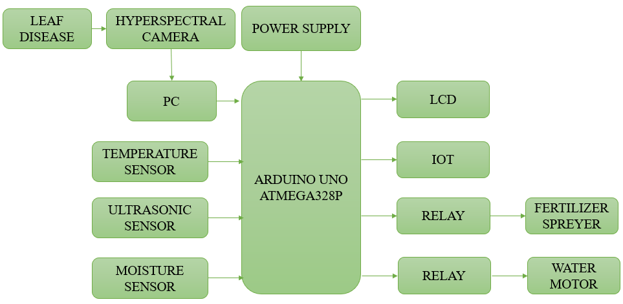
Fig 4.1 Block Diagram
EXPLANATION
The system is designed to optimize crop health management by integrating multiple components that work seamlessly to monitor environmental conditions and automate agricultural processes. The core of the system includes an LCD display for real-time monitoring of key parameters such as temperature, soil moisture, and leaf health. A temperature sensor and moisture sensor are deployed in the field to continuously measure the ambient temperature and soil moisture levels. These sensors provide vital data that helps assess whether crops are receiving adequate water and if the temperature is within optimal growing conditions. If the moisture level falls below a preset threshold, the system triggers the water motor via a relay to activate the irrigation system, ensuring that crops receive the required amount of water as shown in Fig 4.1.
In addition to these environmental sensors, an ultrasonic sensor is used for distance measurement, potentially for monitoring water levels in irrigation tanks or assessing the height of the crops. These sensors all feed into an IoT-enabled platform, allowing the collected data to be sent to a cloud server for analysis and remote monitoring. A machine learning algorithm processes the data to analyze crop health, particularly focusing on detecting leaf diseases. If a disease is detected on the rice leaves, the system automatically suggests specific fertilizer treatments. The relay system manages the activation of the water motor, while the IoT platform provides real-time feedback and control via a mobile or web interface, making the system fully automated, responsive, and optimized for resource-efficient farming.
  - CIRCUIT DIAGRAM
The circuit diagram of the proposed system is shown below:

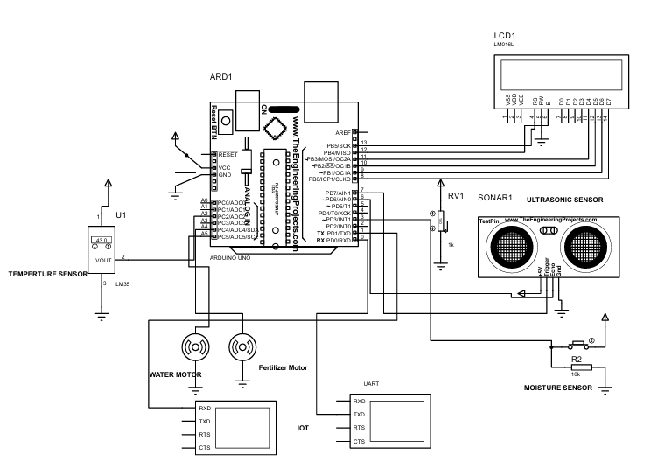
Fig 4.2 Circuit Diagram
EXPLANATION
The circuit diagram for this crop health management system includes several key components, each connected to the Arduino for seamless operation. The LCD display is connected to the Arduino on pins 8 to 13, allowing the user to monitor real-time environmental data such as temperature, soil moisture, and disease detection on the rice leaves. The temperature sensor is connected to A2, enabling the system to continuously measure the ambient temperature of the environment, which plays a critical role in crop growth and health as shown in Fig 4.2.
The ultrasonic sensor, which is essential for measuring water levels or the height of crops, is connected to A6 and A7. These pins are used to send and receive the ultrasonic waves, helping to detect changes in the surrounding environment. The soil moisture sensor is connected to A4, which measures the moisture content in the soil to determine when irrigation is needed. When the moisture level drops below a predefined threshold, the system activates the water motor via pin A4. The water motor is triggered through a relay that is responsible for controlling the water delivery to the crops.
Similarly, the fertilizer motor is connected to A5, and when the system detects a nutrient deficiency or identifies a disease in the crops, it automatically activates the fertilizer motor through a relay to apply the necessary fertilizer. All these components work in tandem to automate and optimize the irrigation and fertilization processes, ensuring that the crops receive the proper care based on real-time data. This system is fully integrated with an IoT platform, allowing remote monitoring and control, further enhancing the automation and efficiency of the agricultural process.

CHAPTER 5
HARDWARE REQUIREMENTS
  - ARDUINO UNO
The Arduino UNO is an open-source microcontroller board based on the Microchip ATmega328P and developed by Arduino.cc. It features 14 digital I/O pins, 6 analog inputs, and is programmable via the Arduino IDE using a USB type B cable. It can be powered through USB or a 9V battery, with voltage support ranging from 7 to 20V. The Uno differs from earlier boards by replacing the FTDI USB-to-serial chip with an ATmega16U2 (or ATmega8U2 in earlier versions) as a USB-to-serial converter. It comes preloaded with a bootloader that allows code uploads without external programmers as shown in Fig 5.1. "Uno," meaning "one" in Italian, marks the release of Arduino IDE 1.0 and serves as the reference board for the Arduino platform. Arduino originated at the Interaction Design Institute Ivrea in Italy, aiming to create affordable tools for digital design. In 2003, Hernando Barragán developed Wiring as a Master’s thesis, which inspired Massimo Banzi and others to fork the project into what became Arduino. Early Arduino boards used ATmega168 microcontrollers and FTDI chips before evolving into the more capable Uno model with ATmega328P and USB support via ATmega16U2.
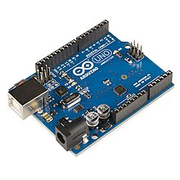
Fig 5.1 Arduino UNO
COMMUNICATION
The Arduino/Genuino Uno has a number of facilities for communicating with a computer, another Arduino/Genuino board, or other microcontrollers. The ATmega328 provides UART TTL (5V) serial communication, which is available on digital pins 0 (RX) and 1 (TX). An ATmega16U2 on the board channels this serial communication over USB and appears as a virtual com port to software on the computer. The 16U2 firmware uses the standard USB COM drivers, and no external driver is needed. However, on Windows, a .inf file is required. The Arduino Software (IDE) includes a serial monitor which allows simple textual data to be sent to and from the board. The RX and TX LEDs on the board will flash when data is being transmitted via the USB-to-serial chip and USB connection to the computer (but not for serial communication on pins 0 and 1). A Software Serial library allows serial communication on any of the Uno's digital pins.
  - POWER SUPPLY
The 7812 and 7805 voltage regulators are commonly used components to provide stable DC voltage outputs of +12V and +5V, respectively, from a higher input voltage source. These regulators are essential for powering microcontrollers, sensors, and other electronics that require specific voltage levels. The 7812 provides +12V output, suitable for motor drivers or relays, while the 7805 supplies +5V, ideal for logic circuits as shown in Fig 5.2. Both include internal current limiting and thermal shutdown features for protection. The heat sink attached to the 7805 helps dissipate heat during operation. This board simplifies multi-voltage power supply setups in embedded systems.
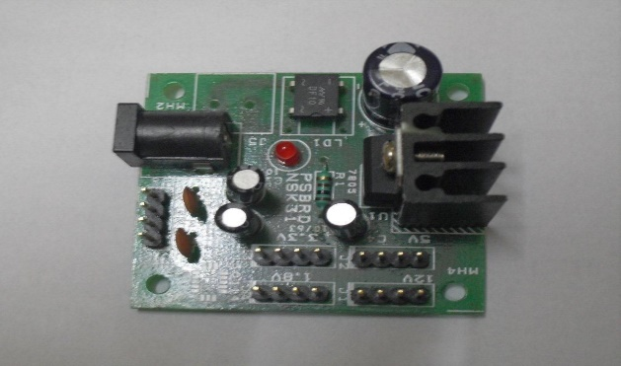
Fig 5.2 Power Supply Circuit Board
  - MOISTURE SENSOR
A moisture sensor, also known as a soil moisture sensor, is a device designed to measure the water content in soil. It's widely used in agriculture, gardening, and environmental monitoring to ensure optimal soil moisture levels for plants as shown in Fig 5.3.
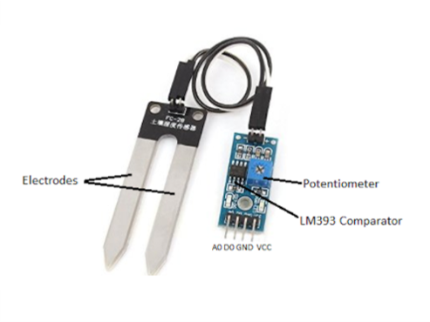
Fig 5.3 Moisture Sensor
Key Features
- Measurement Range: Typically measures soil moisture from dry to saturated conditions, providing information on soil water availability.
- Accuracy: Provides accurate readings of soil moisture levels, helping optimize irrigation schedules and water management.
- Response Time: Offers fast response times to changes in soil moisture, enabling real-time monitoring and adjustments.
- Durability: Designed to withstand outdoor conditions and long-term exposure to soil and moisture.
- Integration: Can be integrated with microcontrollers or data loggers to automate irrigation systems or monitor soil conditions remotely.

  - WATER MOTOR
To control a micro DC submersible pump, which operates typically in the range of 6-9V DC, with an Arduino or any microcontroller, you need to ensure that the controller can handle the current requirements of the pump and that the electrical connections are made safely, especially if it's being used in water as shown in Fig 5.4.
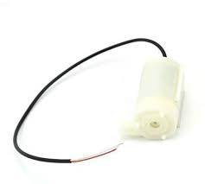
Fig 5.4 Water Motor
  - ULTRASONIC SENSOR
An ultrasonic sensor measures distance by sending sound waves and calculating the time they take to reflect back after hitting an object. In a Smart Waste Management System, it is used to monitor the waste level in a dustbin. The sensor emits a pulse through the Trig pin, and the Echo pin detects the reflected wave. Using the time taken and the speed of sound (343 m/s), the distance to the waste is calculated as shown in Fig 5.5. This data is sent to an Arduino, which can trigger a servo motor to open the lid or display the level on an LCD. The sensor has four main pins: VCC, Trig, Echo, and GND. It helps prevent bin overflow by ensuring timely waste collection.
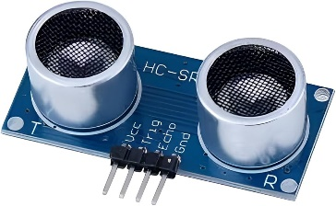
Fig 5.5 Ultrasonic Sensor
  - RELAY
A relay is an electrically operated switch that allows low-power electronic circuits, like those from a microcontroller, to control high-voltage or high-current devices. The 5V relay module shown in the image includes a SRD-05VDC-SL-C relay, which operates on a 5V control signal. The input header is where the control signal is applied, typically from an Arduino or other controller. When activated, the switching transistor boosts the signal to energize the relay coil as shown in Fig 5.6. The freewheeling diode is used to protect the transistor from voltage spikes generated when the coil is switched off. The status LED indicates when the relay is active, while the power LED shows that the module is powered. The output terminal allows connection to external high-power devices such as motors or lights. This setup makes it easy to safely control heavy loads using small electronic circuits.
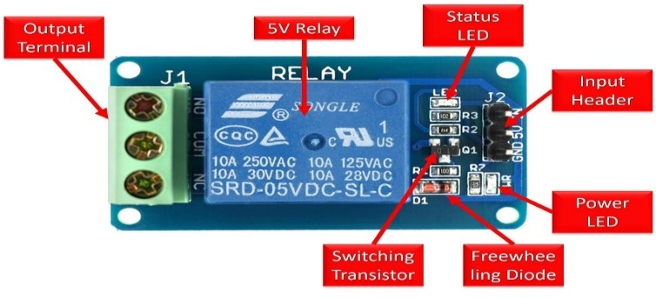
Fig 5.6 Relay Module
  - LIQUID CRYSTAL DISPLAY
An LCD (Liquid Crystal Display) is a flat-panel electronic display that uses liquid crystals to modulate light. Unlike direct light-emitting displays, LCDs require an external light source. They can display arbitrary images or fixed content like digits and preset words. LCDs are commonly used in devices like computer monitors, televisions, clocks, calculators, and phones, replacing older CRT displays. They are cost-effective and easy to interface with microcontrollers, such as Arduino, thanks to standard embedded controllers like HD 44780. LCDs do not suffer from image burn-in but can experience image persistence as shown in Fig 5.6.
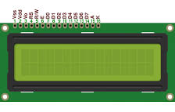
Fig 5.7 LCD Display Unit

CHAPTER 6
SOFTWARE REQUIREMENTS
  - PyCharm (Python IDE)
Purpose and Role:
PyCharm is used to develop and run Python scripts that process the data sent from Arduino. It handles real-time data processing, image recognition, and triggers alerts based on AI models.
Data Handling and Processing:
Using libraries like pyserial, Python receives sensor data from Arduino. The data is cleaned and analyzed to detect patterns or unusual activity like animal presence or possible collisions on the track.
AI and Deep Learning:
PyCharm enables the use of AI techniques like Deep Neural Networks (DNNs) for animal detection. With libraries like TensorFlow and OpenCV, the system can analyze live images or video feeds to identify animals near railway tracks.
Alert and Cloud Integration:
Python scripts in PyCharm can send alerts via email, SMS, or even cloud APIs using smtplib, requests, or Firebase. This provides real-time notifications to train operators or central control systems when potential dangers are detected.
  - ARDUINO IDE
Purpose and Role:
The Arduino IDE is used to write, compile, and upload code to the Arduino Nano microcontroller. It serves as the main environment for controlling the hardware components like sensors, buzzers, and GSM modules in the project as shown in Fig 6.2.
Programming and Libraries:
Coding is done in C/C++ within the Arduino IDE. Key libraries such as IRremote, Ultrasonic, and SoftwareSerial are used to handle sensor inputs and communication modules effectively. These libraries help the Arduino read values from the track and send data accordingly.
Sensor Integration:
IR sensors detect objects on the track, ultrasonic sensors measure distances, and buzzers provide alerts. All these components are programmed and controlled using the Arduino Nano through the Arduino IDE, making real-time decisions based on sensor data.
Communication with Python:
The Arduino sends collected sensor data via serial communication (USB cable) to a computer or Raspberry Pi. This data is then received by Python for further analysis, making Arduino IDE the first stage in the overall detection and alert system.
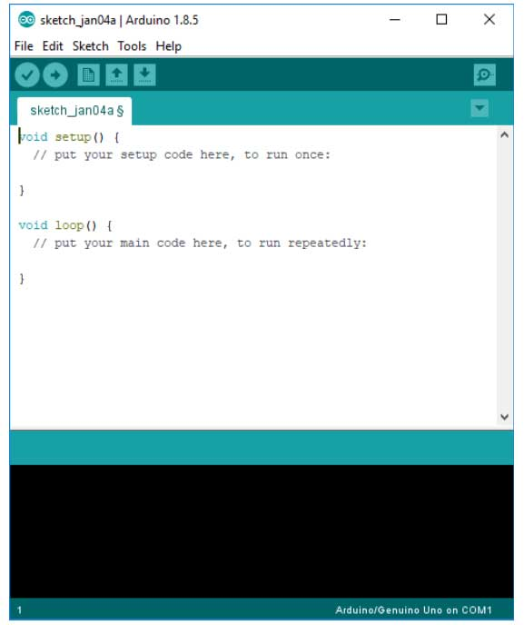
Fig 6.2 Arduino IDE
  - ARDUINO IOT CLOUD
Arduino IoT Cloud is a user-friendly platform that simplifies the development and management of IoT applications. It allows users to connect Arduino and compatible boards, monitor sensor data, and control devices remotely through custom dashboards. With its no-code or low-code design, beginners can easily build projects, while advanced users benefit from its powerful tools and integrations. The platform supports programming via the cloud using the Arduino Web Editor and provides real-time data visualization through widgets like gauges and sliders. It ensures secure communication with encrypted connections and authenticated devices. Arduino IoT Cloud also integrates with services like Alexa and Google Assistant for voice control and offers mobile access for on-the-go monitoring. Its scalability and ease of use make it ideal for both small personal projects and large-scale applications in fields like agriculture, automation, and education.

CHAPTER 7
RESULTS AND DISCUSSION
The project demonstrates the impact of integrating automation and machine learning on crop health and resource use. Real-time environmental and soil monitoring improved irrigation and fertilizer efficiency. By tracking water levels, temperature, and moisture, the system optimizes water and fertilizer delivery, ensuring optimal growth while minimizing waste. This reduces consumption and supports sustainability in modern farming, addressing resource scarcity as shown in Fig 7.1.
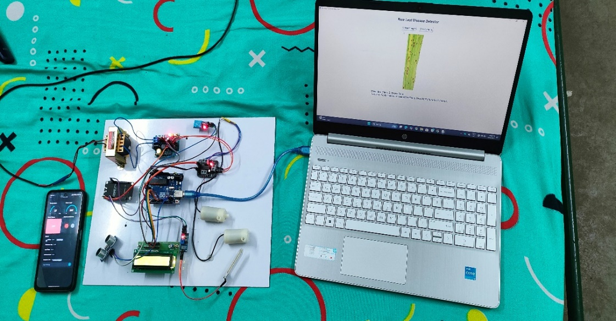
Fig 7.1 Result of the Proposed System
The machine learning component of the system has proven effective in identifying diseases in rice leaves at early stages. By analyzing visual data from sensors, the system is capable of detecting specific disease patterns and providing timely recommendations for tailored fertilizer treatments. This aspect of the project has been pivotal in preventing the spread of diseases, thereby reducing the need for broad-spectrum pesticide applications and supporting more eco-friendly farming practices. The machine learning algorithms demonstrated high accuracy in diagnosing disease types and recommending appropriate interventions, which contributed to improved crop yield and reduced overall chemical usage as shown in Fig 7.2.
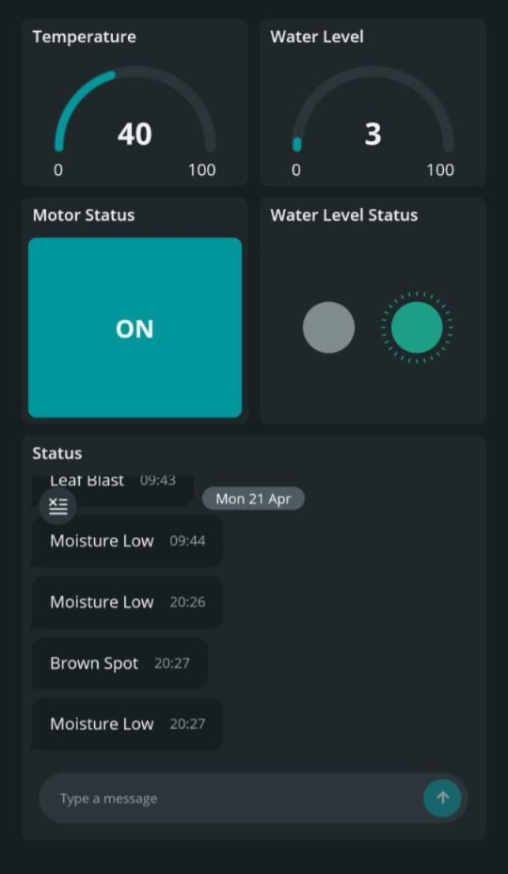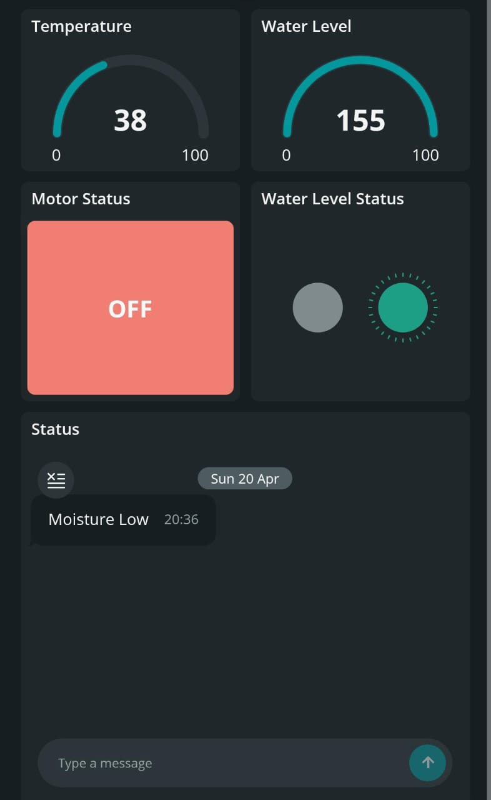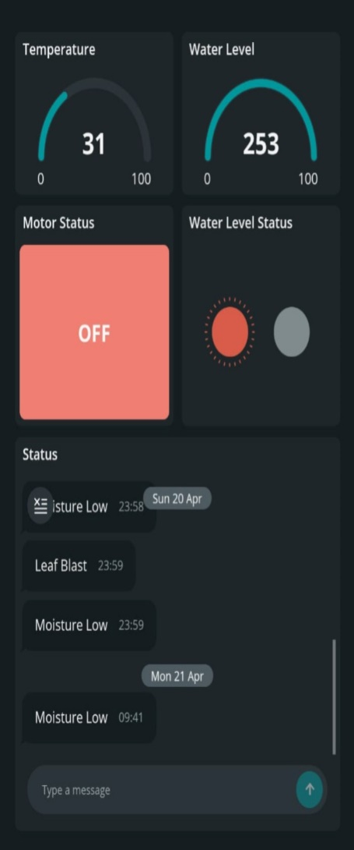
Fig 7.2 Performance Monitoring & Disease Detection Status
The proposed smart agriculture system was tested under controlled conditions to evaluate its performance in automating irrigation, fertilization, and disease detection in rice crops. It effectively monitored soil moisture, water levels, temperature, and plant health using real-time sensor data. The machine learning model accurately detected plant diseases, while the system successfully triggered irrigation and fertilizer application as needed. Real-time analytics and automation reduced the need for manual intervention, lowering labor costs and improving efficiency. Overall, the system demonstrated its potential to optimize resource use, enhance crop health, and support sustainable farming practices
Irrigation and Fertilization Automation
The irrigation system was automated to activate the water pump when soil moisture dropped below the threshold, ensuring optimal hydration. Similarly, the fertilizer sprayer was triggered based on disease detection results, providing targeted care. This approach minimized water and fertilizer waste while enhancing crop health. The table 7.1 summarizes the key results.
Table 7.1 Result Analysis
Parameter | Value (Test 1) | Value (Test 2) | Average Value | Action Taken
Soil Moisture Level (%) | 35% | 28% | 31.50% | Irrigation Triggered
Water Level in Tank (cm) | 50 cm | 60 cm | 55 cm | No Action
Temperature (°C) | 29°C | 30°C | 29.5°C | No Action
Disease Detection Accuracy (%) | 92% | 91% | 91.50% | Pesticide Spraying Triggered
Fertilizer Triggered | Yes | Yes | Yes | Fertilizer Applied

Disease Detection
The machine learning model was able to detect rice leaf diseases with high accuracy. Using a You Only Look Once (YOLO) the system classified the rice leaves as either healthy or diseased. When the system detected a disease, it alerted the user and recommended appropriate actions, such as pesticide application. The detection accuracy was evaluated against a dataset of rice leaf images, and the model was found to have an accuracy rate of over 90%, demonstrating its reliability in disease recognition.
Data Communication and Monitoring
The system successfully transmitted real-time data, including soil moisture, temperature, water levels, and disease alerts, to an LCD display and IoT-enabled mobile app. The farmers could remotely monitor the system's performance and receive notifications, allowing them to make informed decisions. The IoT integration enhanced user experience and improved operational efficiency by enabling remote control and monitoring.

CHAPTER 8
CONCLUSION AND FUTURE WORK
  - CONCLUSION
In conclusion, this project exemplifies the transformative potential of integrating advanced technology into modern agricultural practices for sustainable crop management. By combining intelligent automation with real-time data analytics, the system offers a holistic approach to crop health management and resource optimization. The hardware component automates irrigation and fertilizer application based on real-time conditions, minimizing waste and enhancing resource utilization efficiency. The incorporation of machine learning techniques to detect diseases in rice leaves allows for timely identification and targeted treatments. The system’s ability to provide customized fertilizer recommendations promotes effective treatment and optimized crop yield. This project reduces the need for excessive human intervention and supports data-driven decision-making, ensuring more informed management of agricultural resources. By focusing on sustainable practices, the system aligns with the growing demand for solutions that reduce environmental impact and promote resource conservation. The implementation of smart farming techniques holds the promise of revolutionizing the agriculture sector, offering farmers tools to address challenges related to climate change, soil degradation, and resource scarcity. Overall, this system represents a significant step toward the future of agriculture, where technology plays an integral role in ensuring food security, improving crop health, and fostering long-term sustainability.

  - FUTURE WORK
Future enhancements to this crop health management system could focus on expanding its capabilities and improving efficiency and scalability. One significant advancement would be integrating more diverse sensor technologies to monitor additional environmental factors such as humidity, light intensity, and soil pH, providing more comprehensive insights into crop health. Incorporating weather forecasting data would enable predictive analytics, allowing farmers to adjust irrigation and fertilizer schedules in anticipation of weather changes, optimizing resource use.
Another enhancement could be the incorporation of IoT-based remote monitoring and control features, allowing farmers to interact with the system in real-time via a mobile app or web interface. Integrating drones equipped with high-resolution cameras could enhance the system's ability to monitor crop health and detect disease, providing real-time visual data for more accurate analysis.
The machine learning models used to detect diseases and recommend fertilizers could also be improved by incorporating a wider variety of crop species and diseases, making the system adaptable to different crops and regions. As the system collects more data over time, it could evolve through continuous learning, improving accuracy and recommendations. Lastly, incorporating blockchain technology could improve data transparency and security, enabling farmers to track their system usage, inputs, and outcomes while facilitating data sharing among farming communities.

APPENDICES
Arduino Code
- #include<LiquidCrystal.h>
LiquidCrystal lcd(13,12,11,10,9,8);
#include <Adafruit_Sensor.h>
#include "DHT.h"
#define DHTPIN A5 // what pin we're connected to
#define DHTTYPE DHT11 // DHT 11
int t;
DHT dht(DHTPIN, DHTTYPE);

///////////////////////////////////
const int trigPin = 7;
const int echoPin = 6;
long duration;
int d, distanceInch;
int A,B,Y;
void setup()
{
Serial.begin(9600);
lcd.begin(16,2);
lcd.setCursor(0, 0);
lcd.print(" Smart Plant ");
lcd.setCursor(0, 1);
lcd.print("Disease usingIOT");
delay(3000);
lcd.clear();
dht.begin();
pinMode(trigPin, OUTPUT);
pinMode(echoPin, INPUT);
pinMode(2,OUTPUT);// water motor
pinMode(4,OUTPUT);// Sparyer motor
pinMode(A5,INPUT); //temperature
pinMode(A0,INPUT); //Moisture
digitalWrite(2,LOW);
digitalWrite(4,LOW);
}
void loop()
{
if(Serial.available() > 0) {
char a = Serial.read();
// lcd.clear(); // Clear the previous message
if(a == 'A') {
Serial.print('R');
delay(100);
digitalWrite(4,HIGH);
lcd.setCursor(0, 0);
lcd.print("Bact.Leaf Blight");
delay(4000);
digitalWrite(4,LOW);
}
if(a == 'B')
{
digitalWrite(4,HIGH);
lcd.setCursor(0, 0);
lcd.print(" Brown Spot ");
Serial.print('B');
delay(100);
delay(4000);
digitalWrite(4,LOW);
}
if(a == 'C')
{
digitalWrite(4,LOW);
lcd.setCursor(0, 0);
lcd.print(" Healthy ");
Serial.print('C');
delay(100);
}
if(a == 'D')
{
digitalWrite(4,HIGH);
lcd.setCursor(0, 0);
lcd.print(" Leaf Blast ");
Serial.print('Q');
delay(100);
delay(4000);
digitalWrite(4,LOW);
}
if(a == 'E')
{
digitalWrite(4,HIGH);
lcd.setCursor(0, 0);
lcd.print(" Leaf Blight ");
Serial.print('E');
delay(100);
delay(4000);
digitalWrite(4,LOW);
}
if(a == 'F')
{
digitalWrite(4,HIGH);
lcd.setCursor(0, 0);
lcd.print(" Leaf Scald ");
Serial.print('F');
delay(100);
delay(4000);
digitalWrite(4,LOW);
}
if(a == 'G')
{
digitalWrite(4,HIGH);
lcd.setCursor(0, 0);
lcd.print(" Leaf Smut ");
Serial.print('G');
delay(100);
delay(4000);
digitalWrite(4,LOW);
}
if(a == 'H')
{
digitalWrite(4,HIGH);
lcd.setCursor(0, 0);
lcd.print("Narrow BrownSpot");
Serial.print('H');
delay(100);
delay(4000);
digitalWrite(4,LOW);
}
delay(100);
}
if((A==1) && (B==1) && (Y==1))
{
digitalWrite(2,HIGH);
Serial.print('M');
delay(700);
}
else
{
digitalWrite(2,LOW);
Serial.print('m');
delay(700);
}
int m=digitalRead(A0);
if (m==LOW)
{
lcd.setCursor(6,1);
lcd.print("MH");
Y=0;
Serial.print("y");
delay(700);
}
else
{
lcd.setCursor(6,1);
lcd.print("ML");
Y=1;
Serial.print("Y");
delay(700);
}
dht11();

digitalWrite(trigPin, LOW);
delayMicroseconds(2);
digitalWrite(trigPin, HIGH);
delayMicroseconds(10);
digitalWrite(trigPin, LOW);
duration = pulseIn(echoPin, HIGH);
d = duration*0.034/2;
lcd.setCursor(13,1);
lcd.print(d);
lcd.print(' ');
Serial.print('D');
Serial.print(d);
delay(700);
if (d <5)
{
lcd.setCursor(9,1);
lcd.print("W_H:");
B=1;
Serial.print("Z");
delay(700);
}
else
{
B=0;
lcd.setCursor(9,1);
lcd.print("W_L:");

Serial.print("z");
delay(700);
}
}
void dht11()
{
int h = dht.readHumidity();
t = dht.readTemperature();
float f = dht.readTemperature(true);

if (isnan(h) || isnan(t) || isnan(f))
{
//Serial.println("Failed to read from DHT sensor!");
return;
}
lcd.setCursor(0,1);
lcd.print("T:");
lcd.setCursor(2,1);
lcd.print(t);
Serial.print('T');
Serial.print(t);
delay(700);
if(t > 38)
{
lcd.setCursor(4,1);
lcd.print("H");
A=1;
}
else
{
lcd.setCursor(4,1);
lcd.print("L");
A=0;
}
}

- #include <ArduinoIoTCloud.h>
#include <Arduino_ConnectionHandler.h>
#include <Arduino_DebugUtils.h>
#include <Wire.h>
#include <ArduinoMqttClient.h>
const char DEVICE_LOGIN_NAME[] = "2f269604-9ce6-4dcb-b546-1849022086e2";
const char SSID[] = "projectiot"; // WiFi Network SSID
const char PASS[] = "123456789"; // WiFi Password
const char DEVICE_KEY[] = "eQY4Ny6W8tHQd!DdGm2YHQb?y"; // Secret Device Key
void onStatusChange();
void onTempChange();
void onWlChange();
void onMotorStatusChange();
void onWaterLevelStatusChange();
String status;
int temp;
int wl;
bool motorStatus;
bool waterLevelStatus;

unsigned long lastUpdateTime = 0;
const unsigned long updateInterval = 1000; // 1 second
void initProperties(){
ArduinoCloud.setBoardId(DEVICE_LOGIN_NAME);
ArduinoCloud.setSecretDeviceKey(DEVICE_KEY);
ArduinoCloud.addProperty(status, READWRITE, ON_CHANGE, onStatusChange);
ArduinoCloud.addProperty(temp, READWRITE, ON_CHANGE, onTempChange);
ArduinoCloud.addProperty(wl, READWRITE, ON_CHANGE, onWlChange);
ArduinoCloud.addProperty(motorStatus, READWRITE, ON_CHANGE, onMotorStatusChange);
ArduinoCloud.addProperty(waterLevelStatus, READWRITE, ON_CHANGE, onWaterLevelStatusChange);
}
WiFiConnectionHandler ArduinoIoTPreferredConnection(SSID, PASS);
void setup() {
Serial.begin(9600);
initProperties();
ArduinoCloud.begin(ArduinoIoTPreferredConnection);
setDebugMessageLevel(2);
ArduinoCloud.printDebugInfo();
delay(1000); // Wait for 1 seconds
}
void loop() {
unsigned long currentMillis = millis();
// Update cloud at set intervals
if (currentMillis - lastUpdateTime >= updateInterval) {
ArduinoCloud.update();
lastUpdateTime = currentMillis;
}
if(Serial.available() > 0) {
char a = Serial.read();
switch (a) {
case 'T':temp = Serial.parseInt();
break;
case 'D': wl=Serial.parseInt();
break;
case 'Z': waterLevelStatus=true;
break;
case 'z':waterLevelStatus=false;
break;
case 'M': motorStatus=true;
break;
case 'm' : motorStatus=false;
break;
case 'Y' : status = "Moisture Low";
break;
case 'y' : status = "Moisture High";
break;
case 'R' : status = "Bact.Leaf Blight";
break;
case 'B': status = "Brown Spot";
break;
case 'C': status = "Healthy";
break;
case 'Q':status = "Leaf Blast";
break;
case 'E': status = "Leaf Blight";
break;
case 'F':status = "Leaf Scald";
break;
case 'G': status = "Leaf Smut";
break;
case 'H': status = "Narrow BrownSpot";
break;
}
delay(100);
}
}
void onTempChange() {}
void onWlChange() {}
void onMotorStatusChange() {}
void onStatusChange() {}
void onWaterLevelStatusChange() {}

Python Code
import tkinter as tk
from tkinter import filedialog
from PIL import Image, ImageTk
import numpy as np
import tensorflow as tf
import cv2
import serial
import time

# Load the trained model
model = tf.keras.models.load_model('yolo.h5')
# Define image size
img_height, img_width = 224, 224
# Define class labels with serial mapping
class_labels = {
'A': 'Bacterial Leaf Blight',
'B': 'Brown Spot',
'C': 'Healthy',
'D': 'Leaf Blast',
'E': 'Leaf Blight',
'F': 'Leaf Scald',
'G': 'Leaf Smut',
'H': 'Narrow Brown Spot'
}
# Fertilizer suggestions for each disease
fertilizer_suggestions = {
'A': 'Use Nitrogen-rich fertilizer like Urea (46% N). Apply during early stages.',
'B': 'Apply Potassium-based fertilizers. Use MOP (Muriate of Potash).',
'C': 'No fertilizer needed. Plant is healthy.',
'D': 'Use balanced NPK (10-26-26) to boost resistance.',
'E': 'Spray Zinc Sulfate and apply compost to improve soil health.',
'F': 'Use Phosphorus fertilizers. DAP (18-46-0) is recommended.',
'G': 'Apply fungicide and avoid excess nitrogen. Use organic compost.',
'H': 'Use Potash and Phosphorous. Avoid excess water.'
}
# Initialize serial communication with Arduino (update COM port)
try:
arduino = serial.Serial(port="COM15", baudrate=9600, timeout=1)
time.sleep(2) # Allow connection to establish
print("Connected to Arduino")
except:
arduino = None
print("Arduino not found. Serial communication disabled.")
# Function to send detected class serial to Arduino
def send_to_arduino(serial_letter):
if arduino:
arduino.write(serial_letter.encode()) # Send as byte
print(f"Sent to Arduino: {serial_letter}")
# Function to predict the class of an image
def predict_image(img):
img = img.resize((img_width, img_height))
img_array = np.array(img) / 255.0 # Normalize
img_array = np.expand_dims(img_array, axis=0)
predictions = model.predict(img_array)
predicted_index = np.argmax(predictions)

# Get serial and class name
serial = list(class_labels.keys())[predicted_index]
predicted_class_name = class_labels[serial]
# Send to Arduino
send_to_arduino(serial)
# Get fertilizer suggestion
suggestion = fertilizer_suggestions.get(serial, "No suggestion available.")
return f"{serial}: {predicted_class_name}", suggestion
# Function to load image from file
def load_image():
file_path = filedialog.askopenfilename()
if not file_path:
return
img = Image.open(file_path)
predicted_result, suggestion = predict_image(img)
# Display image
img = img.resize((400, 400)) # Resize for display
img_tk = ImageTk.PhotoImage(img)
panel.config(image=img_tk)
panel.image = img_tk

# Update label with prediction and suggestion
result_label.config(text=f"Predicted Class: {predicted_result}\nFertilizer: {suggestion}")
# Function to capture image from webcam
def capture_image():
cap = cv2.VideoCapture(0) # Open webcam
if not cap.isOpened():
result_label.config(text="Error: Could not access webcam")
return
while True:
ret, frame = cap.read()
if not ret:
result_label.config(text="Error: Could not capture image")
break
# Display camera preview
cv2.imshow("Press SPACE to capture", frame)
key = cv2.waitKey(1) & 0xFF
if key == 32: # Space key to capture
break
cap.release()
cv2.destroyAllWindows()
# Convert frame to PIL image
frame = cv2.cvtColor(frame, cv2.COLOR_BGR2RGB)
img = Image.fromarray(frame)
predicted_result, suggestion = predict_image(img)
# Display image in GUI
img = img.resize((400, 400))
img_tk = ImageTk.PhotoImage(img)
panel.config(image=img_tk)
panel.image = img_tk
# Update label with prediction and suggestion
result_label.config(text=f"Predicted Class: {predicted_result}\nFertilizer: {suggestion}")
# Create GUI window
root = tk.Tk()
root.title("Rice Leaf Disease Classifier")
root.geometry("600x700") # Increased window size
# Heading label
heading_label = tk.Label(root, text="Rice Leaf Disease Detector", font=("Arial", 18, "bold"))
heading_label.pack(pady=10)

# Buttons for Upload and Camera
btn_frame = tk.Frame(root)
btn_frame.pack(pady=10)
upload_btn = tk.Button(btn_frame, text="Upload Image", command=load_image, font=("Arial", 12))
upload_btn.grid(row=0, column=0, padx=10)
camera_btn = tk.Button(btn_frame, text="Use Camera", command=capture_image, font=("Arial", 12))
camera_btn.grid(row=0, column=1, padx=10)
# Image display panel
panel = tk.Label(root)
panel.pack(pady=10)
# Prediction result label
result_label = tk.Label(root, text="Predicted Class: ", font=("Arial", 14), justify="left")
result_label.pack(pady=10)
# Run the GUI
root.mainloop()

REFERENCES
- E. S. Mohamed, A. A. Belal, S. K. Abd-Elmabod (2023). "Building an Automatic Irrigation Fertilization System for Smart Farm in Greenhouse." IEEE Transactions on Consumer Electronics, 70(2), 364–373.
- Jizhong Deng, Chang Yang, Kanghua Huang (2023). "Deep-Learning-Based Rice Disease and Insect Pest Detection on a Mobile Phone." Agronomy, 13(8), 2139.
- Bhosale, J. D., & Lomte, S. S. (2023). "Rice Crop Disease Detection Using Machine Learning Algorithms." In Computer Vision and Robotics (pp. 423–432). Springer.
- Tiwari, A., & Richhariya, P. (2023). "Harnessing Deep Learning for Timely Detection and Classification of Rice Leaf Diseases." International Journal of Innovations in Science, Engineering and Management, 2(3), 19–29.
- Ying Zhang, Xiaoyan Li, Yong Zhang (2025). "Rice Leaf Disease Identification and Classification Using Machine Learning Techniques: A Comprehensive Review." Engineering Applications of Artificial Intelligence, 139, 109639.
- Yara Ali Alnaggar, Ahmad Sebaq, Karim Amer "Rice Plant Disease Detection and Diagnosis Using Deep Convolutional Neural Networks and Multispectral Imaging." arXiv preprint arXiv:2309.05818.
- Sudhesh K. M, Sowmya V, Sainamole Kurian P (2023). "AI-Based Rice Leaf Disease Identification Enhanced by Dynamic Mode Decomposition." Engineering Applications of Artificial Intelligence, 105836.
- Jizhong Deng, Chang Yang, Kanghua Huang (2023). "Deep-Learning-Based Rice Disease and Insect Pest Detection on a Mobile Phone." Agronomy, 13(8), 2139.
- D. Chanchan, S. P. Nayse, L. M. Waghmare (2021). "A Cotton High-Efficiency Water-Fertilizer Control System Using Wireless Sensor Network for Precision Agriculture." Processes, 9(10), 1693.
- S. A. Alavi, A. Rahimian, K. Mehran (2018). "An IoT-Based Data Collection Platform for Situational Awareness-Centric Microgrids." In Proceedings of the IEEE Canadian Conference on Electrical and Computer Engineering (pp. 1–4). IEEE.
- V. Gezer, J. Um, M. Ruskowski (2017). "An Extensible Edge Computing Architecture: Definition, Requirements, and Enablers." In Proceedings of the 11th International Conference on Mobile Ubiquitous Computing, Systems, Services and Technologies (pp. 1–6). IEEE.
- Nawandar, N. K., & Satpute, V. (2019). "IoT-Based Intelligent Irrigation Support System for Smart Farming Applications." Advances in Distributed Computing and Artificial Intelligence Journal, 8(2), 73–85.
- E. S. Mohamed, A. A. Belal, S. K. Abd-Elmabod (2021). "Smart Farming for Improving Agricultural Management." Egyptian Journal of Remote Sensing and Space Science, 24(3), 971–981.
- J. H. Jeong, H. J. Kim, S. H. Lee (2019). "A Study on the Monitoring System of Growing Environment Department for Smart Farm." Journal of Korea Institute of Information, Electronics, and Communication Technology, 12(3), 290–298.
- D. D. Chaudhary, S. P. Nayse, L. M. Waghmare (2011). "Application of Wireless Sensor Networks for Greenhouse Parameter Control in Precision Agriculture." International Journal of Wireless and Mobile Networks, 3(1), 140–149.
- E. Navarro, J. González, J. Serrano (2020). "A Systematic Review of IoT Solutions for Smart Farming." Sensors, 20(15), 4231.
- X. Yang, Y. Zhang, L. Wang (2021). "A Survey on Smart Agriculture: Development Modes, Technologies, and Security and Privacy Challenges." IEEE/CAA Journal of Automatica Sinica, 8(2), 273–302.
- A. R. Al-Ali, A. Al-Nabulsi, S. Mukhopadhyay (2019). "IoT-Solar Energy Powered Smart Farm Irrigation System." Journal of Electronic Science and Technology, 17(4).
- P. Visconti, R. de Fazio, R. Velázquez (2020). "Development of Sensors-Based Agri-Food Traceability System Remotely Managed by a Software Platform for Optimized Farm Management." Sensors, 20(13), 3632.
- J. Choi, S. Lee, J. Park (2020). "Light Control Smart Farm Monitoring System with Reflector Control." In Proceedings of the 20th International Conference on Control, Automation, and Systems (pp. 69–74). IEEE.

