Required Resources for Python and Django

Python
- VS Code
- Python (latest version recommended)
- PIP (usually gets installed while installing Python)
- VS Code Extension:
- Code Runner
- Black Formatter
- Python
- Python Debugger
- Pylance
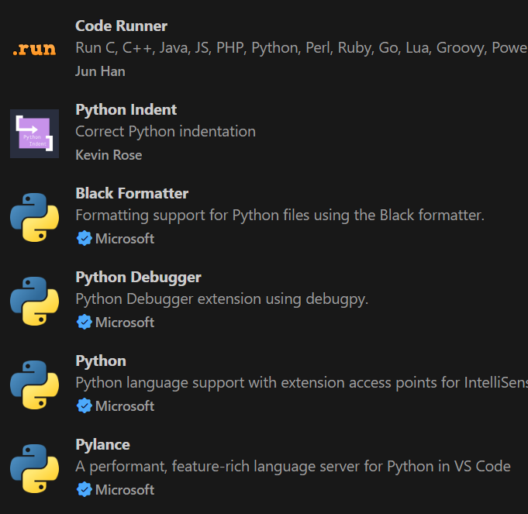

Django
- Virtualenv (should be installed and activated inside the project)
- Django (install after activating virtualenv)
- VS Code Extensions
- Django
- Django Template Support
- Djaneiro – Django Snippet
- SQLite Viewer

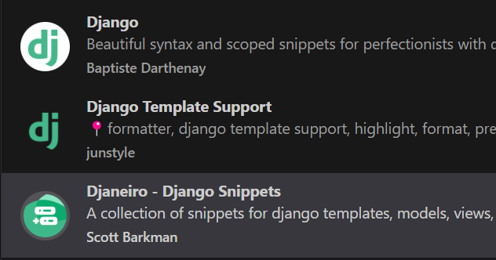

Additional Resources

Documentation
- Python: https://docs.python.org/3/
- Django: https://docs.djangoproject.com/en/5.2/
- Tailwind: https://v2.tailwindcss.com/docs

Mentor GitHub
- https://github.com/SumaniqueCode/SumaniqueCode

Mentors’ Reference Website
- https://www.sumanr.com.np/commands

