CMPG313 – Theory Assignment

Question 1 (Campus Navigation)

Formulate a search problem for a new student who needs to find the quickest route from the main entrance to the various departments on campus. [6]

Question 2 (Event Planning)

Devise a search problem for planning and scheduling campus events in a semester without conflicts. [6]

Question 3 (Library Book Retrieval)

Formulate a search problem for finding and retrieving a set of books from different sections of the university library. [6]

Question 4 (Solving Problems by Searching)

In the United States of America, companies like UPS, Federal Express, and the U.S. Postal Service are in the business of shipping parcels between many destinations. The problem for each individual parcel is finding the best path from the sender’s location to its destination. In the following sections, you must apply different search algorithms to solve a simplified parcel routing problem. The graph with the cities (nodes) to be considered is shown below. For each of the algorithms, you need to do the following:

- Mark the sequence in which the nodes are visited.
- Use the alphabetical order of the full names of the nodes (not their abbreviations) to determine the order in which successor nodes are examined.
- You can assume that your algorithms avoid cycles by not re-visiting previously inspected nodes.

- Traverse the graph from the starting point of San Luis Obispo to the goal of Austin according to the breadth-first search method. Draw the search tree for each iteration. [15]
- Traverse the graph from the starting point of San Luis Obispo to the goal Austin according to the iterative deepening depth-first search method. Draw the search tree for each iteration. [15]

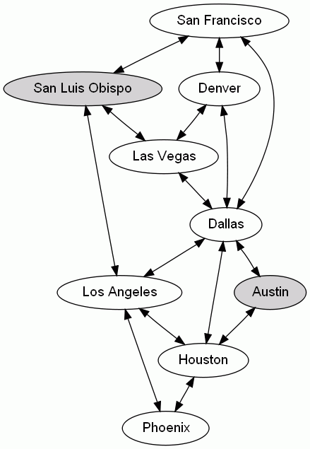

Total: [48]

