REGENT EDUCATION &

RESEARCH FOUNDATION

*GROUP OF INSTITUTIONS*



**Student Details for Continuous Assessment-ii 2023**

**NAME:** *Pritom Paul*

**ROLL NO:** *26300322042*

**DEPARTMENT:** *ECE*

**REGISTRATION NUMBER:** *222630120396*

**SEMESTER:** *4th*

**SUBJECT:** *Analog Electronic Circuits*

**SUBJECT CODE:** *EC-402*

**TOPIC:** *Analog Circuits*



# **Analog Circuits**

*Analog circuits are integrated circuits that make a representation of continuous signals in electrical form.*

#### **Description:**

Before digital circuits were invented, there were Analog circuits. One of the two main types of integrated circuits, the Analog integrated circuit is a completely different beast from the digital integrated circuit in several ways.

An Analog circuit works with Analog signals: the full signal (a continuously variable signal) in the form of a wave has more data in it—because it is a continuous wave—as opposed to digitized waveform that is made up of binary ups and downs (or pulses). We live in an Analog world. All the waves in the electromagnetic spectrum are Analog. Furthermore, the world “Analog” means proportional: the Analog circuit makes a proportional representation of the real-world signal in electronic voltage or current. Since the way we hear and see things is a continuous wave, an Analog circuit makes an electronic representation of our physical world. Again, the signal isn’t being translated into binary pulses or some other approximation of the real world signal, as a digital integrated circuit would. Another way to see it is Analog waves are smooth, whereas digital is jagged.

[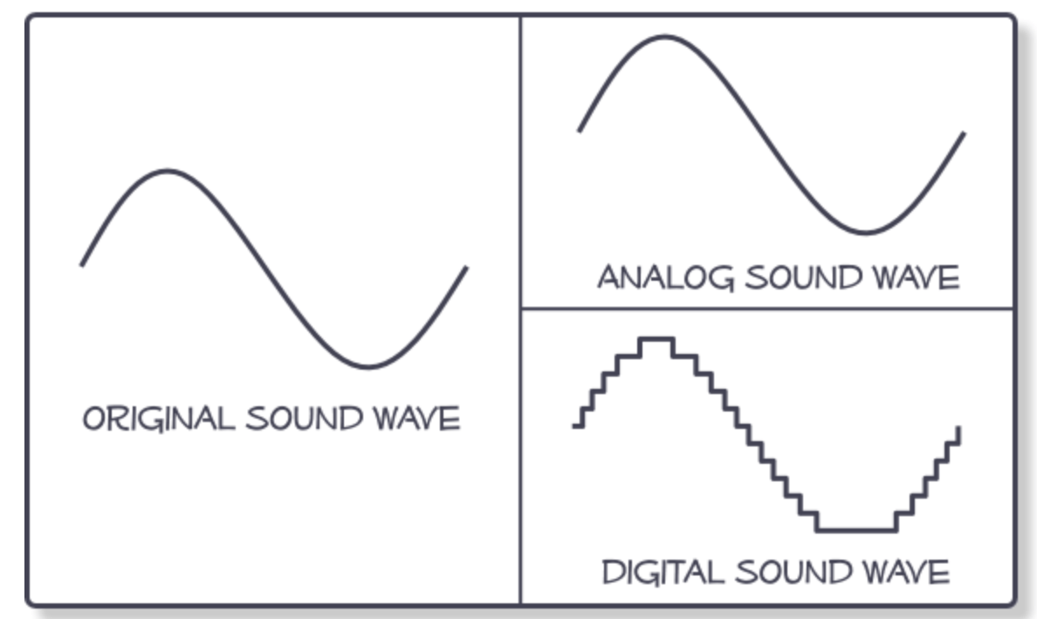](https://i0.wp.com/semiengineering.com/wp-content/uploads/2018/11/digitalvsanalog.png?ssl=1)

I can make Analog circuits by soldering discrete components on a breadboard more easily than making a digital circuit on a breadboard. Although integrating that Analog circuit onto a chip puts all those components onto one substrate just as with a digital integrated circuit, the Analog ICs are notoriously hard to design well and require a different approach, much of which stems from designer experience rather than a heavy reliance on tools. Analog circuit design is not automated as much as digital circuit design is, which can have an effect on error rate. Also, Analog is sensitive to noise in the environment.

Reports show that Analog content causes the most test failures and contributes significantly more than digital to field returns. This error rate is caused by high complexity, an error-prone process, full-custom design, variability, limited systematic verification to assess robustness, and much less automation compared to its digital counterpart. Some of it is due to the maturity of Analog design and verification. While great strides have been made in digital circuitry, [Analog design automation and verification methodologies](https://semiengineering.com/knowledge_centers/eda-design/definitions/analog/analog-design-and-verification/) have lagged. In addition, leading-edge nodes make it increasingly difficult to construct reliable Analog circuitry.

Standards are finally catching up. IEEE P2427, “A Standard for Analog Defect Modelling and Coverage” ,will define how to model faults and calculate test coverage. The standard should accelerate the development and deployment of tools for Analog fault simulation of test coverage in 2019.

Analog circuitry stopped following Moore’s Law a long time ago. Unlike digital circuits, Analog circuitry does not scale well. Analog is, therefore, behind digital in node shrinkage. Analog transistors often need to be larger to ensure that loads, power distribution and signal fidelity are all well maintained within an application.

One advantage of Analog is staying in older nodes, which saves money and hassle. With less pressure to shrink the transistors and move Analog to next nodes, Analog engineers can continue to build experience with older nodes.

**How Analog integrated circuits are similar to digital integrated circuits?**  
 Analog circuits consist of combination of transistors, resistors, capacitors, and so on. For some basic Analog circuit configurations, see National Instruments page [Basic Analog Circuits](https://www.ni.com/en-us/innovations/white-papers/06/basic-analog-circuits.html#section--983809924).

Analog and digital circuits sometimes do the same thing. For instance, memory storage circuits have Analog and digital flavours.

Intellectual property (IP) can be purchased for Analog, digital and mixed-signal circuits.

**Examples of Analog integrated circuits:**  
 Although Analog may seem like a dinosaur, it is not just an antiquated world for hardcore, old-school Analog engineers. Analog circuits are used in many communications devices and being debated now are questions of whether Analog has significant performance advantages over digital for some applications. For the base stations, for instance, the choice is whether to use digital versus Analog for beamforming.

**Examples of Analog ICs:**

* + - * some memory chips,
      * power supply chips,
      * some sensors,
      * wideband RF and some 5G applications, AFEs—Analog front end (AFE) solutions,
      * operational amplifiers (op-amps),
      * RC low pass and high pass filters dynamic signal acquisition (DSA) devices.

**Changing the signal:**  
The continuous signal that Analog circuits work with can be manipulated to decrease noise, increase (amplify) or decrease the signal.

* + - * sensors, which take an Analog signal such as sound waves or other vibrations, may use a transducer that changes the size of the signal by amplitude or frequency, or may just use the signal without modification.
      * amplifiers increase voltage, current, or power of a signal.

**References:**

<https://semiengineering.com/knowledge_centers/integrated-circuit/ic-types/analog-circuits/>