DAY6 SESSION ASSIGNMENTS (Theory)
1. How do you evaluate the performance of a project in agile?
2. Compare traditional monitoring & control with agile monitoring & control
with respect to metrics generation
3. With a total project budget of $ 175,000, and having completed one out of
four Iterations, we have this product backlog and these actuals:
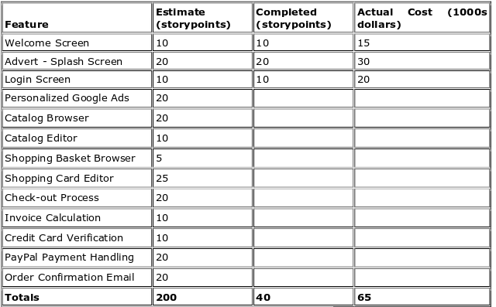


In our example, after Iteration 1 we should be at 25% complete)

Calculate Planned Value
Actual % Complete
Earned Value

1. Agile project performance is based on a collabrative environment.where in regular meetings and check inns should be there. So first of all the the project in agile should be monitored effectively.Frequent delivery should be there for the customer.
So face to face conversation should be there between bussiness people and developers.Focused and daily team meetings should be there.
Timebox meeting also should be there which includes product demonstration and retrospective.
Certain key measures are there for agile development is velocity,hitrate,work remaining on tasks and project cost.based on these key measures monitoring and performance is sone.velocity is the rate at which a working software is made.
it also means how many story points we can accomodate.The actual velocity collected during the project development is used to calculate subsequent timeboxes in the realease plan.
Hitrate is the percentage of work allocated to a timebox that was actually completed.each day the team should what is the remaining work on each active task.

Also certain other measures such as SPI,CPI and earned bussiness value.certain criterias are there in which like planned value which is the how much value was planned to have been generated by a particular milestone or point in time.The earned value indicates how much value has actually been generated at a particular milestone or point in time.Actual Cost is the cost incurred for that increment of work.
CPI is cost performance index.This metric indicates how many cents have been earned out of every dollar spent. It measures cost efficiencies.Its the ratio of earned value and actual cost.Schedule performance index which measures schedule efficiency. It indicates how fast you are progressing against the rate of progress planned.
So if taking an example the actual budget at complete will be given.we calculate the planned value and based on this we calculate the business earned value.so success of project is calculated.

2.

Traditional Monitoring | Agile monitoring
Develop a plan and changes cannot be made | Variance from the plan could be there for customer satisfaction
Frequent delivery is not done during the development | Frequent delivery is done during the development.
Factors tracked are cost,quality and effort. | Certain project metrices are there like velocity,hitrate,project cost etc.
Controlling and monitoring are not done through daily meetings | Monitoring and controlling is done through daily meetings(Scrum meetings).
Colocation is not there | Colocation is there.
Based on staffing the number of members can be upto 20 | Based on scheduling the number of members can be upto 9
Its based on SPI and CPI | Its based on earned bussiness value.
Communication can be of any form | Face to face communication between developers and bussiness people
No burn down charts are shown during the results | Burn down charts is shown.
Testing done only after completion of development | Testinf done parrallel to development.

3.
BAC (budget at complete) – $ -175000 (the budget asssigned to complete the work.

Planned percent complete – 1/4 (25% is complete) only one iteration(1 sprint is complete)

Planned value - BAC* planned percent complete

planned value = 175000 * (1/4) = $ 43750

Actual percent complete(APC) - Story points completed / Total planned story points

Total story points – 40
Total planned stories – 200

= 40/200 = 0.2 = 20%

Earned value – BAC*APC (The earned value indicates how much value has actually been generated at a particular milestone or point in time.)

= 175000*0.2

= $ 35000

