1.When to use (Rapid Application Development) RAD model
When not to use (Rapid Application Development) RAD model
2.
Define an ER diagram of a software Organization
with all the relationship
model that was discussed in the
classroom
3.
Describe the Entity Relationships for the following diagram

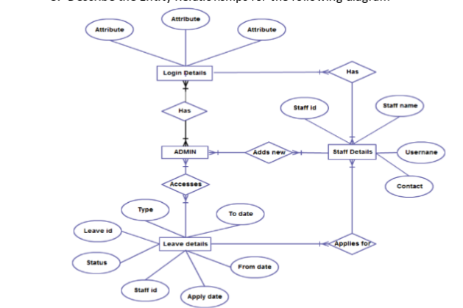

1.
WHEN TO USE RAD

- Rapid application development is actually an object oriented model.
- RAD is used when faster application development is there.
- When systems can be modularized RAD can be used.
- RAD model requires minimal planning.
- RAD model should be used when resources with high bussiness knowledge(designers) are available.
- It should be used when budget is there enough for application generation.
- When the project is to done with fewer people in less span of time so that productivity can be optimized.
- Used for systems which are component based and scalable
- When more user involvment is there.

WHEN NOT TO USE RAD

- When there is no high reliability requirments RAD model cannot be used.
- Its not used when there will be incremental delivery like agile methadology.
- Inapplicable to cheaper projects.
- When there is no skilled labour and designers.
- When management complexity is more

2.
ER diagram or entity relationship diagram shows the relationship and information about various objects(entities) that may be people,places, events etc.The features of entity is called as attributes. There is a relationship between two entities that can be many to many, one to many etc.
Here the case of an organization is considered which may consists of entities like employee,department.

First name
Mid name
Last name

salary
address
name
dept_id
EMPLOYEE
empl_id
sex
empl_id
dept_id
Phone no
empl_id
experience
dept_id
Works_for
PROJECTS
p_name
cost
No of workers
manages
Project lead
has
empl_id
p_name

N
is_in

HAS
HAS
N
N
N
DEPARTMENT
1
MANAGER
N
TRAINEE
dept_id

d_name
N
N

N

N
1

- ATTRIBUTE
- ENTITY

- MULTIVALUED ATTRIBUTE
- RELATION - RELATION
-

- primary key

Here an organization is considered.Many departments will be there in a organization.here I have considered a employee who may be trainee or manager.He may work for any no of departments or in one department.
Each department may have many projects.and that projects are managed by each manager.
So here employee,manager,project,project lead,trainee are the entities respresented in rectangle and attributes are the functions represented in oval shape.the relationship represented is diomond shape.

3.
In this example admin is considered as the primary entity and from there he does many functionalities.
Here the entities are- ADMIN,LOGIN DETAILS,STAFF DETAILS,LEAVE DETAILS
Each entity will be having attributes.The relationship between them is represented in a diomond shape and they are applies for,has,access,and adds new.primary key is staff id and its also used in another table ie it will be the foriegn key.

1) admin has login details
Here admin is the entity and he has login details of the people who login into the system.Many admins will be there in an organization.so considering that fact here, many admins will be having many login details.so its many to many
login details entity will be having many attributes such as staff id,login time etc.

2) admin will be adding staff details
its a many to many relationship.as one admin can add many staff details.but when considering multiple admins its a many to many relationship.
Staff details have many attributes and in that staff id is the primary key of entity staff details.other than that username,staff name,contact.

3) admin can access leave details of staff.
In that staff id is there as the forign key for the entity leave details.its a many to many to relationship.leave details have attributes like leave id, from date to date,reason etc.

4)Staff can apply for leave. Its a many to many relationship.

5 )many login details will be having staff details. Its a many to many relationship.

