- Autograder results for all 6 questions:


- 1. Depth First Search: Use Stack to create the frontier, the LIFO principle allows DFS to explore one path as deeply as possible.
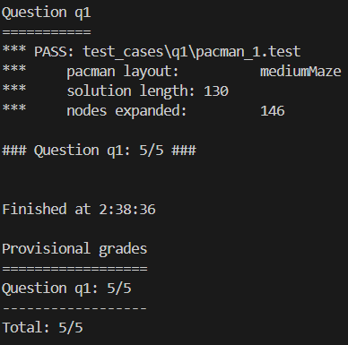

- 2. Breadth First Search: Use Queue to create the frontier, the FIFO principle allows BFS to explore one path as wide as possible.
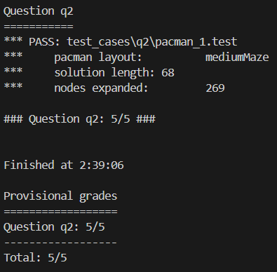

- 3. Uniform Cost Search: Use Priority Queue to create the frontier, it allows us to search the node with the least cost because it sets priority for each node.
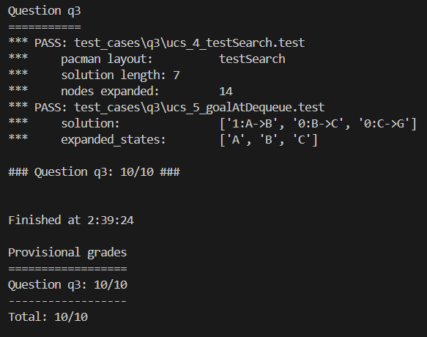

- 4. A* Search (null Heuristic): Use Priority Queue With Function to create its frontier, the priority function will calculate the lowest path cost combining the heuristic to prioritize the node.
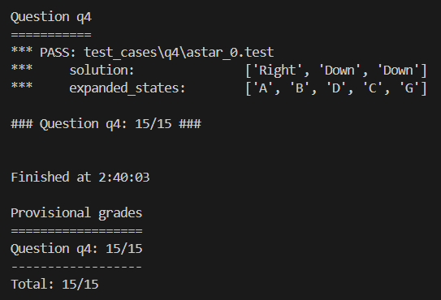

- 5. Breadth First Search (Finding all the Corners): Each state is a tuple of the state’s position and the 4 corners’ coordinates. The start state is the starting and 4 corners’ position. The goal is to check if there are no more corners left. Successors will check if the next position hits the wall and append corners.
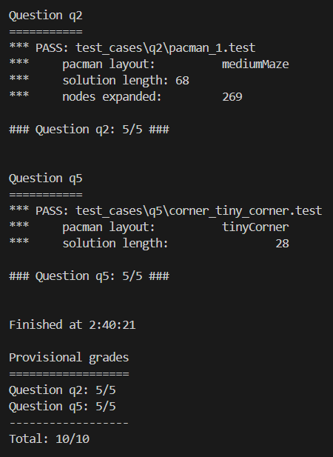

- 6. A* Search (Corners Problem: Heuristic): Loop through all corners and calculate minimum Manhattan Distance between the current position and remaining corners, pop out the nearest corner, update current position to that nearest corner, and continue to calculate the nearest Manhattan Distance till all corners have been visited.
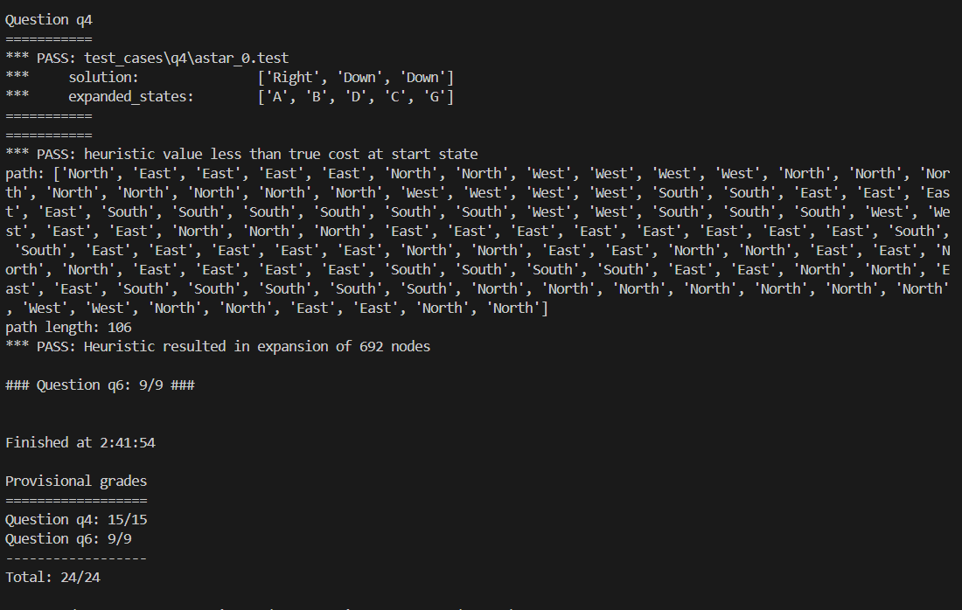

- Difference between Uniform Cost Search and A* Contours:
UCS expands nodes in all directions, which will look like circles getting larger and larger till it reach the goal. In contrast, A* Contours expands nodes more efficiently towards the goal due to the heuristic. Therefore, in larger graphs, A* will be more efficient than Uniform Cost Search.

- Admissibility Heuristic:
An admissible heuristic is a heuristic function that estimates the cost of the cheapest path from any node to the goal (and non-negative). The defining characteristic of an admissible heuristic is that it never overestimates the true cost to reach the goal. It is optimistic because it never suggests a solution that is worse than the actual optimal solution.

