● Autograder:
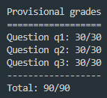
● Q1. Reflex Agent:
The evaluation function takes ghosts position, food position, and capsules into account. Add points if pacman eats the food, or gets closer to the food and the capsules, and while pacman is far away from ghosts. Minus points if it stops.
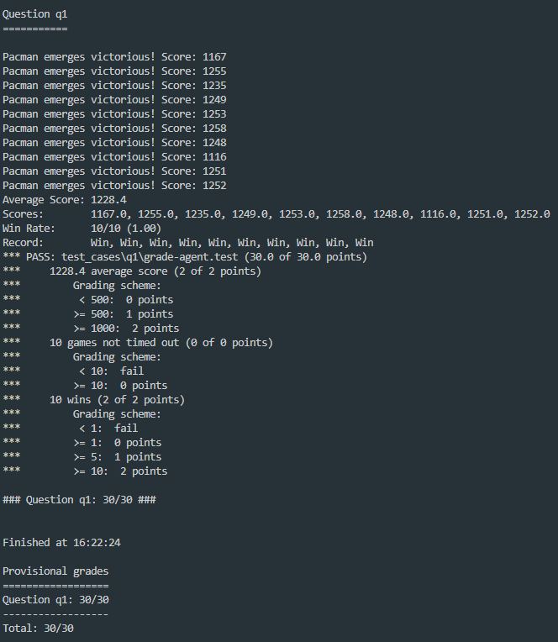

● Q2. Minimax:
Create a Max value and Min value function to recursively calculate the players and ghosts’ best moves. Max for Pac-man, Min for the ghosts. If all ghosts have their best actions, move onto next depth and continue calculating.
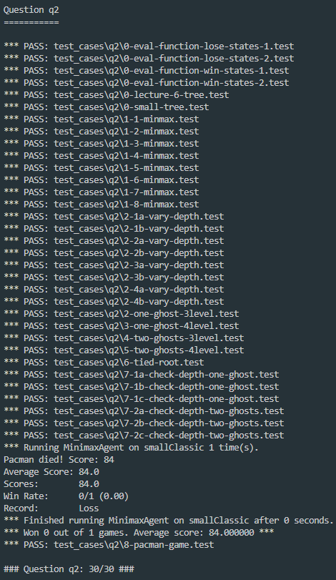
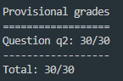

● Q3. Alpha-Beta Pruning:
Similar to minimax problem, I create a Max value, and a Min value function to calculate their best actions. Compare the v value with an Alpha constant and a Beta constant. Alpha constant means Max’s best option on path to the root, Beta is Min’s best option on path to the root.
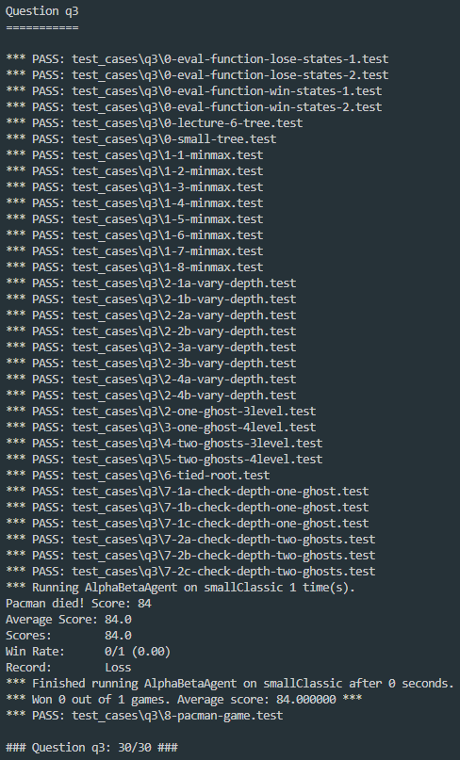
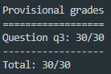

■ Describe the idea of your design about evaluation function in Q1
I reward the Pacman if he gets closer the food, and be farther from the ghosts. Eating food and capsules also get rewards. If Pacman stops, will be punished. Therefore, the evaluation function will consider the ghosts’, all the food, capsules’ positions, and calculate their Manhattan distance with Pacman’s position. Then, either it gets rewards or punishes, finally return the evaluation score.
■ Demonstrate the speed up after the implementation of pruning.
Alpha-beta pruning will cut off some of the branches that do not need to be explored, so it reduces many nodes in the game tree. This optimization technique for the minimax algorithm will speed up the Pacman because of the reducing search space, enhancing faster decision-making without sacrificing the quality.

I use a timer to calculate the runtime, and Alpha-beta pruning(0.03s) did run faster than Minimax(0.09s).
