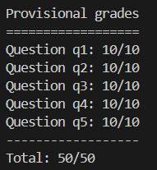
Q1 – Logic Warm-up (2%)
Sentence1 and Sentence 2 functions just write their respective logic expressions. Sentence3 function is the same, but in real sentences, not just symbols.
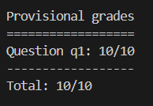
Q2 – Logic Workout (2%)

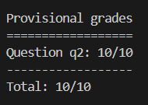
Q3 – Pacphysics and Satisfiability (2%)

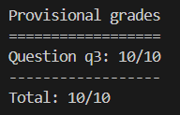
Q4 – Path Planning with Logic (2%)

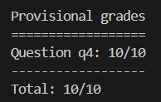
Q5 – Eating All the Food (2%)
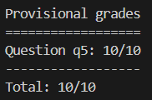

Problems in Modern VLM models
Q1:
There are several reasons why LLM can’t reach AGI. First, LLMs are good at mimicking human language but do not truly understand the content like humans. They lack an understanding of the world. Secondly, AGI requires the ability to generalize knowledge and skills across a wide range of domains, while LLMs are limited based on the data they trained on. Lastly, AGI would need some creativity and innovation. LLMs can generate novel content, but their creativity is bounded by the patterns present in their training data. Therefore, while LLMs represent a significant advancement in the field of AI, they are still far from achieving the broad, flexible, and deep intelligence that AGI represents.

Q2:
Positive samples: The image correctly matches the event description.
Negative samples: Change event type or change agent, through these 2 kinds of changes, the description can no longer match the image.
Using contrastive learning loss, allows the model to maximize the similarity of positive samples to close to 1, and minimize the similarity of negative samples to close to 0. Kullback-Leibler divergence will show whether the description is a positive description.

Q3:
- Conventional descriptions fall short of structured information that effectively represents the interconnections among entities or attributes linked to a particular category.
- We leverage existing large language models to obtain the structured information from vanilla descriptions. Given a specific category, we feed hand-crafted instructions into LLMs, intending to generate human-like descriptions, as well as structured relationships within each description, including entities, attributes, and relationships among them.

Q4:
OxfordPets Dataset
- Beagle:
- A pet beagle is a medium-sized dog breed with white, black, and tan fur, floppy ears, and a friendly expression.
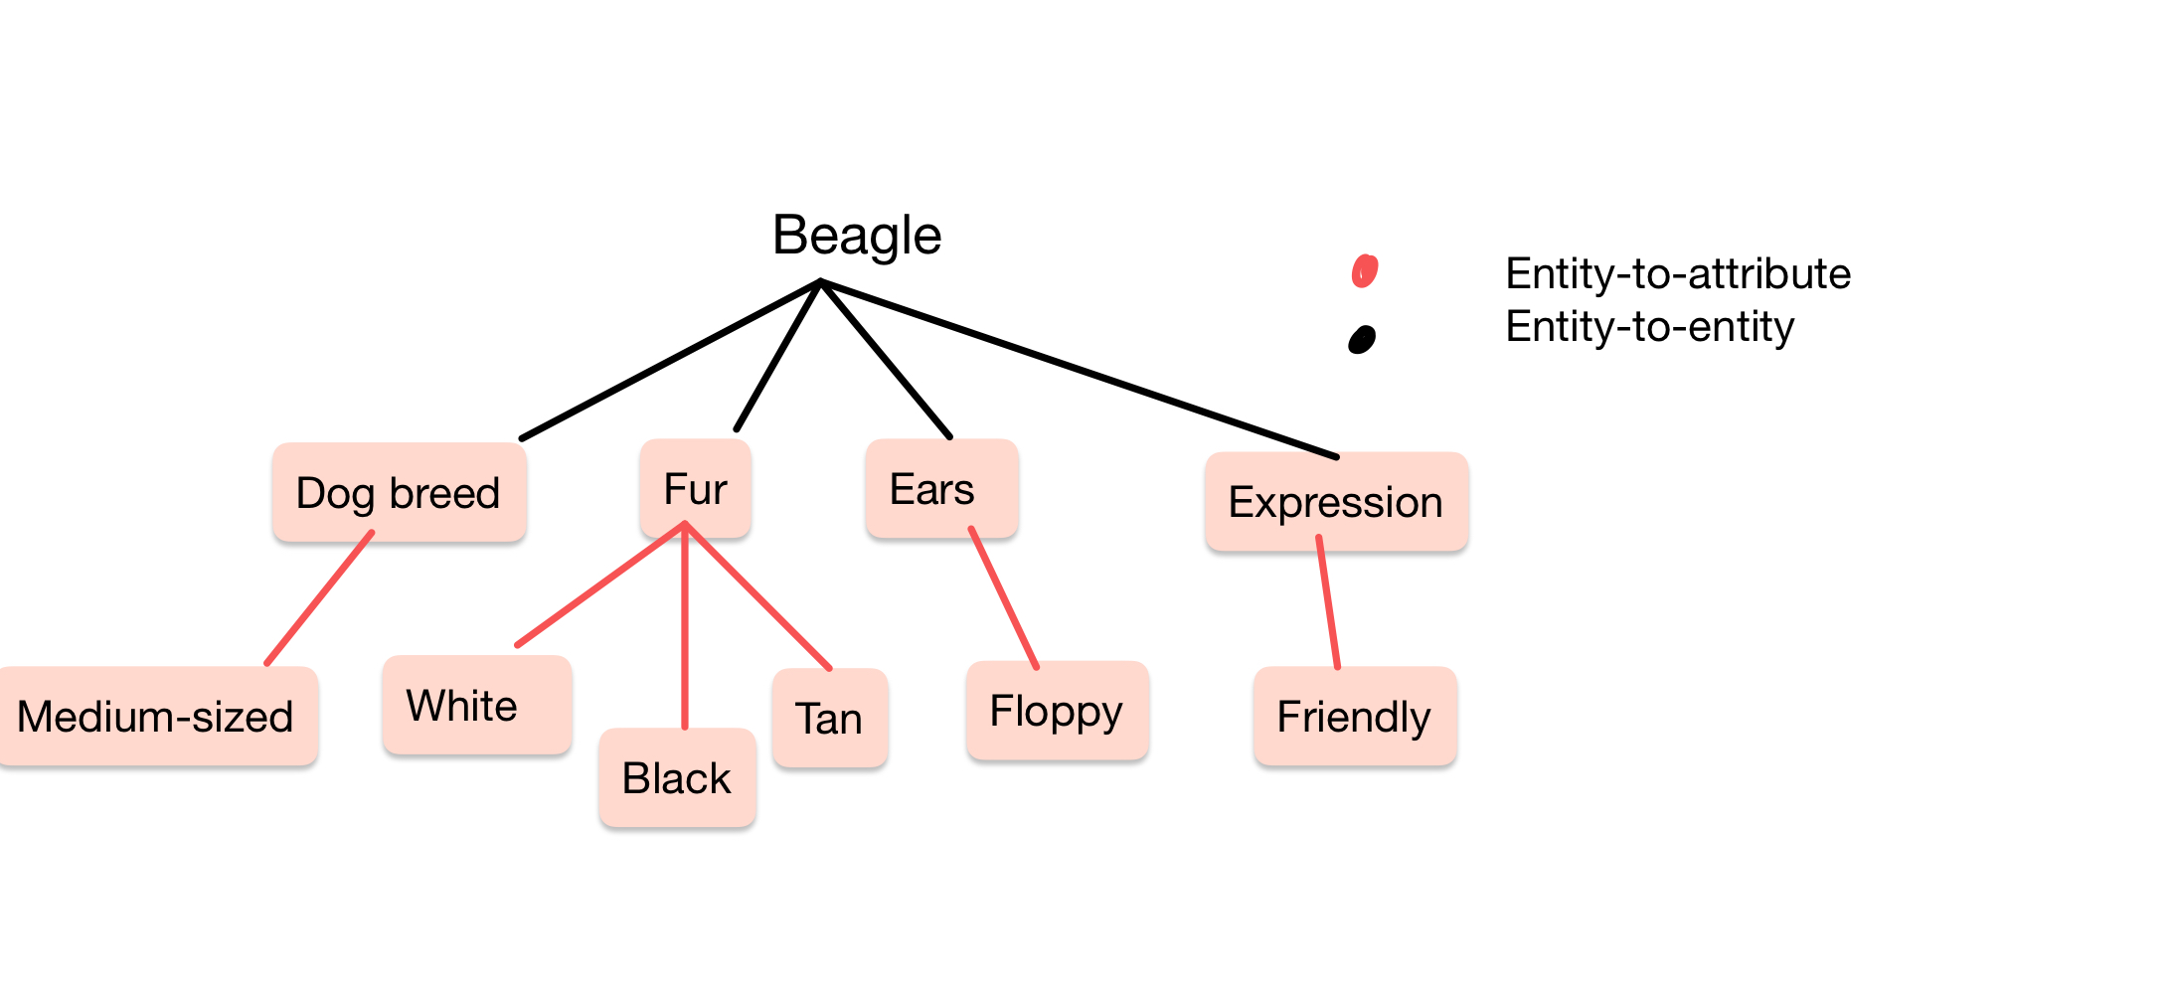
- Beagles have a tri-colored coat, long droopy ears, black nose, and a white-tipped tail. They are medium-sized and muscular.
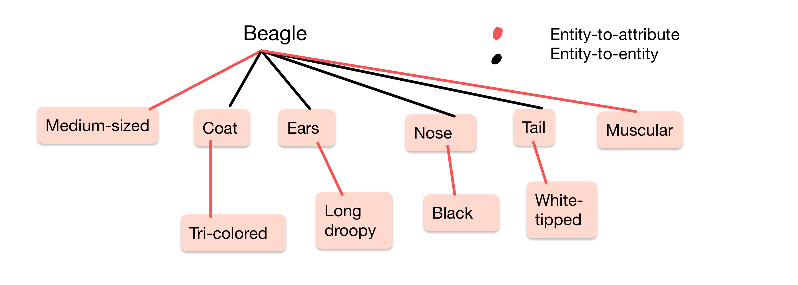

- American bulldog:
- A pet American bulldog is a muscular, medium to large sized dog, with a short, smooth coat and distinctive wrinkled face.
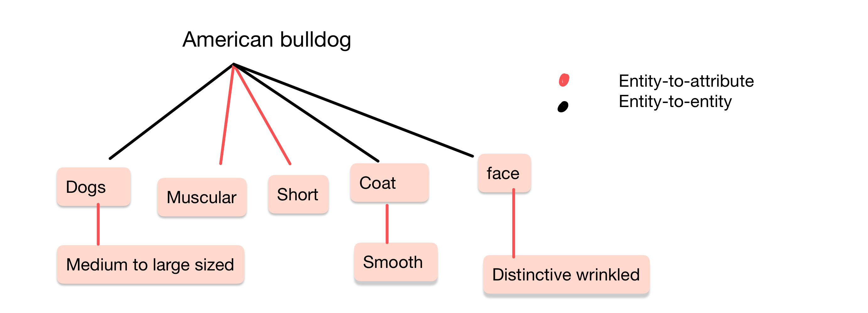
- "Distinctive features of an American Bulldog include a muscular build, large head with strong jaw, wrinkled face, and short hair coat.",
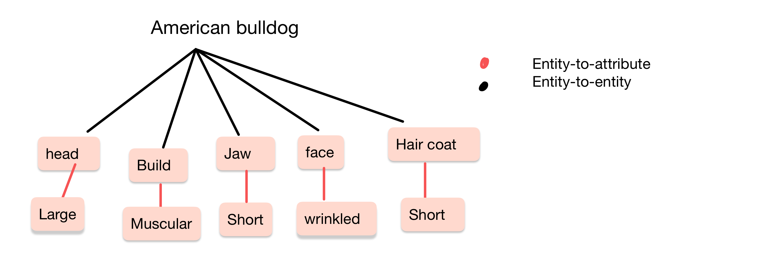
Q5:
Other deep semantic knowledge like Causal Relationships can be helpful for understanding the reasons behind certain events and improve its ability to predict future events based on past patterns. Also, Cultural Knowledge is another useful knowledge. Humans have a rich cultural heritage that includes customs, traditions, and beliefs. Providing VLM with cultural knowledge can help it understand the nuances of language and communication in specific cultural contexts. Additionally, Humans possess vast general knowledge about various topics, such as history, geography, science, and culture. Providing this knowledge to VLM models can enhance their understanding of complex subjects and improve their ability to generate coherent and relevant responses.

