**Slayilicious 2.0 Software**

<https://forums.raspberrypi.com/viewtopic.php?t=343733#p2059324> - python code

<http://razzpisampler.oreilly.com/ch07.html> - wiring buttons

<https://raspberrypi.stackexchange.com/questions/22708/is-there-some-trick-to-getting-aplay-audio-output-working> - playing audio out the speaker

<https://docs.python.org/3.5/library/subprocess.html#subprocess.run> - running aplay from Python

<https://www.raspberrypi-spy.co.uk/2013/06/raspberry-pi-command-line-audio/> - coding the speaker

<https://www.waveshare.com/wiki/2inch_LCD_Module?Amazon> - coding the screen

<https://realpython.com/python-command-line-arguments/#displaying-arguments> - giving the name of the image file to the screen

<https://github.com/pimoroni/bme680-python?tab=readme-ov-file> - coding the air quality sensor

<https://learn.pimoroni.com/article/getting-started-with-bme680-breakout> - coding the air quality sensor

<https://pcbartists.com/product/i2c-decibel-sound-level-meter-module/> - coding the sound sensor

<https://www.partnersinrhyme.com/soundfx/watersounds.shtml> - the waves sound file

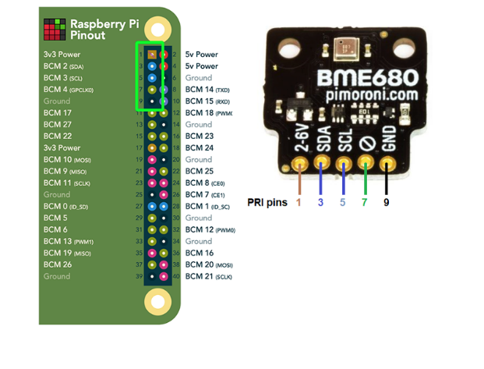

Wiring up the speaker and the air quality sensor ^