SQL COMMANDS EXERSICE-4
PROGRAM NO: 17 DATE:
WRITE SQL QUERIES FOR THE FOLLOWING QUESTIONS
JOBID | JOBTITLE | SALARY
101 | President | 200000
102 | Vice President | 125000
103 | Administration Assistant | 80000
104 | Accounting Manager | 70000
105 | Accountant | 65000
106 | Sales Manager | 80000
- TO DISPLAY EMPLOYEE IDS, NAMES OF EMPLOYEES, JOB IDS WITH CORRESPONDING JOB TITLES.
SELECT EID,ENAME,EMPLOYEE.JOBID,JOBTITLE FROM EMPLOYEE,JOB WHERE EMPLOYEE.JOBID=JOB.JOBID;
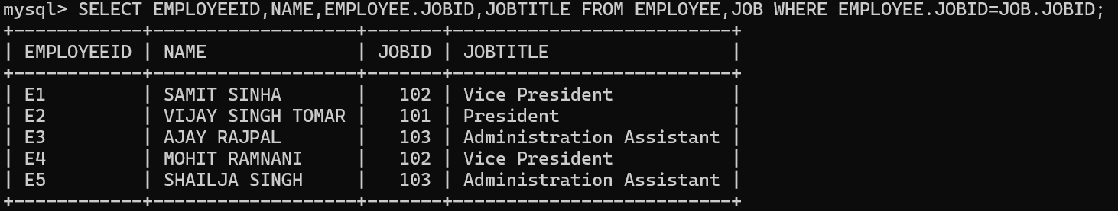
B)TO DISPLAY NAMES OF EMPLOYEES, SALES AND CORRESPONDING JOB TITLES WHO HAVE ACHIEVED SALES MORE THAN 1300000.
SELECT ENAME,SALES,JOBTITLE FROM EMPLOYEE,JOB WHERE EMPLOYEE.JOBID=JOB.JOBID AND SALES>1300000;
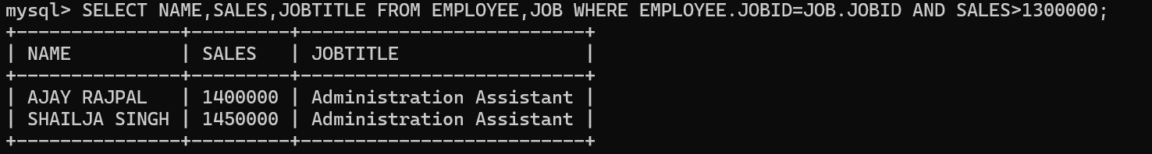
C)TO DISPLAY NAMES AND CORRESPONDING JOB TITLES OF THOSE EMPLOYEES WHO HAVE 'SINGH' (ANYWHERE) IN THEIR NAMES.
SELECT ENAME,JOBTITLE FROM EMPLOYEE,JOB WHERE EMPLOYEE.JOBID=JOB.JOBID AND ENAME LIKE '%SINGH%';
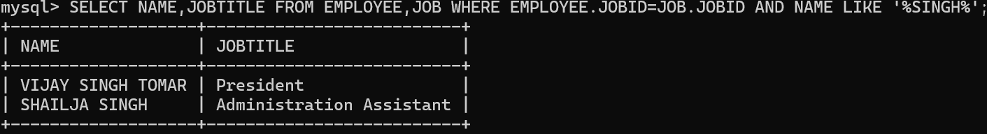
- IDENTIFY FOREIGN KEY IN THE TABLE EMPLOYEE.
DESC EMPLOYEE;
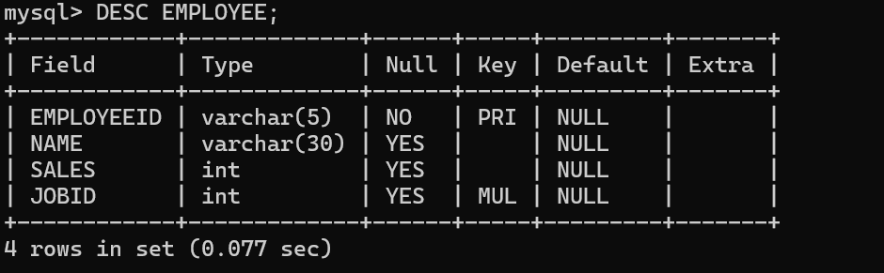E)WRITE SQL COMMAND TO CHANGE THE JOBID TO 104 OF THE EMPLOYEE WITH ID AS E4 IN THE TABLE EMPLOYEE.
UPDATE EMPLOYEE SET JOBID=104 WHERE EMPLOYEEID='E4';
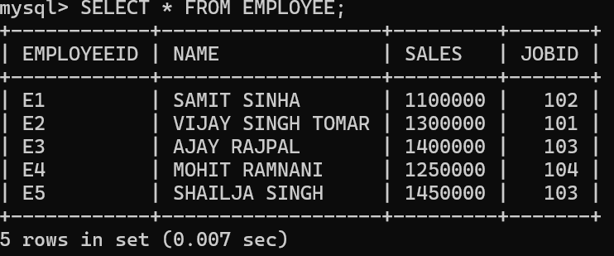

SQL COMMANDS EXERCISE-5
PROGRAMNO:18 DATE:
TO WRITE QUERIES FOR THE FOLLOWING QUESTIONS BASED ON THE GIVEN TABLE:
TABLE:UNIFORM
UCODE | UNAME | UCOLOR | STOCKDATE
1 | SHIRT | WHITE | 2021-03-31
2 | PANT | BLACK | 2020-01-01
3 | SKIRT | GREY | 2021-02-18
4 | TIE | BLUE | 2019-01-01
5 | SOCKS | BLUE | 2019-03-19
6 | BELT | BLUE | 2017-12-09

TABLE:COST
UCODE | SIZE | PRICE | COMPANY
1 | M | 500 | RAYMOND
1 | L | 580 | MATTEX
2 | XL | 620 | MATTEX
2 | M | 810 | YASIN
2 | L | 940 | RAYMOND
3 | M | 770 | YASIN
3 | L | 830 | GALIN
4 | S | 150 | MATTEX

- TO DISPLAY THE AVERAGE PRICE OF ALL THE UNIFORM OF RAYMOND COMPANY FROM TABLE COST
SELECT AVG(PRICE) FROM COST WHERE COMPANY='RAYMOND';
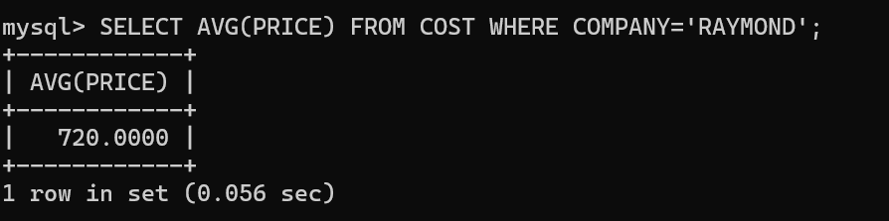
B)TO DISPLAY DETAILS OF ALL THE UNIFORM IN THE UNIFORM TABLE IN DESCENDING ORDER OF STOCKDATE.
SELECT * FROM UNIFORM ORDER BY STOCKDATE DESC;
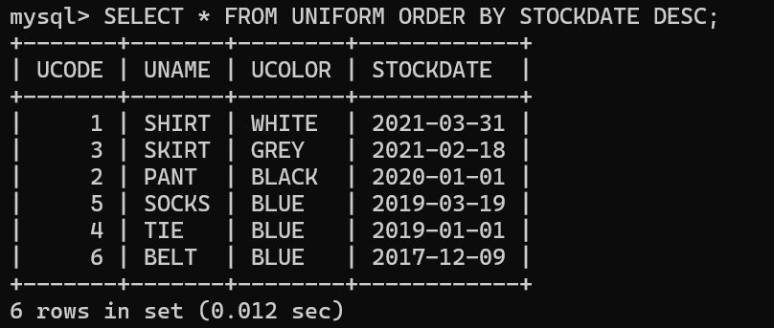
- TO DISPLAY MAX PRICE AND MIN PRICE OF EACH COMPANY.
SELECT COMPANY,MAX(PRICE),MIN(PRICE) FROM COST GROUP BY COMPANY;
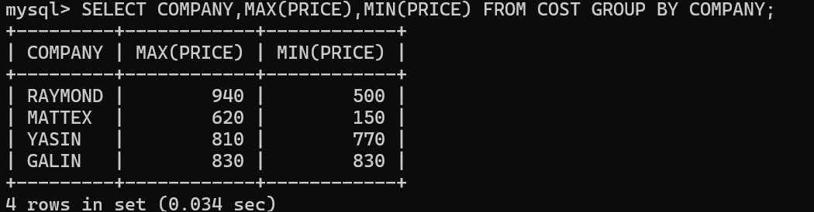
- TO DISPLAY MAX PRICE AND MIN PRICE OF EACH COMPANY.
SELECT COMPANY,MAX(PRICE),MIN(PRICE) FROM COST GROUP BY COMPANY;
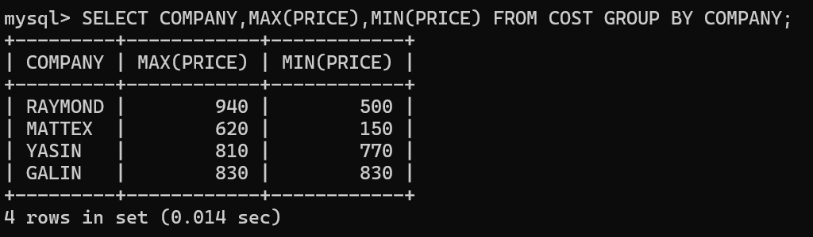
- TO DISPLAY THE COMPANY WHERE THE NUMBER OF UNIFORM SIZE IS MORE THAN 2.
SELECT COMPANY,COUNT(*) FROM COST GROUP BY COMPANY HAVING COUNT(*)>2;
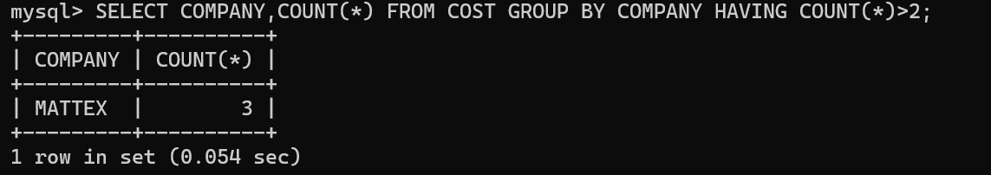
- TO DISPLAY THE UCODE, UNAME, UCOLOR, SIZE AND COMPANY OF TABLES UNIFORM AND COST.
SELECT U.UCODE,UNAME,UCOLOR,SIZE,COMPANY FROM UNIFORM U,COST C WHERE U.UCODE=C.UCODE;
