**DATA MODEL :-**

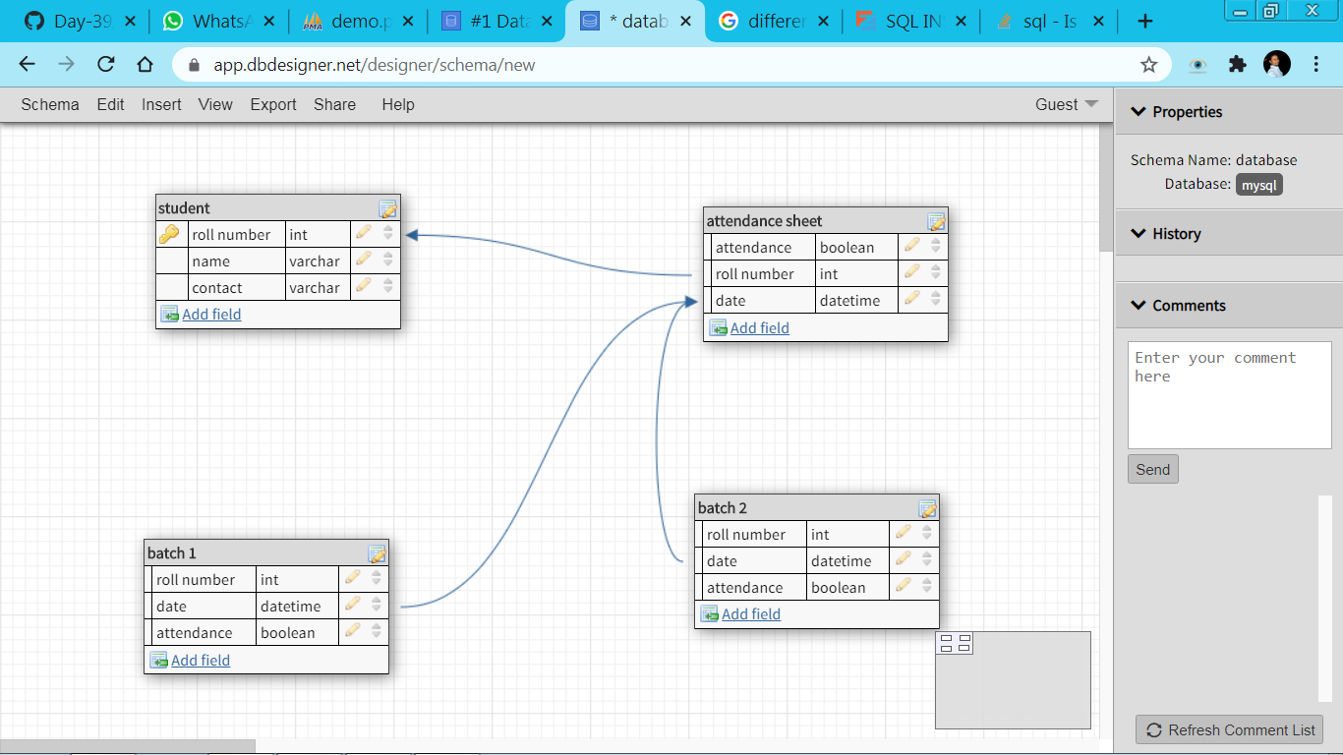

**QUERIES**

Write a query to insert student details in student table

INSERT INTO student(roll number,name,contact) VALUES (4,"Ram",8888888888);

Write a query to insert batch details in batch table

INSERT INTO batch1 (roll number) VALUES (4);

INSERT INTO batch2 (roll number) VALUES (4);

Write a query to Mark attendance for the students at respective batch on Jan 23 2020.

SELECT count(case attendance when 'TRUE' then 1 else null end) AS STUDENTS_PRESENT FROM attendance sheet WHERE DATE=23/01/2020 GROUP BY DATE;

Write a query to display the batch details and attendance history of student 1.

SELECT * FROM batch1 INNER JOIN batch2 ON batch1.roll number = batch2.rollnumber;

Write a sql query to display a table containing students attending batch1 along with their attendance history

SELECT * FROM batch1 INNER JOIN attendance sheet ON batch1.rollnumber= attendance sheet.rollnumber;

Write a sql query to display a table containing batch details and attendance history of student 1

SELECT * FROM batch1 WHERE roll number = 1;