LINUX INFRASTRUCTURE
DRIFT DETECTION &
AUTO REPAIR SYSTEM
FULL PROJECT REPORT

Project Type | Python-based configuration monitoring and repair prototype
Primary Environment | Linux terminal / Python 3.12.3
Configuration Model | Baseline JSON compared against current JSON configuration
Evidence Date | October 2026 (based on provided terminal evidence)
Prepared from the project structure, terminal output, test results, and screenshots supplied during the build and verification process.

Abstract
The Linux Infrastructure Drift Detection & Auto Repair System is a Python command-line prototype that compares a current configuration file against a trusted baseline configuration. It identifies mismatched settings, allows controlled simulation of configuration drift, repairs the project’s test configuration back to baseline values, verifies the result, and records key events in an audit log.
The demonstrated configuration contains six settings: SSH root login, SSH password authentication, firewall status, automatic updates, file permissions, and backup enablement. The supplied terminal evidence shows a simulated drift being detected, a repair being applied to the project test configuration, and post-repair verification reporting PASSED and COMPLIANT. Seven unit tests also completed successfully.
This report describes the implemented prototype and its observed results. It distinguishes tested functionality from items that remain to be integrated or verified, particularly automatic timestamped backup creation from the main menu repair workflow.
Keywords: Linux, Python, configuration management, configuration drift, JSON, automated repair, audit logging, unit testing.

1. Introduction
Infrastructure settings can change unintentionally because of manual edits, configuration mistakes, or inconsistent setup. Configuration drift occurs when a system’s current settings differ from an approved configuration. This project demonstrates a small, safe workflow for identifying and correcting such differences in a JSON-based test configuration.
The application is menu-driven, so a user can view the current configuration, detect differences, introduce test changes, repair the test configuration, review audit events, and exit the program.

2. Problem Statement
Manual configuration checking can be repetitive and may overlook security-related changes. A simple automated tool is useful for comparing expected and actual values, identifying differences clearly, and providing a repeatable demonstration of repair and verification.

3. Objectives
- Maintain a baseline JSON configuration representing expected values.
- Load and display the current project configuration.
- Compare baseline and current settings and report differences.
- Simulate common configuration drift without changing real Linux system settings.
- Repair the project test configuration to match the baseline after user confirmation.
- Verify the configuration after repair and record actions in an audit log.
- Use unit tests to validate configuration parsing, drift detection, and backup/restore helper behavior.

4. Scope and Safety
The demonstrated implementation works on project JSON files, especially baseline.json and current_config.json. The simulation explicitly reports that no real system configuration was modified. The application should therefore be described as a test/prototype tool, not as a production service that directly applies Linux SSH, firewall, update, or filesystem settings.

Included in scope
- JSON configuration comparison
- Drift simulation options
- User-confirmed repair of the project test configuration
- Post-repair compliance check
- Audit logging
- Unit tests and manual backup verification

Outside the demonstrated scope
- Applying changes to real system services or configuration files
- Running as a background daemon or scheduled monitoring service
- Alert delivery, dashboards, role-based access control, or centralized log storage
- Confirmed automatic timestamped backup creation through the main menu repair path

5. Technologies and Tools
Technology Purpose in the project
Python 3.12.3 Implements the command-line workflow, comparison logic, repair,
logging, and tests.
JSON Stores baseline and current configuration values.
pathlib Builds project-relative file paths.
datetime Adds timestamps to audit log entries and backup naming in the
repair utility.
shutil Copies files for backup operations in the separate repair utility and
backup tests.
unittest Runs the seven automated unit tests.
Linux terminal Runs the application, tests, and inspection commands.

6. System Architecture
The prototype uses a file-based architecture. The baseline file contains approved values; the current configuration file represents the state under inspection. The drift detector loads both JSON objects, compares corresponding keys, and presents differences. The simulation function modifies only the current project JSON file. The repair function in the main menu restores the baseline values to the current test file after confirmation, then scans again to verify compliance. Audit events are appended to logs/audit.log.
Workflow: Baseline JSON + Current JSON → Load and compare → Drift report → (optional) simulated drift → User-confirmed repair → Post-repair scan → Audit log.

7. Project Directory Structure
linux-drift-detection/ ■■■ baseline.json ■■■ current_config.json ■■■ drift_detector.py ■■■ linux_repair.py ■■■ report_generator.py ■■■ tests/ ■ ■■■ test_project.py ■ ■■■ test_backup.py ■■■ backups/ ■■■ reports/ ■■■ logs/ ■■■ audit.log
The terminal listing supplied during development shows these files and directories. The report generator and reports directory are present; the available evidence includes four JSON drift report files. The exact report-generation trigger is not established by the terminal excerpts alone.

8. Configuration Model
The baseline and current configuration use six settings. The verified configuration after repair was:
Setting Expected value Meaning
ssh_root_login no Disallow SSH root login in the project model.
ssh_password_authenticatio no Disable SSH password authentication in the
n project model.
firewall_enabled true Firewall should be enabled in the model.
auto_updates_enabled true Automatic updates should be enabled in the
model.
file_permissions 640 Expected permission value represented as a
string.
backup_enabled true Backups should be enabled in the model.

9. Main Functional Modules
Initialization: Creates the logs directory and audit log if needed, checks that the baseline file exists, and initializes the current configuration from the baseline if the current file is missing.
View configuration: Displays the current setting values, number of baseline settings, count of drifted settings, and compliance status.
Detect drift: Compares the union of keys in the baseline and current files. A missing key or a value mismatch is reported as drift.
Simulate drift: Offers options to enable SSH root login, enable SSH password authentication, disable the firewall, disable automatic updates, change permissions to 777, disable backups, or apply all test changes.
Repair: Shows detected differences, asks for confirmation, restores the baseline into the project current-configuration file, and runs a follow-up drift scan. The shown successful run returned “Verification: PASSED” and “System status: COMPLIANT.”
Audit logs: Appends timestamped events such as system initialization, simulated drift, drift scan completion, repair completion, and post-repair verification.

10. Testing Methodology
The test suite was run with the command:
python3 -m unittest discover -s tests -v
Test Observed result
test_backup_can_restore_configuration Passed
test_backup_preserves_configuration Passed
test_baseline_is_valid_json Passed
test_compliant_configuration_has_no_drift Passed
test_invalid_json_is_rejected Passed
test_multiple_drift_is_detected Passed
test_single_drift_is_detected Passed
Observed summary: Ran 7 tests, result OK. The supplied terminal output reports completion in approximately 0.006–0.007 seconds.

11. Functional Test Scenario
A demonstrated end-to-end scenario was performed as follows:
- Start the application with python3 drift_detector.py.
- Choose option 3 to simulate configuration drift.
- Select a test change (the recorded successful example enabled SSH password authentication).
- Choose option 2 to detect drift and review the expected and actual values.
- Choose option 4 to run automatic repair and confirm with y.
- Verify the repair message, then run another drift scan and confirm that no drift remains.
- Exit and inspect the audit log, reports directory, and backups directory.

12. Results and Discussion
The available evidence confirms that the application can compare baseline and current JSON values, detect a simulated mismatch, restore the test configuration, and verify that the current configuration matches the baseline. The audit log includes entries for initialization, drift simulation, scan results, repair completion, and post-repair verification. Four JSON report files were present in the reports directory in the supplied terminal listing.
Manual backup verification was also successful: a manual copy named current_config_manual_test.json was created and compared with current_config.json using diff -s, which reported that the files were identical. The seven unit tests include backup-preservation and restore tests.
Verification note: the most recent listing shown in the conversation did not include a timestamped backup created by the main-menu repair operation. In the supplied drift_detector.py implementation, the menu repair function writes the baseline directly to current_config.json; it does not call the separate linux_repair.py backup routine. Therefore, automatic backup creation by the main menu is not demonstrated as complete.

13. Limitations
- The application modifies project JSON files rather than actual Linux service configuration files.
- The demonstrated repair path restores the whole current JSON object from the baseline, rather than applying a
change through an operating-system configuration management interface.
- The main-menu repair workflow does not currently show timestamped backup creation before overwriting the
current JSON file.
- Reports exist, but the supplied evidence does not establish that every drift scan automatically generates a new
report.
- The prototype does not show scheduling, notifications, remote fleet management, or a graphical dashboard.

14. Future Enhancements

1. Integrate a timestamped backup step into the main repair workflow and verify restoration from that backup.

2. Add a dry-run preview and structured repair summary.

3. Generate a JSON report automatically for every drift scan and repair event.

4. Add configurable baselines for different host roles.

5. Add scheduled checks and notifications.

6. If extending to real Linux configuration, implement strict permission checks, backups, rollback, explicit user
consent, service-specific validation, and tests in a disposable environment before production use.

15. Conclusion
The Linux Infrastructure Drift Detection & Auto Repair System demonstrates a useful baseline-comparison workflow using Python and JSON. The supplied results show successful drift simulation, detection, repair, post-repair verification, audit logging, and seven passing unit tests. The project is suitable as a learning prototype and demonstration of configuration-drift concepts. Before describing it as a fully integrated infrastructure repair tool, the backup operation should be integrated into the main repair path and the report-generation workflow should be verified.

16. Commands Used for Verification
cd ~/linux-drift-detection
cat baseline.json
cat current_config.json
python3 -m py_compile drift_detector.py linux_repair.py
python3 -m unittest discover -s tests -v
python3 drift_detector.py
tail -n 20 logs/audit.log
ls -lh reports/
ls -lh backups/

Appendix A — Initial Configuration
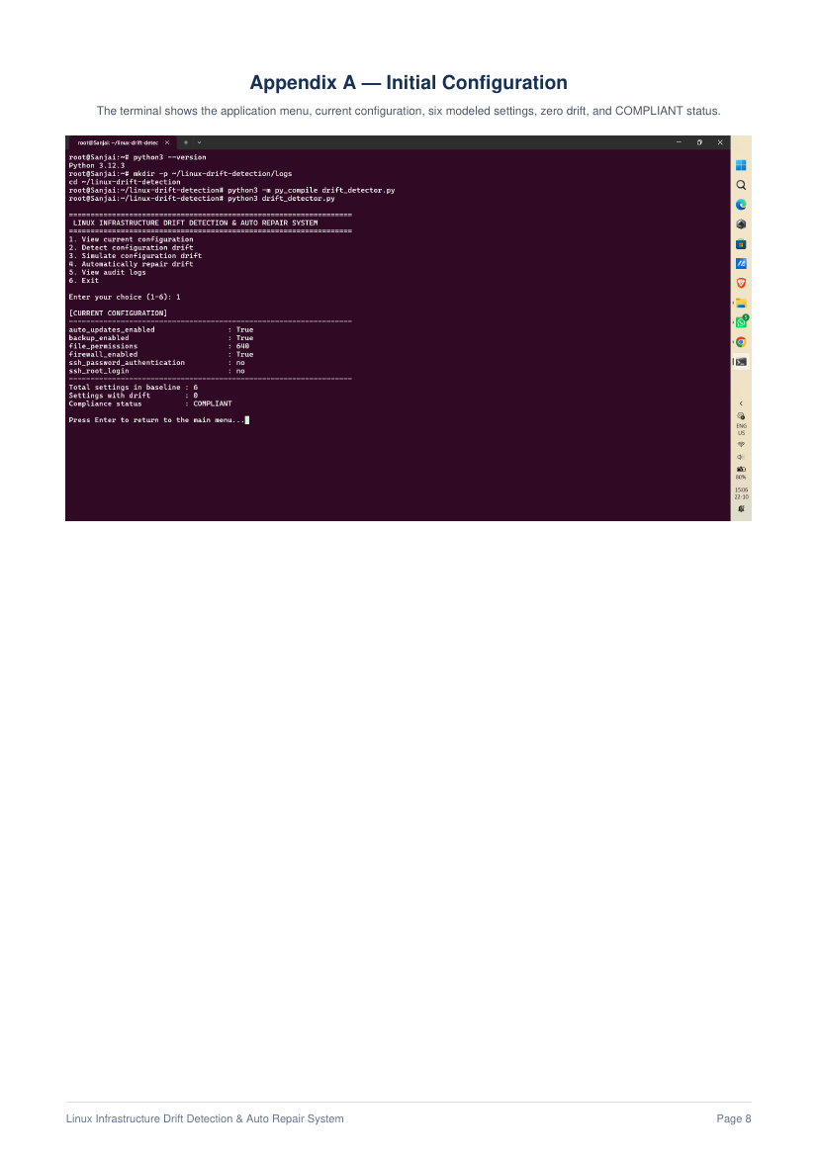

Appendix B — Initial Drift Scan
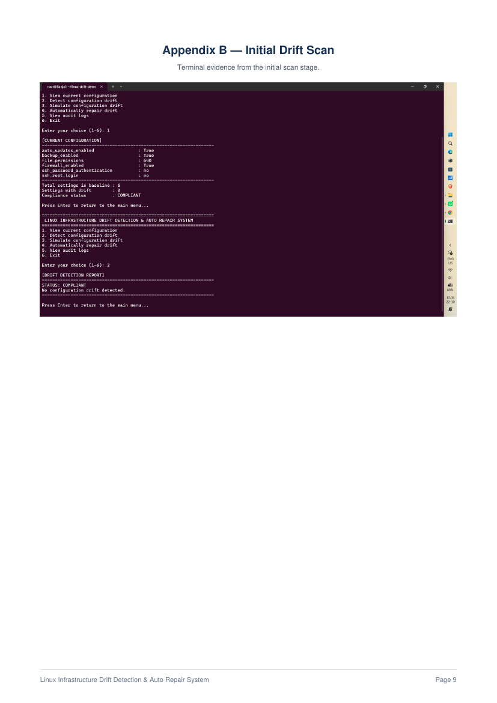

Appendix C — Simulated Drift
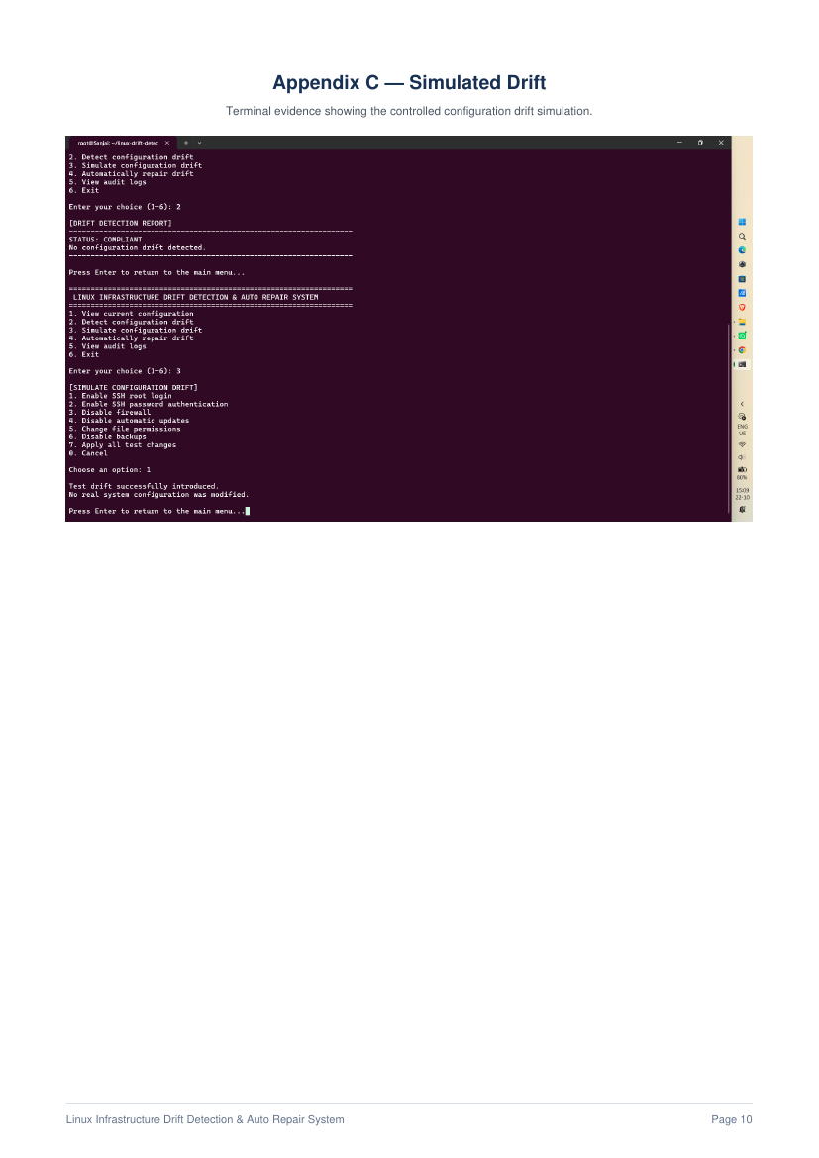

Appendix D — Drift Detection and Repair
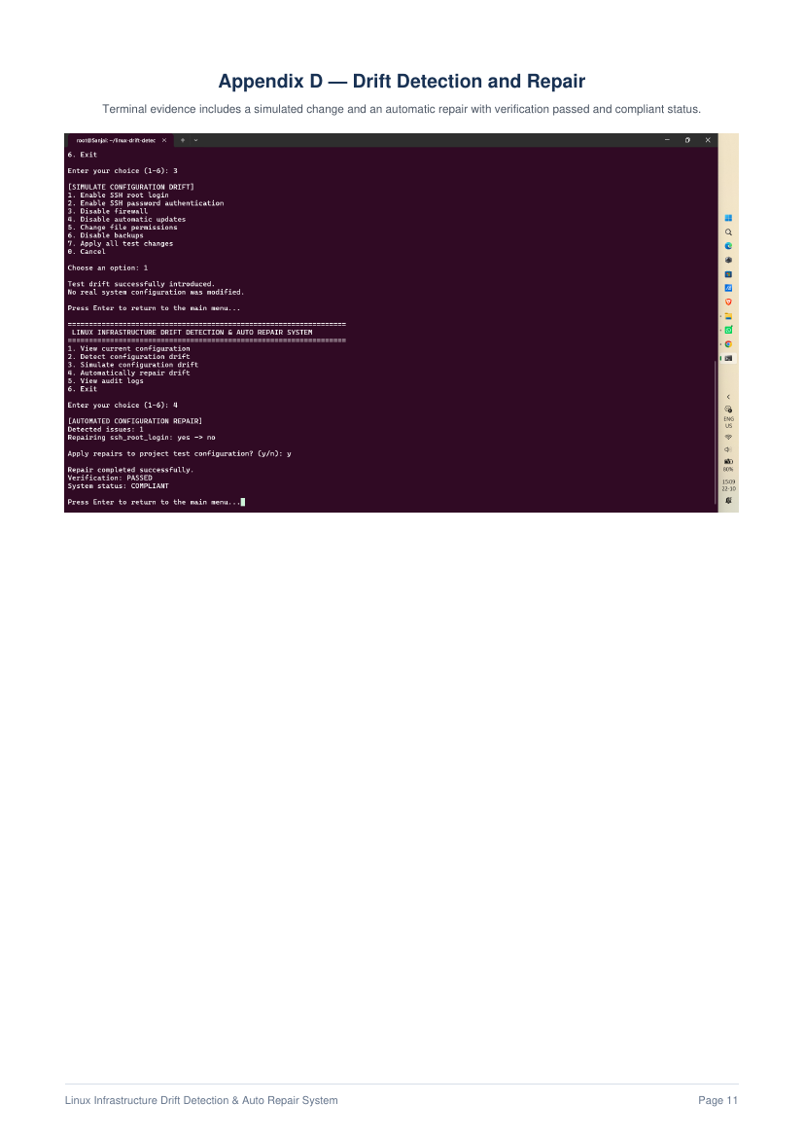

Appendix E — Automated Repair
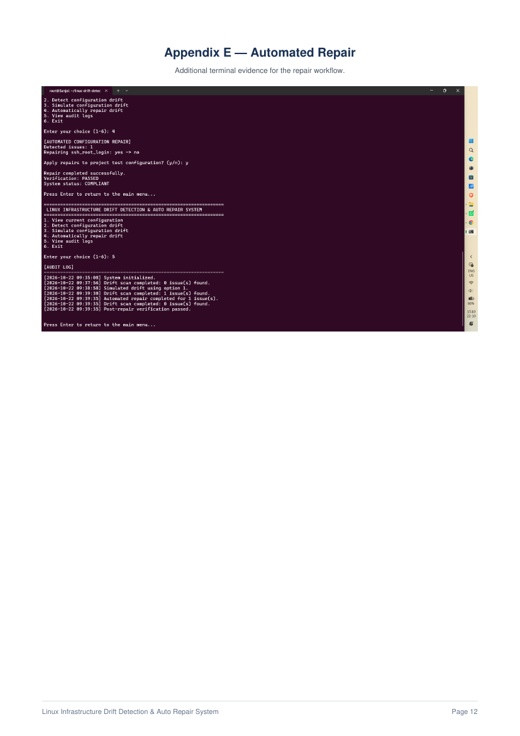

Appendix F — Final Verification


