LibSpace
A Robust Backend for Library Operations

Team ID: SWTID-2026-2404
Team Leader: SANJAIKARTHIKEYAN S K – Project Lead & Backend Development
Team Member: RAGUL R – Database Administrator
Team Member: RAJENDRA SINGH M – Backend Support Developer
Team Member: ROHIT S – API Developer
Team Member: SANTHAKUMAR B – Testing & Documentation

Abstract:
LibSpace is a secure backend-based library management system built using Node.js, Express.js, and MongoDB. It implements JWT-based authentication allowing users to register, login, and logout securely. Authenticated users can perform full CRUD operations on books, with each book privately linked to its owner via MongoDB ObjectId reference. The system follows a layered MVC architecture with separate route, controller, and model layers ensuring clean code organization and scalability. Password security is handled using bcrypt hashing and a token blacklist collection manages session invalidation on logout. All APIs were tested and verified using Postman.

PROJECT OVERVIEW
LibSpace is a backend-based library management system designed to demonstrate secure user authentication and efficient book management using REST APIs. Users can register, log in securely, and manage their personal collection of books. After authentication, users can perform CRUD operations on books including adding, viewing, updating, and deleting book records stored in the database.

PROJECT OBJECTIVE
- Develop a secure backend system using Node.js and Express.js.
- Implement authentication using JSON Web Tokens (JWT).
- Enable CRUD operations for book management.
- Integrate MongoDB database using Mongoose.
- Design a scalable and maintainable backend architecture.

TECHNOLOGY STACK
- Component | - Technology
- Runtime Environment | - Node.js
- Framework | - Express.js
- Database | - MongoDB
- ODM | - Mongoose
- Authentication | - JWT
- Password Security | - bcrypt
- Testing Tool | - Postman

PROJECT DEVELOPMENT PHASES

Phase 1 – Ideation
The ideation phase focused on identifying challenges in traditional library management and proposing a simple backend solution for managing books and users.

Phase 2 – Design Requirements
In this phase, system requirements were defined including authentication, API endpoints, and database design.

Phase 3 – Project Planning
The project was organized into stages such as backend setup, authentication implementation, CRUD operations, and testing.

Phase 4 – Solution Design
The architecture follows a layered structure where routes handle requests, controllers process business logic, and models interact with the database.

Phase 5 – Testing
API endpoints were tested using Postman to ensure correct functionality of user authentication and book management features.

KEY FEATURES
- User registration and login with secure password hashing.
- JWT-based authentication for protected routes.
- Add, view, update, and delete books.
- One-to-many relationship between users and books.
- Secure and structured REST API responses.

PROJECT STRUCTURE

- MY-LIBSPACE-MAIN/
- │
- ├── Config/
- │ └── db.js
- │
- ├── controller/
- │ ├── authController.js
- │ └── bookController.js
- │
- ├── middlewares/
- │ └── verify_token.js
- │
- ├── models/
- │ ├── blackListerToken.js
- │ ├── book.model.js
- │ └── user.model.js
- │
- ├── routes/
- │ ├── book.route.js
- │ └── user.route.js
- │
- ├── node_modules/
- │
- ├── .env
- ├── .gitignore
- ├── index.js
- ├── package.json
- ├── package-lock.json
└── README.md

OUTPUT:
- Server Initialization The server started successfully on PORT 5000. MongoDB connection was established and the application is ready to handle incoming API requests.

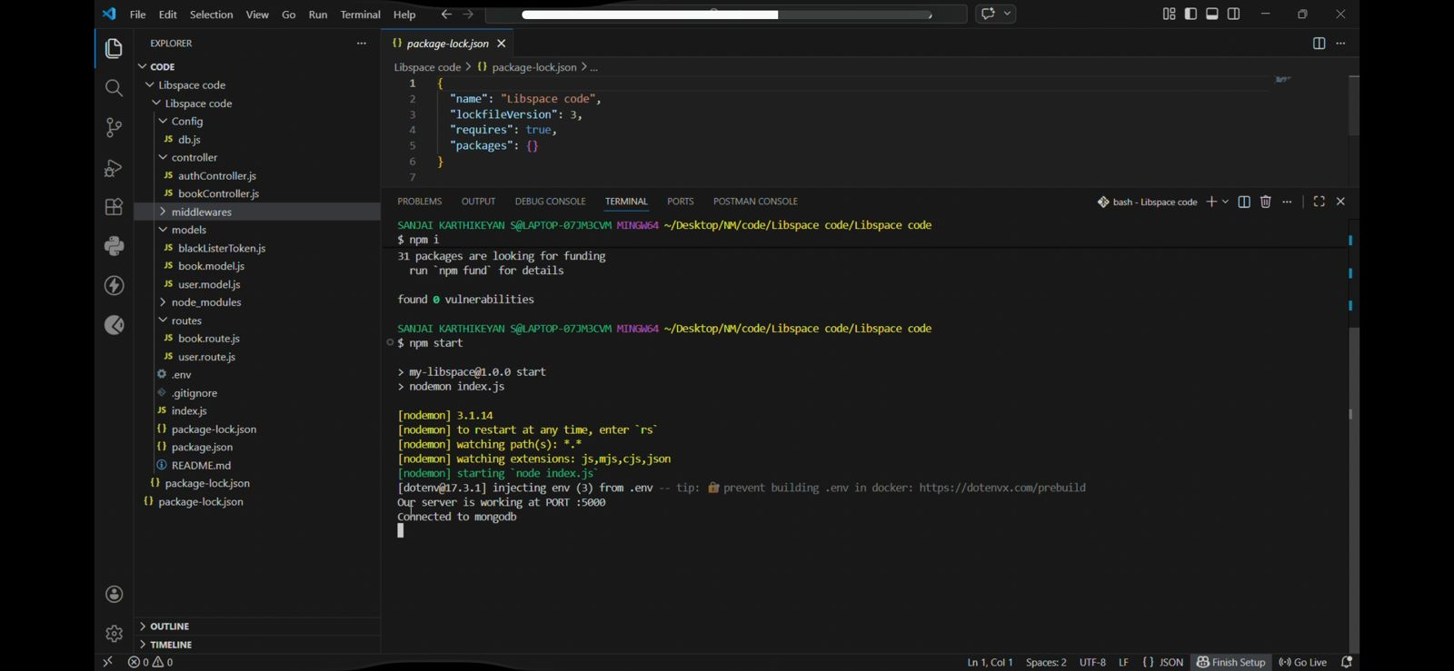

- User Registration A POST request was sent with name, email and password. The user was saved to MongoDB with a hashed password and a success response was returned.
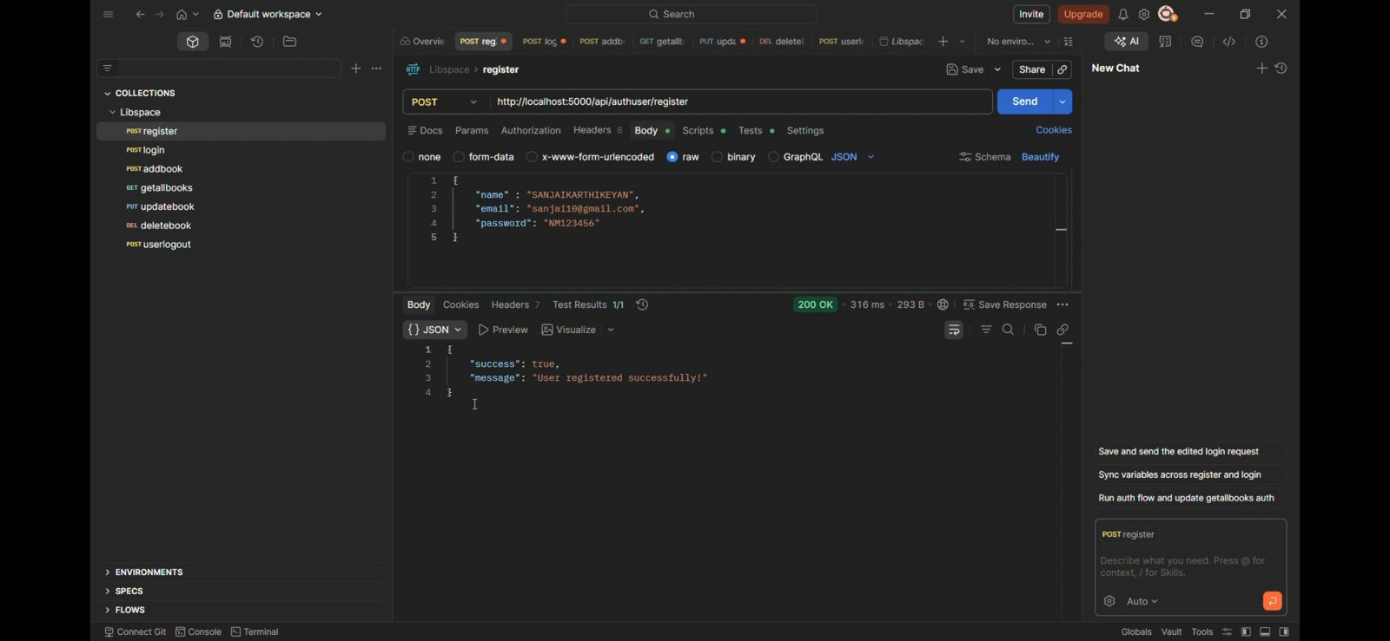

- User Login A POST request was sent with valid credentials. The system verified the user and returned a JWT token to access protected routes.
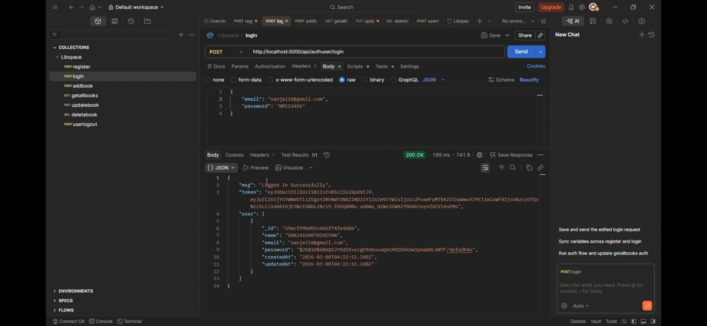
- Add Book An authenticated POST request was sent with book details. The book was linked to the logged-in user and saved successfully to the database.
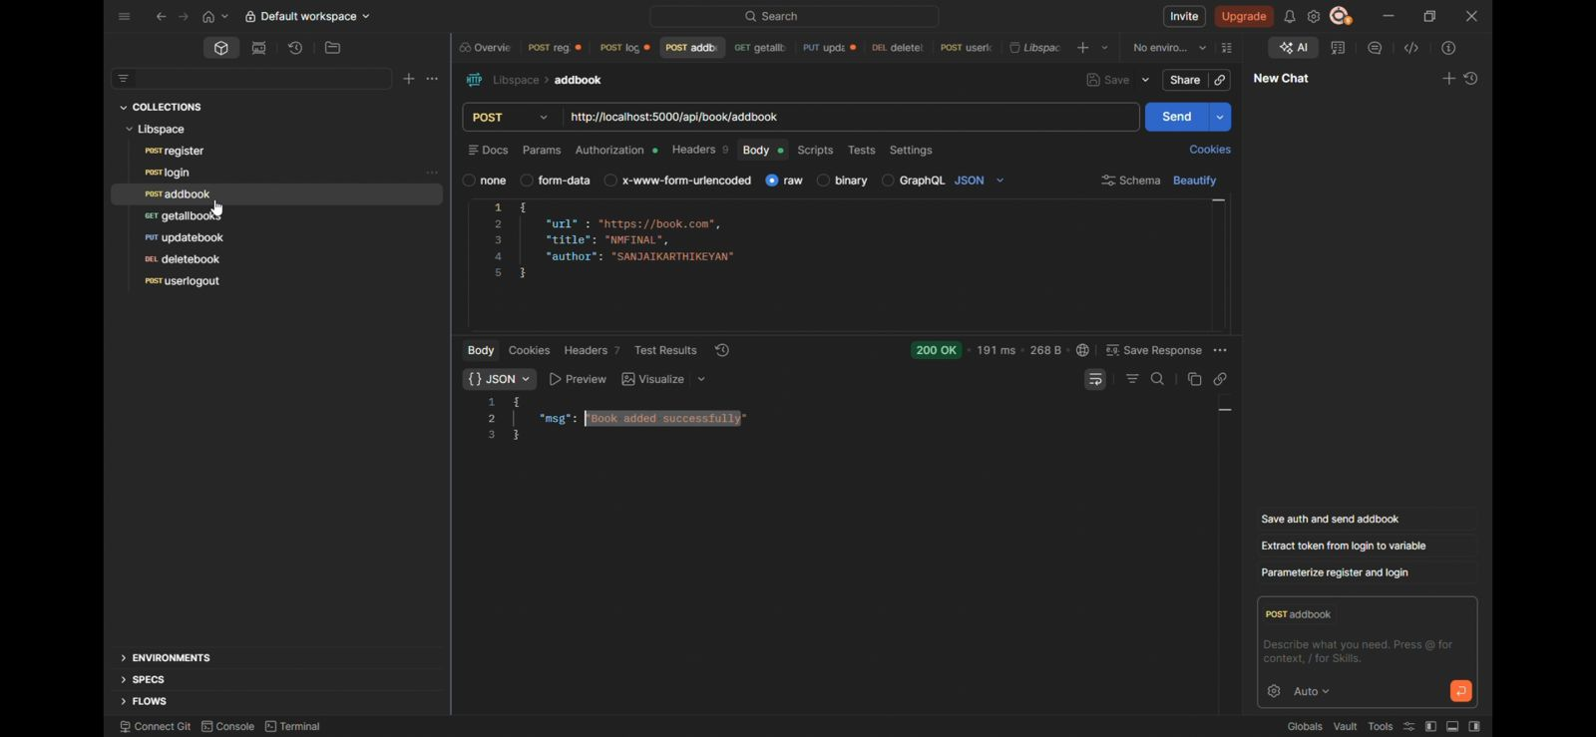

- Get All Books A GET request was sent with a valid token. All books belonging to the authenticated user were retrieved and returned as a JSON array.
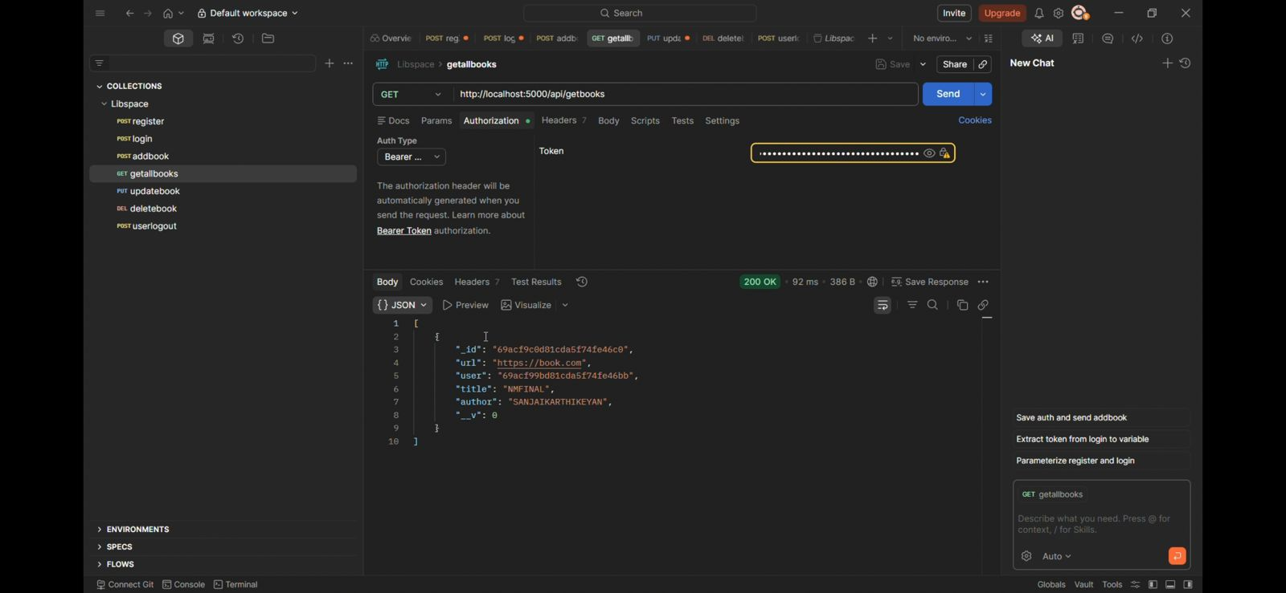

- Update Book A PUT request was sent with updated book details and a valid token. The system located the book and saved the changes successfully.
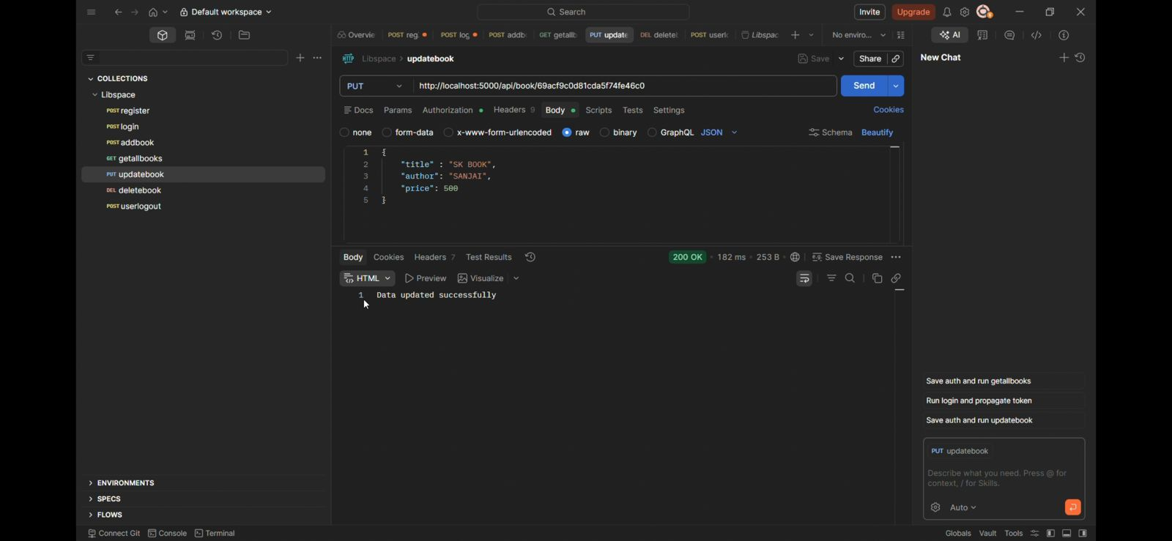
- Delete Book A DELETE request was sent with a valid token and book ID. The book was permanently removed from the database and a success response was returned.
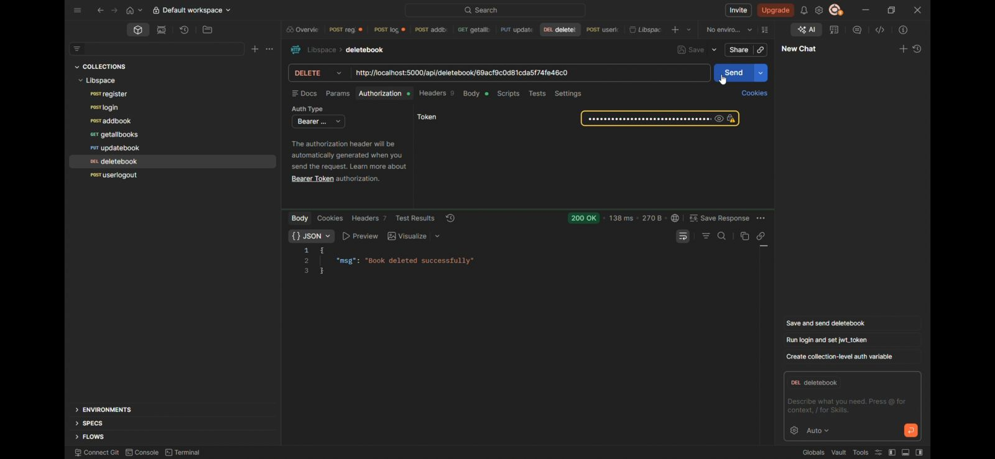

- User Logout A logout request was sent with the current token. The token was blacklisted and the session was invalidated successfully.
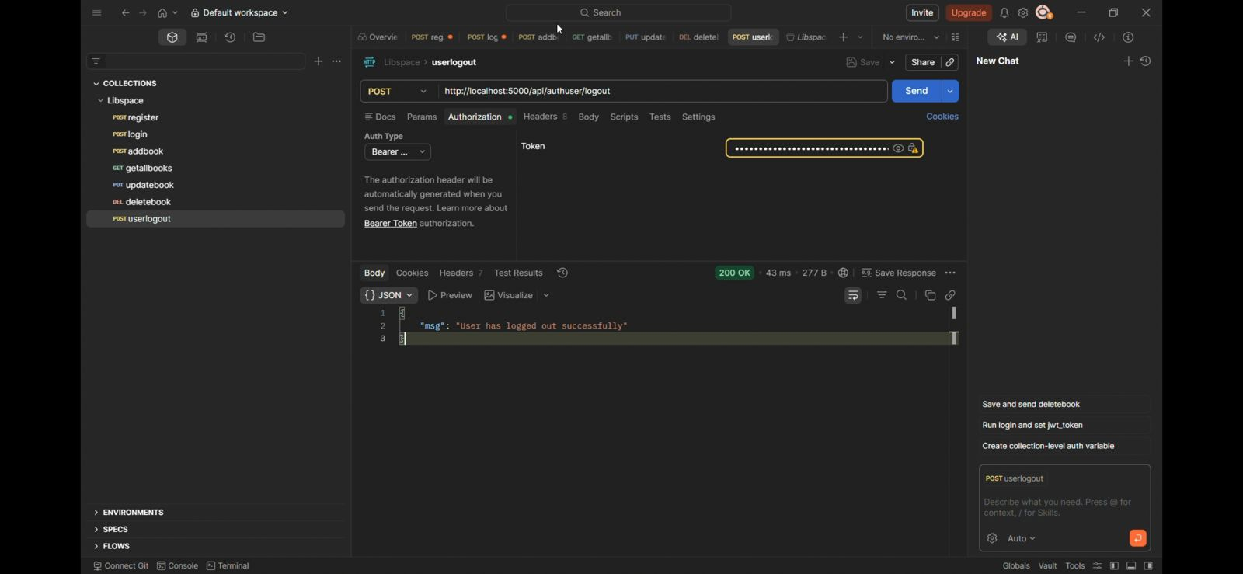

FUTURE ENHANCEMENT
- Develop a frontend interface using React or Next.js for better user interaction.
- Add advanced search and filtering options for books.
- Implement role-based access control (admin and user roles).
- Integrate cloud storage for storing book images or files.
- Add analytics and reporting features for library usage.
- Deploy the application on cloud platforms such as AWS or Vercel.

CONCLUSION
LibSpace demonstrates the development of a secure backend application using Node.js, Express.js, and MongoDB. The project successfully integrates authentication, REST APIs, and database management while following a structured architecture. With further improvements and a frontend interface, LibSpace can evolve into a complete library management platform.

