AI StudyBuddy API
Deliver Intelligent, Personalized Study Assistance.

Description
The AI StudyBuddy API is a robust RESTful backend platform built with Node.js and Express.js, utilizing MongoDB and Mongoose ODM for data persistence. It lets students organize subjects, study topics, and notes in one place, and integrates Google Gemini AI to deliver intelligent summaries, practice questions, and personalized revision recommendations based on the stored study content.
The platform features secure JWT authentication, bcrypt password hashing, and a comprehensive suite of endpoints for managing study topics and generating AI study aids. It includes a resilient fallback mode ensuring API functionality even without external API keys, alongside centralized error handling and request sanitization.

Scenario-Based Case Study

Background
Priya is a college student preparing for multiple semester exams. She needs a streamlined way to organize her subjects and receive AI-driven help such as concise summaries, practice questions, and revision plans.

Problem
- Difficulty organizing study topics, notes, and subjects in one centralized place.
- Lack of personalized study plans and revision suggestions based on individual learning needs.
- Need for simple, natural language explanations and summaries rather than dense textbook content.
- Absence of a secure system to store and sync study materials and progress across devices.

Solution
The AI StudyBuddy API provides a centralized service that handles study data management and AI orchestration. It manages a secure User and Topic database, allowing customized study insights and automated learning workflows through Google Gemini.

Usage
- User Usage: Manages subjects and study topics (CRUD), stores notes and progress, and requests AI summaries, quizzes, and revision recommendations.
- Developer/Admin Usage: Monitors API health, manages user accounts, and verifies the database and AI service integrations.
- Guest User: Interfaces with public endpoints to access general study tips and API information without requiring an account.

Outcome
By leveraging AI and centralized data management, students spend less time reorganizing notes and more time learning effectively. The system ensures data integrity via Mongoose schemas and provides high-value, context-aware study assistance through Gemini integrations.

1. Software Requirements
- Operating System: Windows 10/11, macOS, or Linux (supports cross-platform operations).
- Node.js (v16 or above): Runtime environment running server logic and routing.
- npm (v8 or above): Node package manager to control project dependencies.
- Gemini AI SDK: Integration using @google/generative-ai for natural language study aids.
- MongoDB: NoSQL document database storing users, subjects, topics, notes, and progress.
- Postman: API testing toolkit to verify endpoints, responses, and protected routes.
- Code Editor: Visual Studio Code or a similar IDE.

2. Hardware Requirements
- Processor: Intel Core i5 (8th Gen or above) / AMD Ryzen 5 or equivalent.
- RAM: 8 GB minimum (16 GB recommended for concurrent MongoDB and application instances).
- Storage: 1 GB of available disk workspace.

Epic 1: PROJECT ARCHITECTURE
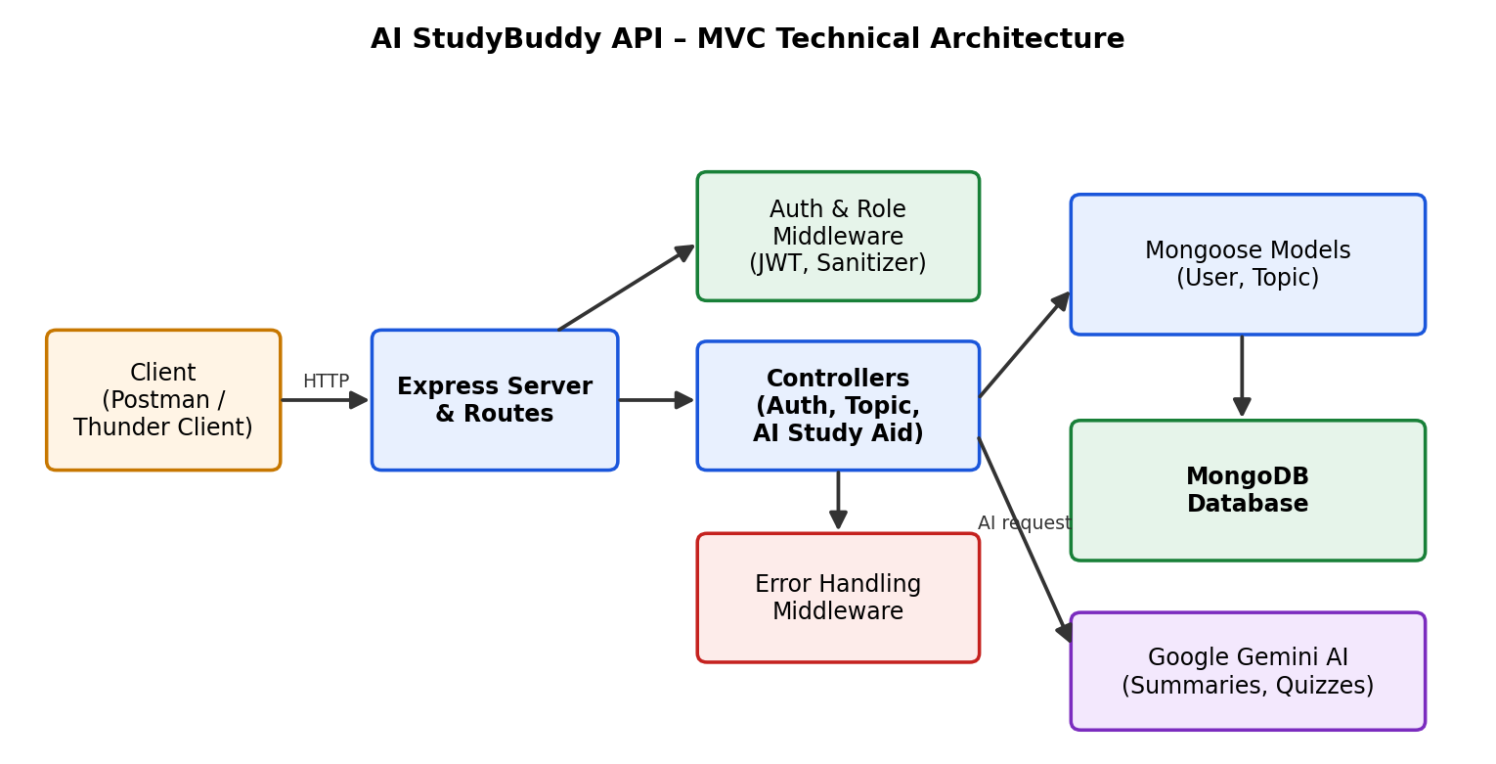
Fig 1.1 – Technical architecture of the AI StudyBuddy API
The AI StudyBuddy application follows the MVC pattern to decouple business logic from data management. The Controller layer orchestrates study topic management and the generation of AI study aids via Gemini, while the Model layer manages User and Topic entities.

Components Definition
- Interface: API tools like Postman query distinct route paths to exchange JSON entities.
- Express Server Gateway: Listens on the network port, maps HTTP methods (GET, POST, PUT, DELETE), parses JSON payloads, and handles CORS headers.
- Authentication & Role Matrix Middleware: Extracts tokens from headers, validates JWT signatures, and checks whether the user's role satisfies authorization requirements for protected routes.
- Granular Services (Logic Modules): Enforce isolated domain rules for subjects, topics, notes, progress tracking, and admin reporting.
- Database Interface Layer: Mongoose translates application logic into native MongoDB queries.
- AI Service Integration: Leverages @google/generative-ai to generate summaries, practice questions, and revision recommendations from stored topic notes.

Entity-Relationship (ER) Diagram Description
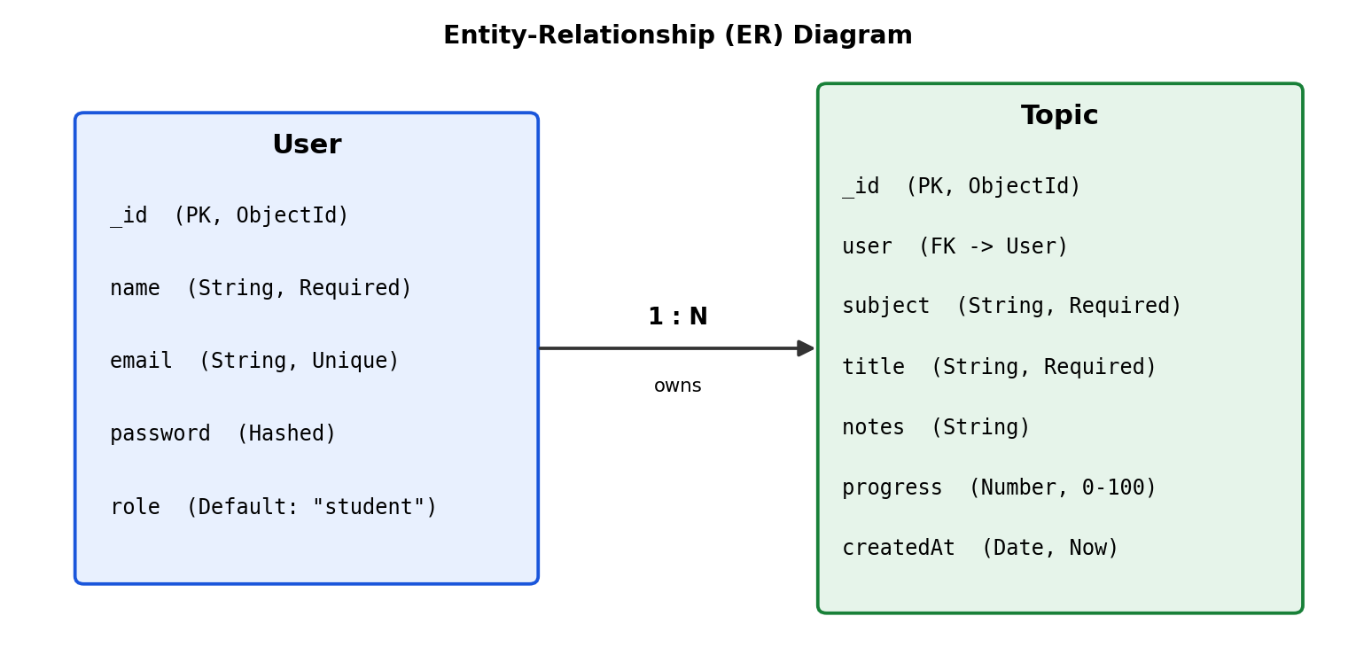
Fig 1.2 – ER diagram: User to Topic (One-to-Many)
The data architecture manages User profiles and their associated study Topics through logical references:

1. User Entity
- _id (Primary Key – ObjectId)
- name (String, Required)
- email (String, Required, Unique)
- password (String, Hashed, Required)
- role (String, Default: "student")

2. Topic Entity
- _id (Primary Key – ObjectId)
- user (Foreign Key referencing User Collection)
- subject (String, Required)
- title (String, Required)
- notes (String)
- progress (Number, Default: 0)
- createdAt (Date, Default: Now)

Key Structural Mappings
- User to Topic (One-to-Many): A registered user can create and store multiple subjects and study topics.

Key Features
- Role-Based Route Guarding: Strict token processing blocks unauthorized access to protected resources and admin operations.
- CRUD Study Management Engine: Complete create, read, update, and delete control over subjects, topics, notes, and progress.
- AI Study Aids: Gemini-powered summaries, practice questions, and personalized revision recommendations.
- Fallback Mode: AI endpoints remain operational with a graceful fallback response when external API keys are unavailable.
- Sanitization Safeguards: Payload sanitation prevents XSS vectors and NoSQL injection.

Roles and Responsibilities
- Admin:
  - Manages user accounts, including creating, deleting, or suspending accounts.
  - Oversees API health and system logs to monitor performance.
  - Monitors and maintains database integrity.
- Registered User:
  - Creates and maintains subjects and study topics with notes and progress.
  - Requests AI-generated summaries, quizzes, and revision recommendations.
  - Manages own authentication credentials and profile details.
- Guest User: Accesses public endpoints for general study tips and API information.

User Flow:
- User logs in or registers.
- User creates a subject and saves a study topic with notes via the API.
- User retrieves stored notes and progress for that topic.
- User requests AI-driven study aids (summaries, quizzes, recommendations) based on the notes.
- System validates the JWT and returns the requested information.
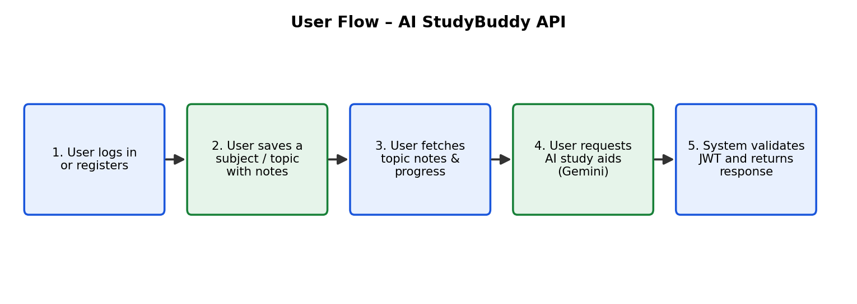
Fig 1.3 – User flow of the AI StudyBuddy API

MVC Architecture Pattern
The system structures its source code around the Model-View-Controller design pattern to completely decouple components.

Model Layer (Data Blueprint)
Defines strongly enforced Mongoose schemas that map fields into MongoDB collections. It sets default values, indexing rules, and validation before data is persisted.

Controller Layer (Execution Matrix)
The intermediary of the system. It receives requests from the routes, checks request constraints, delegates processing to models and the Gemini service, and packages results into standard JSON responses.

View Layer (Routing Network Interface)
In this headless backend service, traditional UI templates do not exist. Instead, the view layer is the API Routing Layer, which links network requests on specified paths to their associated controller handlers.

Epic 2: Project Setup and Configuration

Creating the Project Folder
- Create a new folder named AI StudyBuddy.
- Open the project folder in Visual Studio Code.
- Initialize the project using Node.js and install the required dependencies.

Project Initialization
Open the project folder in the VS Code terminal and execute:
npm init -y

Install the required dependencies:
npm install express mongoose bcryptjs jsonwebtoken cors dotenv @google/generative-ai

Install Nodemon for development:
npm install --save-dev nodemon

Create the Following Files
- index.js
- .env
- package.json
- .gitignore

Create the Following Folder Structure
AI-StudyBuddy/
├── config/
│ └── db.js
├── controllers/
│ ├── authController.js
│ ├── topicController.js
│ └── aiController.js
├── middleware/
│ ├── authMiddleware.js
│ ├── sanitize.js
│ └── errorHandler.js
├── models/
│ ├── User.js
│ └── Topic.js
├── routes/
│ ├── authRoutes.js
│ ├── topicRoutes.js
│ └── aiRoutes.js
├── .env
├── .gitignore
├── index.js
└── package.json

Environment Configuration
Create a .env file in the project root and configure the required environment variables.
PORT=5000
MONGO_URI=your_mongodb_connection_string
JWT_SECRET=your_jwt_secret
GEMINI_API_KEY=your_gemini_api_key

Epic 3: Backend Development
The AI StudyBuddy backend is developed using Node.js, Express.js, and MongoDB, following a modular architecture. The application separates routing, controllers, middleware, models, and utility modules to improve maintainability and scalability. The backend exposes secure REST APIs for authentication, study topic management, AI-powered study aid generation, and administrative operations.

Backend Modules
- Authentication Module: Registration, login, JWT issuance, and bcrypt password hashing.
- Topic Module: Full CRUD for subjects and study topics, scoped to the authenticated user.
- Notes Module: Stores and retrieves study notes and progress details for each topic.
- AI Study Aid Module: Integrates Google Gemini AI to generate summaries, practice questions, and revision recommendations.
- Admin Module: User account management and API/service health monitoring.
- Middleware: Authentication guard, role-based access control, request sanitization, and centralized error handling.

API Endpoints
Method | Endpoint | Description | Access
POST | /api/auth/register | Register a new user | Public
POST | /api/auth/login | Login and receive JWT | Public
GET | /api/topics | List the user's topics | User
POST | /api/topics | Create a subject/topic with notes | User
PUT | /api/topics/:id | Update topic, notes, or progress | User
DELETE | /api/topics/:id | Delete a topic | User
POST | /api/ai/study-aid/:id | Generate summary, quiz, and recommendations | User
GET | /api/tips | General study tips and API info | Public
GET | /api/admin/users | View and manage registered users | Admin
GET | /api/admin/health | API and service health status | Admin

Core System Script Implementations

1. Application Entry Point (index.js)
The index.js file serves as the main entry point of the application. It initializes the Express server, loads environment variables, configures middleware, establishes the MongoDB connection, registers API routes, and starts the server after a successful database connection.
const express = require('express');
const cors = require('cors');
const dotenv = require('dotenv');
const connectDB = require('./config/db');
const sanitize = require('./middleware/sanitize');
const errorHandler = require('./middleware/errorHandler');

dotenv.config();
const app = express();

app.use(cors());
app.use(express.json());
app.use(sanitize);

app.use('/api/auth', require('./routes/authRoutes'));
app.use('/api/topics', require('./routes/topicRoutes'));
app.use('/api/ai', require('./routes/aiRoutes'));

app.use(errorHandler);

const PORT = process.env.PORT || 5000;
connectDB().then(() => {
app.listen(PORT, () => console.log(`Server running on port ${PORT}`));
});

Epic 4: Database Configuration

1. Configure MongoDB
- Install Mongoose. In your Node.js project directory, run:
npm install mongoose

- Create the database connection.
- Create Schemas & Models.

Database Connection
This module establishes a connection between the application and MongoDB using Mongoose. It ensures the backend communicates with the database before processing any client requests.
// config/db.js
const mongoose = require('mongoose');

const connectDB = async () => {
try {
await mongoose.connect(process.env.MONGO_URI);
console.log('MongoDB connected');
} catch (err) {
console.error('MongoDB connection error:', err.message);
process.exit(1);
}
};

module.exports = connectDB;

Mongoose Schema Definitions

User Schema
// models/User.js
const mongoose = require('mongoose');

const userSchema = new mongoose.Schema({
name: { type: String, required: true },
email: { type: String, required: true, unique: true },
password: { type: String, required: true },
role: { type: String, default: 'student' }
});

module.exports = mongoose.model('User', userSchema);

Topic Schema
// models/Topic.js
const mongoose = require('mongoose');

const topicSchema = new mongoose.Schema({
user: { type: mongoose.Schema.Types.ObjectId, ref: 'User', required: true },
subject: { type: String, required: true },
title: { type: String, required: true },
notes: { type: String, default: '' },
progress: { type: Number, default: 0, min: 0, max: 100 },
createdAt: { type: Date, default: Date.now }
});

module.exports = mongoose.model('Topic', topicSchema);

Epic 5: Project Executions
The AI StudyBuddy backend can be executed locally using Node.js. Before running the application, ensure that MongoDB is running and the required environment variables are configured correctly. The backend exposes REST APIs that can be tested using Postman or Thunder Client.

Running the Backend Server
Install all required dependencies:
npm install

Start the development server:
npm start

After successful execution, the server connects to MongoDB and starts listening for incoming API requests.
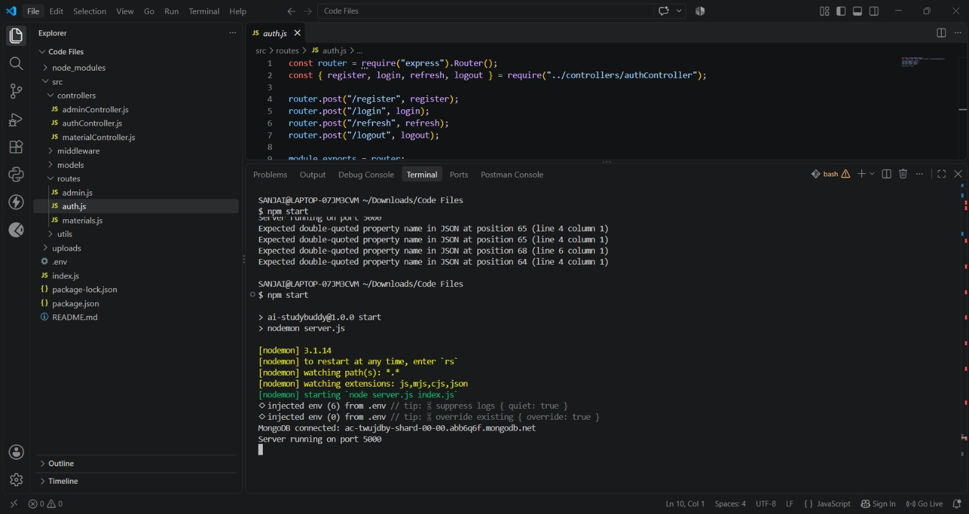
Fig 5.1 – Backend server running and connected to MongoDB

API Testing

Test Cases
ID | Test Case | Input | Expected Output | Result
TC01 | Register API | Valid name, email, password | User created, 201 response | Pass
TC02 | Login API | Valid registered email & password | JWT token returned, 200 response | Pass
TC03 | Login API | Invalid password | 401 Unauthorized error | Pass
TC04 | Topic API | Valid subject, title, notes + JWT | Topic created, 201 response | Pass
TC05 | AI Study Aid API | Valid topic notes + JWT | AI summary & recommendation returned | Pass
TC06 | Topic CRUD | Add / Update / Delete topic | Topic persisted / updated / removed | Pass

Bugs Found and Fixes
Bug | Fix
Missing token returned 500 instead of 401 | Added explicit check in auth middleware to return 401 when no token is supplied
Duplicate email allowed on registration | Added unique index and pre-save validation on the email field
AI service failure crashed the request | Wrapped Gemini AI call in try/catch with a graceful fallback response

Register API:
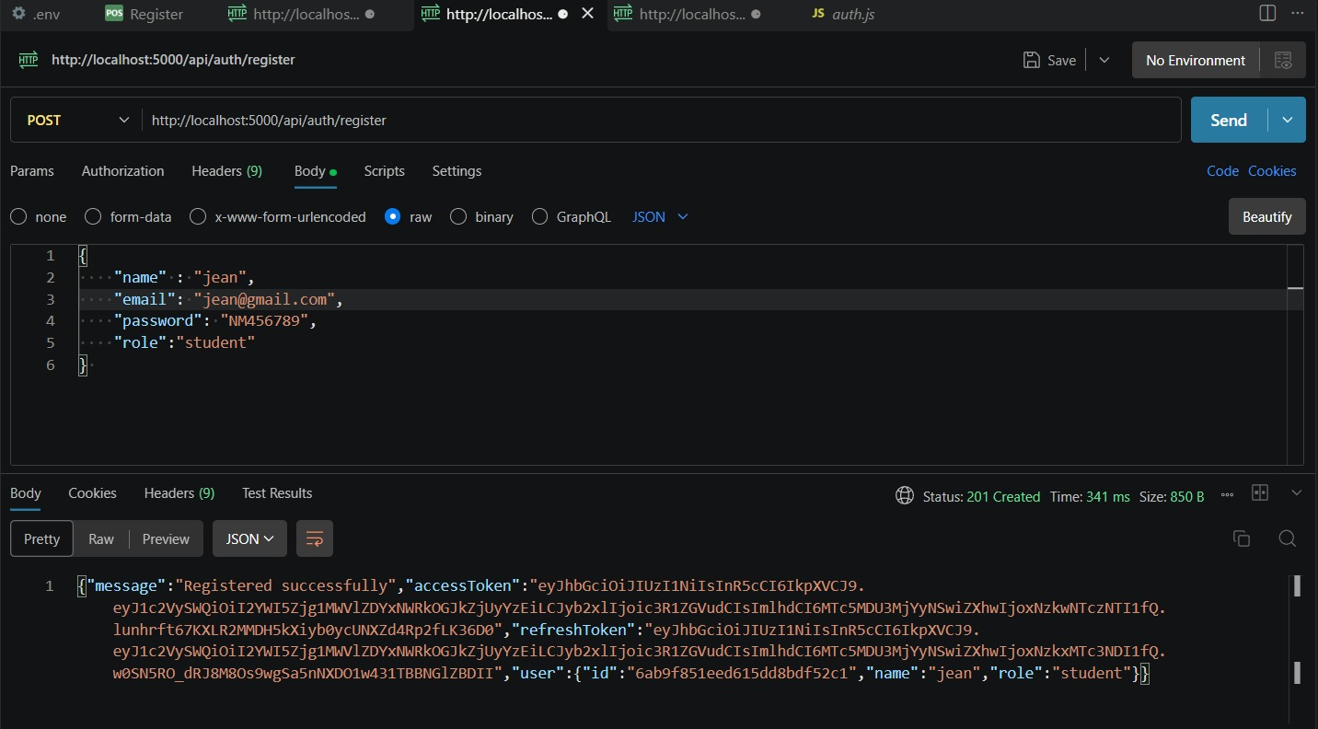
Fig 5.2 – Register API tested in Postman

Login API:
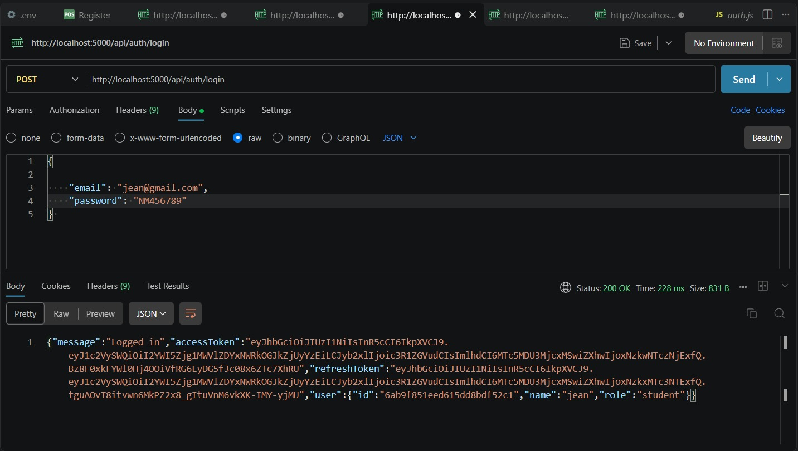
Fig 5.3 – Login API tested in Postman

Logout API:
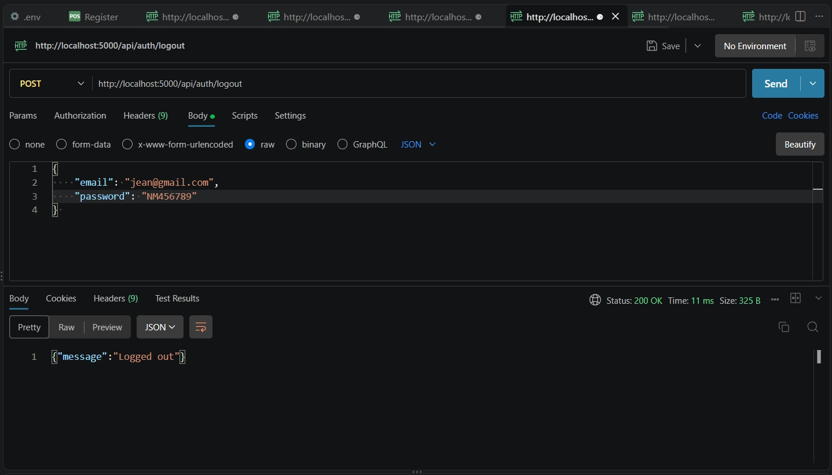
Fig 5.4 – Logout API tested in Postman

Admin – View Users API:
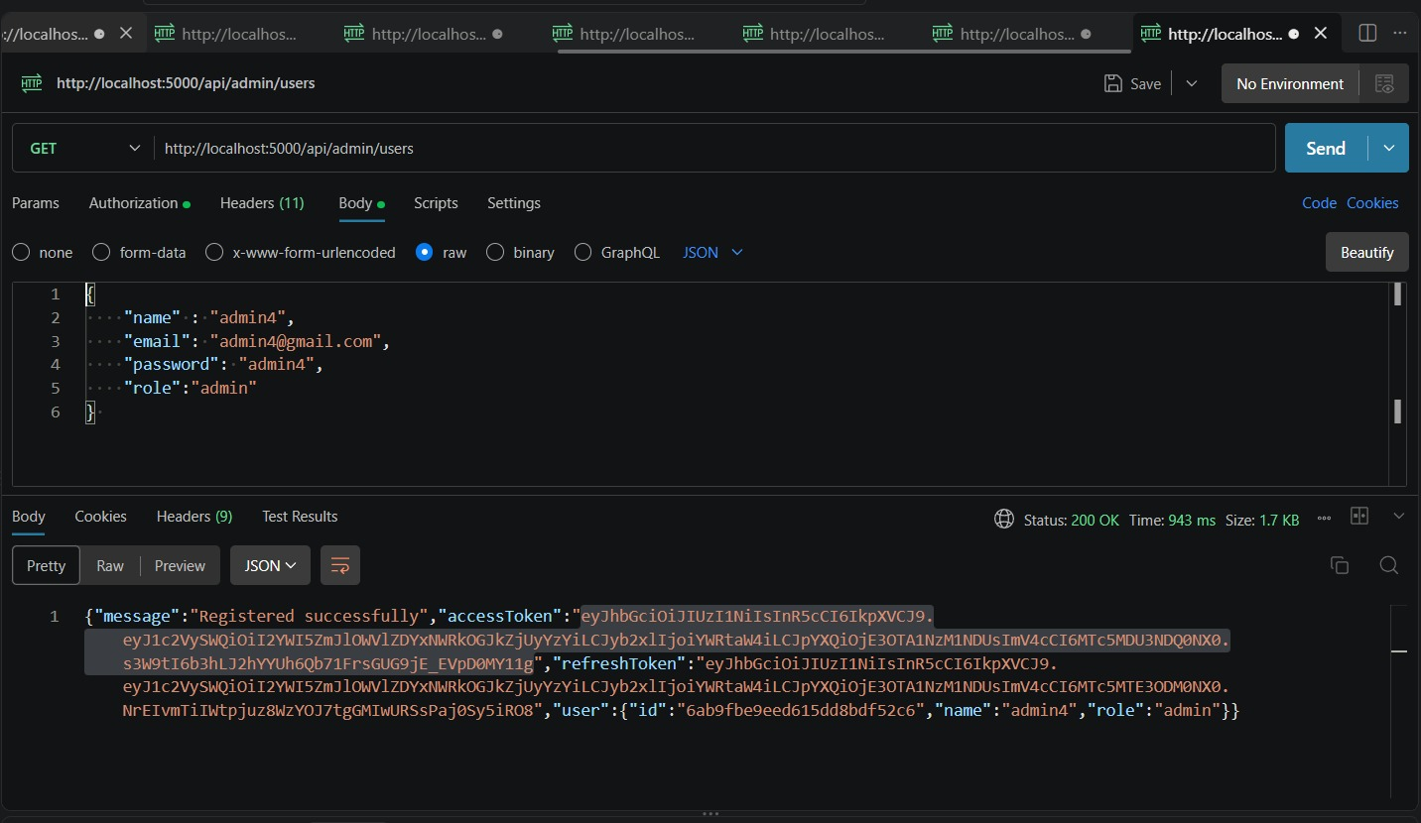
Fig 5.7 – Admin Users API tested in Postman

Admin – Delete User API:
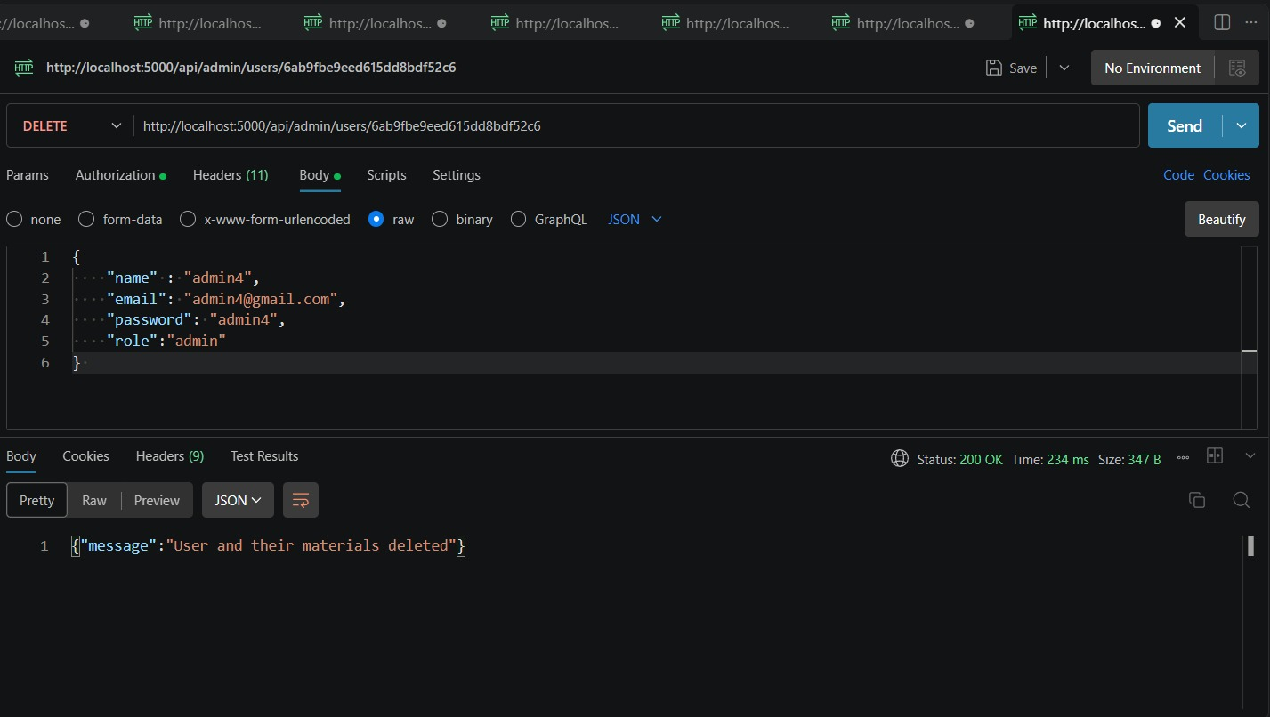
Fig 5.8 – Admin Delete User API tested in Postman

Project Links
API testing video link: https://drive.google.com/file/d/1Hsz0syyzCukHYZKq39xs9mc8n357IC38/view?usp=drive_link
Demo video link:
https://drive.google.com/file/d/1ZaSsEQPKRCTRP-IHba7uzZkaBJ6YmhQH/view?usp=drive_link
Code Drive: https://drive.google.com/drive/folders/1LaL9RJdaRrFwspP5kBXrPJQKPa3iiWjX?usp=drive_link

Conclusion
AI StudyBuddy API demonstrates how a well-structured MVC backend, combined with a modern AI service, can transform raw study notes into meaningful, personalized learning support for students. The project meets its objectives of security, reliability, and intelligent study aid generation.

Future Enhancements
- Develop a companion web or mobile front-end client to consume the REST API.
- Add study reminders and exam countdown notifications.
- Support multi-language AI-generated summaries.
- Introduce caching for frequently requested AI responses.
- Add automated unit and integration tests (Jest/Mocha) for continuous integration.

