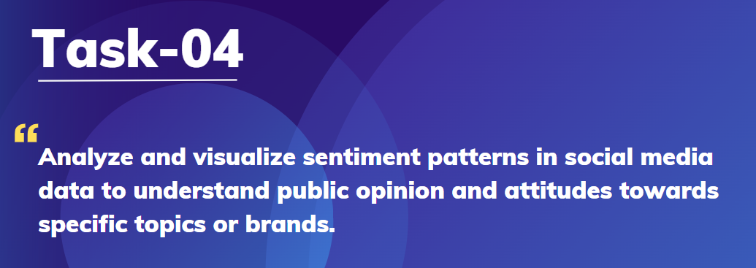

**Overview**

This repository contains the code and documentation for my data science internship project at Prodigy Infotech, focusing on Twitter sentiment analysis. The project aims to analyze sentiment patterns in Twitter data to gain insights into public opinion and attitudes towards various topics, brands, and events.

## Dataset

The [dataset](https://github.com/kindo-tk/PRODIGY_DS_04/blob/main/twitter_training.csv) used for this project consists of Twitter data collected from Kaggle.

## Conclusion

The sentiment analysis provides valuable insights into prevailing attitudes and opinions within the Twitter community regarding various topics. While negative sentiments appear to be more common overall, there is a diverse range of sentiments expressed across different topics. Understanding these sentiment trends can inform decision-making processes, marketing strategies, and community engagement efforts in both online and offline contexts.

