**Chapter 2.1**[**Design of control unit**](https://lms.cuchd.in/mod/resource/view.php?id=814148)

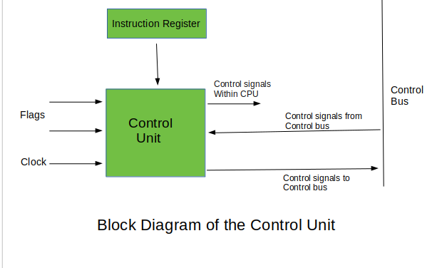

*Control unit is responsible for controlling the overall operation of the CPU. It is responsible for fetching instructions from memory, decoding them, and executing them. There are two types of control units: hardwired control units and microprogrammed control units.*

***Hardwired Control Unit***

* *Uses a combinational logic circuit to generate control signals for instruction execution*
* *Control signals are generated using a fixed set of gates and flip-flops*
* *Fast, simple, and reliable*
* *Inflexible and cannot be easily modified or updated*
* *Suitable for simple and well-defined instruction sets*

***Advantages of Hardwired Control Unit:***

* *Fast and simple design*
* *Reliable operation*
* *Lower cost and complexity*
* *Suitable for simple and well-defined instruction sets*

***Disadvantages of Hardwired Control Unit:***

* *Inflexible and cannot be easily modified or updated*
* *Difficult to implement for complex instruction sets*
* *Larger hardware footprint*
* *Limited functionality*

***Microprogrammed Control Unit:***

* *Uses microcode to generate control signals for instruction execution*
* *Microcode is stored in a ROM or a RAM*
* *Microcode is executed by a control unit called a micro sequencer*
* *More flexible than hardwired control units and can be easily modified or updated*
* *Slower and more complex than hardwired control units*
* *Suitable for complex instruction sets and applications that require flexibility and adaptability*

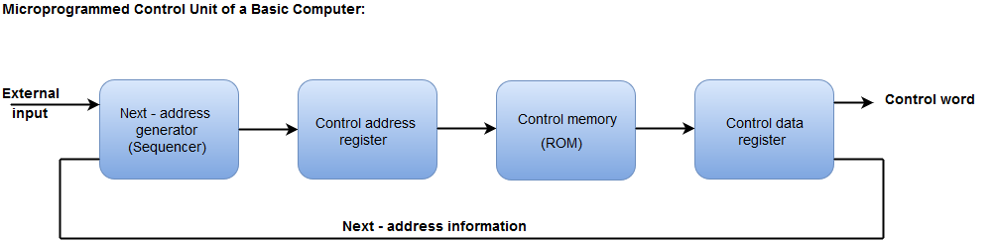

***Advantages of Microprogrammed Control Unit:***

* *More flexible and adaptable than hardwired control units*
* *Can be easily modified or updated*
* *Easier to design for complex instruction sets*
* *Smaller hardware footprint*
* *Can be easily upgraded to support new instructions or features*

***Disadvantages of Microprogrammed Control Unit:***

* *Slower than hardwired control units*
* *More complex design*
* *Higher cost and power consumption*
* *Microcode can introduce errors if not properly designed and tested.*