

AUTOMATIC FIRE EXTINGUISHER

1) PROJECT INTRODUCTION

This automatic fire extinguisher is implemented using a diode as a sensing element which is connected in reverse biased condition and at the output a pump (230v ,50Hz) is connected through a relay. As the external temperature increases, diode reverse current increases and this current energizes the relay which turns ON the pump.

2) COMPONENTS

For Dc Power Supply

* Step Down Transformer(230v to 9v)
* A bridge rectifier using IN4007
* A Filter using 100uF capacitor

For Sensing Circuit

* 2 Diodes IN4007
* Resistors 100k,1k
* Potentiometer 470k
* Capacitors 2.2uF, 100uF
* 2 NPN Transistor BC108, AC128

Output Circuit

* Relay
* 230V ,50Hz AC Pump
* 230V ,50Hz AC Alarm

3) IMPLEMENTED BOARD PHOTO

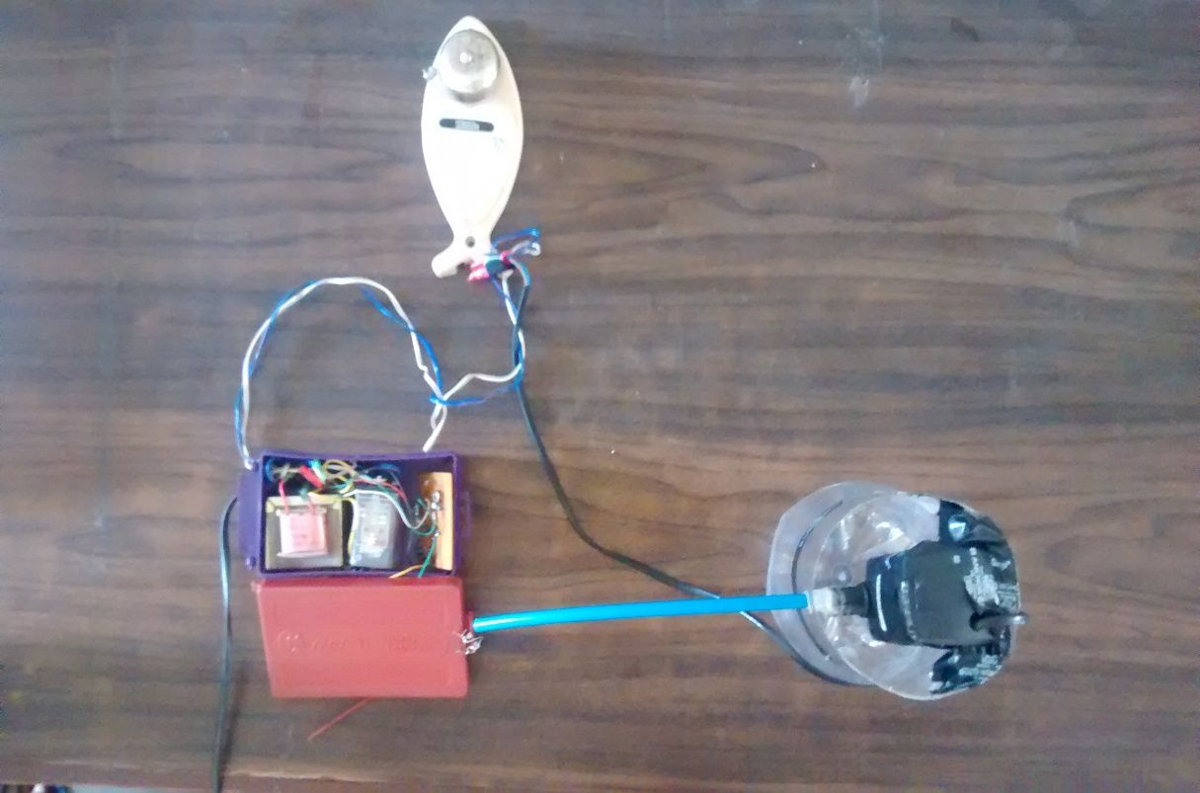

Figure1: Fire Extinguisher setup

4) CIRCUIT DIAGRAM

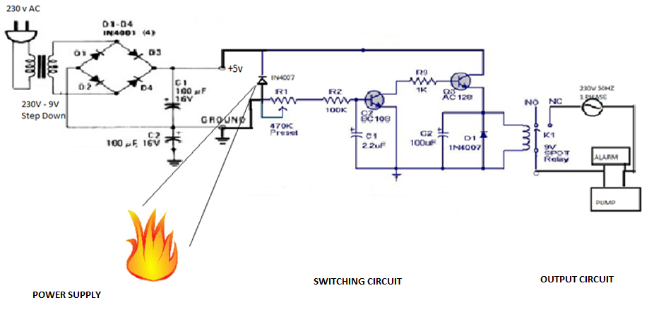

Figure2: Circuit Diagram

5) WORKING

* Power Supply-

The combination of transformer, rectifier and the filter capacitor forms the 9V DC power supply. The Step Down Transformer reduces 230V to 5V. This 5V AC signal when passed through full wave bridge rectifier gets converted to pulsating DC. This pulsating DC gets converted to ripple free constant 5V supply which is being applied to the sensing circuit.

* Sensing Circuit-

The sensing element used in this circuit is IN4007 diode connected in reverse biased condition. As soon as temperature is increased, there is large amount of minority charge carrier that flows across the junction. This minority charge carrier results into tremendous amount of current which results into sufficient flow of base current in transistor T1(first transistor) and as a result collector current flows which results into base current of transistor T2(second transistor). The emitter current of transistor T2 is sufficient to energize the relay. This combination of two amplifier is a multistage amplifier. The purpose behind using multistage amplifier is to amplify the weak signals. The amplification should be sufficient to energize the relay. The potentiometer can be adjusted to respond to very small temperature rise.

As the temperature is increased reverse breakdown voltage (avalanche voltage) is reached at much lower temperature. The typical characteristic of diode voltage versus temperature is shown in the figure3.

* Output Circuit

To respond to change in temperature, AC alarm is connected across an AC pump. As soon as the relay gets energized, the plunger gets attached to NC thereby completing the circuit and the entire 230V ac supply is applied to pump and alarm. The submersible pump sprinkles water to put off the fire.

As temperature drops across diode, it resets to reverse biased condition so no current flows in the circuit and the plunger of relay reset back to its original position.

6) OBSERVATION

The diode used in the reverse biased region. As temperature is increased, there is huge current due to minority carries which is sufficient to drive the output.

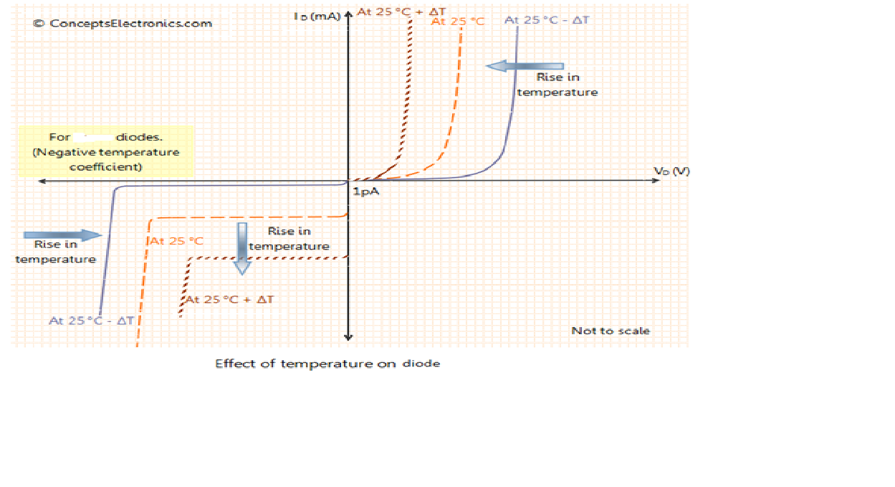

Figure3: Temperature Characteristics of p-n junction diode

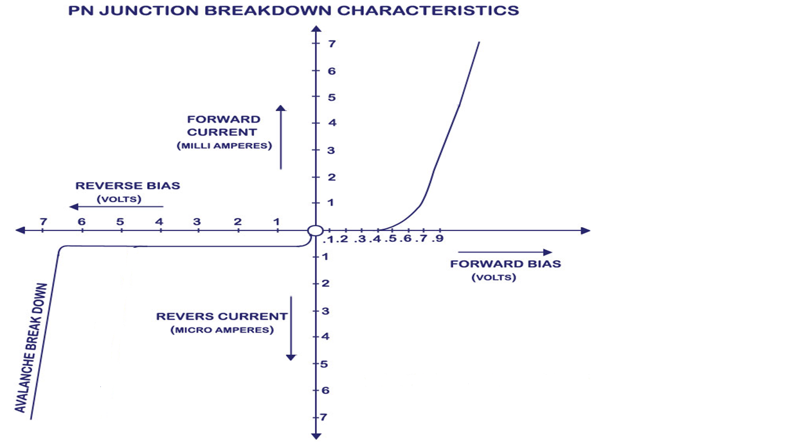

Figure4: P-N junction characteristics

7) APPLICATIONS

Since this system not only sense and detects the fire it also extinguishes it. This kind of system is used where manual extinguishing of fire is not possible. For example in oil rigs where even a small spark is sufficient to ignite or blow off the entire rig and in such situation automatic fire extinguishing system is installed.

8) DIFFICULTIES FACED

Before incorporating a pump we have used a dc fan. The speed of the fan is not sufficient to put off the fire and also we cannot incorporate a DC pump as it cost more. So instead we have installed an AC pump through relay. Now in conditions of relay to work a minimum threshold voltage is necessary to energize it. So here we have amplified the signal through multistage amplifier and the relay gets energized to switch ON the pump and the alarm.

9) CONCLUSION

Due to presence of sensor this kind of system does not require manual equipments to put off the fire. Thus it is less bulky and can be easily installed.

10) FUTURE SCOPE

This kind of deluge systems can be used in hazardous areas such as aircrafts hangers, chemical storage systems, etc.

11) REFERENCES

*1)* [*www.instructables.com/id/AUTOMATIC-FIRE-EXTINGUISHER*](http://www.instructables.com/id/AUTOMATIC-FIRE-EXTINGUISHER)

*2) www.embedds.com/automatic-fire-extinguisher 3) YouTube*