**FAN SPEED CONTROL USING IR REMOTE**

**MINI PROJECT REPORT**

*Submitted in Partial Fulfilment of the*

*Requirement of the degree*

**BACHELOR OF TECHNOLOGY**

**IN**

**ELECTRONICS & COMMUNICATION ENGINEERING**

By

**SAURABH JAIN**

14BEC107

**SANKAB SARMA**

14BEC106

Under the Guidance of

Prof. HARDIK JOSHI



**Department of Electrical Engineering**

**Electronics & Communication Engineering Program**

**Institute of Technology, Nirma University**

# CERTIFICATE

This is to certify that the mini project entitled **“FAN SPEED CONTROL USING IR REMOTE “**submitted by **SAURABH JAIN (**Roll No. **14BEC107) & SANKAB SARMA (**Roll No. **14BEC106)** as the partial fulfilment of the requirements for the award of the degree of Bachelor of Technology in Electronics & Communication Engineering, Institute of Technology, Nirma University. It is the record of work carried out by him/her under my supervision and guidance. The work submitted in our opinion has reached a level required for being accepted for the examination.

**Date: 17/11/2016**

**Prof. HARDIK JOSHI**

**MINI project guide**

**Prof. (Dr.) D. K. Kothari Prof. (Dr.) Alka Mahajan**

**Section Head (EC) HOD (EE /EC / IC)**

.

**ACKNOWLEDGEMENT**

It gives us great pleasure to present our Mini project report on “**FAN SPEED CONTROL USING IR REMOTE**”.

We would like to express our deep gratitude towards **Prof. HARDIK JOSHI**, who gave us his valuable suggestions, motivation and direction to proceed at each step. He gave us his valuable guidance, indispensable help and inspiration at times in appreciation we offer him our sincere gratitude

## Index

**Chapter Title**

**No.**

**Acknowledgement**

**Abstract**

**Index**

### 

1. **Introduction**
2. **TRIAC**
3. Working of Triac
4. Characteristics of Triac
5. Application of Triac
6. **Hardware**
7. Design
8. The Opto-Triac
9. Diac
10. IR-Receiver
11. **Work done on hardware**
12. Working on Arduino
13. Circuit Diagram
14. Advantages Of Circuit
15. **Conclusion and Result**

### 

### LIST OF FIGURES

**Fig. No. Title Page No .**

Figure1: Quadrant1 Operation of Triac 8

Figure2: Triac Equivalent Circuit 8

Figure3: Quadrant2 Opreation of Traic 9

Figure4: Quadrant 3 Operation of Triac 10

Figure5: Quadrant 4 Operation of Triac 10

Figure6: Characteristics of Triac 11

Figure7: Practical regulator implemented with Triac 12

Figure8: Optotriac 13

Figure9: Diac 13

Figure10: Characteristics of Diac 14

Figure11: Pin Diagram of TSOP1738 16

Figure12: Arduino 18

Figure13: Circuit Diagram 20

Figure14: Zero Crossing Detector 20

Figure15: Waveform of Zero crossing detector 21

*CHAPTER-1*

***INTRODUCTION***

Universal IR remote is basically a remote by which you can control any remote by a single piece of hardware. IR remote can be used to control the up and down volume of a television, channels can be changed in the remote apart from the television remote it can be also be used as a remote of air conditioner, projector remote etc. In the making of the remote the concepts of the arduino board is required. A code has to be written in the arduino software for the purpose of the working of the remote in an efficient way. Remote control has became an amenity in the day to day life. All the remote used mainly used the IR radiation for the transmission purpose. The circuitry for the development purpose is simple and can be implemented very easily. The circuit mainly consist of IR transmitter and IR receiver. The transmitter transmits the IR radiation and it is received by the receiver. The IR receiver can be of TSOP173XX type. The one which is used in our implementation is TSOP1738 type of receiver. The value 38 determines the value of the frequency. This frequency is decided based on the electronic filter used.

*CHAPTER-2*

1. ***WORKING OF TRIAC***

*QUADRANT 1-* Quadrant 1 operation happens when the entryway and MT2 are certain as for MT1.

The system is outlined in Figure1. The gate current makes a proportionate NPN transistor switch on, which thus draws current from the base of an equal PNP transistor, turning it on too. Part of the gate current (dabbed line) is lost through the ohmic way over the p-silicon, streaming straightforwardly into MT1 without going through the NPN transistor base. For this situation, the infusion of gaps in the p-silicon makes the stacked n, p and n layers underneath MT1 carry on like a NPN transistor, which turns on because of the nearness of a current in its base. This, thus, causes the p, n and p layers over MT2 to carry on like a PNP transistor, which turns on in light of the fact that its n-sort base gets to be forward-one-sided as for its emitter (MT2). In this manner, the activating plan is the same as a SCR. The proportionate circuit is delineated in Figure 4.

|  |
| --- |
| [Figure 3: Operation in quadrant 1](https://en.wikipedia.org/wiki/File:Triac_Quad_I.svg) |
| Figure1:Quadrant1 Operation of Triac |

Notwithstanding, the structure is not quite the same as SCRs. Specifically, TRIAC dependably has a little current streaming straightforwardly from the gate to MT1 through the p-silicon without going through the p-n intersection between the base and the emitter of the comparable NPN transistor. This current is shown in Figure 3 by a specked red line and is the motivation behind why a TRIAC needs more entryway current to turn on than an equivalently appraised SCR.

[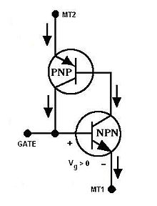](https://en.wikipedia.org/wiki/File:Triac_Quad_I_like_SCR.JPG)

Figure2: Triac Equivalent Circuit

For the most part, this quadrant is the most sensitive of the four. This is on account of it is the main quadrant where entryway current is infused specifically into the base of one of the principle gadget transistors.

*QUADRANT 2-* operation happens when the entryway is negative and MT2 is sure regarding MT1

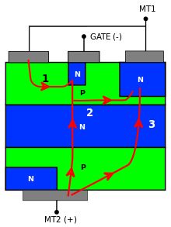

Figure3: Quadrant2 Opreation of Traic

Above Figure demonstrates the activating procedure. The turn-on of the gadget is three-overlay and begins when the current from MT1 streams into the entryway through the p-n intersection under the door. This switches on a structure formed by a NPN transistor and a PNP transistor, which has the door as cathode (the turn-on of this structure is demonstrated by "1" in the figure). As present into the door builds, the capability of the left half of the p-silicon under the entryway rises towards MT1, since the distinction in potential between the door and MT2 tends to lower: this sets up a current between the left side and the right half of the p-silicon (demonstrated by "2" in the figure), which thus switches on the NPN transistor under the MT1 terminal and as an outcome likewise the pnp transistor amongst MT2 and the right half of the upper p-silicon. Along these lines, at last, the structure which is crossed by the significant bit of the current is the same as quadrant-I operation ("3" in Figure )

Quadrant 3 -operation occurs when the gate and MT2 are negative with respect to MT1.

The whole process is outlined in Figure 6. The process happens in different steps here too. In the first phase, the pn junction between the MT1 terminal and the gate becomes forward-biased (step 1). As forward-biasing implies the injection of minority carriers in the two layers joining the junction, electrons are injected in the p-layer under the gate. Some of these electrons do not recombine and escape to the underlying n-region (step 2). This in turn lowers the potential of the n-region, acting as the base of a pnp transistor which switches on (turning the transistor on without directly lowering the base potential is called remote gate control). The lower p-layer works as the collector of this PNP transistor and has its voltage heightened: actually, this p-layer also acts as the base of an NPN transistor made up by the last three layers just over the MT2 terminal, which, in turn, gets activated. Therefore, the red arrow labeled with a "3" in Figure 6 shows the final conduction path of the current.

[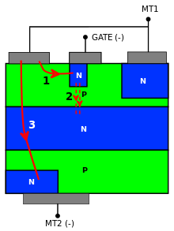](https://en.wikipedia.org/wiki/File:Triac_Quad_III.svg)

Figure4: Quadrant 3 Operation of Triac

Quadrant 4 -operation happens when the gate is sure and MT2 is negative as for MT1.

Activating in this quadrant is like activating in quadrant III. The procedure utilizes a remote door control and is represented in Figure 7. As present streams from the p-layer under the door into the n-layer under MT1, minority transporters as free electrons are infused into the p-locale and some of them are gathered by the basic n-p intersection and go into the bordering n-area without recombining. As on account of an activating in quadrant III, this brings down the capability of the n-layer and turns on the PNP transistor framed by the n-layer and the two p-layers by it. The lower p-layer acts as the gatherer of this PNP transistor and has its voltage elevated: really, this p-layer additionally goes about as the base of a NPN transistor made up by the last three layers directly over the MT2 terminal, which, thusly, gets initiated. Along these lines, the red bolt named with a "3" in Figure 6 demonstrates the last conduction way of the current.

[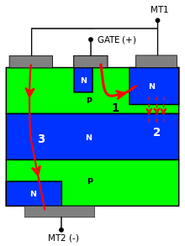](https://en.wikipedia.org/wiki/File:Triac_Quad_IV.svg)

Figure5: Quadrant 4 Operation of Triac

For the most part, this quadrant is minimal delicate of the four. Moreover, a few models of TRIACs (rationale level and snubberless sorts) can't be activated in this quadrant yet just in the other three.

1. **CHRACTERISTICS OF TRIAC**

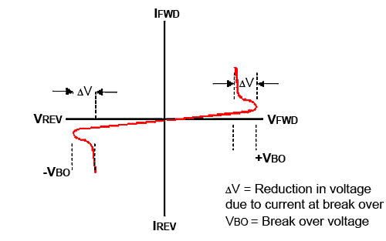

Figure6: Characteristics of Triac

1. **Triac Application**

* High Power TRIACS
* Switching for AC circuits, permitting the control of expansive power streams with milliampere-scale control ebbs and flows
* Can dispense with mechanical wear in a transfer
* Low Power TRIACS
* Light knob dimmers (done by applying power later in the AC cycle otherwise known as PWM of AC wave)
* Motor speed controls for electric fans and other AC engines, and warmers
* Modern automated control circuits in family machines

CHAPTER 3

1. DESIGN

**OPERATION OF REGULATOR**

The circuit outline appeared above is a case of a dimmer switch, where a triac has been used for controlling the force of light. At the point when AC mains is sustained to the above circuit, according to the setting of the pot, C2 charges completely after a specific postponement giving the vital terminating voltage to the diac. The diac leads and triggers the triac into conduction , however this likewise releases the capacitor whose charge diminishes beneath the diacs terminating voltage. Because of this the diac quits leading thus does the Triac. This happens for every cycle of the mains AC sine wave flag, which cuts it into discrete areas, bringing about very much custom fitted lower voltage yield.

The setting of the pot sets the charge and the release timing of C2 which thusly chooses for to what extent the Triac stays in a directing mode for the AC sine signals. Notwithstanding if the heap is an inductive sort, the consideration of C1 turns out to be exceptionally critical. Inductive burdens have a propensity for giving back a part of the put away vitality in the twisting, once again into the supply rails. This circumstance can tear up C2 which then gets to be notable charge appropriately to initiate the following ensuing activating. C1 in this circumstance helps C2 to keep up is cycle by giving blasts of little voltages even after C2 has totally released, and along these lines keeps up the right exchanging rate of the triac. Triac dimmer circuits have the property of creating a ton of RF unsettling influences noticeable all around while working and in this manner a RC arrange gets to be basic with these dimmer switches for diminishing the RF eras. The required is as appeared in the figure.

[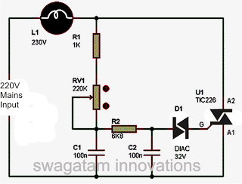](http://1.bp.blogspot.com/-rkz1E6LORHw/T4V2vFMhVPI/AAAAAAAABFc/AgCQsjTTv1s/s1600/simple+triac+lamp+dimmer+switch+circuit.png)

Figure7: Practical regulator implemented with Triac

### The Opto-Triac

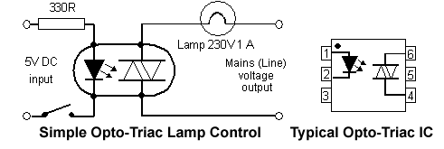

Figure8: Optotriac

The materials utilized as a part of the fabricate of Triacs and SCRs, similar to any semiconductor gadget, are light touchy. Their conduction is changed by the nearness of light; that is the reason they are ordinarily bundled in little lumps of dark plastic. Be that as it may, if a LED is incorporated inside the bundle, it can turn on the high voltage gadget yield in light of a little information current through the LED. This is the rule utilized as a part of Opto-Triacs and Opto-SCRs, which are promptly accessible in incorporated circuit (IC) frame and don't require exceptionally complex hardware to make them work. Just give a little heartbeat at the perfect time and the power is exchanged on. The fundamental preferred standpoint of these optically initiated gadgets is the incredible protection between the low power and high power circuits, (commonly a few thousand volts). This gives safe disconnection between the low voltage info and high voltage yield.

## The Diac

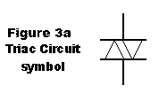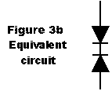

Figure9: Diac

This is a bi-directional trigger diode utilized for the most part as a part of terminating Triacs and Thyristors in AC control circuits. Its circuit image (appeared in figure 3a) is like that of a Triac, yet without the entryway terminal, in truth it is a less complex gadget and comprises of a PNP structure (like a transistor without a base) and acts essentially as two diodes associated cathode to cathode as appeared in figure 3b

The DIAC is intended to have a specific break over voltage, regularly around 30 volts, and when a voltage not as much as this is connected in either extremity, the gadget stays in a high resistance state with just a little spillage current streaming.

Once the break over voltage is come to in any case, in either extremity, the gadget shows a negative resistance as can be seen from the trademark bend in Figure 4. At the point when the voltage over the diac surpasses around 30 volts (a run of the mill break-over voltage) current streams and an expansion in current is joined by a drop in the voltage over the Diac. Regularly, Ohm's law expresses that an expansion in current through a part causes an expansion in voltage over that segment; however the inverse impact is going on here, along these lines the Diac shows negative resistance at break-over.



Figure10: Characteristics of Diac

In the straightforward power control circuit in Figure 2 the Diac is utilized to trigger a Triac by the "Stage Control" technique. The AC mains waveform is stage moved by the RC circuit so that a lessened sufficiency, stage postponed form of the mains waveform shows up crosswise over C. As this wave achieves the break over voltage of the Diac, it leads and releases C into the door of the Triac, so setting off the Triac into conduction. The Triac then leads for the rest of the mains half cycle, and when the mains voltage goes through zero it kills. Some time into the following (negative) half cycle, the voltage on C achieves soften over voltage up the other extremity and the Diac again leads, giving a proper trigger heartbeat to turn on the Triac.

By making R a variable esteem, the measure of stage postponement of the waveform crosswise over C can be changed, permitting the time amid every half cycle at which the Triac flames to be controlled. Along these lines, the measure of force conveyed to the heap can be fluctuated.

Take note of that in down to earth control circuits utilizing Thyristors, Triacs and Diacs, substantial voltages are exchanged quickly. This can offer ascent to genuine RF obstruction, and steps must be taken in circuit plan to minimize this. Likewise as Mains is available in the circuit there must be some type of safe segregation between the low voltage control segments (e.g. the Diac and stage move circuits) and the mains "live" parts, e.g. the Triac and load. This can undoubtedly be accomplished by "Opto-coupling" the low voltage control circuit to the high voltage control (Triac or SCR) part of the circuit.

1. IR Receiver (TSOP1738)

The TSOP 1738 is an individual from IR remote control beneficiary arrangement. This IR sensor module comprises of a PIN diode and a pre enhancer which are inserted into a solitary bundle. The yield of TSOP is dynamic low and it gives +5V in off state. At the point when IR waves, from a source, with a middle recurrence of 38 kHz occurrence on it, its yield goes low. Every key of remote produces a specific HEX code when squeezed which is being perused by arduino serial screen. 4 keys is being customized to do a particular undertaking ie to trigger at various moment (to demonstrate distinctive splendor when diverse keys are squeezed). The TSOP1738 is an all inclusive recipient as it can be controlled with any IR remote.

Lights originating from daylight, fluorescent lights and so forth may make unsettling influence it and result in undesirable yield notwithstanding when the source is not transmitting IR signals. A bandpass channel, an integrator organize and a programmed pick up control are utilized to stifle such unsettling influences. TSOP module has an inbuilt control circuit for intensifying the coded beats from the IR transmitter. A flag is created when PIN photodiode gets the signs. This info flag is gotten by a programmed pick up control (AGC). For a scope of information sources, the yield is sustained back to AGC with a specific end goal to conform the pick up to an appropriate level. The flag from AGC is passed to a band pass channel to channel undesired frequencies. After this, the flag goes to a demodulator and this demodulated yield drives a npn transistor. The authority yield of the transistor is gotten at stick 3 of TSOP module.

Individuals from TSOP17xx arrangement are touchy to various focus frequencies of the IR range. For instance TSOP1738 is touchy to 38 kHz though TSOP1740 to 40 kHz focus recurrence. Lights coming from sunlight, fluorescent lamps etc. may cause disturbance to it and result in undesirable output even when the source is not transmitting IR signals. A bandpass filter, an integrator stage and an automatic gain control are used to suppress such disturbances.

**TSOP module** has an inbuilt control circuit for amplifying the coded pulses from the IR transmitter. A signal is generated when PIN photodiode receives the signals. This input signal is received by an automatic gain control (AGC). For a range of inputs, the output is fed back to AGC in order to adjust the gain to a suitable level. The signal from AGC is passed to a band pass filter to filter undesired frequencies. After this, the signal goes to a demodulator and this demodulated output drives an npn transistor. The collector output of the transistor is obtained at pin 3 of TSOP module.

Members of TSOP17xx series are sensitive to different centre frequencies of the IR spectrum. For example TSOP1738 is sensitive to 38 kHz whereas **TSOP1740** to 40 kHz centre frequency.

**Pin Diagram:**

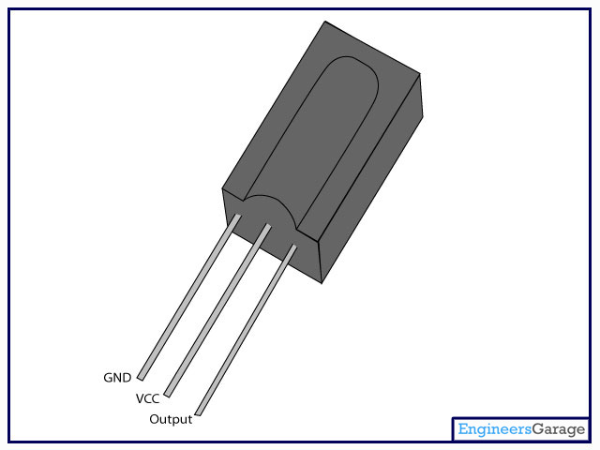

Figure11 Pin Diagram of TSOP1738

11) DATA SHEET OF TSOP1738

* The TSOP 1738 from Vishay is a miniaturized IR receiver module for infrared remote control systems. A PIN diode and a preamplifier are assembled on lead frame, the epoxy package contains an IR filter. The demodulated output signal can be directly connected to a microprocessor for decoding. This device is widely used for remote controlling.
* Photo detector and preamplifier in one package
* Internal filter for PCM frequency
* Improved shielding against EMI
* **Supply voltage range** from 2.5V to 5.5V
* **Transmission range** of 45m
* **Improved immunity** against ambient light
* **Carrier frequency** of 38KHz
* D**irectivity** of 45°
* **Supply current** of 950µA
* **Operating temperature** range from -25°C to 85°C
* **Carrier Frequency** 38kHz
* **Transmission Range** 45m
* **Directivity** 45°
* **Supply Voltage Max** 5.5V
* **Supply Voltage Min** 2.5V
* **Operating Temperature Min** -25°C
* **Operating Temperature Max** 85°C
* **Supply Current** 800µA
* **Packaging** Each

CHAPTER 4

1. CONTROLLING THE CIRCUIT WITH ARDUINO

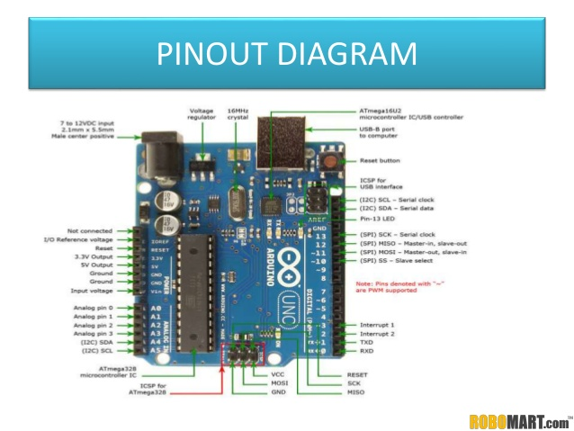

Figure12 Arduino

Hardware

* It is an open source microcontroller based on Atmel megaAVR  chips
* The boards feature serial communication interfaces, including Universal Serial Bus (USB) on some models, for loading programs from personal computers.
* For programming the microcontrollers, the Arduino project provides an integrated development environment (IDE) based on a programming language named *Processing*, which also supports the languages C and C++.

Software

* The Arduino project provides the Arduino integrated development environment (IDE), which is a cross-platform application written in the programming language Java.
* The Arduino IDE supports the languages C and C++ using special rules to organize code. The Arduino IDE supplies a software library called Wiring from the Wiring project, which provides many common input and output procedures. A typical Arduino C/C++ sketch consist of two functions that are compiled and linked with a program stub *main()* into an executable cyclic executive program:
* *setup()*: a function that runs once at the start of a program and that can initialize settings.
* *loop()*: a function called repeatedly until the board powers off.

In arduino UNO there are a total of 28 pins out of which 14 pins are for digital i/p, o/p of which 6 can supply a PWM outputs. the microcontroller used has 14 pins. There are 6 analog pins and 2 pins are there for the power supply. The power supply in the arduino board is of 5v or 3.3v. The power supply of 3.3v is supply inside the board whereas the 5v power supply is given through a dc battery of 7-12v. It has a fuse to protect the board from currents above 500 mA.

There is pushbutton on the board itself which resets the board. The Uno has 6 analog inputs, labelled A0-A5. By default they measure from ground to 5 volts, though is it possible to change the upper end of their range using the AREF pin. There is a total of 3 grounds available. Two capacitors are used both of 47microFarad as bypass capacitors or in a 555 timer to set its frequency 38kHz.

The pin 13 is the output pin where the output is taken mainly by the led. A reset pin is also there in the arduino board which can be used to reset the arduino board. A microcontroller ATMEGA3825 is used in the following arduino board which has 14 pins IC. There are 7 digital pins in which can be used for digital input and digital output. The voltage regulator in the arduino is used to interact with the arduino. It is used to know what is for, It is mainly used to control the voltage of the arduino board. The harmful voltage is turn away by the voltage regulator and only the useful voltage is being used for the process. TX and RX led is used in the arduino. TX is short for transmitter and Rx is short for the receiver. These pins are mainly used for the process of serial communication. TX and Rx appear by the digital pins indicated by 0 and 1. TX and RX LEDS are also present in the arduino board. A nice visual indicators when our arduino is receiving or transmitting. A port is present in the arduino which is used to connect the arduino with the computer system.

1. CIRCUIT DIAGRAM

The lower part of the circuit is the yield circuit which controls the period of sinusoidal flag. The upper part of the circuit is the info circuit or the zero intersection location circuit.

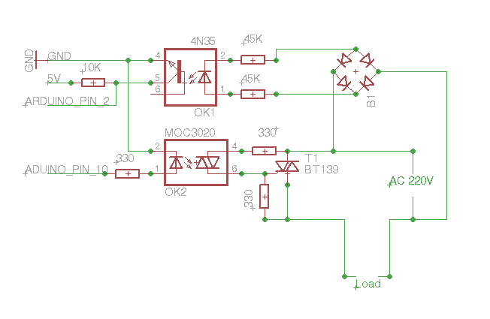

Figure13 Circuit Diagram

(i) PHASE CONTROL CIRCUIT – In this circuit the heap (globule) is associated in arrangement with AC supply and the triac. The door is associated with arduino pin1 for activating. The door is not associated specifically to arduino but rather it is associated through some seclusion circuit (MOC3020). This is on account of there is some reverse of AC current (75 v) through entryway which may devastate the arduino. So to keep this optotriac is being utilized as a detachment. When gating sign is being connected through arduino stick the triac permits to pass the air conditioner current through load until the AC flag turns around its sign.

The activating moment of triac can be dictated by zero intersection location circuit which guarantees that zero intersection of the AC flag. After zero intersection has been recognized the arduino can be customized at which moment it ought to trigger. In the event that the activating heartbeat is connected at stage more prominent than 90 then force of knob is most extreme , generally if the activating heartbeat is connected at under 90 stage then in strained quality of globule will diminish.

(ii) ZERO CROSSING DETECTION CIRCUIT – For location of zero intersection the AC flag is gone through an extension rectifier which is being gone through a segregation circuit optotransistor(4N25).

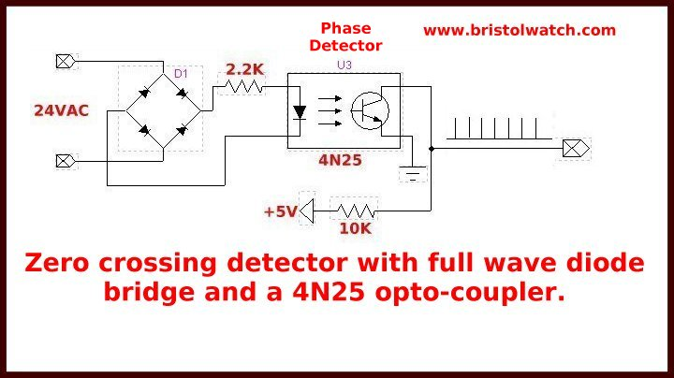 Figure14 Zero Crossing Detector

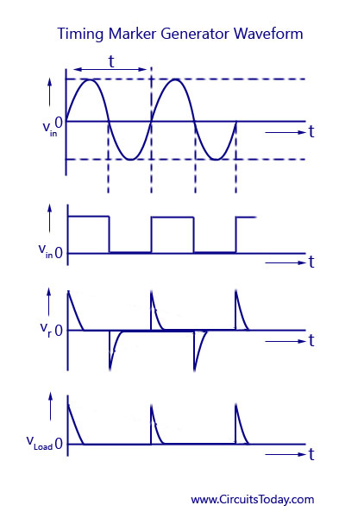

Figure15 Waveform of Zero crossing detector

As soon as the base of opto-transistor receives ir signal when AC signal changes its polarity, the collector current flows from Vcc. This can be read from the serial monitor form arduino.

1. Advantages

* Home appliances like lights and fans can be switched on/off with the help of remote directly.
* No need for the special remotes. They can be controlled with the ordinary TV remotes.
* Reduces the work.
* Very much helpful to the patients and old people.
* Cheaper.
* It is safer than directly switch on/off with the hand.

CHAPTER 5

**RESULT and CONCLUSION**

RESULT

* We learnt the working of normal regulator.
* The basic principle of working of Triac and optocoupler.
* Controlling motor speed with Arduino.
* Controlling lamp with Arduino

Conclusion

* Most reliable and the transmitter and receiver circuit is reduced.
* A single universal remote can be interfaced with all the appliances
* Future scope
* Make everything wireless to make life comfortable.
* Controlling everything with TV Remote.