KISAN

Documentation

Kisan is designed to accurately detect crop diseases within seconds. Kisan detects problem in real time and shows accurate treatment solutions. Here is the best home farming app.

Kisan is a user friendly app that helps your plant to grow disease free. You can easily find the solution for your plant and get suggestions for healthy growth.

Features

KISAN trained in deep CNN with many layers to predict the diseases with high accuracy. It can also provide the solutions for insects and pathogens. Kisan was trained over 100 globally identified crop diseases. Kisan takes probabilities for the diseases to find the interlinked causes for the disease so that the solutions are quicker to cure the plant

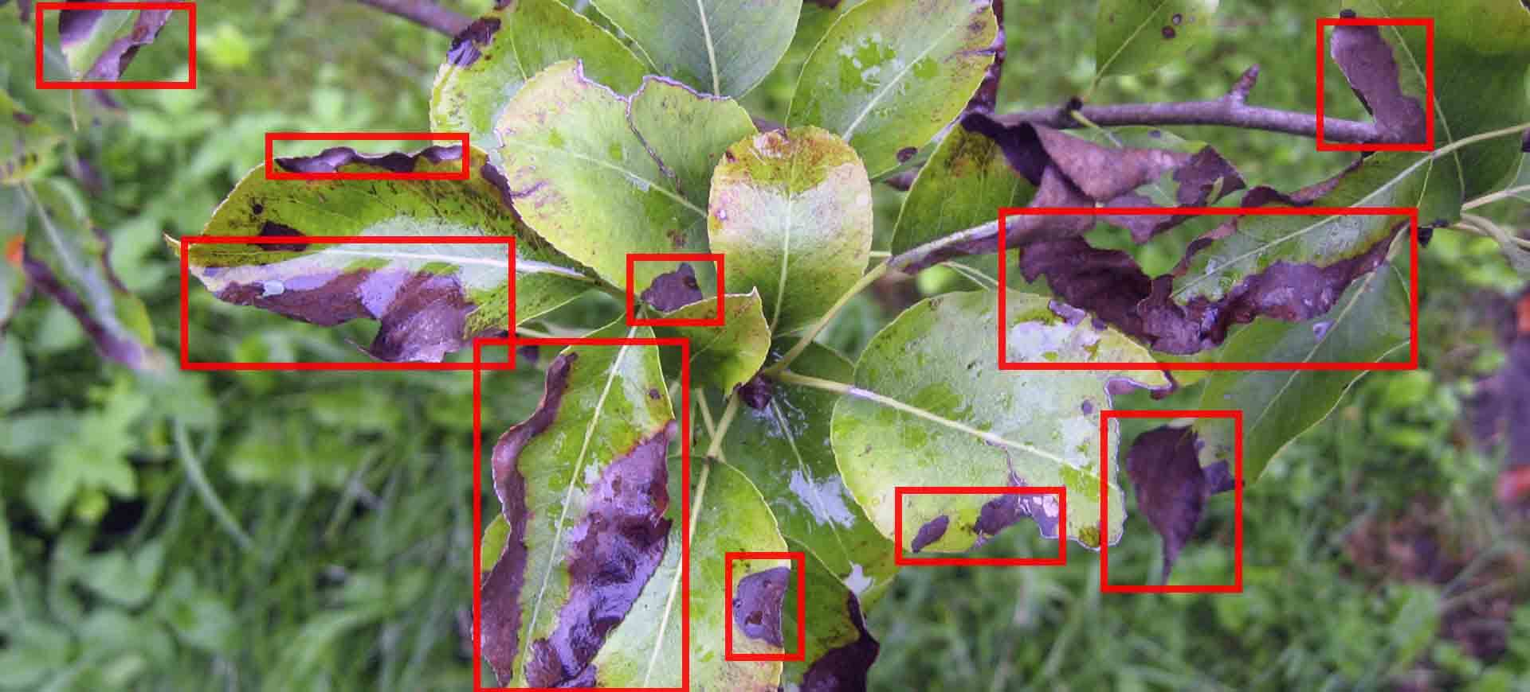

### Technologies used

* python
* kivy
* tenser flow/keras
* opencv

PROJECT THEME:

AGRO-TECH

GitHub:

<https://github.com/SANNATHKOUSHIK/KISAN>

TEAM:

MUDUNURU SAI HARINI

SANNATH KOUSHIK SHARMAN