1.To write a shell script that reads a number and prints its reverse.

Ans.

1.Nano [reverse.sh](http://reverse.sh) And enter the code

#!/bin/bash

echo -n "enter the number :"

read n

rev=0

while [ $n -gt 0 ]

do

r=$(( n % 10))

rev=$((rev * 10 + r))

n=$((n / 10))

done

echo "reversed number is: $rev"

2.Ctrl+o →enter→ctrl+x

3. to execute the code ./reverse.sh

Output

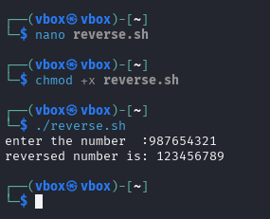

2.write a shell program to implement the question s=ut+1/2at^2

Sudo apt install bc -y (bc -l is used for floating-point math in Bash.)

Nano [motioneqn.sh](http://motioneqn.sh)

#!/bin/bash

read -p "enter initial velocity (u) :" u

read -p "enter acceleration (a) :" a

read -p "enter time (t) : " t

s=$(echo "$u * $t + 0.5 * $a * $t * $t " | bc -l)

echo "the displacement (s) is : $s "

Output

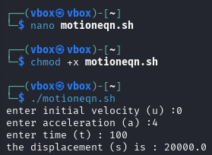

3.To calculate the factorial of a number using a shell script.

Nano [fact.sh](http://fact.sh)

#!/bin/bash

read -p "Enter a positive integer: " num

if [ "$num" -lt 0 ]; then

echo "Factorial not defined for negative numbers."

exit 1

fi

fact=1

for (( i=1; i<=num; i++ ))

do

fact=$((fact * i))

done

echo "Factorial of $num is: $fact"

Output

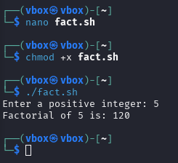

4.To find the largest and smallest element in an array using shell scripting.

Ans

!/bin/bash

read -p "Enter number of elements: " n

echo "Enter $n numbers:"

read -a arr # Read entire array in one line

min=${arr[0]}

max=${arr[0]}

for num in "${arr[@]}"

do

(( num > max )) && max=$num

(( num < min )) && min=$num

done

echo "Largest element: $max"

echo "Smallest element: $min"

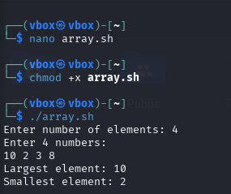

5.To perform bitwise operations (AND, OR, XOR, NOT) based on user input.

!/bin/bash

echo "Bitwise Operations Menu:"

echo "1. AND"

echo "2. OR"

echo "3. XOR"

echo "4. NOT"

read -p "Enter your choice [1-4]: " choice

if [ "$choice" -eq 4 ]; then

read -p "Enter a number: " a

else

read -p "Enter first number: " a

read -p "Enter second number: " b

fi

case $choice in

1) echo "$a AND $b = $((a & b))";;

2) echo "$a OR $b = $((a | b))";;

3) echo "$a XOR $b = $((a ^ b))";;

4) echo "NOT $a = $((~a))";;

*) echo "Invalid choice!";;

esac

Output

